Evidence of Learning E-Portfolio BLOG

This blog contain the main 3 topics “Climate Change” “Social challenges” “Possible Bias”

Topic 1: Climate change and its effect.

What is climate change?

“Climate Change and Health.” World Health Organization, 30 Oct. 2021, www.who.int/news-room/fact-sheets/detail/climate-change-and-health.

Weather patterns and temperatures have shifted over time as a result of climate change. It is possible that these shifts are caused by natural phenomena, such as variations in the solar cycle. Climate change is primarily caused by human activities since the 1800s, primarily the burning of fossil fuels like coal, oil, and gas.
The burning of fossil fuels releases greenhouse gas emissions that trap the sun's heat and raise temperatures.
Climate change is caused by greenhouse gas emissions such as carbon dioxide and methane. Gasoline used for driving a car or coal used for heating a building, for instance, results in these emissions. Clearing land and forests can also release carbon dioxide. Landfills for garbage are a major source of methane emissions. Energy, industry, transport, buildings, agriculture and land use are among the main emitters. According

GREENHOUSE GAS CONCENTRATIONS ARE AT THEIR HIGHEST LEVELS IN 2 MILLION YEARS

And emissions continue to rise. As a result, the earth is now about 1.1°c warmer than it was in the late 1800s. The last decade (2011-2020) was the warmest on record.
Many people think climate change mainly means warmer temperatures. But temperature rise is only the beginning of the story. Because the earth is a system, where everything is connected, changes in one area can influence changes in all others.
The consequences of climate change now include, among others, intense droughts, water scarcity, severe fires, rising sea levels, flooding, melting polar ice, catastrophic storms and declining biodiversity.

How does climate change affect people?
People are experiencing climate change in diverse ways

“Climate Change and Health.” World Health Organization, 30 Oct. 2021, www.who.int/news-room/fact-sheets/detail/climate-change-and-health.

Climate change can affect our health, ability to grow food, housing, safety and work. Some of us are already more vulnerable to climate impacts, such as people living in small island nations and other developing countries. Conditions like sea-level rise and saltwater intrusion have advanced to the point where whole communities have had to relocate, and protracted droughts are putting people at risk of famine. In the future, the number of “climate refugees” is expected to rise.

Why is climate change important? And why should climate change not increase?
In a series of UN reports, thousands of scientists and government reviewers agreed that limiting global temperature rise to no more than 1.5°C would help us avoid the worst climate impacts and maintain a livable climate. Yet policies currently in place point to a 2.8°C temperature rise by the end of the century. The emissions that cause climate change come from every part of the world and affect everyone, but some countries produce much more than others. The 100 least-emitting countries generate 3 per cent of total emissions. The 10 countries with the largest emissions contribute 68 per cent. Everyone must take climate action, but people and countries creating more of the problem have a greater responsibility to act first. Climate change is already impacting health in a myriad of ways, including by leading to death and illness from increasingly frequent extreme weather events, such as heatwaves, storms and floods, the disruption of food systems, increases in zoonoses and food-, water- and vector-borne diseases, and mental health issues.

Topic 2: Social challenges

What are social challenges?
Social challenges refer to problems that people have interacting with other people in our society or that are taking part in normal social behaviors.
Some of the most social challenges that are happening in our society right now are:
Bullying
Sexism
Racism

According to “Morin, Amy. “The Top 10 Social Issues Teens Face in the Digital World.” Verywell Family, 24 June 2020, www.verywellfamily.com/startling-facts-about-todays-teenagers-2608914”
Bullying happens often in our society. About “22% of teens in the U.S. experienced bullying in 2019, according to the National Center for Education Statistics. About 22% of teens in the U.S. experienced bullying in 2019, according to the National Center for Education Statistics.”

Sexism happens often in our society with different age and groups of women and girls. Some of the sexism happening in schools are:
According to “Challenging sexism and gender stereotypes in education (chartered.college)”
-Sexist language and sexist bullying in schools’ comments to reinforce gender stereotypes typically stem from beliefs about the inferiority of a sex
- comments that seek to demean, ridicule, intimidate, isolate or harm others, innuendo, lewd comments, sexual remarks about clothing, spreading rumors about a person’s sexual reputation, sexualized name calling or sexually abusive terms, sexual jokes or taunting
- comments or sexual remarks on a person’s bodily appearance, sexual objectification – treating a person or parts of their body just as an object of sexual desire or a commodity without concern for their personality or dignity

according to “institute, European. “Sexism at Work.” European Institute for Gender Equality, 2020, eige.europa.eu/publications/sexism-at-work-handbook/part-1-understand/sexism-work.”

The perception that women and men have different skills is part of the reason they are concentrated in different professional fields. While women are over-represented in care and pre-primary education, men dominate politics and fields related to science, technology, engineering and mathematics^{[1]}.
Such horizontal gender segregation is partly responsible for the gender pay gap, as fields dominated by men tend to be more highly paid than those dominated by women. Even when women are concentrated in a certain field, men will have more opportunities for promotion, take more senior posts and earn higher salaries^{[2]}.
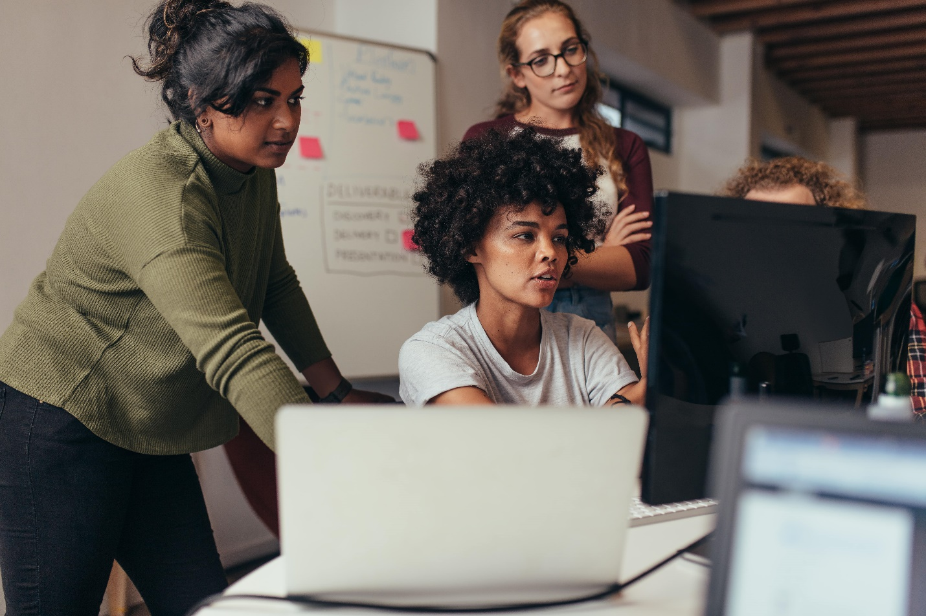Computer programming used to be dominated by modestly paid women
Gender stereotypes linked to the value of work are partly to blame, with salaries in a profession going down when women enter and rising with the entry of men: computer programming was once the preserve of modestly paid women, but started to gain prestige and become lucrative once men entered the profession^{[3]}.

Topic 3: Possible Bias

What is possible bias? What are some possible biases in our society?

Age bias, gender bias, race bias, background bias.
There are many different biases. The most common biases people experience in our society are gender and race biases. Gender bias would happen a lot of time in workplaces too. This resulting on less women getting jobs and having a pay gap
. According to Asana. “19 Unconscious Bias Examples and How to Prevent Them • Asana.” Asana, 17 May 2021, asana.com/resources/unconscious-bias-examples”
This type of bias may affect recruitment practices and relationship dynamics within the company. An example of this bias during hiring is if the hiring panel favors male candidates over female candidates even though they have similar skills and job experience.
Another well-known example is the gender pay gap. As of 2021, the average median salary for men is about 18% higher than women’s.
The gender bias may reduce job and career advancement opportunities for certain populations.

Another example in work place biases are gender biases where the white race would get chosen for the job over the other people with a different ethnic background.

According to “workrowd, blog. “Countering Racial Bias & Racism in the Workplace.” Workrowd, 15 Mar. 2022, blog.workrowd.com/2022/03/15/the-impact-of-racial-bias-racism-in-the-workplace/.”

Racial diversity is an important part of any business. It makes companies more profitable, and means they can better tap into their audiences’ needs. It also leads to a happier, more engaged, and more productive workforce.
Yet, for many businesses, diversity, equity, and inclusion (DEI) isn’t a priority.
In fact, a recent survey by Deloitte revealed that more than 40% of upper management respondents feel their organizations are “too focused on DEI”. More than 60% predict their organization will reduce its commitment to DEI as new business threats emerge.
Unfortunately, racism is a lot more prevalent than many people realize. One in four people of color report having experienced racism in the workplace.

Nuffield College’s Centre for Social Investigation sent around 3,200 fake job applications for a range of jobs, from shop assistants to chefs to software engineers. The applicants had identical CVs (which are slightly different from resumes but a similar idea), cover letters, and experience. Only 15% of Black, Indigenous, and person of color (BIPOC) applicants received a call back, compared to 24% of white British applicants. Half of Black women report being sent home from work for wearing their hair in an afro, braids, or twists.
And, while it may be illegal to fire someone for wearing an afro to work in the US, it’s legal to fire someone for going to work wearing protective styles like braids.

Reference List.

“Climate Change and Health.” World Health Organization, 30 Oct. 2021, www.who.int/news-room/fact-sheets/detail/climate-change-and-health.
“Morin, Amy. “The Top 10 Social Issues Teens Face in the Digital World.” Verywell Family, 24 June 2020, www.verywellfamily.com/startling-facts-about-todays-teenagers-2608914”
“Challenging sexism and gender stereotypes in education (chartered.college)
“institute, European. “Sexism at Work.” European Institute for Gender Equality, 2020, eige.europa.eu/publications/sexism-at-work-handbook/part-1-understand/sexism-work.”
19 Unconscious Bias Examples and How to Prevent Them • Asana.” Asana, 17 May 2021, asana.com/resources/unconscious-bias-examples”
workrowd, blog. “Countering Racial Bias & Racism in the Workplace.” Workrowd, 15 Mar. 2022, blog.workrowd.com/2022/03/15/the-impact-of-racial-bias-racism-in-the-workplace/.”

