

BA International Hotel Management
BMIH5001 Entrepreneurship
Individual Business Model Canvas with Entrepreneurial Reflection Using Appropriate Academic Models

Module Title : Entrepreneurship 5001
Lecturer: Neil Dyer
Student Name: Ionela Beatrice Hulub
Student ID Number: 2214483

Table of Contents
Part 1: Essay 3
Introduction 3
Business Model Canvas (BMC) for EcoPlate&Pot in the United Kingdom 3
Conclusion 7
Part 2: Reflective Essay 8
Introduction 8
Reflective Essay with Gibbs Reflective Cycle 8
Conclusion 9
References 10
Appendix 13

Part 1: Essay

Introduction
Individuals who can identify the problem in the market, introduce solutions to the problem, and make a profit out of it, taking high risks, are known as entrepreneurs (Smith et al., 2016). Entrepreneurs have several characteristics, such as forecasting demand, identifying hidden needs and demands, risk-taking, adaptability, leadership, and so on (Barringer and Ireland, 2018). Entrepreneurs are needed by all countries for economic development. Entrepreneurship and entrepreneurship have high economic benefits. The essay is on a new entrepreneurial venture in the United Kingdom.

Business Model Canvas (BMC) for EcoPlate&Pot in the United Kingdom
The hospitality industry has merged several industries, including accommodation, food and beverages, restaurants, travelling, transportation, tourism, resorts, amusement parks and so on (Choudhary, 2013). Restaurants are one of the options in the hospitality industry, which may not require a big initial investment like other sectors of the hospitality industry. Therefore, the proposed business is a restaurant in the United Kingdom. The name would be 'EcoPlate&Pot'. From the name of the restaurant, it is understandable that the restaurant would be an eco-friendly restaurant. There is significance in business model preparation for a new business. The business model must include all the aspects of the business along with future plans for the business (Blackwell, 2011). The proposed business model with the help of Business Model Canvas (BMC) is explained below.
The first phase of the model is the key partners. The key partners are the suppliers of business (Mariotti and Glackin, 2012). EcoPlate&Pot would have several suppliers. Since it would be a restaurant, there is a need for various raw materials for processing and preparing different food items for the restaurant. EcoPlate&Pot would have contracts with several suppliers to reduce the risk level. If supplies were bought from a single supplier, there would be dependency and might pose risks. Therefore, several suppliers would be contracted. In addition, while choosing suppliers, EcoPlate&Pot would be very careful because all the supplies must be hygienic, fresh, and organic. In supplying raw materials, packaging materials and other necessary items, sustainability would be considered. EcoPlate&Pot would try to ensure a lower carbon footprint when purchasing supplies from suppliers.
The second phase of the model is the key activities. It is the activities of the business that generate income for the business. EcoPlate&Pot will sell organic, fresh, and eco-friendly foods to the guests. Since organic, fresh, and sustainable are promoted in the restaurant, it would be a vegetarian restaurant. Food items which are famous from different regions would be served with unique flavours, fresh ingredients and spices. Other than that, EcoPlate&Pot must do some key business functions such as procurement, management, marketing, financing, accounting, leading, monitoring, human resource management, and so on to keep the business running well (Haslam, 2015).
The third phase of the model is the value proposition. The value proposition is setting the values of the company in the minds of the customers so that they can relate the name of the brand with its products and services (Nelson, 2013). The name of the restaurant, 'EcoPlate&Pot', itself indicates the business idea. But the value proposition must be strong enough, including the benefits for the customers as well. So, the proposed value proposition for 'EcoPlate&Pot' would be 'EcoPlate&Pot'- Your Ultimate Veg Destination with Organic, Fresh and Unique Flavours, and Sustainable Serving Plates & Pots to Contribute to Reducing Carbon Footprint'. The positioning statement includes all the aspects, such as the benefits to the customers through unique, fresh, and organic food. It also adds that the restaurant would offer sustainable plates and pots for serving the food, which may reduce the carbon footprint. Thus, it would attract customers to enjoy food at EcoPlate&Pot.
The fourth phase of the business model is the customer relationships. Customer relationships are an essential element in the business model because customers are the individuals to whom services are served, and from them, revenue is generated (Rae, 2008). Therefore, customers should always get prioritised and in touch with the business. EcoPlate&Pot would have face-to-face interactions with the guests who come and eat food in the restaurants. The feedback would be taken from each customer to know about the food, any improvements required in the food tastes or ingredients, the quality of services and the overall business suggestions by the customers. Thus, the data from the customers can easily be collected, and the feedback can be taken into consideration for further improvement. Other than that, there would be the presence of EcoPlate&Pot on social media, where different polls would be arranged to be in touch with the customer to know their needs, tastes and suggestions for the restaurant.
The fifth phase of the business model is the customer segments. Customer segments refer to the segmentation and targeting of customers to whom the company's products and services would be sold (Rickman and Roddick, 2013). EcoPlate&Pot would target a specific customer segment that would like to have fresh, organic, and vegetarian food and wants to lead a healthy and sustainable lifestyle. Sustainability has become a great concern among travellers. Since EcoPlate&Pot would prioritise sustainability and would like to contribute towards attaining sustainable development goals, it would target customers of all ages who want to have a healthy diet through vegetarian foods prepared and served with sustainable ingredients.
The sixth phase of the business model is the key resources. There are different types of resources, including financial, human, intellectual, and physical resources (Timmons and Spinelli, 2008). EcoPlate&Pot would have all these resources. Firstly, the financial resources would be the money needed for the investment, operations and working capital management of the restaurant. It would require purchasing raw materials, packaging foods, providing salaries to the chefs and staff, paying utility bills and so on. Secondly, human resources are the resources of humans in the restaurant. A good and expert chef is one of the core assets of the restaurant. Similarly, the restaurant staff and other management team would be considered human resources. Intellectual resources are the intellectual properties of the restaurant, such as brand recognition and the business's trademark. Finally, the physical resources are the tangible resources such as refrigerators, furniture, computers, POS machines, basins, restaurant land, and so on.
The seventh phase of the business model is the distribution channels. The distribution channels are the ways to distribute products and services to the customers. There are several models through which businesses distribute their products, such as wholesaling, retaining, online, and so on (Williams, 2021). EcoPlate&Pot would have two ways of distributing the foods. Firstly, it would have a face-to-face approach where the guests will come to the restaurant to enjoy food. Secondly, the food would be delivered to consumers' doorsteps through delivery services. EcoPlate&Pot would be present in the online platforms as well. Customers can order food on mobile applications, and delivery personnel will deliver the food. In delivering the food, EcoPlate&Pot will never forget to use eco-friendly serving dishes and pots. However, in maintaining the distribution channel smoothly, there would be some intermediaries, such as the food delivery company and the online payment gateway from which online customers can pay online.
The eighth phase of the business model is the cost structure. The cost structure must be aligned with the revenue streams, too. There would be two types of costs in the business. One is the capital expenditure, and the other is the revenue expenditure (Zimmerer and Scarborough, 2011). The capital expenditure would be the costs incurred to invest the capital. For example, EcoPlate&Pot would inject monetary capital into the business as a form of capital expenditure to purchase furniture, decorative items, POS machines, computers, land and so on. These expenditures are made to increase the assets; therefore, they can be considered capital expenditures. The revenue expenditures are the expenses incurred to generate revenues through operational activities. For example, EcoPlate&Pot may pay the rent, utility bills, and salaries to the chefs, purchase supplies for packaging the food and so on. All these activities of the business are related to business operations to generate revenue. EcoPlate&Pot would be very careful to spend money as a new business in the hospitality industry.
The last phase of the business model is the revenue stream. Revenue streams are the points that generate revenue for the business. Businesses should always look forward to increasing the revenue streams to expand the business and increase profitability. As a restaurant, the one and only revenue stream would be the sale of food to the guests (Cantele and Cassia, 2020). Later on, there is a plan for EcoPlate&Pot to build a website from which different advertisements would be run. Customers who visit the EcoPlate&Pot website will watch advertisements, which may generate revenue for the restaurant. Similarly, EcoPlate&Pot may post some videos on social media and YouTube, where the advertisements may generate revenue for the business. These two are the indirect ways to get revenues, whereas the main revenue stream would be the sale of foods to the consumers of EcoPlate&Pot.

Conclusion
Entrepreneurs play a key role in the economy through innovation, product development, research, job creation and economic growth. Therefore, entrepreneurs can be considered to be the assets of society (Burns, 2022). Entrepreneurs and their entrepreneurial ventures are paramount for the development of society and the economy through digitalisation and innovation (Hisrich et al., 2008). However, entrepreneurs must consider the appropriate use of business plans and models before investing in the business for better performance.

Part 2: Reflective Essay

Introduction
The proposed hospitality venture is a restaurant named 'EcoPlate&Pot'. It is a sustainability-oriented restaurant that would operate in the United Kingdom. The main focus of the restaurant would be to offer vegetarian dishes with unique flavours using fresh and organic ingredients as well as serve eco-friendly dishes to contribute to achieving sustainable development goals.

Reflective Essay with Gibbs Reflective Cycle
The proposed business includes all the aspects of the BMC models. Since there is a higher demand for eco-friendly restaurants, they have been chosen as proposed new businesses in the United Kingdom. All the strategies of the proposed business are justified after analysing all the aspects. In addition, the knowledge and learnings gathered from the class lecture are utilised while planning the business proposal. However, a reflection of the overall module and the business plan can be done.
A reflection is required to assess whether the learning was fruitful or not and how it can be applied for further purposes in life (Thompson and Pascal, 2012). The reflection from the module and the proposed entrepreneurial venture can be given by using Gibbs's reflective cycle. They are explained below.
The first phase of the reflective cycle is the description (Moon, 2013). The module includes a brief understanding of entrepreneurs, entrepreneurship, differences between entrepreneurs and entrepreneurs, entrepreneurial traits and characteristics and so on. In addition, it includes the ways of preparing a business plan.
The second phase of the reflective cycle is feeling. I felt very encouraged while learning the module and proposing and preparing a business plan. There is a high demand for green restaurants nowadays (Kwok et al., 2016). I am thrilled to produce a business with an appropriate template for sustainable restaurants.
The third phase of the reflective cycle is the evaluation of the learning (Bassot, 2016). All the experiences from the module and the production of the business plan were pleasant for me as I learnt new things.
The fourth phase of the reflective cycle is the conclusion. In the conclusion phase, I would consider that if I had more money and enough opportunity, I would have planned a business proposal for the hotel industry. I like the hotel industry because there is a higher scope for revenue generation (Perramon et al., 2014). Hotel industry in the hospitality industry has various scopes such as accommodation services, food and beverages, bars through restaurants in the hotel, self-care sections such as spas, gymnasiums in the hotel, exercise and sports such as swimming, tennis, basketball, badminton in the hotel, and so on (Jang et al., 2017). All these are the scopes of revenue generation inside a hotel that have several opportunities for expansion and growth.
The last phase of the reflective cycle is the action plan. My action plan would be to prepare more business proposals uniquely using the BMC templates. I would like to acquire entrepreneurship skills through watching videos of great entrepreneurs in the world. Finally, I would like to start my own entrepreneurial venture, which is my ultimate action plan.

Conclusion
In conclusion of the reflective essay, it can be said that the business model canvas and the Gibbs reflective cycle have been applied appropriately. The proposed business plan may be successful in the long run by attaining the advantages of the market situation. There is a higher chance of the hospitality industry growing. So, entrepreneurs should look for more new aspects to prepare the business plan and market it for the development of the industry, society and the country (Carvalho and Paiva, 2020).

References
Barringer, B.R. and Ireland, R.D. (2018) Entrepreneurship: Successfully launching New Ventures. 4th ed. New Jersey: Prentice Hall.
Bassot, B. (2016) The Reflective Journal. London: Palgrave/Macmillan Education.
Blackwell, E. (2011) How to Prepare a Business Plan: Planning for Successful Start-up and Expansion. 5th ed. London: Kogan Page.
Burns, P. (2022) Entrepreneurship and Small Business. 5th ed. Basingstoke: Palgrave Macmillan.
Cantele, S. and Cassia, F. (2020) 'Sustainability implementation in restaurants: A comprehensive model of drivers, barriers, and competitiveness-mediated effects on firm performance', International Journal of Hospitality Management, 87, p. 102510. doi:10.1016/j.ijhm.2020.102510.
Carvalho, L.M. and Paiva, I.C. (2020) 'Sustainability Reporting in hospitality sector', Advances in Hospitality, Tourism, and the Services Industry, pp. 150–163. doi:10.4018/978-1-5225-9936-4.ch008.
Choudhary, V. (2013) Hospitality industry. New Delhi: Centrum Press.
Haslam, C. (2015) Business models. London: Routledge.
Hisrich, R.D., Peters, M.P. and Shepherd, D.A. (2008) Entrepreneurship. 7th ed. New York: McGraw Hill.
Jang, Y.J., Zheng, T. and Bosselman, R. (2017) 'Top managers' environmental values, leadership, and stakeholder engagement in promoting environmental sustainability in the restaurant industry', International Journal of Hospitality Management, 63, pp. 101–111. doi:10.1016/j.ijhm.2017.03.005.
Kwok, L., Huang, Y.-K. and Hu, L. (2016) 'Green attributes of restaurants: What really matters to consumers?', International Journal of Hospitality Management, 55, pp. 107–117. doi:10.1016/j.ijhm.2016.03.002.
Linda's (2024) business model and its 9-section template, Conceptboard. Available at: https://conceptboard.com/blog/business-model-canvas-free-conceptboard/ (Accessed: 28 January 2024).
Line, N.D., Hanks, L. and Zhang, L. (2016)' Sustainability Communication: The effect of message construals on consumers' attitudes towards Green Restaurants', International Journal of Hospitality Management, 57, pp. 143–151. doi:10.1016/j.ijhm.2016.07.001.
Mariotti, S. and Glackin, C. (2012) Entrepreneurship: Starting and Operating a Small Business. London: Prentice-Hall.
Moon, J.A. (2013) A Handbook of Reflective and Experiential Learning: Theory and Practice. 6th ed. London: Routledge.
Nelson, O.N. (2013) Enterprise Development in SMEs and Entrepreneurial Firms Dynamic Processes. Pennsylvania: IGI Global.
Perramon, J. et al. (2014) 'Green practices in restaurants: Impact on firm performance', Operations Management Research, 7(1–2), pp. 2–12. doi:10.1007/s12063-014-0084-y.
Rae, D. (2008) Entrepreneurship: From Opportunity to Action. 2nd ed. Basingstoke: Palgrave Macmillan.
Rickman, C.D. and Roddick, D.A. (2013) The Small Business Start-Up Workbook: A Step-by-Step Guide to Starting the Business You Dreamed Of. London: How to Books.
Smith, L., Rees, P. and Murray, N. (2016) 'Turning entrepreneurs into intrapreneurs: Thomas Cook, a case-study', Tourism Management, 56, pp. 191–204. doi:10.1016/j.tourman.2016.04.005.
Thompson, N. and Pascal, J. (2012) 'Developing critically reflective practice', Reflective Practice, 13(2), pp. 311–325. doi:10.1080/14623943.2012.657795.
Timmons, J.A. and Spinelli, S. (2008) New Venture Creation: Entrepreneurship for the 21st Century. Boston: McGraw-Hill.
Williams, S. (2021) FT Guide to Business Start Up: The Most Comprehensive Guide for Entrepreneurs. 32nd edn. Harlow: Financial Times Press.
Zimmerer, T.W. and Scarborough, N.M. (2011) Essentials of Entrepreneurship. 6th ed. New Jersey: Prentice Hall.

Appendix
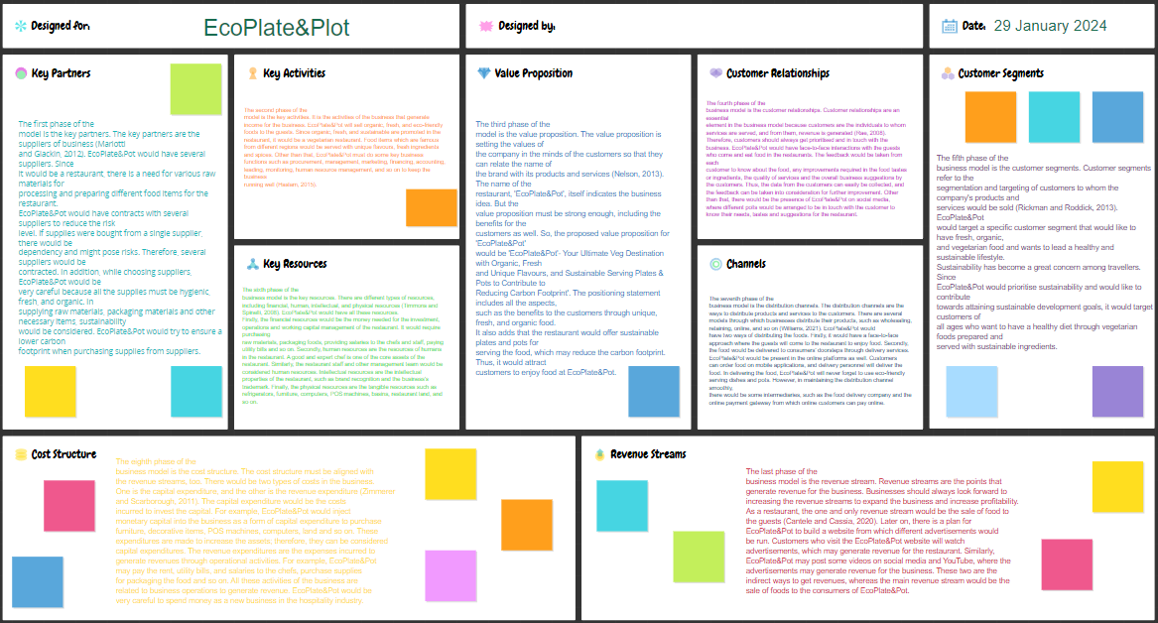
Figure 1: Business Model Canvas (BMC) for EcoPlate&Pot (self-made)
Source: (Linda, 2024)

