Skills for the Workplace
Module Assignment Submission
Student Name: | Roselyn Tenkorang
Student Number: | 1604295
Module No: | EMPL4013
Module Title: | Pathway Project 1

Statement of Confirmation of Authenticity
By the act of making this submission, the student declares that this is the work of the student named above. The work has not, in whole or in part, been knowingly presented elsewhere for assessment, or where assessment has been built on a previous assessment, this has been identified. Where materials have been used from other sources it has been properly acknowledged. If this statement is untrue, the student acknowledges that an assessment offence has been committed.
Attention is drawn to the plagiarism and unfair practice policies of both the University and of ILM.

Table of Contents
Introduction
Personal Skill
Reflection of the presentation assignment
Conclusion
Learning Log
Reference
Appendix 1-12

Introduction
This report will examine my reflection on assignment Pathway Project 1. The topic of the project was Sustainability and Global Citizenship. To give reason on issues when working as a group on our chosen organisation and to give a brief presentation as individual. I will be reflecting on the Learning Log which everyone in the group must complete during preparation of their presentation assignment also using it to complete individually reflective assignment.
I will be demonstrating my learning personal skills and experiences working together as a group regarding to our project work Tesco Sustainability and Global Citizenship by reflecting on the challenging we face as a group and individually.
At conclusion of the assignment to illustrate my strength of work showing my ability to undertake challenging task, use has my advantage to manage my workload. Also would be giving brief reason for managing my planning time schedule. To acknowledge my strength and weakness when applying for job. To create action plan to achieve my skills.

Reflective Body
Reflecting about the project work on my organisation Tesco Sustainability and Global Citizenship is more likely using my brain skill to compel this assignment. According to Buzan (2004) stated that using my brain effectively will be the leading way to be successful at work. Writing the reflection report about the presentation assignment was challenging for me but if I think deep with right thinking and learning tools can be a great rewarding to use for brilliant solution to any type of problem I might encounter.
Studying the course Certificate of Higher Education in Skill for the workplace, I was assigned with Pathway Project work assignment to completed business plan as a group presentation. I recalled my lecturer informing every student in the class to get into groups no more than four people we must decide by ourselves. We were given deadline by our lecturer to form a group within two or three weeks during lecture time, if you are not in a groups by set time, you would not be able to participate in the team presentation.
I firstly started to think whom should I choose to work with, I was little bit apprehensive in decision because of my previous experience working as a group in another subject project work with the same class and the problem I encounter made me feel uncomfortable for my decision. According to Eggert (2013) stated that if you want to be successful in life it is important to learn to get along with other people. For not everyone is easily to deal with and some people can be very difficult. Sometimes when finding it difficult to get along with someone is because there was not enough time to understand them. According Eggert (2013) stated that the effective way to understand other people is to take some time to observe and listen especially when you are having a problem with someone.
The first two weeks was a challenging moment, I decide to draw on positives side by forming a group with one of the student Peter Owusu-Dome, we got along well working together in our previous assignment on Project Planning and there were three other students who requested if we could joint together as a group and we agreed to form a team of five people.
The day we came together as group, we all agreed by mouth to make sure that we will be fully participate and committed to the task and other meeting which would be arrange after classes during the week. Also, we agreed to nominated Peter Owusu-Dome as our team leader. Selecting a team leader was my key point because without good leadership the vision of the task would perish. Working with competent people enable you to achieve your goal. According to Buzan (2004) stated that to be a team leader main importance knowingly you are capable managing yourself.
We arranged to meet at university campus on the following day to discuss on how to start the project work. At that instant everyone in my team agreed to meet, the day of our meeting myself and other two students turn up, the other two did not come along. I was not amused, because working with Lambeth Social Service as administrator has taught me how to be adapted to any circumstance. According to Parker (2008) defining team is known to be everywhere, in business there is a department of team, in sport you have a team of offensive and defensive. There are so many ways to define as a team and it play significant role in our personal and professional lives. Unfortunately, not every group can definition as a team and not every team capable of working together. An effectual team is a group of people with extreme degree of interdependence focus toward accomplishing a set of goals and completion of a task, by agreeing to achieve the goals is to work together.
We decided between three of us to start planning on our assignment by selecting the orgainsation we going to use for our project work. Which was Tesco Supermarket about their Sustainability and Global Citizenship.
The time management as a group was very important, because realise we have only two weeks to complete the task. To be successful in life or in business time management need to be your priority according to Burke (2013). I start out by planning how well going to manage my time of work and with family. I start by using the priority organiser list to decide the best way to complete my task and the amount of time I need to spent doing my work and the same time spending with my son.
According to Cottrell (2013) Time management as a student is using timetable has weekly to year. But it is your responsibility to be proactive with time study. Planning the amount of socializing, managing assignment deadline and the amount of time spent personal study and online.
My experience working Administration for many years had enable me to plan effectively and to develop my ability to undertake any sort of challenging. I have learnt to be organise and prioritize to meet the requirement time. Having these experiences had been great advantage to gain vast understanding on how to manage my time effectively and working together with Team managers has enable me to be responsible independent worker. For these reasons working on the assignment Tesco Sustainability and Global citizen was a challenging but planning efficiency allow me to research the right information to complete the task.
Working as a team the time management is to have Action plan with a check list and meeting once a week to discuss on the progress of the project work, finding out where and what resources acceptable to used. Our deciding is to use online information about Tesco Sustainable and Global citizen. As a group not, everyone was able to used their time wisely, we change our schedule planning most times to be able to achieve the target. It was obvious only three students in the group include me were active and participating in the assignment to accomplish the project work presentation.
During our team meeting we decide to delegate tasks according to each person preferences and can be manageable, by my understanding everybody work differently and some are good at participating in classes but not so great working independently. We share the work according to each person mentally capacity. According to Cultural Careers Council Ontario’s stated that delegation is a tasks or projects is giving someone to take responsibility and authority to do something that would otherwise be done by yourself.
My delegation of task is to explain what is meant by the term Global Citizen and describe two examples of sustainable projects from within my chosen sector Tesco Supermarket. I will give a brief reflection on my finding of what is Global Citizen and Sustainability on Tesco Supermarket organisation. The meaning of Global Citizen stated in my presentation is profound as what must be done to create a better world and what initiatives or context we need in our community to make a great impact to our lives and examine the situation in globally and finding solution to resolve them.
According to Tesco Global Citizen acknowledging that using sale of 10 pence carrier bag enable them to make an impact to their community by creating project work to give support and wellbeing of people in all ages and backgrounds. Tesco contribution is to developed communities to aim high in achieving things. Its show in the picture The Queen acknowledge one of the Tesco project work in the community.
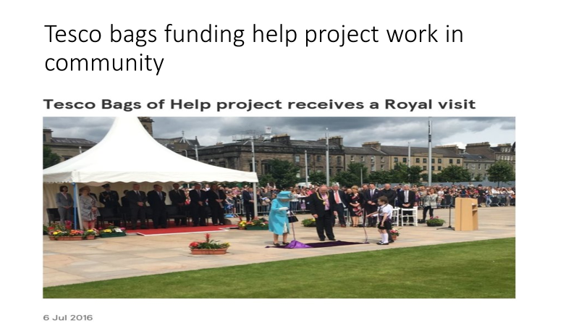
According to Tesco report their Sustainable to Farmer is to create a good rapport with their suppliers. Providing them with affordable and transparent pricing. Working alongside their supplier to becomes British Agriculture most trusted partner in sustainable product. It is important for Tesco to improved animal welfare by ensuring that the arable and livestock meet their standards which will help environment target and bring into line with industry best procedure. According to Tesco, they are in support of working Sustainable Agriculture Initiative known as SAI Platform in April 2016, who are non-profit organisation imparting knowledge and best practice in relating to sustainable agriculture. They have more 80 member incorporating business with effective environmental track record.

By finding this information I used my Information Technology Skill to research online resource about the Tesco organisation and compel my report into presentation format to present my project work presentation.

Reflecting on working as a group had giving me more insight how to interact with people. Working as a team unfold many challenges but it helps people to shows creativity skills to solve everyday challenges of life. According to Paul, Cadle and Thomas ( 2012) stated that working as groups define as bring people together either to share function, to discover all type of different accomplish and information and see complex views of problem. In family also related as a group of people. At work environment a group can be formal as set up structured by management or informal meaning individually, it initiated when task need to be achieved and it is difficult for individual to accomplish. Also working as a group does not promise the set goal would be accomplish especially when there are a lot of disagreement.

Communication was also challenging in term of how to speak so that the other people can understand you clearly. According to Ludlow (1992) stated that communication can be refer as personal proceeding that involves of transition of information and can contain some behavioural input. Communication is what people do daily, it cannot occur without people activate, it need associated with people which sometime is complex, simple, formal or informal depending on the kind of message is proceed and received.

I could use my communication skill in many ways such as writing on my Personal reflective assignment, creating my presentation and using my listen skill to help and support my team when it is required.
Working as an administrator with Lambeth Social Service had given me vast experience to improve my communication skill. For example, writing correspondence to customer, taking minute at meeting by converting to report help me to develop my written skills. It enables me to improve by discover how to use my learning style as a Reflector. According to Kolb my way of learning is by thinking deeply about my experiences and reflect them from different side of views to improve in the future as vital learning key skill.

Reflecting on my presentation event I realise working on the actual assignment of the presentation was not as much challenging for me compare to standing front of a group of 20 people at university, made me bit nervous. According to Bradbury (2006) people feel confident in writing letter or comfortable speaking to people on the phone and having face to face conversation shows instantly signed such as verbal and non-verbal display illustration of the person body language. But delivering a presentation is tend as receiving feedback which poster as positive or negative especially when focusing at more than 3 people face, or looking particular person face who can project friendly face or negative phrase can be difficult to remain focus.
Recalling from the starting of my presentation was a bit shaking, not the way I intended. Being the first person in my group to present my work was very challenging thought. My mind we blank I could not use my communication skill effectively. I managed to compose myself by focusing attention on the projector of my work and using my breathing technic then I notice was getting better and my speech of tone improve in clarity and pace and realising I overcome my nervousness and was able to take in charge of the presentation while up until my lecturer wave his hand to indicate have presented enough information. As group the overall presentation was not great because of two people who did not fully participate could not give their best and it was pick up by our lecturer who make a comment about it. The positive side we overcome our differences and manage to complete our task.

To reflecting on interpersonal communication of my project work, I would prefer to acquire more skill in presentation, finding out how to improve my lack of confident for presentation by researching on various book or information. I will also practice my presentation several times with people before the day of event to build up my confident and tried to be less anxious.
According Bradbury (2006) stated at presentation it is important to have eyes contact between only two people rather than focusing on the all whole groups. Using Aura Effect work well in presentation it positions you to maintain connection with whole groups rather than trying look at everyone faces, also doing presentation changing your visualisation when presenting the work more than your normally looking especially standing in front of people.
This enable me to use my learning style as a Reflector and Observation to use my critical thinking to evaluate the event and analyse task of the group presentation work, overall work we presented as a group and view the key point of disadvantages and advantage using as future references to improve my learning skill at university or work and to progress to modifying my learning style for achieving goal and development efficiency communication skill according to Cottrell (2015). Acquiring these knowledges would enable to become more compete as administrator would be excellent help to improving personal achievement. Looking at my communicating orally working as a group consider myself was able to be used it effectively. At work I used my communication skills to the best of my ability to take telephone messages from client and passing to the right department or staffs.

Conclusion
The reflection of this actual assignment had reminded me of my personal development goal and lesson to learned when working as group. It has taught me importance of planning ahead of every task and be committed in achieving your purpose because without vision there is no goal. According to Eggert (2013) stated that Creativity of self-vision meant for you to do sombre thinking of life. Reflecting on the presentation assignment had enlighten me to do self-evolution of my personal skill and to acquire deeper understanding of myself, my strength of communication skills, my weakness in standing front of people, my values of challenging work to gain best result, my skill of using for creating new ideas and my competence to undertake multiplicity of task for achievement, using as a tool reflector for my project assignment. Also setting goals which can be attainable. Working as team enable us to set our SMARTI goals, which I use as a guideline to complete my assignments.

Learning log
The group came together by individual agreement to form the team. We all agree to make effort contribution to the task and to be available for the group meetings. Task was delegated to group members according to their manageable. Peter Owusu-Dome was nominated to lead the group. Peter work on Tesco Supermarket Entrepreneurship and Leadership. Roselyn Tenkorang on Tesco Supermarket Global Citizen and Sustainable. Bandekila Jacques Nkenda work on Tesco Supermarket Community Participation .Terry Moses work on Tesco Supermarket Good practice of Leadership . Visagan Maduraiweeran work on Tesco Supermarket Environmental Sustainability.
After delegation of task, the action plan is all members were expected work on their presentation assignment within 2 weeks research work. Our first group meeting two member could not come was Visagan couldn’t make it because of work commitment and Terry could not make it because of dental appointment. It was not good impression of time keeping and reliability. Availability and punctuality was not keen for some members of the group members. At time of getting together the presentation slide assigned by individual task, some member was not ready with their assigned task. During the 2 weeks of learning and research of Tesco retail Visagan and Terry were not regular at group arranged learning meetings. On the day of the presentation because of some members not ready with their part of task, the group couldn’t have a chance to practice the presentation.
We as a group manage to come together to present a reasonable presentation.
As a group we all learn how difficult it can be working in teams but we all managed to work together through discussion and constant communication to achieve our objective.
What we have all realised that in working in teams can be hard because of time keeping and others availability resulting from work and family commitments. Gathering research information from human resource department was not accessible.
This assignment was challenging but interesting since it motivates you to research more on your chosen industry.
In all the group is satisfied in reaching our goals, objectives and achievement

Reference:

E-Book
Paul, D. Cadle, J. Thomas, P. (2012) The Human Touch Personal Skill for Professional Success. Swindon: British Computer Society Learning and Development Ltd.
Bradbury, A. (2006) Successful Presentation Skills, 3rd Edition. London: Kogan Page Ltd.
Parker, M.G. (2008) Team Players and Teamwork: New Strategies for Developing Successful Collaboration, Completely Updated and Revised. Jossey Bass Ltd. eISBN-13: 9780470241028

Book:
Cottrell, S. (2015) Skills for Success: The Personal Development and Employment (3rd Edition). UK: Palgrave MacMillan, 2015.
Cottrell, S. (2013) Palgrave The Study Skills Handbook (4th Edition). UK: Palgrave MacMillan, 2013.
Eggert. A. M. (2013) Brilliant Personal Development. Harlow: Pearson Education Limited, 2013.
Malone. A. S. (2009) Mind Skill at Work. Gloucestershire: Management Books 2000 Ltd, 2009.
Burke, R. (2013) Project Management: Planning and Control Techniques (5th Edition). UK, TJ International Ltd.
Ludlow, R. (1992) The Essence of Effective Communication. Hertfordshire. Prentice Hall Europe

Website:
http://www.workinculture.ca/getmedia/a7574c25-f9f4-42b5-8746-f104d7e457d9/ToolsDeligation.pdf.aspx
https://www.tescoplc.com/news/news-releases/2016/tesco-bags-of-help-project-receives-a-royal-visit/
https://www.tescoplc.com/news/blogs/topics/carrier-bags-of-help-money-tesco/

https://www.tescoplc.com/little-helps-plan/places-communities/bags-of-help/
https://www.tesco.com/carrier-bags/
https://www.tescoplc.com/little-helps-plan/products-sourcing/farming/sustainable-farming-groups-production-agriculture-uk/

https://www.tescoplc.com/little-helps-plan/products-sourcing/ff-clothing-fashion-corporate-responsibility/sourcing-sustainable-cotton/

https://www.wwf.org.uk/sites/default/files/2017-10/Sustainable%20Cotton%20Ranking%202017%20FA%20lores%2020170930.pdf

Appendix 1

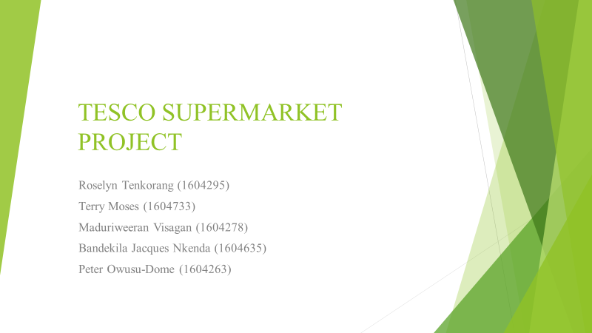

Appendix 2
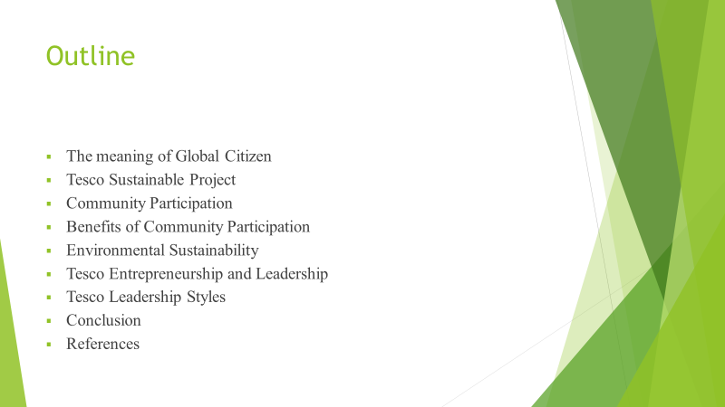

Appendix 3

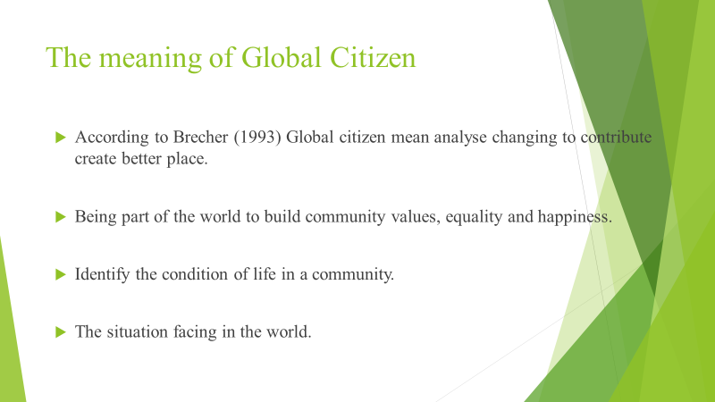

Appendix 4
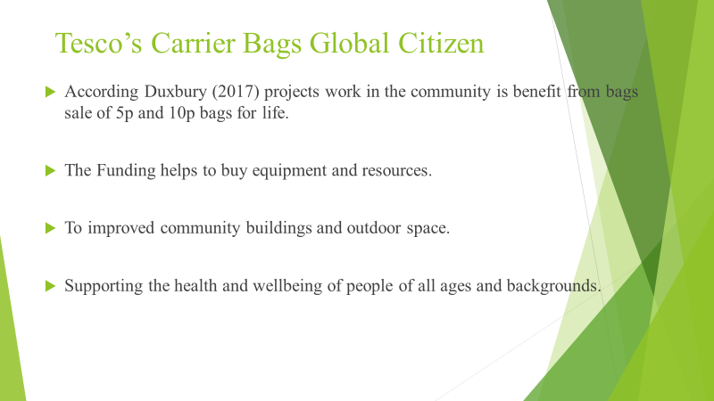

Appendix 6

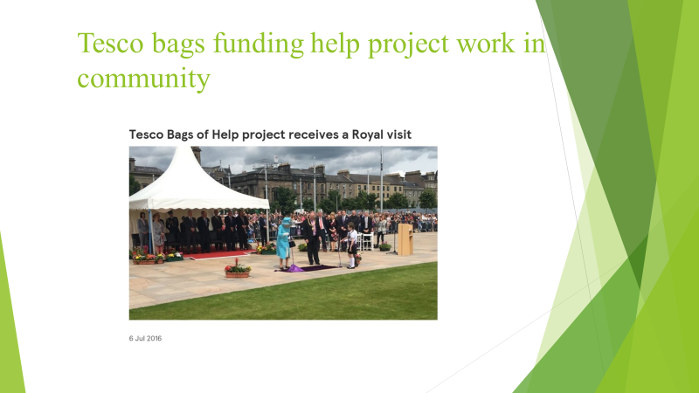

Appendix 7

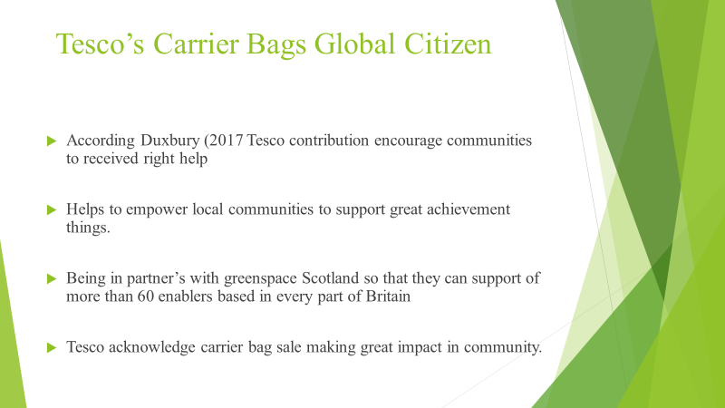

Appendix 8

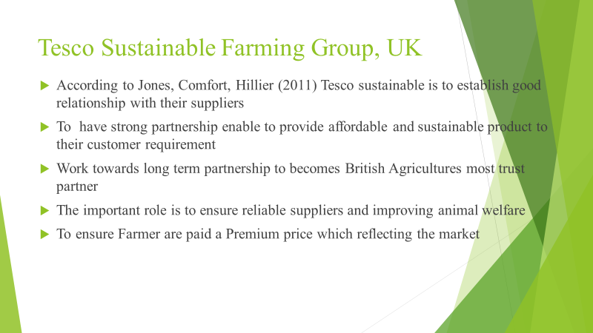

Appendix 9

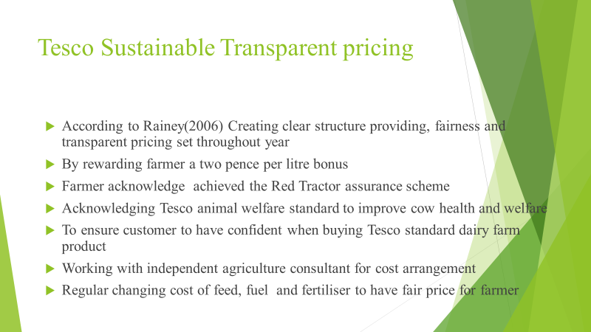

Appendix 10

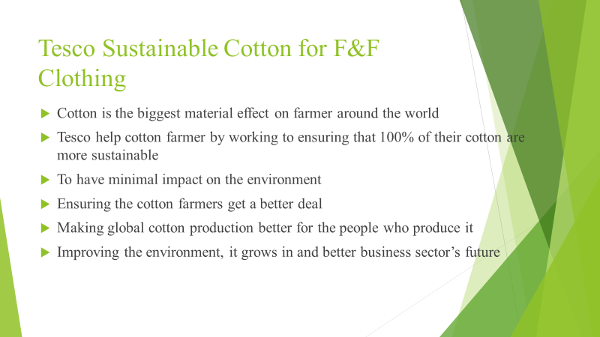

Appendix 11

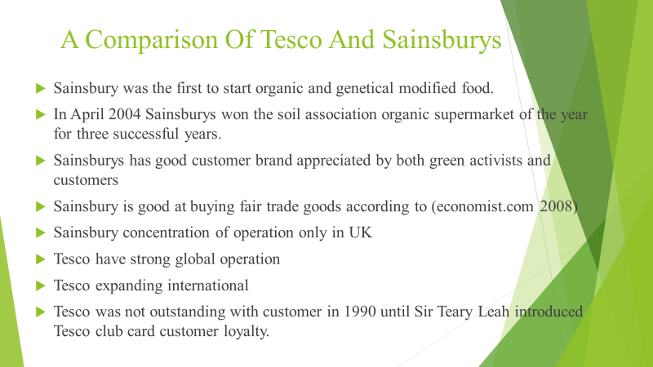

Appendix 12



