Assignment 1: Identifying a research topic/question – 15%

The importance of animals in Christianity
I decided to choose this topic as when reading the bible or about the bible I noticed that animals are often used as metaphors and used to portray certain ideas. I think there will be a lot of recourses / information on this topic.
Throughout the Bible animals have been used to portray a wide range of symbolic meanings, warnings, and stories. It is difficult to think of an example in the Bible where the mention of an animal did not have a deeper meaning behind it. Animals are used as a tool to help promote obedience to God. "And the pig, though it has a divided hoof, does not chew the cud; it is unclean for you. You must not eat their meat or touch their carcasses; they are unclean for you." (Leviticus 11:7-8). The Bible uses the pig to drive in the importance of following God and staying disciplined, but also to help keep the people safe. As the events of the Bible take place in a geographically hot region it is likely that the pork could have gone bad quicker than other animals in the region.
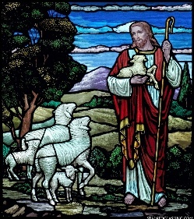
Another example of an animal being used for deeper purpose is the lamb is used to portray innocence, sacrifice, and redemption. It is often associated with Christ the “Lamb of God”. This is referring to his sacrifice he made for humanity, the ultimate act of redemption. The depiction of the lamb comes up very often in Christian iconography. Often depicted is Jesus Christ holding a lamb in his arms. This shows how important what the lamb portrays is to the faith. In this stained-glass window Jesus is portrayed as a Shepheard, leading the flock. The sheep looking up to Jesus and following him symbolises the followers of Christianity.
Similarly, doves are also used in pictures to portray the idea of innocence and hope. In the story of Noah’s ark, the dove comes back with an olive branch to symbolize new beginnings and hope for the future. Pictured is an example of the art created of the dove. Showing just how important of a symbol it is to the faith.
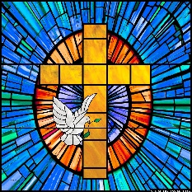

References
Stained glass window of Jesus with lambs- \
The Holy Bible. Leviticus 11:7-8. New International Version.

