

Griffiths and Hughes

2018

February 28

COMPANY NAME
Maria Paparozzi-Shipman


Contents
Introduction 3
Griffiths and Hughes’s current operating procedure and future strategy. 4
Asia 4
Africa 7
South America 9
ISO 56000 11
Conclusion and Positioning of Locations 14
References 15

Introduction
The purpose of this report is to determine where Griffiths and Hughes Ltd can strategically position themselves globally to have a positive impact on the manufacturing, marketing, and distribution of their product range on a global scale to expand their product range from security cameras to commercial CCTV equipment. Griffiths and Hughes also wants to respond to the COVID-19 demands, developing a new thermal imaging and facial recognition camera for enterprises to control Covid-19 within their workforce.

This report will also explore locations in South America, Asia and Africa and detail the manufacturing, logistical, and business engagement benefits as well as the political and social implications of expanding throughout the three continents.

Thirdly this report will give a detailed analysis on how Griffiths and Hughes can introduce and implement innovation management standards and the benefits of global collaborative standards that the enterprise currently adheres to.

Griffiths and Hughes’s current operating procedure and future strategy.
Griffiths and Hughes has the desire to strategically position themselves from not just Europe with their headquarters based in Mid Wales but throughout Asia, Africa, and South America, forwarding the logistical and manufacturing capabilities of their products and adopting skills and capabilities of local work forces for the development of their new product ranges.
With the UK leaving the EU, we need to consider that trade agreements are still new or in negotiations, and relationships of trade are being developed. Griffiths and Hughes need to also be concerned about the differing regulations between countries they are wishing to distribute their products to and should factor in regulatory boards such as ISO to adhere to the same standards globally.

Asia
Shenzhen (China)

China is one of the world’s leading production hubs in terms of exported goods, machinery and specialises in electronic manufacturing. Shenzhen has gained a reputation of the ‘worlds factory’ and is heavily supported by the Chinese government opening its economy and low tariff access to western markets. This saw foreign firms and investors investing heavily in the early 2000s and moving their manufacturing capabilities to South China. with its proximity to Hong Kong, it has a repute of being the place to ‘get things done’ (MAKE:, 2022).
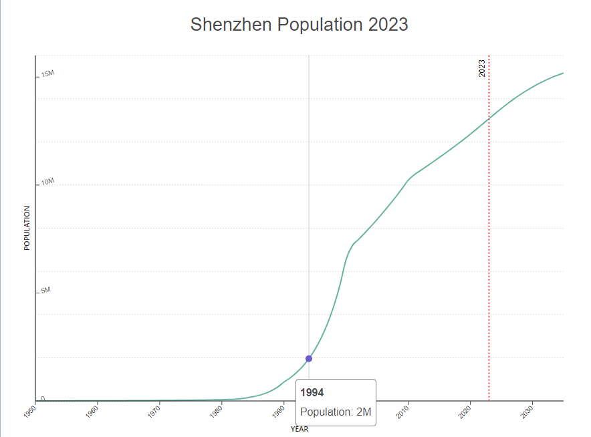
Western companies are often lured to Shenzhen by its cheap labour, but highly skilled workforce. Shenzhen prides itself on recently reforming its local curriculum with local colleges and schools introducing new subjects that support industry in emerging technology and manufacturing sectors (The World Bank, 2020). However due to Shenzhen being a relatively new city and industrial hub, they do have fluctuations of fair working conditions and local amenities for the rapidly growing population.

Figure 1 (World population review, 2023)

The port of Shenzhen is large and expanding using up 260 kilometres of coastline and can inhabit a variety of different importation and logistical challenges. Local governments cite this port as being incredibly important transport links to Hong Kong and throughout Southeast Asia.

Politically the UK and China how hot a tumultuous but strong partnership, this was strained slightly during the Covid 19 and the mishandling of the pandemic and the UK's relationship with Huawei, a Hong Kong based technology company Which was accused of harvesting UK data for political gain. With MPs looking to change their strategy between China and Britain (Landale, 2020), They pushed for resilience and tougher rhetoric to be less dependent on China.

Mumbai (India)

Mumbai a coastal city, which is densely populated, is India's financial and commercial centre and the principal port on the Arabian Sea. Previously known for its textile industry, it's recently transformed to be an epicentre of computer technology and a financial hub. with large investments in infrastructure, and local government enforcing low rent this became attractive for companies to relocate businesses in the late 20th century (Raghavan, 2023).

India has a large labour pool with almost 1.2 billion people working, and are categorised as unskilled, semi-skilled, skilled and highly skilled, which often can show great disparity between wages, having a knock-on effect on how available education and upskilling is to the Mumbai workforce. Proximity to large urban cities such as Mumbai, gives investors a chance to tap into skilled talent located nearby (Gonsalves, 2019).

Mumbai is quickly transforming itself to stay competitive with the modern world, with online digital marketing agencies basing their offices within the city. With a global outreach, Mumbai prides itself on having high business engagement, and return on growth. Large corporations such as KFC, Amazon and BMW have moved vast proportions of their marketing and web development teams over to Mumbai, attracting large investments from western companies (Shroff, 2023).

Politically the UK and Mumbai have a long, collaborative history together, with Theresa May stating in 2016 that they're ‘taking a shared stake in each other’s prosperity’ (Prime Minister's Office, 10 Downing Street, Foreign & Commonwealth Office,, 2016). in 2022 there was a proposed India to UK free trade agreement, estimating the growth of potential exportation and positive impacts on the UK and Indian economies (Manocha & Bhasin, 2022), thus becoming an attractive and easy way to enhance the global distribution of products.

Taipei (Taiwan)

Key manufacturing exports from Taipei include electrical machinery, IT and plastics, with a combined grossing economy of $170 Billion from these industries. With a focus an electrical chipboards and medical devices Taiwan is an attractive alternative to China (Burkhart, 2018).

With a highly skilled workforce Taipei ranks higher in terms of skilled workforces, Which in turn means that is a higher productivity costs in manufacturing (as seen in figure 2), Something that Griffiths and Hughes should consider when reviewing their expansion into Asia.

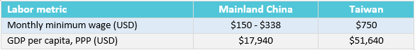
Figure 2 (Burkhart, 2018).

Taipei in Taiwan has had a tumultuous Political Landscape, with tensions rising between China and local government over sovereignty, as a result, Taipei has seen significant sanctions which in turn has had a considerable in fact to their economy and supply chain. With recent Prime Minister Liz Truss having a confusing stance over the UK's policy (Ni, 2022), friendship with Taiwan and tensions with China it is unclear when and if the reunification will have a negative impact on Taipei.

Africa
Durban (South Africa)

Durban historically has thrived in industry, specialising in automotive manufacturing, Durban has now expanded to have a variety of engineering sectors under their belt. It’s widely been argued that the recent regeneration throughout the city has boosted both employment creation and the local economy, with companies such as BMW, Nissan and Toyota moving their manufacturing plants to the city (Wangare, 2022).

Durban house is the largest port in the South African coastline, and are supported financially by the South African government, with significant infrastructure drive to boost the economy and increase capacity of import and exportation of goods (DLCA , 2023). The South African Department of Public enterprises announced a plan for the port of Durban which will seek private investment of over R100 billion within the next 10 years, increasing job availability and security. South Africa has the 35 most skilled work force globally which can be reflected in the workforce’s mass movement from agriculture into manufacturing roles. However, if Durban would like a sustainable work force, there needs to be investment into educational infrastructure, with the work force starting at the age of 15 in South Africa (Moletsane, 2019) – there is a giant educational leap between employees in South Wales and Durban.

South Africa has a free trade agreement with other member countries in the SACU (Southern African Customs Union) (International Trade Administration, 2023), offering Griffiths and Hughes to distribute to a further 15 countries throughout the continent.
Bulawayo (Zimbabwe)

Bulawayo is experiencing difficulties politically, which is seen the economy shrink as it battled through the economy crisis in Zimbabwe. last portions of industries are closing, and service sectors and the agricultural sector considerably, with the ones that are remained open, operating at below sustainable capacity (Mbira, 2015).

Zimbabwe is ranked as one of the most corrupt countries globally, With corruption being identified the biggest problem as well affecting the country's economy and growth which is lead to debt due to missing of funds and resources, leading to be cut off by the Worlds central Bank due to failure of repayments or creating return on investments (Khadija Sharife, 2022).

Tunis (Tunisia)
Tunisia has an established automotive equipment and services industry, however they largely focused on agriculture oil mining, renewable energy, and electricity to support their economy, naturally Tunis doesn’t have the infrastructure that is offered by is African counterparts in South Africa.

Politicly Tunisia is going through a turbulent and ever-changing governments, with Tunisia’s economy never really recovering from the 2011 revolution. Thus, resulting in a loss of decades of growth which is only been exasperated by Covid 19 (The World Bank, 2023). this has resulted in a significant decline in productivity within their industries as well as being an off-putting location for external investors and start-ups to base manufacturing from.

South America
Mercosur is an economic and political agreement between Argentina, Brazil, Paraguay, and Uruguay. In the area of trade, Mercosur's purpose is to promote free trade and the fluid movement of goods, people, and currency between its members. (EU comission, 2022). Thus, meaning that all countries under consideration would be ideal distributors throughout the continent.
Porto Alegre (Brazil)

Porto Alegre is the fastest growing economy in Brazil and is the 7th largest regional economy, with roughly 10% of Brazil is total exports Porto Alegre contributes at least 20% of that figure, with the major exports being plastics, oil grains, fruit, meat, vehicle parts, soybeans, leather, and rice.

Porto Alegre is historically known as a logistical hub as it is the junction of five major rivers and is situated on the coast which boost Porto Alegra's economic growth. Furthermore, Porto Alegre has excellent railroad services as well as highways that link the city to neighbouring countries.

Brazil has a relatively skilled workforce, ranking number 45 globally, with the workforce who choose to enter higher education choosing a subject that links to an industry within the city (Teleport , 2023)

Montevideo (Uruguay)

Uruguay has a ranking of 77 skilled workforces globally with higher education only offered in the capital city, which is reflected in the young and well-educated population. We can be attributed behind the growth of moving industry from traditional manufacturing into service product's development such as software (Kiprop, 2018). Furthermore, Uruguay has a relatively stable political, democratic and social stability society, in recent years Uruguay’s economy has grown and become more resilient and has a strategy to open up its trade agreements beyond its Latin American borders and is in the process of creating a free trade agreement with the EU. Uruguay has a reputation of being transparent and easy to do business with (GOV, 2022).

Montevideo is largely considered the manufacturing hub of Latin America, with a focus of energy and software as major factor to the economy totalling at 40.8% (Trading Economics, 2023).

Additionally, an attractive factor of Montevideo is it's the main port in Uruguay, which has had considerable investment from the government of 280 million and are undertaking an expansion project which is set to open in 2023. The port is one of the busiest within South America and contribute significantly to the nation's economy as it functions as a vital gateway for landlocked countries bordering Uruguay such as Bolivia Paraguay and pass to Brazil and Argentina, Because of this, they invest heavily into the high-tech facilities (Joshi, 2022)
Buenos Aires (Argentina)

Famous Aries ports is the largest in South America and isn't high importance to Argentina as they are overwhelming dependence on production and export. Much possible ports are reported to be old and inefficient; the port was privatised in 1994 and new investments and for the infrastructure began. However, maintaining and innovating the port to stay competitive with other transport links in South America has not been a priority. The port is often seen as unreliable, with a long wait time which has a negative economic effect on imports coming into Argentina.

Unlike a considerable parts of Argentina the city has a varied economy which helps maintain stability, despite inflation, and the devalued peso, there is an opportunity here for growing market potential as large scale investment plans are in place for production and industry and export of in Buenos Aires and throughout Argentina (Department of international trade, 2023). Alternatively in 2022 new measures were introduced by the Argentine central bank aiming to restrict access to foreign exchanges for businesses, in which UK companies need to seek authorisation talk to us foreign exchange to pay for imported goods or services, this adds complexity to trading and doing business with Argentina (GOV, 2023)

Argentina has a highly skilled workforce, ranking 44 globally, 1/5 of the Buenos Aires labour force worked in manufacturing (Moodys analystics, 2023), which is attractive for start-up companies who need local employees to form their personnel.

ISO 56000
With Griffiths and Hughes expanding globally, what operational procedures can they put in place to guarantee but the quality of product that they produce in South Wales will be emulated across the world. Introducing international standards can alleviate manufacturing discrepancies and instil quality assessments.

To create a sustainable business, Griffith and Hughes may want to consider introducing ISO standard 56000, a standard that focuses on innovation management, provides fundamental concepts and principles of innovation with a systematic implementation (ISO, 2020). The standard could improve the communication through all common parties; if Griffiths and Hughes implement the same development train, manufacturing techniques and management system using the agreed by vocabulary and fundamental concepts, this could save the enterprise both time and money.

Griffiths and Hughes could take this a step further to really ensure the longevity of their global expansion, looking at local infrastructure, suppliers, and local amenities to explore the standards they uphold and adapting similar ISO standards could bring large benefits to supply chain in terms of quality assurance.

Conclusion and Positioning of Locations
Griffiths and Hughes needs to evaluate which countries align with their strategy of global expansion. For the purpose of this report, the recommendations compiled are as follows:
- Mumbai to host Griffiths and Hughes Asia.
- Montevideo to host Griffiths and Hughes South America
- Durban to host Griffiths and Hughes Africa.

The positives of the locations picked are due to the ports and ease of transporting goods between continents and back to the UK, please refer to figure 3. All locations have strong trade agreements not only with the UK, but also throughout their continent, offering Griffiths and Hughes further distribution networks that they previously have not been able to access.
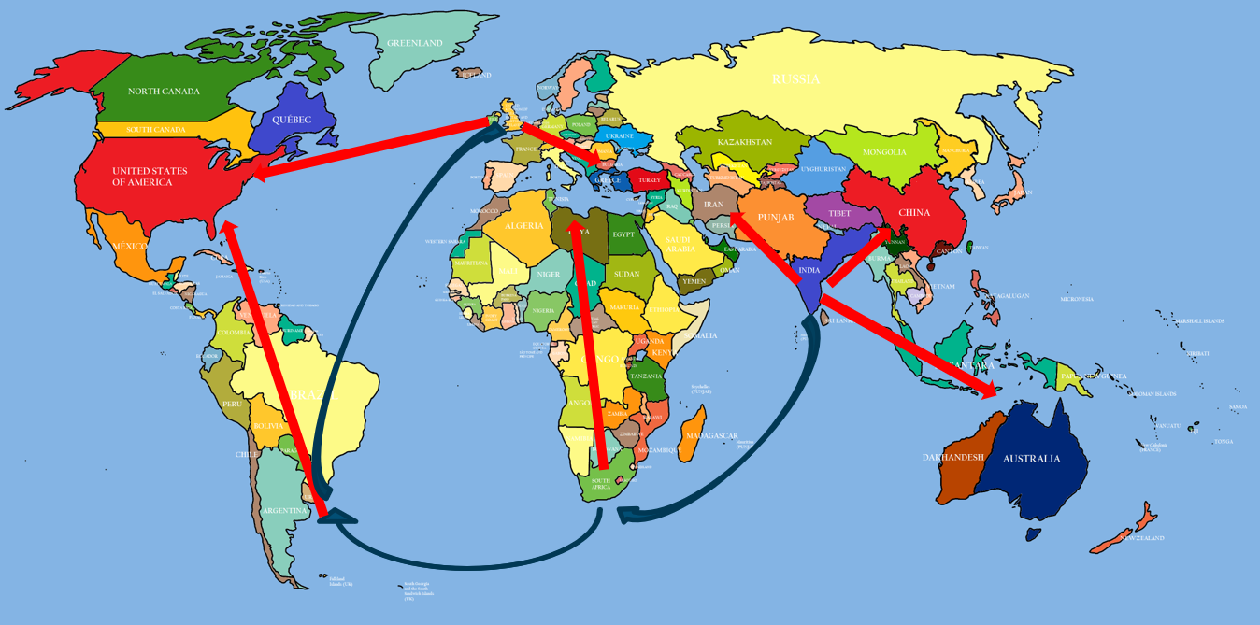
Figure 3
With Mumbai having strong manufacturing capabilities as well as a high business engagement, Griffiths and Hughes would benefit from the local talent and production facilities.

Montevideo would be a promising location for the product development of Griffiths and Hughes new product range, with their highly skilled work force and knowledge of software would positively aid their creation expansion.

With Durban sitting comfortably between these locations, as well as having a stable and thriving logistics and distribution capabilities could propel the circulation of Griffiths and Hughes products globally.

References
Burkhart, M., 2018. MANUFACTURING IN TAIWAN VS. MAINLAND CHINA: AN IMPORTER’S GUIDE. [Online]
Available at: https://www.intouch-quality.com/blog/manufacturing-in-taiwan-vs.-mainland-china-an-importers-guide
[Accessed 3 2 2023].
Department of international trade, 2023. Exporting to Argentina. [Online]
Available at: https://www.great.gov.uk/markets/argentina/
[Accessed 13 02 2023].
DLCA , 2023. Logistics capacity assesment. [Online]
Available at: https://dlca.logcluster.org/display/public/DLCA/2.1.1+South+Africa+Port+of+Durban
[Accessed 14 02 2023].
EU comission, 2022. Argentina. [Online]
Available at: https://policy.trade.ec.europa.eu/eu-trade-relationships-country-and-region/countries-and-regions/argentina_en
[Accessed 19 1 2023].
Gonsalves, O., 2019. The Labor Market in India: Structure and Costs. [Online]
Available at: https://www.india-briefing.com/news/labor-market-india-structure-costs-18264.html/
[Accessed 19 2 2023].
GOV, 2022. Guidance. [Online]
Available at: https://www.gov.uk/government/publications/overseas-business-risk-uruguay/overseas-business-risk-uruguay
[Accessed 18 2 2023].
GOV, 2023. Changes to capital controls in Argentina affecting foreign trade. [Online]
Available at: https://www.check-international-trade-barriers.service.gov.uk/barriers/GXREJG/?resolved=0&location=ar&sector=advanced-engineering
[Accessed 21 02 2023].
International Trade Administration, 2023. South Africa - Country Commercial Guide. [Online]
Available at: https://www.trade.gov/country-commercial-guides/south-africa-trade-agreements
[Accessed 3 2 2023].
ISO, 2020. ISO 56000:2020. [Online]
Available at: https://www.iso.org/standard/69315.html
[Accessed 23 2 2023].
ISO, 2020. ISO 56000:2020. [Online]
Available at: https://www.iso.org/standard/69315.html
[Accessed 03 02 2023].
Joshi, R., 2022. 10 Major Ports of Uruguay. [Online]
Available at: https://www.marineinsight.com/know-more/ports-of-uruguay/
[Accessed 14 2 2023].
Khadija Sharife, M. A., 2022. As U.S. Sanctions Loomed, a Tycoon ‘Mopped Up’ Zimbabwe’s Scarce Dollars, and Acquired a Lucrative Platinum Mine. [Online]
Available at: https://www.occrp.org/en/investigations/as-us-sanctions-loomed-a-tycoon-mopped-up-zimbabwes-scarce-dollars-and-acquired-a-lucrative-platinum-mine
[Accessed 19 2 2023].
Kiprop, J., 2018. The Biggest Industries In Uruguay. [Online]
Available at: https://www.worldatlas.com/articles/the-biggest-industries-in-uruguay.html
[Accessed 19 1 2023].
Landale, J., 2020. Political battle looming over UK China relations. [Online]
Available at: https://www.bbc.co.uk/news/uk-52762916
[Accessed 28 02 2023].
MAKE:, 2022. An Insider’s Guide to Shenzhen Manufacturing. [Online]
Available at: https://makezine.com/article/maker-news/making-in-shenzhen/
[Accessed 19 02 2023].
Manocha, R. & Bhasin, N., 2022. Proposed India-UK Free Trade Agreement: Estimating Potential Export Gains for India. Productivity (New Delhi), Volume 63, pp. 156-168.
Mbira, L., 2015. THE DE-INDUSTRIALIZATION OF BULAWAYO. International Journal of Economics, Commerce and Management, 3(3).
Moletsane, R. O. A.-O. a. R., 2019. Towards quality early childhood development for refugee children: An exploratory study of a Grade R class in a Durban child care centre. South African Journal of Childhood Education, 9(1).
Moodys analystics, 2023. Argentina - Labor Force. [Online]
Available at: https://www.economy.com/argentina/labor-force/
[Accessed 29 1 2023].
Ni, V., 2022. Liz Truss summons Chinese ambassador over aggression towards Taiwan, London: The guardian.
Prime Minister's Office, 10 Downing Street, Foreign & Commonwealth Office,, 2016. Joint statement between the governments of the UK and India. [Online]
Available at: https://www.gov.uk/government/news/joint-statement-between-the-governments-of-the-uk-and-india
[Accessed 03 02 2023].
Raghavan, C., 2023. Mumbai. [Online]
Available at: https://www.britannica.com/place/Mumbai
[Accessed 19 02 2023].
Shroff, M., 2023. 14 Best Digital Marketing Agencies in Mumbai – 2023 Updated. [Online]
Available at: https://iide.co/blog/digital-marketing-agencies-in-mumbai/
[Accessed 3 2 2023].
Teleport , 2023. Porto Alegre. [Online]
Available at: https://teleport.org/cities/porto-alegre/education/
[Accessed 3 2 2023].
The World Bank, 2020. Guangdong, China: Training a Skilled Workforce for Industrial Upgrade. [Online]
Available at: https://www.worldbank.org/en/news/feature/2020/06/04/guangdong-china-training-a-skilled-workforce-for-industrial-upgrade
[Accessed 30 1 2023].
The World Bank, 2023. The World Bank in Tunisia. [Online]
Available at: https://www.worldbank.org/en/country/tunisia/overview
[Accessed 17 02 2023].
Trading Economics, 2023. Uruguay Manufacturing Production. [Online]
Available at: https://tradingeconomics.com/uruguay/industrial-production
[Accessed 28 02 2023].
Wangare, P. W. J., 2022. List of 50+ top manufacturing companies in South Africa Read more: https://briefly.co.za/30945-list-manufacturing-companies-south-africa.html. [Online]
Available at: Peris Walubengo Jackline Wangare Read more: https://briefly.co.za/30945-list-manufacturing-companies-south-africa.html
[Accessed 03 02 2023].
World population review, 2023. Shenzhen population. [Online]
Available at: https://worldpopulationreview.com/world-cities/shenzhen-population
[Accessed 14 2 2023].

