

Module name
Community Care and Management of Long-term Conditions

Student name: Josephine Osei Amoah
Student ID: 2233505
Module code: (LCHS7003_LON)
Lecturer name: Muhammed Khan
Institution Name: University of Wales Trinity Saint David

I confirm that I have not used any AI tools in the research and creation of this assignment. I confirm that I have not presented any AI-generated materials as my own work. I confirm I have copies of my drafts, notes, and other resources I used, which I may be asked to provide in evidence.

Contents Page
Introduction
1.1 Definition and overview of heart failure
1.2 Epidemiology and prevalence
1.3 Physical, psychological, and social impact
Global and UK Policy Context
2.1 WHO Innovative Care for Chronic Conditions Framework
2.2 NHS Long Term Plan
2.3 National and local strategies for chronic disease management
Public Health Strategies
3.1 Prevention of cardiovascular risk factors (smoking, obesity, inactivity)
3.2 Government and community-led initiatives
3.3 Health promotion campaigns
Clinical Management of Heart Failure
4.1 Medication and pharmacological interventions
4.2 Lifestyle modification and diet
4.3 Use of medical devices and interventions
Person-Centred Care Approaches
5.1 Self-management and patient empowerment
5.2 Multidisciplinary and integrated care teams
5.3 The House of Care Model
Advanced Care and End-of-Life Considerations
6.1 Palliative care in heart failure
6.2 Symptom management and quality of life
6.3 Patient and family-centred decision making
Recommendations for Enhancing Care
7.1 Improving early diagnosis and monitoring
7.2 Strengthening health policy and integrated care
7.3 Supporting patient education and adherence
Challenges in Heart Failure Management
8.1 Multimorbidity and ageing populations
8.2 Healthcare resource limitations
8.3 Barriers to patient engagement
Conclusion
9.1 Summary of key points
9.2 Future directions in care and policy
References


Heart failure

Definition
Heart failure is a chronic condition characterized by the heart's inability to pump enough blood to meet the body's metabolic needs. This situation arises from structural or functional deficiencies, leading to diminished cardiac output or increased intracardiac pressure (NICE, 2018). It is typically categorized into heart failure with reduced ejection fraction (HFrEF) and preserved ejection fraction (HFpEF) (McDonagh et al., 2021).

The condition is frequently triggered by underlying illnesses such as coronary artery disease, hypertension, and diabetes (Roger, 2013; Ponikowski et al., 2016). Symptoms encompass breathlessness, fatigue, and fluid retention, which tend to progressively deteriorate over time (British Heart Foundation, 2023).
While heart failure cannot be cured, it can be effectively managed with the use of medication, lifestyle modifications, and regular monitoring. (NHS England, 2022; Conrad et al., 2018).

From an evaluative standpoint, heart failure has a profound effect on quality of life, restricting physical activity and independence, particularly among older adults (Ponikowski et al., 2016). It also poses a significant healthcare challenge due to frequent hospitalizations and the necessity for long-term treatment (Conrad et al., 2018). Effective self-management is essential but may be difficult for patients with complex health needs. Furthermore, inequalities in access to care can influence outcomes (McDonagh et al., 2021). In summary, heart failure is a multifaceted, progressive condition that necessitates multidisciplinary and patient-centered care strategies (NICE, 2018).

Prevalence and Burden of Heart Failure (UK and Global Perspective)

Heart failure represents a significant and escalating global health issue, impacting more than 64 million individuals worldwide and ranking among the most prevalent cardiovascular diseases (World Health Organization, 2023; Shahim et al., 2023). In the United Kingdom, the burden remains considerable, with an estimated 920,000 individuals currently living with heart failure and approximately 200,000 new diagnoses made each year (NHS England). This situation underscores the mounting strain on healthcare systems, particularly the NHS.
The occurrence of heart failure in the UK is calculated to affect roughly 1–2% of the general population, with a dramatic increase to about 20% among those aged over 80 years (NHS England). Epidemiological research indicates that the actual prevalence may be underestimated, with some estimates suggesting a range between 1.5% and 3% due to undiagnosed cases (Health Research Authority). This issue of underdiagnosis is particularly concerning, as many individuals may not receive prompt treatment.
Heart failure imposes a significant strain on healthcare services in the UK. It leads to more than 100,000 hospital admissions each year and constitutes a considerable share of NHS spending, with around 70% of expenses associated with hospital stays (Heart Research UK).
Furthermore, it results in diminished quality of life, elevated mortality rates, and a rise in disability among those affected (Savarese and Lund, 2017; GBD, 2021).

The increasing prevalence is primarily driven by an ageing demographic, enhanced survival rates following myocardial infarction, and rising Occurrences of risk factors including hypertension and diabetes (Savarese and Lund, 2017; NHS England, 2023). Forecasts suggest that the population experiencing heart failure in the UK is anticipated to keep rising and could nearly double by 2040 (NHS England).

In summary, heart failure remains a significant factor in causing morbidity and a burden on healthcare systems both globally and in the UK, highlighting the critical need for better prevention, early detection, and effective long-term management strategies.

Statistical graph of the world's heart failure

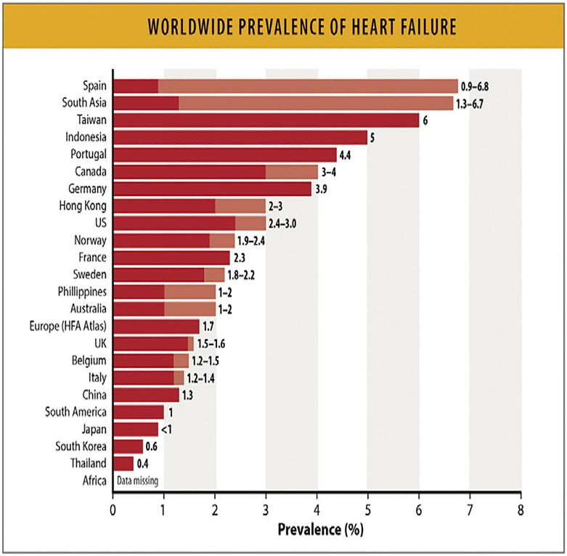

UK Statistics
In the United Kingdom, there are currently around 1 million individuals living with heart failure, with approximately 200,000 new cases diagnosed annually (British Heart Foundation, 2024). The incidence is notably higher among older adults, especially those aged 65 and older, rendering heart failure a major public health issue (Roger, 2013; Conrad et al., 2018). It ranks as one of the primary causes of hospital admissions within this demographic, exerting significant pressure on healthcare services and incurring substantial costs for the National Health Service (NHS England, 2019; NICE, 2018).

Hospital readmissions are frequent, often occurring within 30 days post-discharge, which underscores the progressive nature of the condition and the difficulties associated with long-term management (Ponikowski et al., 2016; McDonagh et al., 2021). Furthermore, variations in access to specialized care and early intervention can significantly affect patient outcomes, with socioeconomic factors playing a vital role in the management of the disease (British Heart Foundation, 2023).

These statistics highlight the necessity for early detection, patient education, preventive measures, and organized follow-up care. The implementation of effective self-management programs, in conjunction with multidisciplinary support, is crucial for reducing hospitalizations, enhancing quality of life, and alleviating the economic burden of heart failure in the UK (NHS England, 2022).

Graph of statistics of how Heart failure is rising

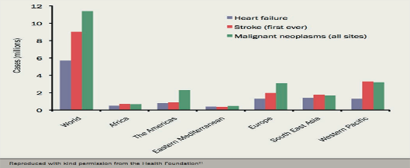
Diagram of the age risk of heart failure

(British Heart Foundation, 2024)
Impact of Heart Failure

Physical impact

- Breathing difficulties
- Shortness of breath
- Dizziness, (European Society of Cardiology, no date)
- weight gain and loss of appetite
- Increase in heart rate
- Swelling of the feet and ankles





As the illness advances, individuals might face deteriorating symptoms and recurrent hospitalizations, which can greatly diminish both life expectancy and quality of life (Savarese and Lund, 2017).

Psychological Impact

Living with a chronic condition like heart failure can lead to significant psychological impacts. Patients frequently suffer from depression, anxiety, and emotional turmoil due to the unpredictable nature of the illness and the restrictions it places on their daily activities (Bekelman et al., 2011). Symptoms such as fatigue, breathlessness, and recurrent hospital visits can intensify feelings of helplessness and social isolation, greatly diminishing overall quality of life (Hobbs et al., 2016).

Depression is especially common among elderly individuals with heart failure, and research indicates that it correlates with increased rates of hospital readmissions and lower compliance with treatment regimens (Rutledge et al., 2006). Anxiety often stems from concerns regarding symptom worsening, side effects of medications, and the risk of sudden health decline (Jaarsma et al., 2010). Emotional strain can further worsen physical symptoms, creating a feedback loop that negatively affects both mental and physical health (Riegel et al., 2009).

Thus, psychological support is vital in the management of heart failure. Approaches such as counselling, cognitive-behavioural therapy, and peer support groups have demonstrated effectiveness in enhancing emotional health, encouraging self-management, and improving adherence to treatment (Bekelman et al., 2011; Jaarsma et al., 2010). Incorporating mental health services into standard heart failure care is essential for comprehensive patient management.
Social Impact and Causes of Heart Failure

Heart failure can greatly limit an individual's capacity to engage in work, social interactions, and physical activities, resulting in diminished independence and increased social isolation (NHS England, 2019). These restrictions may also lead to financial challenges, especially for older individuals or those who are unable to sustain employment. Social withdrawal and dependence on others for everyday tasks can further detract from quality of life (British Heart Foundation, 2023).

The condition also has repercussions for families and caregivers. Family members frequently offer emotional support, assist with medications, and help with daily tasks. While caregiving can enhance relationships, it may also impose significant emotional, physical, and financial strain on family members (Bekelman et al., 2011). Access to caregiver support services, education, and respite care is vital to alleviate caregiver burden and enhance outcomes for both patients and their families (Jaarsma et al., 2010).

The primary causes of heart failure include:

- Heart attack (myocardial infarction)
- Issues with heart valves
- High blood pressure (hypertension)
- Cardiomyopathy, a condition affecting the heart muscle (NICE, 2018)

Recognizing these causes is essential for early intervention, prevention, and long-term management strategies that consider not only the patient but also their social and familial environment (McDonagh et al., 2021).
Risk Factors

A person with heart condition 
Several risk factors increase the likelihood of developing heart failure.
Lifestyle factors


(Harley Street Heart and Vascular Centre, no date)

(First Aid Supplies, no date)

(The Economic Times, 2025)
- Smoking
- Poor diet
- Physical inactivity
- Excess alcohol consumption

Lifestyle Management

Making lifestyle changes is a vital aspect of managing heart failure. These changes include:
• Decreasing salt intake
• Maintaining a healthy weight
• Participating in regular physical activity
• Quitting smoking
• Restricting alcohol consumption (NHS England, 2019)

Biological factors
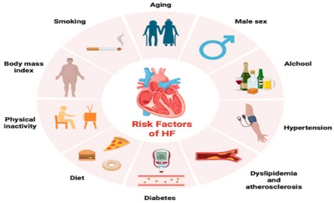

Heart failure is linked to various biological risk factors that play a role in its onset and progression. Ageing is a significant non-modifiable factor, as the structural and functional changes in the cardiovascular system diminish cardiac efficiency over time, thereby increasing the likelihood of heart failure in older individuals (Heidenreich & Sandhu, 2024). Obesity also serves as a major contributor, as excess body fat results in changes to cardiac structure and function, which include ventricular dysfunction and an increased workload on the heart (Alansari et al., 2025).

Diabetes mellitus markedly raises the risk of heart failure due to metabolic disruptions, vascular injury, and direct impacts on the myocardium, frequently resulting in diabetic cardiomyopathy (Li et al., 2024; Haji et al., 2023). Furthermore, genetic predisposition is a factor, as hereditary elements can affect cardiac structure and heighten susceptibility to heart disease (Wilk et al., 2024).

Recognizing these biological risk factors is crucial for prevention and early intervention. Lifestyle changes such as maintaining a healthy weight, managing blood glucose levels, and fostering cardiovascular health are vital strategies for mitigating risk (World Health Organization, 2023). Timely identification and management of these factors can postpone disease onset, lessen complications, and enhance long-term outcomes for those at risk of heart failure.

Evidence-Based Treatments in the UK (Heart Failure)
The treatment of heart failure aims to relieve symptoms, slow disease progression, and improve overall quality of life. In the United Kingdom, management is guided by the National Institute for Health and Care Excellence (NICE, 2018), which promotes a patient-centred and evidence-based approach. Treatment plans are usually tailored to the severity of the condition and individual patient needs, often involving a combination of medications, lifestyle changes, and advanced therapies.

Medication
A variety of medications are commonly prescribed to manage heart failure and improve cardiac function. These include:
- Ramipril (an ACE inhibitor)
- Bisoprolol (a beta-blocker)
- Furosemide (a diuretic)
Water for life

These medications work by lowering blood pressure, reducing strain on the heart, and removing excess fluid from the body. As a result, symptoms such as breathlessness, fatigue, and swelling are improved. Evidence indicates that consistent use of these medications can reduce hospital admissions and improve survival rates (NICE, 2018; McDonagh et al., 2021).

Medical Devices and Advanced Treatments
In more advanced cases, patients may require additional medical interventions such as pacemakers and implantable cardioverter defibrillators (ICDs). These devices help regulate abnormal heart rhythms and prevent sudden cardiac death. Cardiac resynchronisation therapy (CRT) may also be used to improve the coordination of heart contractions.
Overall, effective heart failure management in the UK involves a multidisciplinary approach combining medication, device therapy, and ongoing monitoring to achieve optimal patient outcomes.
Pacemaker for heart conditions



(Premier Cardiology Consultants, 2020)

These medications assist in lowering blood pressure, eliminating excess fluid, and improving heart performance (NICE, 2018).
Defibrillators (IDC)
• Heart transplantation in severe cases (British Heart Foundation, 2024).

Defibrillator 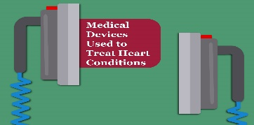
These treatments are designed to enhance heart rhythm, avert sudden cardiac death, and increase survival rates.
Theoretical Models for Long-Term Condition Management
UK Model: The House of Care Model
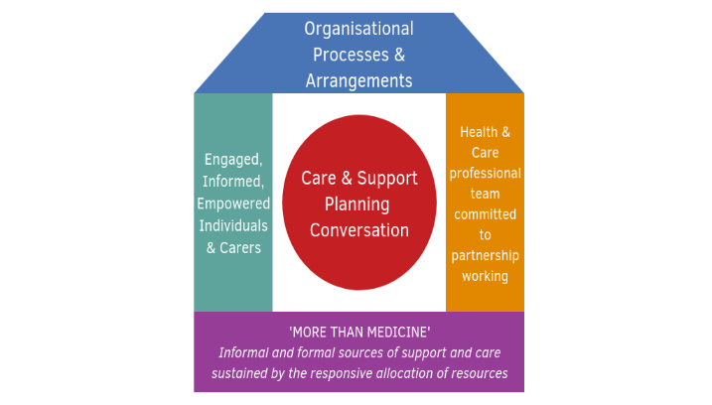
Health and Social Care Alliance Scotland (n.d.)
The House of Care Model is extensively implemented in the United Kingdom to assist individuals living with long-term conditions, including heart failure. Created by NHS England, this model advocates for a holistic and patient-centered approach to care, ensuring that patients actively participate in managing their own health (NHS England, 2016). It is organized around four essential components: engaged and informed patients, healthcare professionals dedicated to collaborative working, organizational systems that facilitate coordinated care, and commissioning processes that allow for effective service delivery (Coulter et al., 2015).
Categories of preventive healthcare measures
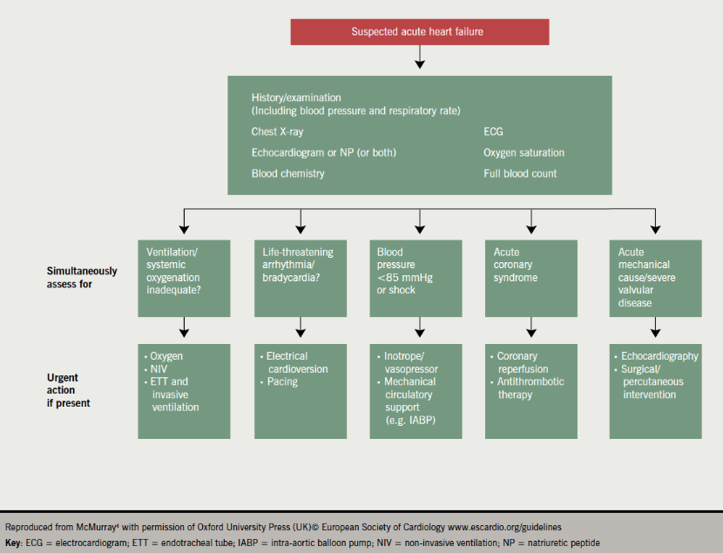
(O’Sullivan, K., 2014)
A fundamental principle of the model is shared decision-making, wherein patients and healthcare professionals work together to create personalized care plans (Elwyn et al., 2017). This strategy empowers individuals to assume greater responsibility for their condition, enhancing self-management and adherence to treatment (Baird et al., 2016). The model also highlights the significance of effective communication and continuity of care, which are crucial in managing complex long-term conditions (Nolte & McKee, 2018).
Moreover, the House of Care model fosters integrated care by promoting coordination among primary, secondary, and community health services (Ham & Alderwick, 2015). This approach minimizes care fragmentation and enhances patient outcomes. Evidence indicates that person-centered strategies like this can improve patient satisfaction, decrease hospital admissions, and elevate quality of life (Taylor et al., 2014; NHS England, 2016).
In summary, the House of Care model offers a thorough framework for managing long-term conditions in the UK, emphasizing collaboration, empowerment, and continuity of care to achieve improved health outcomes.
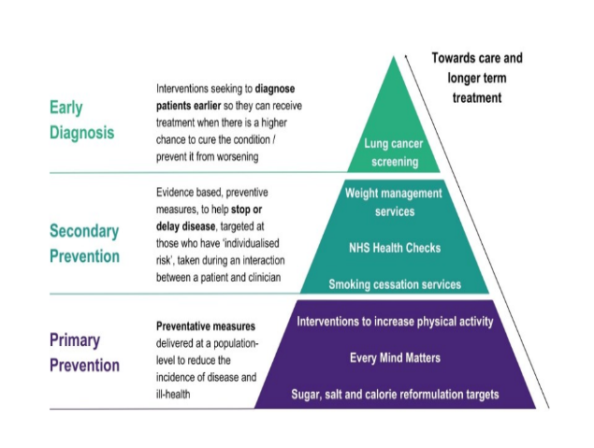
(Department of Health and Social Care, 2023)
International Model: World Health Organization (WHO) Innovative Care for Chronic Conditions Framework

The World Health Organization (WHO) developed the Innovative Care for Chronic Conditions (ICCC) Framework to enhance the global management of chronic diseases and tackle the growing burden of long-term conditions (WHO, 2002).

This framework highlights the significance of patient-centred care and outlines essential components required for effective chronic disease management. These components encompass empowering patients to take an active role in their care, establishing robust community support systems, delivering integrated and coordinated healthcare services, and enacting supportive health policies at both national and local levels (WHO, 2002; Nolte and McKee, 2008).

By fostering collaboration among patients, healthcare professionals, and policymakers, the framework emphasizes the necessity for a comprehensive and proactive approach to managing long-term conditions (Barr et al., 2003). Moreover, the ICCC model stresses that better health outcomes are realized when care is continuous, coordinated, and customized to meet individual needs, especially for older adults with multiple health issues (Wagner et al., 2001; Goodman et al., 2013).

In the UK, policy initiatives such as the NHS England Long Term Plan embody similar principles, strongly focusing on prevention, early diagnosis, and enhanced treatment pathways for chronic conditions, including cardiovascular diseases like heart failure (NHS England, 2019). The plan emphasizes the expansion of community-based cardiovascular services, improved access to diagnostic testing, and the implementation of early intervention strategies to decrease hospital admissions and enhance patient outcomes (NHS England, 2019; Bhatnagar et al., 2016). Furthermore, it advocates for integrated care systems that promote collaboration across primary, secondary, and social care services, closely aligning with the ICCC framework’s emphasis on coordinated care (Ham, 2010; Alderwick et al., 2015).

In summary, these policies reflect a transition towards person-centered, preventive healthcare, which is crucial for the effective management of long-term conditions in an aging population.

Public Health Strategies and Recommendations for Enhancing Person-Centred Care

Government-led public health initiatives are designed to mitigate cardiovascular risk factors such as smoking, obesity, and physical inactivity, which significantly contribute to heart disease and heart failure (Department of Health and Social Care, 2022; Bhatnagar et al., 2016). Policies including smoking cessation programs, national campaigns promoting physical activity, and nutritional guidance aim to lessen the overall burden of cardiovascular disease and enhance population health outcomes (Public Health England, 2019; Townsend et al., 2019). These preventive measures are in line with the principles of person-centred care, fostering patient empowerment and engagement in health-promoting behaviours (Wagner et al., 2001; WHO, 2002).

Enhancing Self-Management

It is crucial to support patients in managing their own health conditions. Educational interventions, symptom monitoring, and adherence to prescribed medications empower patients to take an active role in managing their heart failure (NHS England, 2016; Lorig and Holman, 2003). Self-management programs not only lead to improved clinical outcomes but also boost patients’ confidence and autonomy in handling chronic conditions (Richardson et al., 2014).

Integrated Care

Collaboration among healthcare professionals, including doctors, nurses, pharmacists, and social workers, enhances continuity of care and patient outcomes. Multidisciplinary approaches facilitate comprehensive support, timely interventions, and the coordination of services across primary, secondary, and community care settings (Ham, 2010; Alderwick et al., 2015).

End-of-Life Care

For patients experiencing advanced heart failure, palliative care is crucial for alleviating symptoms, enhancing quality of life, and ensuring that treatment decisions align with patient and family preferences (Bekelman et al., 2011; National Institute for Health and Care Excellence [NICE], 2018).

Person-centered end-of-life care fosters dignity, respect, and compassionate assistance during the concluding phases of life.

Conclusion
Heart failure is a complex and multifaceted chronic condition that has a significant impact on individuals, families, and healthcare systems. Its effects extend beyond physical health, encompassing profound psychological, emotional, and social repercussions, which include diminished quality of life, increased reliance on caregivers, and financial pressure on households and healthcare services (Bhatnagar et al., 2016; Bekelman et al., 2011). Consequently, the management of heart failure necessitates comprehensive and holistic strategies that cater to both the medical and psychosocial requirements of patients.

Effective treatment comprises a blend of pharmacological therapies, lifestyle changes, and coordinated care provided by multidisciplinary healthcare teams. Collaborative methods involving doctors, nurses, pharmacists, and social workers have demonstrated improvements in patient outcomes, reductions in hospital admissions, and the provision of ongoing support tailored to individual needs (Ham, 2010; Alderwick et al., 2015; NHS England, 2019). National initiatives, such as the NHS Long Term Plan, along with frameworks like the House of Care and the World Health Organization’s Innovative Care for Chronic Conditions framework, highlight the importance of person-centred care, integrated services, and patient empowerment in effectively managing long-term conditions (WHO, 2002; Health and Social Care Alliance Scotland, n.d.; Wagner et al., 2001).

To improve outcomes for individuals living with heart failure, healthcare systems must focus on early diagnosis, patient education, self-management support, and strong health policies that promote preventative care and equitable access to services. Enhancing these aspects ensures that patients can actively engage in their care, alleviates the strain on healthcare resources, and ultimately enhances quality of life. Therefore, the integration of evidence-based strategies, patient involvement, and systemic support is crucial for tackling the ongoing challenges associated with heart failure management.

REFERENCES
Alderwick, H., Ham, C. and Buck, D(2015) Population health systems: going beyond integrated care. London: The King’s Fun

Bekelman, D.B., et al. (2011) ‘Symptoms, depression and quality of life in patients with heart failure’, Journal of Cardiac Failure, 17(3), pp. 209–215.
Bhatnagar, P., et al. (2016) ‘Epidemiology of cardiovascular disease in the UK’, Heart, 102(24), pp. 1945–1952.
British Heart Foundation (2024) UK factsheet: Heart failure statistics. London: BHF.
Department of Health and Social Care (2022) Cardiovascular disease prevention strategy. London: DHSC.
European Society of Cardiology (no date) Dizziness. Heart Failure Matters. Available at: https://www.heartfailurematters.org/understanding-heart-failure/dizziness/ (Accessed: 17 March 2026).
The Economic Times (2025) Just 30 minutes a day of these type of exercises could help you beat heart disease. Available at: https://economictimes.indiatimes.com/magazines/panache/just-30-minutes-a-day-of-these-type-of-exercises-could-help-you-beat-heart-disease/articleshow/123190051.cms (Accessed: 7 March 2026).
EMMA International (2021). Medical devices used to treat heart conditions. Available at: https://emmainternational.com/medical-devices-used-to-treat-heart-conditions/ (Accessed: 9 March 2026).
European Society of Cardiology (no date) Dizziness. Heart Failure Matters. Available at: https://www.heartfailurematters.org/understanding-heart-failure/dizziness/ (Accessed: 7 March 2026).
European Society of Cardiology (no date). Implantable devices. Heart Failure Matters. Available at: https://www.heartfailurematters.org/what-your-doctor-can-do/implantable-devices/ (Accessed: 10 March 2026).
European Society of Cardiology (no date) Loss of appetite. Heart Failure Matters. Available at: https://www.heartfailurematters.org/understanding-heart-failure/loss-of-appetite/ (Accessed: 17 February 2026).
First Aid Supplies (no date) No smoking sign. Available at: https://www.firstaid.org.uk/supplies/health-and-safety-products/signage-posters/no-smoking-sign/ (Accessed: 1 March 2026).
Harley Street Heart and Vascular Centre (no date) Foods to avoid with heart failure: Tips from a cardiologist. Available at: https://www.harleystreet.sg/blog/foods-to-avoid-with-heart-failure/ (Accessed: 1 March 2026).
Ham, C. (2010) The ten characteristics of the high-performing chronic care system. London: The King’s Fund.
Health and Social Care Alliance Scotland (n.d.) The House of Care Model. Available at: https://www.alliance-scotland.org.uk/past-work-and-projects/scotlands-house-of-care/the-house-of-care-model/ (Accessed: 9 March 2026).
Health Research Authority (HRA) (2022) Where is all the heart failure? A community study. Available at: https://www.hra.nhs.uk (Accessed: 11 March 2026).
Kauvery Hospitals (no date) What is the connection between heart failure and edema? Available at: https://www.kauveryhospitalsbangalore.com/blog/heart-failure-edema-connection/ (Accessed: 7 March 2026).
Lorig, K. and Holman, H. (2003) ‘Self-management education: history, definition, outcomes, and mechanisms’, Annals of Behavioral Medicine, 26(1), pp. 1–7.
MDPI (2025) [Title of article]. International Journal of Molecular Sciences, 26(16), 8046. Available at: https://www.mdpi.com/1422-0067/26/16/8046 (Accessed: 17 February 2026).
National Institutes of Health (NIH) (2023) Figure illustrating heart failure imaging/phenotyping (nihms-1951796-f0006). Available at: View image on PMC (Accessed: 9 March 2026).
National Institute for Health and Care Excellence (NICE) (2018) Chronic heart failure in adults: diagnosis and management (NG106). London: NICE.
NHS England (2016) The House of Care framework for long-term conditions. London: NHS England.
NHS England (2019) The NHS Long Term Plan. London: NHS.
NHS England (2023) Managing heart failure. Available at: https://www.england.nhs.uk (Accessed: 05 March 2026).
O’Sullivan, K. (2014) Obesity module 1: management in primary care (Figure 21). The British Journal of Cardiology. Available at: https://bjcardio.co.uk/files/uploads/2013/03/Figure-21.png (Accessed: 11 March 2026).
Premier Cardiology Consultants (2020) 5 symptoms that may mean you need a pacemaker. Available at: https://www.premiercard
Public Health England (2019) Health matters: prevention – a public health priority. London: PHE.
Richardson, G., et al. (2014) ‘Self-management interventions in chronic disease’, BMJ, 348, g1505.
Savarese, G. and Lund, L.H. (2017) ‘Global public health burden of heart failure’, Cardiac Failure Review, 3(1), pp. 7–11.
Shahim, B., et al. (2023) ‘Global heart failure epidemiology and outcomes’, Journal of the American College of Cardiology.
The Economic Times (2025) ‘Just 30 minutes a day of these type of exercises could help you beat heart disease’. Available at: https://economictimes.indiatimes.com/magazines/panache/just-30-minutes-a-day-of-these-type-of-exercises-could-help-you-beat-heart-disease/articleshow/123190051.cms
(Accessed: 20 February 2026).
Townsend, N., et al. (2019) Cardiovascular disease statistics 2019. London: British Heart Foundation.
Wagner, E.H., et al. (2001) ‘Improving chronic illness care’, Health Affairs, 20(6), pp. 64–78.
World Health Organization (2002) Innovative care for chronic conditions: building blocks for action. Geneva: WHO.
World Health Organization (2023) Cardiovascular diseases (CVDs) fact sheet. Geneva: WHO. Available at: https://www.who.int (Accessed: 10 March 2026).

