Name: Charlie Macdonald

Student ID: 2304849

Module: Global destinations and Resort Management (BMTP6003)

Lecturer: Jacqui Jones

Assignment: Tourism Manifesto Essay

Word count: 2,500

A Manifesto for 21st Century Tourism: Rethinking Over tourism and Digital Influence in Yosemite National Park

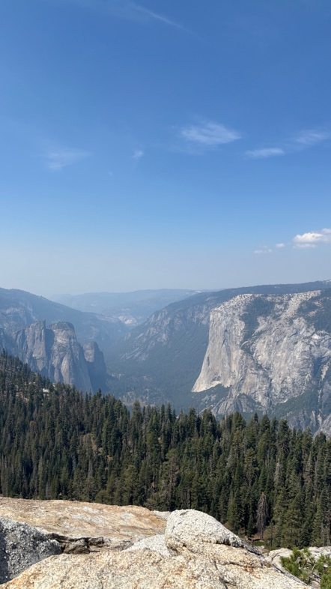
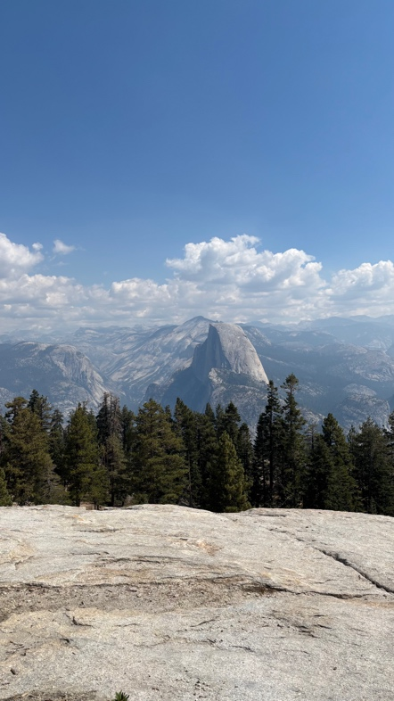
Tourism in the twenty-first century is ever changing and it stands at a critical crossroad, affected by rapid technological advancement, shifting consumer expectations and growing concerns over sustainability. As highlighted by Professor Terry Stevens, contemporary tourism is no longer defined solely by transactions, but by the creation of meaningful immersive experiences rooted in local culture, community values, and a sense of wonder (Stevens, 2025). However, this idea is increasingly challenged by the realities of mass tourism and digital influence. Platforms such as social media and online booking systems have opened up travel, making destinations more accessible than ever before, yet they have simultaneously intensified pressures on fragile environments and local communities. In this context, tourism is not merely evolving it is reaching a turning point where its current trajectory may undermine its own long-term viability (BBC Bitesize, 2024).

This tension is particularly evident in Yosemite National Park, one of the most iconic natural destinations in the world. Renowned for its dramatic landscapes, biodiversity and cultural significance, Yosemite has become a global symbol of natural beauty and conservation. However, its popularity has surged in the recent years due to platforms such as Instagram and TikTok showcasing the beauty of the national park. As a result, the park now faces significant challenges associated with over tourism, including environmental impacts, congestion and the erosion of the very sense of tranquillity and connection to nature that it seeks to provide (Pletcher, 2020).

This essay argues that tourism in Yosemite National Park exemplifies how digital platforms and contemporary destinations strategies have contributed to the escalation of over tourism. Bringing in key tourism theories, evidence and emerging trends, the discussion critically evaluates the extent to which tourism has shifted to a source off strain. In response this essay proposes a manifesto for 21st Century Tourism, advocating for a reorientation towards sustainability, controlled access and meaningful engagement, in order to restore balance between visitor fulfilment, community wellbeing and environmental preservation (Geographyfieldwork.com, 2026).

Yosemite National Park is located in central California, nestled within the Sierra Nevada mountain range. The national park covers approximately 1,187 square miles across parts of Tuolumne, Mariposa and Madera counties. The park is roughly 165 miles from San Francisco and roughly 300 miles north of Los Angeles. Yosemite first became protected as a national park in 1864 and is now one of 63 national parks across the US. Yosemite on average welcomes around 4 million visitors per year and largest group of visitors are usually from California, the majority of people visit between May and October but the busiest months are July and August with those two months accounting for roughly 30% of the annual visitation (UNESCO World Heritage, 2023).

Yosemite National Park contributes massively to the local economy, it generates an annual economic impact of approximately $624 million. The revenue created by Yosemite supports the regional economy, local businesses and also provides thousands of jobs in the surrounding areas (Annual Report Fiscal Year, 2021). The national park serves as a critical marketing asset for the entire region as it is a premier destination for leisure and tourism. Yosemite National Park has many environmental and cultural values as it is a recognised UNESCO World Heritage site because of its unique landscapes created by glaciers, it’s also recognised for its giant sequoias which are some of the biggest trees in the world and its diverse ecosystem which the wildlife thrives in. The cultural value of the national park should not be overlooked as it is the birthplace of the national park concept and holds deep ancestral value for Indigenous communities such as the Southern and Central Miwok and Northern Paiute, within the park you can still see the history of these communities and you can learn all about the history in Yosemite Village (Patterson, 2014).

Digital platforms such as Instagram and TikTok have played a big role in the growth of tourism as it allows people to view places on social media before deciding where to visit. The growth of bucket list tourism has grown massively as people want to visit places they see on social media and Yosemite National Park is one of those places as people see the beautiful scenery and want to visit (Hall, 2025). Social media has had a positive impact on some locations as it promotes place that people might not have seen otherwise but, on some locations, it has negatively affected the area as it has contributed to over tourism. One of the main negative point for social media tourism in Yosemite National Park is the effect on the culture and history. People who visit Yosemite after seeing the beautiful scenery on social media don’t understand the history of Yosemite and the culture of the park. Social media is good for promoting destinations by showcasing the beautiful scenery in places but people who just visit these places just to get that viral picture are damaging the history of these locations. With people visiting Yosemite just based of pictures on social media it has transformed Yosemite into a visual commodity, where destinations are consumed for digital validation rather than meaningful engagement (Tas, 2021).

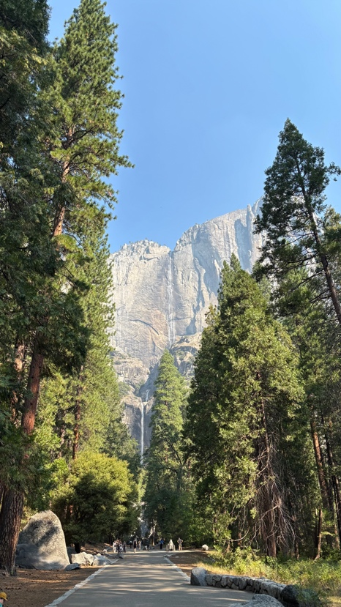
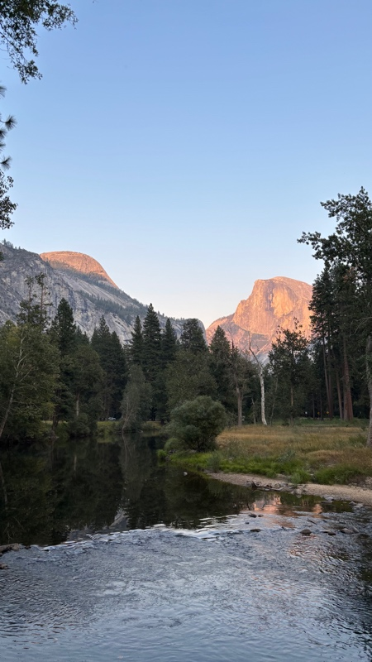
Over tourism impact Yosemite National Park in many different ways such as environmental, social and economic factors. The effect of over tourism on the environmental side significantly degrades its ecosystem through habitat fragmentation, severe air and noise pollution and the accumulation of over 6,200 tons of waste annually (Shiflett et al., 2025). Due to the large number of visitors increased traffic causes smog that hinders visibility and harms wildlife. Visitors also walk off the designated trails which leads to erosion in sensitive meadow systems, which have shrunk by more than half since the 19th century (Schisa, 2022).

Some of the effects on the social side because of over tourism include traffic congestion, reduced visitor satisfaction and local community strain. Over tourism creates significant challenges including degradation of the visitor experience due to loss of solitude, overcrowding at view points and the exclusion of indigenous perspectives (Iucn.org, 2014). Yosemite has brought in a strategy over the last few years in which you need a reservation to enter the park and only offer a certain number of reservations per day in a bid to tackle the effects of over tourism however in 2026 they are getting rid of this policy which means the amount of tourist visiting the park could increase (National Park Service, 2026).

The key question for economic effects is the amount of money coming in from tourism worth the sustainability and environmental effects. Yosemite is one of the biggest earners for the local economy and offers over 100,000 jobs within the area. However, the effects on the environment are a concern as the national park needs to be protected which might get worse with the new policy which doesn’t require reservations to enter the park (Brown and Jenkins, 2023).

One useful framework for understanding the pressures facing Yosemite National Park is Butler’s Tourism Area Life Cycle model, which suggests that destinations evolve through stages of exploration, involvement, development, consolidation, stagnation, and either decline or rejuvenation. Currently Yosemite sits between consolidation and stagnation stages, where visitor numbers are at or beyond peak levels and the negative impacts of tourism become increasingly visible. At this point in the cycle the destination experiences overcrowding, environmental degradation, and a decline in the quality of visitor experience, these issues are now widely documented in Yosemite particularly during peak seasons. Rather than maintaining its original appeal as a place of natural tranquillity and discovery, the park risks becoming over commercialised and over managed. Importantly, TALC highlights that without strategic intervention, destinations in the stagnation phase may enter decline. However, it also allows for the possibility of rejuvenation through sustainable planning and innovation. In the case of Yosemite, this suggests that current management strategies must go beyond short-term visitor control and instead address the structural drivers of demand, particularly those linked to digital exposure, in order to reposition the park towards a more sustainable and experience-focused future (Butler, 2024).

Another framework that describes the current situation of Yosemite is Pine and Gilmore’s experience economy which shows a shift from meaningful experiences towards superficial consumption. This implies that people care less about the history and culture of Yosemite and are more interested in just visiting the viral viewpoints to get the perfect picture for Instagram. There are less people interested in exploring the history of the area and protecting the wildlife which is what Yosemite is all about. This could lead to a whole ecosystem being damaged in the future and Yosemite need to protect these ecosystems (Pine and Gilmore, 1998).

Yosemite does currently have many strategies to control the number of tourists, even though they have got rid of park reservations they now encourage people to enter the park before 9 a.m. or after 5 p.m. to avoid traffic congestion. There is still a standard fee to enter the park which is the same as every other national park across the US. They also promote utilizing public transport, visitors are encouraged to use the Yosemite Area Regional Transportation System, which does not require people to bring their cars to park and is more of an environmentally friendly way to travel (Yosemite Conservancy, 2024). Another strategy they promote is park and ride, if you drive to the park they recommend parking the car and then use the free Yosemite Valley Shuttle System to navigate around the park. These buses run frequently and stop at all the main points in the park. Using the free shuttle is better for the environment as well as easing the traffic congestion (Tenaya at Yosemite, 2025).

Other strategies Yosemite is using this year is the “Hidden Gem” alternatives, they recommend hiking in the Merced Grove instead of the busier and more popular Mariposa Grove to see the giant sequoias (Nps.gov, 2016). They are also recommending people visit areas outside the main Yosemite Valley, such as places like Tuolumne Meadows, Glacier Point or Hetch Hump to escape the large crowds (yosemitethisyear.com, 2024).

They also have a visitor management planning strategy, this plan is focused more on the long term plan to balance visitor access with resource protection. This strategy may include bringing back reservations and a timed entry system for peak seasons if congestion remains high. It is also strongly recommended to book a hotel or camping ground well in advance to ensure entry and reduce the stress of finding somewhere to park during your visit (Travelyosemite.com, 2026).

These current strategies attempt to manage symptoms rather than address the structural causes of over tourism driven by digital exposure. The strategies don’t offer enough protection to the wildlife and ecosystems in Yosemite National Park. If anything, getting rid of the reservation system is going to make the situation worse as there is no way to control the numbers entering the park. Some of their strategies are affective however, the free shuttle around the park is effective as it reduces the number of cars driving around the park. Also, the strategy promoting different areas to visit will help reduce the visitor numbers in some areas but it could just move the problem to a different area, it is a very difficult situation to manage (National Parks Conservation Association, 2026).

To protect the national park from over tourism and the effect of digital technology on natural places thing need to change or in the future these places will be severely damaged and the ecosystems will struggle to continue. To protect Yosemite National Park, they should follow a new manifesto, the new manifesto has six different points to ensure the protection of the park:
- Tourism must respect ecological limits
- Technology should manage demand, not create it
- Experiences over consumption
- Local and environmental priorities first
- Decentralisation of tourism flows
- Digital responsibility
The first point will enforce strict rules for visitors to remain on the man-made walkways which are already in place to reduce the damage to the meadows throughout the park, this will also reduce erosion and ensure the park will be around for a long time. The second point will limit algorithm-driven promotion, this will ensure that people will understand more about the place before visiting and be more willing to protect the natural side. Third we have experiences over consumption, this point encourages slow, immersive tourism. This will encourage more people to take in the whole park and the culture and history of the area and ensure that people return to enjoying the relaxing natural side of the park, instead of just visiting the busy and popular areas (ETC Corporate, 2024).

The fourth point focuses on conservation over profit. Even though Yosemite brings in a large amount of money to the local economy it is also important to conserve the wildlife and the natural environment. As there are lots of other major tourist areas in the state of California which could share the number load. The next point decentralisation of tourism flows would include promoting lesser known areas to ease the pressure on the main sights to give them a chance to recover whilst boosting tourism in new areas (ABTA, 2024). Finally, we have digital responsibility, this would focus on ethical marketing of destinations to ensure that people understand the importance of Yosemite National Park to the environment and understand how important it is to protect the park and not over crowed the area. This manifesto could be considered slightly bold in some places but to protect the national park it’s important that everything is thought of to ensure the right policies are in place to ensure the park is around forever (European Tourism Manifesto, 2024).

In conclusion the effect of digital platforms and contemporary destination strategies have contributed to the escalation of tourism in Yosemite National Park. It shows that recently the number of tourists visiting the national park have increased due to the fact people have been seeing photos and videos on social media. The effects of over tourism are starting to become more obvious throughout the park with ecosystems being damaged and long traffic queues. However due to the large number of visitors the locale economy has benefited greatly and other locations have benefitted from tourism in the park. But in the long run the effects are negative and will affect the park greatly in the future if the current trends continue. Yosemite needs to implement new strategies to control the number of tourists visiting the park to ensure the parks protection. The use of social media is very powerful but it can also be used to educate people on the park and the effects over tourism has. By using social media to educate people it could help protect the park whilst controlling the number of visitors. But in any case, something needs to be done to protect the natural environment either by reducing the number of visitors or bring in new strategies to control the effects of over tourism with stricter rules and promote using public transport to reduce the carbon effect. By bringing in these new strategies it will ensure that Yosemite will be around for hundreds of more generations.
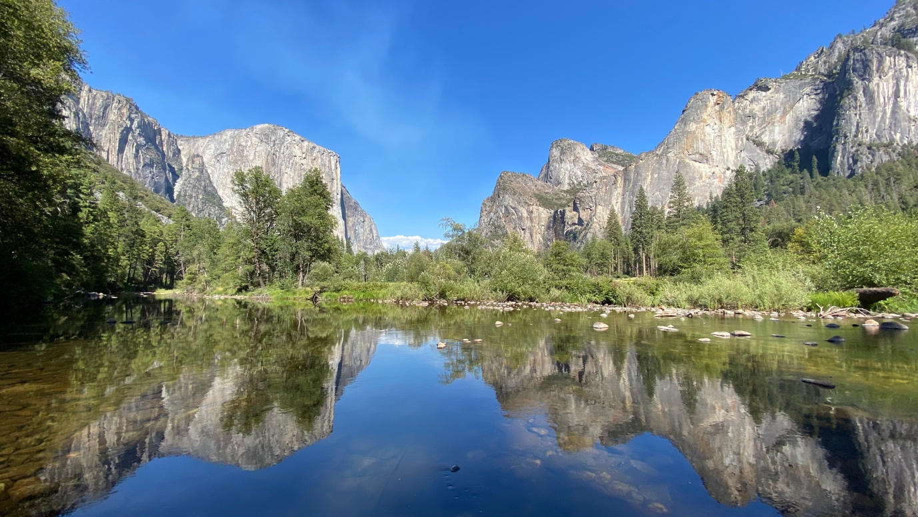

Reference List

ABTA. (2024). A Manifesto for Travel and Tourism. [online] Available at: https://www.abta.com/industry-zone/reports-and-publications/manifesto-travel-and-tourism.
Annual Report Fiscal Year. (2021). Available at: https://www.yosemite.com/wp-content/uploads/2023/05/2022-2023-Annual-Report-FINAL.pdf [Accessed 24 Apr. 2026].
BBC Bitesize. (2024). Impact of mass tourism - Global tourism - National 5 Geography Revision. [online] Available at: https://www.bbc.co.uk/bitesize/guides/zkgxsbk/revision/4.
Brown, M. and Jenkins, J. (2023). Wildfire-driven entry closures influence visitor displacement and spending to alternative park entrance corridors and gateway communities around Yosemite National Park. Journal of Outdoor Recreation and Tourism, 43, pp.100675–100675. doi:https://doi.org/10.1016/j.jort.2023.100675.
Butler, R. (2024). Tourism destination development: the tourism area life cycle model. Tourism Geographies, [online] pp.1–9. Available at: https://www.tandfonline.com/doi/full/10.1080/14616688.2024.2325932#:~:text=It%20proposed%20that%20the%20life,destinations%20at%20each%20of%20those.
ETC Corporate. (2024). European Tourism Manifesto. [online] Available at: https://etc-corporate.org/tourism-manifesto/ [Accessed 24 Apr. 2026].
European Tourism Manifesto. (2024). Policy Priorities. [online] Available at: https://tourismmanifesto.eu/policy-priorities/.
Geographyfieldwork.com. (2026). Yosemite | Tourism | Contrasting Attitudes to Tourist Management. [online] Available at: https://geographyfieldwork.com/YosemiteTourismAttitudes.htm [Accessed 24 Apr. 2026].
Hall, L. (2025). Is it time to ditch the bucket list? [online] Bbc.co.uk. Available at: https://www.bbc.co.uk/travel/article/20250815-is-it-time-to-ditch-the-bucket-list [Accessed 24 Apr. 2026].
Iucn.org. (2014). Yosemite National Park | World Heritage Outlook. [online] Available at: https://worldheritageoutlook.iucn.org/explore-sites/yosemite-national-park.
National Park Service (2026). Visitor Use & Social Science - Yosemite National Park (U.S. National Park Service). [online] www.nps.gov. Available at: https://www.nps.gov/yose/learn/nature/visitor-use.htm.
National Parks Conservation Association. (2026). Visitors Will Suffer After Yosemite Cancels Popular Reservation System. [online] Available at: https://www.npca.org/articles/11339-visitors-will-suffer-after-yosemite-cancels-popular-reservation-system.
Nps.gov. (2016). Plan Your Visit - Yosemite National Park (U.S. National Park Service). [online] Available at: https://www.nps.gov/yose/planyourvisit/index.htm.
Patterson, A. (2014). Indian Removal from Yosemite National Park | Intermountain Histories. [online] Intermountain Histories. Available at: https://www.intermountainhistories.org/items/show/339.
Pine, J. and Gilmore, J. (1998). Welcome to the Experience Economy. [online] Harvard Business Review. Available at: https://hbr.org/1998/07/welcome-to-the-experience-economy.
Pletcher, K. (2020). Yosemite National Park | Location, History, Climate, & Facts | Britannica. In: Encyclopædia Britannica. [online] Available at: https://www.britannica.com/place/Yosemite-National-Park.
Schisa, K. (2022). The Adverse Effects of Ecotourism as Seen in Yosemite National Park. [online] The Emerald Review. Available at: https://emeraldreview.com/2022/10/the-adverse-effects-of-ecotourism-as-seen-in-yosemite-national-park/.
Shiflett, S.A., Jenkins, J.S., Mattos, R.F., Thiry, K., Ibsen, P.C., Booher, M., Tricomi, A. and Athearn, N.D. (2025). Monitoring visitor activity and informal trail disturbance in Yosemite Valley meadows to assess temporal changes in use and impacts. Journal of Outdoor Recreation and Tourism, [online] 50, p.100896. doi:https://doi.org/10.1016/j.jort.2025.100896.
Stevens, T. (2025). Professor Terry Stevens. [online] Repucon Consulting. Available at: https://repucon.ie/about/professor-terry-stevens/ [Accessed 24 Apr. 2026].
Tas, G. (2021). The Role of Social Media in Tourism Marketing. [online] Digital Travel Summit APAC 2020. Available at: https://digitaltravelapac.wbresearch.com/blog/social-media-in-tourism-marketing.
Tenaya at Yosemite. (2025). How to Avoid Crowds - Visiting Yosemite National Park. [online] Available at: https://www.visittenaya.com/ways-to-visit-yosemite/ways-to-avoid-crowds/ [Accessed 24 Apr. 2026].
Travelyosemite.com. (2026). Yosemite National Park Lodging & Activities. [online] Available at: https://www.travelyosemite.com/plan/travel-tips [Accessed 23 Apr. 2026].
UNESCO World Heritage (2023). Yosemite National Park. [online] UNESCO World Heritage Centre. Available at: https://whc.unesco.org/en/list/308/.
Yosemite Conservancy. (2024). The Beginner’s Guide to Yosemite’s Draft Visitor Access Management Plan — Yosemite Conservancy. [online] Available at: https://yosemite.org/yosemite-visitor-access-management-plan/.
yosemitethisyear.com. (2024). Embrace Innovative Visitor Management Solutions. [online] Available at: https://www.yosemitethisyear.com/embrace-innovative-visitor-management-solutions [Accessed 23 Apr. 2026].

