ACDA 4004
Micros peripherals and interfaces
Course work
Student number: 2317422
Rhys Jones

Section 1
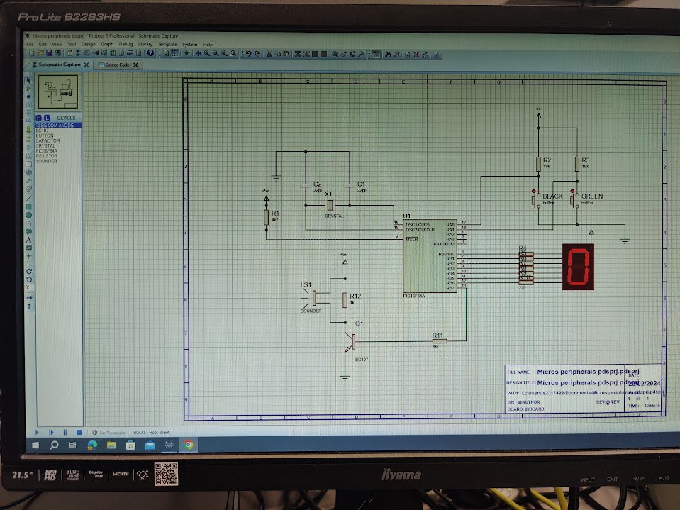
For this project we will be using the PIC16F84A to power the 7 segment LED display. The circuit we will be using is pictured below. This schematic displays hexadecimal digits depending on what the buttons are programmed to do.
Figure 1: The whole schematic
Firstly, I will be talking about the crystal, which is in figure 2 featured below. the crystal oscillator is necessary for this circuit in order to add a specific delay interval whenever needed to the circuit. This will ensure that the circuit will function properly and effectively. The reason for using a crystal oscillator is due to its stable and accurate clock signals which are crucial for time sensitive operations. The use of the 2 capacitors in parallel allows the crystal to operate at a lower frequency. By choosing the right amount of capacitance we can minimize the risk of oscillator refusing to work because of high frequency and avoid damaging it by providing to much power to the crystal oscillator. The crystal also offers very good stability compared to other alternatives, ensuring the microcontroller stays consistent over a long period of time. Crystal oscillators offer a low jitter which keeps the transitions predictable and consistent. The +5V connected to the 4k7 ohm resistor allows the Pic to operate at a reasonable voltage and current.
Figure 2: crystal oscillator and power supply

Next, I will be talking about the buttons and how they operate the circuit. The two buttons in figure 3 can be used to operate the circuit in many ways, such as turning all segments on and off, increasing and decreasing the value of the digit displayed and display a certain digit. In this circuit all the uses mentioned will be used throughout this project to showcase how they can be used affectively. The two buttons will use code in order to operate and can easily be changed.

Figure 3: buttons

Figure 4 shows the 7 segment LED display and its connections to the PIC. The power supply connected directly to the display keeps the LED activated. The 7 connections going from the pic to the LED or used to provide data in binary. This data is however converted into hexadecimal to keep the storage to a minimum. Each connection is responsible for operating 1 segment on the display. In order to correctly display each segment a truth table will be used, which will be discussed later on. The display is connected to the pic with 220-ohm resistors since that is the maximum value current you can safely have running into a LED display without the risk of burning out.

Figure 4: Led display and connection
The last part I want to discuss is the transistor and sounder pictured in figure 5.
Figure 5: Transistor and sounder

The use case for the sounder here is for a high pitch noise to be produced when the value increases and a low pitch noise to be produced when decreasing the value.
The transistor is used in order to ground the connection when the sounder is not needed and opens up briefly for the sounder to produce noise before closing again. This way it is easy to control the sounder as the transistor has many different functions.

Section 2
For the truth table we worked out the hex value by putting the binary values in and then converting them into hex on the next row. In figure 6, shown below, the character displayed on the led is on the left, the next 8 digits is the binary value needed for that character and the last column is the he value converted from binary. Thee hex value is what will be used in the program as it takes up the least amount of storage.
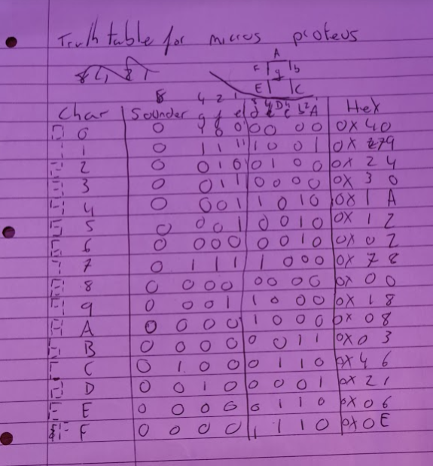
Figure 6: truth table from binary to hex

Section 3
3.1

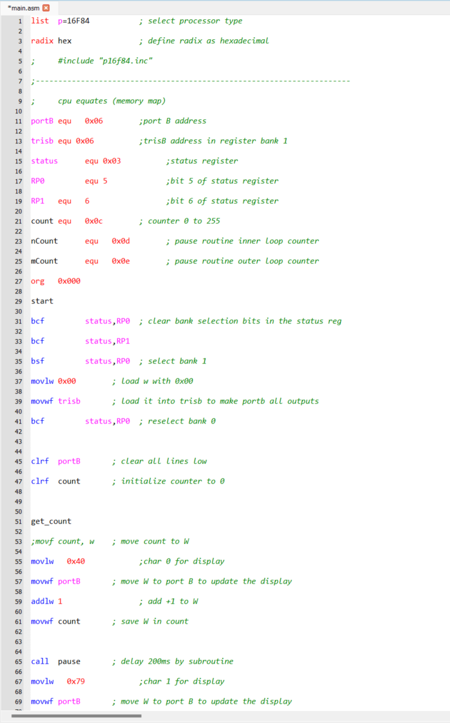
Figure 7:Code 3.1 part1
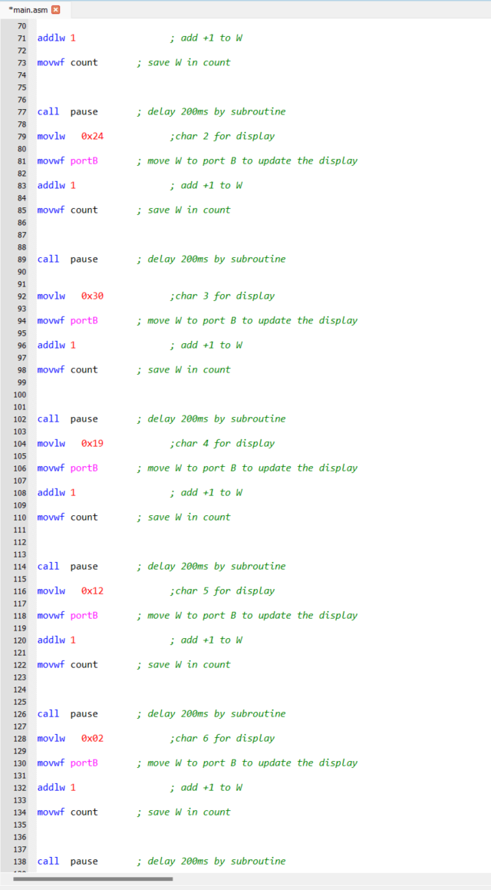
Figure 8:code 3.1 part 2

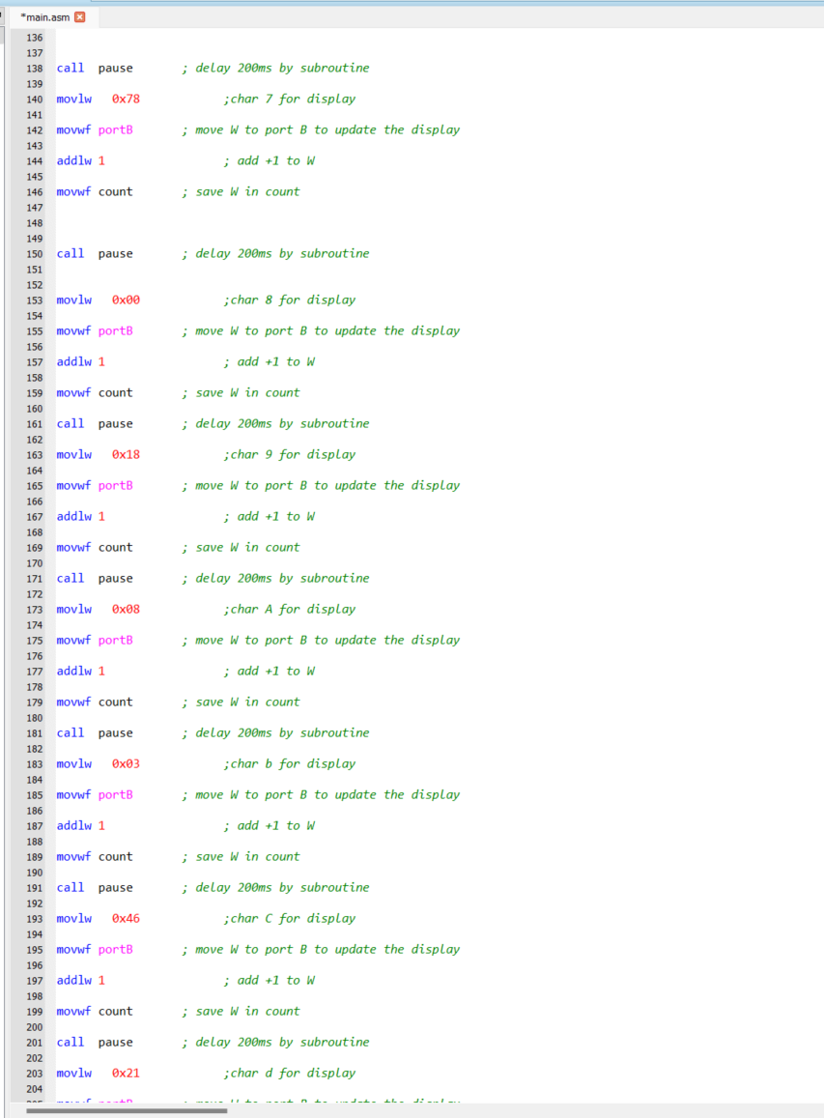
Figure 9:code 3.1 part 3

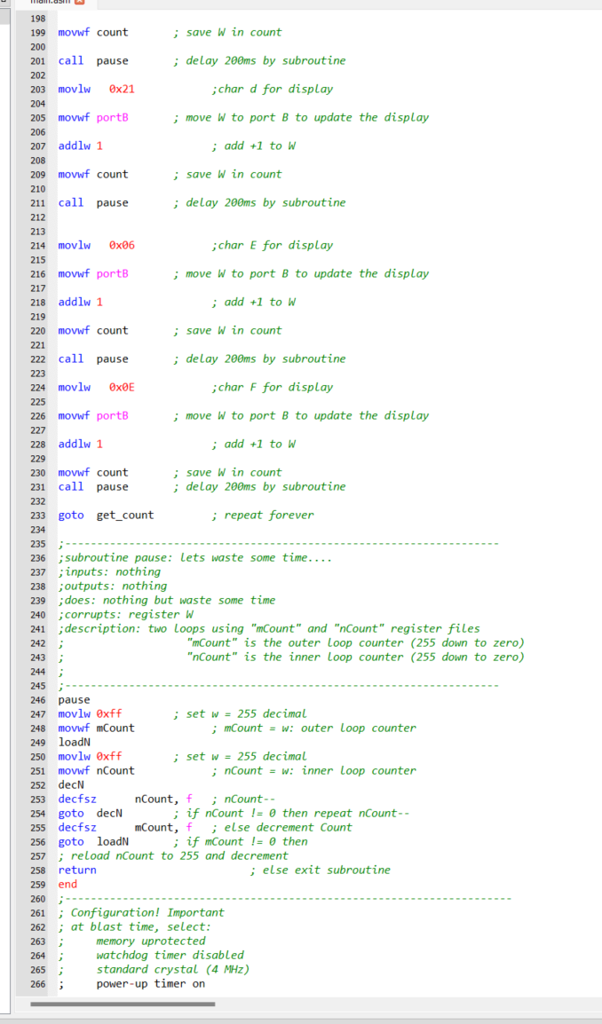
Figure 10:code 3.1 part 4
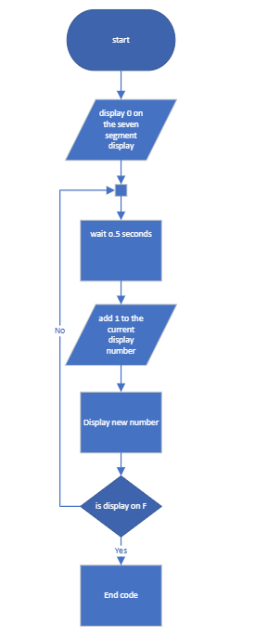
Figure 11: flowchart to show process of 3.1
Section 3.2
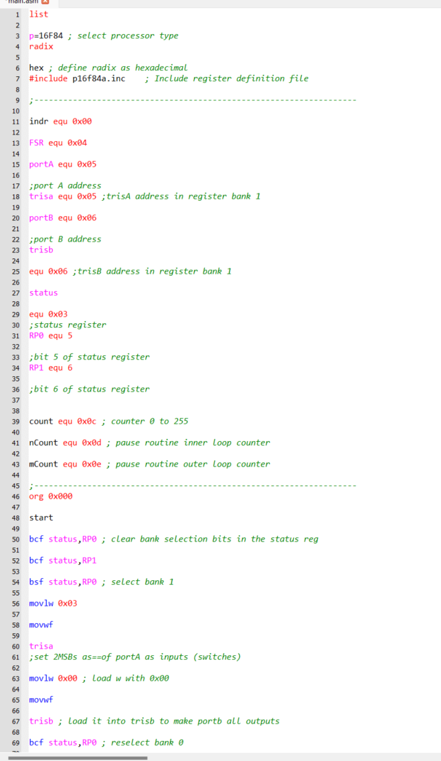
Figure 12:code 3.2 part 1

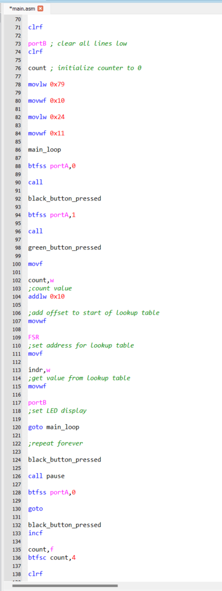
Figure 13:code 3.2 part 2
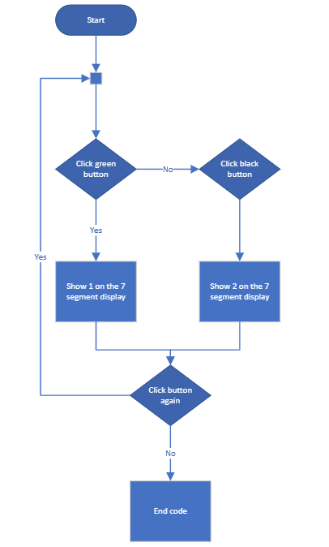
Figure 14:flowchart to show process of code 3.2

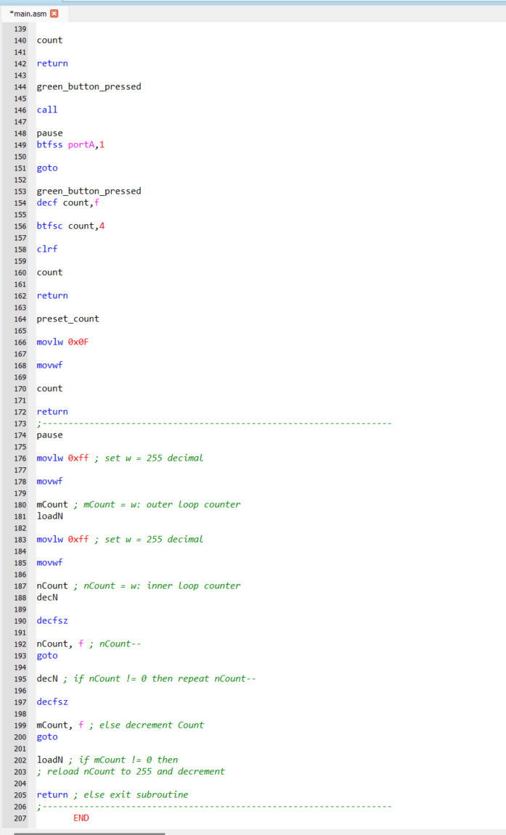
Figure 15:code 3.2 part 3
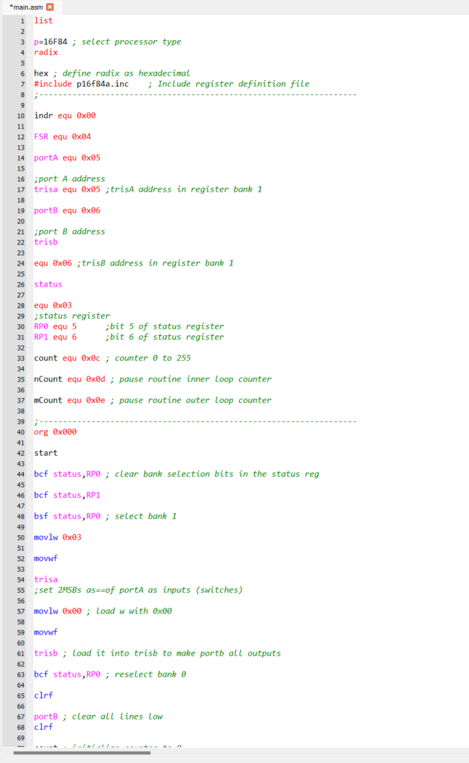
Section 3.3
Figure 16:code 3.3 part 1

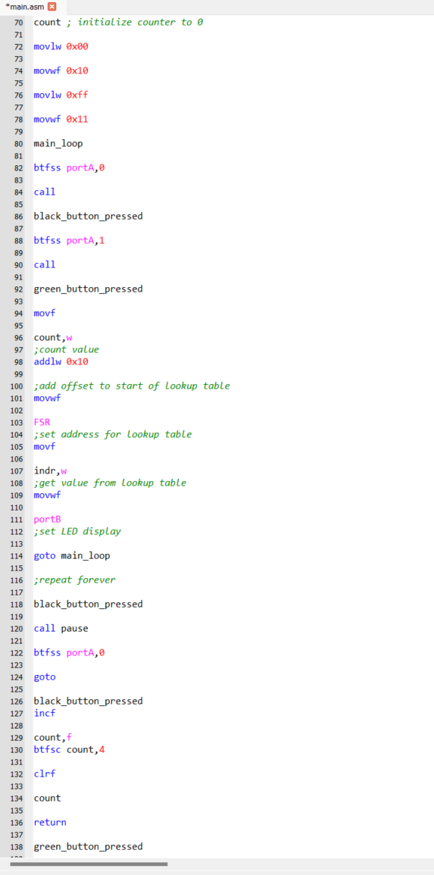
Figure 17:code 3.3 part 2

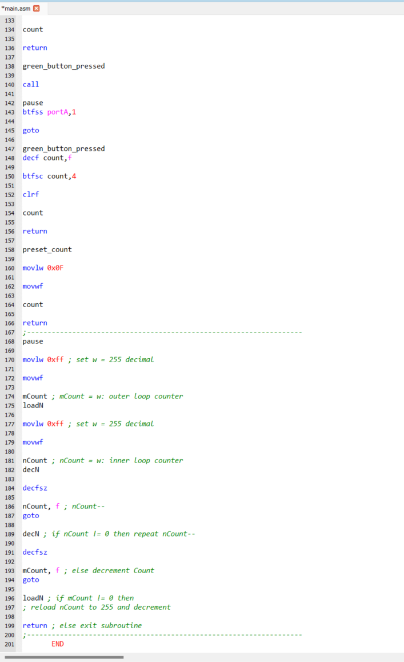
Figure 18:code 3.3 part 3

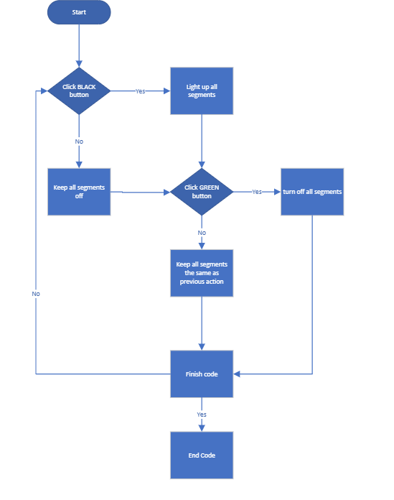
Figure 19: Flowchart to show process of code 3.3

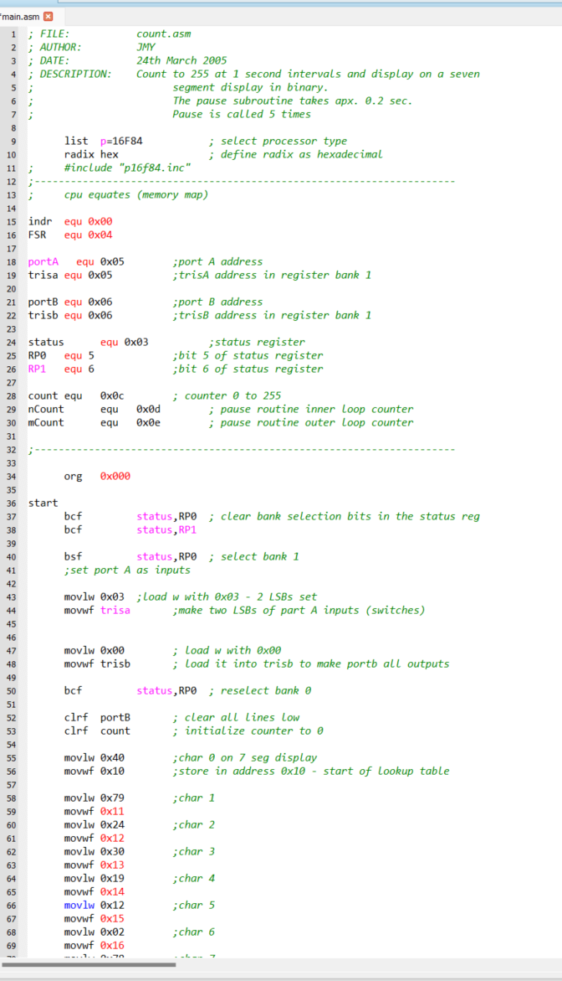
Section 3.4
Figure 20:code 3.4 part 1

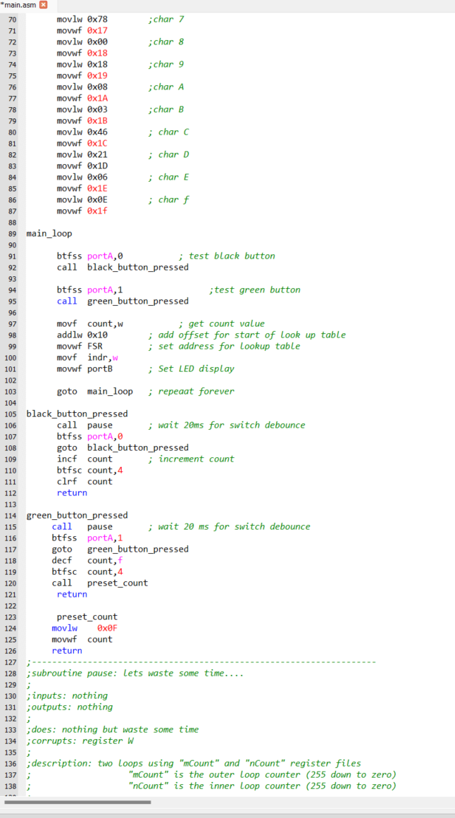
Figure 21:code 3.4 part 2

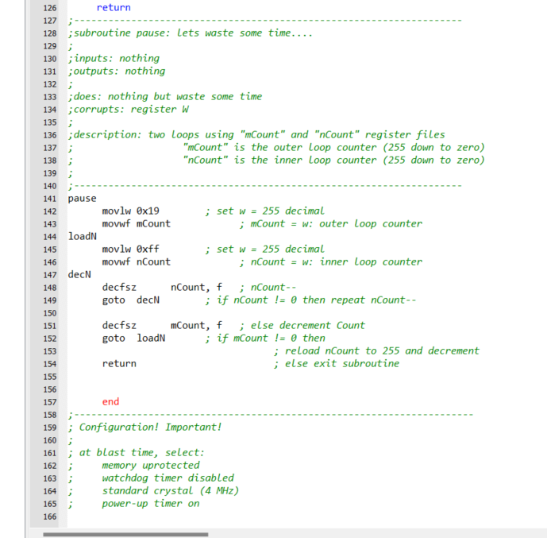
Figure 22:code 3.4 part 3

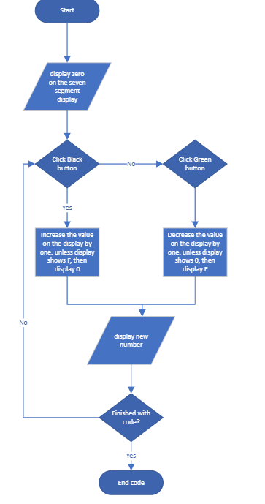
Figure 23:flowchart to show process of code 3.4

