

Assignment Title: component 1 - Online portfolio
Student name: Genabu Barri
Student ID: 2328229
Module name: Changemakers: Building your Personal Brand for Sustainable Employment
Module Code : BMHP5015
Lecture Name : Brian Mashumba

Introduction | The assignment shows a reflective portfolio on the four fundamental units of the module Changemakers: Building Your Personal Brand to Sustainable Employment. It discusses the role that the various units have played in enhancing my personal, academic, and professional development in health and social care. In this reflection, I would like to show how the knowledge gained in these units has improved my knowledge of employability, global awareness, and wellbeing, as well as developed my professional identity (Szántó, Papp-Váry and Radácsi, 2025). Unit 1, Brand They, helped me to realise my own strengths and create a true professional image. The unit 2, It’s a Small World, broadened my knowledge of the global interconnectedness and cultural competence in a health and social care practise. Opportunity Knocks, unit 3, made me realise, evaluate, and apply the opportunities of career development by setting strategic goals and self-reflection. Lastly, Unit 4, The Pursuit of Happiness, taught me about the importance of wellbeing, resilience, and emotional intelligence to sustainably grow personal or professional (Stewart et al., 2024). Together, these units have given me a good understanding and practical skills on how to make myself employable and effective in the dynamic health and social care environment.  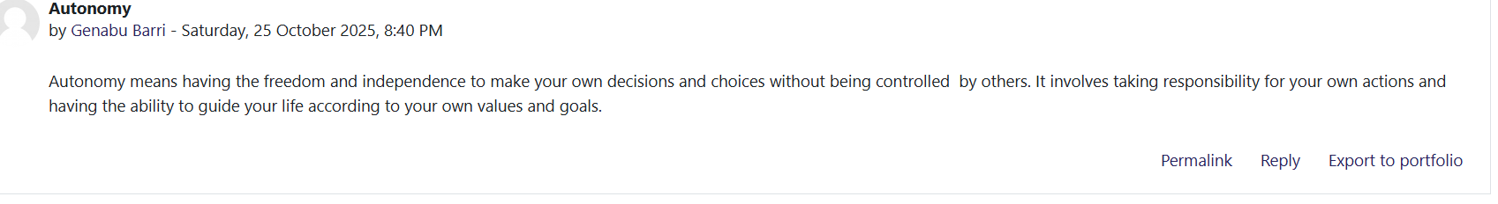  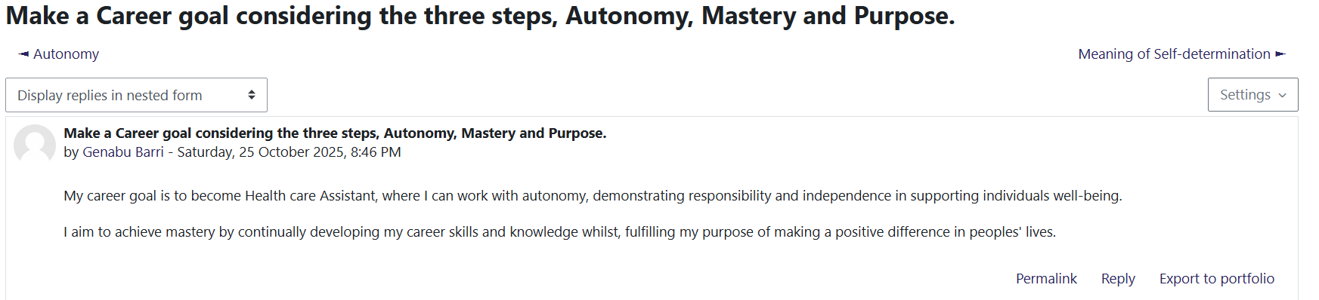
Reflection on Unit 1: Brand You | The unit 1, Brand You was an insightful experience that allowed exploring the notion of personal branding and its crucial role in the formation of the professional identity in the context of health and social care. Lectures and Moodle online activities taught me the importance of the personal brand, which can be used to convey skills, values, and strengths of individuals. I understood that personal branding is more than self-promotion, as it is about constructing a professional and sincere image that demonstrates personal competencies and ethical ideas. This realisation made me reflect a lot on what I represent as a professional, who I would be in the eyes of others in my career (WHO, 2023).  Self-awareness was also one of the most important spheres of learning to me. Through undertaking reflective tasks, I was able to determine my most significant strengths, areas of development, and values that drive my behaviours and judgement in practise. I got to know that knowing yourself is the key to professional development and growth in the career. Self-awareness is also closely related to the Window Model by Johari by Luft and Ingham in 1955, which suggests that feedback, as well as self-disclosure, is an essential aspect of human development (Luft and Ingham, 1955). The use of this model enabled me to identify the role of openness and reflection to enhance communication and collaboration in health and social care environments.  I also visited the Personal Branding Theory which was discussed by Peters in 1997 and which states that people must consider themselves as brands to be able to emerge successfully in competitive workplaces (Peters, 1997). This idea allowed me to realise that a personal brand should be developed in a consistent, authentic, and reflective way. I used this learning by determining qualities that make me stand out amongst others and taking into consideration how to portray these strengths in the workplace, be it during job interviews or in a healthcare team.  The online practises also helped me to evaluate the compatibility of my values and professional objectives with what employers in health and social care sector expect. I also came to understand that I should uphold integrity, empathy, and accountability attributes that promote personal credibility and trustworthiness in the eyes of the people. These thoughts made me reflect on my further efforts to enhance my communication, leadership, and interpersonal skills, which will help me become a better and more empathetic healthcare professional (Szántó, Papp-Váry and Radácsi, 2025).  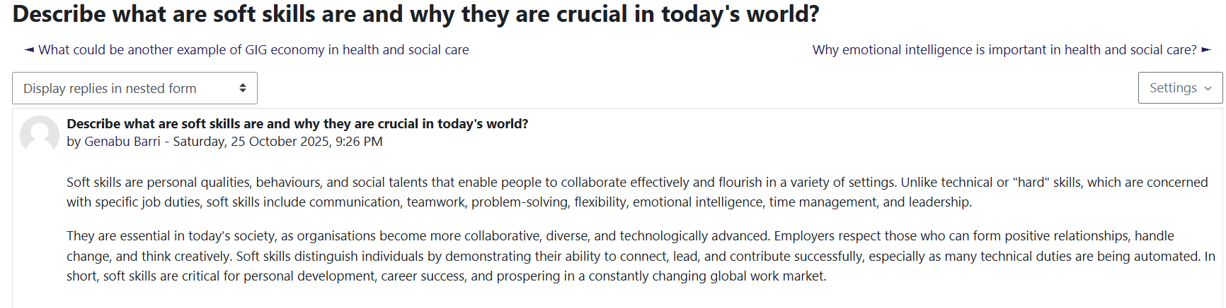
Reflection on Unit 2: It’s a Small World | Unit 2, It is a Small World, has expanded my knowledge on the importance of global connexion, cultural competence and diversity in the development of effective health and social care practises. Lectures and interactive activities on the Moodle helped me to realise that healthcare today is no longer limited to national borders but is affected by international policies, international trends and other cultural views (McCullom, 2024). I also came to understand that cultural competency is crucial in delivering equitable and patient-centred care, particularly in settings where practitioners deal with people who may belong to other ethnic, linguistic, and cultural societies. This unit assisted me in valuing the role of being aware of global health in strengthening empathy, communication, and inclusiveness in practise.  In this unit, I learned more about the notion of cultural competence that can be defined as the skill to be able to engage with individuals with different cultures effectively (Betancourt et al., 2003). I understood that cultural competence is not an acquired competence that can be attained overnight, but a lifelong learning process consisting of reflection, learning and adjusting. The Cultural Competence Framework allowed me to realise the significance of cultural values, beliefs, and traditions respect in the provision of health and social care.  The use of the Cultural Dimensions Theory of Hofstede in 1980 was very informative as it reflected the impact of cultural values on communication patterns, attitudes to power, and decision-making in healthcare teams (Zidkova et al., 2025). As an example, I was informed that in certain cultures, the principles of hierarchy and collectivism have a great influence on patient expectations and communication with medical professionals. Knowledge of these differences may be used to prevent misunderstanding and enhance the level of trust between professionals and patients. It was also through the discussion online that I learnt about using cultural intelligence to enable teamwork in a multicultural health and social care setting to enable practitioners offer more responsive and inclusive services.  Another aspect that this unit helped me to improve my understanding of issues related to global health such as disparities in access to healthcare, the consequences of pandemics, and differences in health systems amongst different countries. I have acquired the knowledge that poverty, migration and educational problems are the problems that impact a lot on the health outcomes of the world. The Moodle tasks helped me think about how the global cooperation in the form of organisations such as the World Health Organisation (WHO) can assist countries to deal with common health problems (WHO, 2023a). I have now realised that a global mindset is important towards the ability to come up with innovative and culturally sensitive solutions to health and social care practise. On the whole, Unit 2 enabled me to appreciate culture diversity as an asset instead of a hindrance. It has motivated me to use international mindsets in my practise, and empathy, respect, and understanding are the main tenets that I would use to provide equitable healthcare in a globalised world.  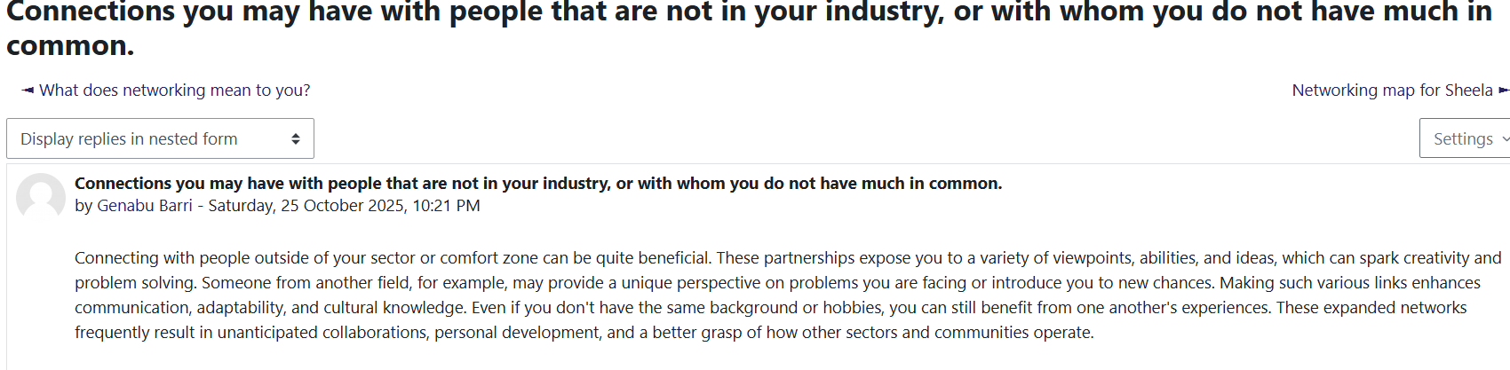  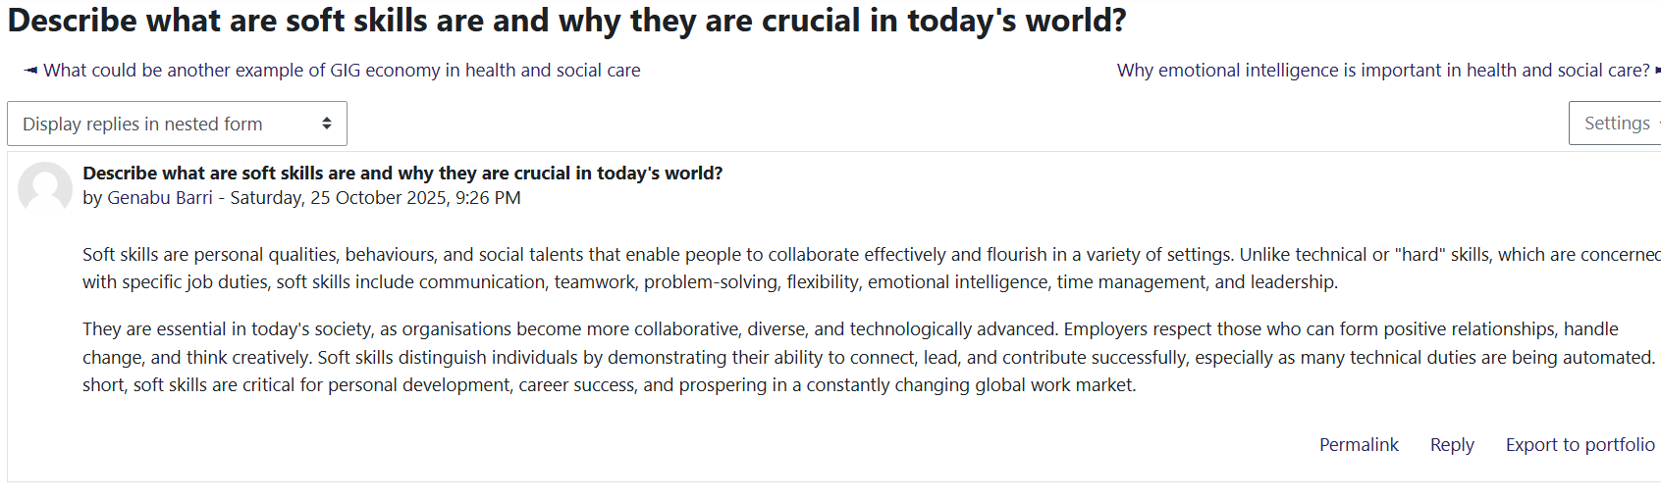  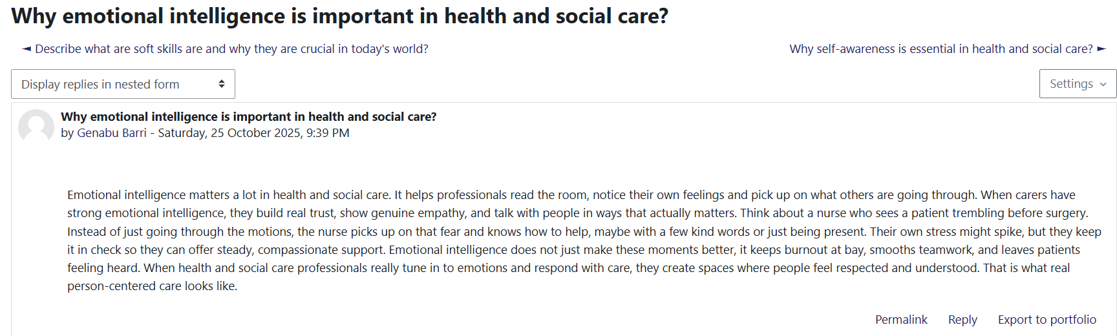
Reflection on Unit 3: Opportunity Knocks | Unit 3, Opportunity Knocks, equipped me with some very valuable information on how to identify, assess, and maximise on the opportunities that may be available to me that will improve my professional and personal development in the field of health and social care. Via the interesting lectures, and Moodle assignments, I came to know that not all opportunities present themselves in an obvious manner; furthermore, many opportunities are outcomes of personal understanding, planning, and acting out (Stewart et al., 2024). This course got me to think in the most critical way about my career objectives and have a better focus of how I want to pursue my career. I understood that employability is not only related to technical competence, but also with adaptation, lifelong learning, and matching individual competences with organisational requirements.  The greatest concept that I have learned was about the importance of Personal Development Planning (PDP). Working on my competencies and formulating realistic goals, I started to comprehend how systematic reflection contributes to the professional growth. Using the SMART Goal Framework Doran in 1981, I developed specific, measurable, achievable, relevant, and time-bound goals to realise my development (Simon Bell, 2019). As an illustration, I have made a target to improve my leadership and communication skills by being involved in community health campaigns that are team-based. This method assisted me to keep track of my progress, stay responsible enough, and stay motivated despite my career.  Another thing that this unit taught me was Gibbs Reflective Cycle (1988), which provided a systematic approach to the experience analysis and conclusion of the lesson that can be learned to make the situation better next time (Gibbs, 1988). With the help of Gibbs model which talks about a structured process of six stages which includes description, feelings, evaluation, analysis, conclusion and action planning. All these help individuals to examine experiences deeply, understand outcomes, and develop informed steps.  I managed to consider the positive and negative experiences I had during my fieldwork and the way my reactions to the situation contributed to my confidence and decision-making. This model made me learn that reflection is a continuous process that helps to enhance self-efficacy and resilience, which are important in ensuring long-term success in health and social care.  Moreover, I studied some theories of career development, including the Theory of Vocational Personalities and Work Environments by Holland where the author focuses on how well the personality type of an individual fits his or her career. The theory allowed me to evaluate my own personal values, empathy, and the desire to contribute to the wellbeing of the population in terms of role assignment in community health and preventive care. Online activities led me to realise that I am especially attracted to such jobs as patient education, vaccination, and popularising health-related activities, in which case I can integrate clinical knowledge with communities (Holland, 1997). All in all, Unit 3 helped me which gave me an opportunity to recognise and act on the opportunities that are aligned with my career goals. I came up with a strategic career planning based on reflection, flexibility, and goal orientation.  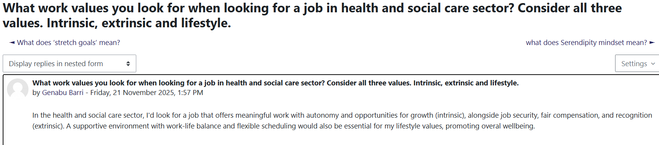  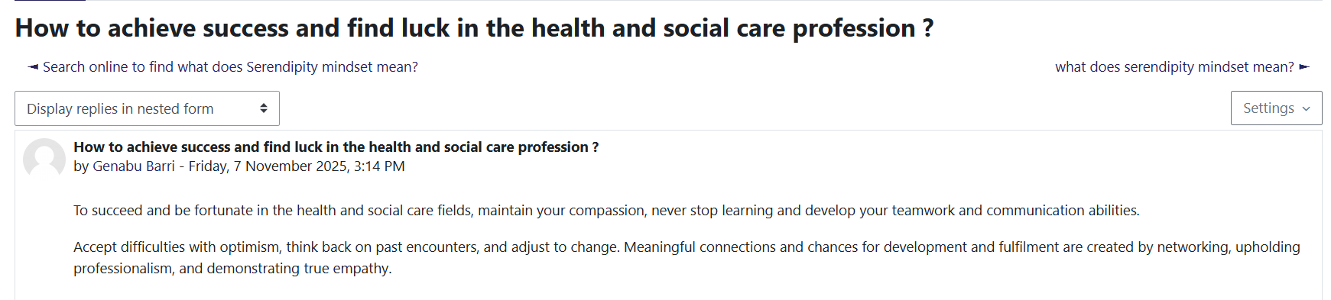  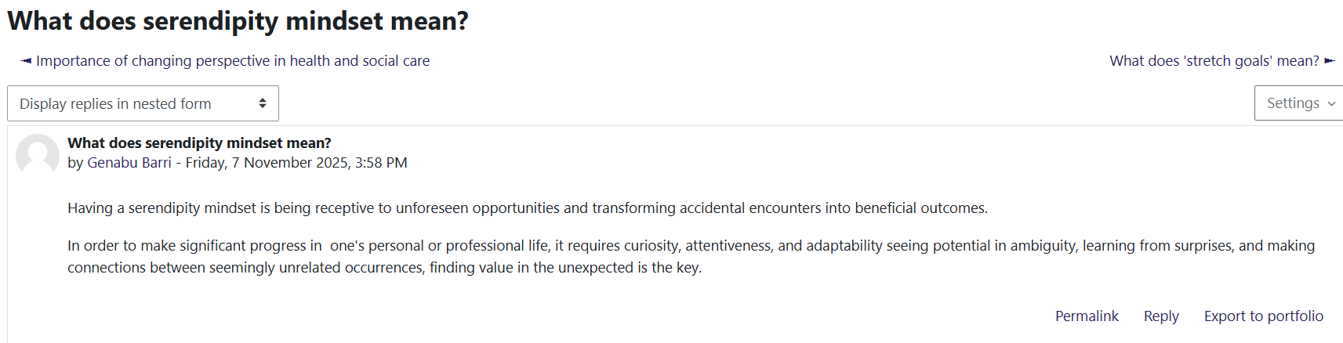
Reflection on Unit 4: The Pursuit of Happiness | One of the most transformative aspects of this module is Unit 4, The Pursuit of Happiness, which helped me understand more about wellbeing, emotional intelligence, and resilience as the three needed in sustainable professional practise in health and social care. The lectures and Moodle activities helped me to see that happiness in the workplace does not necessarily have anything to do with job satisfaction, but with finding the balance between personal and professional wellbeing (Al-Hendawi et al., 2024). The unit also made me consider how emotional awareness, self-regulation, and optimism can be used to positively affect my performance as a healthcare worker. I have acquired the knowledge that emotional intelligence helps practitioners to empathically relate with patients and cope with stress and providing conducive environments to colleagues and service users.  The PERMA Model of Wellbeing by Seligman in 2018 was one of the most valuable models I learned since it outlines five main pillars of happiness: Positive Emotion, Engagement, Relationships, Meaning, and Accomplishment. The model made me realise that professional wellbeing is based on staying positive, establishing effective relationships with colleagues and patients, and having a sense of meaning in work (Seligman, 2018) I used this knowledge by acknowledging that my desire to serve the community and enhance the health of the population is one of the reasons that bring me my satisfaction and interest. Author Al-Hendawi et al.(2024) state that the implementation of the principles of PERMA in the professional environment leads to increased productivity and an improvement in mental health, which is essential in the case of healthcare workers who are exposed to emotional pressure and burnout.  Another theory that the unit introduced me to is the Resilience Theory, which emphasises on the capability to overcome stress, cope with change and stay emotionally stable when faced with pressure. I contemplated the fact that resilience is a vital component in health and social care, and professionals can often find themselves in emotionally pressurising circumstances. Through mindfulness exercises and self-care plans, I acquired the ability to balance my work and life and take care of my emotions. Research by Ibrahim in 2023 also stresses that resilience and mindfulness training enhance focus, decrease stress, and overall wellbeing in medical workers in the long term (Ibrahim et al., 2023). Reflective exercises allowed me to realise that I need to take a rest, set manageable boundaries, and find support when I need it to be able to remain professionally motivated and compassionate (Al-Hendawi et al., 2024). All in all, Unit 4 provided me with better insights into myself and taught me to appreciate happiness as a professional skill instead of a hypothetical concept. I gained a more integrative perspective on wellbeing, in which emotional intelligence, resilience, and mindfulness inter-relate in promotion of sustainable employment in health and social care. This learning has helped me become more empathetic, balanced and emotionally strong in future to go about my professional life and make sure that I am effective and fulfilled in my position.  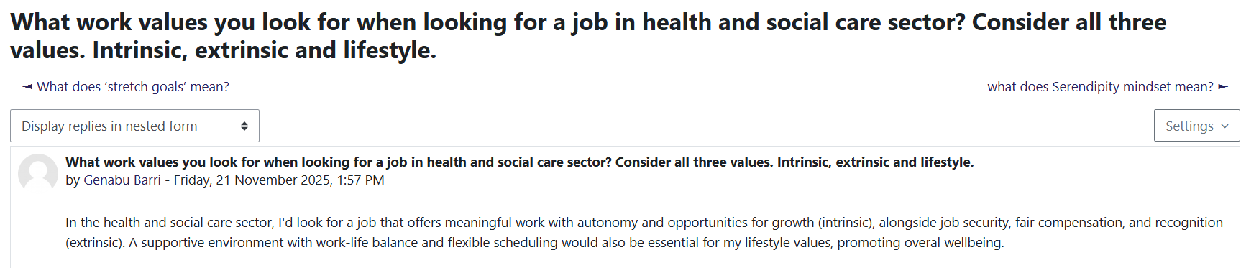  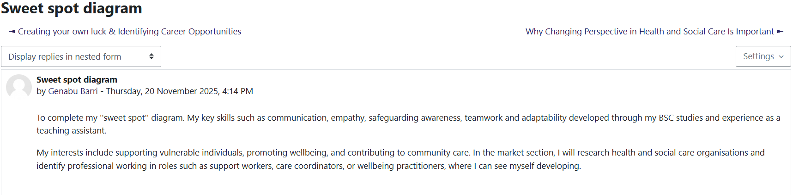  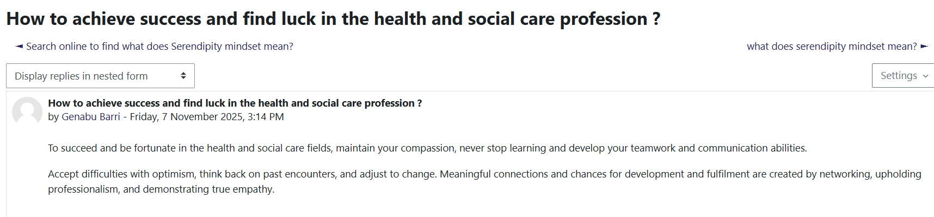  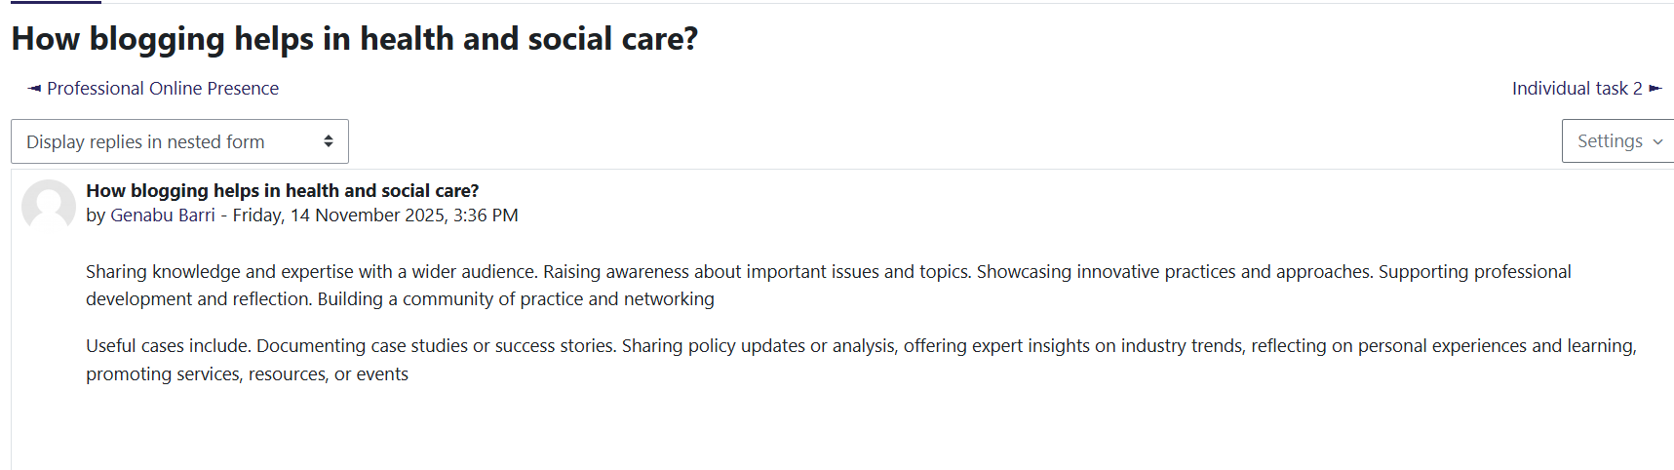
Conclusion | The ability to reflect upon all the four units of this module has greatly informed me about personal and professional development in health and social care. The unit was informative in each way and when combined contributed to enhancing my employability, flexibility, and emotional resilience. The unit 1, Brand You, allowed me to gain a better understanding of who I am and what my professional purpose is to communicate my strengths and values suitably. The lesson, Unit 2, It’s a Small World, has helped me broaden my understanding of the viewpoints of the world and cultural diversity, which will assist me in delivering inclusive and culturally competent care to various communities. Unit 3, Opportunity Knocks, gave me the knowledge of recognising and responding to career opportunities by reflecting on goal formulation and organising personal development planning, which has strengthened my confidence and focus on career development. Lastly, Unit 4, The Pursuit of Happiness, strengthened the value of wellbeing, resilience, and emotional intelligence to ensure balance and satisfaction in the long-term professional practise.

References | Al-Hendawi, M., Alodat, A., Al-Zoubi, S. and Bulut, S., 2024. A PERMA model approach to well-being: a psychometric properties study. BMC psychology, 12(1), p.414. https://doi.org/10.1186/s40359-024-01909-  Betancourt, J.R., Green, A.R., Carrillo, J.E. and Ananeh-Firempong 2nd, O., 2003. Defining cultural competence: a practical framework for addressing racial/ethnic disparities in health and health care. Public health reports, 118(4), p.293. https://journals.sagepub.com/doi/pdf/10.1093/phr/118.4.293  Gibbs, G. (1988, reaffirmed 2019). Learning by Doing: A Guide to Teaching and Learning Methods. Oxford Polytechnic  Holland, J.L. (1997) Holland, J.L. (1997) making vocational choices a theory of vocational personalities and work environments. 3rd edition, Psychological Assessment Resources, Odessa. - references - scientific research publishing. Available at: https://www.scirp.org/reference/referencespapers?referenceid=1970223  Ibrahim, N.F., Sharif, S.M., Saleh, H., Hasan, N.H.M. and Jayiddin, N.F., 2023. PERMA well-being and innovative work behaviour: A systematic literature review. F1000Research, 12, p.1338. doi: https://10.12688/f1000research.141629.1  Luft, J. & Ingham, H. (1955, reaffirmed 2019) The johari window model, Communication Theory. Available at: https://www.communicationtheory.org/the-johari-window-model  McCullom, R. (2024) Cultural competency in Health Care Can Save Lives, Nature News. Available at: https://www.nature.com/articles/d41586-024-03414-1  Peters, T. (1997, revisited 2020). The Brand Called You. Fast Company. Available at: https://www.fastcompany.com/28905/brand-called-you  Seligman, M., 2018. PERMA and the building blocks of well-being. The journal of positive psychology, 13(4), pp.333-335. https://doi.org/10.1080/17439760.2018.1437466  Simon Bell (2019) Home, MindTools. Available at: https://www.mindtools.com/a4wo118/smart-goal  Stewart, V., McMillan, S.S., Hu, J., Collins, J.C., El-Den, S., O’Reilly, C.L. and Wheeler, A.J., 2024. Are SMART goals fit-for-purpose? Goal planning with mental health service-users in Australian community pharmacies. International Journal for Quality in Health Care, 36(1), p.mzae009. https://doi.org/10.1093/intqhc/mzae009  Szántó, P., Papp-Váry, Á. and Radácsi, L., 2025. Research Gap in Personal Branding: Understanding and Quantifying Personal Branding by Developing a Standardized Framework for Personal Brand Equity Measurement. Administrative Sciences, 15(4), p.148. https://doi.org/10.3390/admsci15040148  WHO (2023) Global competency framework for universal health coverage , World Health Organization. Available at: https://www.who.int/publications/i/item/9789240034686  WHO (2023a) Global competency framework for universal health coverage , World Health Organization. Available at: https://www.who.int/publications/i/item/9789240034686  Zidkova, R., Furstova, J., Malinakova, K., van Dijk, J.P., Tavel, P. and Gulis, G., 2025. National cultural characteristics as defined by Hofstede’s dimensions and their associations with population health. BMC Public Health, 25(1), p.1879. https://doi.org/10.1186/s12889-025-22915-w

