Introduction
This written work will investigate the manufacturing process behind body of an acoustic guitar. This investigation will cover the main manufacturing process in detail including the material used and its properties. This will be followed by investigating one other manufacturing process and comparing it to the original one.

The Content
- The Current manufacturing process investigation
    - The origin of the design
    - List of components
    - The material used
    - The process description
    - Attachments to the component
- The new consideration
    - Material consideration
    - The alternative process
    - Component list
    - The manufacturing process
    - Attached components
- Conclusion
- Bibliography

The Current Manufacturing process

The origin of the design
Guitar has gone through many stages’ trough out its life time however the design this investigation is centred around originates from Spain by Antonio Torres around 1850s. before this the guitars were smaller and had lower sound quality. This was due to reinforcements on the inside of the body which did strengthen the body however this was at the cost of the acoustic qualities.

The list of components

The list of components may weary slightly depending on the manufacturer, and or the wood used. The general list of components of the body are:
- The back
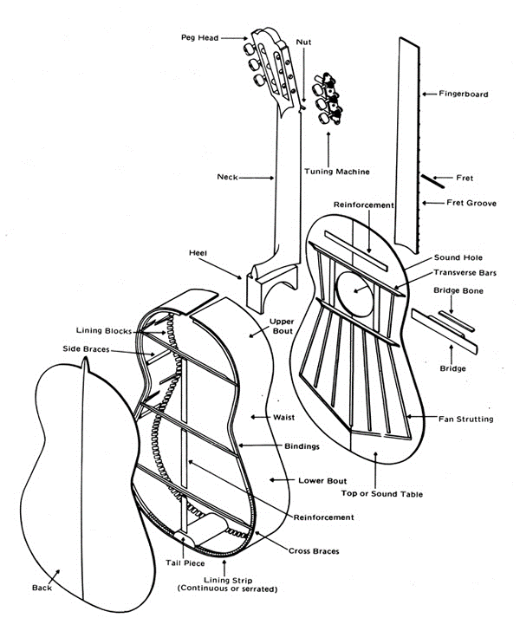
- The top
- The tail piece
- The lining strip
- The side braces
- The lining blocks
- The waist
- The bindings
- The lower bout
- The reinforcement
- The cross braces
- The upper bout
- The fan strutting
- The reinforcement
to see where each component belongs refer to FIG. 1
FIG. 1 the explode view of the

The materials
The guitar body is made out of wood. There is plenty of different wood types to choose from and each have different properties. The woods that are most often used in the manufacturing of guitars are:
- Mahogany

Mahogany is most often used for the sides and the back of the guitar. The use of mahogany back and sides improves the guitars bass and treble.
- Maple

Maple is most often used as the front of the guitar body. This is because it allows lot of the sound that is generated pass through with minimal change to the sound.
- Sitka spruce

The Sitka Spruce is the most popular wood for the top of the guitar body as its strength to weight ratio is very good and it is known for having imparting clear, powerful tone.
- Red spruce

The red spruce is highly desired wood for the guitar tops as it shares may qualities of the Sitka spruce. Whiles at the same time it has rich, full, clear and loud tonal quality.
- Brazilian rosewood

The Brazilian rosewood is used in the sides and backs of the guitar body because of is clear resonance of the sound.
- Indian rosewood

The Indian rose wood is very similar to the Brazilian rosewood with lower range between high and low quality as it mostly sticks around middle of the spectrum with its thicker sound resonance.
- Koa
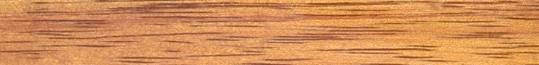
Koa is used in all parts of the body as its acoustic properties are similar to mahogany with more outcoming resonance.

The process description
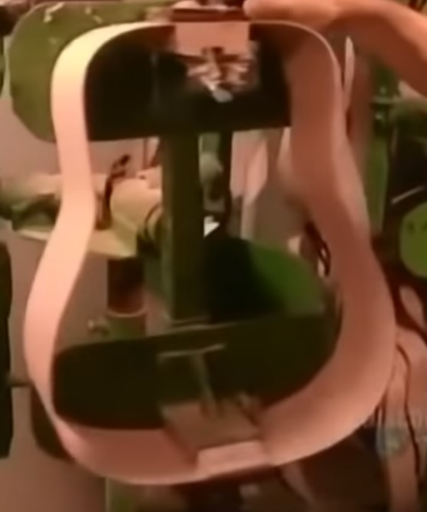
- The first step in the manufacture of the body of the guitar is to cut out the back and the front panels. This is done by a process called press-cutting. This process cuts out the shape by applying an even pressure over the metal outline that outlines the shape.
  - For the front it is needed to drill out the opening hole. This is done with a drill (most likely pillar drill) the size of the hole affects the end sound of the guitar. The smaller the hole is the baser sound.
- Next the sides are prepared. The two pieces of the wood are first soaked in boiling water for a short time before their put in a heated press to give them the curved shape.
- The two side pieces are glued together with a block at the bottom and the top (these pieces are most often out of mahogany) shown in FIG.2
FIG. 2
- The next step is to glue the wooden lining around the edge this lining has small notches cut into it allowing it to bend around the curves.
- When the lining is glued in it has additional notches machined into it on a milling machine to allow the attachment of the wooden cross braces that increase the strength of the body and reduce the stress applied to the back peace.
- The next step is to add the braces. There are between three to four braces on the back part that are glued to the wooden in lining. There are also some braces that are glued to the front panel in a specific pattern in order to increase the strength of the front panel.
- When all the braces are in place its time to glue the back and front panels to the sides. During the gluing process the body is placed in a vacuum press to ensure that the glue is spread evenly.
- After the main body parts are glued together it’s time to glue a plastic lining over the edges. This is done to protect the edges from protentional damage.
- After the lining is attached its time for some sanding. The whole peace is smoothed out by fine sanding.
- The next step is carried out by a specialized machine that drills out the holes that will be used to attach the neck to the body. This machine also sands the edge to make Shure that the neck will fit perfectly.
- Next comes several coatings of lacer (usually four to eight coatings)

This concludes the manufacturing of the body. The other components are glued to the body later.

The attached pieces to the body
There are only few pieces that are attached to the body one of them is the neck of the guitar. The neck of the guitar is attached to the body at the top. The process used to attach the neck are screws and glue. The one other peace attached to the guitar body is the bridge this peace is attached to the body by glue.

The alternative process

The alternative process I have chose to investigate is blow moulding. I have chosen this manufacturing process because it would allow to make the component in one go on a mass production scale. Because of this change in manufacturing I have had to investigate alternative material as swell as wood doesn’t work for blow moulding.

The material investigation
The biggest problem with searching for the most suitable material for this component and manufacturing process was the fact that there seems to be no study researching the acoustic qualities of polymers like PET, TPO, PP, LLDPE and similar.
Since I’m looking at the materials after I have limited my research to the specific manufacturing process I’m limited to a choice of these materials:
The material | TPO | HDPE | PP | PET | WOOD  (Mahogany)
image |  |  |  | 
Density | 0.875g / cm³ | 0.93 to 0.97 g/cm³ | 0.946 g/cm³ | 1.38 g/cm³ | 10 g/cm³
Defection temperature | 40.6 C⁰ | 85 C⁰ | 100 C⁰ | 70 C⁰ | N/A
Tensile strength | 5 MPa | 15 MPa | 40 MPa | 55 MPa | 27.3 MPa
Tensile modulus | N/A | 0.8 GPa | 1.9 GPa | 2.7 GPa | 6.73 GPa
After careful consideration I have settled on using PET due to its material properties I was un-able to find any record of the acoustic properties of any of the listed materials. Due to lack of resources and funding for this project it will have to do with what I have found in an ideal world I would joust test these myself.

The alternative process
As I have mentioned above the alternative process, I’m investigating is blow moulding. the reason why I have decided to investigate blow moulding is because I couldn’t find any record of previous investigations to use this process for this specific product. Through my investigation I have discovered that there are some material limitation and that there is no available source of acoustic properties of the materials suitable for this process. This may be because the limitation of this process is the lack of control over the wall thickness. The positive in this scenario is that it massively reduces component number and the manufacturing time.

the component list:
- The main body
- Wooden block to enable the attachment of the neck

The manufacturing process
- First the polymer would be extruded into the mould
- This would be followed by a pressurised air that will push the polymer and mould it around the mould
- To reinforce the obvious weakness of the material these steps would be repeated two to three times in order to thicken the walls
- After the body would leave the mould it would need to have the wooden block (most likely mahogany) glued to the inner top of the body and on smaller one bellow the body hole to allow the attachment of the bridge.
- The outer body would be sanded and polished to increase its surface finish and remove any excess material
- When the wooden block is in place and the outer body is polished. The specialised machine that drills the holes in the right angle for both the body and neck would again be used to ensure the perfect fit.

Attached components
There are only two at maximum three external components that need attaching to the body these are the neck of the guitar, the bridge, and in some cases, there is a plastic pad by the strings.
The neck would be attached by screws and glue mostly the same as in the original process with the only change being the type of binding agent (this is to ensure correct bonding without damaging the material).
The bride would also be connected by screws and a binding agent (glue)
The possible plastic pad if included would simply be glued with some kind of binding agent depending on the material selected for the pad.

The conclusion
The comparison:
The original process- this process is slow but steady and guaranties to produce good quality guitars
The alternative consideration – this process is much faster and in long term cheaper however it would produce low quality (most likely unusable) guitars
In retrospective the alternative process I have investigated would not work and the reason it hasn’t been investigated in past is because in logical sense it’s a non-feasible idea. This is because none of the materials used in this process have suitable properties for an instrument. When comparing the material properties, it’s was blatantly obvious that it wasn’t going to work as the difference in the numerical properties were too great. If there were better materials it might be a suitable process in the future for producing quick and cheap guitars. However, as it stands this process would not work at this point in time. The other big question if it were possible would there be market for? The guitars that are produced at this point in time are not that popular of an instrument to require such large quantities as are usually produced by blow moulding process.
The over all conclusion is that Blow moulding is not a suitable process for manufacturing bodies for acoustic guitars.

Bibliography
Note to self need to finish
https://www.youtube.com/watch?v=kJogy9pANEU
https://www.fender.com/articles/gear/how-7-different-woods-affect-your-acoustic-sound
FIG. 1 http://www.its-all-about-guitar.com/acoustic-guitar-anatomy.html
blow moulding https://www.custompartnet.com/wu/blow-molding , http://www.charloma.com/blow-molding-materials.html
http://www5.csudh.edu/oliver/chemdata/woods.htm
http://www.matweb.com/reference/tensilestrength.aspx
https://www.ineos.com/show-document/?grade=T00G-02&bu=INEOS+O+%2526+P+USA&documentType=Technical+Data+Sheet&docLanguage=US-EN&version=b0e9ce7054e1b3d5bd20d55fdeb52d7e
https://books.google.co.uk/books?hl=en&lr=&id=3s2FRq58oJAC&oi=fnd&pg=PP1&dq=history+of+acoustic+guitar&ots=ovvzw9fq7y&sig=3BPrnyHZPQnszRDK0bc-urhINQE#v=onepage&q&f=false

