

Effective Teamwork and Communication
Report

Name: Oliver Tabala
Student Id: 2111307
Teacher’s name: Lizeta Demetriou

Submitted on: 02/05/2023

Table of Contents
1. Introduction 1
2. Models of communication 2
2.1 Berlo Communication Model 2
2.2 Shannon-Weaver Communication Model 3
2.3 Aristotle's Communication Model 4
3. Communication Skill 5
4. Advantages and Disadvantages of Technology in Communication 7
5. Conclusion 9
References 10

Introduction
Possessing strong communication abilities is essential to achieving success in all walks of life. Relationship building, collaboration enhancement, conflict resolution, professional advancement, and personal development are all aided by strong communication abilities. They enable people to communicate effectively, listen attentively, take into account the views of others, and relay information properly (Lynch and Kidd, 2017). Misunderstandings, arguments, and wrong assumptions may crop up in any aspect of life when communication is lacking, leading to unfavorable results. Success in life and work depends heavily on one's ability to communicate effectively; as such, honing these abilities is crucial. Throughout the years, several models of communication have been presented by experts in the field. Some examples of popular models are as follows:
- Berlo's Model
- Shannon-Weaver Model
- Transactional Model
- Osgood-Schramm Model
- Aristotle's Model

Models of communication

Berlo Communication Model
David Berlo, a communication theorist, and educator, created Berlo's Communication Model in 1960. This model is a straightforward and useful framework for learning about the building blocks of communication. The four main components of Berlo's model are the sender, the message, the channel, and the receiver. Let's break it down and look at the parts individually:
Sender: The person or organization that creates and sends a message is known as the sender. Someone, something, or anything mechanical might be the sender.
Message: The sender creates the message and intends for the recipient to receive it; it is the substance of the communication. There may be both deliberate and unintended clues in the message, which may be delivered verbally, in writing, or by nonverbal means.
Channel: Messages go from the sender to the recipient over a medium called a channel. The medium might be direct interaction, a phone call, an email, a message posted on a social networking site, or anything else (Rubin et al., 2020).
Receiver: A message's recipient is the one who reads and understands what was conveyed. Someone, something, or anything mechanical might be the recipient.
In addition to these four components, Berlo's approach also incorporates the idea of feedback, which enables the recipient to respond to the sender. Verbal and nonverbal feedback both assist confirm that the intended message has been heard and comprehended.
Berlo’s Model of Communication
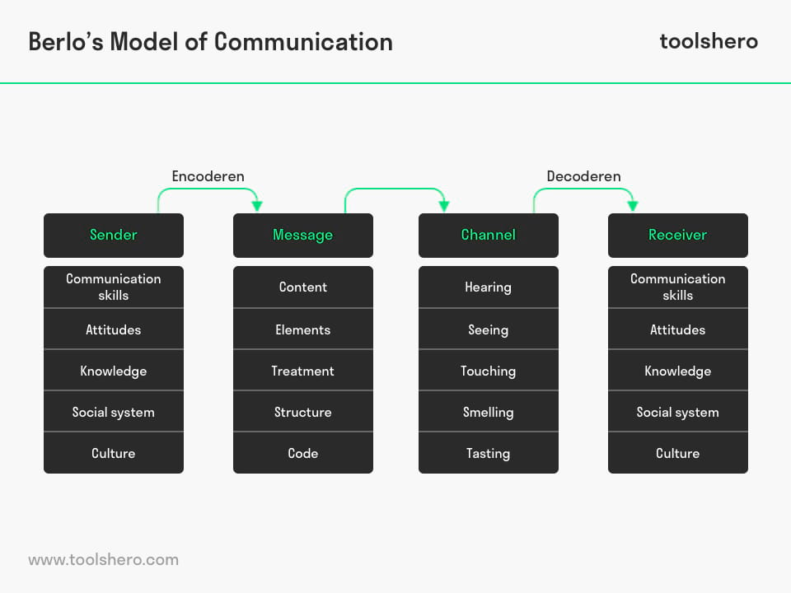
Figure 1: Source (Broca & Ferreira, 2015)

Shannon-Weaver Communication Model
In 1949, Claude Shannon and Warren Weaver devised the Shannon-Weaver Communication Model, sometimes called the Information Transmission Model (Dotzler, 2020). The essential premise of this paradigm is that communication entails passing data along a path from a source to a destination. There are five main parts to the model:
Sender: The person or organization that creates and sends a message is known as the sender. The sender converts the message into an encoded signal for transmission.
Message: The sender creates the message and intends for the recipient to receive it; it is the substance of the communication. There may be both deliberate and unintended clues in the message, which may be delivered verbally, in writing, or by nonverbal means.
Channel: Messages go from the sender to the recipient over a medium called a channel. The channel may be any available method of communication, including but not limited to in-person meetings, postal letters, or online forums.
Receiver: The recipient is the one who gets the message and figures out what it means. The signal is decoded and reconstructed into a meaningful message by the receiver.
Noise: Noise is any unwanted background activity, such as interference or distortion, that degrades the clarity of transmission. Physical noise, like static on a phone line, or mental noise, like a distraction that prevents the recipient from properly processing the message, both fall into this category.
The Shannon-Weaver Model of Communication stresses the need of being understood clearly and precisely. The objective of the sender in this model is to craft a message that can be sent through a channel and received by the receiver with as little distortion or interference as possible. This may be accomplished with cautious message encoding, channel selection, and awareness of possible noise sources.

Figure 2: Source (Gillespie and Schiffman, 2018)

Aristotle's Communication Model
The Greek philosopher Aristotle came up with one of the oldest models of communication. The three pillars of Aristotle's paradigm are the credibility of the speaker (ethos), emotional appeal (pathos), and logical reasoning (logos).
Ethos: The ethos of a speaker is their reputation and authority in the field. Aristotle argues that people are more willing to listen to and be convinced by those who have earned their credibility.
Pathos: Emotional appeal is what we mean when we talk about pathos (Haskins, 2016). According to Aristotle, an effective speaker would connect with his or her listeners on an emotional level and speak to their values, beliefs, and wants via the use of such appeals.
Logos: Logos is the message's rational appeal. According to Aristotle, to convince an audience, a speaker must provide an argument that is both logical and persuasive.
Audience analysis is a part of Aristotle's Communication Model that entails learning about the target group's wants, requirements, and values so that the message may be tailored to them. Aristotle argues that it is impossible to effectively communicate without first gaining a thorough comprehension of the listeners' worldview, values, and goals.
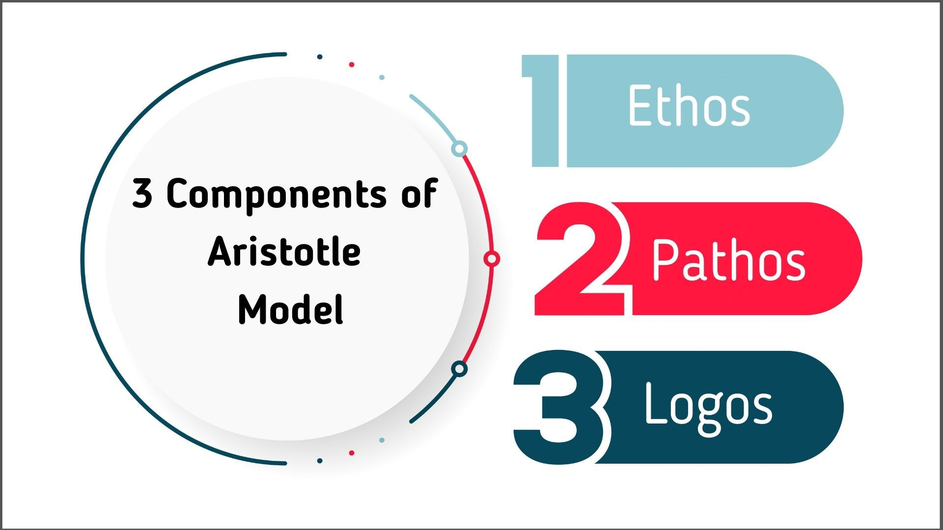
Figure 3: Source (Tautz, 2022)

Communication Skill
The capacity to successfully share and listen to information, ideas, thoughts, and emotions is what we mean when we talk about communication skills. Nonverbal cues like body language and facial emotions are also part of effective communication (Bora, 2023). One must be able to actively listen to others, express oneself clearly and with assurance, deliver information properly, and correctly understand signals to have effective communication skills. It also entails being sensitive to cultural differences, in control of one's own emotions, and able to adjust one's communication style accordingly. Superior communicators are valued in all walks of life because of their ability to forge lasting bonds with others, work together productively, and accomplish shared objectives.
There is a wide variety of talents needed for effective communication. Essential components of effective communication include:
Clarity: Effective Communication will be clear, succinct, and simple to comprehend. Methods for accomplishing this goal include making use of clear, non-technical language and a well-organized structure.
Active listening: Listening attentively is equally as important as talking when it comes to communicating effectively. This involves actively listening to the other person, asking questions to ensure comprehension, and demonstrating sympathy and compassion.
Nonverbal communication: Body language, facial expressions, and tone of voice are all examples of nonverbal indicators that may have a significant influence on how well we're able to convey our thoughts and feelings to one another. Skilled communicators know how to express their feelings and thoughts via body language.
Empathy: Understanding the other person's position is crucial to having productive conversations. For this, it's important to demonstrate compassion and to communicate in a way that avoids making value judgments.
Adaptability: Ability to modify one's approach to communicating based on the specifics of one's target audience (Greene, 2021). To do so requires awareness of the cultural, social, and emotional contexts within which the message will be received and processed.
Confidence: Communicating with confidence means avoiding defensiveness and using direct language. Being able to wait for the right moment before speaking is also important.

Effective communication is a mix of verbal and nonverbal qualities that allow one to clearly and concisely transmit information while also comprehending and empathizing with the other person's position.
Here are some concrete suggestions for using the models of communication in the workplace:
Berlo's Communication Model: According to Berlo's model, there are five essential components to any successful communication: the sender, the message, the channel, the receiver, and the feedback. You might use this paradigm to enhance workplace communication by:
Please elaborate: Make sure the message is easy to understand and uses suitable language for the target audience.
Make use of proper avenues: Choose the most suitable method of delivery for any message, whether that's by email, the phone, or in person (Greene, 2021).
Comment on this: It's important to get the recipient's input to make sure their end of the conversation went well.
The Shannon-Weaver Model of Communication: The Shannon-Weaver model is concerned with how data travels across a given channel. With this framework, users may do the following to enhance workplace interactions:
Subtract the sound: Find and remove any obstacles to communication, such as noise, bad lighting, or technological issues, that might prevent the message from getting over.
Just tune in to the proper station: Consider the urgency, intricacy, and emotional depth of the message to choose the best delivery method.
Use redundancy: To make sure that message gets through and is comprehended, use redundancy by repeating crucial points or giving written evidence.
Aristotle's Communication Model: According to Aristotle, effective communication depends on the speaker's authority, the audience's empathy, and the soundness of the argument. With this framework, one may do the following to enhance workplace interactions:
Boost their standing: Build trust with their audience by showing that they know what they're talking about.
Use emotional appeal: Making an emotional connection with your audience and appealing to their values, beliefs, and wants is a certain way to win them over.
Use logical arguments: Persuade the reader or listener by presenting arguments that make sense and are backed up by facts and reasoning.
Improving relationships, increasing productivity, and achieving better results are all possible by adopting these communication concepts in the workplace and putting them into practice.

Advantages and Disadvantages of Technology in Communication
The benefits of using technology to have conversations:
Speed: Technology has sped up the rate at which we can exchange information. It just takes a few seconds to compose and send an email or text message to someone on the other side of the planet.
Convenience: Smartphones, tablets, and laptops have made global communication possible at any time and from any location (Wentao et al., 2017).
Cost-effective: Email, online meetings, and instant messaging applications are all examples of cost-effective online communication methods.
Efficiency: The efficiency of modern methods of sending and receiving messages is a direct result of technological advancements.
Accessibility: Because of technological advancements, persons with impairments now have greater access to the means of interpersonal communication.
Another advantage of technology in communication: through technology is that it has made it easier than ever to stay connected with people all over the world. With the rise of social media, instant messaging, and video conferencing, it is now possible to communicate with friends, family, and colleagues no matter where they are located. This has made it easier to maintain long-distance relationships, collaborate with co-workers across different time zones, and stay in touch with loved ones who live far away.
However, technology is that it has made it easier to access information and stay informed about what is happening in the world. With the rise of the internet, it is now possible to access news, research, and other information from anywhere in the world. This has made it easier for people to stay informed about current events, learn new things, and stay up-to-date with the latest trends and developments in their field. Overall, communication through technology has made the world a more connected and informed place.
Although there is no doubt that technology has made significant strides in the realm of communication, it is nevertheless essential to be aware of the possible downsides and to use technology with care and purpose if we are to maximize its benefits.

Technology's negative effects on human interaction
Misunderstanding: The absence of physical body language in electronic communication increases the likelihood of communications being misunderstood.
Overreliance: When people rely too much on electronic devices, they risk losing the capacity to connect with others in person.
Security risks: Loss of privacy is a real possibility while using electronic communication due to the prevalence of hacking and other cyber dangers.
Social isolation: Isolation from others: Too much reliance on technological rather than personal means of communication might result in social isolation.
Distractions: Negatively impacting productivity is the continual barrage of technological communication such as texts and alerts (Lamanauskas & Makarskaitė-Petkevičienė, 2021).
Disinformation: This is when individuals, groups or entities deliberately produce and circulate false information knowingly to mislead people i.e. sharing and distributing conspiracy theories.
In most cases, this can sometimes lead to a lack of face-to-face interaction which can lead to isolation. While technology has made it easier than ever to stay connected with people around the world, it can also make it harder to connect with people in person. Often the symptom of isolation and loneliness can always lead to people feeling rather lost and could also result in radicalisation, and can make it harder to build and maintain meaningful relationships.
Another disadvantage of communication through technology is that it can sometimes be unreliable – information can be very hard to verify – this is often seen in places like social media sites and apps. Technical glitches, poor internet connections, and other issues can make it difficult to communicate effectively as well. Additionally, there are concerns about privacy and security when communicating through technology, as sensitive information can be vulnerable to hacking and other types of cyber-attacks. Overall, while communication through technology has many benefits, it is important to be aware of these potential downsides as well.

Conclusion
The ability to communicate clearly and concisely is essential in both personal and professional settings, as it facilitates the development of relationships, the dissemination of knowledge, and the attainment of objectives. Learning about the many communication models and components of good communication may help us become better communicators, better listeners, and better relationship builders. Even though technology has made it easier to communicate in many ways, its usage should be deliberate to avoid pitfalls and maximize the benefits of communication. The conversation as a whole has shed light on the significance of communication and offered methods for enhancing it in a variety of settings.

References
Bora, P. (2023) “Importance of writing skill to develop students’ communication skill,” Journal for Research Scholars and Professionals of English Language Teaching, 7(35). Available at: https://doi.org/10.54850/jrspelt.7.35.009.
Broca, P.V. and Ferreira, M.de (2015) “Communication process in the nursing teama based on the dialogue between Berlo and king,” Escola Anna Nery - Revista de Enfermagem, 19(3). Available at: https://doi.org/10.5935/1414-8145.20150062.
Dotzler, B.J. (2020) “Shannon, Claude Elwood / Weaver, Warren: The mathematical theory of communication,” Kindlers Literatur Lexikon (KLL), pp. 1–2. Available at: https://doi.org/10.1007/978-3-476-05728-0_22975-1.
Gillespie, D.J. and Schiffman, R. (2018) “A critique of the shannon-weaver theory of communication and its implications for nursing,” Research and Theory for Nursing Practice, 32(2), pp. 216–225. Available at: https://doi.org/10.1891/1541-6577.32.2.216.
Greene, J.O. (2021) “The course of Communication-Skill Acquisition,” Essentials of Communication Skill and Skill Enhancement, pp. 60–71. Available at: https://doi.org/10.4324/9781003083450-6.
Greene, J.O. (2021) “The nature of communication skill and communication competence,” Essentials of Communication Skill and Skill Enhancement, pp. 32–47. Available at: https://doi.org/10.4324/9781003083450-4.
Haskins, E.V. (2016) “Aristotle,” The International Encyclopedia of Communication Theory and Philosophy, pp. 1–4. Available at: https://doi.org/10.1002/9781118766804.wbiect132.
Lamanauskas, V. and Makarskaitė-Petkevičienė, R. (2021) “Distance lectures in university studies: Advantages, disadvantages, improvement,” Contemporary Educational Technology, 13(3). Available at: https://doi.org/10.30935/cedtech/10887.
Lynch, C. and Kidd, J. (2017) “Early communication skills.” Available at: https://doi.org/10.4324/9781315175409.
Rubin, R.B., Palmgreen, P. and Sypher, H.E. (2020) “Source credibility scale–berlo,” Communication Research Measures, pp. 327–331. Available at: https://doi.org/10.4324/9781003064343-55.
Tautz, J. (2022) “How research on Honeybee Communication began,” Communication Between Honeybees, pp. 9–20. Available at: https://doi.org/10.1007/978-3-030-99484-6_2.
Wentao, C., Jinyu, Z. and Zhonggen, Y. (2017) “Advantages and disadvantages of clicker use in education,” International Journal of Information and Communication Technology Education, 13(1), pp. 61–71. Available at: https://doi.org/10.4018/ijicte.2017010106.

