Elisabeta Alexandra Badea (2011897)
lecturer: md kalam Group 2, London Campus
Knowledge and information managEment

TABLE OF CONTENT

Contents
KNOWLEDGE MANAGEMRNT IN ORGANISATIONS 2
INTRODUCTION 2
AMAZON.COM 2
STRUCTURE 2
KNOWLEDGE AND INFORMATION MANAGEMENT 3
AMAZON BACKROUND 4
EVALUATION OF KNOWLEDGE MANAGEMNT MODELS 5
KNOWLEDGE EMBEDED INTO PRODUCTS 6
KNOWLEDGE MANAGEMENT AND INFORMATION THEORIES 6
THE ROLE OF MANAGEMENT INFORMATION SYSTEM 8
KNOWLEDGE MANAGEMENT TECHNIQUES USED BY AMAZON 9
OUTCOME OF KNOWLEDGE MANAGEMENT USED BY AMAZON 11
CONCLUSION 11
RECOMANDATIONS 12
Reference list 13
Task 2- poster presentation 14

KNOWLEDGE MANAGEMRNT IN ORGANISATIONS

INTRODUCTION

The purpose of the report is to critically assess and evaluate the concept and importance of knowledge management in terms of Amazon knowledge assets and their management. The report focuses on understanding the key knowledge management process required for organisational development and developing a framework for establishing a knowledge management culture.

AMAZON.COM

Amazon is an American multinational technology company, it is the number one company in 2021. Amazon.com is an internet-based enterprise, there are no physical shops or showrooms. The only physical workplace of amazon is the fulfilment centres. Amazon’s fiscal revenue is $386.064B (2020) and 21.331B fiscal profit (2020). Amazon was opened in 1994 by founder Jeff Bezos, the company headquarters are based in Seattle Washington. Amazon strives to be Earth’s most customer-centric company, Earth’s best employer, and Earth’s safest place to work.

The evaluation of Amazon’s knowledge management and framework will be analysed using different Knowledge Management theories, such as Wiig and Nonaka models. The outcome of the report is to identify and understand how Amazon manage knowledge and information. Evaluate knowledge and information models, investigate the knowledge and management models and develop a framework for establishing knowledge management culture.

STRUCTURE

The report follows a three sections structure
Introduction-Purpose and outcome of the report, knowledge management theories used to analyse Amazon’s knowledge management, an overview of Amazon
Main body
- Section 1: Knowledge and Information Management
- Section2: Evaluation of Knowledge and Information Management
- Section 3: Investigating KM techniques used by Amazon.com
Conclusion -Findings from the beginning to the end

KNOWLEDGE AND INFORMATION MANAGEMENT

Knowledge management enables you to use appropriate knowledge in a specific area. In other words, knowledge management helps you to structure your information effective. Knowledge is a combined result of a person’s experiences and the information they possess.

According to (Bhatt 2000) The knowledge management is the process of:

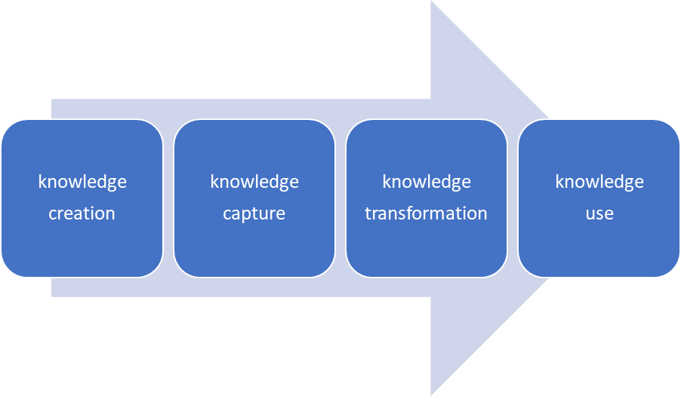

Knowledge is a thus process of facilitating knowledge-related activities such as creation, capture, transforming and, use of information.”
Knowledge is an organised combination of ideas, rules, procedures, and information (Marakas, 1999, p. 264).

However, this theory has been argued in the modern knowledge era as well as in the “ancient” philosophy.
At 151d7–e3 Theaetetus proposes D1: “Knowledge is nothing other than perception” (aisthêsis).
Aristotle, the most influential thinker of all times considered that “mankind by nature desire to know”. The three types of knowledge according to Aristotle are Episteme, Techne and Phronesis. Episteme means scientific knowledge, Techne means knowledge of craft and Phronesis means ethical knowledge. Aristotle also thought that not the best argument win a debate when it comes to mase. While many people argued Aristotle’s philosophy the strongest voice that could not stand it was Plato. Plato aimed high and he created The Rhetoric, the art(knowledge)of persuading, Plato considered that the person must have a set of assets to win the debate. The point of his philosophy was to recognise, acknowledge and soothe people’s fears/emotions. According to Plato principles, knowledge is different from true opinion. The opinion is when I have a belief and it happens to be true. Knowledge is a belief that happens to be true and there is a justification for it. Socrates on the other hand believes that knowledge is rigid and certain and that everything in the world is innately connected ( if there is one truth known, everything can be divided from it). He defines knowledge as absolute truth. Knowledge is a belief that happens to be true and there is a justification for it. Socrates considered that wisdom starts with assuming you know nothing, stressing humanity need of discovering and the importance of knowledge.
Although those were the arguments in the ancient philosophy, they could all agree that knowledge is of what is true and that this truth must be justified in a way that it must be true.

AMAZON BACKROUND

Jeff Bezos, a former Wall Street hedge fund, back then, build Amazon.com in 1994. He was inspired by the South American River, Amazon. Not only that he wants Amazon.com to be as gigantic and well known as the Amazon river, but his decision was also influenced mainly by the letter A, the first one in the Alfabet. As you can say from his idealistic perspective, Jeff Bezos had big plans for Amazon and he saw what others were not even able to speculate back in the 1994’s, the internet based enterprise. The beginning of Amazon was not as spectacular and welcomed by the public, not even the Amazon employees were convinced that this is going to work out and become a real company. Amazon started with selling books online, they promised to deliver any book to any reader anywhere. Amazon was the target of scepticism and criticism in media and business analytics due to the lack of profit, until 2001. The Amazon former never referred to Amazon as online commerce or selling books on the internet, he defined Amazon as a technology company that facilitates online transactions for the customers. There was not much profit for Amazon, even though in 1999, Amazon start selling video games, consumer electronics, toys and many others, as well as books for the United Kingdom and Germany.

In the light of the technology company perspective, in 2006, Amazon launched Amazon Web Services, which lead further in developing Elastic Compute Cloud (EC2), Storage Service (S3), Kindle e-reader and many other inventions
Business-wise, knowledge and information management improves the work performance, the overall development of the organisation and last but not least to obtain a competitive advantage. An organisation aim is to collect knowledge of individuals, known as tacit knowledge and transform this into organisational knowledge, also known as explicit knowledge and later, embed this knowledge into the augmented product.
Knowledge management, together with operational systems enables the company to know its customers. You cannot satisfy someone without knowing their likes and dislikes, their needs and expectations. The organisation must have data and information to conduct analysis, in order to deliver strategically. Proper use of knowledge management helps establish better communication of the customer and organisation, therefore better results and future strategy. Analysing the customer's needs and expectations, allows you to understand more about future product creation too, therefore competitive advantage can be obtained with the right strategy.

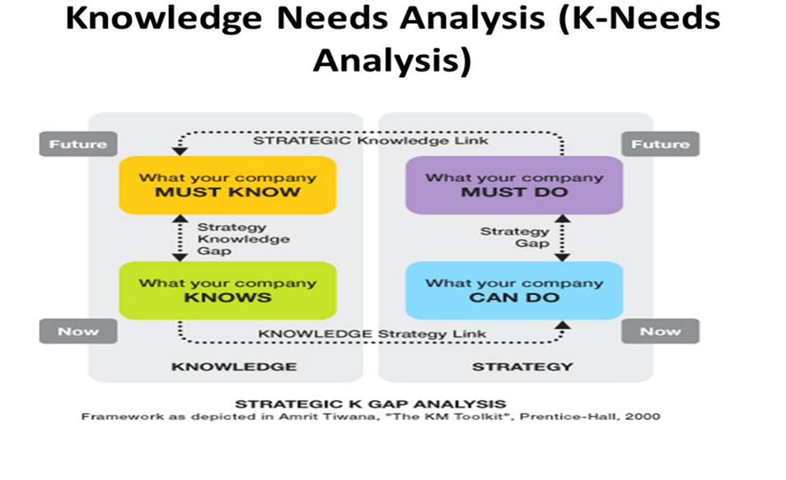
Above is an example of an analysis that organisations can work with in order to satisfy the customers and obtain competitive advantage.

EVALUATION OF KNOWLEDGE MANAGEMNT MODELS

KNOWLEDGE EMBEDED INTO PRODUCTS

It is not the same as closeness to the customer or the term “customer as partner” (Wiersema, 1996).
The organisation aims to maximise the profit through maximisation of the revenue. To embed the knowledge into products organisations use the Focus Knowledge Management strategy. The strategy has three focuses and objectives :
Products- come up with new ideas and launch quickly in the market
Relationship with the customers- knowing your customer and understanding their needs and expectations increase customer satisfaction.
Internal- improve efficiency, minimise the cost and share new knowledge and ideas within the organisation.

When talking about embedding knowledge into products, looking from the marketing perspective, you need to understand what the product is. Organisations use the concept of Core product- Kolter P(1967) Marketing management. Using the Core concept in research and development organisations understand their customers better, which, ultimately will bring a competitive advantage.

Core product-is the purpose of the product that will bring benefit to the customer
Actual product – is all about the tangible product, materials, colours, size etc
Augmented product- is a special service that comes to support the actual product.
Analysing the concept, it can be observed that knowledge is used in the creation of a product but, the very important layer of the concept where knowledge is embedded into a product is the augmented product. The augmented product is the overall experience of the consumer with the product.
To embed the knowledge successfully into a product and maximise the revenue, the product must be taken through 7 P’s of marketing.
- Product
- pricing strategy
- place
- Promotion
- People
- Process
- Physical evidence

KNOWLEDGE MANAGEMENT AND INFORMATION THEORIES

The theory’s focus is knowledge creation. Nonaka and Tkeucky theory defines knowledge as tacit knowledge-known as individual knowledge acquired from years of experience/expertise and the explicit knowledge- knowledge well documented. According to the theory, knowledge creation is a continuous process that occurs planned or accidentally in an individual life cycle. Due to the high amount of information creation, it is important that knowledge is captured. Knowledge creation is the way to innovation, knowledge capture is the way for improving. Thus, those stages of the knowledge process are co-related and important. The theory proposes a model to explain how tacit and explicit knowledge interact along a continuum. (SECI model)
The SECI model contains 4 components of knowledge conversion:
1. Socialisation (tacit to tacit)

The process of socialisation can be formal on informal can you cannot cure between two individuals during a break or can take place through a presentation or a demonstration. It can't take place while inducting a new member of staff within the organisation.
2. Externalisation(tacit to explicit)
At this step, the tacit knowledge is transformed into explicit knowledge through externalisation. Six symbolisation usually takes place from the tacit knowledge of an individual through a group of individuals. The externalisation usually takes place in a planned manner for examples training's research and development publications.

- Combination(explicit to explicit )

is the process where explicit knowledge is collected from internal and external factors combined and processed to a complex and systematic explicit knowledge.
Internalization( tacit to tacit)

Internalisation is the process of transforming the explicit knowledge into tacit knowledge the explicit knowledge created is shared within the organisation end converted into tacit knowledge which later it's used by individuals to create routines or in problem-solving.

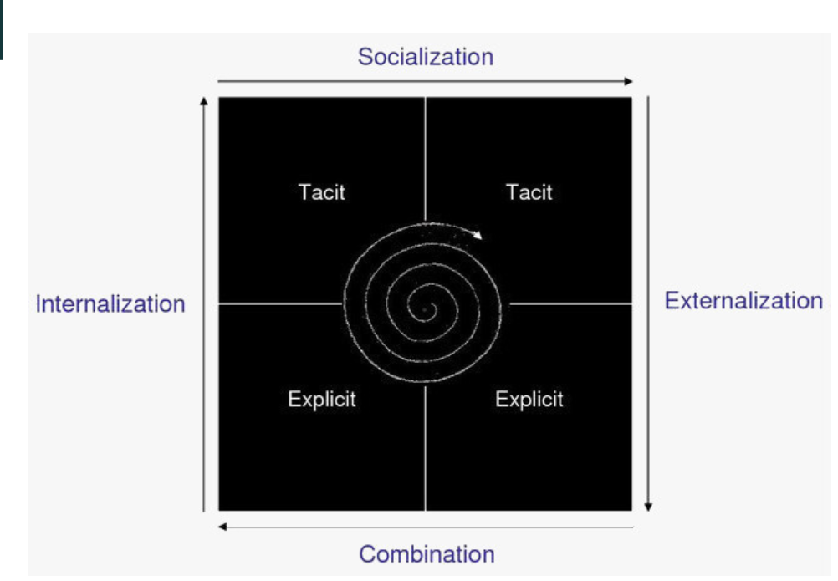
As a result, an individual's knowledge becomes interconnected to new knowledge, as described in the SECI model by Nonaka-Takeuchi.
Using the SECI model organizations can spiral their knowledge within and outside of their organisation to refine and amplify the value of their knowledge stock. This is the case with Amazon.com too. Wheatear this knowledge is acquired informally during a break, or formal into an organised and controlled environment during a training session or a presentation, amazon flows the information within the organisation following the SECI model, assisted by advanced systems.

THE ROLE OF MANAGEMENT INFORMATION SYSTEM

The Management Information System plays an important role within the organisation at each level. Information System come to support another three systems important for the decision making process.
Decision support system(DSS)- providing information to facilitate the decision-making process
Information reporting systems (IRS)- generates day to day reports for day to day decision making
Executive information system(EIS)- the system enables the senior managers to compare, highlight and analyse trends, to decide on the strategic direction of the organisation.

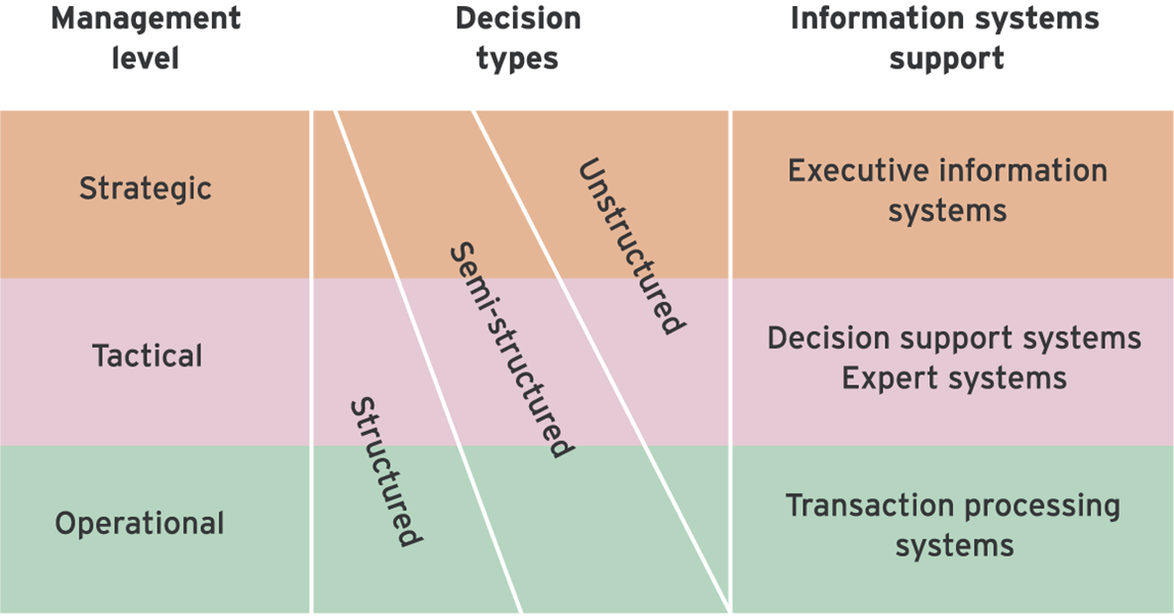

Paul BociJ, Andrew Greasley, Simon Hickie; Business Information Systems, 5th edn: Technology, Development and Management for the E-Business

KNOWLEDGE MANAGEMENT TECHNIQUES USED BY AMAZON

We live in the information age. The business environment is a period of shifting from the industrial era to the knowledge era. Business dynamics have always been important, dynamics enables the organisation to analyse the business environment and plan for future delivery of the service. Although the business dynamics can predict and enables the organisation to speculate, 2020 has changed the business dynamics without any warning. The coronavirus pandemic devasted the global economy. Not only in the medical sectors jas been struggles, but the pandemic starting in 2020 collapsed many businesses around the world.
While during these hard times many retail closed their doors or collapsed or interrupt their activity, organisations made their employees redundant, cutting hours, employing the furlough scheme, out there, on the Market, Amazon maximised the workforce and revenue up to 30%.
Considering we live in a knowledge era, Knowledge has become important to any organisation, especially to Amazon. Amazon uses knowledge management and the operating system to increase productivity. As Amazon.com is online e-commerce and it is increasing its diversity, it is important to make use of advanced systems and technology to avoid any errors, risking to satisfy the customers, but also for the organisation structure to remain organised and focused.

Amazon standard operations are simple end effective. Whether they call it knowledge management or not, they have proven a proper use of Knowledge management.
As in structure, amazon works under the hierarchical structure, however, they also follow a decentralized organizational structure, in order to enable employees to have different degrees of independence. Amazon has a successful combination, containing the marketing mix and knowledge management procedure. Such as:
Amazon’s pricing strategy is a cost-based strategy, which means that price can vary depending on the market demand However, Amazon aims to deliver the lowest price for the buyer.

Amazon becomes successful by reducing the distribution channel. Amazon uses MRP and ERS to make their product available to the consumer even same day ordered and delivered through Amazon Prime
Promotion-Amazon is known for being the most customer centred company. A mazon.com track consumers behaviour and preferences and heavily advertise to pull people to the specific products.

Amazon have its own procedures when it comes to people. Below are few of the Amazon Terms and Definitions:
The two pizza team- teams should not be larger than the amount of people that can eat 2 pizza- 6 team members
Single-threated people- at least one employee will come to work every day trying to drive a critical initiative without competing priorities
Think Big- “thinking small is a self-fulfilling prophecy. Leaders create and communicate a bold direction that inspire results. They think differently and look around the corner to serve the customers”
Hackathon- a day experience when employee compete or collaborate to create a stereotype solution
Working Backwards process- the process that ensures that customer obsession is maintained, visioning how to delight customers, evaluating the approach through the process of creating idea
Press Release- used for tye new products and features. The process helps the employees to see what is what customers miss from the market, is there anything to be invented

Process
Day 1 is Amazon’s model of operating, putting the customers in the centre of everything Amazon does. Day 1 is Amazon’s culture. Day one represents full potential of the company.

Physical evidence- Amazon they take important step and use the km to add significant value to their customer experiences:
- One portal, one interface
- Consistent presentation
- Modular content
- Distributed upstream content creation
- Almost magical personalization
- Crowdsourcing
- Insanely easy and consistent transactions
- Subscription, alerts and reminders
- Feedback
- Reduced servicing
- Performance-centred
- Great online help
- Mobility

OUTCOME OF KNOWLEDGE MANAGEMENT USED BY AMAZON

While there was a navigated widespread unemployment and economic turmoil, Amazon kept hearing. Using the knowledge management procedure and advanced system, The company brought more than 175.000 new warehouse and delivery workers between March and mid-April2020. Amazon added 36.400 people in the three months ended June 30, bringing its headcount to 876,800. Following the KM principles and advanced technology, Amazon become the no1 company in 2021, and their growth is not expected to slow down shortly considering the holidays.

CONCLUSION

One of Amazon’s success components of this e-commerce was the integration of the advanced information systems within the organisation. In addition to its Simple Storage Service, Amazon operates the Amazon Web Service, which facilitates access to the E-commerce platform. These two components of Amazon's information management system provide e-commerce access to both the Simple Storage Service and the Amazon Web Service. The system is advanced and supports interoperability of any internet-enabled device, which, promotes effective communication between sellers, buyers and the organisation. The Management Information System is efficient not only in communication but, also in key business processes such as ordering, delivery, transactions processing and relations management. To improve business process analysis, Amazon has integrated its database and customer relationship management system with different components of its information system, by decentralizing the decision-making processes, and increase transparency. Amazon used business intelligence analytics to understand the market environment and the customers.

RECOMANDATIONS

Although Amazon successfully manages their knowledge, the organisation should always look for the business dynamics, haven given the utility of the business, it was easy for amazon to grow and develop during the pandemic and, although the pandemic is not over yet, things are going slightly back to normal. One of the challenges Amazon can face in the future is that customers are going towards in-person shopping.

Reference list

2 0 2 0. (n.d.). [online] Available at: https://s2.q4cdn.com/299287126/files/doc_financials/2021/ar/Amazon-2020-Annual-Report.pdf.
Academy of Ideas (21AD). Introduction to Aristotle: Knowledge, Teleology and the Four Causes. [online] www.youtube.com. Available at: https://www.youtube.com/watch?v=yjXOmwXENjc&t=21s [Accessed 7 Jan. 2022].
Ağan, Y., Acar, M.F. and Erdogan, E. (2018). Knowledge management, supplier integration, and new product development. Knowledge Management Research & Practice, 16(1), pp.105–117.
Amazon (2021). Our mission. [online] UK About Amazon. Available at: https://www.aboutamazon.co.uk/uk-investment/our-mission [Accessed 3 Jan. 2022].
Amazon Web Services, Inc. (n.d.). Elements of Amazon’s Day 1 Culture | AWS Executive Insights. [online] Available at: https://aws.amazon.com/executive-insights/content/how-amazon-defines-and-operationalizes-a-day-1-culture/.
Brozovich, B.G., John Golden III, and Stephen and Brozovich, B.G., John Golden III, and Stephen (2019). Inside Day 1: How Amazon Uses Agile Team Structures and Adaptive Practices to Innovate on Behalf of Customers. [online] SHRM. Available at: https://www.shrm.org/executive/resources/people-strategy-journal/Spring2019/Pages/galetti-golden.aspx [Accessed 1 Jan. 2022].
Chappell, S.-G. (2019). Plato on Knowledge in the Theaetetus. Winter 2019 ed. [online] Stanford Encyclopedia of Philosophy. Available at: https://plato.stanford.edu/entries/plato-theaetetus/#FirDefD1KnoPer151187 [Accessed 21 Nov. 2020].
Chappell, S.G. (2013). Plato on Knowledge in the Theaetetus (Stanford Encyclopedia of Philosophy). [online] Stanford.edu. Available at: https://plato.stanford.edu/entries/plato-theaetetus/.
Demir, M. (2017). Management Information System: Case Study of Amazon.com. Quest Journals Journal of Research in Business and Management, [online] 4(11), pp.2347–3002. Available at: http://www.questjournals.org/jrbm/papers/vol4-issue11/B4111117.pdf.
Ferguson, E. (2017). Amazon.com Inc. Operations Management: 10 Decisions, Productivity - Panmore Institute. [online] Panmore Institute. Available at: http://panmore.com/amazon-com-inc-operations-management-10-decisions-areas-productivity.
Hall, M. (2018). Amazon.com | History & Facts. In: Encyclopædia Britannica. [online] Available at: https://www.britannica.com/topic/Amazoncom [Accessed 10 Dec. 2021].
Kess, P., Law, K.M.Y., Kanchana, R. and Phusavat, K. (2010). Critical factors for an effective business value chain. Industrial Management & Data Systems, 110(1), pp.63–77.
Kotler, P. (2007). Marketing management : Analysis planning implementation and control. New Delhi: Prentice Hall Of India.
Nonaka, I. and von Krogh, G. (2009). Perspective—Tacit Knowledge and Knowledge Conversion: Controversy and Advancement in Organizational Knowledge Creation Theory. Organization Science, 20(3), pp.635–652.
Online, R., Tibben, W., Sangal, K. and Gonsalves, S. (2006). Unlocking the secrets of Amazon: understanding tacit knowledge and its Unlocking the secrets of Amazon: understanding tacit knowledge and its implications for e-business implications for e-business. [online] University of Wollongong, p.9. Available at: https://ro.uow.edu.au/cgi/viewcontent.cgi?referer=https://www.google.com/&httpsredir=1&article=10306&context=infopapers.
The Good Life Mentor (2017). Jeff Bezos discusses what made Amazon so successful, including his key principles. YouTube. Available at: https://www.youtube.com/watch?v=FJ3jw6TkVmc [Accessed 5 Dec. 2021].

Task 2- poster presentation

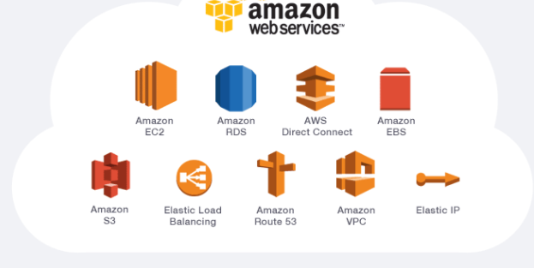


The poster focuses on Amazon possible challenges and steps required to be taken, in order to overcome them.

