MARKETING ESSENTIALS

Module code: M4X01916
Lecture: Dale Clarke
Written assignment part 1

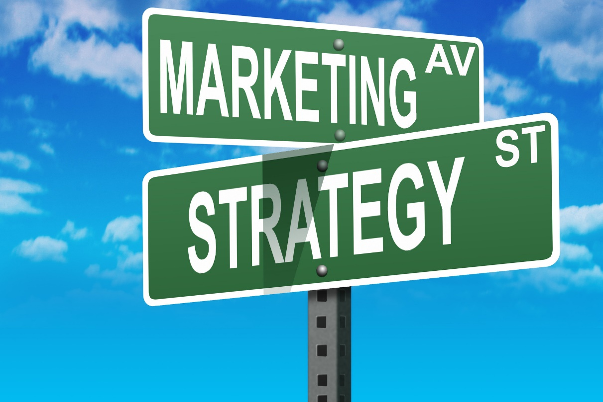

Аuthor: Elena Todorova
Student number: 1815652

Table of contents 2
Introduction 3
Definition of Marketing and Marketing Mix 3
Definition of Marketing Information System 4
MIS for information gathering 6
MIS for communicating 6
MIS in Arena di Serdica Boutique Hotel 6
Conclusion 7
References 8

INTRODUCTION

Each company tries to choose and use the most effective methods and tools to manage its business. This means adopting certain principles of company management, developing a strategy and policy consistent with these principles, and applying appropriate tools to compete.
In a dynamic competitive environment, companies in the tourism industry are planning an active marketing policy to impose their competitive advantages on the basis of their capabilities and skills to create travel services, organise their resources, maintain a specific corporate culture and image.
The accessibility of modern and dependable data is about the environment and the organization's inner circumstance is significant for the achievement of strategic and tactical marketing decisions.
In this paper, I will try to show how the Arena di Serdica Boutique Hotel uses the marketing information system to meet its set goals.
First of all, I will explain the definition of Marketing and Marketing Information System.

Definition of Marketing and Marketing mix

Kotler defines marketing as: "an administrative and social process through which individuals and groups obtain what they need and desire by the generation, offering and exchange of valuable products with their equals.” ⁴
This definition is extensive and shows that marketing can be applied not only in sales but in hotel services as well. Drucker writes: "The aim of marketing is to make selling superfluous. The aim of marketing is to know and understand the customer so well that the product or service fits and sells itself." ²
For a hotel to exist, it depends on its customers, so satisfying their needs is the main goal of the company. Therefore, the hotel marketing manager should know the behaviour of his present and potential visitors. In order to influence customers, the hotel uses four tools: product, price, promotion and place, which in their collective structure are the marketing mix.
Bernard Booms and Mary Bitner (1981) mentioned in their book that: “In 2012, a new four P's theory was proposed with people, processes, programs, and performance. In service marketing, however, the four Ps are expanded to the seven P's or Seven P's to address the different nature of services.” ¹
Sereikienė-Abromaitytė defines marketing mix as “interrelated actions and solutions to meet consumer needs and to achieve the company's marketing goals, a whole" (Sereikienė-Abromaitytė (2013)) ⁶

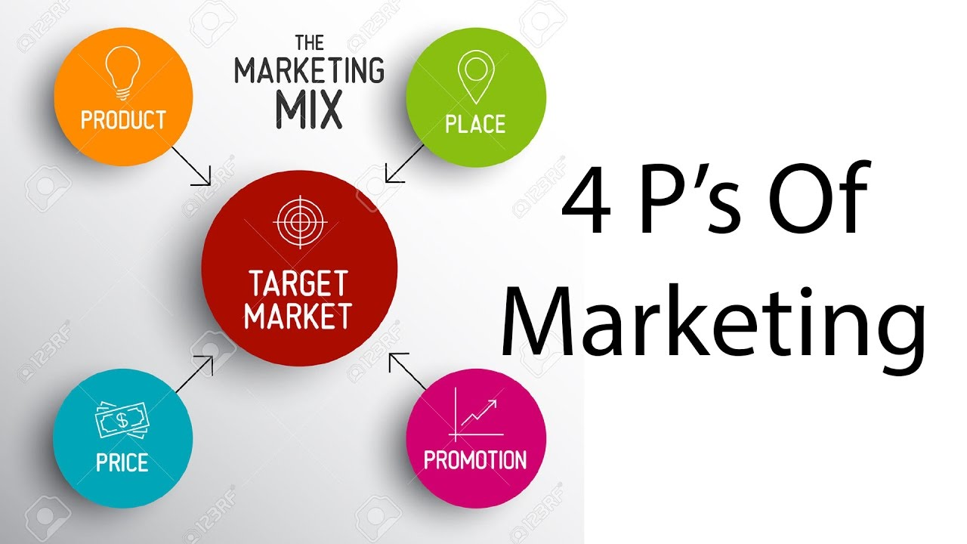

The application of marketing mix tools takes place in the marketing process, which includes gathering and analysing various data about the hotel, clients, contenders, the external environment, arranging, executing and controlling marketing activities, portioning the market, choosing a target market section and situating, setting a marketing budget.

Definition of Marketing Information System

Marketing activity is one of the most significant functions in the advanced association which should guarantee a steady, competitive position of the organization on the market, considering the condition of the external and internal environment. During the process of analysing, executing and controlling marketing strategies and techniques, professionals need an assortment of data for costumers, contenders and agents, about the organization's abilities and various different areas. Each organization gets an assortment of data from different external and internal sources. Assuming, in any case, this becomes incidental and irregular, just in situations where there is an urgent need for information on a specific marketing issue, various problems may arise. These issues can be prevented if the organisation introduces and keeps up an integrated data processing that serves marketing management.
According to Philip Kotler (1998) Marketing Information System (MIS) is a "continuous and interactive structure of people, equipment and procedures to gather, sort, analyse, evaluate, and distribute needed, timely and accurate information that is used by marketing decision makers to improve marketing planning, implementation and control." ⁴
In today’s IT era we can consider marketing information system as „a computerised system that provides an organized flow of information to enable and support the marketing activities of an organisation. A Marketing Decision Support System is a set of core applications in the Marketing Information System that provides computer-based tools, models, and techniques to support the marketing decision process.” (Harmon, 2003). ³
As Talvinen, (1994, p. 8) said “Managing marketing information by means of IT has become one of the most vital elements of effective marketing” ⁷
The elements of the MIS are:
1. Internal Database System - a sub-system of MIS providing information about the organisation's internal condition, its strengths and weaknesses, and its ability to respond to market opportunities and threats.
2. Marketing Intelligence System - a sub-system of MIS providing daily information on business-related changes in the marketing sphere.
3. Marketing Research System - Systematic arrangement, gathering, analysis and provision of information that is identified with a specific marketing situation faced by the organisation.
4. Marketing decision support system - These are the tools which help the marketing managers to analyse information and to make better marketing decisions.
The scheme of MIS is presented in Figure 1

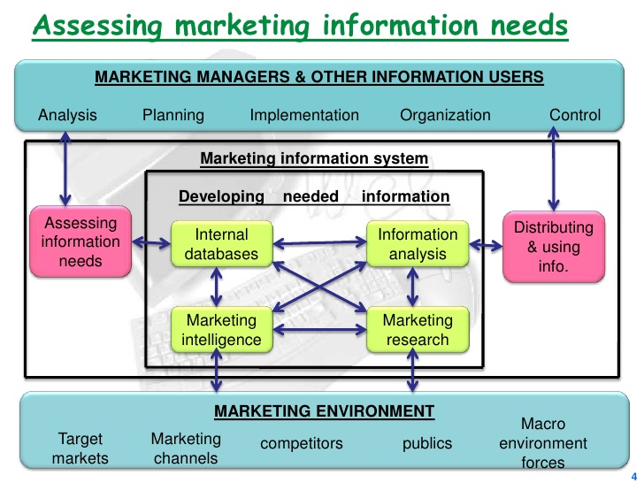
I.ytimg.com (2019)
Figure 1

MIS for information gathering

Collection of information can be from internal or external sources. It is gathered all the time by hotels in their daily operations and stored in the information system. The goal is to integrate this information so that it can be used by the hotel's managers and staff to make good decisions

MIS for communicating

Philip Kotler and Kevin Lane Keller explain marketing communications as "the means by which firms attempt to inform, persuade and remind their customers - directly and indirectly - of products and brands they sell.” ⁵
There are several methods for marketing communication as advertising, sales promotion, public relations, direct marketing and personal selling whose purpose are to use communications to make people buy some products or services.

MIS in “Arena di Serdica Boutique Hotel”

“Arena di Serdica Boutique Hotel” is located in the centre of the capital of Bulgaria. It is close to the National Assembly, the Parliament, several of financial institutions, state institutions, many embassies, the National Library and others. The exceptional strategic location of the complex is also favoured by the good transport arrangements.
Using the MIS and its components, the company gathers information on prices by room type, level of competition, revenue generated by type of services, profile of individual and group visitors, characteristics of guests due to hotel accommodation, booking analysis - how many are accepted, how many are declined.
On the basis of this information, the company clarifies the question which is how people use the hotel, why they use it and what influences their choice. This determines the selection of hotel products that will satisfy customer demand.
The sources of gathering information are primary - surveys, observations, experiments, and secondary - hotel register, reservation register, guest information files, room inquiries, orders, sales, publications, reference books, annual reports. As a source of information about the above-mentioned indicators, Arena di Serdica Boutique Hotel uses a specialised hotel program as well as the information received by the servicing staff which helps analyse the guests and their preferences. The information is gathered and processed on different basis (daily, weekly or seasonal) and plays an important role in decision-making for future activities and problem-solving. The collected information is archived.
On the basis of the information gathered and the results of the researches and forecasts, it is possible to make an adjustment to the company's original primary goal. For example, the initially planned increase in profit may be corrected due to the inability to achieve the planned sales or due to the inability of filling the entire hotel.
The hotel forms its objectives for the future and chooses a strategy to accomplish the objectives as a result of customer researches, their financial capabilities and preferences, as well as a study of the strengths and weaknesses of the hotel. The strategy of Arena di Serdica Boutique Hotel is aimed at keeping the old clients and attracting new ones. This is accomplished by:
- Better customer knowledge - includes customer analysis;
- Perspective vision;
- Product innovation;
- Expanding the range of services offered, renovating the hotel;
- Promotional advertisement – preparing brochures, the hotel is included in several tourist catalogues, it is also included on the Internet through a travel agency or by being advertised on television, etc.;
- increasing sales of their employees through bonuses;
- increasing the qualification of the staff through interviews, company training, etc.;
- Promotion of purchases to customers through deferred payments, discounts, promotional materials, etc.
In my opinion, this hotel has a good practice of using the marketing information system and its components. This is evident from the way the hotel operates. The hotel is full of tourists almost all year round. The advantage of using the MIS is that it helps to organise the hotel’s database thereby improving productivity.
On the other hand, more and more tourists use the internet to plan their holiday. That is why the hotel should take advantage of the internet and constantly improve its presence there. Relationship-marketing can be very effective if information technology is used to keep in touch with customers and get feedback. The Internet allows timely contact regardless of the time-zone and location, which facilitates marketing efforts.
The hotel can take advantage of the internet as a means of creating experiences through online promotional campaigns and games. Ultimately, internet and modern marketing approaches must be in direct dependence on achieving high operating results.

Conclusion

Taking everything into account, I can say that Marketing as a whole has a rich and successful tool kit, the components of which must to be chosen and adjusted to the specific situation. They should also be integrated and well-coordinated as one. Each component of the marketing mix is significant and without it the others can’t be powerful.
It can be concluded that in today's information age, where information flows are huge, the marketing information system is a vital tool for gathering information and communication in every company and in particular in the hotel and the hospitality industry.

References

¹ Booms, Bernard H.; Bitner, Mary Jo (1981). "Marketing Strategies and Organization Structures for Service Firms". Marketing of Services. American Marketing Association: 47–51.
² Drucker, P. (1999). Management. Oxford: Butterworth-Heinemann.
³ Harmon, Robert R. (2003): Marketing information systems. In Encyclopaedia of Information Systems Vol.3, p. 137-151.
⁴ Kotler, Philip (1998), Marketing Management: Analysis, Planning, Implementation and Control, Sixth edition, Prentice-Hall International Editions, p. 102.
⁵ Kotler, P. and Keller, K. (2012). Marketing management. 14th ed. Harlow: Pearson Education.
⁶ Margarita Išoraitė, “MARKETING MIX THEORETICAL ASPECTS” International Journal of Research – Granthaalayah, Vol. 4, No. 6 (2016): 25-37
⁷ Talvinen J. 1994. Information systems in marketing. European Journal of Marketing 29(1): 8-26

Used pictures
Imgur. (2019). Imgur. [online] Available at: http://i.imgur.com/mAd2R.jpg [Accessed 25 Jul. 2019].
I.ytimg.com.(2019).[online] Available at: https://i.ytimg.com/vi/M_ljns_tMXA/maxresdefault.jpg [Accessed 25 Jul. 2019].
Image.slidesharecdn.com.(2019).[online] Available at: https://image.slidesharecdn.com/areportonmarketinginformationsystem-100210092246-phpapp02/95/a-report-on-marketing-information-system-4-728.jpg?cb=1265793807 [Accessed 25 Jul. 2019].

