NAME: EDOSA GODDAY OMORODION OMORODION.
STUDENT ID: 2513334
MODULE CODE: LCHS4003
MODULE: INTRODUCTION TO HEALTH AND SOCIAL CARE.
LECTURER: FARAH ISLAM.
ASSIGNMENT: PHARMACY SERVICES AND COMMUNITY MENTAL HEALTH IN THE UNITED KINDOM.
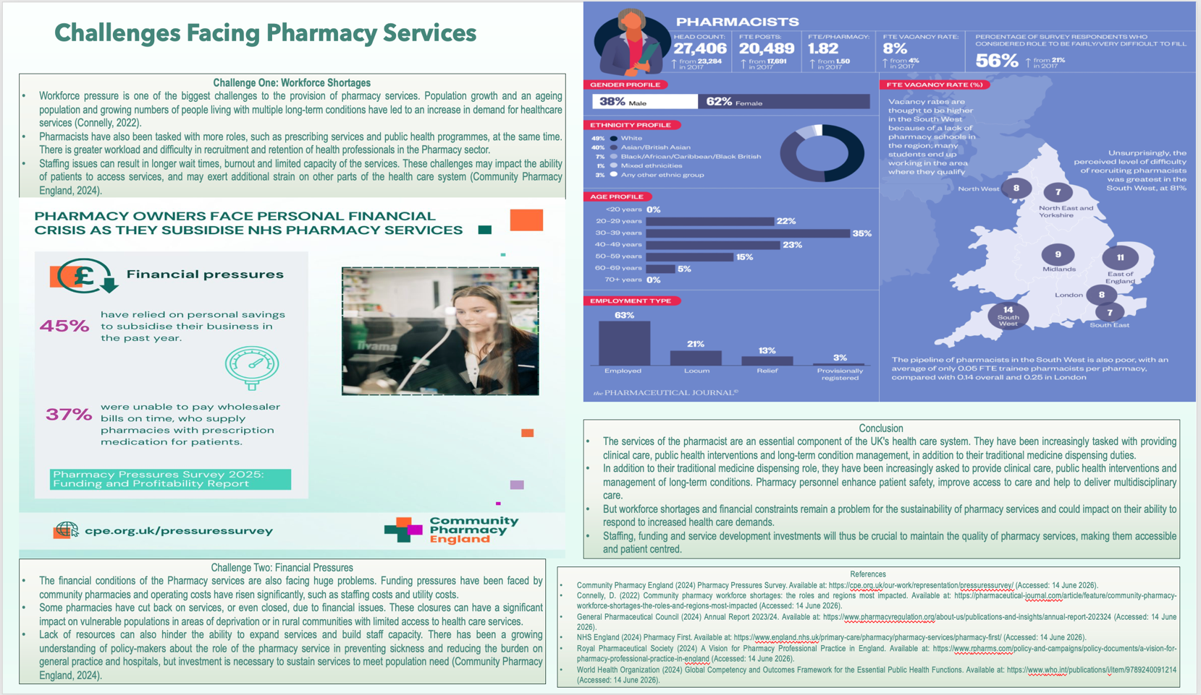
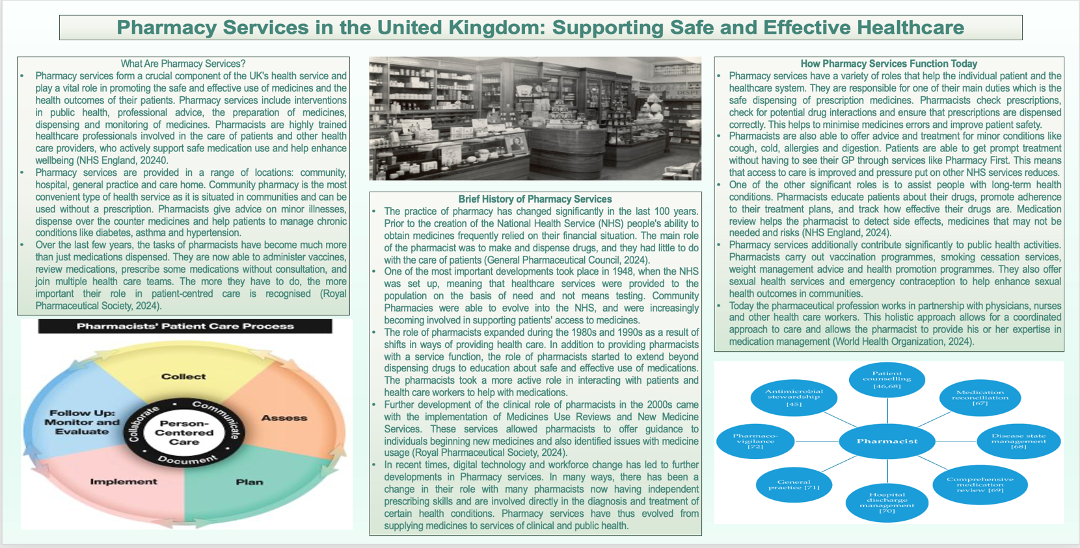
TASK 1: Pharmacy Services in the United Kingdom: Supporting Safe and Effective Healthcare

References
Community Pharmacy England (2024) Pharmacy Pressures Survey. Available at: https://cpe.org.uk/our-work/representation/pressuressurvey/ (Accessed: 14 June 2026).
Connelly, D. (2022) Community pharmacy workforce shortages: the roles and regions most impacted. Available at: https://pharmaceutical-journal.com/article/feature/community-pharmacy-workforce-shortages-the-roles-and-regions-most-impacted (Accessed: 14 June 2026).
General Pharmaceutical Council (2024) Annual Report 2023/24. Available at: https://www.pharmacyregulation.org/about-us/publications-and-insights/annual-report-202324 (Accessed: 14 June 2026).
NHS England (2024) Pharmacy First. Available at: https://www.england.nhs.uk/primary-care/pharmacy/pharmacy-services/pharmacy-first/ (Accessed: 14 June 2026).
Royal Pharmaceutical Society (2024) A Vision for Pharmacy Professional Practice in England. Available at: https://www.rpharms.com/policy-and-campaigns/policy-documents/a-vision-for-pharmacy-professional-practice-in-england (Accessed: 14 June 2026).
World Health Organization (2024) Global Competency and Outcomes Framework for the Essential Public Health Functions. Available at: https://www.who.int/publications/i/item/9789240091214 (Accessed: 14 June 2026).

TASK 2: Community Mental Health Services in the United Kingdom
Community mental health services (CMHS) are social care services that provide support, treatment and rehabilitation services to people with a mental health condition and maintain their place in the community. These services have a person-centred approach and are recovery orientated, designed to increase wellbeing, promote independence and increase social inclusion (NHS England, 2019). This essay will consider the history and origins of community mental health services, consider the current role of these services and explore their contribution to improving the quality of life of service users.
Origins and Historical Development
In the United Kingdom in the past, those who suffered from mental illness were treated in psychiatric hospitals or asylums. These institutions were established to separate people who suffered from mental illnesses from society, leading to social exclusion and long-term institutionalisation. A greater awareness of poor living conditions and the harmful effects of institutionalisation, however, meant that important changes were made in mental health policy (World Health Organization, 2022).
The second half of the twentieth century saw a gradual shift towards community-based provision of mental health care. This deinstitutionalisation process sought to offer support services in the community so that people could live in a family environment and be able to take a larger role in the community. More recently, prevention, early help and integrated health and social care has been a major focus of policy (Department of Health and Social Care, 2022).
Current Functioning of Community Mental Health Services
Community mental health services are now working with multidisciplinary teams, comprising psychiatrists, mental health nurses, psychologists, social workers and occupational therapists. They work together to deliver assessments, treatment plans, crisis intervention, NHS England, 2019, medication management and rehabilitation services.
The services are planned to provide care beyond symptom control to emphasise recovery and strengths. The person-centred approach to care planning and decision making is promoted and encouraged as a part of the service users' involvement in service use. Community based care also enables early help and support in the local setting and helps avoid unnecessary hospitalisation and the continuity of help (National Institute for Health and Care Excellence, 2020).
However, there are also a number of barriers to community mental health services. Access to mental health services is significantly increased and there is a heavy demand for these services. The number of individuals using mental health services is growing, which is creating pressures on the workforce and delay in some services (NHS England, 2025). Community mental health services thus have significant advantages but need adequate resources and equitable access to be effective.
Significance in Enhancing Quality of Life
Community mental health services have an important role to play in enhancing service users' quality of life. They care for people in their communities, supporting independence and helping to prevent isolation and keep them connected to others and to learning, work and social life. Moreover, a comprehensive approach is taken to the services, covering psychological, social and practical needs as well as medical treatment (World Health Organization, 2022).
A focus on recovery and the involvement of service users may also help to build confidence and self-management. So, community mental health services have a significant role in social inclusion, personal recovery and social wellbeing, and are relevant in today's health and social care systems.
Conclusion
The system of community mental health services is very different from that provided in institutions to the integrated, person-centred approach that is provided locally. They are a reflection of a changing attitude towards mental illness and recognition of the importance of social inclusion and recovery. While modern services offer a broad range of support to help people achieve greater independence and wellbeing, funding issues, workforce capacity and access remain issues that impact their effectiveness. It is therefore imperative that further investment and working together is required to ensure that the services available to the community can keep up with the demand for services and continue to be a positive influence on the service users' quality of life.

Reference
Department of Health and Social Care (2022) The Mental Health and Wellbeing Plan: Discussion Paper. Available at: https://assets.publishing.service.gov.uk/media/64c3d943331a650014934e4f/mental-health-and-wellbeing-plan-results-easyread.pdf (Accessed: 14 June 2026).
NHS England (2019) Community Mental Health Framework for Adults and Older Adults. Available at: https://www.england.nhs.uk/wp-content/uploads/2019/09/community-mental-health-framework-for-adults-and-older-adults.pdf (Accessed: 14 June 2026).
NHS England (2025) Mental Health Services Monthly Statistics. Available at: https://digital.nhs.uk/data-and-information/publications/statistical/mental-health-services-monthly-statistics (Accessed: 14 June 2026).
National Institute for Health and Care Excellence (2020) Rehabilitation for Adults with Complex Psychosis (NG181). Available at: https://www.nice.org.uk/guidance/ng181 (Accessed: 14 June 2026).
World Health Organization (2022) World Mental Health Report: Transforming Mental Health for All. Available at: https://www.who.int/publications/i/item/9789240049338 (Accessed: 14 June 2026).

