Food and Bevarage Operations

Assignment 2

Menu Engineering

Student name: Ionel Simion
Student ID: 2220997

Table of Contents
Part 1: Restaurant Concept 2
Introduction 2
Target Audience 2
The Reasoning Behind Menu Choices 2
Conclusion 3
References 4
Part 2: Poster 5

Part 1: Restaurant Concept

Introduction
The growth of the restaurant business has introduced different concepts of dining. Thus, this task will focus on restaurant concepts by introducing a new restaurant concept "Green Bistro". It is a restaurant of the Trinity Hotel Chain (Walker, 2021). The purpose is to provide eco-friendly dining (Yarış and Yazıcıoğlu, 2022). Thus, the objective of this restaurant is to provide eco-friendly dining to enhance customer engagement and reduce environmental impacts.

Target Audience
People are becoming more concerned about the environment as they understand its importance (Yang et al., 2021). So, their target audience includes those who prioritize eco-friendliness, food lovers, and corporate clients (Vermeir et al., 2020). Below, it has provided the target audience of this restaurant:
- Eco-friendly people
- Food lovers
- Due to being a part of the Trinity Hotel Chain, corporate clients are also included here.

The Reasoning Behind Menu Choices
The purpose of this restaurant is to provide an eco-friendly dining experience to its customers. Thus, their menu reflects their purpose. Below, it has explained the reason for such a menu:
- They want to reduce their carbon footprint by focusing on locally sourced and seasonal ingredients for their food (Kim et al., 2021).
- Their foods are plant-based to ensure the fitness of their customers. Additionally, they have vegetarian and vegan options to ensure proper nutrition (Blondin et al., 2022).
- They offer sustainably sourced seafood so that it doesn't impact the water's lives (Belton et al., 2020).
- Waste management is their priority. Thus they select every ingredient to ensure zero waste (Kupalova et al., 2021).
- They avoid using plastics to ensure their purpose. Thus, they use eco-friendly packaging like reusable packaging, biodegradable packaging, etc (Ketelsen et al., 2020).
- To ensure that the menu reflects their purpose, this restaurant highly prioritizes collaboration with local suppliers for eco-friendly ingredients.
- They ensured the proper payment of locally sourced ingredients of every product. Thus, it reflects their ethical and fair trade practices (Paciarotti. and Torregiani, 2021).
- Their menu highlights the importance of eco-friendly practices which encourages their guests to understand the importance of eco-friendliness. As a result, their menu also works as an educational initiative.

Conclusion
From the discussion of this concept, it can be said that Green Bistro is a restaurant that focuses on both the environment and fine dining. As a result, they combined these two factors and made this the primary concept of this restaurant. As this restaurant is focused on eco-friendliness, its target audience includes environment-conscious people, food lovers, and corporate clients. Because their focus is on environmental factors, their menu reflects it highly.

Part 2: Menu Engineering
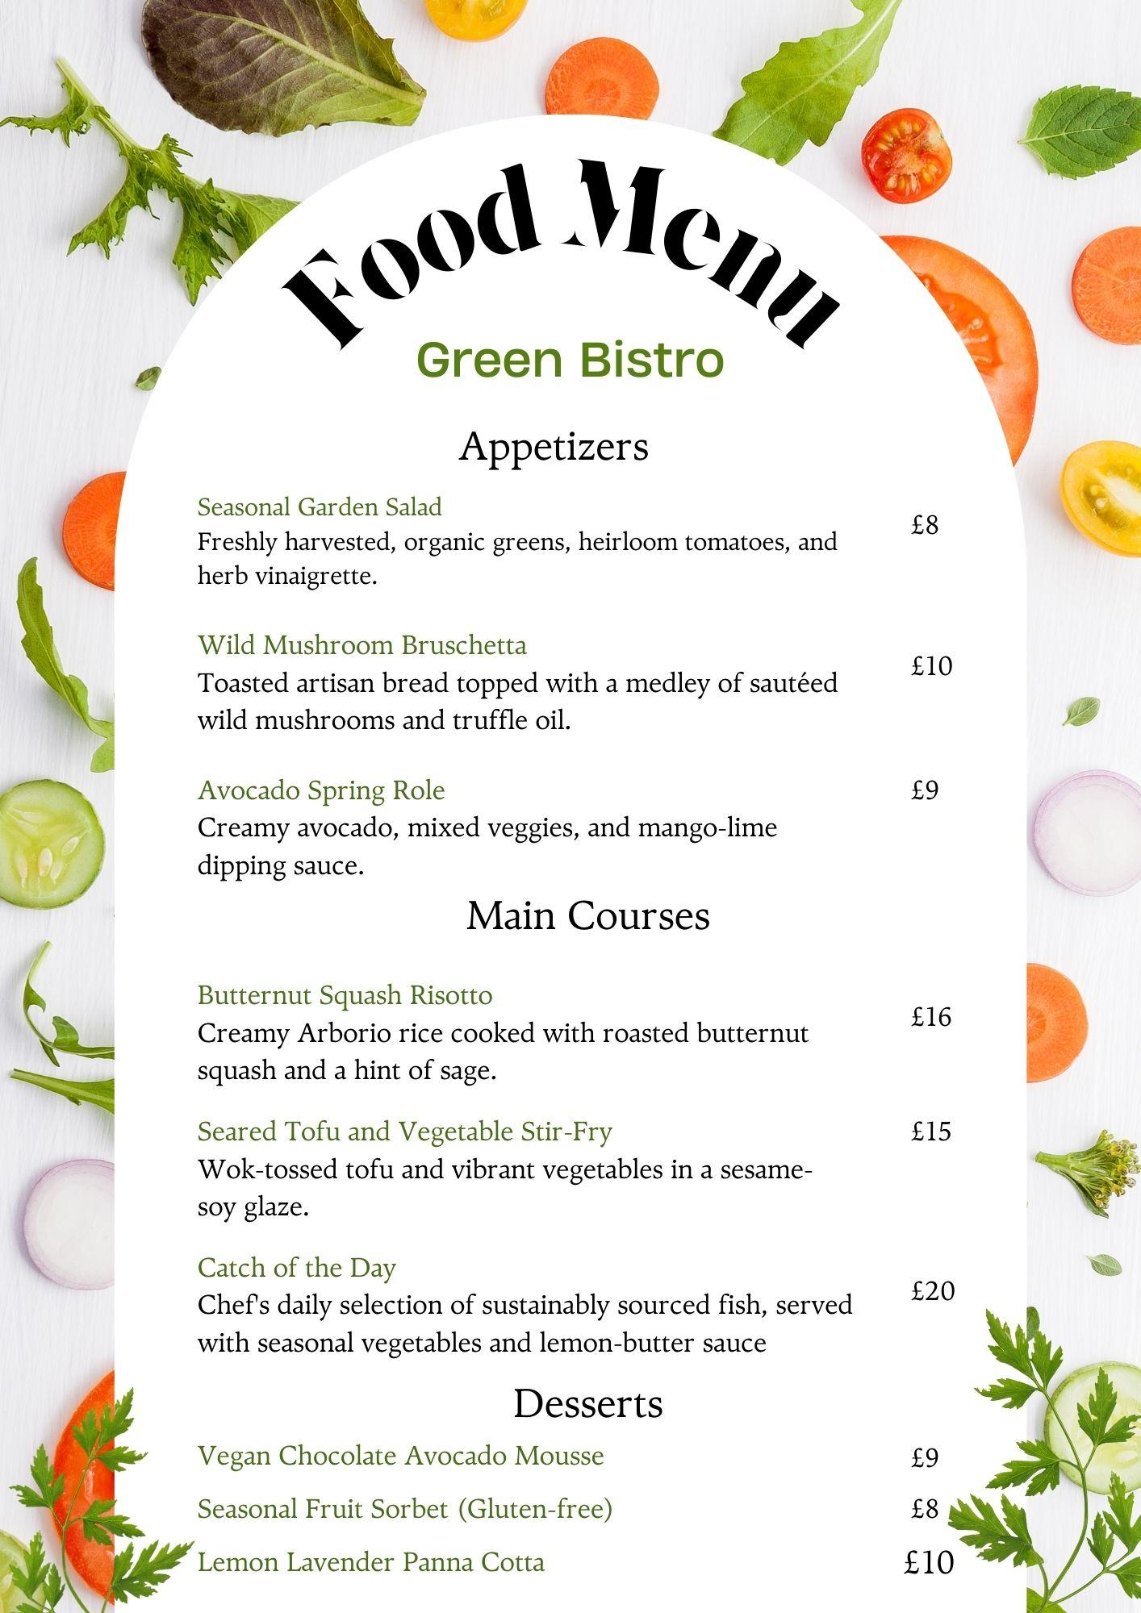

References
1. Belton, B., Reardon, T. and Zilberman, D., 2020. Sustainable commoditization of seafood. Nature Sustainability, 3(9), pp.677-684.
2. Blondin, S., Attwood, S., Vennard, D. and Mayneris, V., 2022. Environmental messages promote plant-based food choices: An online restaurant menu study. World Resources Institute.
3. Ketelsen, M., Janssen, M. and Hamm, U., 2020. Consumers’ response to environmentally-friendly food packaging-A systematic review. Journal of Cleaner Production, 254, p.120123.
4. Kim, S.H., Jeon, D.H. and Jeon, H.M., 2021. Well-being perception and lovemarks formation through experiential value in the context of the eco-friendly restaurant. British Food Journal, 123(12), pp.4264-4283.
5. Kupalova, H., Goncharenko, N. and Andrusiv, U., 2021. Environmental management of agricultural enterprises in the context of european environmentally-friendly food system. Journal of Environmental Management & Tourism, 12(3 (51)), pp.718-728.
6. Paciarotti, C. and Torregiani, F., 2021. The logistics of the short food supply chain: A literature review. Sustainable Production and Consumption, 26, pp.428-442.
7. Vermeir, I., Weijters, B., De Houwer, J., Geuens, M., Slabbinck, H., Spruyt, A., Van Kerckhove, A., Van Lippevelde, W., De Steur, H. and Verbeke, W., 2020. Environmentally sustainable food consumption: A review and research agenda from a goal-directed perspective. Frontiers in Psychology, 11, p.1603.
8. Walker, J.R., 2021. The restaurant: from concept to operation. John Wiley & Sons.
9. Yang, M.X., Tang, X., Cheung, M.L. and Zhang, Y., 2021. An institutional perspective on consumers' environmental awareness and pro‐environmental behavioral intention: Evidence from 39 countries. Business Strategy and the Environment, 30(1), pp.566-575.
10. Yarış, A. and Yazıcıoğlu, İ., 2022. Intentions to Adopt Eco-friendly Practices in Restaurant Operations. Journal of Culinary Science & Technology, 20(5), pp.430-452.

