John James

ACDA6020 LAB No.1
FT-IR Analysis and Identification of Organic Materials

Purpose
Following an inspection of a small materials testing facility, a series of reference powders were found which required disposal. For this to be done safely, they first required identification so that a suitable disposal technique can be utilised. For this to be achieved, a suitable analysis technique was first determined, assuming that the powders were organic compounds. The technique in question was the Fourier Transform-Infra-Red (FT-IR) spectrometry.

Hypothesis
Given the use of compounds used to develop energetic formulations, it would be expected for traces of nitro groups to be present, forming strong absorption regions of the 1535 – 1520 cm⁻¹, 1355 – 1340 cm⁻¹ wavenumbers.

Objectives
The key objectives were to:

- Obtain FT-IR spectra within the 4000-650 cm⁻¹ range of four samples, labelled A-B;
- Determine the key functional and substituent groups;
- Compare the observed spectra to known data values for the observed groups, noting differences in intensity and shifts;
- Produce a report suitable for the verification of what was observed.

This technique utilises the absorption of infrared radiation by certain molecules, resulting in changes to the modes of vibration of the bonds between the atoms. Those wavelengths within the infrared spectrum which are absorbed pertain to transitions between quantized energy levels [1]. The wavelength of absorption is characteristic of the type of bond present and result in two types of structural information:

- Certain groups of atoms within a molecule demonstrate characteristic absorptions, which can be utilised to identify specific functional groups e.g. an alcohol group (-OH);

- Molecules with different structures have different vibrational energy levels, acting as a ‘fingerprint’ (expanded below) which is not shared with another compound. Therefore, compounds with corresponding infrared spectra are identical.

Not all bonds absorb energy at infrared wavelengths. For energy to be absorbed, a chemical bond must have an electric dipole, where electrons are shared unequally in a covalent bond due to differences in electronegativity between the atoms of a molecule. For example, ethene has a symmetrically distributed bond (C=C) around which are the symmetrically distributed hydrogen atoms.

The Fourier Transform-Infra-Red (FT-IR) spectrometer used in this investigation, pass several wavelengths through the sample simultaneously and analyse the results using the mathematical technique of Fourier analysis. Whereby, each single frequency component of the resultant complex waveform are analysed and the amplitudes determined [1].

The fingerprint region is a complex section of the spectra which typically falls between the 1450 to 600 cm⁻¹ [1], and is unique to each compound, rather than the functional groups. For example, propan-1-ol and propan-2-ol contain the same functional group and number of constituent atoms but a different orientation. This produces markedly different spectra in the fingerprint region, pointing towards the different positional isomerism, as illustrated in Figure 1 [2].

Figure 1 - Fingerprint region of propan-1-ol and propan-2-ol
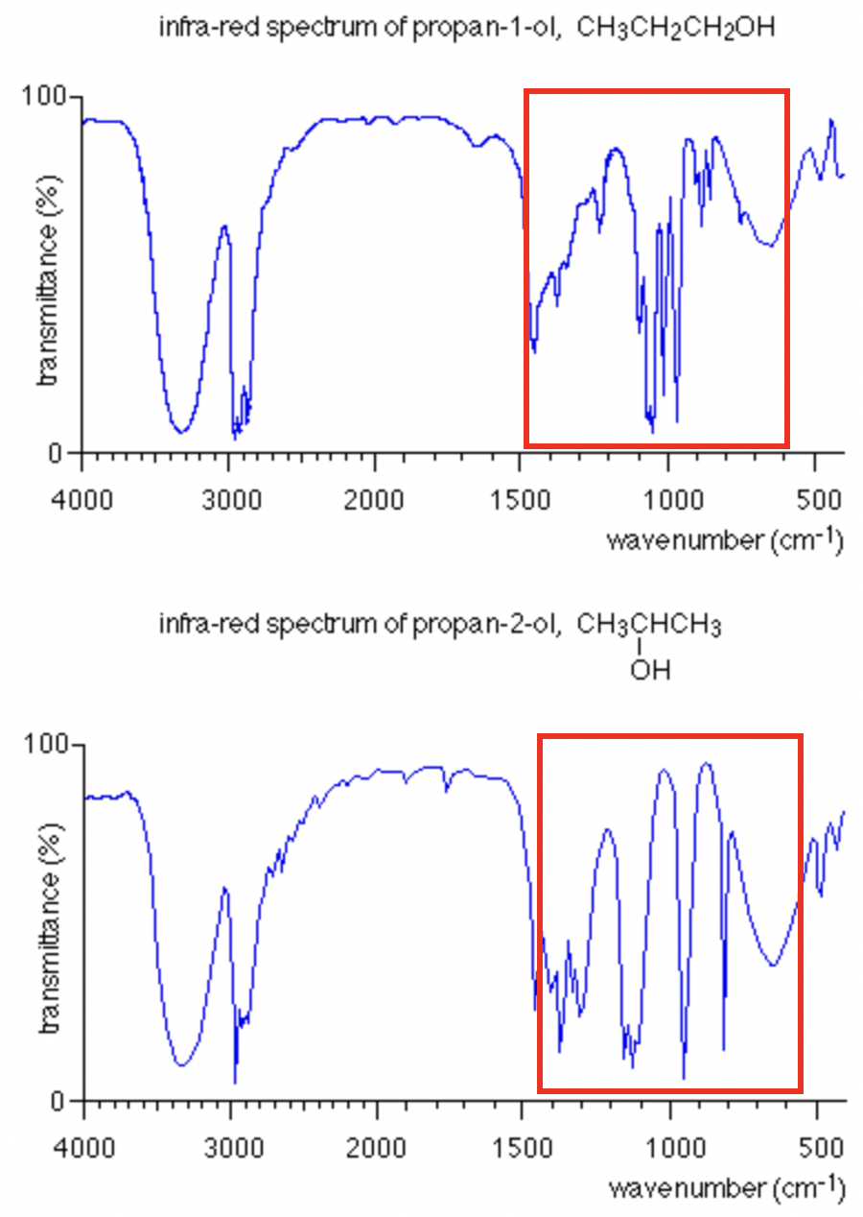

Method
The ATR (Attenuated Total Reflectance)-FT-IR spectrometer utilised in this investigation had an effective spectral range of 4000 – 450 cm⁻¹, with a diamond ATR crystal fitted.

The procedure required the following steps:

- Baseplate and footplate areas to be cleaned with IPA (isopropyl alcohol) solvent prior to each scan;
- Amount of substance to be tested to be sufficient to cover the test plate with the substance in question ground down to a fine powder prior to testing;
- Background test scan to be carried out prior to each scan to ensure the sample area is clear of contaminants;
- Test plate to be fixed into position with the appropriate loading force via the use of the ratcheted mechanism – one audible ‘click ‘is sufficient;
- Scan process can then commence with a repeat of each sample of 15 times to produce statistically significant results;
- Validation of results against a library search will have an acceptance threshold of >50%

Results
Figure 2 - Sample A - Ascorbic acid
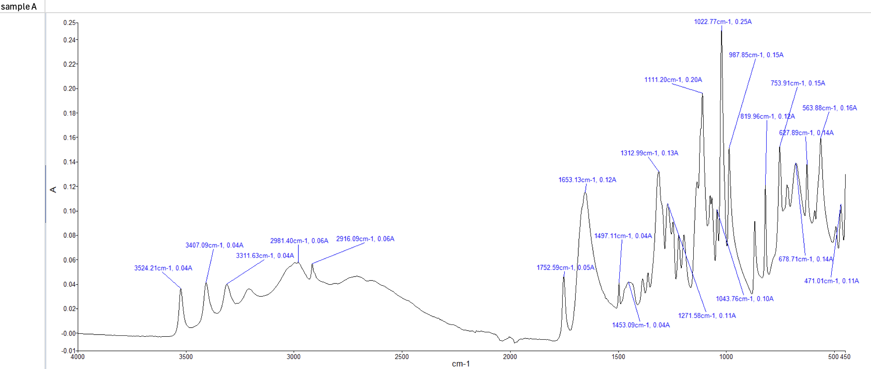

Sample A - Results
Key general peaks / functional groups | Key fingerprint peaks / functional groups
Absorption of wavelengths in the 3500 – 3650 cm⁻¹ are consistent with those pertaining to the hydroxyl group. This can be seen in the left-hand side of the graph. | Peak at 1022 cm⁻¹ indicates a lactone group which literature notes to be in the 1200-1000cm⁻¹ region.

Figure 3 - Sample B - Guanidine
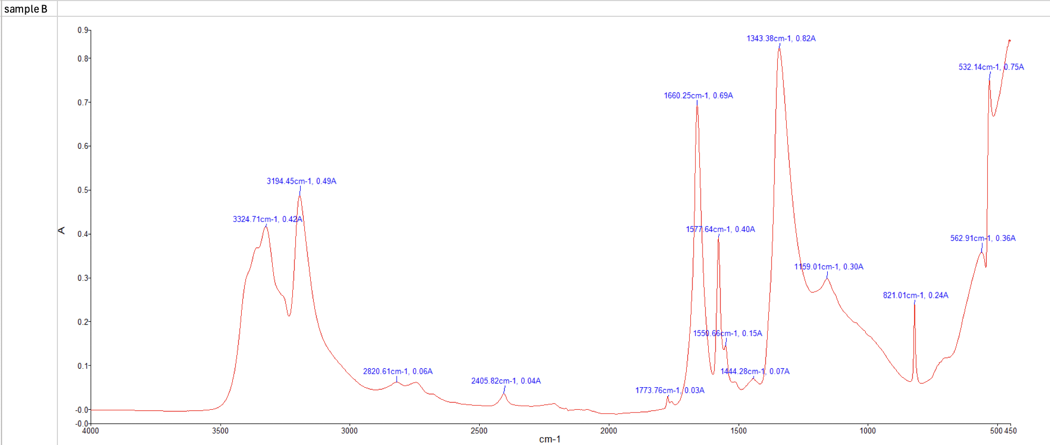

Sample B - Results
Key general peaks / functional groups | Key fingerprint peaks / functional groups
Absorption of wavelengths in the 3400 – 3000 cm⁻¹ range are consistent with the N-H functional group | Peak at 1660 cm⁻¹ points towards a C=N functional group as well as a peak at 1343 cm⁻¹, indicating a C-N bond, which correlates to literature data (1340-1250 cm⁻¹).

Figure 4 - Sample C - Methyl-3-nitrobenzoate
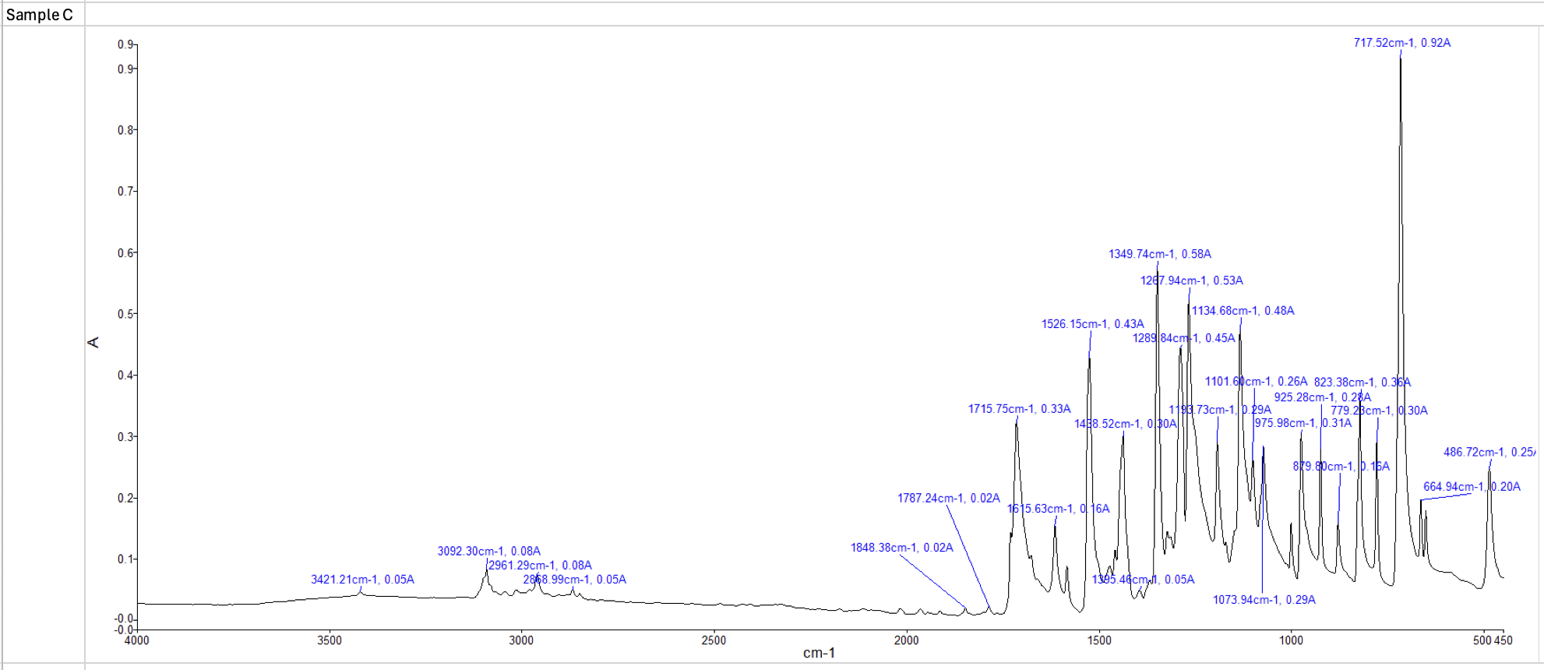

Sample C - Results
Key general peaks / functional groups | Key fingerprint peaks / functional groups
 | Peaks at 1717, 1526 and 1349 cm⁻¹ indicate the presence of an ester / NO₂ functional groups which in literature are found to exhibit values within the following ranges: 1735-1715, 1535 & 1355, 1260-1210 cm⁻¹.

Figure 5 - Sample D - Acetaminophen
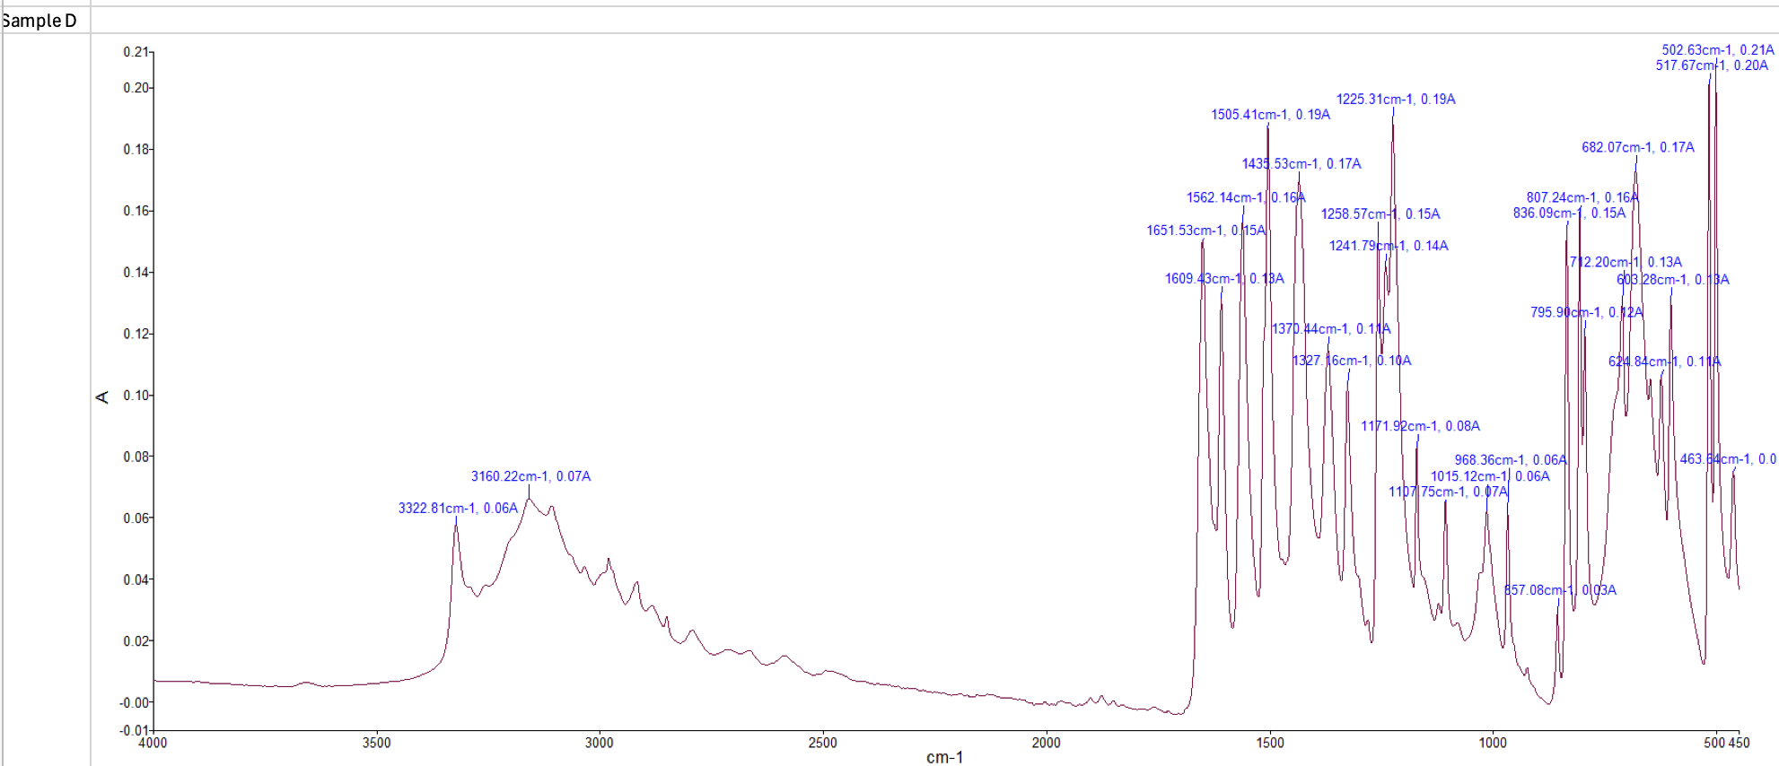

Sample D - Results
Key general peaks / functional groups | Key fingerprint peaks / functional groups
Peaks within the 3300 cm⁻¹ range, specifically at 3322 and 3160 cm⁻¹, indicate a hydroxyl group attached to a benzene ring (phenol). | Strong peaks within the 1600-1500 cm⁻¹ would suggest a presence of the C=C bond which is consistent with a benzene ring which forms part of phenol.

From the data captured above, the following substances were identified and assigned to the relevant sample, noting the key structural features in relation to the FT-IR readings.

Sample A – Ascorbic acid

Structural features:

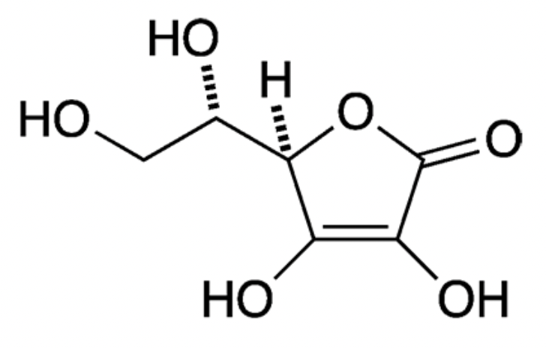
  - Hydroxyl groups (-OH);
  - Cyclic lactone functional group: an ester group (R-COO-R’) contained within a six membered ring.

Relevance to energetic materials chemistry:

Can be utilised as a fuel source in black powder substitutes when combined with potassium perchlorate. Their accessibility makes them ideal for this purpose [3].

Sample B – Guanidine

Structural features:

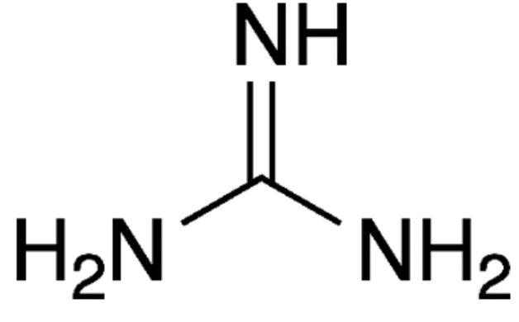

  - Trigonal planar geometry around the central carbon atom.

Relevance to energetic materials chemistry:

Guanidine nitrate, a salt of guanidine is used to produce nitroguanidine which is used in triple-base gun propellants where it reduces flame temperature, muzzle flash, and gun barrel erosion whilst preserving chamber pressure due to the high nitrogen content [4].

Sample C – Methyl-3-nitrobenzoate

Structural features:

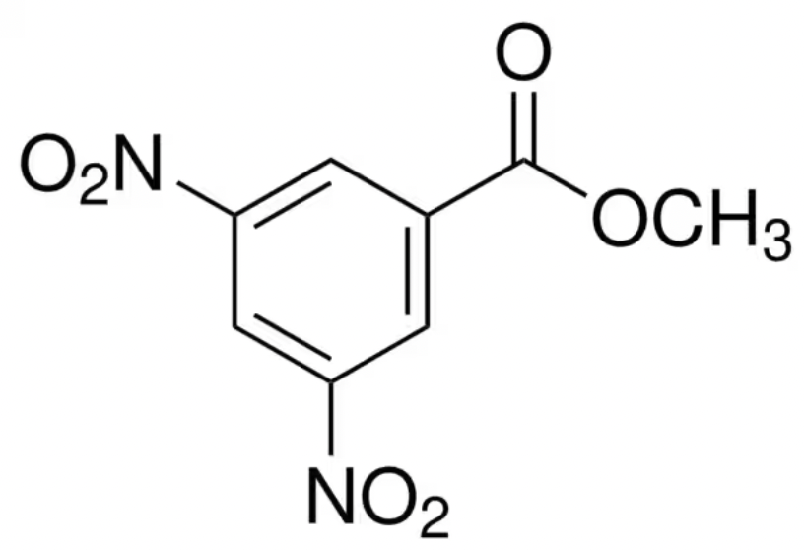

  - Benzene ring - planar hexagonal sigma framework: six C-H σ bonds, and six C-C σ bonds, with the remaining electrons ‘delocalised’ in ring-shaped molecular orbitals;
  - Ester functional group, R-COO-R’;
  - Nitro groups -NO₂

Relevance to energetic materials chemistry:

Used in the production of energetics due to the presence of an NO₂ (oxidizer) group and benzene ring (fuel).

Sample D - Acetaminophen

Structural features:

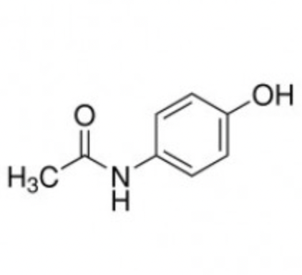
- Phenolic group: benzene ring with a hydroxyl group attached;
- Secondary amide group: where a nitrogen atom is bonded to a carbonyl group and the aromatic/benzene ring.

Relevance to energetic materials chemistry:

Can be used in the production of pyrotechnics (esp. improvised pyrotechnics) as a fuel source due to their availability in commonly purchased medication i.e. paracetamol [4].

Conclusions
The hypothesis had postulated that the unknown substances would be rich in the nitro (-NO₂) functional group, given their use in the development of energetics. However, only a single substance, Methyl-3-nitrobenzoate, had been found to contain the functional group.

It should be noted that the experiment was liable to errors which may have affected the results, namely:

- Sample thickness could have affected the intensity of the absorption bands. A weighted sample could be used to prevent this error in future;
- It was noted that the samples were open to potential moisture absorption from the ambient environment. Samples could be tested for moisture content prior to examination with an appropriate threshold applied;
- The process was labour intensive which naturally makes the process susceptible to human error. Whether an automated process is appropriate for such a analysis would need to be subjected to some sort of cost-benefit analysis.

References

[1] | R. F. Mike Clugston, Advanced Chemistry Second Edition, Oxford: Oxford University Press, 2013.
[2] | LibreTexts, “The Fingerprint Region”.
[3] | National Library of Medicine, “Analysis of ascorbic acid based black powder substitutes by high-performance liquid chromatography/electrospray ionization quadrupole time-of-flight mass spectrometry”.
[4] | J. Akhavan, The Chemistry of Explosives 3rd Edition, RSC Publishing, 2011.
[5] | GENEVA INTERNATIONAL CENTRE FOR HUMANITARIAN DEMINING, “BASIC CHEMISTRY OF EXPLOSIVES AND HAZARDS OF HOME-MADE EXPLOSIVES AND CHEMICAL PRECURSORS Handbook”.

