

Usability Engineering
Assignment 2

Jamie Thomas (261948)

Project submitted as part of the requirements for the award of BSc (Hons) Applied
Computing
May 2020

Contents
Introduction 2
Usability Reviews 2
Guidelines and Accessibility 8
Virtual Reality 9
References 11

Word count excluding References + Front Cover = 3197

Introduction
This report will cover the content for Usability Engineering Assignment 2, looking at the usability of museum exhibits, usability guidelines, virtual reality, as well as a proposal for Welsh heritage virtual reality exhibit.
Interactive Displays
The following are examples of interactive museum displayed which are publicly available. One good example and one bad example will be compared and analysed to evaluate the effectiveness of both displays.
Both displays come from the Louvre Museum in Paris but are for different exhibitions. The display used for an example of a good display is the Founding Myths: From Hercules to Darth Vader exhibition [1]. The display used for an example of a bad display is the Egyptian Antiquities exhibition. [2].

Usability Reviews
Prior to conducting usability reviews for each system, a brief introduction to the work of Alan Dix will be outlined to give a context for comparison.
Alan Dix is a Welsh researcher, university professor and author who focuses on human-computer interaction. Alongside three co-authors, Dix worked on Human-Computer Interaction, a book taught at universities across the United Kingdom. Dix laid out key rules of usability engineering.
Predictability
- Enable the user to make logical predictions about how a portion of the system operates.
- This can be done by using consistent design features and principles.
Synthesizability
- The user must be able to assess the results of prior actions, to see the changes which have been made to the system based on their actions.
- This relies on the system being honest to the user when something happens which changes the internal operations of the system, the user must be able to see this or at least be informed.
Familiarity
- When a new user uses a system, they often bring with them a wealth of experience and understanding of prior software solutions.
- It is important that a system has familiarity so that the user feels comfortable.
- Where possible, common design practices conventions should be implemented to make the system as familiar as possible to as many users as possible.
Generalizability
- Generalizability is a form of consistency. It focuses on understanding how the user extends their understanding of known systems, to unknown systems.
- One example of this is the Microsoft line of products, all of which follow near-identical user interface design principles. Because of this, users often feel more confident and comfortable using similarly designed software.
Consistency
- Consistency refers to the similarities that happen within a system. This can be something as simple as a green button meaning progress, or something more complex like navigation design.
- Users should feel like the system they are using is cohesive and consistent, based on prior knowledge and experience of other systems. [3]
Founding Myths: From Hercules to Darth Vader
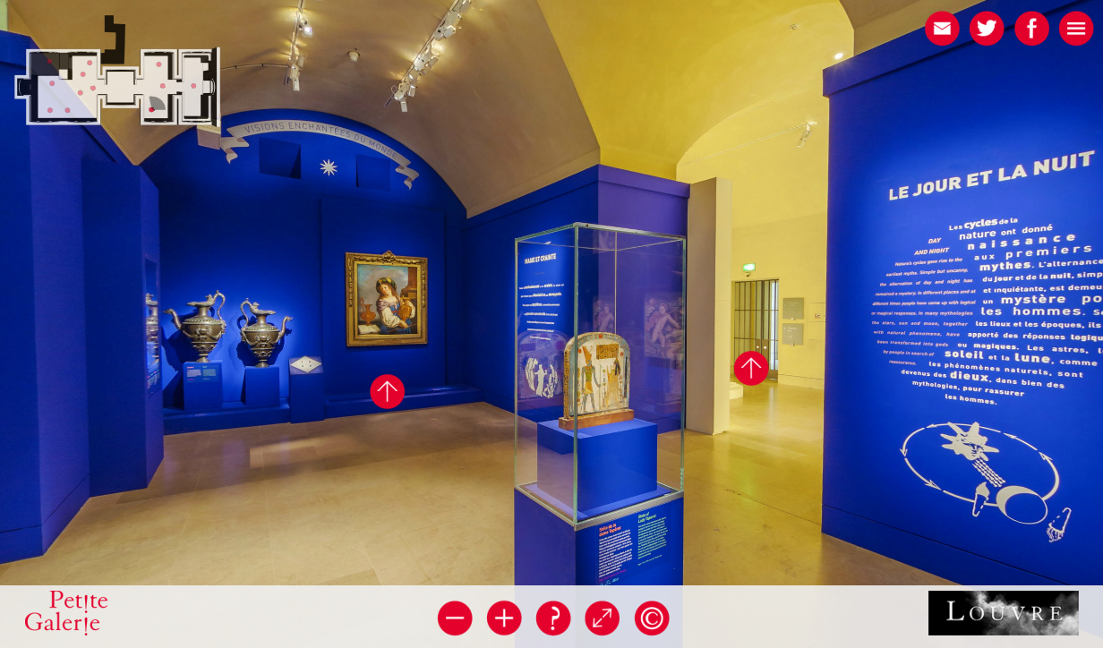
- Interactive
- Good Camera Quality
- Information Overlaid Exhibits
- Ability to move around
- Camera can be panned and zoomed
- Metaphors and iconography used
The exhibition used as an example of a good online display is found at the Founding Myths: From Hercules to Darth Vader exhibition found at the Louvre Museum in Paris, France. The application utilises high definition images to present the exhibition to viewers. The user interface is predictable and feels familiar.
Metaphors and iconography are used throughout the user interface to add familiarity and generalizability to the application. Information for exhibits is overlaid on top of information panels at the museum, so the user can read from a modal on the screen, rather than squinting at an image to make out the text.
When visiting the online exhibition, the application fills the whole browser. This provides an open and expansive feel to the exploration process, it does not feel like there are too many limitations when moving throughout the exhibition. This exhibition can be seen to be one where the design and user experience has been carefully executed to enhance the experience as much as possible. Alongside this, the final application lines up with many of the usability key rules that Alan Dix laid out during his research.

Egyptian Antiquities
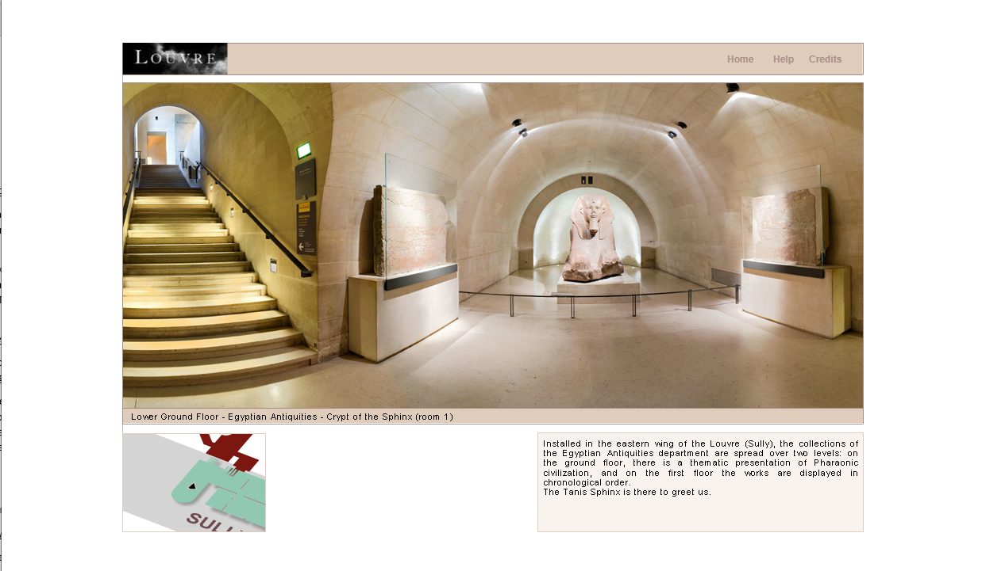
Bad Example
- Poor camera quality
- No ability to zoom in
- No information overlaid on the page
- Slow and clunky to use
- Area of view is not big enough on the web page. A lot of unnecessary white space around the view.
This exhibition is the Exhibition Antiquities virtual tour which has been chosen as a bad example to contrast the previous analysed exhibition. This exhibition can also be found at the Louvre Museum in Paris, France.
The overall feel of this virtual tour and application is very different to that of the previous analysed application. One of the most obvious differences is the way in which the application is presented on the page to the user. In this example, the content area Is limited to the centre of the page, and the whole application is surrounded by white space. This brings a limited feeling to the movement and immersion of the application.
The presentation of relevant information throughout the application is limited, with no information overlay, but instead a separate text box being presented under the application. Iconography and metaphors are not used effectively throughout the application which presents a problem from a user understanding perspective.
Overall, the application seems as if less care has gone in to the process of design according to clear usability guidelines laid out by relevant academics like Alan Dix.
Comparison
Founding Myths: From Hercules to Darth Vader | Egyptian Antiquities
Interactive | Poor camera quality
Good camera quality | No ability to zoom in
Relevant information overlaid exhibits | Information is presented in text box below application, effecting immersion
Ability to move throughout exhibition | Slow and clunky when moving the camera, no ability to change position in exhibition
Camera can be easily panned and zoomed | Area of view is not big enough, too much white space surrounding application
Metaphors and iconography used throughout | Metaphors and iconography not used effectively throughout

The outlined exhibitions, both of which are found at the Louvre museum in Paris, have their positives and negatives. But when comparing both, it is evident that the Founding Myths exhibition is clearly a better designed and developed virtual museum experience.
One of the most noticeable differences between the two exhibitions is the quality of camera used. Founding Myths uses a wide-angle lens at a high resolution which displays well across a full page or large monitor. On the other hand, the Egyptian Antiquities camera is clearly inferior as well as being limited by the dimensions of the application on the web page. This is important as vision is a key human sense which will receive a large percentage of the feedback when using a system like a virtual museum tour.
The interactivity of both virtual experiences has stark differences. The Found Myths application encourages users to pan the camera around and zoom in and out of artifacts. Iconography is used effectively to encourage the user to click elements on the page to read more information. The external relevant information is synthesized effectively with the experience of panning and zooming, both of which make you feel like you are immersed in the exhibition.
The Egyptian Antiquities exhibition offers far less interactivity. There is no ability to zoom in and out of the artefacts you are viewing, as well as having no ability to move around the exhibition. Rather than information being integrated into the exhibition images, the information is presented below the images, which does take away from the immersion slightly when using the virtual tour.
Dix mentions the need for applications to feel familiar [3]. He says that users often come with a wealth of experience using systems, this is important when it comes to considering the overall expectations when using an application. This is also mentioned by other scholars in the Usability field, one of Ben Schneiderman’s key rules is that developers must “understand and meet user’s expectations” [4].
From a personal perspective, the outdated nature and overall lack of visual quality make the Egyptian Antiquities exhibition feel unfamiliar. The Founding Myths contrasts that feeling by presenting what has become the normal for modern applications - high quality imagery, smooth animations and navigations tools, information integration, and an overall higher feeling of immersion.
Both virtual museum experiences offer a certain degree of immersion, and both fundamentally meet the core functionality. But through comparison it is evident that the Founding Myths exhibition suggests more thought has gone into user interface design principles, as outlined by Alan Dix.
Improvements
There are clear improvements which could be made to the Egyptian Antiquities virtual display. This area will look to make some basic suggestions which could work to improve the overall quality of the applications. These suggestions are made with the work of Alan Dix, Jacob Nielsen, Donald A.Norman and Ben Schneiderman all being considered.
The first major improvement that cold be made to the Egyptian Antiquities exhibition is how the content is presented on the page. As mentioned earlier, the content for this exhibition has a limit and is centred in the page, resulting in large amounts of white space. Removing this white space and having the application fill the whole page could work to improve the immersion of the exhibition.
Donald A. Norman outlines the important of visibility within an application [5]. Norman says that it is important that functions of the systems are as visible as possible. For this reason, it is suggested that the relevant exhibit information is overlaid throughout the application to make for better visibility of features and information.
The use of metaphors and iconography is not prevalent through the Egyptian Antiquities virtual display and is an area which should be expanded. This links in Norman’s studies on visibility, as metaphors and iconography could be used to overlay information in the application.
The final suggestion for improvements is the implementation of better functions for operating the camera. As mentioned previously, the Egyptian Antiquities does not utilise zoom, pan and movement options for navigating through the exhibition. For this reason, a major improvement would be the implementation of a navigation system which allows users to zoom in and out of exhibits, pan around, and move the camera around the room.
It is evident that the Egyptian Antiquities virtual display has room for improvement, the very basic ideas laid out in this section should go some way towards improving the overall quality of the application.
Interface Evaluation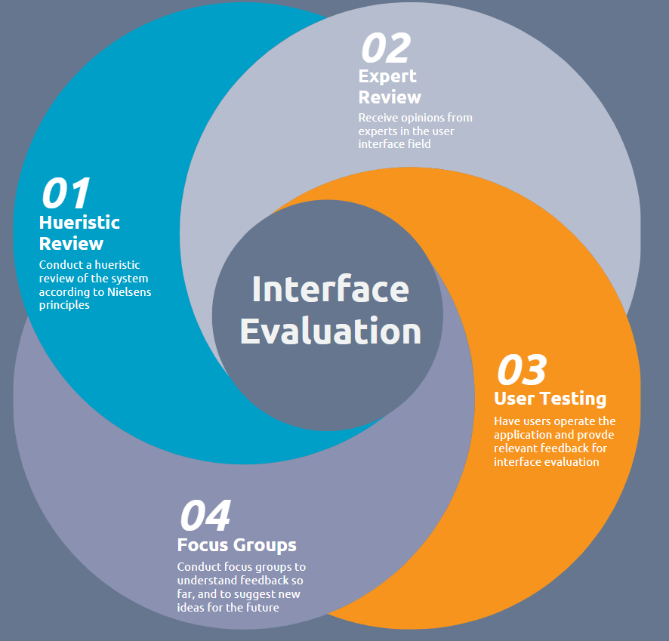This section will look to discover and develop an interface evaluation. A step by step process will be outlined which will determine how well an interface has been designed, developed and deployed. An interface evaluation is very similar to a code review, in that it inspects to application to determine the success of the implemented features. Rather than reporting on bugs, an interface evaluation will look to determine the quality and usefulness of interface features.
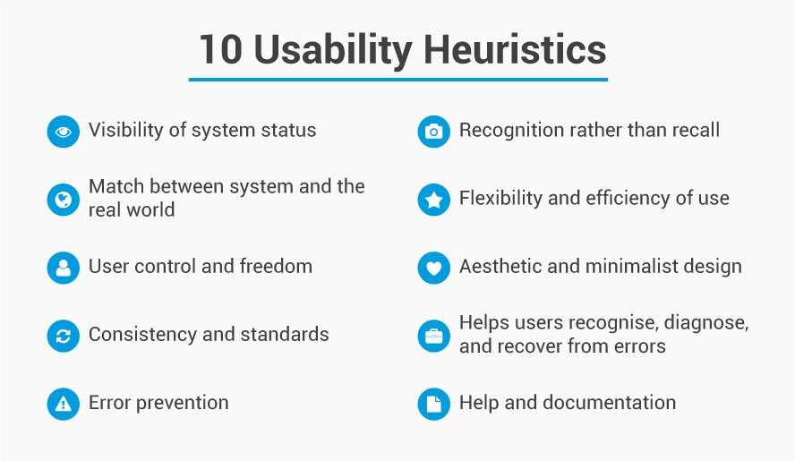
A Heuristic evaluation [6] on is extremely popular for determining how effectively an interface implementation has been.

[7]

The usability heuristics outlined by Jakob Nielsen will provide a solid basis for providing comparisons. In this interface evaluation, the Egyptian Antiquities exhibition will be compared with Nielsens rules to determine if the system effectively deploys heuristic techniques.
Egyptian Antiquities Heuristics Review
Usability Heuristics | Review Notes
Visibility of system status
Match Between system and the real world
User Control and freedom
Consistency and standards
Error prevention
Recognition rather than recall
Flexibility and efficiency of use
Aesthetic and minimalist design
Helps users recognise, diagnose and recover from errors
Help and documentation

Expert Review
Expert reviews are usually used to expand on the conclusions gathered from the heuristic evaluation step as laid out in the previous section. This is the process of gathering valuable insight from a professional within the field. Expert reviewers bring a wealth of knowledge and experienced which can be utilised to improve the quality and usability of an application. Experts are well equipped to understand exactly what users expect and how they act when using an application. The standard method for conducting an expert review Is for the reviewer to extensively use the system, view previous information from heuristic evaluations, and then provide expert feedback in the form of a document. [8]
https://www.nngroup.com/articles/ux-expert-reviews/
User Testing
User testing Is a key part of the evaluation as it allows for developers to understand how users will act while using the application. Users will often use features differently than the developer intended, so it is important that these are identified, and any fixes or changes are implemented. Gathering a varied group of users with differing technology proficiency is ideal for gathering the most varied and useful results. Once user testing is done, evaluation documentation should be produced by user to give valuable and useful feedback for further iterations of the application. [9]
Focus Group
The final stage of the proposed Interface Evaluation Plan is to conduct focus groups. Focus groups are useful not only for gathering feedback on the current state of the application, but also for suggesting new ideas for features or changes in the future. Focus groups can also be used at the beginning of the development life cycle to develop new features. In this case, the focus groups would be more suited to providing evaluations and suggestions for new features in further iterations. [10]
Conclusion
All the combined proposed methods are industry standard and tested means of producing effective user interface evaluations. The combination of these methods makes for a logical, well thought out and effective interface evaluation solution.

Guidelines and Accessibility
It is essential that web applications can be accessed by everyone, no matter their hardware, software, location or disabilities. The responsibility falls on all developers to implement accessibility functionality into applications. To do this, developers can refer to industry standard guidelines which outline the steps to take to develop accessible applications.
The World Wide Web Consortium, also known as W3C, are an organisation which “develop open standards to ensure the long-term growth of the Web”[11]. W3C run a Web Accessibility Initiative which outlines key accessibility guidelines. Below are a few examples which would be relevant to museum exhibits such as those outlined in this report so far.
Alternative Text for Images
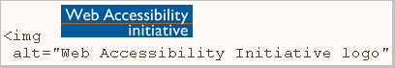[12]
When programmers are coding applications it is important that alternative text tags are used. This allows screen readers to scan the code and find alt tags, allowing the system to give a description of images to those who are unable to adequately see.
Keyboard Input
Not all users are able to use a mouse effectively, to combat this, developers can develop applications using inputs which do not lean on fine-motor skills as much as a mouse does. Navigation can be implemented in the application without the use of a mouse, using arrow keys and shortcuts on the keyboard.
Transcripts for Audio
Providing transcripts for portions of the application which rely on audio is essential to those who are unable to hear. This can be done in the form of subtitles over a video, or a document transcript with context being provided alongside the audio content.
Code Structure
It is important that developers utilise adequate coding structure when programming applications which are to be used by the public. Screen readers systematically work through each element in a web page, one-by-one. For this reason, it is important that code is logically built with accessibility in mind.
Users have enough time to read/use content
People consume media at differing rates and it is an important factor to consider when developing a system. If a slideshow is being used to convey information, then users should have enough time to comprehend and understand the information that is being presented on the screen.
Conclusion
All the outlined accessibility guidelines are found within The World Wide Web Consortium’s Web Accessibility Initiative guidelines. These guidelines should be considered by developers and designers of museum exhibits, to ensure that exhibits are accessible to all of those in society. Adequately adhering to the guidelines outlined in this section will result in an application with research and considered accessibility functionality.

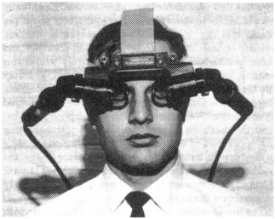
Virtual Reality

What is VR
Perhaps a fact that is surprising to many is that virtual reality is a technology which was initially studied thoroughly over 50 years ago. Virtual reality is a technology which has only hit the consumer market in the last decade, despite this, Ivan E. Sutherland detailed a “head-mounted three-dimensional display” in an academic paper for the University of Utah in 1968. [13]
[14]
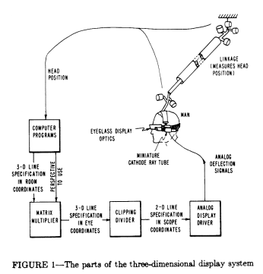
Sutherland outlined the idea behind a three-dimensional display which presents the user of the device with an images which moves as the user moves, appearing three dimensional. Sutherlands paper was more of a theory than technological jump, but despite this, Sutherland still made technology recommendations which are used today.
Sutherland outlined the need for “eyeglass display optics”, computer programs to intercept the display data and a means for tracking the head position of a user. All of these concepts are now used in commercial virtual reality systems. Much of the suggested ideas from Sutherland’s work in his 1968 paper for a foundation for technology that is used today.

Virtual Reality Museum Exhibit Proposal
The following section outlines a proposed virtual realist museum exhibit based around Welsh heritage. The usability guidelines outlined throughout this document will form the basis for an effective solution.
Virtual Mine Shaft Experience
The proposed idea is for a virtual reality mine shaft experience. The user is sat into a simulation device with the ability to provide movement and sound. Users are also provided with a virtual reality headset. The simulation device emulated the experience of travelling on a mine card deep in Welsh mines. The user can move their head around and explore each area of the mine. Relevant exhibition information is show to the user as they travel along the mine cart track. Users feel the movement of the track through the simulation device, bumping and turning through the mine shaft.
Simulation Device
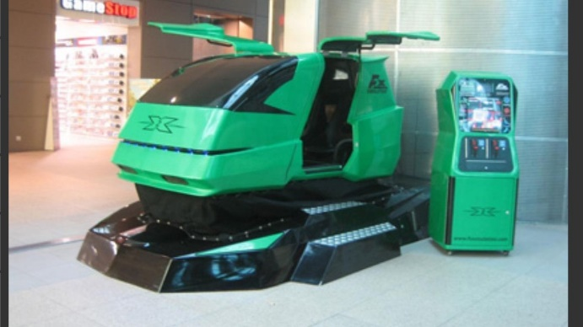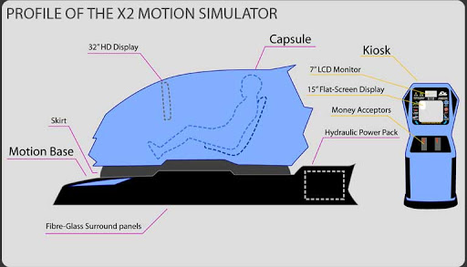
This is the X2 Motion Simulator [15] which provides all of the functionality requited to implement the proposed exhibit. Rather than utilising the 32” HD display provided with the X2 Motion Simulator, a virtual reality headset would be used instead. This increases the immersion aspect of the experience.
It is important to consider accessibility in an exhibit like this. The motion simulator lacks wheelchair access, so an alternative experience using a motion simulated chair which is not enclosed could be explored. Audio descriptions of the information overlaid throughout the experience will add another layer of accessibility to users who have difficulty with vision.
Visual Experience Example

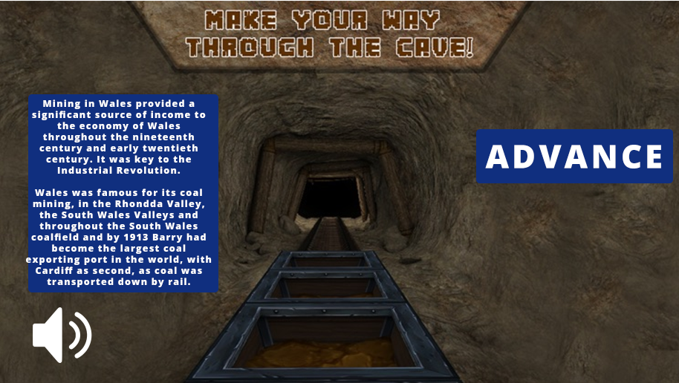

Conclusion
All parts combined, the audio from the simulator and virtual reality headset, the visuals from the headset, the feel of motion simulator, provide a usable well thought out exhibit. There are still accessibility issues to be addressed, but the proposed application provides a solid starting platform for a virtual reality museum exhibit. Further development would look to identify more areas which could be improved from both an accessibility standpoint, and a usability standpoint. Drawing off the information laid out by valuable scholars in the field, the proposed application adequately satisfies usability guidelines.

References
1. Découvrez la petite galerie du musée du Louvre [Internet]. Louvre.fr. 2015 [cited 2020 May 17]. Available from: https://petitegalerie.louvre.fr/visite-virtuelle/saison1/
‌2.Panoramas | Musée du Louvre [Internet]. Louvre.fr. 2020 [cited 2020 May 17]. Available from: http://musee.louvre.fr/visite-louvre/index.html?defaultView=rdc.s46.p01&lang=ENG
‌3. Human-Computer Interaction. Alan Dix, Janet Finlay, Gregory D.Abowd, Russel Beale. Principles to support usability. Page 271. [cited 2020 May 17].
4​ . Research-Based Web Design & Usability Guidelines. Design Process Page 3. Ben Shneiderman. 2007. [cited 2020 May 18]
5. The Design Of Everyday Things. Donald A. Norman. Preface. Page 8. [cited 2020
Mar 26]
6. Reading 17: Heuristic Evaluation [Internet]. Mit.edu. 2018 [cited 2020 May 19]. Available from: http://web.mit.edu/6.813/www/sp18/classes/17-heuristic-evaluation/

‌7. How to Conduct a Heuristic Evaluation for Usability in HCI and Information Visualization [Internet]. The Interaction Design Foundation. UX courses; 2016 [cited 2020 May 19]. Available from: https://www.interaction-design.org/literature/article/how-to-conduct-a-heuristic-evaluation-for-usability-in-hci-and-information-visualization
‌8. UX Expert Reviews [Internet]. Nielsen Norman Group. 2018 [cited 2020 May 19]. Available from: https://www.nngroup.com/articles/ux-expert-reviews/
‌9. Unmoderated User Tests: How and Why to Do Them [Internet]. Nielsen Norman Group. 2019 [cited 2020 May 19]. Available from: https://www.nngroup.com/articles/unmoderated-usability-testing/
‌10.Focus Groups in UX Research: Article by Jakob Nielsen [Internet]. Nielsen Norman Group. 2020 [cited 2020 May 19]. Available from: https://www.nngroup.com/articles/focus-groups/
‌ 11. About W3C [Internet]. W3.org. 2019 [cited 2020 May 20]. Available from: https://www.w3.org/Consortium/
‌12. Accessibility - W3C [Internet]. W3.org. 2014 [cited 2020 May 20]. Available from: https://www.w3.org/standards/webdesign/accessibility
13. A head-mounted three dimensional display. Ivan E.Sutherland. The University of Utah. Page 1. Available from: https://www.cise.ufl.edu/research/lok/teaching/ve-s07/papers/sutherland-headmount.pdf
14. A head-mounted three dimensional display. Ivan E.Sutherland. The University of Utah. Page 3. Available from: https://www.cise.ufl.edu/research/lok/teaching/ve-s07/papers/sutherland-headmount.pdf
‌15. FX Simulation (UK) Ltd – Manufacturers of the X2 Simulator, The World’s Leading Coin Operated 2 Seater Motion Simulator [Internet]. Fxsimulation.com. 2020 [cited 2020 May 20]. Available from: http://www.fxsimulation.com/

