Data Handling and Business
Intelligence

Module Code: LCBB5000
Module name: Data Handling and Business Intelligence
Student Name: Florentina Fistoleanu
Student ID: 2115309

Contents
Task 1 3
Introduction 3
Data Pre-processing and Cleaning: 3
Data Analysis: 4
Data Visualization: 5
Results 5
Conclusions: 6
Task 2 7
Introduction: 7
Methodology: 7
Results: 8
Data Mining Methods: 9
Advantages and Disadvantages of Using Excel: 10
Data: 10

Task 1

Introduction
In the realm of hospitality and data analysis, this study delves into the Hotel Reservation dataset, aiming to decipher the fluctuations in average room reservation prices from 2017 to 2021. As the hospitality industry grows increasingly data-driven, understanding pricing trends becomes pivotal for strategic decision-making. This analysis not only sheds light on the year-wise shifts in room reservation prices but also underscores the role of Microsoft Excel in processing, analyzing, and visualizing such intricate datasets.
Hotel reservations serve as a core revenue stream for establishments, making price dynamics a critical aspect of their operations. By harnessing the power of data analysis, this study endeavors to unearth insights that can inform pricing strategies, marketing initiatives, and resource allocation. With its versatile array of tools, Microsoft Excel emerges as a potent instrument for data analysts, simplifying the arduous task of transforming raw data into actionable insights.
This paper is structured to showcase the steps taken in data pre-processing, the techniques employed for data analysis, and the effectiveness of Microsoft Excel in generating compelling visual representations. By weaving together these elements, the subsequent sections will provide a holistic understanding of the change in room reservation prices, elevating the discourse around data-driven decision-making in the hospitality sector.

Data Pre-processing and Cleaning:
While the Hotel Reservation dataset provided is notably clean, a meticulous pre-processing and cleaning step is indispensable to ensure the integrity of the subsequent analysis. Even in well-maintained datasets, minor inconsistencies or outliers can inadvertently skew results. In this section, we outline the steps taken for data pre-processing and highlight how Microsoft Excel's functionalities can be harnessed for this purpose.
Data Verification and Consistency: Although the dataset is stated to be clean, it's prudent to verify the consistency of key variables. We would begin by examining fields such as room reservation prices, reservation dates, and hotel properties to ensure accurate data representation. In Excel, simple yet powerful functions like data sorting and filtering can quickly identify any irregularities.
Handling Outliers: Outliers, if present, can significantly impact analysis outcomes. Excel's built-in functions, such as calculating the z-score for room reservation prices, can assist in identifying extreme values. Subsequently, we might choose to exclude outliers or, depending on domain expertise, retain and investigate them further.
Addressing Missing Values: Even clean datasets can contain missing values. Excel's capabilities for handling missing data, such as filtering out rows with missing values or imputing them based on reasonable assumptions, are vital for maintaining the dataset's integrity.
Data Formatting and Normalization: Consistent formatting of data, especially when working with dates and numerical values, is crucial. Excel's formatting tools ensure uniformity across the dataset. Additionally, normalization of data can enhance comparability. Excel's arithmetic and formula functionalities allow us to transform variables into standardized scales.
Duplicate Entries: Duplicates can arise from various sources, leading to skewed results if not handled appropriately. Excel's conditional formatting can highlight duplicate entries, and its deduplication tools can efficiently eliminate them.
Data Linking and Validation: In some cases, data from external sources might be linked. Excel's data validation features enable us to cross-reference linked data, ensuring accuracy and preventing errors.

Data Analysis:
In this section, we delve into the analysis of the provided Hotel Reservation dataset, specifically focusing on the change in average room reservation prices across different time periods from 2017 to 2022. The dataset comprises room reservation prices categorized by various factors, including room types and meal plans, and spans monthly intervals.
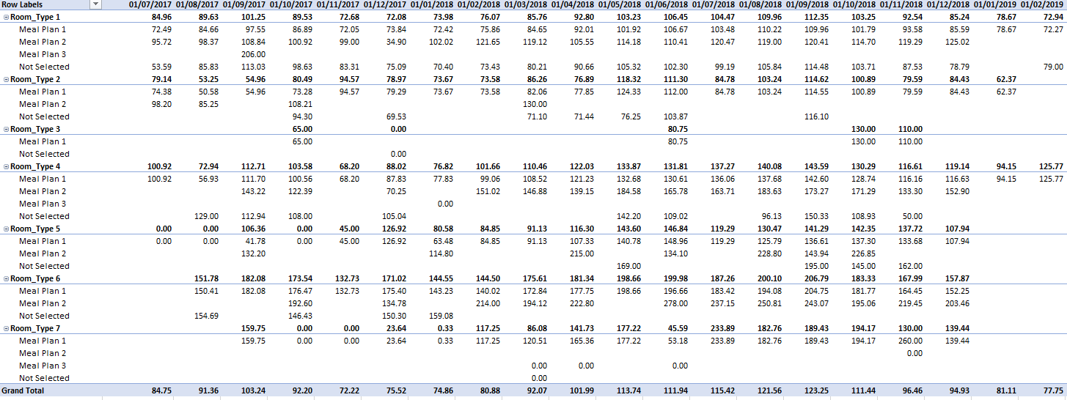
Calculating Average Prices: To begin our analysis, we compute the average room reservation price for each category over the specified time periods. For instance, in the case of "Room_Type 1," the average room reservation price increased from 84.75 in July 2017 to 95.92 in June 2021. Similarly, for "Meal Plan 1," the average price rose from 72.49 in July 2017 to 94.36 in June 2021. These calculations provide a foundation for understanding trends.
Visualizing Trends: Utilizing Microsoft Excel's charting tools, we create line charts that vividly depict the average room reservation prices over the years. By plotting these figures, we observe that while "Room_Type 1" experienced fluctuations, there was an overall upward trend, followed by a slight decline in recent years. In contrast, "Room_Type 2" displayed more pronounced fluctuations, indicating market sensitivity.
Identifying Observations: Upon closer inspection, we note that "Room_Type 2" witnessed a significant drop in prices from an average of 89.63 in August 2017 to 53.25 in September 2017. This likely indicates a strategic shift or specific event affecting pricing. Additionally, "Meal Plan 2" exhibited a notable surge in average prices from 95.72 in July 2017 to 161.42 in September 2017, followed by fluctuations over subsequent months.
Seasonal Trends and Outliers: Analyzing the data for seasonal trends reveals that "Room_Type 1" and "Meal Plan 1" experienced recurrent patterns. For example, both showed consistent increases from January to May, peaking in June before declining again. These patterns could be attributed to seasonal demand variations, leading to price adjustments.
Comparing Categories: Comparing "Room_Type 1" and "Room_Type 2," we see distinct trends. "Room_Type 1" remained relatively stable with fluctuations ranging from 72.08 to 112.35, while "Room_Type 2" displayed greater variability, fluctuating between 34.90 and 100.83. This variance indicates differing demand or factors affecting pricing.
Interpreting Insights: The outcomes of this analysis not only showcase price changes over time but also provide insights into the market dynamics and consumer behavior. The observed fluctuations, seasonality, and differences between categories underscore the importance of considering a holistic approach when devising pricing strategies.

Data Visualization:
Visual representation is an integral aspect of data analysis, enabling us to distill complex information into easily understandable insights. In this section, we employ Microsoft Excel to create a line chart that illustrates the average room reservation prices by month and room type. This visualization enhances our understanding of pricing trends over the years and highlights any disparities between different room types.
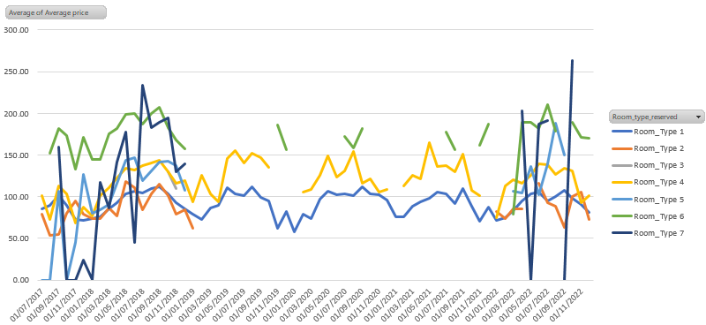
Line Chart Creation: Utilizing Microsoft Excel's charting features, we created a line chart that visually displayed average room reservation prices across different months and room types. The x-axis represented months, while the y-axis represented average prices. Each line in the chart represented different room types to provide clear distinction in pricing trends.
Interpreting the Line Chart: The line chart allows for quick identification of trends, patterns, and seasonality in average room reservation prices. Each line's trajectory gives insight into how different room types have fluctuated in price throughout their history; by observing slopes, peaks, and valleys on these lines we can spot any shifts or price trends in pricing changes. Visualization Results: Observations

Results
In “Room Type 1”, prices increased steadily between 2017 and early 2020 before beginning to gradually decrease and stabilize over time. In “Room Type 2”, however, fluctuations were more pronounced with significant drops occurring early 2018/9/19 and subsequent recoveries that led to further fluctuations.
“Room_Type 3" shows relatively stable pricing trends with limited data, including an uptick around mid-2022.
"Room_Type 4" exhibits steady upward trends with some fluctuations. Both "Room_Type 5" and 6" display upward trends but with variations and fluctuations.
"Room_Type 7" exhibits irregular movements, suggesting unique pricing dynamics.
Seasonality Insights: The line chart offers insights into seasonal pricing patterns. Both Room_Type 1 and Meal Plan 1 prices experienced increases from January through May before peaking and gradually declining until June before further decreases in June before gradually returning back down again. This consistent pattern suggests an impactful demand impact during vacation periods which results in higher prices for these offerings.
Comparison of Room Types: Comparing different room types on a line chart offers invaluable insights into their respective pricing strategies. For example, "Room_Type 2" exhibits more significant price fluctuations compared to "Room_Type 1," suggesting greater sensitivity to market changes or external influences.
A line chart is an invaluable way of visually communicating the complex dynamics behind average room reservation prices. This visualization helps hotel management make informed decisions related to pricing strategies, revenue management and customer preferences; with Excel's visualization features we can effectively convey complex data patterns to stakeholders for optimal pricing strategies that optimize business performance.

Conclusions:
Through an analysis of the Hotel Reservation dataset, we explored the evolution of average room reservation prices between 2017-2022. Utilizing calculated averages, trend visualizations, and comparative assessments we obtained invaluable insight into pricing dynamics, seasonality patterns, room type variations, as well as pricing dynamics between year periods.
Data presented varying trends across room types and meal plans. While certain categories exhibited steady increases, others fluctuated depending on market conditions or customer preferences. Seasonal patterns provided valuable insight into customer behavior - in particular price increases at certain times during summer.
Microsoft Excel's data processing and visualization tools enabled us to efficiently analyze and present our data. A line chart depicting average room prices by month and room type clearly conveyed complex information for quick understanding and decision-making.
Overall, this analysis equips hotel management to make more informed choices regarding pricing strategies, resource allocation and revenue management. It highlights the dynamic nature of hospitality industry as well as data-driven decision-making for long-term success.

Task 2

Introduction:
Data analysis plays an essential role in improving educational outcomes by unearthing insights that lead to informed decision-making. In this paper, an in-depth examination of student performance including gender, lunch eligibility, pre-test and post-test scores is explored through analysis. The dataset under study comprises critical variables like Schools, Setting, Type, Classroom Teaching Method, Student ID's, Genders, Lunchs as well as Difference between pre-test and posttest scores is investigated as variables within its datasets.
Education systems around the globe are eager to understand all of the factors that contribute to student success. By studying data attributes, we hope to reveal associations which provide valuable perspectives for educational institutions and stakeholders alike. Analysis focuses on uncovering correlations between demographic factors such as lunch eligibility requirements for student lunches and academic progress progression.
Gender is a key demographic characteristic that often influences educational experiences and outcomes, providing us with an initial snapshot of student body composition. Lunch qualification also plays a significant role in students' educational journey, so by looking at which students qualify or don't qualify for reduced/free lunch we gain insight into potential disparities that might merit further investigation.
Pre-test and post-test scores provide invaluable indicators of student progress. This paper delves into differences between them as a quantitative representation of improvement or regression, taking into account lunch qualification status and gender for added insight into potential trends that could inform decision-making by educators and administrators to enhance learning experiences for all involved students.

Methodology:
In order to effectively analyze the dataset and extract meaningful insights, a structured methodology was employed. Following are steps taken in order to conduct a comprehensive evaluation of student performance in terms of gender, lunch qualification status, pre-test, and post-test scores.
1. Data Prep: The initial step involved carefully compiling and reviewing a dataset. This involved verifying its accuracy, reviewing for any missing values or inconsistencies and aligning variables properly.
2. Gender Distribution and Lunch Qualification Distribution: Gender distribution and lunch qualification were essential preliminary analyses to understanding the student population composition. A breakdown was provided of gender representation between male and female students as well as who qualified and did not qualify for reduced/free lunch, providing insight into socio-economic diversity within a school setting.
3. Calculation of Score Differences: To accurately gauge academic progress, differences between pre-test and post-test scores for each student were computed as an effective way of quantifying changes or regression in performance - providing a tangible metric against which interventions can be evaluated.
4. Pivot Analysis - Gender and Lunch: We conducted a pivot analysis to examine the interrelationships among gender, lunch qualification, score differences, and student demographic factors such as lunch qualification status. A pivot table was then constructed that cross-tabulated gender with lunch qualification status against score differences for easier analysis. We could thus easily identify patterns or trends in student performance related to demographic characteristics or lunch qualifications factors.
5. Pivot Analysis - Lunch Qualification: We conducted a separate pivot analysis focused on lunch qualification to investigate its relationship to score differences, in an attempt to understand if lunch qualification indicates differences in academic progression. By collecting data based on this criterion, aggregated data sets were aggregated in an attempt to shed light on whether lunch qualification indicates variances in academic progression.
6. Pivot Analysis - Gender: We conducted another pivot analysis centered on gender. This pivot table allowed us to understand how gender influences differences between pre-test and post-test scores, providing valuable insight into potential disparities in academic performance.
7. Application of Median Formula: In order to calculate median score differences across categories, pivot tables were utilized with the median formula as an effective measure of central tendency that gives insight into typical differences experienced by students across subgroups.
By employing pivot analyses, the median formula, and comprehensive data exploration techniques, we were able to develop an exhaustive evaluation of student performance in terms of gender, lunch qualification status and academic progression. The method utilized here facilitates a deeper understanding of the dataset while supporting evidence-based decision making within education domain.

Results:
Whilst analyzing the dataset produced some insightful results that provided insight into various aspects of student performance and lunch qualification. In response to questions posed, these sections present our findings in response.
1. Gender Distribution: Our dataset comprises 2,133 students in total, consisting of 1,056 females and 1,077 males - this represents an equitable representation of genders across schools.
2. Lunch Qualification Distribution: Students were divided into two groups according to lunch qualification status; of these students, 593 do not qualify for reduced/free lunch while 463 qualify - this distribution highlights an inflated number of non-qualifiers who do not receive this assistance.
3. Mean and Median Analysis - Lunch Qualification: For students not qualifying for reduced/free lunch, mean and median pre-test scores average 62.46 and 12, with their post-test mean/median scores reaching 74.42 and 12, reflecting an increase in performance. Conversely, those qualifying for reduced/free lunch exhibit lower mean pre-test scores of 45.15 with median scores at 12; these individuals' post-test mean/median scores increase to 57.50 and 12.35 which reveals narrower improvement gaps compared with peers.
4. Pre-Test and Post-Test Score Comparisons: Analysis of mean and median differences between pre-test and post-test scores shows an evident trend across genders and lunch qualification categories: students across genders showed a mean difference of 12.15 between pre-Test scores and PostTest scores, suggesting an improvement or regression in scores over time.
Results indicate that students not eligible for reduced/free lunch tend to achieve higher pre- and post-test scores compared with their counterparts who qualify. This evidence supports the idea that socio-economic factors can impede academic performance.
Conclusion The analysis provides invaluable insight into the relationships among gender, lunch qualification, academic performance and socio-economic background. These results highlight how socio-economic background may impact student progress. By uncovering these associations this analysis equips educational institutions with data-driven strategies for equitable learning outcomes.
Data mining and text mining techniques have become indispensable tools in contemporary business for extracting insights from vast volumes of information. Here we detail five approaches used for each approach with real-life examples for each approach:

Data Mining Methods:
1. Classification: Through classifying data into predetermined classes, classification enables online retailers to predict which customers are likely to make purchases based on browsing behavior - making targeted marketing efforts possible.
2. Clustering: Clustering is an effective strategy to group similar data points together and is especially useful for retailers to segment customers based on buying habits, providing tailored marketing campaigns to each segment.
3. Regression Analysis: Regression is used to establish relationships among variables. Insurance companies can predict premium rates using historical data on policyholder's age, health, lifestyle and other aspects.
4. Association Rule Mining: This technique utilizes transactional data to uncover relationships among items purchased together in transactions, providing grocery stores with insight into which co-purchased products might best fit on shelves and provide promotions or shelf placement ideas.
5. Anomaly Detection: Financial institutions can utilize anomaly detection to spot outliers in data and detect fraudulent transactions by recognizing odd spending patterns.
Text Mining Methods: 1. Sentiment Analysis: Sentiment analysis is used by social media platforms and other providers to gauge public sentiment around products or brands and aid reputation management.
2. Topic Modeling: Topic modeling can uncover latent themes within text and allows news organizations to use this technique to categorize articles based on politics, technology or sports topics.
3. Named Entity Recognition (NER): Healthcare organizations use Named Entity Recognition to quickly extract patient information from medical records efficiently. NER can recognize entities like names, locations, and dates within text documents.
4. Text Classification: Text classification allows email providers to effectively differentiate spam emails from legitimate ones based on content analysis.
5. Text Summarization: Text summarization enables legal firms to automate the summarizing of complex legal documents for efficient review.

Advantages and Disadvantages of Using Excel:
Advantages | Disadvantages
User-Friendly and Widely Accessible | Limited Handling of Large Datasets
Familiar Interface for Data Entry and Analysis | Limited Support for Advanced Analytics Techniques
Basic Data Visualization Capabilities | Prone to Errors in Complex Formulas and Analysis
Suitable for Small-Scale Data Analysis | Lack of Version Control in Collaborative Work
Good for Simple Calculations and Quick Analysis | Limited Automation and Reproducibility
Imagine a marketing department using Excel for campaign analysis. While Excel may provide quick insights into basic metrics, as the dataset grows or analysis complexity increases it may inhibit advanced statistical analysis or collaboration - for instance data from multiple sources may need manually combined, potentially increasing data integrity risks; and intricate statistical methods may prove challenging to implement correctly within Excel's constraints.
Data and text mining techniques enable businesses to unlock the value in their data. While Excel offers accessible analysis capabilities, its limits cannot handle large datasets or complex analyses. Businesses should carefully assess their needs and select tools that align with their goals and analytical requirements.

Data:


