Last liberation movement of Mongolia in the 20th century (HPAN 5020, essay outline)
How democracy was born in Mongolia
Mongolia is a modern democratic country with rich history, locating in East Asia. To reach to the point where the state of democracy is held in its governmental sphere, Mongolia had many turnouts in the 20th century. In which Mongolia has gone through 3 different constitutions and the fourth being the one that guarantees democracy to the people since 1992. My main written work will focus on the last change in which Mongolia became a democratic country from a socialist country. Even though the modern constitution came into power in 1992, the change of becoming a democratic country had started at the end of 1989, led by mostly dissidents who had studied abroad at the time. Therefore, the aim of my essay will be analysing the liberalisation and movements of Mongolia in the period of 1989 to 1992.
To delve deep into the liberation movement, we must begin with the history of Mongolia in the early 20th century. Mongolia became a socialist country in 1924. It was a satellite state of the USSR. Therefore, there was a soviet military base in Erdenet, Mongolia. For that reason, the liberation movement has started in Erdenet on the 6th of December 1989, demanding the authorities in the city to get the Soviet Soldiers out. Around the same time in Khovd city, the teachers and students of higher education institute were protesting peacefully for the resignation of the entire communist government. Three days later after that in the Capital city Ulaanbaatar, Mongolian Democratic Union, led by Zorig Sanjaasuren, did its first meeting on December 10, 1989, called for establishing a multi-party system, respecting human rights, holding early general election in the first half of 1990, acquitting the oppressed, and guaranteeing freedom of the press. By setting total of 13 such demands, it was announced that the democratic revolution had begun in Mongolia (B.Dulguun, 2015).
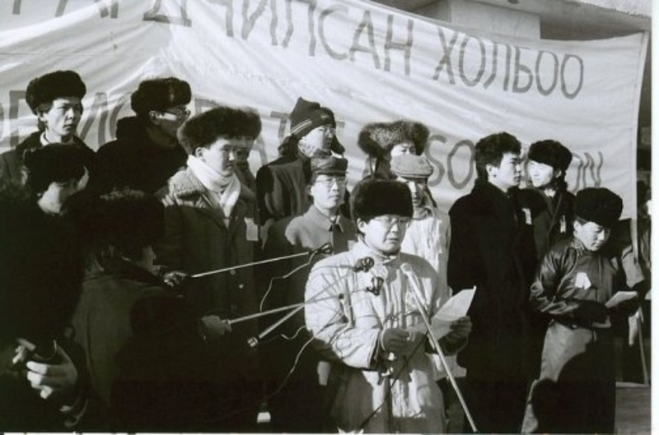
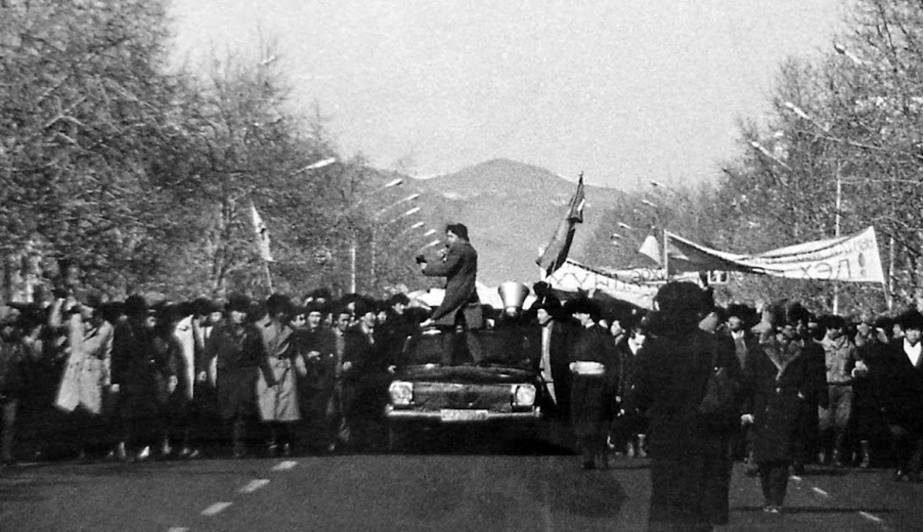
The key questions I would like to answer in my essay are as follows;
- How the democratic revolution started? Led by who? What was the first demands?
- How did the movement leaders negotiate with the government officials? How did the government officials approach to the movement? Had any of the demand been met?
- Did the demands come into reality? In other words, Mongolia after the movement.
Personally, it has always been fascinating to wonder how the government officials approach to the liberation movement. It is obvious that the officials had a notion of democratic movements that was happening in the other socialist countries, particularly in the east Europe. One of the leaders of the democratic revolution, Elbegdorj Tsahia, had studied journalism in Lviv, Ukraine. Therefore, both sides must had an idea of what was happening around the world. Probably, that was the reason why the democratic revolution has not endured any blood. I will try to answer for this question without a probability in my essay. However, I would like to note here that Elbegdorj Tsahia became Prime Minister and President, whereas Zorig Sanjaasuren was killed on October 2, 1992, after the first democratic parliament was formed in Mongolia. The second of October is now Remembrance Day in Mongolia.
The primary source of the essay will be the official website for history of Mongolia (https://mongoltoli.mn). Also, it will be used with the websites of Ikon (Mongolian online news agency, https://ikon.mn) and International Republican Institute (IRI, https://www.iri.org) as the secondary sources.

