

Course Title: MBA - International Business

Term 2

Student Name: Vishal Ramjibhai Bhalala

Student ID: 2509170

Module Name: International Business Concepts

Module Code: LCMB7034

Lecturer’s Name: Akshay Narayanan

Work Count: 5381/5000

Table of Contents
Section 1 - International Industry and Business Analysis 6
1. Introduction 6
2. Industry and Country Overview 6
a. Introduce the Selected Industry within the Context of Vietnam 6
a.1 Overview of Vietnam’s Economic Environment 6
a.2 Development of the Electronics Manufacturing Industry in Vietnam 8
a.3 Role of Foreign Direct Investment (FDI) in Industry Growth 9
a.4 Vietnam’s Position in the Global Electronics Supply Chain 10
b. Size, Scope, and Economic Importance of the Industry 10
b.1 Size of the Electronics Manufacturing Industry 10
b.2 Contribution to Vietnam’s GDP and Export Economy 11
b.3 Employment Generation and Industrial Development 11
c. Major Firms and Competitive Positioning in the Electronics Industry 11
c.1 Major Domestic Electronics Firms in Vietnam 11
c.2 Major Multinational Corporations Operating in Vietnam 12
c.3 Competitor Analysis of Key Firms 13
c.4 Market Segmentation and Strategic Positioning 14
c.5 Comparative Performance of Leading Companies 16
3.Global Competitiveness Analysis using Porter’s Diamond Model 16
3.1 Overview of Porter’s Diamond Model of National Advantage 16
3.2 Factor Conditions in Vietnam 18
3.2.1 Labour Availability and Cost Advantages 18
3.2.2 Infrastructure and Technological Capabilities 19
3.3 Demand Conditions in Vietnam 19
3.3.1 Domestic Market Demand for Electronics 19
3.3.2 International Export Demand 20
3.4 Related and Supporting Industries 20
3.4.1 Supply Chain Networks 20
3.4.2 Supporting Manufacturing and Technology Industries 21
3.5 Firm Strategy, Structure and Rivalry 21
3.5.1 Competitive Strategies of Firms 21
3.5.2 Industry Rivalry and Competition 22
3.6 Government Role in Developing the Electronics Industry 22
3.7 Role of Chance and External Factors 23
3.8 Evaluation of Vietnam’s Global Competitiveness in Electronics Manufacturing 23
4.Analysis of Foreign MNC Operations – Foxconn in Vietnam 23
4.1 Introduction to Foxconn 23
4.1.1 Company Background 23
4.1.2 Global Operations and Market Position 24
4.2 Foxconn’s Entry into Vietnam 26
4.2.1 Reasons for Expanding Manufacturing to Vietnam 26
4.2.2 Investment and Production Facilities in Vietnam 26
4.3 Market Attractiveness of Vietnam for Foreign Investors 27
4.3.1 Overview of Vietnam as an Investment Destination 27
4.4 PESTLE Analysis 27
4.4.1 Political Environment Analysis 29
4.4.1.1 Government Stability 29
4.4.1.2 Foreign Direct Investment Policies 30
4.4.2 Economic Environment Analysis 30
4.4.2.1 Economic Growth and Industrial Development 30
4.4.2.2 Labour Cost and Workforce Availability 31
4.4.3 Legal Environment Analysis 31
4.4.3.1 Business Regulations and Compliance 31
4.4.3.2 Trade Agreements and Export Regulations 31
4.4.4 Cultural Environment Analysis 32
4.4.4.1 Business Culture in Vietnam 32
4.4.4.2 Workforce Culture and Management Practices 32
4.4.5 Application of PESTLE Analysis for Foxconn in Vietnam 32
4.4.5.1 Political Factors 32
4.4.5.2 Economic Factors 32
4.4.5.3 Social Factors 33
4.4.5.4 Technological Factors 33
4.4.5.5 Legal Factors 33
4.4.5.6 Environmental Factors 33
4.4.6 Opportunities for Foxconn in Vietnam 34
4.4.7 Challenges and Risks Faced by Foxconn 34
4.4.8 Evaluation of the Success Potential of Foxconn in Vietnam 34
5. Conclusion 35
Section 2 - Reflective Account of the Research Process Using Kolb’s Reflective Cycle 35
Introduction 35
Concrete Experience 36
Reflective Observation 37
Abstract Conceptualization 38
Active Experimentation 39
Conclusion 39
References 41

Section 1 - International Industry and Business Analysis

1. Introduction
This report provides an overview of the global business environment of Vietnam as it relates to the electronics manufacturing and electronics components industry. It first describes the economic environment, electronics industry and foreign direct investment (FDI) in Vietnam, together with Vietnam's role in the global electronics supply chain. It then provides an overview of the competitiveness of Vietnam in the global electronics manufacturing industry using Porter's Diamond Model. The report concludes with an overview of Foxconn in Vietnam, its market entry strategies and investment, and the political, economic, social, technological, legal and environmental factors that affect its operations and growth in Vietnam.

2. Industry and Country Overview

a. Introduce the Selected Industry within the Context of Vietnam

a.1 Overview of Vietnam’s Economic Environment
Vietnam has become one of the fastest growing economies in Southeast Asia, with its prominent features of industrial development and export-oriented growth.
The country has shifted from the centrally planned economy to socialist-oriented market economy following the introduction of the Doi Moi economic reforms in 1986 that fostered trade liberalization, private investment and the influx of foreign direct investment (FDI) (Ngoc et al., 2019).
As a result, Vietnam has become Asia's manufacturing centre with the GDP amounting to about USD 476.3 billion in 2024 and growth rates projected at about 6-7% until 2026. Rapid industrial booms and the movement of labour from agriculture to manufacturing and services have played an important role in this economic growth.
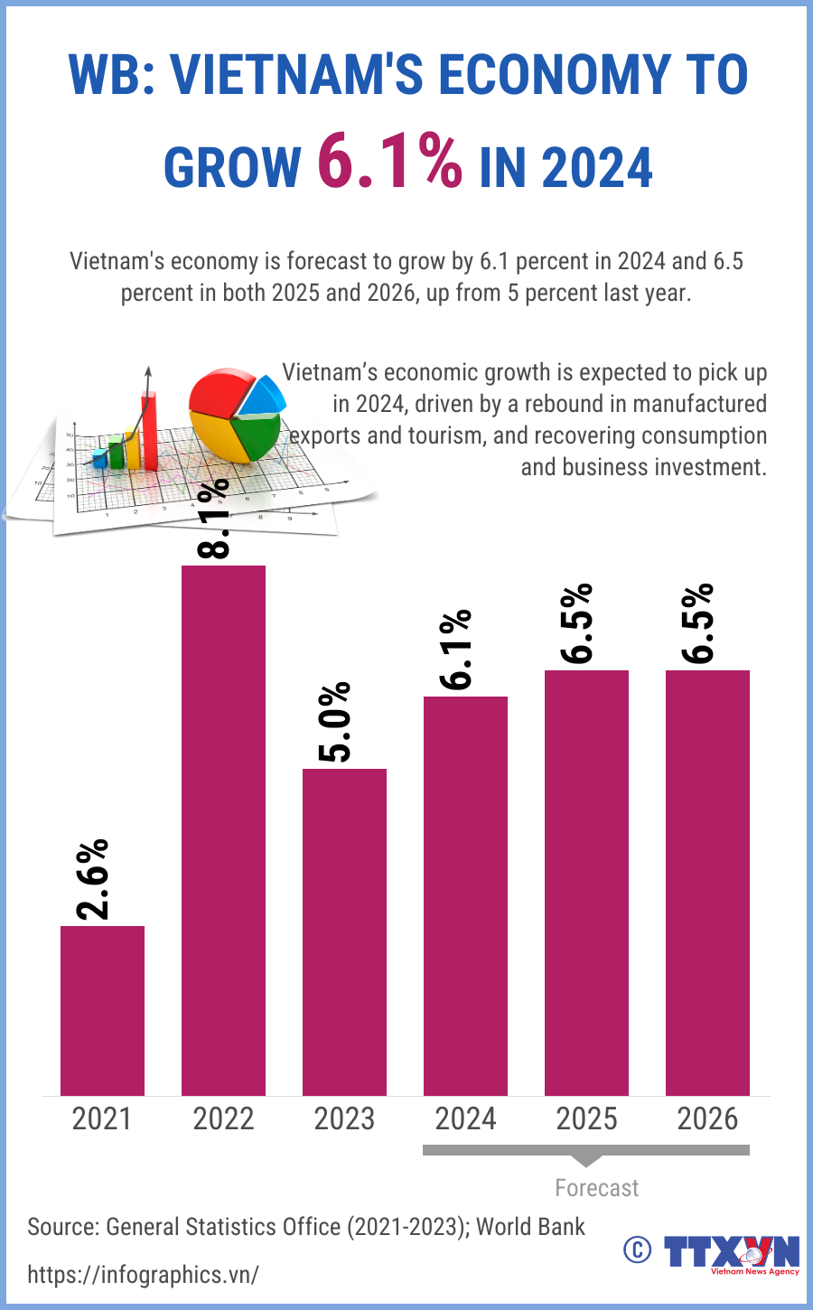
Figure 1: Vietnam’s Economic Growth Forecast (2021–2026)
(Source: General Statistics Office (2021–2023))
Furthermore, Vietnam's open trade policies and membership in several bilateral and regional trade agreements have enhanced its integration into the global economy and have drawn the interest of multinational companies, which have set up production facilities in the country (Hoang et al., 2026).

a.2 Development of the Electronics Manufacturing Industry in Vietnam
Initially, the sector concentrated mainly on low-cost assembly operations with Vietnam's low cost and strategic location in Asia. However, in the last decade, there has been an evolution of more advanced manufacturing processes in the industry, such as semiconductor components, electronic devices, and high-tech assembly processes (Nguyen et al., 2022).
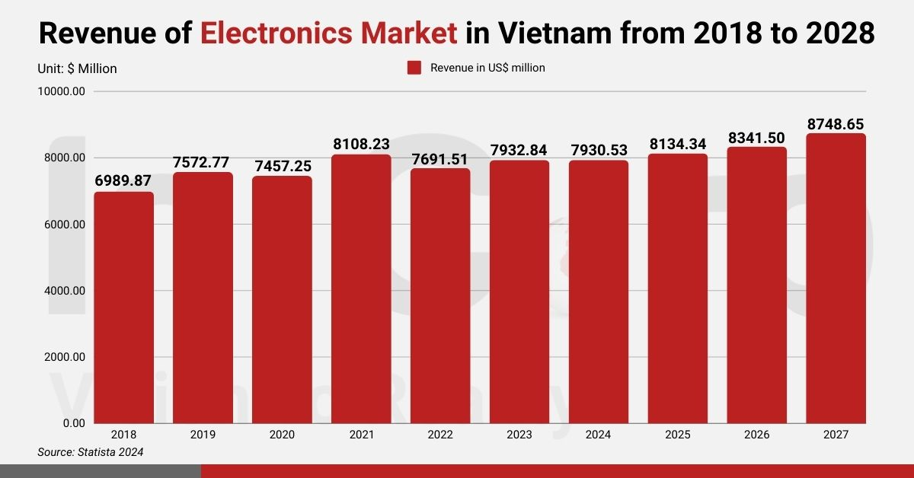
Figure 2:Revenue of the Electronics Market in Vietnam (2018–2027)
(Source: Statista (2024))
Vietnam is presently one of the world's largest exporters of electronics products and has established solid electronic product production clusters in areas like the Red River Delta and Ho Chi Minh City (Zhang, 2025).

a.3 Role of Foreign Direct Investment (FDI) in Industry Growth
Vietnam boasts of skilled labour force, competitive cost as well as favourable investment policies that have made it the focal point of international companies that have invested a lot into it (Fu et al., 2025). Such investments have helped in transfer of technology, better management practices and increased the productivity of the industry in the country. Research has shown that inflows of FDI play a pivotal role in industrial expansion through adopting new technology and enhancing the worldwide production system (Supriyanto et al., 2025).
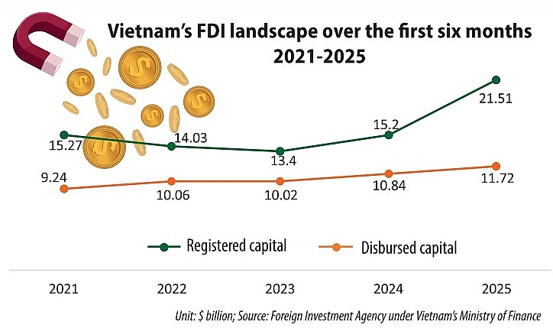
Figure 3:Vietnam’s FDI Landscape in the First Six Months (2021–2025)
(Source: Foreign Investment Agency under Vietnam’s Ministry of Finance, 2025)
Also, it is possible to note that FDI fosters local suppliers’ networks and creates employment opportunities, as well as enables domestic companies to become a part of the international value chains (Fu et al., 2025).

a.4 Vietnam’s Position in the Global Electronics Supply Chain
Vietnam has been increasingly flexing its muscles in the global electronics supply chain. Today the country is recognized as a key production base for international electronics companies, especially for smart phones, consumer electronic products and electronic components.
According to international trade data, Vietnam is now the fourth-largest exporter of electronics products in the world and the second-largest exporter of smartphones in the world (Ng, 2022).

b. Size, Scope, and Economic Importance of the Industry

b.1 Size of the Electronics Manufacturing Industry
The industry incorporates manufacture of smartphones, computers, electronic parts, semiconductors and consumer electronics.
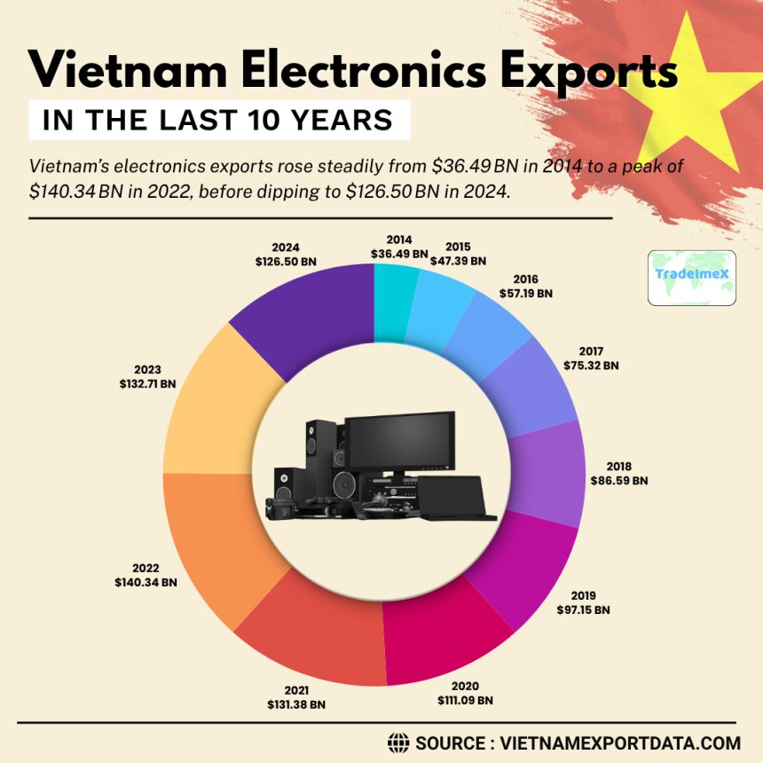
Figure 4:Figure: Vietnam Electronics Exports in the Last 10 Years (2014–2024)
(Source: VietnamExportData.com)
According to industry statistics, the exports of electronics in Vietnam amounted to about USD 126.5 billion in 2024; almost a third of the total value of exports in the country (Ngoc et al., 2019).

b.2 Contribution to Vietnam’s GDP and Export Economy
The electronics manufacturing industry is a key component of the performance of the entire Vietnamese economy. The sector is the biggest contributor in terms of export to the country as it generates about 18-20 percent of the GDP of the country and is the largest export-making sector in the Vietnam economy. Vietnam remains in a trade surplus and in the global markets as the export of electronics products including smart phones, integrated circuits and electronic components has been high (Hoang et al., 2026).

b.3 Employment Generation and Industrial Development
The electronics industry is also a source of major jobs in Vietnam in addition to its economic value. In the country, hundreds of thousands of workers are working in manufacturing plants and technology parks, especially in industrial zones in the country, which are in the north and south provinces. The fact that foreign companies also help in developing the workforce due to technical training and enhancing labor productivity (Thakur et al., 2025).

c. Major Firms and Competitive Positioning in the Electronics Industry

c.1 Major Domestic Electronics Firms in Vietnam
Whereas the electronics industry is full of multinational corporations, there are a few local companies in the same industry. The areas that Vietnamese companies are primarily interested in are on supporting industries like electronic parts, packaging, and subcontract manufacturing. The companies are in the habit of cooperating with multinationals as the suppliers in the electronic manufacturing chain (Nguyen et al., 2022).
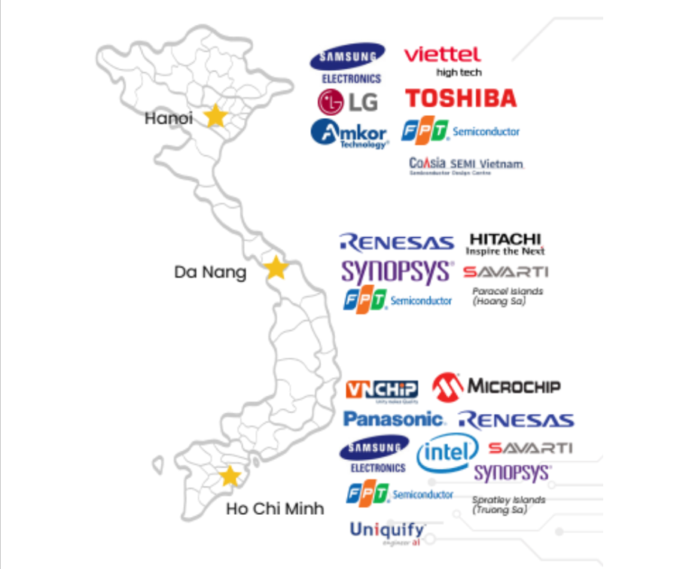
Figure 5:Major Domestic Electronics Firms in Vietnam
(Source: Developed by student)

c.2 Major Multinational Corporations Operating in Vietnam
Vietnam is home to some of the major multinationals of electronic manufacturing namely Samsung, Intel, LG, Luxshare and Foxconn. Foxconn is one of these firms that have a rather significant role in Apple products as one of the largest assemblers of MacBooks, ipads and AirPods. Foxconn has extensive production plants in some of the provinces like Bac Giang or Bac Ninh that have made heavy contribution to the export of electronic and the industrial capacity of Vietnam.

c.3 Competitor Analysis of Key Firms
The market in the electronics manufacturing sector in Vietnam is naturally competing with the multinational firms who rival in terms of production efficiency, integration of supply chain and technological capacity. Samsung and Foxconn companies are investing in various sophisticated manufacturing technologies and research and development centres to ensure that they have competitive advantages in the international markets (Zhang, 2025).
Competitor Analysis of Key Firms in Vietnam’s Electronics Manufacturing Industry
Company | Type | Key Competitors | Key Strategies | Market Position
Samsung Electronics | Multinational | Foxconn, LG Electronics, Intel | Large-scale production, advanced technology investment, strong R&D capability | One of the largest electronics manufacturers in Vietnam with strong export performance
Foxconn (Hon Hai Precision Industry) | Multinational | Samsung, Luxshare Precision, Pegatron | Global supply chain integration, contract manufacturing for major brands such as Apple | Leading contract electronics manufacturer with strong production efficiency
LG Electronics | Multinational | Samsung, Foxconn, Intel | Consumer electronics innovation, investment in smart technology and display manufacturing | Strong competitor in electronics and home appliance manufacturing
Intel Products Vietnam | Multinational | Samsung, Foxconn | Semiconductor manufacturing, advanced chip technology and high-tech production | Major semiconductor producer contributing significantly to Vietnam’s exports
Luxshare Precision Industry | Multinational | Foxconn, Pegatron | Electronics assembly for global brands, supply chain partnerships | Rapidly growing electronics manufacturer in Vietnam
Table 1: Competitor Analysis of Key Firms in Vietnam’s Electronics Manufacturing Industry
(Source: Developed by student)

c.4 Market Segmentation and Strategic Positioning
Different firms of the electronics industry specialize in particular market segments. For instance, Samsung is focused on manufacturing smartphones and consumer electronics, whereas Foxconn is more involved in contract manufacturing services and assembly services for technology brands around the world. Intel on the other hand specializes in semiconductor assembly and in testing operations. This segmentation helps firms to position themselves strategically in the global supply chains while maximising efficiency of production (Ng, 2022).
Market Segmentation and Strategic Positioning (STP Analysis)
Company | Segmentation | Target Market | Positioning
Samsung Electronics | Consumer electronics, smartphones, home appliances, and digital devices | Global consumers, technology users, and electronics retailers | Positioned as a leading global technology brand focusing on innovation, high-quality electronics, and advanced smartphone technology
Foxconn | Electronics contract manufacturing and assembly services | Global technology companies such as Apple, Dell, and other electronics brands | Positioned as a world-leading contract manufacturer providing efficient large-scale production and supply chain integration
Intel | Semiconductor manufacturing, chip assembly, and testing services | Technology firms, computer manufacturers, and electronics producers | Positioned as a high-tech semiconductor leader providing advanced processors and chip technologies
LG Electronics | Consumer electronics, smart appliances, and display technologies | Global household consumers and electronics markets | Positioned as an innovative electronics brand focusing on smart technology, home appliances, and entertainment devices
Table 2:Market Segmentation and Strategic Positioning (STP Analysis)
(Source: Developed by student)

c.5 Comparative Performance of Leading Companies
Multinational corporations are much better performers, compared to local businesses, because they boast of availed technologies, capital facilities and worldwide distribution channels.
Samsung has already a substantial portion in the electronics exports of Vietnam, and Foxconn only keeps growing the manufacturing presence to accommodate the demand of Apple products worldwide (Ngoc et al., 2019).

3.Global Competitiveness Analysis using Porter’s Diamond Model

3.1 Overview of Porter’s Diamond Model of National Advantage
The Diamond Model by Porter describes the impact of national conditions on the competitiveness of industries on a national level with regards to the global competition (Abdelkawy, 2026; Sibanda et al., 2025). The model comprises of four core determinants,
- Factor Conditions
- Demand Conditions
- Related and Supporting Industries
- Firm Strategy, Structure, and Rivalry
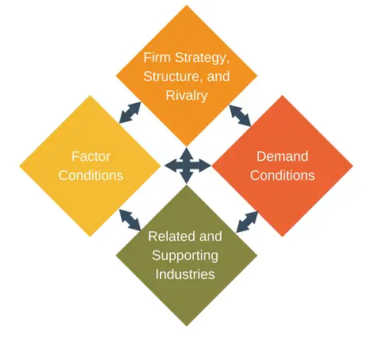
Figure 6:Porter’s Diamond Model
(Source: Developed by student)
These forces within the business environment interact with government policies and external events of chance to determine competitive advantage in international markets (Tan, 2025). Literature that has used the model emphasizes that effective domestic competencies and institutional facilitation can make an industry productive and a competitive one on a global platform (Setiawan et al., 2023).

3.2 Factor Conditions in Vietnam

3.2.1 Labour Availability and Cost Advantages
Vietnam has high and relatively young labour force and hence a competitive edge to labour-based manufacturing businesses like production of electronic products. This is due to the availability of skilled and semi-skilled workforce, which boosts the development of manufacturing companies and entices multinational companies to invest in the nation (Pham, 2025).
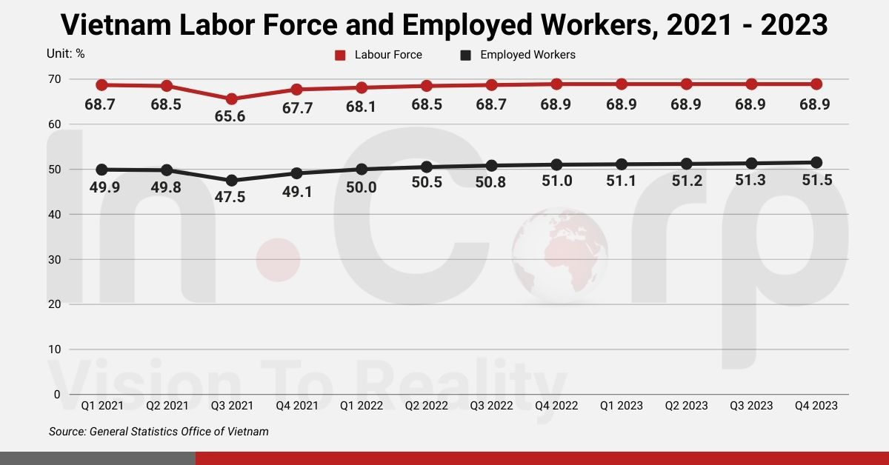
Figure 7: Vietnam Labour Force and Employed Workers (2021–2023)
(Source: General Statistics Office of Vietnam)
Vietnam is also good in the production of electronics due to competitive labour costs compared to other Asian manufacturing centres (Nguyen et al., 2026). In addition, enhanced labour productivity and workforce competence has reinforced the competitiveness of Vietnam in terms of manufacturing and its export capabilities (Ha et al., 2025).

3.2.2 Infrastructure and Technological Capabilities
Vietnam has made several investments in the development of infrastructure, such as industrial zones, logistics infrastructure, and digital infrastructure that facilitates the manufacturing activities. Such advances have led to the vibrant development of the manufacturing industries in the country and its internationalisation (Ngoc et al., 2025). Secondly, digital transformation efforts have improved labour productivity and technological advancement among Vietnamese companies (Ha et al., 2025). Advanced manufacturing technologies are also adopted in the electronics industry through the development of technological capabilities and open innovation systems (Xuan, 2025).

3.3 Demand Conditions in Vietnam

3.3.1 Domestic Market Demand for Electronics
The demand within a country is significant towards ensuring industrial competitiveness since this motivates companies towards increased product quality and innovation.
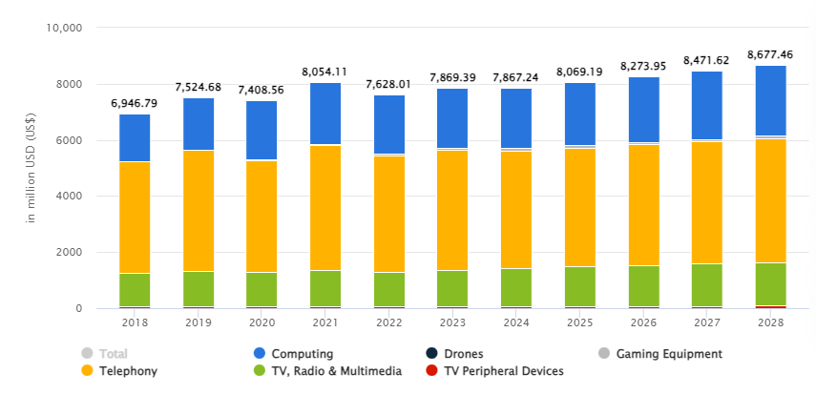
Figure 8: Electronics Market Revenue by Product Segment in Vietnam (2018–2028)
(Source: Adapted from Statista (2025))
Due to the presence of the growing middle-income population and the growth of the usage of technology in Vietnam, the demand of electronic appliances including smartphones, computers, and other home electronics is on the rise. The advances in economy and the structural change have also made consumer purchasing power and usage of technology to grow in the country (Ngoc et al., 2025).

3.3.2 International Export Demand
The electronic manufacturing sector in Vietnam is hugely export driven. The integration of trade and the cheap cost of production have seen the nation turn into a significant production hub of the world technology firms. There is a growing economic interdependence on the international markets creating more export opportunities of the Vietnamese manufacturing companies (Lim et al., 2025). The high exportation demand in global trade markets has been promoting the growth of big manufacturing plants in Vietnam, which would enhance its dominance in the global electronic supply chains (Vien et al., 2025).

3.4 Related and Supporting Industries

3.4.1 Supply Chain Networks
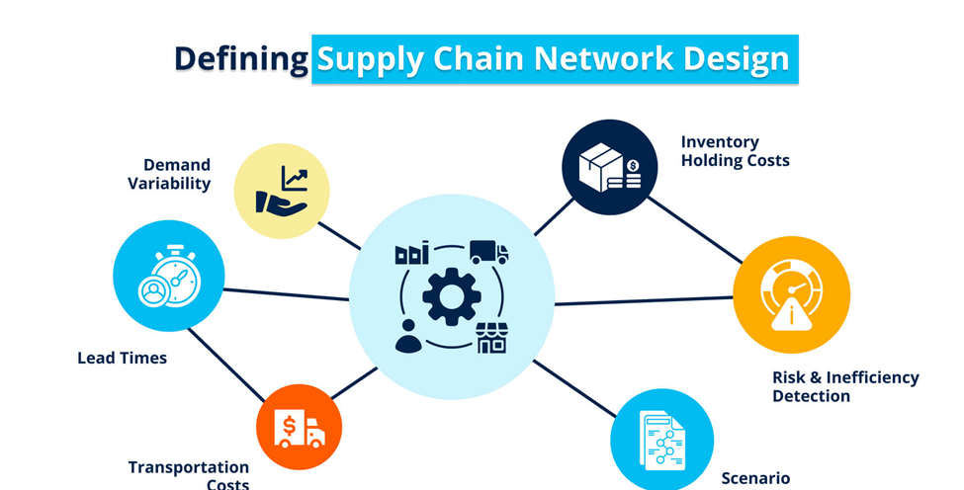
Figure 9: Key Factors Affecting Supply Chain Performance
(Source: Student)
Good supporting industries and supply chain networks are relevant towards enhancing the competitiveness of industries. The manufacturing industry in Vietnam is enjoying a large supplier base in addition to logistics and component producers to aid in the production of electronics. Supply chain networks have been enhanced in the nation due to the growth of domestic businesses and rising investment requirements (Ha et al., 2025).

3.4.2 Supporting Manufacturing and Technology Industries
The electronic industry is supported by the supporting industries like the component production, logistic services and information technology. Ecosystems of innovation and interfirm relationship boost the technology capacity and productivity in industries (Xuan, 2025). Other researchers who identified and implemented the Diamond Model of Porter reveal that competitive national industries are largely enhanced by robust supporting industries as it has the capacity to provide the efficiency and innovation (Zhao, 2018).

3.5 Firm Strategy, Structure and Rivalry

3.5.1 Competitive Strategies of Firms
The electronics companies that are present in Vietnam have diverse competitive strategies in the international markets. The aim of many companies is on the cost-effective approach of production, technology cooperation, and the export manufacturing process. Innovation capacity, market orientation, and strategic management capabilities are also the factors that affect the competitiveness of enterprises in Vietnam (Wu et al., 2025).

3.5.2 Industry Rivalry and Competition
The rivalry between the local companies and multinational corporations is an important factor in the enhancement of the productivity and innovation. The level of competition is very high, which reasons companies to enhance their operational performance and embrace new technologies to retain market position (Wu et al., 2025).
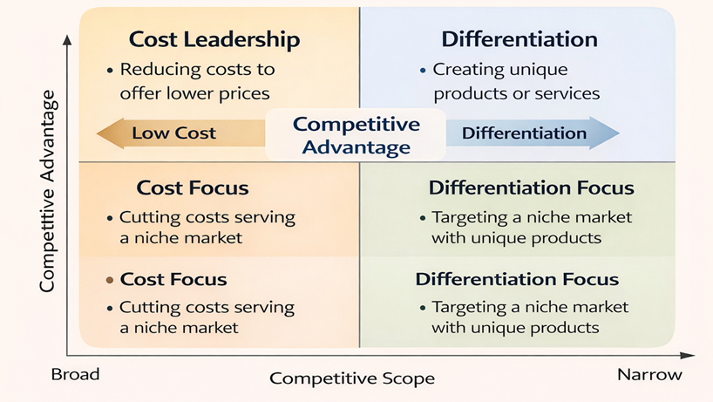
Figure 10: Porter’s Generic Competitive Strategies Matrix (Cost Leadership, Differentiation, Cost Focus, and Differentiation Focus
(Source: Student)

3.6 Government Role in Developing the Electronics Industry
The policies of the government have a vital contribution to fortification of the electronics manufacturing sector of Vietnam. The Vietnamese government has put in place policies that are aimed at attracting foreign direct investment, industrial development and export promotion. Strategic industrial policies and economic reforms have had a significant impact on Vietnam in its high rate of economic transformation and industrialization (Vu et al., 2025).

3.7 Role of Chance and External Factors
The competitiveness of the industry may be affected by external forces like economic changes in the world, change in technology, and geopolitics. The changes in global supply chain, trends in international trade have brought new opportunities to manufacturing sector in Vietnam. Research indicates that the occurrences of the world that might be unforeseen and the changes in markets can redefine national competitiveness in industries in large proportions (Abdelkawy, 2026).

3.8 Evaluation of Vietnam’s Global Competitiveness in Electronics Manufacturing
Generally, the favourable factor conditions, rising demand, good supply chain networks and favourable government policies have helped Vietnam to build competitive advantages in the manufacture of electronic products. Management of these aspects has enhanced the business of the country in the electronics supply chains across the globe. Studies show that the competitiveness of enterprises, the ability to innovate, and international integration is still advancing the performance of the Vietnamese production (Wu et al., 2025; Lim et al., 2025).

4.Analysis of Foreign MNC Operations – Foxconn in Vietnam

4.1 Introduction to Foxconn

4.1.1 Company Background
Foxconn or formally, Hon Hai Precision Industry Co. Ltd. is among the largest companies in the world that manufacture electronic products. The company started in Taiwan in the year 1974 and has since become the largest electronic contract manufacturing company in the world with its products being the components and devices that are used by the global technology giants like Apple, Sony, Microsoft and Dell. Foxconn is a large original equipment manufacturer (OEM), original design manufacturer (ODM), that is an organisation supplying services to manufacture, assemble, and manage a supply chain of major technology corporations. Foxconn has emerged as a major participant in the international electronics manufacturing sector because of constantly innovating now and having ICTs of development and production, which are linked globally (Zhang, 2025).
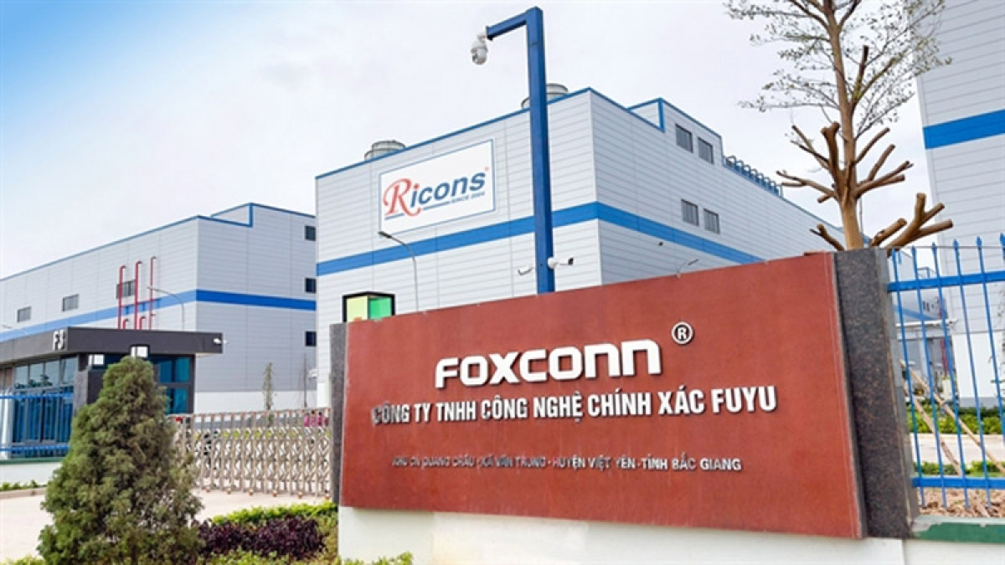
The major success of the company depends on its skill of organising huge production processes with the effective supply chain management and cost optimization strategies. To diversify its manufacturing network to ensure that it can enjoy competitive advantages in the dominant electronics market, Foxconn has created manufacturing units in countries such as China, Vietnam, India, Mexico, and the United States (Ngoc et al., 2019).

4.1.2 Global Operations and Market Position
Foxconn has its network of factories all around the world that work for major multinational technology companies. The firm manufactures a large variety of electronic goods such as smartphones, computers, semiconductors, networking equipment and consumer electronics. The company is known especially for assembling Apple products such as iPhone, MacBooks, iPads, and AirPods. Foxconn's mastery of mass production and supply chain logistics has enabled it to take over the contract make sector of the electronic industry.
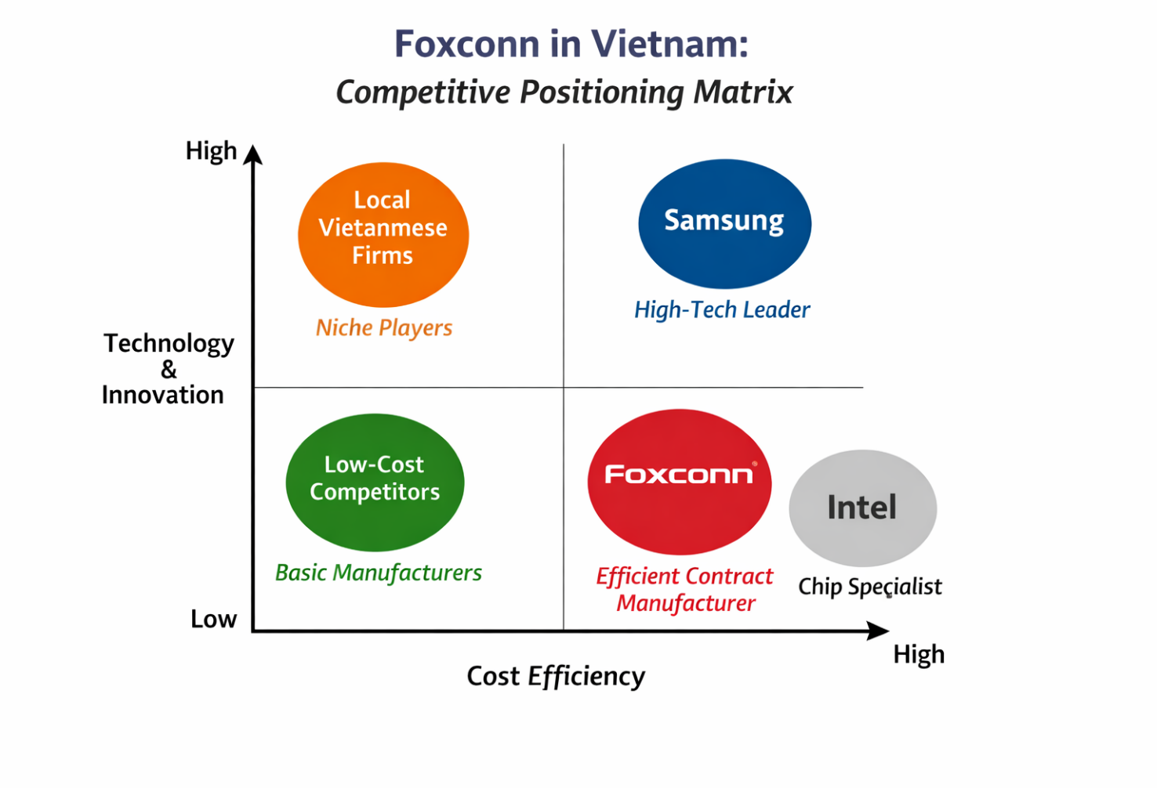
Figure 11: Competitor positioning matrix
(Source: Author, 2025)
The global position of Foxconn is secured by its integration in international supply chains and strategic partnerships with top tech brands. The company has many production establishments across the globe, facilitating achieving quick response to the market requirement and ensuring production efficiency. As global electronics production becomes more complex, Foxconn keeps adding more manufacturing presence in emerging markets to keep the supply chain flexible and less reliant on one country for production (Hoang et al., 2026).

4.2 Foxconn’s Entry into Vietnam

4.2.1 Reasons for Expanding Manufacturing to Vietnam
Company Foxconn started expanding into Vietnam in large part due to the necessity to diversify its production processes and avoid dependence on China. As global supply chain disruptions and increased labour costs in China have led to the strategy of China Plus One, in which, to counter this, multinational companies have opted to form other production plants in other nations like Vietnamese. Vietnam has emerged as one of the appealing countries to relocate manufacturing activities because of its competitive labour charges, strategic location and great integration into international trade networks (Davis, 2025).
The other key element that prompted the decision by Foxconn to increase its operation in Vietnam is the robust foreign direct investment policies and the government favouring high-tech industries in the country. Vietnam has been an aggressive investor in electronic production by setting up special economic zones, industrial parks and export processing zones to offer incentives to foreign investors (Tafese et al., 2025).

4.2.2 Investment and Production Facilities in Vietnam
Foxconn has made significant investments in Vietnam, opening several manufacturing plantations in provinces like Bac Giang, Bac Ninh and Quang Ninh. They are mainly involved in the assembly of electronic products and parts of technology firms worldwide. The increase in the manufacturing of Foxconn business in Vietnam has been a major boost to the export business of electronic products and industrial growth in Vietnam.
The northern industrial region of Vietnam is now a key electronics manufacturing centre because of its location relative to key transportation networks and associated supply chain infrastructure. According to Nguyen et al., multinational companies like Foxconn, Samsung, and Intel have made Vietnam one of the key electronics manufacturing locations in the Asian region (Nguyễn et al., 2022).

4.3 Market Attractiveness of Vietnam for Foreign Investors

4.3.1 Overview of Vietnam as an Investment Destination
Vietnam is now one of the most appealing locations of foreign direct investment in all Southeast Asia. The high economic growth of the country, the political stability, and the growth of manufacturing industry have made the country appealing to the multinational corporations with fresh investment opportunities. Inflows of foreign direct investment in Vietnam are quite high, and the amount disbursed FDI in 2025 is USD 27 billion that proves the increasing significance of this country as the manufacturing hub worldwide (Nguyen et al., 2025).
Vietnam is also attractive as an investment destination by the virtue of its involvement in quite a few free trade agreements. Such trade agreements enable firms in Vietnam to enter exports to foreign markets with lower tariffs together with potential access to the market. Consequently, it is due to this reason that multinational corporations consider Vietnam as one of the strategic places to produce and export electronic products to the international markets (Lim et al., 2025).

4.4 PESTLE Analysis
Factor | Key Points
Political Factors | • Vietnam has a stable one-party political system led by the Communist Party, which provides policy stability for foreign investors.  • Government strongly supports foreign direct investment (FDI) through pro-investment policies and industrial development strategies.  • The Investment Law 2025 simplifies procedures for foreign investors and accelerates business establishment processes.  • Vietnam actively promotes high-tech industries such as electronics, semiconductors, and digital technology through government policies.
Economic Factors | • Vietnam is one of the fastest-growing economies in Southeast Asia, with GDP growth projected around 6–7%.  • The country has competitive labor costs, making it attractive for electronics manufacturing companies such as Foxconn.  • High levels of foreign direct investment (FDI) support industrial expansion and infrastructure development.  • Strong export performance and participation in global supply chains enhance the country’s manufacturing competitiveness.
Social Factors | • Vietnam has a young and growing workforce, providing a large labor supply for manufacturing industries.  • Workforce culture is influenced by Confucian values such as respect for hierarchy, teamwork, and collective harmony.  • Increasing education levels and technical training support the development of skilled workers in technology sectors.  • Urbanization and a growing middle class are increasing domestic demand for electronic products.
Technological Factors | • Vietnam is gradually transforming from a low-cost manufacturing base to a high-tech production hub.  • Increasing investment in electronics manufacturing, semiconductors, and digital technologies.  • Development of industrial parks, technology zones, and digital infrastructure supports advanced manufacturing.  • Multinational companies such as Foxconn bring technology transfer and innovation capabilities to the local industry.
Legal Factors | • Vietnam has improved business regulations and legal frameworks to attract foreign investors.  • Participation in multiple Free Trade Agreements (FTAs) such as EVFTA supports export-oriented industries.  • Regulatory reforms aim to reduce administrative barriers and simplify business procedures.  • Companies must comply with labour laws, environmental regulations, and trade policies when operating in Vietnam.
Environmental Factors | • Growing government emphasis on sustainable industrial development and environmental protection.  • Increasing focus on green manufacturing, renewable energy, and sustainable supply chains.  • Electronics manufacturing companies must manage waste management, energy consumption, and environmental compliance.  • Environmental regulations are gradually strengthening to ensure sustainable economic growth.
Table 3: PESTLE Analysis of Vietnam
(Source: Student)

4.4.1 Political Environment Analysis

4.4.1.1 Government Stability
Vietnam's political system is characterized by strong government control and political stability over time. Governance of the country is by the Communist Party of Vietnam who offers a consistent policy environment for economic development and foreign investment in the country. Political stability is a huge benefit for multinational corporations as it helps to minimize the business risks and establish the foreseeing regulatory conditions (Davis, 2025).

4.4.1.2 Foreign Direct Investment Policies
The Vietnamese government has introduced several policies to attract foreign investors.
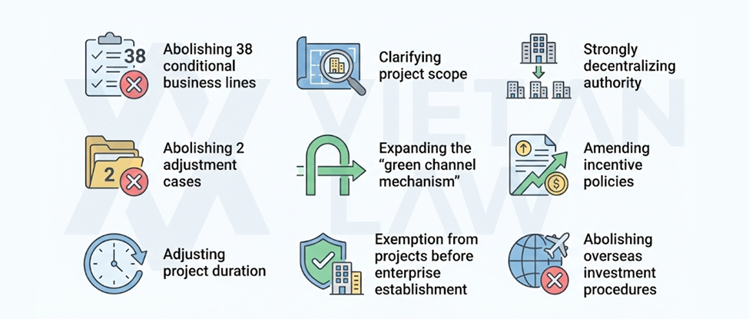
Figure 12:Investment Law 2025
(Source: Student)
Recent regulatory reforms such as the Investment Law 2025 ease the administrative procedures and enable foreign investors to setup business entities in a more efficient way. These policy reforms show that the government is serious about improving the investment environment and promoting industrial growth (Tran et al., 2025).

4.4.2 Economic Environment Analysis

4.4.2.1 Economic Growth and Industrial Development
The economy of Vietnam has been growing at a fast rate in recent years in which the export-oriented manufacturing and the rising foreign investment have contributed to this economic growth. The GDP growth rate of the country has also been above 6 per cent in a year and the country has been one of the fastest growing economies in the southeast Asian region. Vietnam has been enhanced in terms of robust industrialization and export growth, which have enhanced the country in the global manufacturing systems (Kumar et al., 2025).

4.4.2.2 Labour Cost and Workforce Availability
Vietnam also has major benefits in labour costs over other manufacturing nations. The industrial labour force is young and increasing in number and labour supply in the country is good. Research has shown that the relatively low labour costs and rising labour productivity are favourable to foreign companies with operations in Vietnam to ensure smooth manufacturing operations (Tafese et al., 2025).

4.4.3 Legal Environment Analysis

4.4.3.1 Business Regulations and Compliance
To enhance transparency and streamline business processes of the foreign investors, Vietnam has also introduced regulatory reforms. These reforms will provide a more competitive investment environment in terms of bureaucratic barriers minimization and the legal frameworks supporting international businesses (Phan, 2021).

4.4.3.2 Trade Agreements and Export Regulations
The involvement of Vietnam in various trading agreements with other countries offers a great benefit to the firms that are in operation within the country. Laws and treaties like the EU Vietnam Free Trade Agreement are enabling business owners to enter international markets at a low tariff and a better trade condition (Lim et al., 2025).

4.4.4 Cultural Environment Analysis

4.4.4.1 Business Culture in Vietnam
The business culture of Vietnam is based mostly on Confucian principles, meaning that businessmen value the respect of hierarchy in business, group harmony, and the need to have long-term relations. The cultural values have an impact on business negotiations and management behaviours in organizations based in Vietnam (Source of Asia, 2025).

4.4.4.2 Workforce Culture and Management Practices
The Vietnamese working environments focus on team and group achievements, instead of personal achievement. Employees tend to prioritize the group harmony and respect of authority, which tends to affect the organizational communication and management patterns. Simultaneously, younger workers demand more chances of professional development and work-life balance (Source of Asia, 2025).

4.4.5 Application of PESTLE Analysis for Foxconn in Vietnam

4.4.5.1 Political Factors
Vietnam's stable political environment and consistent government policies are a great environment for foreign multinational corporations like Foxconn to operate in. The government actively encourages industrial developments and foreign direct investments through investment subsidies, industrial parks and trade policies. This is a political stability that decreases the risks of business and supports the long-term investment of manufacturing in Vietnam (Davis, 2025).

4.4.5.2 Economic Factors
Vietnam's rapid economic growth and growing manufacturing industry provide very favourable economic conditions for Foxconn's operations. Competitive pricing of labour, and a large pool of employees allow companies to run efficient production and minimize operational costs. In addition, good exports and rising rates of foreign investments enhance the position of Vietnam as a global centre of electronics manufacturing (Kumar et al., 2025).

4.4.5.3 Social Factors
Vietnam's young population and growing labour force is an important source of human capital for the electronics manufacturing industry. Improvements in education and vocational training programs have contributed to improvements in worker technical skills. These social developments are conducive to industrial productivity and enable companies like Foxconn to have access to a reliable and skilled labour force (Nguyen et al., 2025).

4.4.5.4 Technological Factors
Vietnam is gradually transforming into a technology-oriented manufacturing economy. Investments in digital infrastructure, industrial automation, and technology parks are improving productivity in manufacturing industries. The presence of multinational companies contributes to technology transfer and innovation, which strengthens Vietnam’s technological capabilities and supports Foxconn’s advanced manufacturing operations (Ali et al., 2025).

4.4.5.5 Legal Factors
Multiple regulatory reforms have been practised in Vietnam to facilitate foreign investors. These reforms make investment processes easier and enhance the legal regulations of international trade and industrialization. The engagement in the global trade agreements also promotes the manufacturing tasks that are export-driven and allows such a company as Foxconn to enter the international markets effectively (Phan, 2021).

4.4.5.6 Environmental Factors
Vietnam is becoming more environmentally friendly and sustainable in industrial development. Environmental regulations have been put forward by the government to warrant that manufacturing activities are carried out in a sustainable manner. To enable the achievement of sustainable economic development, firms in Vietnam will have to adhere to the environmental standards in waste management, energy-saving, and reduction of emissions (Nguyen et al., 2025).

4.4.6 Opportunities for Foxconn in Vietnam
The opportunities available to Foxconn in Vietnam are as follows; growing worldwide demand of electronic devices, good foreign investment policies and expanding supply chain networks. The incorporation of Vietnam in the world value chains also gives Foxconn the power to enhance its position as a key producer and exporter of electronic products (Hoang et al., 2026).

4.4.7 Challenges and Risks Faced by Foxconn
Along with these advantages, Foxconn has certain disadvantages that include growing labour costs, intensifying competition with other countries of manufacturing, and the necessity to ensure technological modernisation. Also, global trade ambiguities and supply chain interruptions can impact the production processes within the electronics sector (Thakur et al., 2025).

4.4.8 Evaluation of the Success Potential of Foxconn in Vietnam
Vietnam, in general, has high potential regarding long-term manufacturing of Foxconn. The positive aspect of the investment climate, the presence of a quality workforce, and the high level of penetration into international supply chains makes significant benefits to the multinational corporations in the country. As the government continues to support it, along with the infrastructure, Vietnam is likely to continue playing an important role in the international strategy of Foxconn to manufacture its products and produce electronics in the years to come (Ng, 2022).

5. Conclusion
The reason why Vietnam has become a very competitive destination especially in manufacturing electronics is because it has a close-knit economic growth, is a development model that is export oriented, increased foreign direct investment, and is becoming accessible on global supply chains. The report demonstrated that electronics sector has evolved to be among the most significant industries in Vietnam by providing a significant contribution to the GDP, exports, industrialization, as well as job creation. The Diamond Model of Porter even indicated how Vietnam has favourable factor conditions, increasing domestic and foreign demand, developing supply chains, intense rivalry between firms and favourable government policies have contributed to its competitiveness.
The report also discovered that the expansion of Foxconn in Vietnam is indicative of the attractiveness of the country as a manufacturing destination based on the China Plus One strategy. Foxconn could use Vietnam to enjoy several strategic benefits such as political stability, competitiveness in labour costs, developing infrastructure, incentives on investment, as well as the international markets through trade agreements. Simultaneously, Foxconn must deal with the issue of increased labour expenses, environmental regulations, and market instability across the globe. In general, Vietnam has great long-term opportunities and Foxconn, and it can be considered an essential global electronics manufacturing and international business development centre.

Section 2 - Reflective Account of the Research Process Using Kolb’s Reflective Cycle

Introduction
Reflection is an important learning process, through which students critically assess their experiences and enhance their knowledge and skills. Kolb's cycle of experiential learning is a popular framework for reflective learning since it describes how people learn through experience, reflected learning, conceptualisation and experimentation. The model is comprised of four stages: concrete experience, reflective observation, abstract conceptualization and active experimentation (Villarroel et al., 2025). In this section a reflective account of the process followed in the research, analysing and preparation for the previous section of this assessment is given. The reflection is applying Kolb's learning cycle to evaluate the learning experience undergone in the process of the research and to determine areas that need to be improved in future academic work.
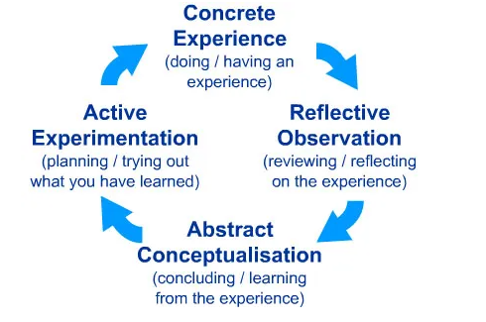
Figure 13: Kolb’s Experiential Learning Cycle
(Source: Adapted from Kolb (1984) cited in Villarroel et al. (2025))

Concrete Experience
The concrete experience is the first step in the experience learning cycle of Kolb, and it implies the actual activity or experience that is involved in the learning process of a learner. The practical experience in this evaluation consisted in the study of the international business environment in Vietnam and an analysis of the electronics manufacturing industry with references to the work of Foxconn. This was done by ensuring that academic journal articles, industry reports and other academic sources were collected concerning the economic environment in Vietnam, international competitiveness and multinational corporations in the electronic industry.
In the process, I sought all kinds of information in several academic databases and online sources to learn how the electronics manufacturing industry in Vietnam was developed and the contribution of foreign direct investment in the growth of the industry. The theoretical models that were analysed as part of the research process included using the diamond model by Porter and extrapolating them to the Vietnamese environment. This step gave me a good hands-on experience in undertaking academic research and analysing international business concepts. Villarroel et al. (2025) state that the stage of the concrete experience is also necessary since it provides students with the opportunity to interact with real-life issues and academic assignments.

Reflective Observation
The second phase in the learning cycle as given by Kolb entails reflective observation which requires the learner to critically analyse the experience and learns areas of strengths and weaknesses in the learning process. In the process of writing the above part of the assessment, I recalled the effectiveness with which I gathered and examined information about the electronics sector of Vietnam and the activities of the Foxconn.
Among the positive aspects of the research process, the possibility to find the corresponding academic sources and implement them in the analysis of the industry and country environment should be highlighted. The academic literature was used to enhance the credibility of the report and presented facts that verify the main points based on the economic development and international competitiveness of Vietnam. Nevertheless, I also came to understand that to reveal the hypothesis through analysis of great amounts of academic data, I needed to pay sufficient attention to organisation and time management so that I could provide the results in a transparent and systematic way.
It was also through reflective observation that I was in position to appreciate the contribution derived through various sources towards the entire analysis process. Others were concerned with economic conversion and foreign direct investment whereas others spoke of supply chain progress as well as industrial competitiveness. This step was useful in building my skills in critical thinking through comparison of various perspectives of academics to establish the most pertinent information to the report. Reflective learning has been regarded as one of the significant processes in building profound knowledge and analytical skills in scholarly work (Cheng et al., 2025).

Abstract Conceptualization
The third stage of Kolb's experiential learning cycle is abstract conceptualization in which the learner constructs new ideas or theoretical understanding based on reflecting the experience. During this stage, I reconciled the research finding with the international business theories and concepts. A competitive advantage of Vietnam’s electronics manufacturing industry Porter’s Diamond Model was used to analyse its competitive advantages.
Through this stage, I learned how different elements such as availability of labour force, development of infrastructure, domestic demand and government policies effect the competitiveness of industries within a country. I also learned how multinational corporations such as Foxconn chose where to invest a business based on factors like economic conditions, supply chain networks, and government incentives.
The process of conceptualization enabled me to relate the theoretical knowledge to real-life business scenarios. Study reported that Kolbs learning cycle helps learners to convert practical experiences into theoretical knowledge and professional competence (Almeida et al, 2024). Having framed theoretical frameworks onto the case of Vietnam's electronics industry, I was able to gain a better understanding of the relationship between global business strategies and national economic environments.

Active Experimentation
Active experimentation is the last step in the Kolb experiential learning cycle, and it entails application on the part of the learners in the future of their new knowledge and skills. Due to the learning experience during this assessment, I have established various methods of enhancing my research and analytical skills in my future academic undertakings.
To begin with, I would work on my planning and time management of research to structure academic resources better. This will enable me to examine complicated things in a more effective way and provide better arguments with backing evidence. Second, I will become more critical analysing by comparing various academic insights instead of making use of a small number of sources. Lastly, I will also work on enhancing my academic writing abilities to make sure the body of theoretical representations and research discoveries is presented in a coherent and understandable manner.
Active experimentation is also related to using the experiential learning to be applied to the future academic and professional assignments. Learning models like the Kolb cycle promote the usage of reflection and implementation of new ideas to constantly enhance the knowledge of learners (Watson et al., 2019). Likewise, experiential learning in higher education has proven to improve the level of analytical thinking and problem-solving due to its tendency to make students contemplate the real-life case study and project the theoretical content to the real-life scenario (Salinas-Navarro et al., 2026).

Conclusion
Overall, the use of Kolb's reflective cycle was a structured framework in which to evaluate the learning process involved in the researching and preparation of the previous section of the assessment. The four stages of the model concrete experience, reflective observation, abstract conceptualization, and active experimentation enabled me to understand how the research process contributed to the development of academic and analytical skills. The reflection shown was that research on the electronics industry in Vietnam and Foxcon's operations, it improved my ability to analyse international business environments, put into some theoretical frameworks and integrate the academic literature to structure my analysis. Furthermore, the reflection brought out certain areas of improvement such as time management, critical analysis, and academic writing sense. By using the insights gained from this reflection, I will be able to improve my approach to research and develop greater analytical capabilities in my future academic and professional work.

References
Abdelkawy, N.A. (2026) National Competitiveness and Economic Transformation in Saudi Arabia: A Conceptual Analysis Using Porter’s Diamond Model. Systems, 14(4), p.338. Available at: https://doi.org/10.3390/systems14040338 (Accessed: 20 March 2026).
Ali, I., Nguyen, K. and Oh, I. (2025) Systematic literature review on Industry 5.0: current status and future research directions with insights for the Asia Pacific countries. Asia Pacific Business Review. Available at: https://www.tandfonline.com/doi/full/10.1080/13602381.2025.2452877 (Accessed: 18 March 2026).
Almeida, L.G. and Nascimento, L.F.C. (2024) The approach to experiential learning by David Kolb and its influence on the development of professional competencies in leadership. Contribuciones a las Ciencias Sociales, 17(10). Available at: https://www.researchgate.net/publication/385412358_The_approach_to_experiential_learning_by_David_Kolb_and_its_influence_on_the_development_of_professional_competencies_in_leadership (Accessed: 18 March 2026).
Cheng, J. et al. (2025) Integrating Kolb’s experiential learning theory into nursing education: a four-stage intervention. Frontiers in Medicine, 12. Available at: https://pmc.ncbi.nlm.nih.gov/articles/PMC12408510/ (Accessed: 15 March 2026).
Davis, F. (2025) Vietnam Rising: Why Multinational Corporations Should Invest in Southeast Asia’s Fastest-Growing Economy. Available at: https://www.researchgate.net/publication/396656475_Vietnam_Rising_Why_Multinational_Corporations_Should_Invest_in_Southeast_Asia's_Fastest-Growing_Economy (Accessed: 15 March 2026).
Fu, L. and Liang, W. (2025) How Improving the Quality of Foreign Direct Investment Can Promote Sustainable Development: Evidence from China. Sustainability, 17(9), p.3824. Available at: https://doi.org/10.3390/su17093824 (Accessed: 19 March 2026).
Ha, N.M., Ngoc, B.H. and Tram, N.H.M. (2025) Does digital transformation reinforce labor productivity and income in Vietnam? Cogent Economics & Finance, 13(1). Available at: https://www.tandfonline.com/doi/full/10.1080/23322039.2025.2587500 (Accessed: 17 March 2026).
Ha, T.P.D. and Tran, M.D. (2025) An Analysis of Investment Demand and the Development Trend of Non-State Enterprises in Vietnam. Financial and Credit Activity Problems of Theory and Practice, 1(60), pp.273–287. Available at: https://www.researchgate.net/publication/389433033_AN_ANALYSIS_OF_INVESTMENT_DEMAND_AND_THE_DEVELOPMENT_TREND_OF_NON-STATE_ENTERPRISES_IN_VIETNAM (Accessed: 18 March 2026).
Hoang, V.H. et al. (2026) Engagement in global value chains and export quality: Micro evidence from manufacturing firms in a developing country. Journal of International Trade & Economic Development, 35(3). Available at: https://www.tandfonline.com/doi/full/10.1080/09638199.2025.2463398?af=R (Accessed: 18 March 2026).
Kumar, R.R., Stauvermann, P.J. and Dau, L.T.M. (2025) Exploring the Tourism and Economic Growth Relationship in Vietnam: A Cointegration Analysis with Model-Specific Structural Breaks. Economies, 13(2), p.29. Available at: https://doi.org/10.3390/economies13020029 (Accessed: 18 March 2026).
Lim, G., Xu, C. and Binh, D.T. (2025) Vietnam’s growing economic integration with the world: more or less Asian? Asia Europe Journal, 23(2–3), pp.435–456. Available at: https://www.researchgate.net/publication/391397468_Vietnam's_growing_economic_integration_with_the_world_more_or_less_Asian (Accessed: 16 March 2026).
Mano, M.M., Tita, A.F. and Obalade, A.A. (2025) Value-adding effect of foreign direct investment inflow on manufacturing: evidence from South Africa. Cogent Economics & Finance, 13(1). Available at: https://www.tandfonline.com/doi/full/10.1080/23322039.2025.2468888 (Accessed: 15 March 2026).
Ng, T. (2022) Enhancing Vietnam's Position and Role in the Global Supply Chain. Available at: https://www.researchgate.net/publication/361274852_Enhancing_Vietnam's_Position_and_Role_in_the_Global_Supply_Chain (Accessed: 16 March 2026).
Ngoc, N.T.B. et al. (2025) Analyzing Vietnam’s Economic Transformation from 2007 to 2023. Economies, 13(7), p.182. Available at: https://doi.org/10.3390/economies13070182 (Accessed: 20 March 2026).
Ngoc, T.T.B. and Binh, D.T. (2019) Vietnam’s Electronics Industry: The Rise and Problems of Further Development. Humanities & Social Sciences Reviews, 7(4), pp.01–12. Available at: https://files01.core.ac.uk/download/pdf/268004378.pdf (Accessed: 16 March 2026).
Nguyen, H.T., Tran, T.H.M., Nguyen, T.X. and Vo, N.M.T. (2025) The impact of foreign direct investment (FDI) attraction on economic development in Vietnam - the mediating role of environmental sustainability and social inequality. Multidisciplinary Science Journal, 7(11). Available at: https://www.researchgate.net/publication/393760168_The_impact_of_foreign_direct_investment_FDI_attraction_on_economic_development_in_Vietnam_-_the_mediating_role_of_environmental_sustainability_and_social_inequality (Accessed: 19 March 2026).
Nguyen, H.T.T. et al. (2026) Predicting Career Trends in Vietnam’s Labor Market Through News-Based Sentiment Analysis. International Journal of Asian Business and Information Management. Available at: https://www.sciencedirect.com/org/science/article/pii/S1947963826000109 (Accessed: 15 March 2026).
Nguyễn, T.T.H., Nguyen, T.L. and Trinh, T.T.T. (2022) Development of the Electronics Industry of Thai Nguyen Province, Vietnam: Achievements and Limitations. European Journal of Development Studies, 2(2), pp.66–71. Available at: https://www.researchgate.net/publication/360326164_Development_of_The_Electronics_Industry_of_Thai_Nguyen_Province_Vietnam_Achievements_and_Limitations (Accessed: 15 March 2026).
Pham, T.P. (2025) A Study on the Employment Situation of Vietnamese Workers. European Journal of Development Studies, 5(6), pp.23–28. Available at: https://www.researchgate.net/publication/398623869_A_Study_on_the_Employment_Situation_of_Vietnamese_Workers (Accessed: 16 March 2026).
Phan, S.T. (2021) The effect of PESTLE factors on development of e-commerce. International Journal of Data and Network Science. Available at: https://www.researchgate.net/publication/348131882_The_effect_of_PESTLE_factors_on_development_of_e-commerce (Accessed: 15 March 2026).
Salinas-Navarro, D.E., Palma-Mendoza, J.A. and Da Silva-Ovando, A.C. (2026) Live Case Studies in Industrial Engineering Education for Experiential Learning and Authentic Assessment. Education Sciences, 16(4), p.508. Available at: https://doi.org/10.3390/educsci16040508 (Accessed: 16 March 2026).
Setiawan, R.F. et al. (2023) Cocoa Export Competitiveness: A Strategic Analysis Based on Porter’s Diamond Model. Available at: https://www.researchgate.net/publication/399649168_Cocoa_Export_Competitiveness_A_Strategic_Analysis_Based_on_Porter's_Diamond_Model (Accessed: 15 March 2026).
Sibanda, B. et al. (2025) Using Porter’s Diamond Model to Enhance Reindustrialisation and Export Performance in Zimbabwe. Journal of Management Sciences Innovation and Technology, 1(1). Available at: https://www.researchgate.net/publication/393994391_Using_Porter's_Diamond_Model_to_Enhance_Reindustrialisation_and_Export_Performance_in_Zimbabwe (Accessed: 16 March 2026).
Siskos, D.V., Maravas, A. and Mau, R. (2025) PESTLE Analysis of a Seaplane Transport Network in Greece. Aerospace, 12(1), p.28. Available at: https://doi.org/10.3390/aerospace12010028 (Accessed: 16 March 2026).
Siskos, D.V., Maravas, A. and Mau, R. (2025) PESTLE Analysis of a Seaplane Transport Network in Greece. Available at: https://www.mdpi.com/2226-4310/12/1/28 (Accessed: 17 March 2026).
Supriyanto, S., Widayani, H., Rini, R.C. and Armin (2025) The Impact of Foreign Direct Investment (FDI) on Economic Growth in Developing Countries to Acceleration in Digitalization. Daengku Journal of Humanities and Social Sciences Innovation, 5(3), pp.337–353. Available at: https://www.researchgate.net/publication/398408469_The_Impact_of_Foreign_Direct_Investment_FDI_on_Economic_Growth_in_Developing_Countries_to_Acceleration_in_Digitalization (Accessed: 18 March 2026).
Tafese, T., Lay, J. and Tran, V. (2025) From Fields to Factories: Special Economic Zones, Foreign Direct Investment, and Labour Markets in Vietnam. Journal of Development Economics, 174, p.103467. Available at: https://www.researchgate.net/publication/388736085_From_Fields_to_Factories_Special_Economic_Zones_Foreign_Direct_Investment_and_Labour_Markets_in_Vietnam (Accessed: 16 March 2026).
Tafese, T., Lay, J. and Tran, V. (2025) From fields to factories: Special economic zones, foreign direct investment, and labour markets in Vietnam. Journal of Development Economics, 174, p.103467. Available at: https://www.sciencedirect.com/science/article/pii/S0304387825000185 (Accessed: 17 March 2026).
Tan, K.H. (2025) Porter’s Diamond Model and Global Competitive Advantage Strategic Marketing. Available at: https://www.researchgate.net/publication/391700433_Porter's_Diamond_Model_and_Global_Competitive_Advantage_Strategic_Marketing (Accessed: 19 March 2026).
Thakur, D.S. and Singh, V.K. (2025) Foreign Direct Investment (FDI) Trends and Patterns in Emerging Markets. Available at: https://www.researchgate.net/publication/394142943_Foreign_Direct_Investment_FDI_Trends_and_Patterns_in_Emerging_Markets (Accessed: 20 March 2026).
Tran, D.M. et al. (2025) The nexus of supply chain managerial competence expectation and possession in the new era: the case of Vietnam. The International Journal of Logistics Management, 36(7), pp.63–98. Available at: https://www.sciencedirect.com/org/science/article/pii/S095740932500001X (Accessed: 17 March 2026).
Tran, T.T., Phan, B.T.H., Trang, P.T. and Tho, D.T. (2025) The key driver to FDI's attraction in Vietnam in the context of digital transformation. International Journal of Innovative Research and Scientific Studies, 8(3), pp.312–320. Available at: https://www.researchgate.net/publication/391866957_The_key_driver_to_FDI's_attraction_in_Vietnam_in_the_context_of_digital_transformation (Accessed: 20 March 2026).
Vien, B.V. et al. (2025) Export performance of Vietnamese manufacturing SMEs: A PLS-SEM test. Problems and Perspectives in Management, 23(4), pp.602–619. Available at: https://www.researchgate.net/publication/398952054_Export_performance_of_Vietnamese_manufacturing_SMEs_A_PLS-SEM_test_of_resource-based_determinants_absorptive_capacity_and_international_competition (Accessed: 19 March 2026).
Villarroel Henríquez, V., Castillo Rabanal, I. and Santana Abásolo, J. (2025) Applying Kolb’s experiential learning cycle for deep learning: A systematic literature review. Social Sciences & Humanities Open, 12, p.102096. Available at: https://www.sciencedirect.com/science/article/pii/S2590291125008253 (Accessed: 19 March 2026).
Villarroel Henríquez, V., Castillo Rabanal, I. and Santana Abásolo, J. (2025) Applying Kolb’s experiential learning cycle for deep learning: A systematic literature review. Available at: https://www.researchgate.net/publication/396676840_Applying_Kolb's_experiential_learning_cycle_for_deep_learning_A_systematic_literature_review (Accessed: 20 March 2026).
Vu, L.H. and Nguyen, A.N. (2026) The nutrition transition in Vietnam: evidence from national household survey data 2012–2020. Critical Public Health, 36(1). Available at: https://www.tandfonline.com/doi/full/10.1080/09581596.2025.2598702 (Accessed: 15 March 2026).
Vu, L.H. et al. (2025) New structural economics and its implications for Vietnam's high economic growth paths. Discover Sustainability, 6, article 1414. Available at: https://link.springer.com/article/10.1007/s43621-025-02290-7 (Accessed: 19 March 2026).
Vu, N.X. (2025) Factors affecting open innovation in Vietnam: New insights from the ARDL method. Environmental and Sustainability Indicators, 27, p.100787. Available at: https://www.sciencedirect.com/science/article/pii/S2665972725002089 (Accessed: 17 March 2026).
Watson, M.K. et al. (2019) Using Kolb’s Learning Cycle to Improve Student Sustainability Knowledge. Sustainability, 11(17), p.4602. Available at: https://doi.org/10.3390/su11174602 (Accessed: 17 March 2026).
Wu, W.Y. et al. (2025) Empirical analysis of enterprise competitiveness in Vietnam: Key determinants and their interactions. Available at: https://www.researchgate.net/publication/396640973_Empirical_analysis_of_enterprise_competitiveness_in_Vietnam_Key_determinants_and_their_interactions (Accessed: 20 March 2026).
Wu, W.Y. et al. (2026) Empirical analysis of enterprise competitiveness in Vietnam: Key determinants and their interactions. Asia Pacific Management Review, 31(1). Available at: https://www.sciencedirect.com/science/article/pii/S1029313225000387 (Accessed: 18 March 2026).
Zhang, K. (2025) Impact of Artificial Intelligence on Comparative Advantages in the Electronics Manufacturing Industry: A Study of China and Vietnam. Advances in Economics Management and Political Sciences, 162(1), pp.207–214. Available at: https://www.researchgate.net/publication/388050369_Impact_of_Artificial_Intelligence_on_Comparative_Advantages_in_the_Electronics_Manufacturing_Industry_A_Study_of_China_and_Vietnam (Accessed: 17 March 2026).
Zhao, L. (n.d.) Determinants of Food Industry Competitiveness in China from the Perspectives of Porter’s Diamond Model. Available at: https://onlinelibrary.wiley.com/doi/10.1002/tie.5060350403 (Accessed: 17 March 2026).

