
Netherlands Industry Review
Robbie Baxter
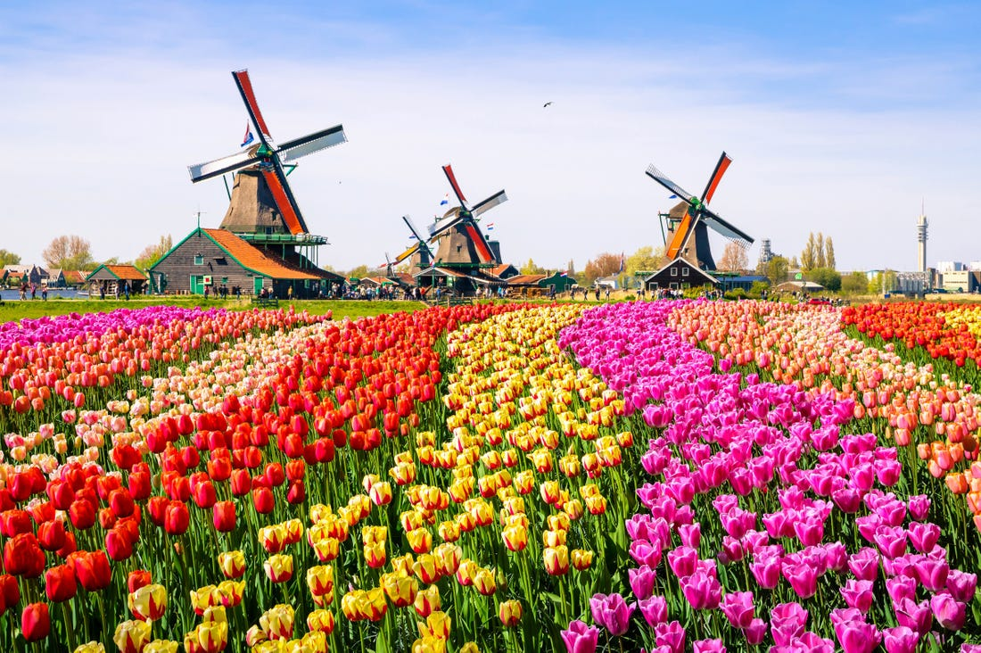

May 15, 2020
University of Wales Trinity Saint David

Table of Contents
Introduction 2
Brief Overview 2
Culture, History and Social Context 2
Current Emphasis on Tourism 5
Employment within Hospitality Sector 6
Funding and Sector Investment 6
Marketing 8
Government Involvement 8
Future Marketing Strategy 9
Comparison Country – Thailand (sex tourism) 10
Bibliography 12

Introduction

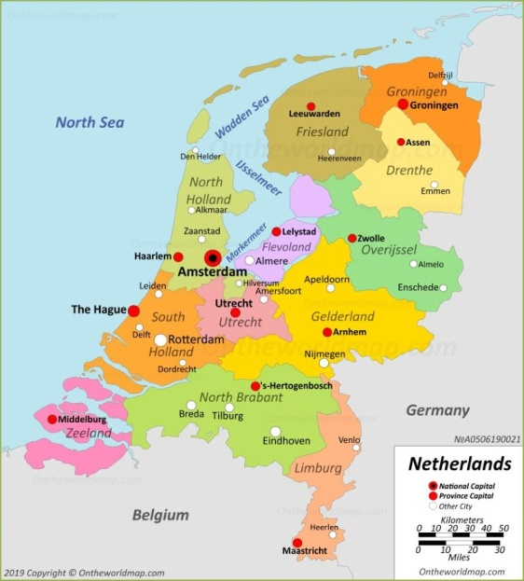
Brief Overview
The Netherlands, is a country which is situated in the North/west of Europe with Germany just to the east, some will know the country as Holland although this only really applies to the provinces that are north and south of the country. They have a population of 17.28 million as of 2019 and split their country up into 12 provinces with Amsterdam as its capital, they were one of the first counties to adopt the Euro and the language spoken there is Dutch.

Culture, History and Social Context
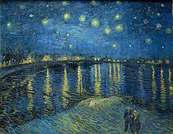
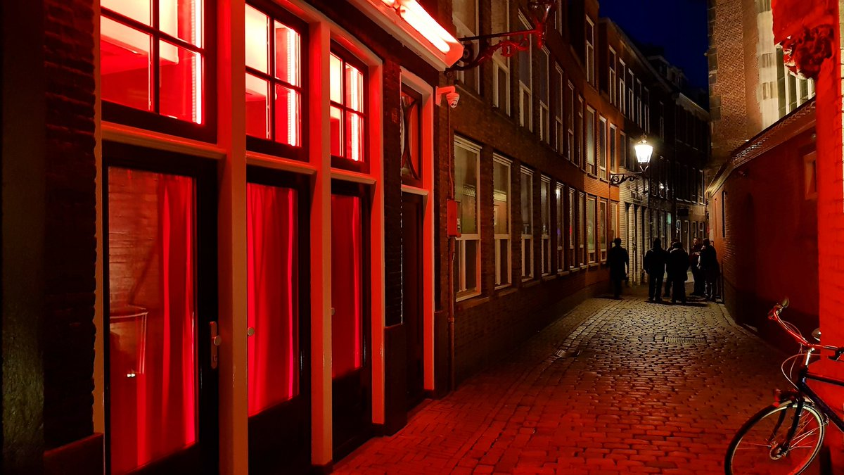
The United Provinces declared their independence from Spain in 1579 then; during the 17th century, they became a leading seafaring and commercial power, with settlements and colonies around the world. After a 20-year French occupation, a kingdom of the Netherlands was formed in 1815 and then in 1830, Belgium seceded and formed a separate kingdom (PWC, 2019). The country has been known for years as having famously flat landscapes although 27% of its surface is below sea level and therefore falls into three natural topographical divisions: the dunes, the lowlands or ‘polders’ (low-lying land reclaimed from the sea and from lakes and are protected by dikes), and the higher eastern section of the country (Nations Encyclopaedia, 2020). Today, the Dutch economy is the sixth largest in Europe and has been noted in the past for their stable industrial relations, moderate unemployment levels and important role filled by them as a European transportation hub. The cultural life of the Netherlands is varied and lively, Dutch paintings and crafts have been renowned all over with some Dutch painters being the best the world has ever known such as Vincent van Gogh. It is evident to see that the Dutch take great pride in their culture and heritage as the government there is heavily involved in subsidizing the arts. Indeed, the long-enduring tradition of Dutch freedom of expression has undoubtedly played a significant role in the flowering of Dutch culture through the ages (Encyclopaedia Britannica, 2020). The cuisine in the Netherlands is also notable for many individual dishes including filled pancakes, various pastries and a great variety of hard cheeses including Edam and Gouda meaning that anyone looking to travel to the country will have a choice of dishes to choose from. When looking at some social contexts of the country, the one that stands out most is surrounding the topic of sex; in many other cultures sex is seen as a shameful topic however, Holland will teach about sex education from the age of 4, not only in areas where young people may be exposed to the infamous red light district but to children all over the country, they believe that sex is a natural thing and that by having open discussions about it from a young age they are able to avoid any of the issues seen to be had by other culture (Dutch Review, 2020).

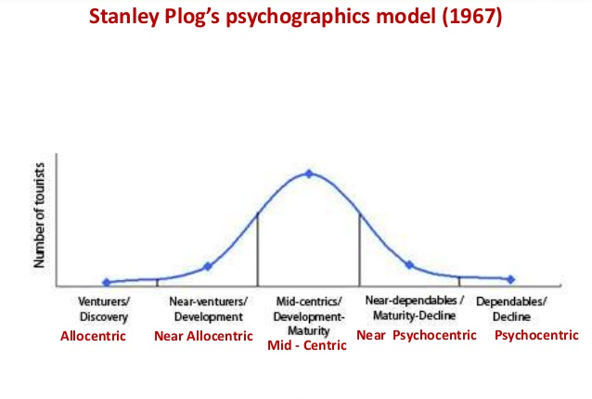
From all this you can gain a better understanding of the kind of people that would like to visit the country, Stanley C. Plog has a theory in which he felt he could classify people based on the location and type of holiday that they were looking to go on, for this he came up with 3 main classifications: allocentric travellers who would often travel alone and are looking for an adventurous experience, mid-centric travellers who will often visit places that have already been discovered and are well known to holiday makers, and psycholcentric travellers who are often uncomfortable about being away from home and will choose a holiday that has a similar scene and feeling to their home town. After reading about the cultural and social contexts of the country it would primarily be filled with allocentric and mid-centric travellers however Plog’s theory doesn’t end there because those who do not feel they fit into one profile then they can be split into ‘near allocentric’ or ‘near psycholcentric’. Even the fact that plenty of tourists will visit Holland to view the famous tulip fields that they have there could give life to the psycholcentric market of people looking to go on holiday.

Current Emphasis on Tourism
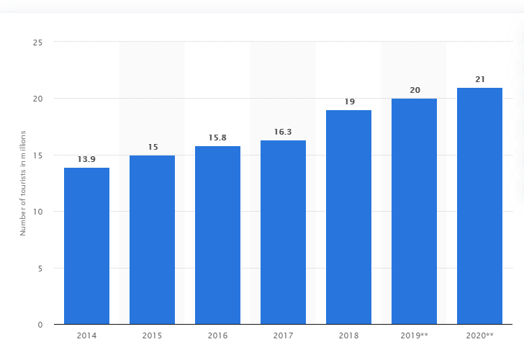
Approximately 19 million tourists visited the Netherlands in 2018, making it the 20th most visited country in the world (Lissa Poirot, 2019) and the amount of tourists that have stayed in accommodation has raised by 10% to 43 million from the previous year which according to Statistics Netherland – CBS is their strongest growth since 2006.
“Year-on-year the tourism industry becomes more important for the Dutch economy. A total of approximately 78 billion euros was spent by tourists in 2018 (excluding outbound and other expenditure). An important part of this expenditure can be attributed to tourists from abroad; roughly 32.5 billion euros was spent by inbound tourists (45 billion euros of domestic expenditure). This is roughly twice as much when compared to 2010” (Statista, 2020).
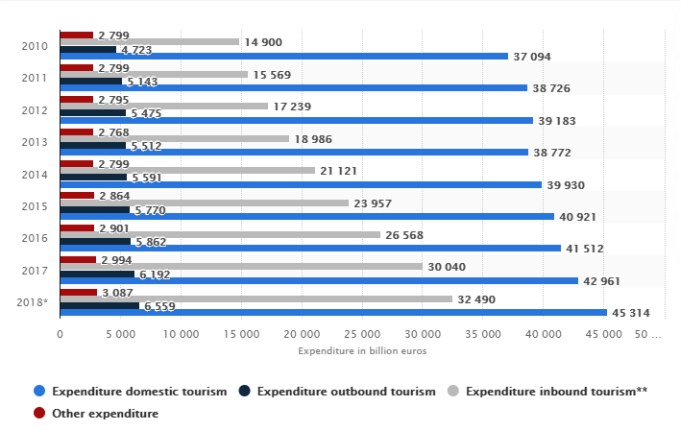

Employment within Hospitality Sector
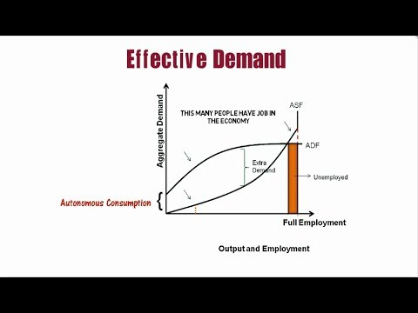
“The number of jobs in the Dutch tourism sector rose by 3.6 percent to 791 thousand in 2018. The share of the sector in the total number of jobs went up to 7.5 percent” (CBS, 2019). Although economic growth is good for creating a good recruitment pool it is important that growths occurs in provinces that have the ability to take on new employees on a large scale. Use of J.M. Keynes’ “general theory of employment” could be used to monitor employment in the country as it is viewed from the demand side of the model, according to Keynes “the volume of employment in a country depends on the level of effective demand of the people for goods and services. Unemployment is attributed to the deficiency of effective demand” (Keynes, 2016). Keynes’ theory however was seen in the short term mind and is suggestive under the circumstance that population, labour force and technology do not change and so it could be argued that the employment opportunities in a country depends on the level of national income and output.

Funding and Sector Investment
The Netherlands tourism sector will often use funding from public and private sectors with one of their major investors being the Ministry of Economic Affairs which is a government lead scheme to promote the global marketing of the country, their other responsibilities include:
- Funding the Netherlands Bureau of Tourism and Conventions (NBTC), this is responsible for the international marketing of the Netherlands and the promotion of international conventions.
- Stimulating innovation, entrepreneurship and sustainability – the tourism industry can make use of a range of general policy instruments available within the ministry.
- Stimulating the synergy bet ween nature, recreation and entrepreneurship.
- Acting as the first point of contact within central government for tourism industry associations and stakeholders.
OECD, Tourism Trends and Policies, 2014

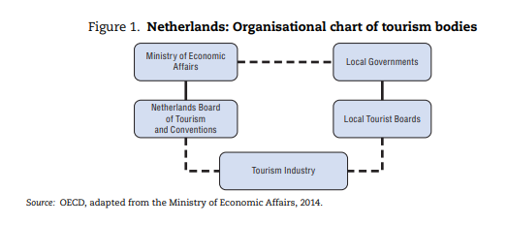
They also have support from NBTC Holland which is state funded yet sits in the private sector and can make it difficult for government bodies to intervene and make changes to any national or international marketing strategies.

Marketing
The Dutch have always been successful in the marketing of their country to international tourists, through their work with organisations like The Ministry of Economic Affairs and the Government of the Netherlands they have been able to maintain a strong and positive brand which appeals to many market segments, from young travellers who are looking to experience the better known tourism attractions of Amsterdam, older niche markets of tourists who might appreciate the arts and crafts of the country, to families who might be looking for a cheap flight holiday to a place with friendly people; Netherlands have been able to appeal to all!

Government Involvement
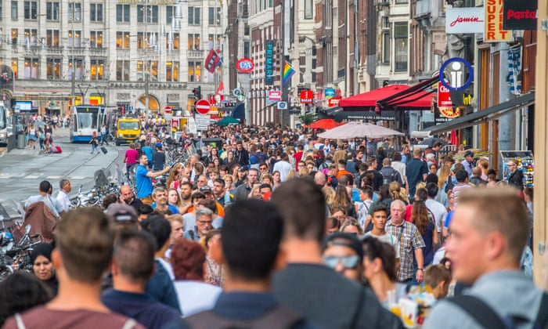
But now, according to the Government of Netherlands website “in 2017, a record number of foreigners visited the Netherlands: 17.6 million tourists and business people. This number is expected to increase even more, perhaps to 24.6 million by 2030. The UN expects the number of travellers worldwide to reach 1.8 billion by that year” (Government.nl, 2020). While the increase in tourism does produce more job opportunities and income to the country, it can cause problems with locals who feel their homes and attractions are being overrun by tourists in places like Amsterdam where the streets are always packed and littered with ques of tourists; it is for this reason that the Dutch government has said they will be looking to spread out their tourism hotspots and attract more business tourists as opposed to leisure tourists. With Amsterdam being one of the bigger problem areas, the new movement will hope to see red light district tours banned and more coffee shops insisting on customers providing some proof of ID to show they live in the country before being served (Forbes, 2019).

Future Marketing Strategy
The main priority for Netherlands tourism is now to spread out the number of places that people will go to visit instead of just Amsterdam and Rotterdam, giving a chance for other businesses in the country to reap the rewards of their continued growth in tourism. A new plan called the Holland City Strategy was planned out with the main 4 goals listed as:
- Promoting the Netherlands by means of cultural and regional themes. In 2018, there will be an extra focus on Leeuwarden, which has been designated European Capital of Culture 2018
- Making ‘Rembrandt and the Dutch Golden Age’ the theme of 2019.
- Using storylines to tempt tourists to go to different places in the Netherlands. In 2018, a flower-themed storyline was launched, centering on Keukenhof, various bulbfields and the international flower trade.
- Letting foreign tourists know that in the Netherlands you don’t have to travel very far to see the different sights. So that they don’t just go to Amsterdam, but visit other places too.
Government.nl, 2020

Comparison Country – Thailand (sex tourism)
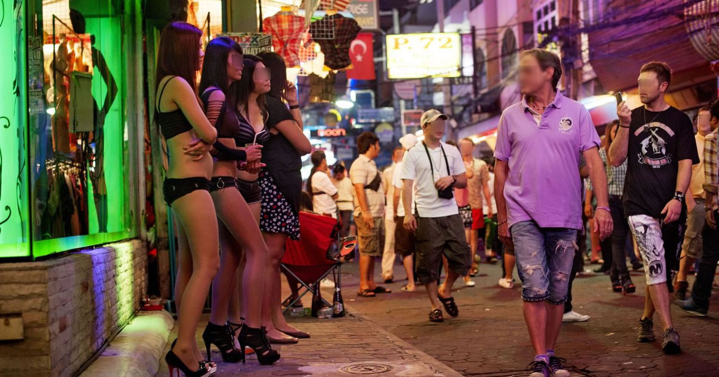
There are an estimated 300,000 sex workers currently working in Thailand (The Asean Post, 2020) and although it has been its most popular attraction for years, prostitution has been illegal in the country since the 1960’s however it is legal to buy sex as long as the sex worker is 18 or older. Those living there who decide to enter the industry will find they’ll make and estimated BHT5,000 (minimum wage in Thailand is BHT300) and will be contributing around 10% of the revenue generated from the entire entertainment industry in Thailand. While sex work has ensured their economic growth rate to increase at an incredible rate and has now become a major part of Thailand’s brand as a tourist destination it is worth noting that 18% of sex crime offence cases that are reported to local police are often dismissed with minor trafficking charges. Even though this may not affect every tourist travelling to cities in Thailand, the country has famously had a corrupt policing system for years and the show of sex crimes offences which were dismissed only proves that further and could cause bad fortune in other areas.

Conclusion
It is clear to see that the Netherlands have been able to establish themselves in a way which almost sets them in their own league of tourism as visiting figures have grown significantly over the years due to their excellent marketing capabilities, beautiful scenes, culture and the countries minimal crime rates. Their main issue as of current would be their mass tourism which is flooding places like Amsterdam due to their niche market capture of drug and sex tourism which given the locals education and their open minded approach sort of gives it more humanity as opposed to places like Thailand. The government however are combatting their issue with mass tourism by enforcing a strategy in which they will tempt tourists to other regions of the country in a bid to let other provinces across the country reap the benefits of a successful tourist destination, where families can go on short breaks to enjoy beautiful views and long walk paths and where older travellers can go to learn about a loving culture and immerse themselves in the crafts. If using the Butlers life cycle model you could place Amsterdam at the ‘stagnation’ stage as they implement new ways to spread out their tourism, the final stage of the model says about stagnation that “the last stage of his model offers five scenarios between complete rejuvenation and total decline:
A: Successful redevelopment leads to renewed growth.
B: Minor modifications to capacity levels lead to modest growth in tourism.
C: Tourism is stabilised by cutting capacity levels.
D: Continued overuse of resources and lack of investment leads to decline.
E: War, disease or other catastrophe causes an immediate collapse in tourism.
Butler, R. 2006
While it’s doubtful there will be a war with Netherlands given their historical stance on war, the changes to their tourism sector could result in travellers choosing an easier destination where the rules are perhaps clearer, however the more likely option is that the country will see tourism flourish and benefit locals all over the country whereby the country would ‘rejuvenate’ according to his model.

Bibliography
Butler, R. (2006). The Tourism Life Cycle. Oxford: Channel View Publications.
CBS, S. N. (2019, August 28). Tourists spent 87.5 billion Euro in 2018. Retrieved from CBS: https://www.cbs.nl/en-gb/news/2019/35/tourists-spent-87-5-billion-in-2018
Kamer, L. (2020, April 7). Statista. Retrieved from Inbound Tourism in the Netherlands: https://www.statista.com/statistics/658819/inbound-tourism-forecast-in-the-netherlands/
Keynes, J. M. (1936). The General Theory of Employment. London: Macmillan.
Ledsom, A. (2019, May 11). Why The Netherlands Tourist Board Wants To Discourage People From Visiting. Retrieved from Forbes: https://www.forbes.com/sites/alexledsom/2019/05/11/why-the-netherlands-tourist-board-wants-to-discourage-people-from-visiting/#34fd154851ab
Nortajuddin, A. (2020, May 14). Thai Sex Workers Hit Hard By Virus Lockdown. Retrieved from The Asean Post: https://theaseanpost.com/article/thai-sex-workers-hit-hard-virus-lockdown
OECD. (2014). Netherlands. OECD Publishing.
Poirot, L. (2019, October 25). 20 Most Visited Countries in the World. Retrieved from Far & Wide: https://www.farandwide.com/s/most-visited-countries-792c34d8901f4bc9
Tourism and Recreation. (2020, May 12). Retrieved from Government of the Netherlands: https://www.government.nl/topics/tourism-and-recreation/strengthening-the-tourism-industry
With More Tourists Arriving, Government Must Draw Up Tourism Strategy, MPs Say. (2019, October 21). Retrieved from Dutch News.nl: https://www.dutchnews.nl/news/2019/10/with-more-tourists-arriving-government-must-draw-up-tourism-strategy-mps-say/

