Contents
- Part 1 – Study Timetable – Pages 2-3.
- Part 2 – AI Activity – Pages 4-8
- Part 3 – Poster and reference page – Page 9
- Part 4 – Link to oral presentation also shared with lecture team – Page
AI Acknowledgment
I acknowledge the use of Microsoft 365 Copilot https://copilot.microsoft.com/ on 11/9/2026 to research study skills techniques. I used the
Initial prompt(s):
1. How do time management and managing wellbeing and study time find a balance in my learning?
2. Provide me with information about how I can best manage my wellbeing and studying?
3. Show me time management techniques to help me with my studies in university
I confirm that I have not presented any AI-generated text as my own work. I confirm I have copies of my drafts, notes, and other resources I used before and after the use of AI tools, which I may be asked to provide as evidence.
I acknowledge the use of Grammarly https://app.grammarly.com/?source=doc-title-bar on 18/9/2026 to check my own text for grammatical mistakes.

Part 1:
Time | Monday | Tuesday | Wednesday | Thursday | Friday  Day Off | Saturday | Sunday
00:00 – 06:59 | Sleep
07:00 - 07:59 | Wake up, shower and wake up kids. Prepare and eat breakfast together. | Wake up, shower and wake up kids. Prepare and eat breakfast together. | Wake up, shower and wake up kids. Prepare and eat breakfast together. | Wake up, shower and wake up kids. Prepare and eat breakfast together. | Wake up, shower and wake up kids. Prepare and eat breakfast together. | Lay in | Lay in
08:00 – 08:30 | Commute to work | Commute to work | Commute to work | Commute to work | Travel to school. | (same as above) | Wake up and shower.
08:31- 10:59 | Work |  |  |  | Read over structure and research and first draft of assignment | Family breakfast and getting ready for the day. | Breakfast and Rugby club commute and match.
11:00 - 11:59 | Lunch break | Lunch break | Lunch break listening to Panopto | Lunch break listening /reading articles | Pick kids up from school and quality time | Daughter swimming lesson. | Commute home from rugby club.
12:00 – 14:59 | Work |  |  |  | Time for food shopping and family time. | Lunch  Take dog for a walk and visit family | Family lunch and family time e.g. walk or park.
15:00 - 15:59 | Dinner Prep and look over notes from previous lecture. | At home gym– leg day. | Walk dog listening to relevant research linking to assignment. | At home gym – stretch and tone | Walk the dog. | Finalise final draft of assignment and research. | Church
16:00 - 16:59 | Commute to university. | Dinner prep and check in with the kids about their day | Daughter at gymnastics – planning /structuring for assignment. | Dinner prep and check in with the kids about their day | Dinner prep. | Finalise final draft of assignment and research. | Church
17:00 - 17:59 | In lecture | Family dinner | Family dinner | Family dinner | Family dinner | Free time | Prepare dinner
18:00 - 18:59 |  | Housework | Housework | Son at rugby training – first draft of assignment | Housework | Takeaway. | Family dinner
19:00 - 19:59 |  | Put kids to bed and kids' reading. | Put kids to bed and kids' reading. | Put kids to bed and kids' reading. | Time to reflect on first draft and research relevant information. | Family movie/games night. | Kids bedtime routine.
20:00 - 20:59 | Drive home. | Catch up with husband. | Catch up with husband. | Catch up with husband. | Catch up with husband. | Kids bedtime routine. | Free time.
21:00 - 21:59 | Wind down, reflection about the day and preparing for bed. | Wind down, reflection about the day and preparing for bed. | Wind down, reflection about the day and preparing for bed. | Wind down, reflection about the day and preparing for bed. | Wind down, reflection about the day and preparing for bed. | Wind down, reflection about the day with husband and preparing for bed. | Wind down, reflection about the day and preparing for bed.
22:00 – 22:30 | Reading for pleasure and guided mediation. | Reading for pleasure and guided mediation. | Reading research then guided mediation. | Reading research then guided mediation. | Reading research then guided mediation. | Reading research then guided mediation. | Reading for pleasure and guided mediation.
23:00 - 23:59 | Sleep.

Part 2
Initial prompt(s):
1. How do time management and managing wellbeing and study time find a balance in my learning?
2. Provide me with information about how I can best manage my wellbeing and studying?
3. Show me time management techniques to help me with my studies in university
Output from initial prompt:
Build a Routine That Protects Your Energy
Your wellbeing depends more on predictability than motivation.
What to do:
Wake up and sleep at roughly the same time.
Have set blocks for studying, meals, and rest
Keep weekends lighter but still structured.
Why it helps:
Routine reduces stress, decision fatigue, and procrastination. Your brain performs better when it knows what’s coming.
🧠 2. Use Study Techniques That Reduce Stress
Some methods make studying harder than it needs to be. These make it easier:
Active recall → boosts memory without hours of rereading
Spaced repetition → prevents last-minute cramming.
Cornell notes → keep your revision organised
Pomodoro blocks → protect your focus and prevent burnout
Why it helps:
You learn more in less time, leaving space for rest, hobbies, and social life.
🧘‍♀️ 3. Protect Your Mental Health Daily
Small habits make a huge difference.
Try:
10–15 minutes of walking or fresh air
A short mindfulness or breathing exercise
Journaling your thoughts or worries
Keeping your phone away during study blocks
Saying “no” when your schedule is full
Why it helps:
These habits regulate your nervous system, improve focus, and reduce anxiety.
🍎 4. Support Your Body to Support Your Brain
Your physical wellbeing directly affects your academic performance.
Focus on:
Sleep (7–9 hours) — memory consolidation happens at night
Nutrition — stable blood sugar = stable concentration
Hydration — even mild dehydration reduces focus
Movement — boosts mood and cognitive function
Why it helps:
A healthy body gives you the mental clarity you need to study effectively.
🤝 5. Stay Connected — Don’t Isolate Yourself
University can feel overwhelming if you try to do everything alone.
Stay connected by:
Talking to friends regularly
Joining societies or study groups
Asking lecturers or tutors for help
Using university wellbeing services when needed
Why it helps:
Social connection reduces stress and increases motivation.
📅 6. Use Time Management to Prevent Overwhelm
Good wellbeing comes from not feeling constantly behind.
Techniques that help:
Weekly planning
Daily “Rule of 3” priorities
Breaking tasks into microtask's
Starting assignments early
Keeping your timetable visible
Why it helps:
You stay ahead instead of catching up — which massively reduces anxiety.
🧩 7. Create a Study–Life Balance That Actually Works
Balance doesn’t mean equal time. It means intentional time.
Build your week around:
Study blocks
Rest blocks
Social time
Exercise
Personal hobbies
Sleep
Why it helps:
You avoid burnout and enjoy university life without sacrificing your grades.
❤️ 8. Be Kind to Yourself
You’re learning how to manage your life independently — that’s huge. Some days will be productive. Some days won’t.
What matters:
You show up consistently
You rest without guilt
You ask for help when needed
You celebrate small wins

Refined Prompts:
- Provide me with information about how better sleeping patterns can affect study technique. Include where you retained this information, making sure these are credible sources.
- Provide me with information about Cornell notes and how to do it. How was it discovered? Use credible sources
- Is the information you have provided correct, and how does Copilot source this information?
Prompts used to identify sources:
- Where do find your information sources from?
- List the exact sources you gave me on how sleep improves study performance and Cornell note-taking?
- How can sleep benefit the brain cognitively?

Discussion:
Introducing techniques to support studying is supportive practice in higher education. Techniques like the Cornell Note-Taking System and the importance of adequate sleep are both different techniques with different methods and structures, but together they provide knowledge to better study skills.
The Cornell Note-Taking System was created by Walter Pauk at Cornell University in the 1950’s; it helps structure information by dividing a page into three sections: a main notes section, a cue column, and an area for summary. The notes column should be used to record key information. The cue column is used for keywords and questions, and the summary area is for individuals to strengthen their understanding of the information. Seo, Ji-Young, a professor at Kookmin University in South Korea, researched the Cornell technique by experimenting with 77 students, separating them into two groups: one using Cornell note-taking and the other using personal notetaking. Results from the study revealed that the Cornell note-taking group achieved higher results that the personal note-taking group, showing a increased gap in testing outcomes over time (Seo 2025).
When the brain is well rested, it can maintain attention for longer periods of time to manage information efficiently and reduce brain overload. Sleep disorders and insomnia can affect a student’s academic success. (Schlarb, Friedrich and claßen 2017). Sleep plays an important role in supporting concentration for university students. Adequate sleep strengthens memory skills, supporting students to retain and recall information along with our brains having a break (Grace and ShortCutsTV 2023). Sleeps also improves mental health and wellbeing, reducing anxieties, enhancing motivation, and helping with critical thinking in lectures (Cotrell 2024).
Sufficient sleep and Cornell note-taking improve focus and strengthen memory. When combined, they offer a balanced approach to studying. Adequate sleep supports concentration and improves wellbeing, while the Cornell method boosts brain retention.
Reflection:
This reflection shows my experience with using the A.I tool Copilot. My reflection considers how A. I have contributed to my research in finding study techniques and validating the research's credibility.
Although A. I can be controversial, there are many positive attributes. I found Copilot easy to require information quickly, with a tap of my fingers, I had the answer to my prompt, making it easy for me to identify a study skill that would benefit my academic success. I found Copilot very easy to use; it was visually appealing, and I appreciated the column in which Copilot saved all my conversations for me to access later. This helped me with identifying potential research ideas and keywords that I could later use to refine my research.
However, I came into a few problems when using Copilot for my assignment. It may have been easy and quick, but I found the output Copilot was giving me were in lengthy paragraphs. Copilot would never give you one answer to the question; it would give you multiple answers to questions related to the original question. This made finding information sometimes time-wasting. I also experienced a lack in creditability; Copilot often gave me research that was from Wikipedia, a known website that is peer-edited and unreliable evidence.
An example of this is when I entered the prompt ‘provide me positive information on the Cornell note-taking method?’. Copilot's output to this prompt was to provide me with an experiment that, on the contents page, worded the method positively, but as I read the whole article, the article's conclusion page talked about the experiment's result as inconclusive. This contradicted what I asked of Copilot in the initial prompts. This shows how information from A.I is not always credible.
While I have positive and negative points in my reflection, I do recognise that Copilot should be used as a tool to support research rather than an answer to it. It provides good keywords and starting points for research to elaborate on. I can see how Copilot has the potential to improve my studies, but I also see the ethical concerns about it (Honeybourne 2025).
Going forward with my first year in university, I will use A.I as a tool and I will use responsibly. I will do this by double checking information and making sure I always use my critical thinking to validate information throughout my studies.
Part 3.
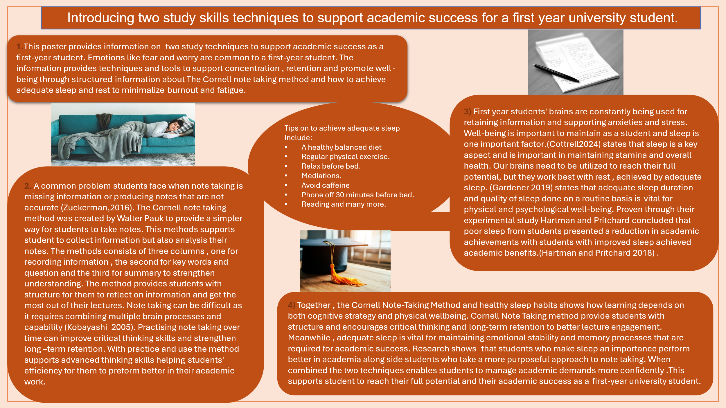
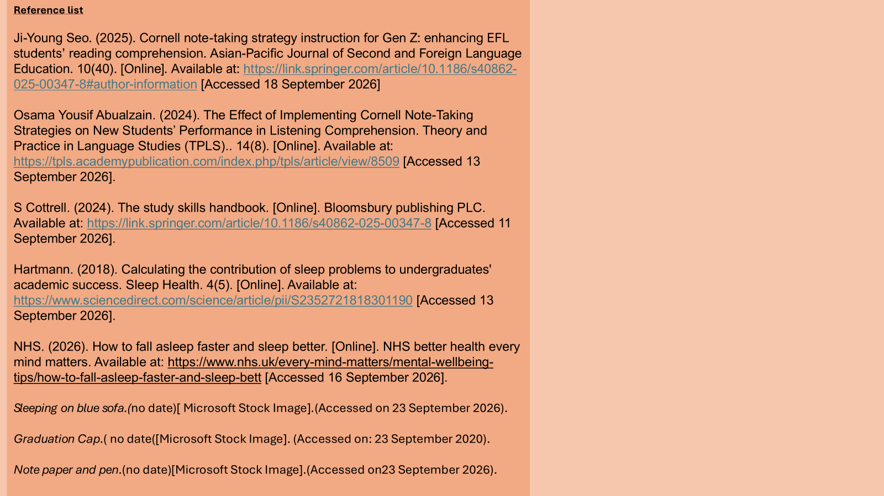

Reference list-
Honeybourne V (2025) Finding Joy in Studying: An Autistic and ADHD Guide to Uncovering the Study Skills That Work for You. Philadelphia: Jessica Kingsley Publishers. Available at: https://research-ebsco-com.uwtsd.idm.oclc.org/plink/45c69cd2-d1d0-3bc4-9019-ecb14c6fa3cc (Accessed: 17 September 2026).
Ji-Young Seo. (2025). Cornell note-taking strategy instruction for Gen Z: enhancing EFL students’ reading comprehension. Asian-Pacific Journal of Second and Foreign Language Education. 10(40). [Online]. Available at: Asian-Pacific Journal of Second and Foreign Language Education [Accessed 11 September 2026].
Fan, Y., Li, J. and Qiao, S. (2024). Sleep deprivation-induced memory impairment: Exploring potential interventions. Frontiers in Psychiatry, [online] 15, p.1470976. doi:10.3389/fpsyt.2024.1470976.
Osama Yousif Abualzain. (2024). The Effect of Implementing Cornell Note-Taking Strategies on New Students’ Performance in Listening Comprehension. Theory and Practice in Language Studies (TPLS), 14(8). [Online]. Available at: https://tpls.academypublication.com/index.php/tpls/article/view/8509 [Accessed 13 September 2026].
S Cottrell. (2024). The study skills handbook. [Online]. Bloomsbury Publishing PLC. Available at: https://link.springer.com/article/10.1186/s40862-025-00347-8 [Accessed 11 September 2026].
Hartmann. (2018). Calculating the contribution of sleep problems to undergraduates' academic success. Sleep Health. 4(5). [Online]. Available at: https://www.sciencedirect.com/science/article/pii/S2352721818301190 [Accessed 13 September 2026].
NHS. (2026). How to fall asleep faster and sleep better. [Online]. NHS Better Health Every Mind Matters. Available at: https://www.nhs.uk/every-mind-matters/mental-wellbeing-tips/how-to-fall-asleep-faster-and-sleep-bett [Accessed 16 September 2026].
SCHLARB, A.A., FRIEDRICH, A. and CLAßEN, M., 2017. Sleep problems in university students – an intervention. Neuropsychiatric Disease and Treatment, 13, pp. 1989-2001. DOI:10.1371/journal.pone.0156372
Grace, P. and ShortCutsTV, publisher (2023) Dynamic learning. Sleep and memory. Leicestershire, England: ShortCutsTV.

