Reflection of employability skills

Stefania Claudia Bulete-2106754
Tutor: Giridhar Katti
BMSW4001 Academic and employability Skills

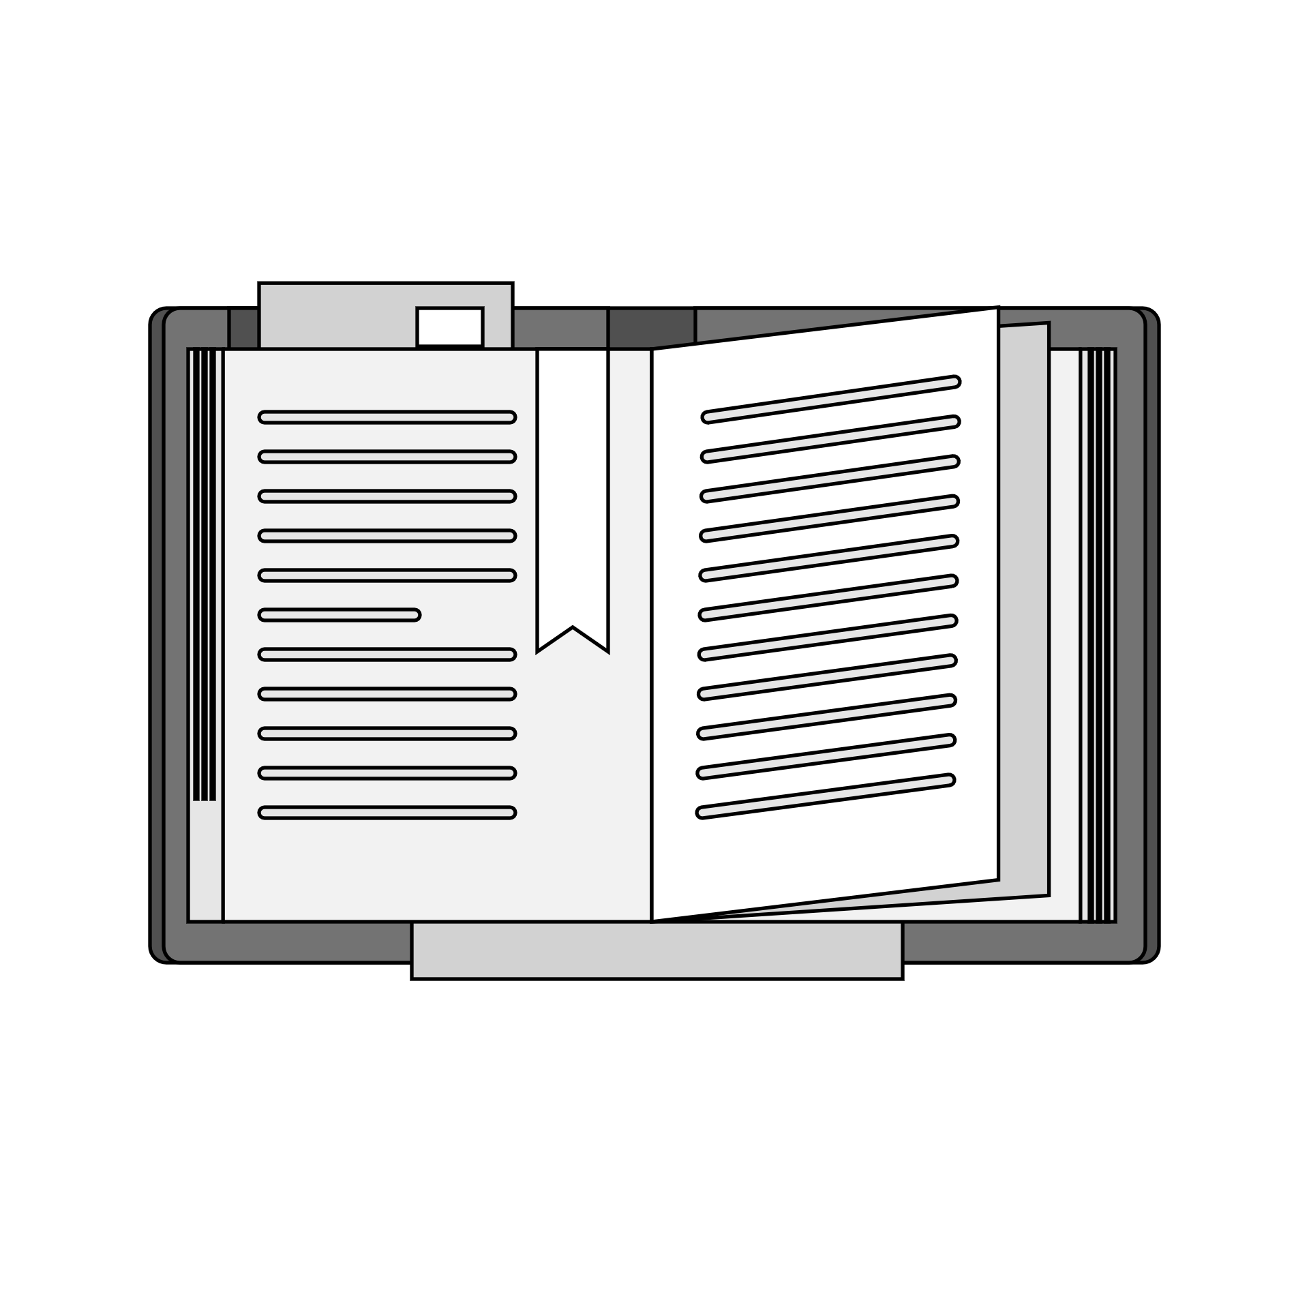

Table of Contents
Introduction 2
Time management 3
Presentation Skills 5
Research Skills 6
Team Working Skills 8
conclusion 10
References 10

Introduction

As a very motivated individual who wants to step in the working industry it is so vital to have a set of skills which meet and suits the industry to work for.
Being a very driven person, I have joined university with a clear development path in mind.
By now the courses helped me to achieve the following set of skills:
Time management is helping me to organise my work and meet the deadlines of projects, this feature is valued by employers.
Presentation skills will come in handy in my future positions where I will have to present data and new projects to colleagues and possible new customers of the business. I do consider that having this particular skill involve having other skills such as public speaking and multitasking.
When it comes to research, I think it can not be replaced by any other. It is the first step when preparing a report aider for work or studies.
In my opinion in nowadays, organisations put a big pressure on teamwork. It is so important to know how to work in a team effectively to understand others ideas and to be understood.

Time management

It is the process of organizing and planning how to divide your time between specific activities. Good time management enables you to work smarter – not harder – so that you get more done in less time, even when time is tight, and pressures are high.
A lot of people believe they cannot reach their dreams, travel to exotic locations, land their dream jobs, finish their projects before the deadline, get enough sleep every night, and spend enough time with loved ones because they don’t have enough time.
But here’s the deal: It is not limited time that is the problem, it is bad time management.
Effective time management is the effective use of your time that allows you to plan your days in such a way that you finish your work with less effort and make the most of the limited time you’ve got.
The benefits of time management:
- It helps you achieve what you want, and faster.
- It helps you get more done, but in less time.
- It helps you waste less time and avoid more friction and problems.
- It helps you clear your schedule for more leisure time and feel more energized.
- It helps you fulfil more tasks in less time, and in turn, feel more fulfilled.
- It helps you feel calmer and less stressed over time.
- It helps you make a change in your lifestyle for the better.

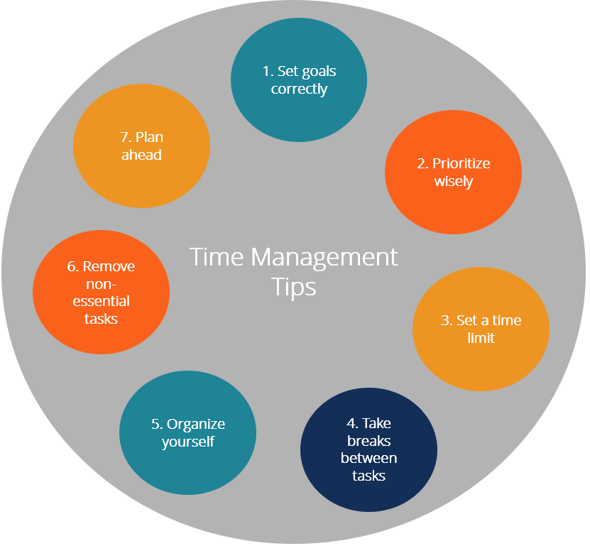

4 D Technique
DO:
- Planning my week well ahead
-Having my schedule wrote on paper and displayed in my room
DUMP:
-Going outside so often
-Unnecessary time spent in shopping centre
DELAY:
-Watching films and series
-Spending too much time on social media
DELEGATE:
-My mother to come with me shopping and avoid staying too much
-My best friend to push me respecting my schedule

Personal development plan
Step 1  Description | 2 weeks ago, I had booked an interview for a position that I really wanted.  I was aware that it was a tough interview and I had to prepare for it.  Because of my poor time management, the evening before interview, instead of preparing my answers I felt tired and fall asleep.
Step 2  Feelings | During the interview I was feeling nervous and unprepared.  After the interview I was feeling disappointed and powerless.
Step 3  Evaluation | On the positive side I have got a positive response from the interviewer.  Afterward I just felt angry with myself because I knew I could have done better.
Step 4  Analysis | On reflection I should have not get scared of the interview and prepare as much as I could in advance. I was feeling tired the evening before just because of my poor time management.
Step 5  Conclusion | On balance, I do realise that a good interview come with experience and knowledge. The good part of it, is that I have learned my lesson and I am sure I will do better in the future.
Step 6  Action Plan | Plan my days well ahead.  Avoid procrastinating and prioritise the big tasks.

Presentation Skills
A presentation is a means of communication which can be adapted to various speaking situations, such as talking to a group, addressing a meeting, or briefing a team.
Effective presentation skills include:
- Preparing your presentation
- Selecting and using the right visual aids
- Managing nerves and anxiety
- Using your voice: projection, intonation, emphasis, and pacing
- Non-verbal communication

I have massively developed this skill during my first lessons at university.
As a result of the lessons, homework, presentations, informative videos, this skill became a strong one for me.
All of these helped me to do:
- How to research the topic
- How to professionally build up a presentation
- How to deliver the content
- How to get advantage of PowerPoint and use the best of it
- How to maintain the audience engaged
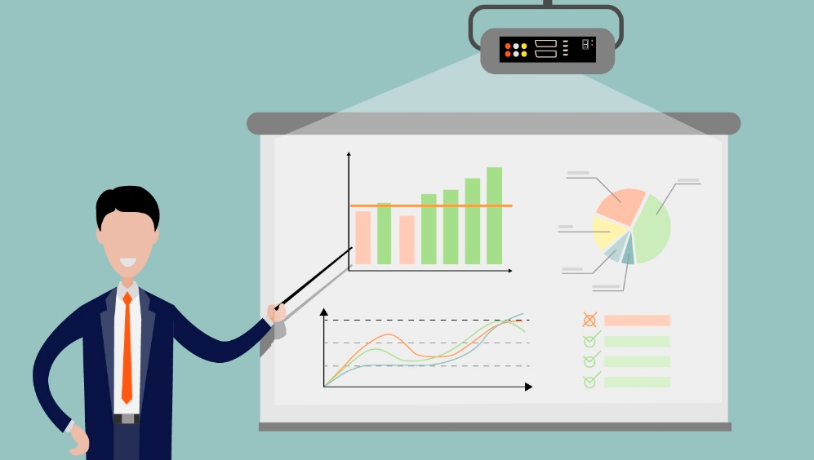

Personal development Plan
Description | This month I had a PowerPoint presentation at university.  I started to work on my homework just 2 days before presentation.  The presentation was not as good as expected.
Feelings | I felt disappointed because I have put on this presentation a lot of challenging work.  I did not feel ready for delivering my homework.  I felt embarrassed in front of the class because my poor work.
Evaluation | Despite I thought my work is bad; I have received from my teacher and my colleague’s good feedback even though it was not the best work but at least I followed the instructions and did my best.
Analysis | For a better presentation I should allow more time to work on, research the subject dipper, and I should analyse and research more about how to create and deliver a good PowerPoint presentation.
Conclusion | Following my feedbacks from colleagues and tutor, I gained valuable experience creating and delivering a piece of work.
Action Plan | Allow enough time to research and build the presentation  Do better research on the topic

Research Skills

Research skills are the ability to find answers or solve a particular problem by studying materials and sources. It includes the ability to gather information, analyse, interpret, and review it before providing a solution. Research is essential in a wide range of industries, and any employee can effectively use it to increase productivity. Research skills can also be a collection of skills that can help you review the information and make an informed decision.
Some elements that make up strong research skills include attention to detail, searching for information, problem solving and the ability to communicate results. Research skills ensure that you have a deeper understanding of an industry or product to craft an interesting sales message. With research skills, it's easy to shape the path you would follow to accomplish a particular goal.
Examples of research skills:
- Data collection
- Online research
- Analysing information from original sources
- Taking notes
One of the helpful research methods I have learned at school was CRAAP test.
Also, we have a library which is even online. The catalogue of library school is extraordinarily rich in books, articles, journals, and the best part of that we had a presentation about how to use the online catalogue and how to use the right information.

The CRAAP test is a test to check the objective reliability of information sources across academic disciplines. CRAAP is an acronym for Currency, Relevance, Authority, Accuracy, and Purpose.

Currency | When was the content written?  When was it published?  Has the content been updated?
Relevance | Why are you reading this article?  Does it deliver what it promises?  Are the language and coverage appropriate?
Authority | Does the author have an academic degree in the field?  Is the writer experienced enough?  Does the writer use a systematic approach?
Accuracy | Has the author cited his or her sources?  Are most of the sources scholarly and academic?  Have the results of these studies been replicated?
Purpose | What is the purpose of the article?  Any evidence of conflict of interest or hidden agenda?

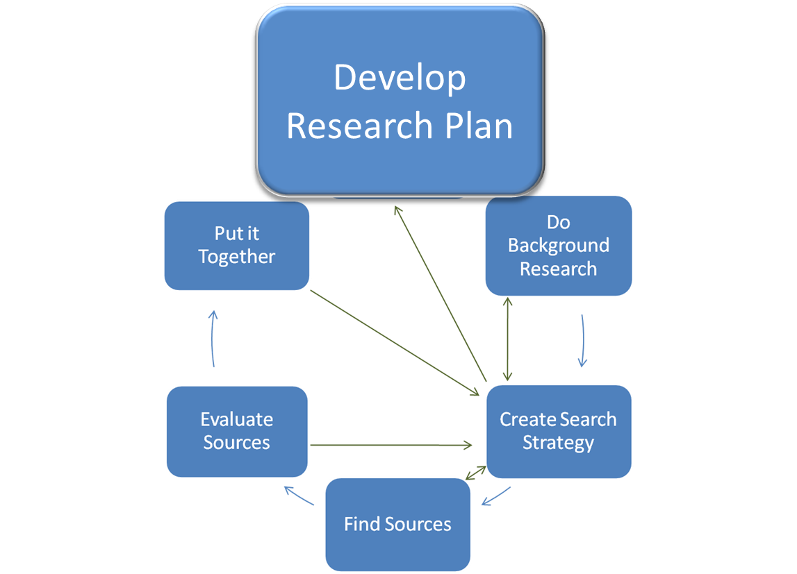

Personal Development Plan
Description | During my first semester at University, I have had to prepare an essay about Blended Learning. I was giving my best to prepare the work but uncertain if it is good or not.
Feelings | After submitting it to the university I felt anxious due to the facts that it was my first essay.
Evaluation | As a positive outcome my tutor was happy with my work and the fact that I have applied what we have learned at university about researching while writing an essay.
Analysis | My teacher gave me extremely helpful feedback and it is much appreciated because the guidance helped me a lot.
Conclusion | I am aware that as a first-time student in a foreign country, struggling with doing the research is very likely to happen. I am glad that I was applying CRAAP technique.
Action Plan | Be patient while learning new skills.  Apply and develop the skills learned.

Team Working Skills
Teamwork is the collaborative effort of a group to achieve a common goal or to complete a task in the most effective and efficient way. This concept is seen within the greater framework of a team, which is a group of interdependent individuals who work together towards a common goal.
The effective teamwork:
- Communication
- Time management
- Problem solving
- Listening
- Critical thinking
- Collaboration
- Leadership
Effective communication is vital both in and out of the workplace because it allows you to clearly translate your intentions and feelings into easily understandable messages.
Developing an effective communication process helps you understand what others are saying and makes you a better collaborator and team member.
How to improve your communication skills:
- Practice active listening
- Focus on nonverbal communication
- Manage your own emotions
- Ask for feedback
- Practice public speaking
- Develop a filter (developing a filter will help supplement other communication techniques and ensure that you maintain a certain level of decorum and avoid conflict in the workplace.)

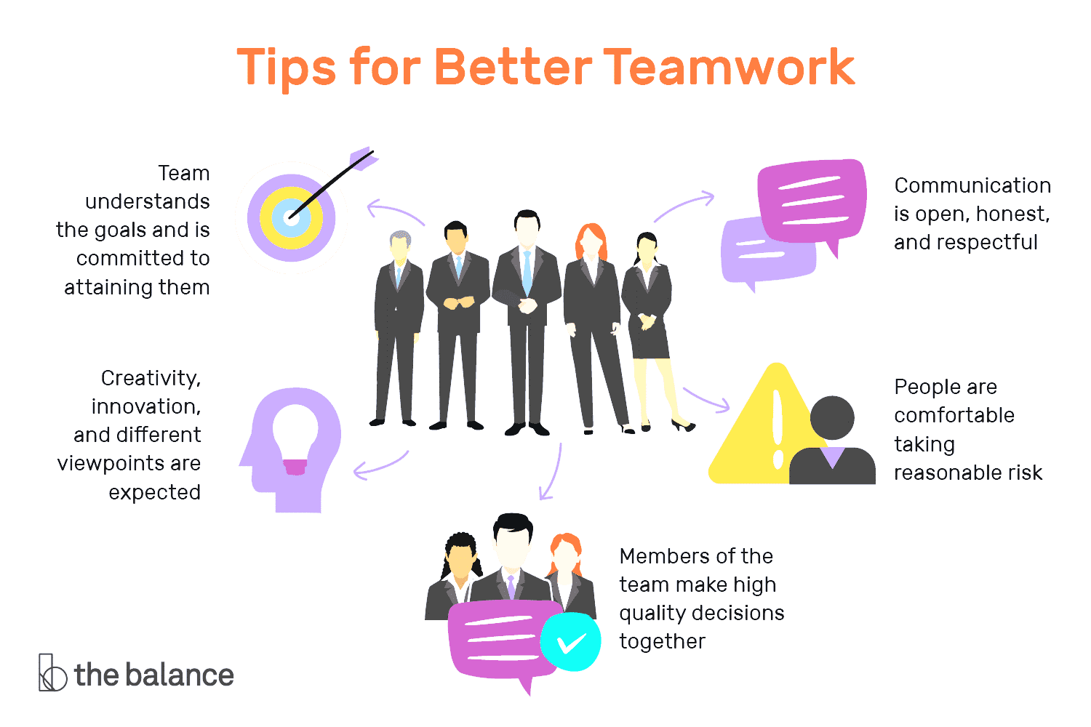

Personal development Plan
Description | The second module at university required a teamwork assignment. Because of it was first time for all of us doing this type of assignments, the teamwork was a bit difficult at the beginning.
Feelings | All of us felt a lot of pressure on our shoulders and a lot of uncertainty
Evaluation | Fortunately, we have received support coming from our tutor and it was one of the best assignments at the end of the day.
Analysis | As a group we have decided to share the responsibilities and ask where we do not feel sure.
Conclusion | We have worked like a real team together and we delivered the assignment in a professional team way.
Action Plan | Create from the beginning a plan so everyone knows what they have to do.  Know and respect individual’s skills and use effective communications within the team.

conclusion
In conclusion as many skills as you can develop during university and first jobs as better.

Job market is so tight therefore having a good set of skills will put you one step ahead from the others and make the candidate’s recruitment process easier and more enjoyable.

I strongly recommend to other individuals to take as many courses and experiences as possible to develop their potential.

References
Allen, A. &. & Allen, M. (1999) Time Management and Personal Development. London: Thorogood Publishing.
Anon (2012) Effective communication skills. MTD Training & Ventus Publishing Aps
Caposey, P. (2018) Manage your time or time will manage you: strategies that work from an educator who’s been there. Alexandria, Virginia: ASCD.
Cook, S. (2011) Essential time management and organisation a pocket guide. 1st edition. Ely, Cambridgeshire: IT Governance Pub.
Griffith, B. A. & Dunham, E. B. (2017) Working in teams: moving from high potential to high performance. Los Angeles: SAGE
Jolles, R. L. (2017) How to run seminars and workshops: presentation skills for consultants, trainers, teachers, and salespeople. Fourth edition. Hoboken, New Jersey: Wiley.
Van Emden, J. & Becker, L. M. (2016) Presentation skills for students. Third edition. London: Palgrave.

Feedback

