Generating Business Data Analysis
Module Code: BMSP4004
Assignment 1
Dr Roisin Mullins

Lauren Price (1807244)

CONTENTS

CONTENTS 0
EXECUTIVE SUMMARY 2
INTRODUCTION 2
THE HALLIWELL CENTRE 2
RATIONALE FOR THE HALLIWELL CENTRE 2
CONFERENCE ROOMS AVAILABLE 3
LENGTH OF CONFERENCES AVAILABLE 3
CONFERENCE AVAILABILITY 3
CONFERENCE FEES 3
PARKING 4
LOCATION 4
WELL-BEING OF FUTURE GENERATIONS (WALES) ACT 2015 4
CONFERENCE VENUE DATABASE 4
PLANNING AND ANALYSIS 5
DATABASE DESIGN 5
IMPLEMENTATION 6
MAINTENANCE 6
EXCEL VS ACCESS 6
ADVANTAGES AND DISADVANTAGES 7
RELATIONAL DATABASE 7
FLAT FILE DATABASE 7
CONCLUSION 7
REFERENCES 8
APPENDICES 9

EXECUTIVE SUMMARY
This report will explain the rationale and the logistics of the conference venue database, designed for the Carmarthen Business School (CBS) in connection with their new business venture to run conferences annually in Wales.

INTRODUCTION
From designing a database of appropriate conference venues throughout Wales, this report will attempt to identify which particular venue best suits the requirements of the Carmarthen Business School’s new annual conference venue business. The report will highlight the appropriateness of the venue and how it aligns with one of the seven key goals contained within the Well-being of Future Generations (Wales) Act. The report will also explain my approach adopted as a Database Administrator in the design of the conference venue database and how I implemented certain database considerations.

THE HALLIWELL CENTRE
The Halliwell Centre is located on the grounds of the University of Wales Trinity Saint David in Carmarthen. It is a purpose built, all year conference venue and can accommodate approximately 705 delegates over five conference rooms ranging in different capacities.
The centre itself is located within walking distance of Carmarthen Town Centre where there are ample facilities available including public transport links via rail and bus/coach.
The centre provides a number of amenities including registration and reception area, office services including photocopying and faxing, audio-visual and technical supplies and a sound induction system for the hearing impaired. The Centre has a bi-lingual policy in place where emphasis is placed on equality of both the English and Welsh language. Catering is available providing a range of different conference menus for delegates. There is also a restaurant and coffee shop located on site which is open from 8.00am until 6.30pm. Parking is available but limited. (Venue Wales; 2018).
The Centre also has up to 500 standard and ensuite bedrooms available for overnight stays for residential conferences.
The Halliwell Centre is ‘the most popular dedicated conference venue in the region, hosting over 1000 conferences every year’ (Venue Wales 2018).

RATIONALE FOR THE HALLIWELL CENTRE
I have decided to use The Halliwell Centre in Carmarthen as my chosen conference venue location.
The Centre is located within easy walking distance of Carmarthen Town Centre. Carmarthen offers a wide range of amenities including hotels, public houses, a well-established shopping area and provides good road links and public transport links including rail and bus/coach services.
Carmarthen sits on the River Towy and is known as being the oldest town in Wales. The town is steeped in history dating back to circa 75 AD. Today, it is known as a well-established market town, and which has encountered some major redevelopment works providing a new shopping complex and up to date indoor market facilities.
The Halliwell Centre boasts one of the town’s finest buildings and effortlessly blends into the town’s picturesque setting.

CONFERENCE ROOMS AVAILABLE
The Halliwell Centre offers five conference rooms/areas ranging in capacities and can host up to circa 705 delegates at any one time. The Centre provides a number of different options in relation to conference styles depending on what is type of conference is required and for how many delegates. The rooms can be arranged to provide a certain style of conference including theatre, classroom, boardroom, horseshoe or cabaret. The rooms are known as The Cothi Suite, The Teifi Suite, The Taf Room, The Flemming Suite and the Halliwell Theatre.

LENGTH OF CONFERENCES AVAILABLE
The Halliwell Centre can provide full day conference packages, evening conference packages and residential conference packages. The Centre boasts 500 standard and ensuite bedrooms available during university vacations which would be beneficial to delegates attending conferences lasting over a day.
I have used 50 delegates attending as an example within my database. The best conference room for the number of delegates attending is The Teifi Suite. The room can be arranged in a theatre style accommodating 80 delegates which would be perfect for a conference. This particular room also contains a bar where beverages can be provided.

CONFERENCE AVAILABILITY
The Centre is available for conferences during the entire year so the options of when to hold the conference is much more flexible which would appeal to more delegates.

CONFERENCE FEES
Fees for conferences vary at The Halliwell Centre depending on the type of conference required and the number of delegates attending. Based on using the Teifi Suite at The Halliwell Centre and using 50 delegates as a guide, the total cost for the room is £175.00 per day or £3.50 per delegate or £85.00 per evening or £1.70 per delegate. Catering can be provided, and flexible menu plans are available, accommodating any dietary requirements delegates may have. Buffet options vary but a typical standard buffet for 50 plus delegates starts are £7.88 per head. This equates to a total cost per delegate of £11.38 to include the all-day conference itself and the buffet package.
Equipment and services are available to hire at an extra cost depending on the requirements of the particular conference holder and include the following: -
Power Point Projector: £50.00
Screen Only: £15.00
Large TV Screen & DVD Player: £50.00
Laptop: £50.00
PA System Inc .1 x Microphone: £95.00
Additional Microphone: £35.00
Flipchart & Pens: £20.00
Staging (4’x6’4): £20.00
Lectern: £20.00
Technician: £17.50 per hour (minimum of 4 hours)
Photocopying: A4 @ 20p per copy A3 @ 30p per copy
Translation facilities available on request
(Venue Wales; 2018).

PARKING
Parking is available to delegates but is limited meaning other methods of transportation to the conference venue may be required. The conference venue itself is located on a regular bus route and the town has taxi services and there is a train station a short walk away.

LOCATION
The location of The Halliwell Centre is extremely beneficial to the Carmarthen Business School (CBS) as it is located on site at the University of Wales Trinity Saint David in Carmarthen. The CBS will be able to oversee the entire conference operation from start to finish and will be able to implement changes where necessary.

WELL-BEING OF FUTURE GENERATIONS (WALES) ACT 2015
‘The Well-being of Future Generations Act gives us the ambition, permission and legal obligation to improve our social, cultural, environmental and economic well-being’ (Future Generations Commissioner for Wales; 2018).
Looking at the seven key goals contained within the Well-being of Future Generations (Wales) Act, The Halliwell Centre most suitably aligns with ‘A Wales of Vibrant Culture and Thriving Welsh Language’ (Ibid).
This particular goal focuses on providing ‘a society that promotes and protects culture, heritage and the Welsh language, and which encourages people to participate in the arts, sports and recreation’ (Ibid).
Looking at the importance of promoting the Welsh Language, The Halliwell Centre has a bi-lingual policy in place which recognises how important it is to support the Welsh language and promotes the rights of Welsh speakers to communicate in their language of choice. The Centre is also focused on increasing the use of the Welsh language in its day to day business. The centre also has translation facilities available, which clearly shows that the centre is focused on promoting the use of the Welsh language.

CONFERENCE VENUE DATABASE
The purpose of the Conference Venue Database is not only to store data relating to the conference venues but also to extract information to make important decisions; in this case, the best venue to hold a conference in Wales.
The database I have created is a Relational Database which is a type of database that allows me to identify and access data in relation to another piece of data contained within it. The data is organised into tables and forms and relationships have been made between the data to analyse the information contained within it. (Codecademy; 2019).
In creating the Conference Venue Database, I have taken on the role as Database Administrator. As a Database Administrator essentially, this means I have complete control over the database including its physical design, ensuring recovery mechanisms are in place and performing backups, access control and security, data usage and performance, problem solving including breaches of security or poor system response time, user training and technical support and acquiring software and hardware resources as needed.
From a designer’s perspective, I have been involved in every phase of the database lifecycle.

PLANNING AND ANALYSIS
During this particular phase I first identified what my objectives were.
I was required to create a database containing a variety of conference venues within the whole of Wales and had to decide on the best one to suit the needs of the Carmarthen Business School’s new business venture. My database is based on 50 delegates attending a particular conference. The data I recorded took this figure into consideration.
I began by initially making an assessment of the extent of the requirements of the database and what information was needed to be included and any problems encountered were addressed at this time. I needed to ensure that all the information captured within the database was useful and corresponded to my overall objective. I knew that a poorly designed database could potentially lead to errors and inevitably bad decision making. I had to take into consideration how the database would be used in order to further the goal of deciding on the best venue. I also had to take into consideration who the users of the database would be and what they wanted to do and how they envisioned doing it.
I needed to understand the fundamental level of attributes contained within my database and the properties of the entities and relationships between the data. (Connolly & Begg; 2015).

DATABASE DESIGN

‘To be useful, the data in a database must be accurate, complete, and organized in such a way that data can be retrieved when needed and in the format desired’. (Harrington; 2009. Pg 45).
When I began to create the database, my goal was to concentrate on the data being recorded within it and to eliminate data redundancy. By using Microsoft Access instead of Microsoft Excel, it becomes much easier to avoid repetition of data. (Roman; 2002). When I focused on the conceptual design, I considered what kind of information was needed and what queries needed to be generated by the system. I knew that the goal was to decide on the best conference venue and that the Carmarthen Business School would be the ones using the information recorded. I found most of the information stored within the database from the internet and included only what was necessary.
I was able to accurately identify the relationships between the entities and the primary keys necessary. I broke down large data groups into smaller groups to ensure data redundancy was eliminated.

IMPLEMENTATION
During this particular phase the database was created. I used tables, forms and queries and it was during this stage that I fine tuned the database and ensured that the information stored was correct and relevant to my objective.
I found the queries tool particularly useful. I used queries to filter specific data and which adhered to certain criteria. (Tech Target; 2019).
I used the query tool to establish how many delegates attending against how many car parking spaces were available (Appendix 1). This could potentially cause a problem if there is inadequate parking available for the number of delegates attending the conference. Other forms of transport may be required.
I also used the query tool to arrange the venue name against car parking to make it easier to see how many car parking spaces were available with each venue. (Appendix 2)
To remove data redundancy and to ensure that data is divided into tables with entities being represented only once, I first had to understand the relationships between my tables and ensured that I placed a common field in tables that are related. (Microsoft; 2019).
Relationships were created between the entities. (Appendix 3)

MAINTENANCE
During this stage it is imperative that to prevent and prepare for any problem situations that may arise that a back up is created. Corrective maintenance is important to address any database system errors, for example recovery. It is also important to be able to adapt to external changes including database update and enhancement. General maintenance includes security audits and system usage analysis, and this must also be taken into consideration.

EXCEL VS ACCESS
I have been using two specific types of database models this semester, one is Microsoft Excel which is a Flat File Database and which I used to record prosumer companies in a spreadsheet and the other is Microsoft Access, which is known as a Relational Database and which I used to record conference venues.
Within the Relational Database, the data is stored in tables and each table consists of a number of columns or fields. The table consists of a number of rows or records and the information content of the database is represented by values in a data table. (Techopedia Inc; 2019).
Within a Flat File Database, data is stored, organised and calculated using formulas in a spreadsheet format. It is a collection of cells arranged into rows and columns containing information and data. (Techopedia Inc; 2019).

ADVANTAGES AND DISADVANTAGES

RELATIONAL DATABASE
Using a Relational Database has many advantages. It reduces redundancy of data, it avoids inconsistency, the data contained within the database can be shared and security of the information within the database can be maintained. Businesses would benefit from using this particular type of database because of its compactness, the speed and that the system is more up to date.
There are also a number of disadvantages to this particular type of database which businesses would need to consider, which could have implications to the business. Security of the data could be compromised, there may be additional hardware required which would have a cost implication, there could also be additional costs of further software and administrators and because the system is complex there may not be as many staff available who understand how to use the system.

FLAT FILE DATABASE
There are a number of advantages of using a Flat File Database such as Excel. The primary function of a Flat File Database is its primary function; to organise large amounts of data into spreadsheets and charts. It is then easy to analyse the relevant data especially when it is being used to create charts or graphs. It is a lot easier to make calculations using Excel by using formulas and equations. (Techwalla; 2019).
As with any software, there are also a number of disadvantages to using this particular type of database. Anyone can use Excel and it is relatively easy to start filling in tables but in order to get the full benefit it takes quite a lot of practice to become familiar with entering calculations and formulas. Excel doesn’t take into consideration human error and this could prove to be a problem. Another disadvantage is the amount of time it takes to manually enter data into Excel. (Techwalla; 2019). It took a considerable amount of time to enter the prosumer information into the database. I found it to be extremely inefficient and frustrating. This could potentially lead to mistakes being made which from a business perspective could be costly.

CONCLUSION
I have been able create a reliable and comprehensive conference venue database by using Microsoft Access and have analysed the data to choose the best possible venue to hold a conference in Wales. A Relational Database is a much more concise way to store and analyse data in comparison to using a flat file database. Although it was more difficult to use at first because it was a new system to me, as time progressed I found that it was much more time effective to use Microsoft Access rather than Excel for creating this type of database and for storing this particular type of information. I found that it was easier to analyse the data contained within the Relational Database which made my decision for choosing a suitable venue straightforward.

REFERENCES
Codecademy. (2019). What is a Relational Database Management System? Available at: https://www.codecademy.com/articles/what-is-rdbms-sql
Connolly, T & Begg, C. (2015). Database Systems: A Practical Approach to Design, Implementation and Management. 6th Edition. Harlow: Pearson.
Future Generations Commissioner For Wales. (2018). Well-being of Future Generations (Wales) Act 2015. Available at: https://futuregenerations.wales/about-us/future-generations-act/
Harrington, J. (2009). Relational Database Design and Implementation – Clearly Explained. 3rd Edition. Amsterdam, Boston: Morgan Kaufmann/Elsevier.
Microsoft. (2019). Guide to Table Relationships. Available at: https://support.office.com/en-gb/article/guide-to-table-relationships-30446197-4fbe-457b-b992-2f6fb812b58f
Roman, S. (2002) Access Database Design and Programming. 3rd Edition. Sebastopol, Calif, Farnham: O’Reilly.
Tech Target. (2019). Query. Available at: https://searchsqlserver.techtarget.com/definition/query
Techopedia Inc. (2019). Microsoft Excel. Available at: https://www.techopedia.com/definition/5430/microsoft-excel
Techwalla. (2019). Advantages and Disadvantages of Microsoft Excel. Available at: https://www.techwalla.com/articles/advantages-disadvantages-of-microsoft-excel
University of Wales. (2018). University of Wales Bilingual Policy. Available at: https://www.wales.ac.uk/Resources/Documents/StaffDocuments/Compliance/Welsh-Language/University-of-Wales-Bilingual-Policy.pdf
Venue Wales. (2018). Canolfan yr Halliwell Caerfyrddin / Halliwell Centre Carmarthen. Available at: http://venuewales.co.uk/halliwell-centre-carmarthen/
Venue Wales. (2018). Halliwell Centre. Available at: http://venuewales.co.uk.s16804.gridserver.com/vw_contentess/uploads/2013/03/Conference-Brochure-Carmarthen-2017-2018.pdf

APPENDICES
Appendix 1 – Query 1
Appendix 2 – Query 2
Appendix 3 – Relationships

APPENDIX 1
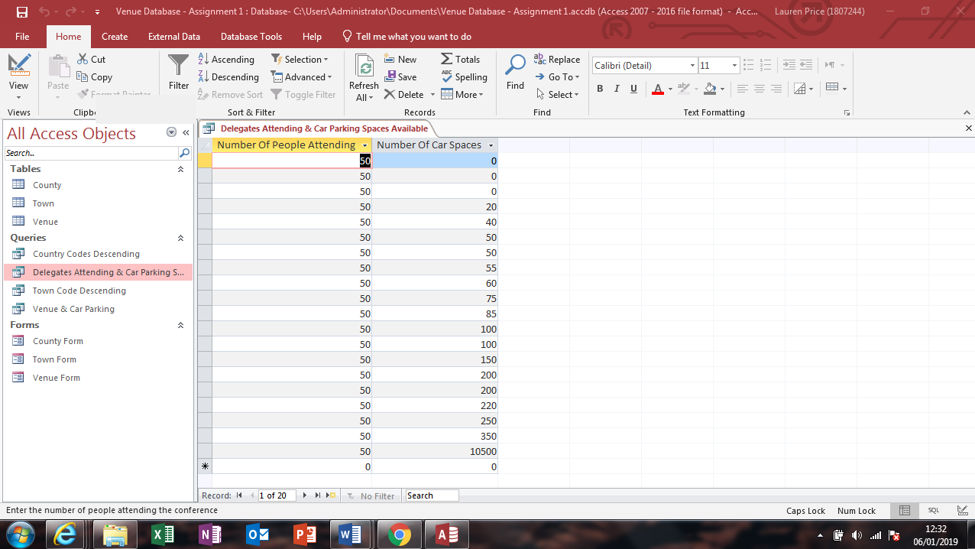

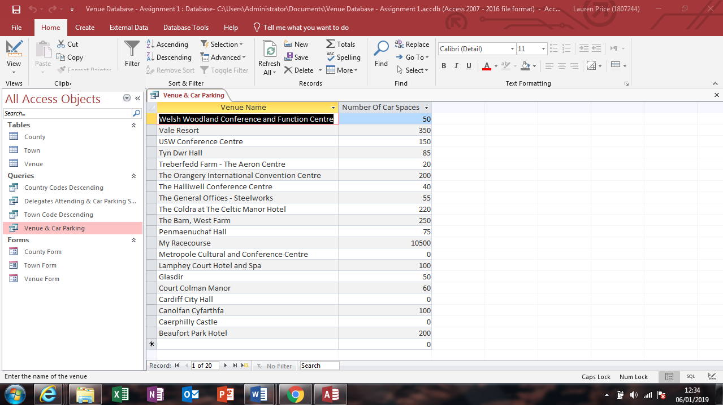
APPENDIX 2

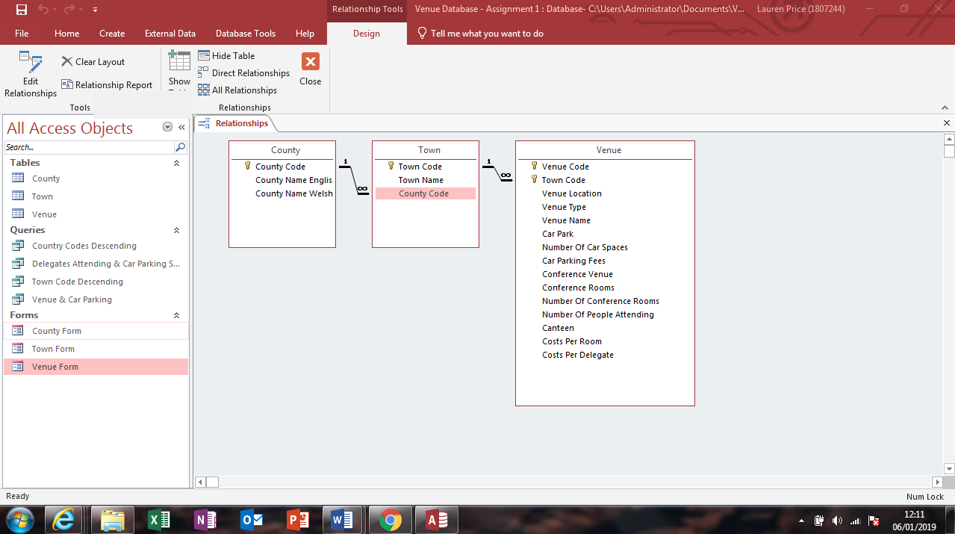
APPENDIX 3

