Thomas Sellwood (2215661)

Data warehousing – rags’n’riches ltd

Table of Contents
Introduction 1
Task 1 1
OLTP Versus Data Warehouse 1
Data Warehouse Architecture and ETL 2
Use of Data Marts 3
Star Schema and Dimensional Design 4
Task 2 6
Data Source and Schema Identification 6
ETL Plan 9
Data Governance 10
Conclusion 10

Introduction
This report examines the design and conceptual development of a data warehousing solution for Rags’n’Riches Ltd., a company specialising in the rental of high-end clothing and accessories. The organisation currently operates across multiple locations, with its headquarters based in Raglan, Monmouthshire, and is undergoing a process of business rationalisation to improve operational efficiency and strategic alignment. As part of this initiative, a comprehensive review of the organisation’s operational information systems has been commissioned, with particular focus on how data is stored, managed, analysed, and presented.

The primary aim of this report is to critically evaluate the structure, capabilities, and overall suitability of a data warehousing solution within a modern business environment. The report will explore how such an approach can support improved data integration, enhance analytical capabilities, and facilitate more informed decision-making across the organisation.

Task 1

OLTP Versus Data Warehouse
Operational data systems and data warehouses fulfil distinct roles within an organisation’s information infrastructure. Online Transaction Processing (OLTP) systems are designed to support day-to-day business operations through the efficient handling of transactional data [1]. These systems typically employ highly normalised schemas (third normal form) to minimise redundancy and ensure data integrity, enabling fast insert, update, and delete operations [1]. Within Rags’n’Riches Ltd., OLTP systems would underpin activities such as processing rental transactions, managing inventory across multiple locations, and maintaining customer records.

However, OLTP systems are not optimised for analytical querying or historical analysis. Their structure and performance constraints make it difficult to efficiently generate insights that support strategic decision-making. In contrast, data warehouses are designed specifically for analytical purposes [1]. They integrate data from multiple sources into a centralised repository and typically their structures are denormalised [1], utilising schemas such as star, snowflake and galaxy [1] [2]. In turn this improves query performance and usability.

Data warehouses are also characterised as time-variant and non-volatile, meaning they store historical data that is not frequently refreshed [1], this allows for trend analysis and reporting over extended periods [1]. For Rags’n’Riches Ltd., this enables the analysis of customer behaviour, seasonal demand patterns, and warehouse performance. This capability is not easily achievable within OLTP systems alone as queries are mostly predefined and simple within their nature [1].

In summary, while OLTP systems are essential for operational efficiency, they are insufficient for advanced analytics. A data warehouse provides a complementary solution, supporting integrated data analysis and more informed decision-making.

Data Warehouse Architecture and ETL
A data warehouse architecture that is well defined is a key step that is essential in the efficient integration, storage and analysis of data [2]. For Rags’n’Riches Ltd., a layered architecture would be proposed. This would consist of:
- Staging layer
- Central data warehouse
- Data Marts

Taking the approach in this way, allows the separation of the operational data processing from the processing of data for analytical purposes, this improves performance on the OLTP system by not bombarding it with large queries that could degrade performance [2].

The staging layer will serve as an intermediate storage area where the raw operational data from the OLTP system will be collected initially. The data collected would include rental transactions, inventory records, customer information and supplier information from the multiple warehouse locations. Data is extracted from these sources and then temporarily stored in the original format so that this data can then be validated and pre-processed [2] [3].

The extract, transform, load (ETL) process is one of the central processes of the architecture. The extraction phase is when the data is retrieved from the source systems at pre-defined scheduled points, this will be done to minimise the disruption to the normal operating of the system [3] [4]. The transformation phase is when the data that has been extracted from the source system is then cleaned. Here missing values will be handled, any inconsistencies will be handled, and any business rules will be applied to the data such as product categorisation and any internal identifiers will also be applied [3][4].

The final phase is the loading phase, this when the data then is inserted into the data warehouse, it is structured using a denormalised schema which supports efficient querying [1][3].

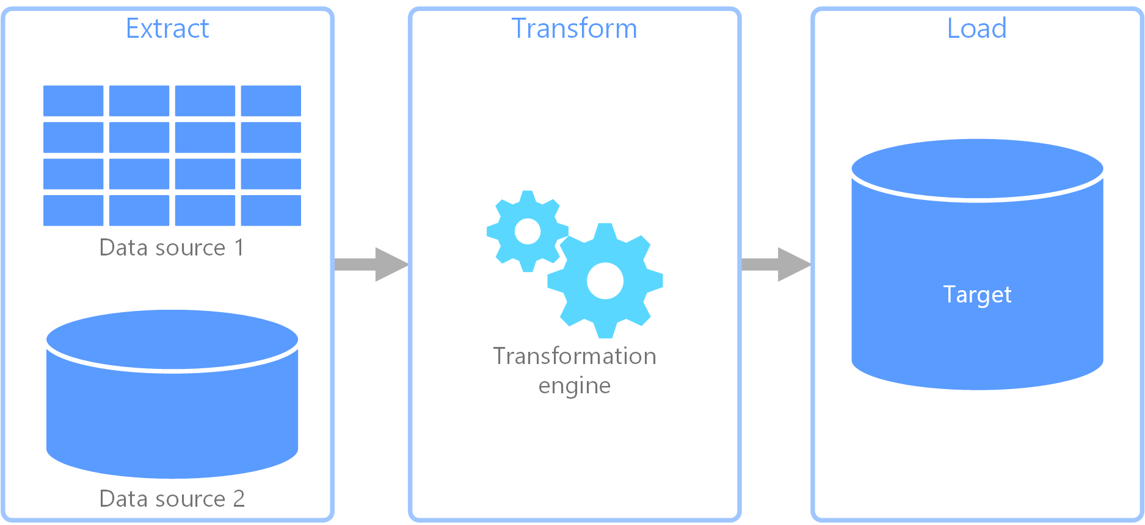
Figure1: ETL Process[3]

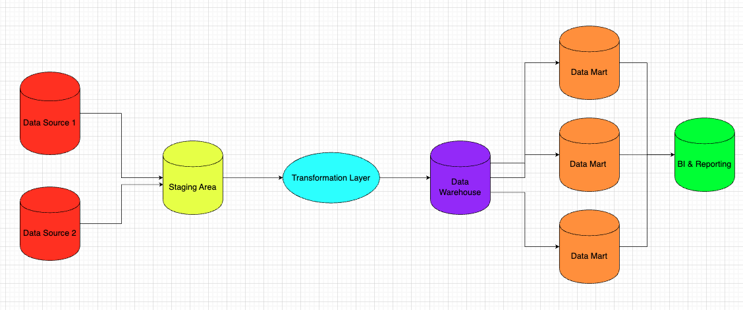
Figure2: ETL Process

Often these processes will run in parallel to save time, so that while data is being extracted it is then being transformed and prepared for loading, and once those pieces of data are transformed, they can be loaded. This parallelisation will be designed around identifies such as date to avoid contention [3].

Overall, this will ensure that Rags’n’Riches Ltd., can integrate data from across multiple sources, can maintain robust data quality, and support analytical capabilities through a structured ETL pipeline.

Use of Data Marts
Data marts are specialised subsets of a data warehouse that are designed specifically for the analytical requirements of specific business departments or function [1] [5]. Unlike the data warehouse described above a data mart is a more focused and efficient environment for users to query and report on data for a specific area of the business such as sales or finance [1][5]. The implementation of these could improve query performance, access to relevant business data and support decision making [1] [2].

For Rags’n’Riches Ltd., the use of data marts would enable different areas of the organisation to effectively analyse operational performance. Varying data marts such as a rental performance data mart could be developed to analyse transaction volumes, rental frequency, demand across the varying product categories. This would assist in managing high demand items and the potential to rationalise the stock allocation between warehouse locations.

A data mart focussed on customer insights could be implemented for the analysis of customer behaviour, including rental preferences, item usage patterns, and the customers demographics. This analysis can help Rags’n’Riches Ltd., to develop insights and targeted marketing strategies which in turn could improve customer retention [6] [7].

The addition of a data mart for inventory management could provide the opportunity for insights into stock availability, item utilisation rates, and warehouse performance. This can support more efficient inventory planning to help reduce the likelihood of overstocking or having shortages of products [8].

By separating out these analytical functions into dedicated data marts for business areas, Rags’n’Riches Ltd., can provide their business users with faster access to information, reduce the complexity of querying the central warehouse [5]. These data marts can contribute to improved reporting efficiency enhanced decision making and greater flexibility and access to data [1] [5].

Star Schema and Dimensional Design
Operational online transaction processing systems typically use a normalised database structure (third normal form) [9], to reduce data redundancy and maintain data integrity for daily business activities. In this normalised structure the data is separated across multiple related tables, which optimises it for transaction processing, but when querying this data can often result in the queries written being quite complex [1] [9].In relation to Rags’n’Riches Ltd., this system would handle business activities such as, rental processing, customer and supplier management and inventory tracking across the warehouse locations.

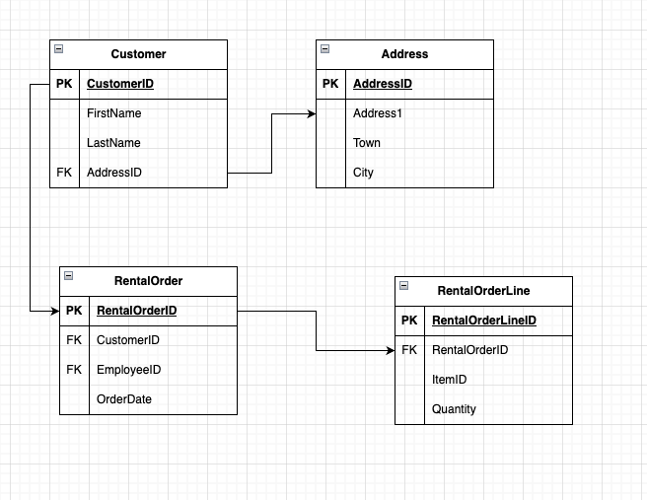
Figure3: Example Normalised Database Structure

Data warehouses on the other hand adopt a dimensional structure, this structure is designed specifically for analytical reporting [1] [2]. Dimensional models are typically denormalised, this denormalization improves query performance by simplifying these queries [2]. One of the more common dimensional models are the star, this consists of a central fact table connected to several surrounding dimension tables [1].

The star schema that would be proposed for Rags’n’Riches Ltd., the central fact table would store measurable transaction data relating to each of the rental activities such as, rental cost, rental duration, and total revenue generated. The granularity of this central fact table would represent each rental transaction as a separate line. Surrounding this fact table would be several dimensional tables providing the descriptive business context of the central data in the fact. As an example, potential dimension tables could be a customer dimension, this could store data such as name, address and contact details. A product dimension table which would store data such as category, brand and size. This concept is demonstrated for rentals in the diagram below.

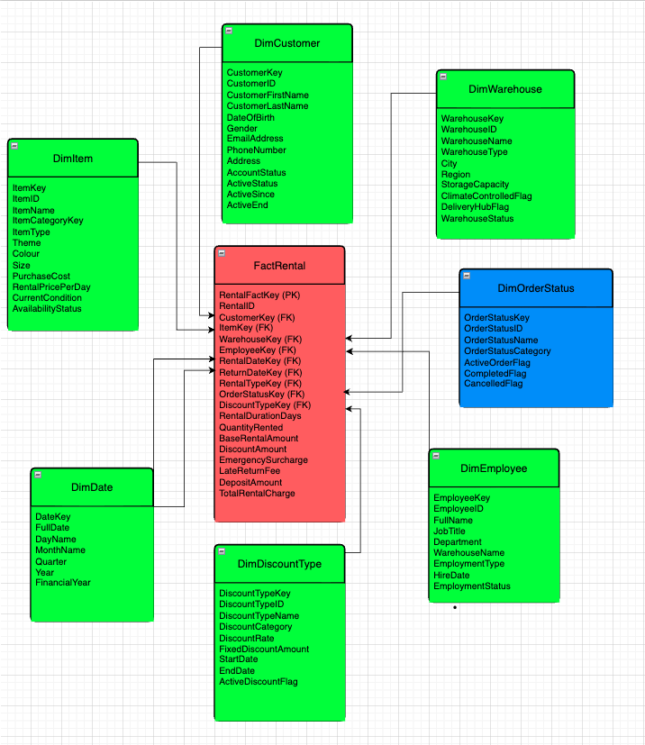
Figure4: Star Schema Rentals

The denormalised structure of the star schema reduces query complexity and enables more efficient reporting and analytical processing, that can facilitate improved decision making across the organisation.

Task 2

Data Source and Schema Identification
The data warehouses effectiveness lies in its dependence on the integration of organizational data from reliable sources [1]. For Rags’n’Riches Ltd., the primary source systems consist of operational databases supporting rental processing, inventory management, transport logistics, customer management, and finance operations across multiple warehouse locations.

The rental orders system records customer transactions, item rentals, delivery schedules, discounts, surcharges, and payment information. Inventory databases store information relating to costumes and props, including item identifiers, warehouse location, rental status, and stock movement between sites.

Additional data is generated through the transport and delivery systems, which record vehicle usage, delivery confirmations, returns, and damage reports captured by warehouse staff using mobile devices. Financial systems also provide invoice and revenue data used for profitability analysis and monthly reporting.

To support the analytical processing, the operational data would be integrated into a dimensional schema using fact and dimension tables [1]. The central fact table would contain measurable rental transaction data, while surrounding dimensions would store descriptive information relating to customers, products, warehouses, and time periods.

This structure would enable Rags’n’Riches Ltd. to efficiently analyse operational performance, customer demand, and inventory profitability across all business locations.

The diagram below demonstrates the proposed multi-star schema for Rags’n’Riches Ltd.

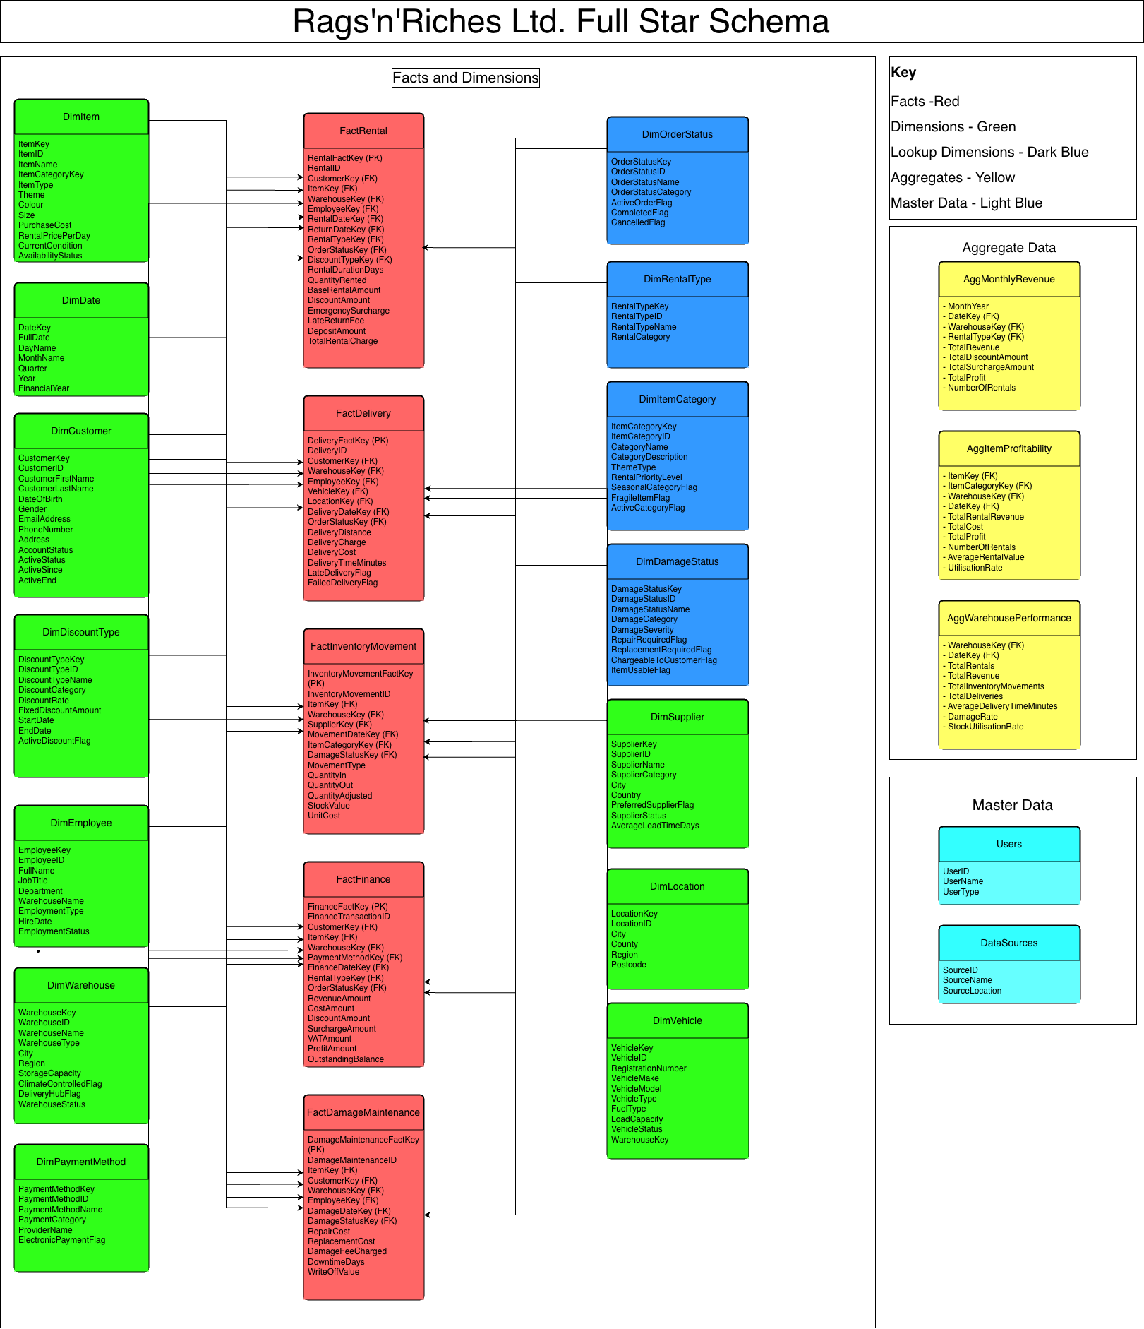
Figure5: Full Star Schema Rags’n’Riches Ltd.

Dimensional modelling is a technique widely used within data warehouse design due to its ability to support efficient analytical querying and business intelligence processes [1]. The star schemas provide a simplified structure in which measurable business events are stored within fact tables, while descriptive business context is stored within surrounding dimension tables [2]. A star schema is particularly appropriate for Rags’n’Riches Ltd. due to the company’s large volume of rental, logistics, inventory, and financial transaction data which is generated across the multiple departments and warehouse locations inhabited by the business.

The proposed star schema would contain several fact tables designed to support different analytical functions of the business. The FactRental table would store measurable transactional data of a single rental item per transaction per day. The fact would include measures such as rental cost, discounts, surcharges, delivery charges, and total rental charge. Additional fact tables would include FactDelivery, containing transport and delivery information, FactInventoryMovement, recording stock transfers between warehouses, FactDamageMaintenance and FactFinance, storing invoicing and profitability data. Structuring the warehouse using multiple fact tables allows the organisation to analyse operational activities from several business perspectives including rentals, logistics, inventory management, and finance while maintaining a consistent dimensional structure [2].

The FactRental table would act as the central transactional fact within the warehouse due to rental processing representing the core operational activity of the business. The table would be linked to several conformed dimensions including DimCustomer, DimItem, DimWarehouse, DimEmployee, DimRentalType and DimOrderStatus. These dimensions would provide descriptive business context to support the reporting and analytical querying of data [10]. As an example, management could analyse rental profitability by warehouse location, identify seasonal demand trends for specific costume categories, or evaluate the performance of employees and delivery operations. The use of conformed dimensions across multiple fact tables would improve reporting consistency and allow integrated analysis across the organisation [2].

The DimCustomer table would contain customer identifiers, demographic information, contact details, and customer classifications to support customer behaviour and retention analysis. Similarly, the DimItem table would contain information relating to item category, theme type, item size, rental pricing, and inventory status. Additional dimensions including DimWarehouse, DimDate, DimVehicle, DimSupplier and DimLocation would support geographical analysis, inventory movement monitoring, supplier performance evaluation, and transport logistics reporting. The DimDate dimension would be particularly important as it would enable time-series analysis, trend analysis, and financial period reporting across all business processes [1].

Several lookup dimensions would also be incorporated including DimRentalType, DimDamageStatus, DimDiscountType, DimOrderStatus and DimItemCategory. These dimensions would standardise business classifications and improve data consistency throughout the warehouse environment. Master data tables would additionally support governance by recording source system mappings, user information improving traceability and supporting data governance processes [3] [11].

To further improve query performance, aggregate tables such as AggMonthlyRevenue, AggItemProfitability and AggWarehousePerformance would be implemented. Aggregate tables reduce the need for repeated calculations on large transactional datasets and improve response times for frequently executed management reports and dashboards [1] [12]. Overall, this dimensional model would provide Rags’n’Riches Ltd. with a scalable and efficient platform for business intelligence and operational reporting.

Data Marts

The proposed data warehouse for Rags’n’Riches Ltd. would support several dedicated data marts aligned to each of the organisational functions.

A Finance Data Mart would extract data from the FactFinance table, including revenue amounts, costs, discounts, surcharges, VAT, outstanding balances, and profitability metrics. The mart would also connect to dimensions including DimCustomer, DimItem, DimWarehouse, DimDate, and DimPaymentMethod to support multidimensional financial analysis [1]. This would enable Rags’n’Riches Ltd. to monitor financial performance by customer, warehouse location, item category, and reporting period. Aggregate tables such as AggMonthlyRevenue and AggItemProfitability would further support management reporting by summarising revenue, profit, utilisation rates, and rental activity, improving query performance for dashboards and financial reports [2]. This structure would support operational finance reporting and help management identify profitable or underperforming assets and warehouse locations.

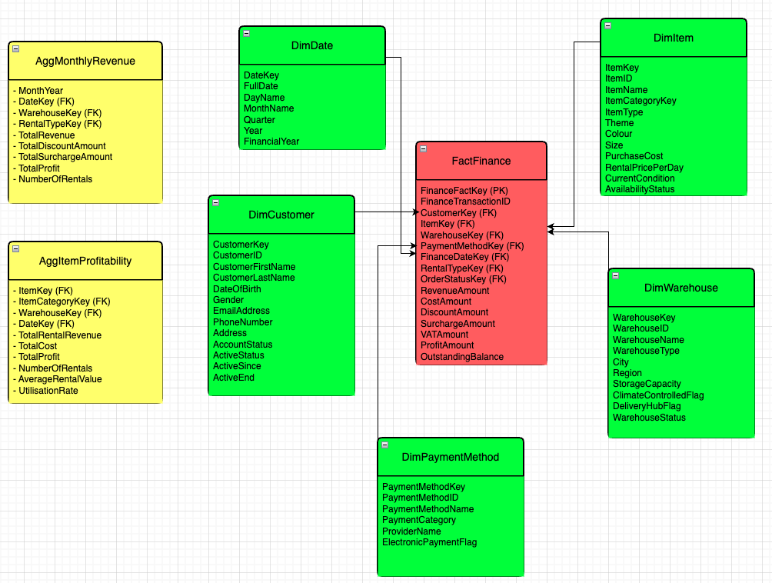
Figure6: Finance Data Mart

An Inventory and Asset Management Data Mart would extract data from the FactInventoryMovement and FactDamageMaintenance tables, including stock movements, stock value, repair costs, replacement costs, downtime days, and write-off values. The mart would connect to dimensions including DimItem, DimWarehouse, DimSupplier, DimDate, DimEmployee, DimItemCategory, and DimDamageStatus to support inventory tracking, warehouse analysis, supplier monitoring, and damage reporting [1]. This structure would allow Rags’n’Riches Ltd. to identify slow-moving or frequently damaged assets, monitor stock utilisation across warehouse locations, and support more effective inventory planning and asset management [2] [8].

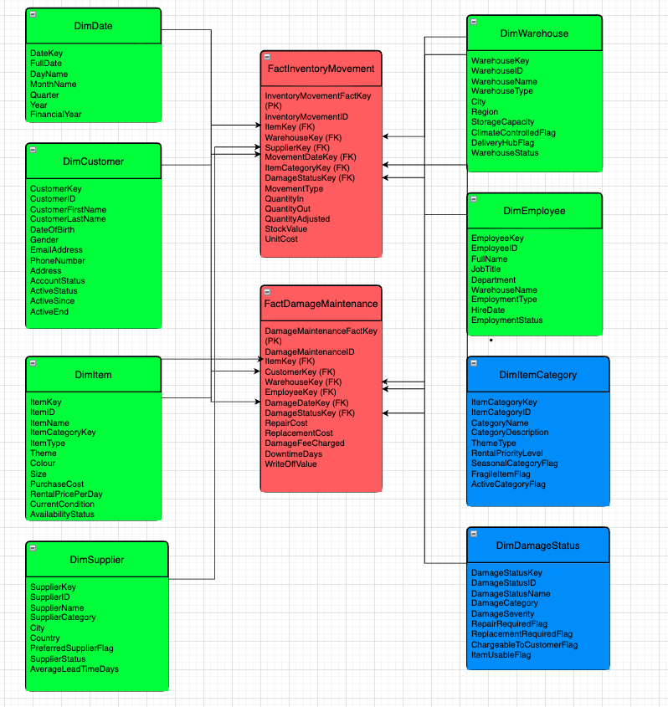
Figure7: Inventory Management Data Mart

A Rental Performance Data Mart would extract transaction-level measures from FactRental, including rental duration, quantity rented, base rental amount, discounts, emergency surcharges, late return fees, deposits, and total rental charge. This fact table would be linked to DimCustomer, DimItem, DimWarehouse, DimEmployee, DimDate, DimRentalType, DimOrderStatus, and DimDiscountType, allowing rental performance to be analysed by customer group, item type, warehouse, employee, rental category, and reporting period [1] [2]. The inclusion of AggMonthlyRevenue would further support faster management reporting by summarising revenue, discounts, surcharges, profit, and rental counts by month and warehouse [10]. This would help Rags’n’Riches Ltd. monitor rental frequency, seasonal demand, item popularity, discount impact, and differences between customer groups such as theatre companies and large-scale film productions.
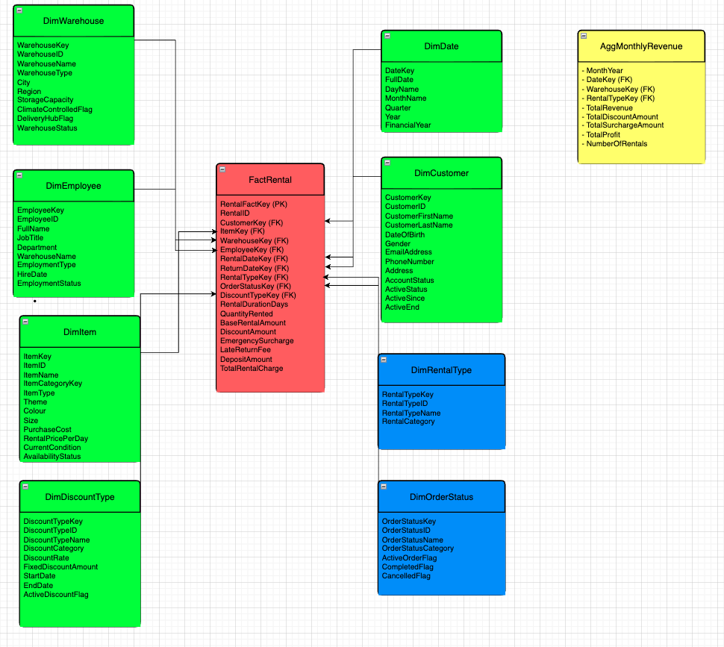
Figure8: Rental Performance Data Mart

ETL Plan

The ETL process for Rags’n’Riches Ltd. would extract data from operational systems including rental orders, inventory management, transport logistics, and finance databases. Rental transaction data would populate FactRental and FactFinance, inventory records would populate FactInventoryMovement and DimItem, while customer, warehouse, supplier, and employee records would populate the associated dimension tables.

The extracted data would first be loaded into a staging area before undergoing transformation processes designed to ensure consistency and data quality [13]. Transformations would include validating unique rental item identifiers, standardising warehouse and customer records, remove duplicate entries, and calculate business metrics such as discounts, delivery charges, and emergency surcharges [2]. Following transformation, the processed data would be loaded into the dimensional warehouse schema and subsequently into the associated data marts using incremental batch loading techniques [14]. Effective ETL processes are essential for maintaining data consistency, integration, and reliability within data warehouse environments [1] [4].

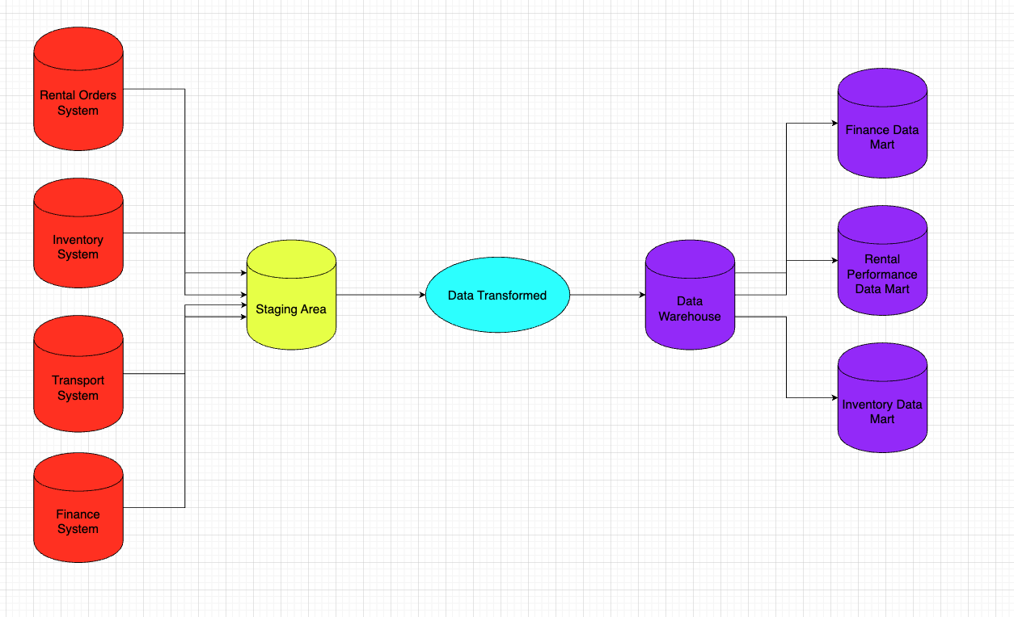
Figure9: ETL Process

Data Governance
During the ETL process, several data quality and governance issues may arise, including duplicate customer records, conflicting definitions of the data, inconsistent warehouse identifiers, incomplete rental information, and inaccuracies within mobile inspection uploads [13]. Appropriate governance controls should therefore include data validation, standardised naming conventions and data definitions (e.g. revenue), access control policies, and audit logging to maintain data integrity and security [13].

Effective data governance is essential to ensure the reliability, consistency, and accuracy of data within analytical systems and decision-making environments [9]. Rags’n’Riches Ltd., should employ suitable data governance roles within the organisation to ensure that data is maintained to the correct standard [11].

Conclusion
In conclusion, this report has demonstrated how a dimensional data warehousing solution could support the analytical and reporting needs of Rags’n’Riches Ltd. The discussion highlighted the differences between OLTP systems used by the business and data warehouses, demonstrating the importance of dimensional modelling, ETL processing, and data marts in supporting business intelligence and strategic decision-making.

The proposed schema and the associated data marts will allow the organisation to integrate data from multiple source systems into a consistent data warehouse environment. The use of fact tables, dimension tables, aggregate tables, and ETL processes would improve reporting efficiency, support trend and profitability analysis, and enhance overall data quality and governance.

Overall, the proposed architecture would provide Rags’n’Riches Ltd. with a scalable and efficient platform capable of supporting operational reporting, performance monitoring, and future business growth.
References
[1] P. Bhatia, Data mining and data warehousing : principles and practical techniques, Cambridge: Cambridge University Press, 2019.
[2] R. Kimball and M. Ross,The data warehouse toolkit : the definitive guide to dimensional modeling, Indianapolis, Ind: Wiley, 2013.
[3] Microsoft. "Extract, Transform and Load (ETL)." Microsoft Learn. Accessed: 6/5 2026. [Online]. Available: https://learn.microsoft.com/en-us/azure/architecture/data-guide/relational-data/etl
[4] S. K. Bansal and S. Kagemann, "Integrating Big Data: A Semantic Extract-Transform-Load Framework," MC. vol. 48, no. 3, pp.42–50, 2015, doi: 10.1109/MC.2015.76.
[5] "What Is a Data Mart? | IBM." Accessed: May 6 2026. [Online]. Available: https://www.ibm.com/think/topics/data-mart
[6] J. John, O. Shobayo and B. Ogunleye, "An Exploration of Clustering Algorithms for Customer Segmentation in the UK Retail Market," vol. 2, pp.809–823, 2023, doi: 10.3390/analytics2040042.
[7] P. Cao, Big Data in Customer Acquisition and Retention for eCommerce – Taking Walmart as an Example, 2021. doi: 10.2991/assehr.k.211209.043
[8] A. Esmail Mohamed, "Inventory Management," in Operations Management - Recent Advances and New Perspectives, T. Bányai, Ed., London: IntechOpen, 2024, doi: 10.5772/intechopen.113282Available: https://doi.org/10.5772/intechopen.113282
[9] T. M. Connolly and C. E. Begg,Database Systems : a practical approach to design, implementation, and management, Boston: Pearson, 2015.
[10] M. Ratia, J. Myllärniemi and N. Helander, "The potential beyond IC 4.0: the evolution of business intelligence towards advanced business analytics," vol. 23, no. 4, pp.396–410, 2019, doi: 10.1108/MBE-12-2018-0103.
[11] D. Plotkin, Data stewardship : an actionable guide to effective data management and data governance, London, United Kingdom: Academic Press, an imprint of Elsevier, 2021.
[12] S. Chaudhuri and U. Dayal, "An overview of data warehousing and OLAP technology," vol. 26, no. 1, pp.65–74, 1997, doi: 10.1145/248603.248616.
[13] B. S. Kumar, Data integrity and data governance, London: IntechOpen, 2023.
[14] N. Biswas, A. Sarkar and D. Mondal, "Efficient incremental loading in ETL processing for real-time data integration," vol. 16, 2020, doi: 10.1007/s11334-019-00344-4.

