Welsh Prehistoric Textile Tools
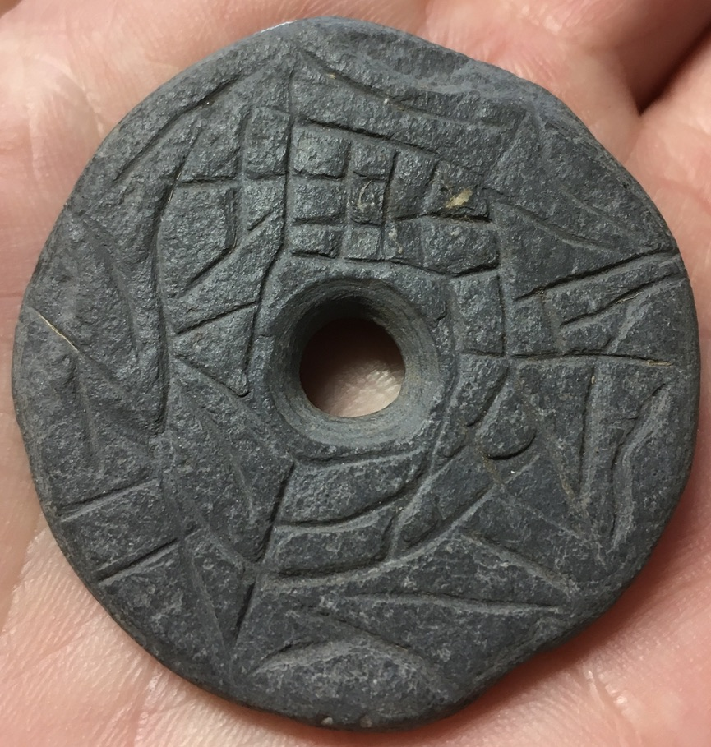

A dissertation submitted to the
University of Wales Trinity Saint David
in fulfilment of the requirements for the
degree of Bachelor of Arts

2020

Karen Davies
1703046

Acknowledgements

Thank you to my Supervisor, Dr Ros Coard, and to Dr Louise Steel and Dr Magdalena Öhrman, for providing guidance, feedback, and support throughout this project. My thanks are also due to Dr Barry Burnham for allowing me access to the textile tools found at Caer Cadwgan, and for the interesting background to the site. The staff at Carmarthen Museum, Ceredigion Museum, Swansea Museum, and Tenby Museum were all unfailingly helpful in providing me with access to the textile tools in their collections, and I am grateful to them.

Table of Contents
Acknowledgements 1
Abstract 6
Chapter 1 7
Introduction 7
Aims of study and Research questions 7
Wales 8
Chapter 2 11
Textiles and Tools in the Archaeological Record 11
Textiles and Fibres 12
Tools 15
Chapter 3 16
Theoretical Perspectives 16
Chapter 4 20
Methodology 20
Data Collection 20
Recording 23
Typology 24
Chapter 5 25
Results 25
Chapter 6 34
Discussion 34
Recording and Handling 36
Classification 38
Spindle Whorls 39
Chronology and Typology 39
Decoration 40
Raw Materials 45
Quantification 46
Chapter 7 48
Conclusion 48
Future Research? 49
Reference List 51
Bibliography 56

Appendix 1 ...................................................................................................................... 1
Textile Tools: Inspected and Recorded...................................................................................... 1
Appendix 2 ................................................................................................................... 132
Textile Tools List: Inspected and Recorded ............................................................................ 132
Appendix 3 ................................................................................................................... 136
Textile Tools/Artefacts Recorded in Printed Sources .............................................................. 136
Table of Figures
Figure 1 - Textile fragments from Llangorse Crannog - display at St Fagan's Museum. (Photograph: K Davies 2020.) 9
Figure 2 - Fragments of carbonised woven textile from Outer Burial, Mynydd Epynt. (Photograph from Archaeologia Cambrensis 97 (1943) Plate XVI, page 182 - G C Dunning.) 10
Figure 3 - SEM photograph of 3-ply cord from Abri du Maras. Z- and S-twist effects shown in blown-up pictures. (Photograph from Hardy et al 2020.) 11
Figure 4 – Linen pleated tunic, tomb 13, Assiut, Egypt, circa 2000 BC, Louvre Museum E 12026. (Photograph : © Musée du Louvre/G. Poncet 2020.) 13
Figure 5 - Linen cloth from burial F.7127, Building 52, Çatalhöyük (2013). (Photograph: Scott Haddow 2013.) 14
Figure 6 - Tintinnabulum depicting textile tools, from Tomb 5 (630 BC cal), Military Arsenal Necropolis (Archaeological Museum of Bologna). (Photograph: Turfa 2012.) 15
Figure 7 - Stone spindle whorl, Hut site 27 from Moel Trigarn Hillfort, Iron Age. Tenby Museum Accession No. 1983:2046-8. Described and illustrated in Archaeologia Cambrensis 17: 207 (1900). (Photograph: K Davies 2020.) 23
Figure 8 - Stone spindle whorl, Minchin Hole, possibly Roman. Swansea Museum Accession No. 1959.11.49. (Photograph: K Davies 2020.) 23
Figure 9 - Examples of Spindle Whorl Typology - primary and secondary classifications. (Drawing: K Davies 2020.) 24
Figure 10 - Loom Weight Numbers and Location. (Graph: K Davies 2020.) 25
Figure 11 - Spindle Whorl Numbers and Location. (Graph: K Davies 2020.) 25
Figure 12 - Spindle Whorl Typology. (Graph: K Davies 2020.) 26
Figure 13 - Spindle Whorl Chronology. (Graph: K Davies 2020.) 26
Figure 14 - Decorative Elements of Spindle Whorls. (Graphs: K Davies 2020.) 27
Figure 15 - Raw Materials used in Spindle Whorl manufacture. (Graph: K Davies 2020.) 27
Figure 16 - 'Spider's web' decoration on broken spindle whorl. Carmarthen Museum, Accession No. A1976/1325. (Photograph: K Davies 2019.) 28
Figure 17 - Patterned spindle whorl. Carmarthen Museum, Accession No. A1975/4733. (Photograph: K Davies 2019.) 28
Figure 18 - Spindle Whorl Range of Diameter Measurement. (Graph: K Davies 2020.) 28
Figure 19 - Spindle Whorl Range of Weight (ordered in Diameter size). (Graph: K Davies 2020.) 29
Figure 20 - Spindle Whorl Range of Height Measurement (ordered in Diameter size). (Graph: K Davies 2020.) 29
Figure 21 - Spindle Whorl Diameter and Height Comparison. (Graph: K Davies 2020.) 30
Figure 22 - Spindle Whorl Weight and Diameter Comparison. (Graph: K Davies 2020.) 30
Figure 23 - Spindle Whorl Moment of Inertia Ratio Calculation. (Graph: K Davies 2020.) 31
Figure 24 - Loom Weight Raw Materials. (Graph: K Davies 2020.) 32
Figure 25 - Loom Weight Chronology. (Graph: K Davies 2020.) 32
Figure 26 - Range of Weights of Loom Weights. (Graph: K Davies 2020.) 32
Figure 27 - Map showing Distribution of Textile Tools examined and researched. (Drawing: K Davies 2020.) 33
Figure 28 - Loom Weights - Height and Weight Comparison. (Graph: K Davies 2020.) 33
Figure 29 - Example of recto side of card index record, Tenby Museum. (Photograph: K Davies 2019.) 36
Figure 30 - Example of verso side of card index record, Tenby Museum. (Photograph: K Davies 2019.) 36
Figure 31 - - St David's Head Type IVb sandstone spindle whorl, Tenby Museum Accession No. TENBM:1983:2051-4. (Photograph: K Davies 2019.) 41
Figure 32 - St David's Head Type IVa sandstone spindle whorl, Tenby Museum Accession No. TENBM:1983:2051-7. (Photograph: K Davies 2019.) 41
Figure 33 - - St David's Head Type IVb slate spindle whorl, Tenby Museum Accession No. TENBM:2050-8. (Photograph: K Davies 2019.) 41
Figure 34 - Decorated spindle whorl from Moel Trigarn. Tenby Museum - Accession Number: TENBM:1983:2046-8. (Photographs: K. Davies. 2019) 41
Figure 35 - Decorated spindle whorl from Moel Trigarn. Tenby Museum - Accession Number: TENBM:1983:2046-8. (Photographs: K. Davies. 2019) 41
Figure 36 - Spindle whorl displaying different stages of refinement: pebble whorl, perforated but shape unmodified with a circle pecked into the pebble, presumably as a decorative motif - this is repeated on the base, Carmarthen Museum Accession No. A1980/0041. (Photograph: K. Davies 2020.) 43
Figure 37 - Spindle whorl displaying different stages of refinement: stone whorl showing drill marks, no other obvious modification, Ceredigion Museum Accession No. 1983.28/2066. (Photograph: K. Davies 2019.) 43
Figure 38 - Spindle whorl displaying different stages of refinement: sandstone whorl, finely shaped and drilled, Ceredigion Museum Accession No. 1984.172.1/2354. (Photograph: K. Davies 2019.) 43
Figure 39 - Spindle whorl displaying different stages of refinement: bone whorl, very finely shaped and decorated, Swansea Museum Accession No. SM1959.11.29. (Photograph: K. Davies 2020.) 43
Figure 40 - Sandstone spindle whorl from Caer Cadwgan, reference no. 610. (Photograph: K. Davies 2019.) 43
Figure 41 - Sandstone spindle whorl from Caer Cadwgan, reference no. 610. (Photograph: K. Davies 2019.) 43
Figure 42 - Stone spindle whorl from Caer Cadwgan, reference no. 499. (Photograph: K. Davies 2019.) 43
Figure 43 - Stone spindle whorl from Caer Cadwgan, reference no. 499. (Photograph: K. Davies 2019.) 43
Figure 44 and Figure 45 - Stone spindle whorl with central perforation and four smaller holes made in a square or possibly diamond shape, scratch marks on edge as possible decoration. CM060 Ceredigion Museum (on loan from Carmarthen Museum). (Photographs: K. Davies 2019.) 45
List of Tables
Table 1 - Site details extracted from ARFAW Later Bronze Age and Iron Age list (2003). 21

Abstract
This dissertation aims to compile a database of prehistoric textile tools from the Ceredigion, Carmarthenshire and Pembrokeshire areas of Wales, and to use that data to investigate any discernible patterns. To date, no systematic investigation has been done on Welsh textile tools, and this study hopes to offer a starting point for a comprehensive survey. Textile tools were researched, inspected and recorded quantitatively and photographically with provenance and chronology being noted where there was sufficient prime data. Insufficient information was forthcoming to allow analyses and mapping of spatial or temporal patterning, but a record of textile tools stored at county museums was collated with notes made of decorative aspects and of raw materials used, particularly slate. A typology was designed to reflect the textile tools encountered. Further study should be made to research and record a Welsh nationwide database of textile tools.

Chapter 1

Introduction
The objective of this study was to investigate the archaeological record of textile production in prehistoric Wales, focussing on the south-western counties of Ceredigion, Carmarthenshire, and Pembrokeshire. Concentrating on a defined area should have ensured a manageable but meaningful quantity of data for the space allowed in this dissertation.

Wales has a rich heritage of prehistoric sites which have been excavated extensively, starting with antiquarians in the 18th and 19th centuries, and more recently by archaeological Trusts, universities, CADW and Comiswm Brenhinol Henebion Cymru (CBHC)/the Royal Commission on the Ancient and Historical Monuments of Wales (RCAHMW). There is a comprehensive oeuvre of publications about prehistoric sites in Wales, with many articles written by the 19th century excavators appearing in the early editions of Archaeologia Cambrensis, and research reports and excavation reports being published by the various commissioning organisations more recently. However, no systematic study of the archaeological evidence for textile production in prehistoric Wales appears to have been done, and it is hoped that this survey will act as a starting point for such a study.

Aims of study and Research questions
The aim of this dissertation was to compile a database of the archaeological evidence for textile production in prehistoric Wales, with specific reference to the material culture recorded in Ceredigion, Carmarthenshire, and Pembrokeshire. By gathering together this material, it should be possible to map the distribution of the textile tools found, using variable parameters to analyse the data. The most abundant textile tool artefact encountered in the museum collections was spindle whorls, and a typology has been devised in order to classify these systematically. Consolidating the data collected might reveal regional or chronological patterns which could then be situated within the broader context of the archaeological material culture.
Questions to be answered are: What assemblage of textile tools is there in the defined area? What are the characteristics of these tools in terms of their stylistic and functional variability? Are there any patterns evident from mapping the tools’ provenance, for example, from use of raw materials, typology, and decoration? Do the tools provide any clues as to the nature of prehistoric society in Wales?

Wales
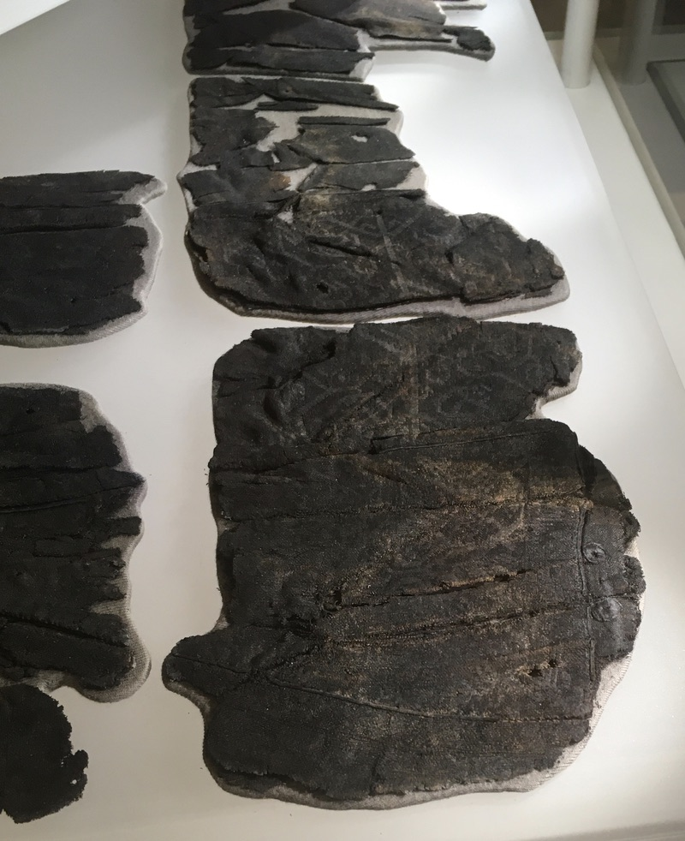
Prehistoric textile tools are present in Wales, although there appears to be a disconnect in the densities of artefacts encountered between sites in north and west Wales. A frustration of this project was reading antiquarian accounts of excavations and sites and realising many artefacts must have been found which now appear lost. Albert Way (1867: 249) writes of a stone whorl found in a hut-circle on Holyhead Mountain, saying it “is of a class of relics occurring constantly on all ancient sites” and Way recounts a contemporary stating that whorls are “frequently found in England”. However, in contrast, Murphy et al (2011) describe west Wales as having numerous enclosed settlements but with few artefacts, describing low artefact densities which the authors ascribe to re-using items, choices of materials, and an aceramic culture. Way’s comments may apply generally to the United Kingdom, whereas Murphy’s are specific to west Wales. In addition to these factors, the Welsh environmental conditions are not conducive to taphonomic preservation of objects. Research has produced accounts of only four finds of textile fragments (see Appendix 3 for sites), with the largest and most spectacular piece coming from Llangorse Crannog. This site is early medieval, and the material is a high status, particularly fine fabric with pieces embroidered or woven using a soumak brocading technique (Redknap & Lane 1994). This fabric is from a later period than the focus of this dissertation; however, the quality of the piece shows the existence of technologically skilled textile workers who have the expertise and knowledge to produce such a fine, complex piece. This is not something that happens overnight – there is a bedrock of skills and knowledge of tools, raw materials, processing, and techniques of spinning, weaving, and dyeing, which have developed over a long period and enable the production of such fine work.
Figure 1 - Textile fragments from Llangorse Crannog - display at St Fagan's Museum. (Photograph: K Davies 2020.)

Four small fragments of a woven textile were found by G C Dunning (1943) when excavating a cairn on Mynydd Epynt in 1940. These were examined by the Victoria & Albert Museum and were deduced to be possibly woollen but, because of the fabrics’ carbonised condition and the technology available at the time, no further analysis was forthcoming. These pieces are listed in Savory’s (1980) Catalogue of Bronze Age collections but online searches have failed to find them on the National Museum of Wales’s portal.
.

Figure 2 - Fragments of carbonised woven textile from Outer Burial, Mynydd Epynt. (Photograph from Archaeologia Cambrensis 97 (1943) Plate XVI, page 182 - G C Dunning.)

Historiographical sources for this early period are rare. Caesar’s Commentarii de Bello Gallico (1869: 5.14) describes the Britons from Kent as wearing skins and using woad to dye their skin blue, but one should consider the author’s motives before relying on his account. Caesar may have wanted to represent the Britons as barbarians to justify his invasion (Lendering 2020). The Welsh bardic oral tradition is recorded in medieval manuscripts and provides glimpses of an earlier lifestyle from stories told over many generations, but these have no definite chronology or exact provenance. The Mabinogion (Davies 2007) mentions grey woollen hunting garb, golden brocaded silk, a red silk dress for Olwen, and pavilions and tents: this variety of fabrics and uses demonstrates a familiarity and commonplaceness that, again, does not appear overnight but is the product of a long period of evolution.

What is certain is that spindle whorls and perforated objects that could be loom weights are present in museum collections and these provide material evidence of textile production in prehistoric Wales. The difficulties encountered in researching prehistoric textiles and textile tools in Wales reinforces the need for a study of the material culture evidence and for a consolidated database.

Chapter 2

Textiles and Tools in the Archaeological Record
Historically, textiles and the tools used to produce them have received scant notice archaeologically, but their production would have formed a fundamental element of society in pre-industrial times. Textile production would have been a more time-consuming activity than pottery or agriculture, and analyses of prehistoric societal structures should take notice of this elemental occupation and its tools (Barber 1991). A fragment of 3-ply cord made up of fibres with an S-twist plied with a Z-twist has been found in the Abri du Maras, France, in a Middle Palaeolithic context (dated using ESR and U-Th methods to 52-41kya) (Hardy et al 2020), which helps substantiate Barber’s (1991) assertion that the textile industry is older than pottery, metallurgy, agriculture, and stock-breeding.
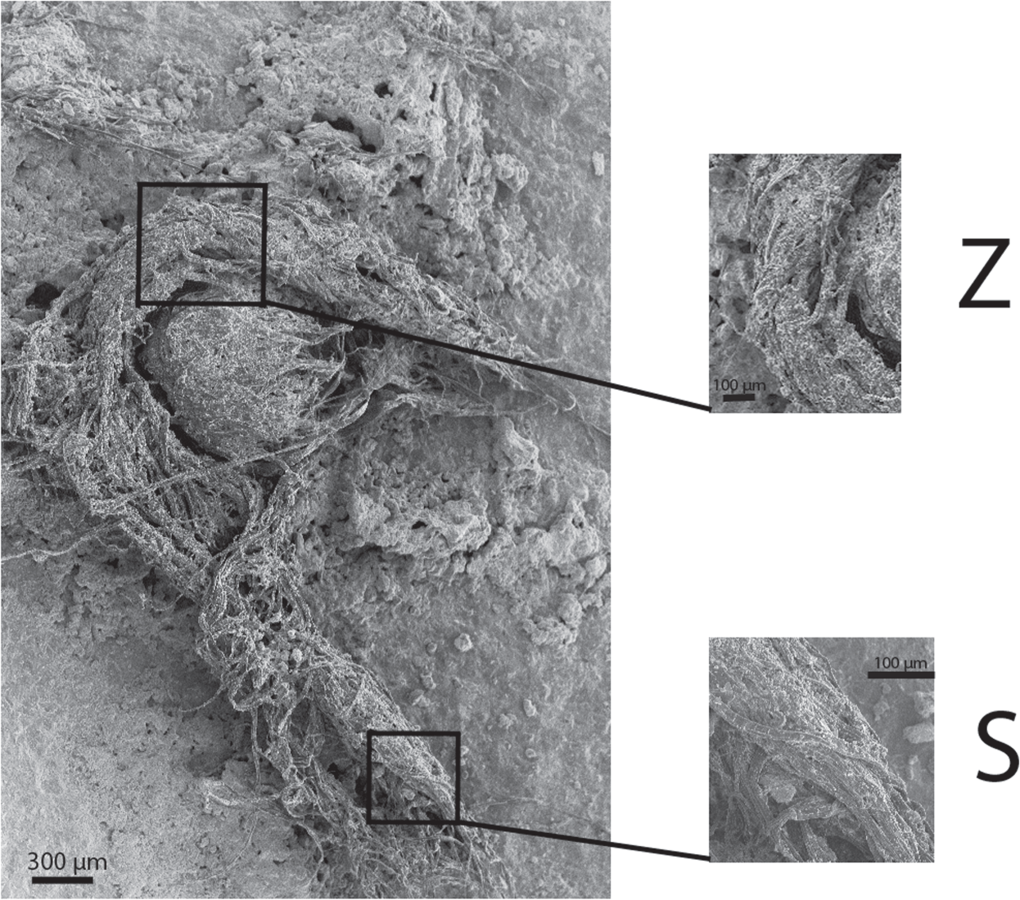

Figure 3 - SEM photograph of 3-ply cord from Abri du Maras. Z- and S-twist effects shown in blown-up pictures. (Photograph from Hardy et al 2020.)

The process of twisting fibres formed the basis for making cords and ropes, nets, mats, bags, sails, shelter, and eventually clothing, and would have become an important part of everyday life, making products which would be essential commodities used in society. However, these are perishable objects, which only survive taphonomically under specific conditions. Is it the paucity of evidence that led to this industry being overlooked previously? When studying Greek or ancient Middle Eastern iconography, did antiquarians not question the textiles depicted and wonder who produced them and how? Textile production is an important topic which merits close attention, and its multidisciplinary analyses produce data which aid archaeological hermeneutics.

Textiles and Fibres
Evidence of early fibres and textiles is accumulating as technology becomes more sophisticated and sensitive, with the earliest fibres (prior to the cord at Abri du Maras) being found in Dzudzuana Cave, Georgia (Bar-Yosef et al 2011). Unit C (27-24ka cal BP) produced fibres of wild flax which were spun and dyed blue, pink and green (Kvavadze et al 2009). Debate about the identification of the source plants highlights the need for highly sensitive instrumentation to analyse the plant bast remains. Bar Yosef et al (2011) states “there are remains of knitted string”: it is unlikely to be knitted, as evidence for knitted items does not exist earlier than circa 1100 AD, with nålbindning (a looped technique using one perforated needle) preceding knitting in 300-500 AD (VAM 2020), so what is probably meant is knotted, which agrees with the photographic evidence. The debate and technical terms illustrate the range of multidisciplinary skills and knowledge needed when analysing and interpreting textile finds.

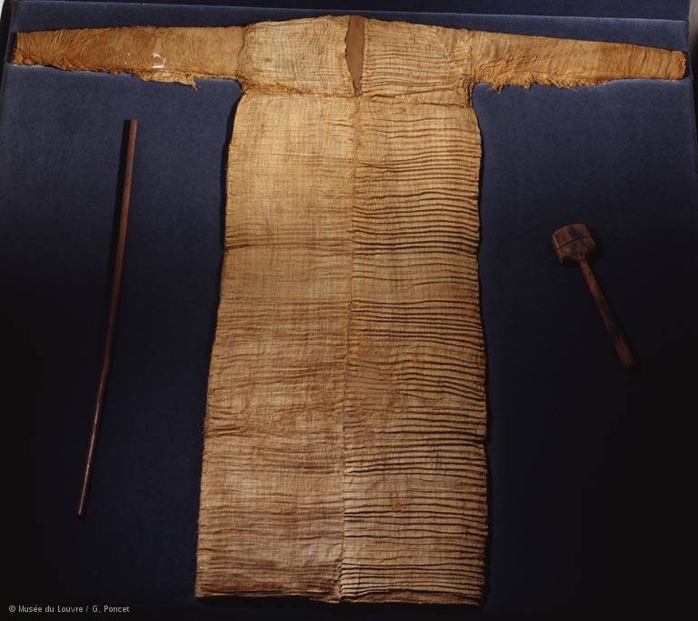
Desert conditions are favourable for textile preservation, with the combination of aridity and salt inhibiting the bacteria that destroy organic fibres (Barber 1991). Evidence of woven linen has been found in a Neolithic settlement dating from circa 5000 BC in the Fayum in Egypt (UCL 2003), and there is a great deal of evidence of fine linen woven textiles from funerary contexts (Hallmann 2015), Egyptian iconography, epigraphy, and textual remains, such as laundry lists (Vogelsang-Eastwood 2000). Excavations have uncovered Meroitic (300 BCE) cotton textile remains in Egypt at Qasr Ibrim (Yvanez and Wozniak 2019).
Figure 4 – Linen pleated tunic, tomb 13, Assiut, Egypt, circa 2000 BC, Louvre Museum E 12026. (Photograph : © Musée du Louvre/G. Poncet 2020.)

Historiography presents sources that provide clues as to the functions and role of textiles in ancient Mediterranean society. For example, Homer’s The Odyssey (1900: Book 19) describes Penelope weaving and unravelling Laertes’ shroud, and relates the use of damask cloths, linen, and spare clothes. The story of the weaving contest between Arachne and Minerva is told in Book 6 of Ovid’s Metamorphoses (1794).

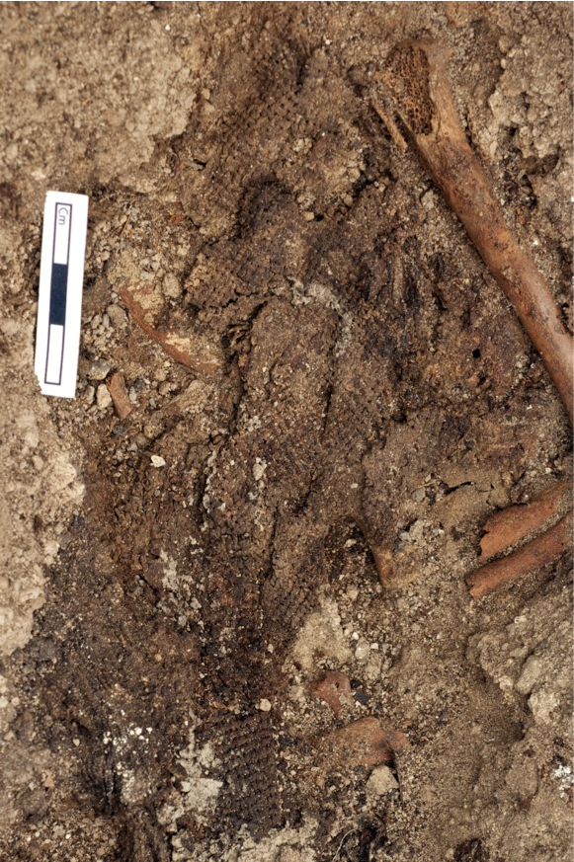
In 2013 in the Neolithic site of Çatalhöyük, a piece of carbonised linen cloth was found in a burial context (F.7127) in Building 52 (Catalhoyuk 2013, Gilligan 2018). The salt mines in Hallstatt, Austria, have been worked since the Bronze Age, and excavations have produced a rich assemblage of textiles because of the preservation conditions provided by the salt (Grömer 2014). Some of these textiles date from 1500-1200 BC and show exceptional qualities, being made of fine wool and of a high technological standard of weaving and hence spinning and showing evidence of dyeing (Grömer 2014). Other excavations containing textiles are crannog sites in Switzerland, bog bodies from Denmark and Ireland, and, in Norway, climate change is melting glaciers and revealing Iron Age clothing (Vedeler and Bender Jørgensen 2013). In 2006, and then in 2015, fragments of Bronze Age woven textiles were found at Must Farm (2015) in Cambridgeshire, and Must Farm’s post-excavation diaries (2019) discuss further Bronze Age finds of yarns and wound threads – exceptional finds in Britain’s challenging taphonomic environment.
Figure 5 - Linen cloth from burial F.7127, Building 52, Çatalhöyük (2013). (Photograph: Scott Haddow 2013.)

The existence of these cords, yarns and threads, textiles and items of clothing all signify societies with a sophisticated, skilful and knowledgeable mastery of textiles and their processing and manufacture. Although the archaeological record in Wales is scanty, the evidence from its surrounding regions infers the existence of a textile industry in Wales.

Tools
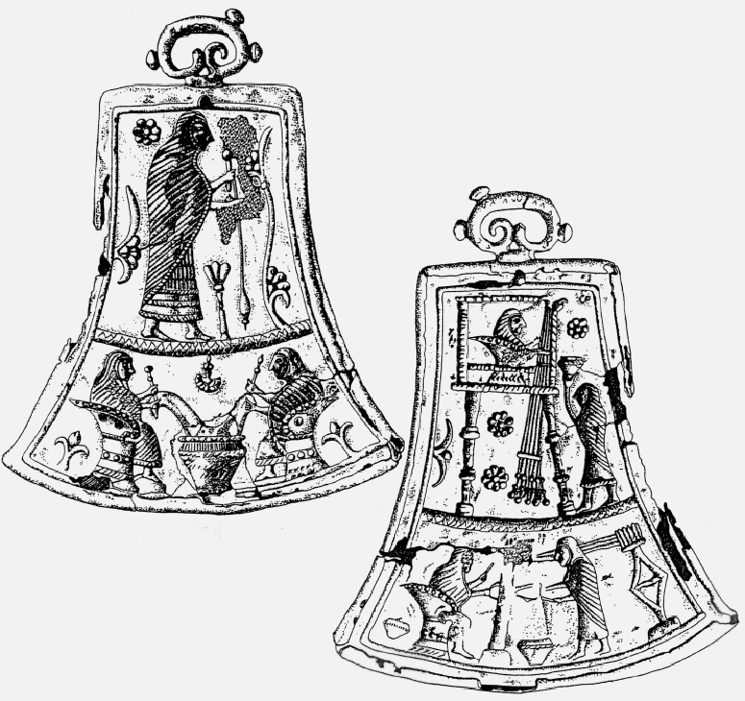
Preservation conditions vary within the Mediterranean basin, North Africa, and Europe, with widespread textile technology evident from the archaeological record comprising spindle whorls, loom weights, and, occasionally, spindles. However, this class of artefact can be difficult to identify - for example, a recent debate concerns Etruscan glass stirring rods and their possible use as distaffs (Barber and Caulfield 2015), and small round perforated objects have been variously classified as buttons, beads, conuli, and spindle whorls (Sabatini and Bergerbrant 2019), or clustered together taxonomically (Crewe 1998). Textile tools would have been widespread and produced from everyday local raw materials, such as stone, wood, and clay, whereas beads tended to be decorative and made of more exotic materials (Barber 1991). The perishability of the raw materials means material culture presents archaeologists with a distorted representation of the industry, and it is important to understand that what is evident is only part of the story.
Figure 6 - Tintinnabulum depicting textile tools, from Tomb 5 (630 BC cal), Military Arsenal Necropolis (Archaeological Museum of Bologna). (Photograph: Turfa 2012.)

The study of textile tools is informative archaeologically: there are regional differences revealed by whorl position (Crewe 1998) and their morphology can be diagnostic, there is a causal relationship between morphology and material composition (Cameron 2002), and their functional analysis can suggest chronological and regional markers.

Chapter 3

Theoretical Perspectives
Archaeological theory has been described as a toolbox (Harris and Cipolla 2017), used to interpret and explain the artefacts and sites we excavate. Concentrating on one theory is too prescriptive and risks blinding oneself to alternative or wider interpretations, an outcome that is particularly likely when working with assumptions and inferences, with no challenge to bias, whether that bias be conscious or unconscious. Therefore, it would seem logical to employ an array of archaeological theories in one’s toolbox, thus ensuring a receptive and responsive approach to the analysis of sites and material culture. This approach allows archaeology to stay vibrant, to encourage debate, and avoid monolithicism.

Antiquarianism was the approach used by the 18th and 19th century excavators when exploring prehistoric Wales, using empirical methods to achieve their object of speaking “from facts not theory” (Hoare 1812 cited in Sweet 2008). This object-orientated process is demonstrated in Hume’s 1863 book elucidating antiquities found in Cheshire, in which he describes spindle whorls at length. Way (1867), in his article about Holyhead, cites Hume’s book as a source of information about “such relics of female industry”, and mentions a gynaecium, a Greek term referring to women’s space. One spindle whorl does not a gynaecium make (with apologies to Aristotle), and this focus on orderliness and classification, and employing a concept from a different cultural milieu, epitomises the problem of being too prescriptive. Way’s dismissive tone appears to discount spindle whorls having any importance or value, whereas other lithic artefacts are pored over in great detail, which suggests a gender bias. It is interesting to compare Way’s 1867 article with Baring Gould’s (1899, 1900), as the latter is meticulous in his recording of the objects found, whereas the former is more discursive and, perhaps, subjective. Therefore, this apparent bias is not repeated in Baring Gould’s excavation reports and the utility of these reports should not be discounted.

However, it cannot be ignored that textile production was a highly gendered activity. Although the tools used are not inherently gendered in themselves, Chapter 2 refers to the historiographical data, the iconography, and the funerary contexts which depict an activity performed by women. Barber (1994) proposes the reason for this was the need for women to be socially productive whilst also breastfeeding young children: the modus operandi of textile-making is easily interruptible which enables such work to be compatible with child-care. This appears a pragmatic approach to maximise labour productivity for the whole community: tasks would be allocated according to ability, and only be gender specific where it is a gendered activity, such as breastfeeding. This does not necessarily mean women’s activities were limited to these tasks forever: as child-rearing occupies only a proportion of a woman’s life, other activities would have been performed. It is also possible that, by performing a task over a period of time, women developed skills that were recognised, valued, and desired in the community, and women then exploited those skills. Women acquired a technical knowledge and displayed an inventiveness which would have been admired, and they took control of their skills’ agency. Eventually, spinning and weaving would have had economic significance, ergo women would have contributed to the economy (Barber 1991). It is important to avoid placing a modern interpretation on a community whose attitudes, activities, and lives were very different to our own. Modern value parameters differ from those of 19th century antiquarians, never mind prehistoric communities, and thus interpretative efforts must be mindful of this diversity. All members of the community would have had a contribution to make which would be valued: our task is not to allow Victorian attitudes to women to cloud our analysis of prehistoric sites.

It was hoped that the results of this dissertation would give clues as to the chaîne opératoire of Welsh textile production, but the available data did not allow this. A neat string of evidence would have been very satisfying, demonstrating the existence of fibre plants such as nettle or flax, to the ability to process the fibre with spindle whorls, to the manufacture of textiles using vertical looms with loom weights. However, no contiguous theories or conclusions were possible with the limited material remains and data available.

The materiality of spindle whorls is intriguing and bears closer inspection. Brück (2019) discusses identity and alterity from a human-centred approach and posits that cloth would have been important in forming a social identity in Bronze Age Britain. Was this importance shared with the tools of manufacture? The Welsh spindle whorls in this dataset display a range of styles from very rough and crude, to neat and finely made. A few are beautifully decorated. One would expect the most beautifully decorated to be the most attractive, but this ignores their properties. Some of the plain whorls have a pleasing weight and shape, intrinsic qualities that feel right in the palm. Our experience of the weight and shape of the whorl is a sense-event that gives us an understanding of its materiality (Harris and Cipolla 2017), aided by their tactility. Whorls become very personal, with spinners having favourites that suit their style of spinning. The boundary between human and thing is blurred, as the whorl has an agentive capacity in offering the human a better outcome. These whorls embody the person using them, with their material properties entrapping the operator. Do we assume the whorl manufacturer and operator are the same person? Is the whorl an entangling object, enmeshing the person who operates it with the person who manufactured it, and perhaps decorated it? Such a small, utilitarian artefact prompts a lot of questions about object biography, materiality of object, object agency, and human-object entanglement – is this because it is a very personal, everyday item, bringing us closer to the tangible person whose object it was? Somehow, the very ordinariness of these items allows us to feel an affinity for their possessors, with a desire to understand their relationship with their whorls.

Chapter 4

Methodology

Data Collection

Initial research was performed online, looking for sites relating specifically to prehistoric Wales. The first site encountered was A Research Framework for the Archaeology of Wales (ARFAW) (2016), a site set up by archaeologists based throughout the UK. The members of this group have formulated a research framework for the archaeology of Wales, considering key questions to be answered and evaluating past achievements. Identified and listed on the site are key Welsh sites presented regionally for the following periods: Palaeolithic and Mesolithic, Neolithic and Early Bronze Age, Later Bronze Age and Iron Age, Roman, and Early Medieval. These lists provided a starting point for research as they give a brief description of the excavation of each site. Concise details of artefacts found are given, as well as other archaeological evidence, authors’ details and dates for publications, and location of the excavation material culture. A perusal of the lists for south west Wales showed no mention of textile tools in the archaeological assemblage described in the Neolithic and Early Bronze Age list (2015). However, the Later Bronze Age and Iron Age list described six sites containing textile tools and one site containing textile remains (2003).

Further details of these sites were found by investigating the list of authors and associated dates, with the reports of the older excavations being published in Archaeologia Cambrensis. These reports were accessed through the National Library of Wales website (2020) and recounted useful details of the excavations themselves, the material culture found, the spatial positioning of the artefacts, and other information about the sites. In some instances, drawings were made of the spindle whorls which were comparable with the artefacts stored in the museums. Another interesting aspect of reading the original published articles was to determine the approach of the authors to the artefacts discovered and described, and to assess the quality of the data reported and attributes recorded. Library searches produced excavation reports and published articles for the more recent sites.

Details of the sites listed are as follows:
Table 1 - Site details extracted from ARFAW Later Bronze Age and Iron Age list (2003).
Site | Location of material culture | Textile tools found | Dates of publications
Caer Cadwgan | University of Wales, Lampeter | Spindle whorl | 1987, 1984-88, 1994
Llawhaden | Pembrokeshire County Museum, Scolton Manor | Decorated spindle whorls | 1998
Clawdd-y-Milwyr (St David’s Head) | Tenby Museum | Decorated spindle whorls | 1899, 1978, 1999
Cwmbrwyn | National Museum of Wales | Spindle whorls | 1907, 1978
Henllys Top Field | Not recorded | Loom weight, spindle whorl | 1986
Moel Trigarn | Tenby Museum | Decorated spindle whorls | 1900, 1978, 1999
Drawsdre Isaf Farm, Llanarthney | Carmarthen Museum | Textile remains | 1893,1917, 1935, 1976

Having identified the location of these sets of artefacts, the next step was to contact the individual museums and request access to the collections. In addition to the museums listed, visits were also made to Ceredigion Museum in Aberystwyth and Swansea Museum, both of which also contained textile tools in their archives.

Another potential source of information identified was the Dyfed Archaeological Trust. The Trust was emailed with a request for any details they might have with regard to textile tools, such as spindle whorls, loom weights, combs, and textile fragments or impressions. A Historic Environment Record search was performed which produced a list of find sites of spindle whorls mainly, with details of possible chronology, publications, and other information. However, in the majority of cases, it was not possible to access the artefacts as there was insufficient information to identify their current location. Their find sites were noted for insertion on the site distribution map.

A further source of find site locations were Savory’s Guide Catalogues (1976, 1980) published by the National Museum of Wales. These catalogues provide a comprehensive list of the Bronze Age and Early Iron Age collections in the National Museum of Wales’s archives, detailing the material culture found with comprehensive descriptions of the items themselves, their find sites, measurements, raw materials, and related publications. Although these are not up-to-date publications, nevertheless they contain extensive information about the Museum’s collections and provided a source of further data for mapping the distribution of artefacts.

Contact was made with the excavators of the Caer Cadwgan site in Lampeter in order to gain access to the excavation finds.

Other online searches were performed using UWTSD’s library database to try and identify further sources of information about prehistoric textile tools and Welsh archaeology, with limited success.

Recording

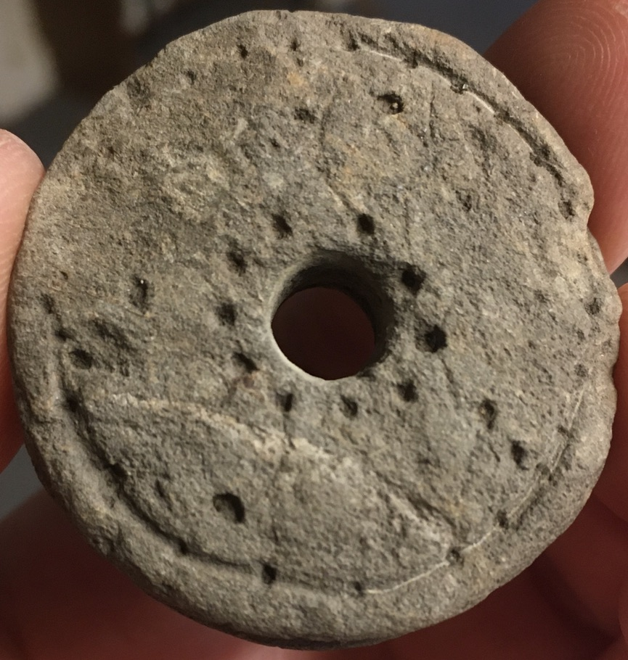
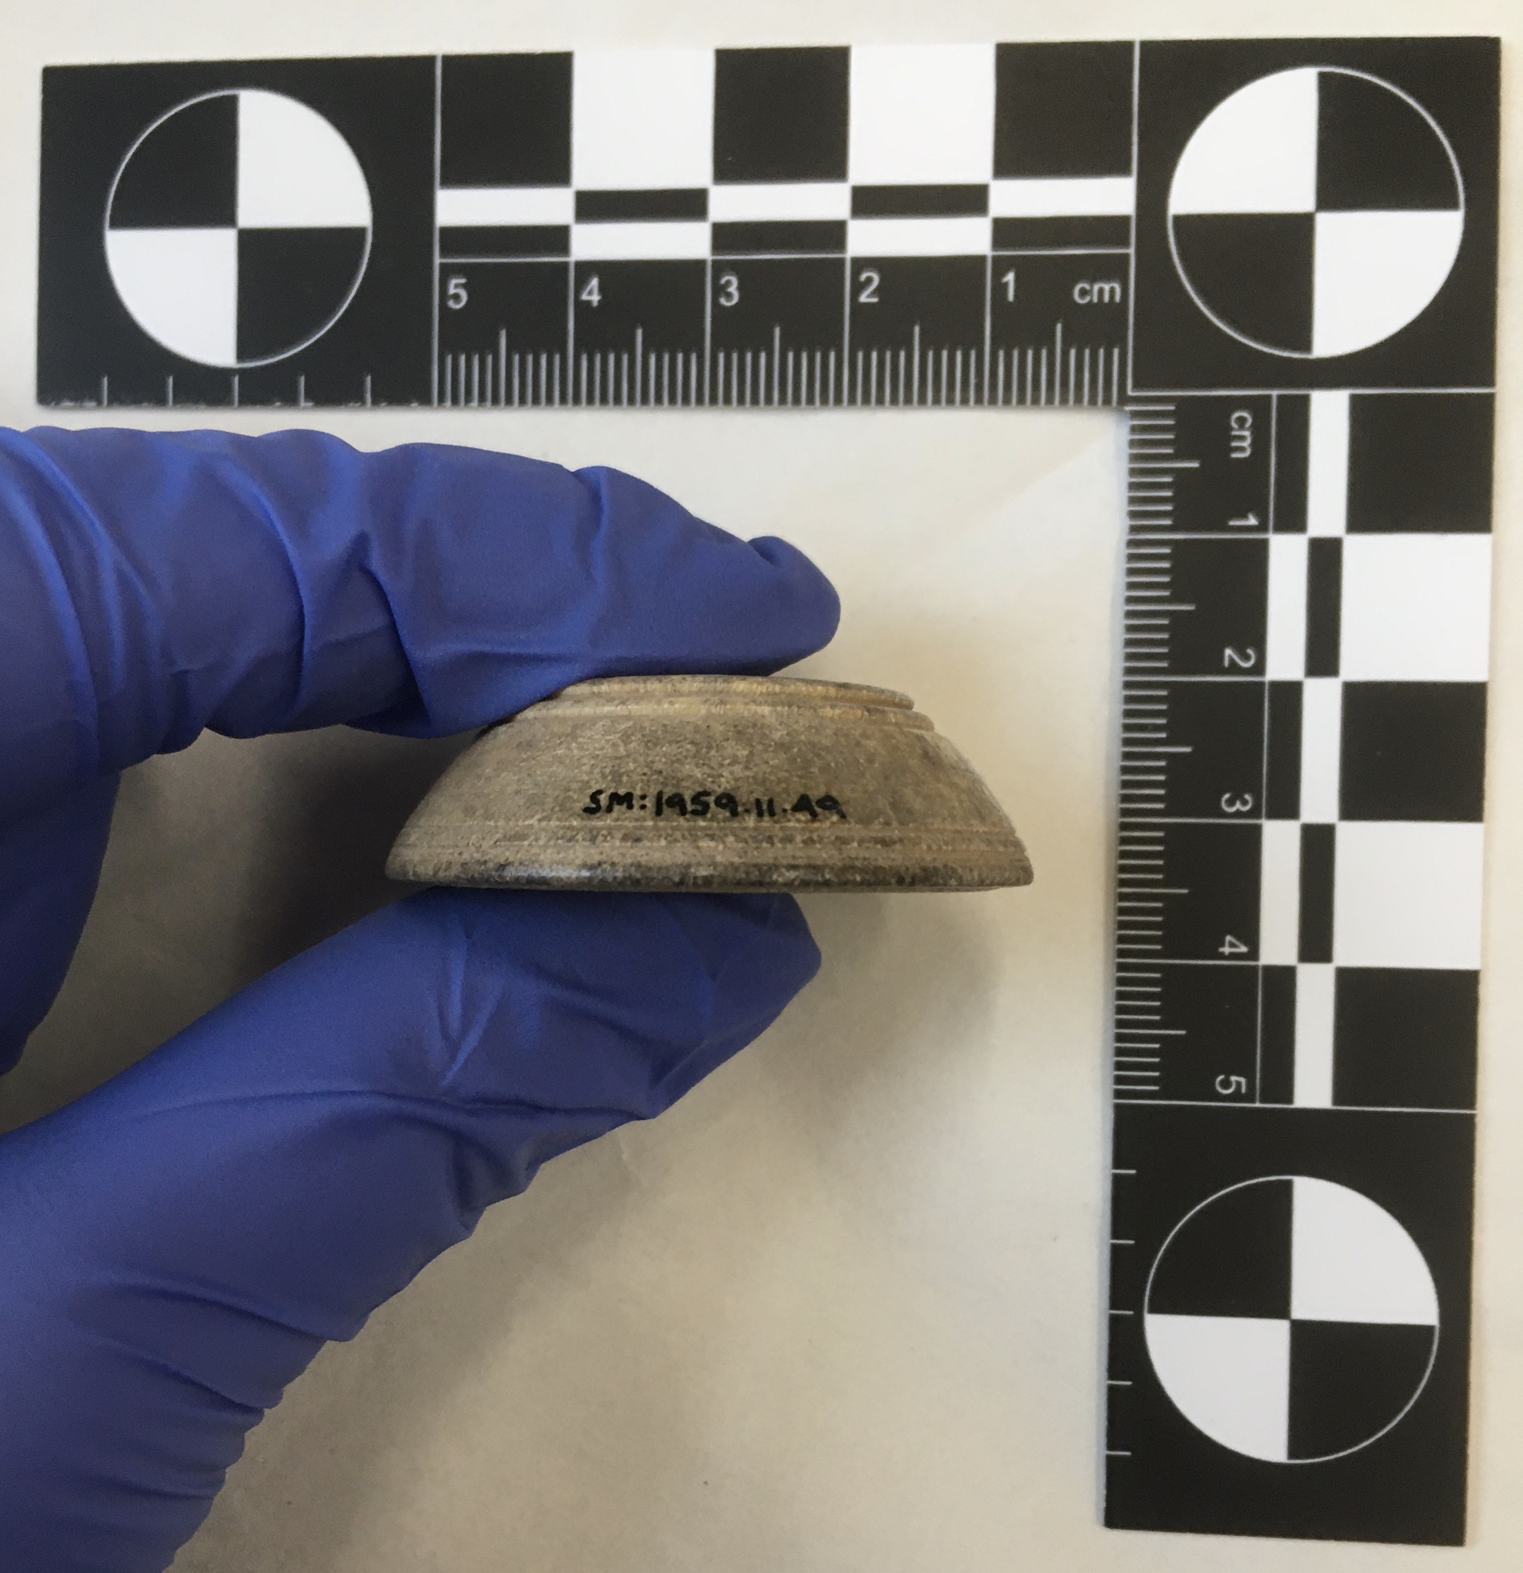
Each museum visit was treated as a ‘recording event’, with a systematic protocol being followed. A toolkit for recording details was needed, comprising photo scale, calipers, electronic weighing scale, camera, and magnifying glass. A useful addition to the toolkit would be a portable light source, as it was discovered the lighting in museums can be very variable and having one’s own light would result in consistently clear photographs. Where possible, a list of the textile tools in the museum’s archive was obtained and photographed. Each textile tool was inspected individually, with photographs being taken of the upper (superior) and lower (inferior) surfaces and the lateral surface with a standard L-shape 8cm photo scale for comparison. Measurements were taken of diameter and height using calipers. Where perforations were present, these were also measured using calipers. Each item was weighed on an electronic scale. Any unusual markings, such as possible use-wear or manufacturing wear, were photographed, and all decoration was recorded. For each artefact, detailed notes were made as to artefact location, museum accession number, artefact type (such as spindle whorl or loom weight), raw materials used, provenance, chronology, shape (typology), diameter, height, perforation size, weight, decoration, use-wear or other marks, and associated publications. These notes were incorporated in an Excel spreadsheet to enable future data analysis and interrogation.
Figure 7 - Stone spindle whorl, Hut site 27 from Moel Trigarn Hillfort, Iron Age. Tenby Museum Accession No. 1983:2046-8. Described and illustrated in Archaeologia Cambrensis 17: 207 (1900). (Photograph: K Davies 2020.)
Figure 8 - Stone spindle whorl, Minchin Hole, possibly Roman. Swansea Museum Accession No. 1959.11.49. (Photograph: K Davies 2020.)

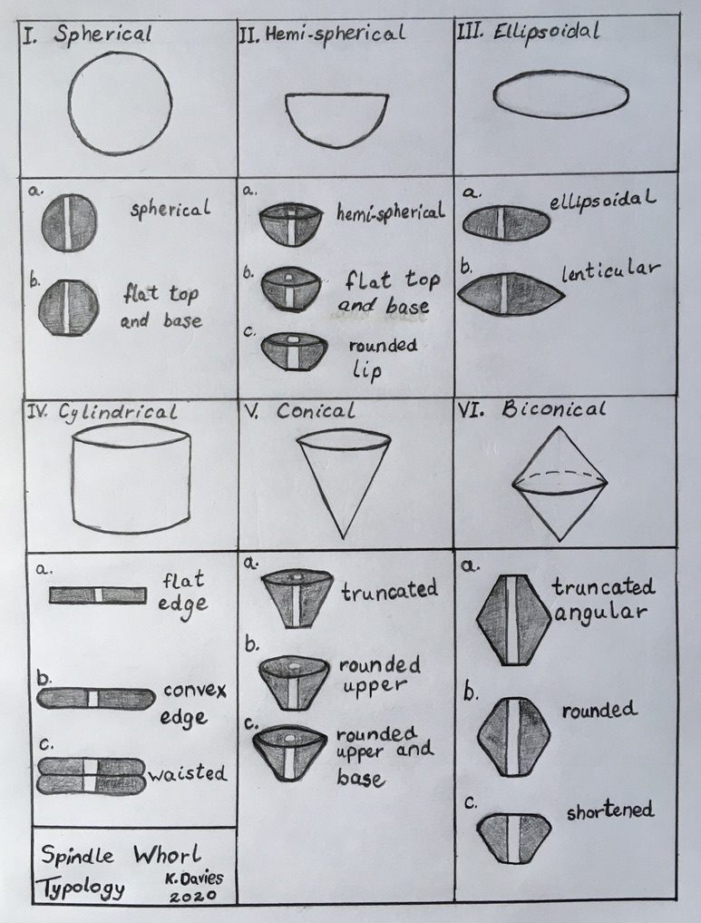
Typology
A typology was devised using shape to delineate the categories and sub-categories of the spindle whorls. This typology was used to aid the classification of the different whorls inspected and helped systematise checking for morphological variation.
Figure 9 - Examples of Spindle Whorl Typology - primary and secondary classifications. (Drawing: K Davies 2020.)

Archaeological typologies are analytical tools devised to demonstrate stylistic variation in material culture.

By photographing, measuring, weighing, and recording the artefacts, and by devising a shape typology, it is hoped the data will display a standardised recording of attributes which can be used for comparative purposes, comparing the results of this data with textile tools from other sources in Wales or other regions of the UK or Europe.

Chapter 5

Results
Ninety-nine spindle whorls were examined, with four museums visited and access to excavation finds being provided for one site local to Lampeter. A further thirty-one artefacts were examined at the same sites – these are tentatively identified as loom weights. This caution highlights the conjectural aspect of some of the classification of this material culture – there is a small potential cross-over between the artefacts identified as spindle whorls and those as loom weights, and, in addition, some of the “loom weights” have unusual characteristics which lead one to question their categorization.
Figure 10 - Loom Weight Numbers and Location. (Graph: K Davies 2020.)
Figure 11 - Spindle Whorl Numbers and Location. (Graph: K Davies 2020.)
Carmarthen Museum contained the greatest number of artefacts, with 39 spindle whorls and 13 loom weights, with Tenby Museum following in the ranking, with 32 spindle whorls and 10 loom weights. Next is Ceredigion Museum, with 17 spindle whorls and 6 loom weights, Swansea Museum had 7 spindle whorls but no loom weights in store, and the Caer Cadwgan site produced 4 spindle whorls and 2 loom weights.

The majority of the collections stored in the museums were artefacts whose only relationship was that of being locally found, although even this codification is not necessarily definite as a lot of the artefacts were of unknown provenance. Tenby Museum profits from being the depository for the finds from two significant sites – the excavation at St David’s Head by Reverend Baring Gould et al (1899), with 18 artefacts stored in Tenby, and the excavation at Moel Trigarn Hillfort, also by Baring Gould et al (1900), with 16 artefacts in Tenby. Therefore, Tenby Museum and Caer Cadwgan had the best provenance for their objects, with collections showing a more coherent picture albeit with a lesser range, and Carmarthen Museum had the worst provenance as the majority of its artefacts were of unknown find location.
Figure 12 - Spindle Whorl Typology. (Graph: K Davies 2020.)
Figure 13 - Spindle Whorl Chronology. (Graph: K Davies 2020.)
The variation in data quality between museums continued in the recorded information available for the chronology of the artefacts, with almost half (45%) of the spindle whorls being of unknown date, and the majority of the remainder (38%) being identified as Iron Age. There is a clear bias in the typology of the spindle whorls towards a cylindrical shape, with 70% being of Type IVb (cylindrical) with a convex edge, and 11% being Type IVa with a flat edge. A further 6% were Type IIIa with an ellipsoidal shape.

The overwhelming majority of raw materials used for the fabrication of the spindle whorls examined were from naturally occurring, local stone. 49% were stone, 28% sandstone, 7% slate, 6% shale, and 2% mudstone. Four of the slate spindle whorls were from the St David’s Head excavation, with one from the Moel Trigarn site, one from Caer Cadwgan, and one from Cwmbrwyn and identified as of Roman-British date. Many of the sandstone spindle whorls were found at the former three sites. 5% were made of terracotta/clay/pottery, and 2% were identified as bone with one labelled Roman from the Minchin Hole.
Figure 14 - Decorative Elements of Spindle Whorls. (Graphs: K Davies 2020.)
Figure 15 - Raw Materials used in Spindle Whorl manufacture. (Graph: K Davies 2020.)

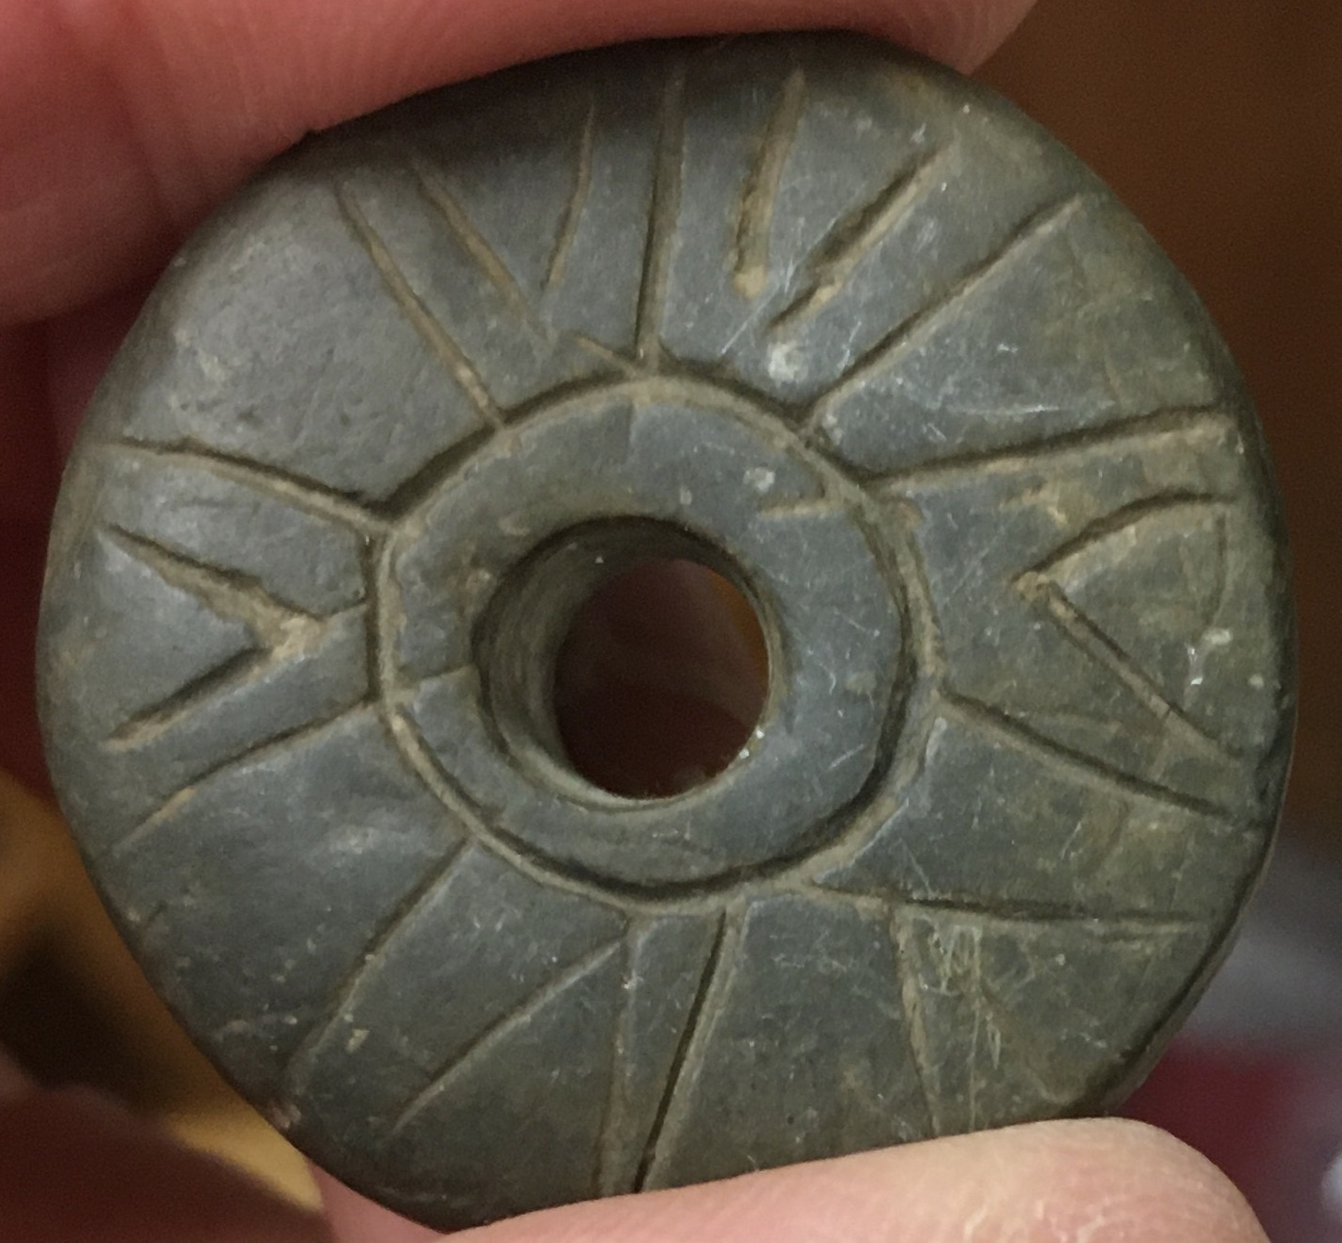
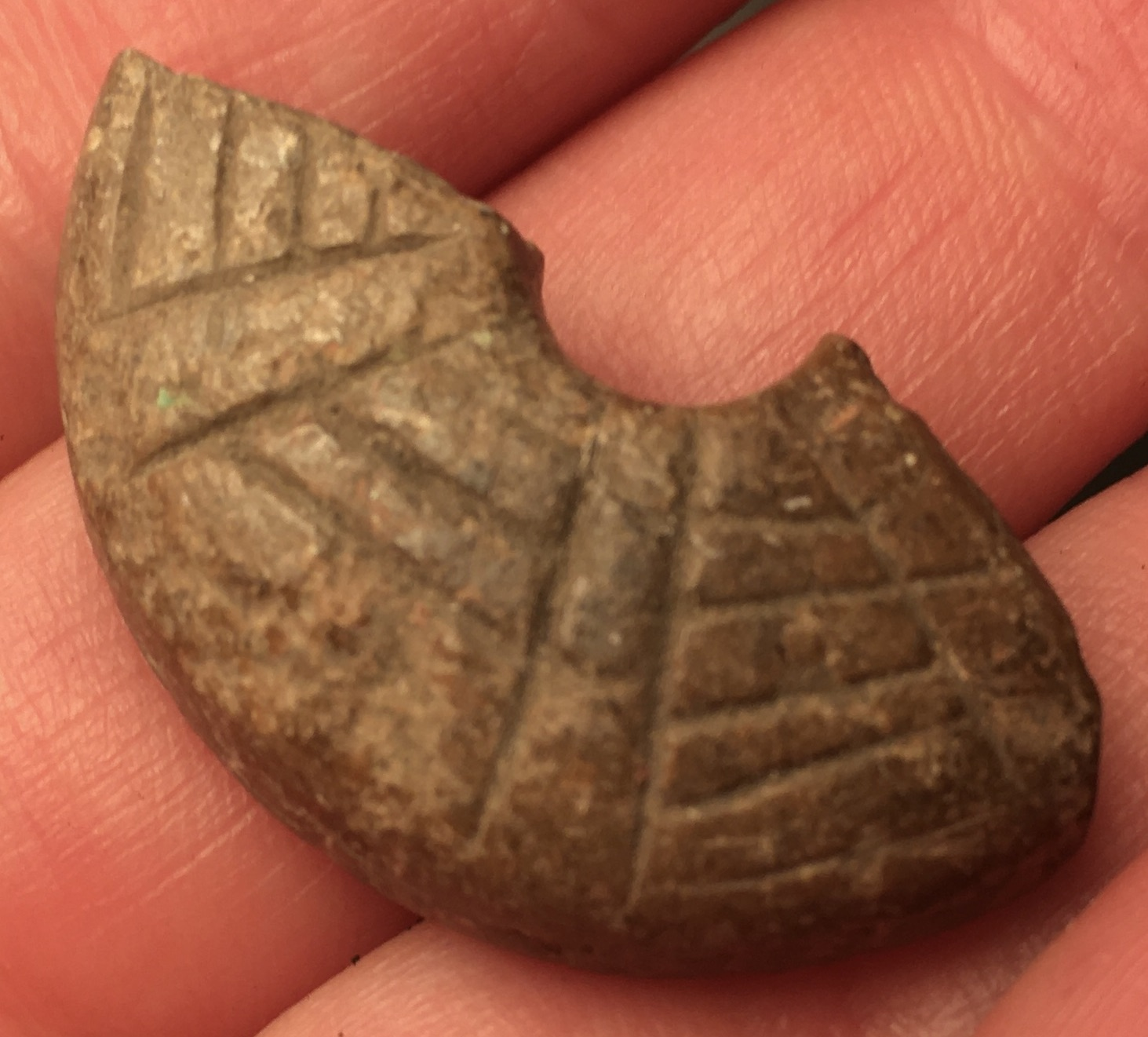
The majority (65%) of the spindle whorls were undecorated. 14% had scratch marks made on their surfaces or edges, and 7% had concentric circles incised into their surfaces. 5% had heavy lines inscribed on their surfaces. There was a stylistic similarity in the decoration between two of these lined whorls found at St David’s Head but with one being made of slate and the other of sandstone. Another whorl had decoration reminiscent of a spider’s web, another had a roughly etched design, and another showed what appears to be an attempt at a crude pattern being made but, if so, with a possible error.
Figure 16 - 'Spider's web' decoration on broken spindle whorl. Carmarthen Museum, Accession No. A1976/1325. (Photograph: K Davies 2019.)
Spacer gap missing between inverted 'V's?
Figure 17 - Patterned spindle whorl. Carmarthen Museum, Accession No. A1975/4733. (Photograph: K Davies 2019.)
Having the opportunity to handle objects allowed measurements to be taken, and it was found that the diameters of the spindle whorls ranged between 25-63mm. Heights varied from 2.5-22mm, with weights spanning 4-51g. Inner perforations were also measured, showing a broad range of 3-16mm. The graphs on this and the following page display the measurement results, placed in order of diameter size, and appear to show no discernible pattern of weight or size, but instead a broad, and seemingly random, range.
Figure 18 - Spindle Whorl Range of Diameter Measurement. (Graph: K Davies 2020.)

Figure 19 - Spindle Whorl Range of Weight (ordered in Diameter size). (Graph: K Davies 2020.)
Figure 20 - Spindle Whorl Range of Height Measurement (ordered in Diameter size). (Graph: K Davies 2020.)

The graphs presenting comparisons of weight and diameter, and diameter and height, also show no obvious discernible pattern within the spindle whorl assemblage.
Figure 21 - Spindle Whorl Diameter and Height Comparison. (Graph: K Davies 2020.)
Figure 22 - Spindle Whorl Weight and Diameter Comparison. (Graph: K Davies 2020.)

Figure 23 - Spindle Whorl Moment of Inertia Ratio Calculation. (Graph: K Davies 2020.)
The same lack of discernible pattern applies when calculating the Moment of Inertia of the whorls, which is an index used to address technical variability, and is a useful indicator of performance. This variability is a product of spindle whorl function and cultural preferences – it becomes diagnostic when there is a consistent choice (Sackett 1977). The whorl acts as a flywheel on the spindle shaft, with its mass prolonging rotation and increasing tension, and a large Moment of Inertia ratio indicates more efficient mass to radius dimensions. Applying this calculation to the measurements resulted in ratios extending from 450 to 18,502, displaying another very broad range. In addition, the reliability of this ratio as a measure is hampered by the problem of breakages, with a number of spindle whorls being incomplete because of fracturing in half, shattering, or chipping.

A similar picture emerges when applying the same principles of analysis to the artefacts identified as loom weights. Insufficient data recording, lack of discernible pattern, and incomplete artefacts all contributed to muddy any interpretation possible. 55% (17) of loom weights were of unknown chronology, with 39% (12) being identified as Iron Age. Only one loom weight was made of clay – a fine teardrop shaped, white clay, Roman artefact of unknown provenance. 45% (14) were made of stone, 26% (8) of shale, and 16% (5) of slate. Once more, the overwhelming majority of the
Figure 24 - Loom Weight Raw Materials. (Graph: K Davies 2020.)
Figure 25 - Loom Weight Chronology. (Graph: K Davies 2020.)
artefacts were made from locally sourced raw materials.

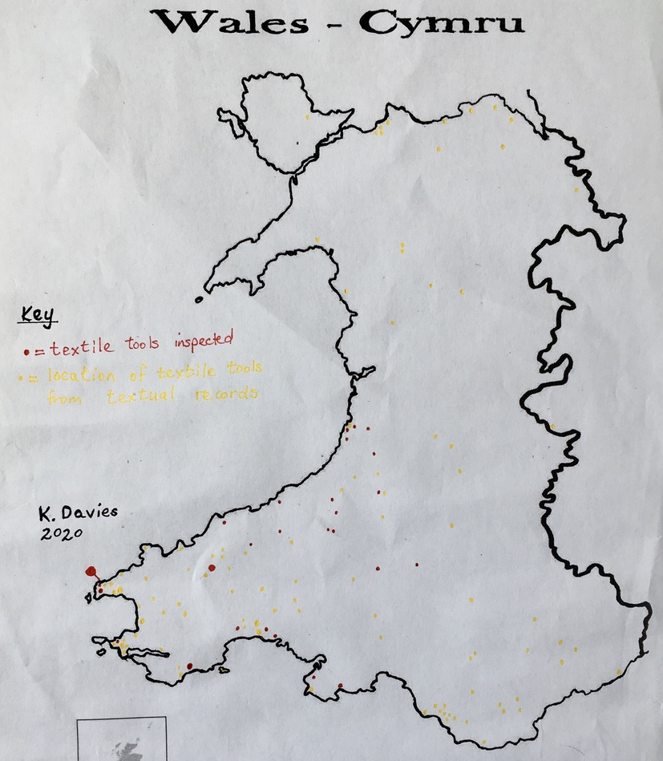
The weights of the finds ranged from a very light 5g, which was a finely made, triangular shaped, perforated piece of plain slate from the excavation at St David’s Head, to a beautifully shaped, very black, large, lenticular perforated stone of 519g with an illegible provenance written on the artefact, and unknown chronology. No obvious pattern was discernible from the graph displaying height and weight and the same proviso applies as with the spindle whorls, in that caution is needed in interpreting the data as there will be a problem of measurement bias because of breakage and incompleteness.
Figure 26 - Range of Weights of Loom Weights. (Graph: K Davies 2020.)
Figure 27 - Map showing Distribution of Textile Tools examined and researched. (Drawing: K Davies 2020.)
Figure 28 - Loom Weights - Height and Weight Comparison. (Graph: K Davies 2020.)
For full details of the artefacts examined, please see Appendix 1.

Chapter 6

Discussion
A number of problems were encountered in gathering the data needed to achieve the aims and objectives of this dissertation. It became apparent that, in general, prehistoric textile tools do not inspire interest, either in modern-day museum curators, or in antiquarians reporting on their excavations. Museums had different data recording protocols and there was uncertainty about the classification of artefacts.

Not all collections were accessible. Three county museums were contacted, resulting in a favourable response from Carmarthen and Ceredigion but a less promising one from Pembrokeshire, based at Scolton Manor - initially the existence of textile tools at Scolton Manor was denied; when it was pointed out that the museum was recorded as being the repository of the Llawhaden excavation which contained decorated spindle whorls (ARFAW 2003), there was a reluctant acceptance that they did have the artefacts in store but that they had not been catalogued, and it would be inconvenient to arrange a visit within the suggested time-scale. Two out of the four museums visited kept their spindle whorls in store, with one displaying 50% of their collection, and another displaying 15%. The latter museum had put on a larger display in the past, as their whorls were stored with the original information board, from which provenance was extracted. This lack of presentation is disappointing but is probably explained by lack of exhibition space, curator’s indifference to this type of artefact, and desire to promote artefacts with more appeal or glamour. When investigating the artefacts in store, one might expect there to be a correlation between the number of spindle whorls and the number of loom weights located at each museum, but this is not supported by the evidence. This surmise might be true if a collection were site-specific, or a comprehensive display of artefacts were found in a defined area, providing a possible representation of what activities were undertaken in that area. Tenby Museum does have site-specific artefacts, being the location of the archives for two important sites - St David’s Head and Moel Trigarn, containing an interesting collection of spindle whorls and possible loom weights; however, the other museums are the locations for a random collection of artefacts which cannot be shown to have any association or coherence. Therefore, no correlation is observed. Obviously, the artefacts from the excavation at Caer Cadwgan are assessed as a discrete site.

Mr Way (1867:249) discloses the prevalent attitude towards what antiquarians considered women’s artefacts by stating spindle whorls suggest ‘the gynaecium or resort of the mistress of the cyttiau’, possibly being ‘relics of female industry’ (a phrase mentioned twice) (1867:250). On the same page, he suggests that many of these artefacts were actually dress fastenings, using Mexico as a source for the theory; examples found in North Wales do not present any ‘remarkable variation in their size or fashion’ (1867:250) and generate no further comment. It is frustrating to think how many of these whorls may have been lost because of collector bias – perhaps their very abundance led to their being neglected.

Recording and Handling
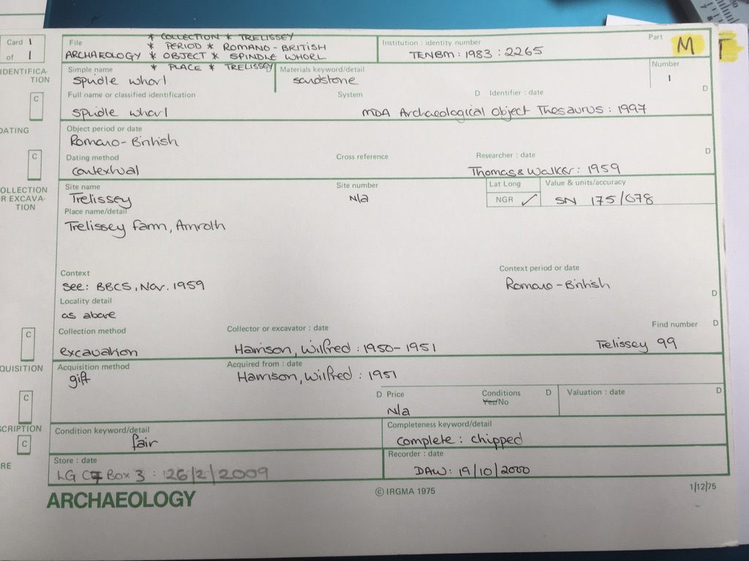
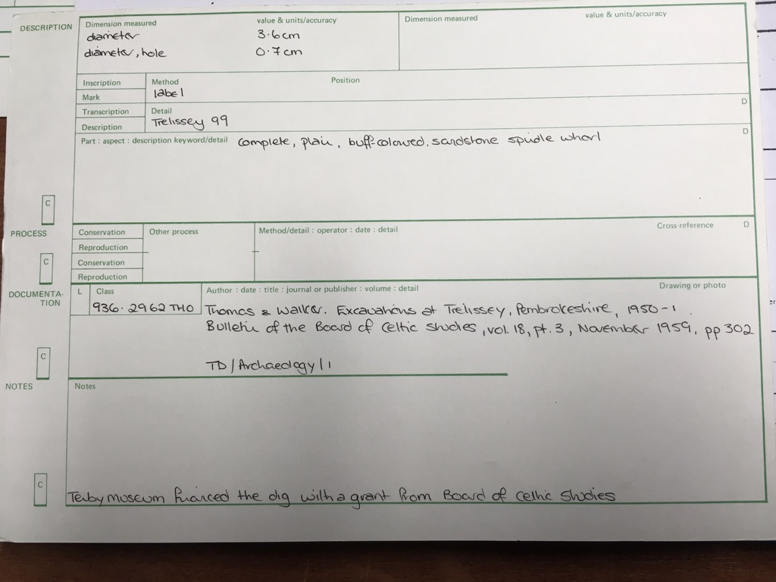
Three of the museums visited were maintained by the local authority – Carmarthen, Ceredigion and Swansea – with Tenby Museum (2020) being the only independent museum, run as a charity, and with a background of interest in local history from the museum’s inception in 1878. There was no consistency between the four museums with their artefactual recording protocols or handling procedures. One museum used a manual pre-printed card index system with very detailed records for each artefact; the other three had printouts of computer-generated records from either databases or spreadsheets containing limited, and sometimes inaccurate, information about their collections. Gloves were provided at two museums, and two different museums requested a signed access statement. Three museums supervised access, and one museum allowed unfettered access to the collection and nearby display cabinets. Although a card index system is old fashioned, it does work and is simple to maintain and use, and its questions prompt a comprehensive record; the data stored in different formats on computers is probably more quickly accessible but is only as good as the data input (although that is true of any collection of information). Is the data available at the museums an example of the limitations of the initial program set up? Were the right questions asked to produce an effective database? Without adequate planning for a database, the data can be worthless. As an example, one museum had ‘prehistoric’ input for the chronology for each artefact, with no further expansion or exegesis. These computer records did all produce an accession number and a name for the artefact – however, the other information supplied varied in quality, quantity, and usefulness. One museum had no data about provenance or chronology, another had provenance but no chronology. Where chronology had been recorded in another museum, there was a suspiciously large number of artefacts from the ‘Iron Age’, but, on investigation, 78% of these were from identifiable sites with a known chronology, so their dating appears more reliable. As county museums, the bulk of their collections are donations, so it is unsurprising that there is no coherence of collection policy. Lack of funding also impacts on their collections, storage, and data recording facilities. This experience does show, however, how a simple standardisation in terms of recording information about our cultural heritage archives would assist future researchers and ensure consistency across the industry. The different handling and access procedures also suggest a lack of homogeneity, as well as a disconcerting insignificance attached to the artefacts, and highlight the need for a coherent policy throughout the field.
Figure 29 - Example of recto side of card index record, Tenby Museum. (Photograph: K Davies 2019.)
Figure 30 - Example of verso side of card index record, Tenby Museum. (Photograph: K Davies 2019.)

These examples of lack of standardisation meant the failure of the aim of plotting patterns of distribution using chronology and provenance as data mapping tools, as there was insufficient data available to do this with any meaningful result. Where enough information was available, the low numbers meant the sample size was too small to produce anything worthwhile.

Classification
The sheer size of museum collections results in another problem encountered, which is that of uncertain classification. Artefacts in museums will display evidence of bias, whether it be collection bias, excavation bias, donation bias, or curator bias. This is because a decision was made to collect an item, to excavate a site, to donate an artefact, or to select something to put on display. The curator then has the problem of classifying the artefact, an action which reveals the diligence of the museum staff in presenting a truthful and comprehensive interpretation. Where there are a lot of artefacts, there is the temptation to gloss over, say, chronology, as in the ‘prehistoric’ example above, or to surmise as to the classification. Here, the artefacts recorded as spindle whorls seem to follow the expected norm exhibited by prehistoric whorls found in other countries. However, the items identified as loom weights were less persuasive. The features that link these artefacts are the fact that they are perforated, and their overall size and weight. The three excavation sites – St David’s Head, Moel Trigarn, and Caer Cadwgan – all produced spindle whorls and heavy perforated weights, not necessarily in the same excavation context, but the association of items could suggest textile production on the sites and the existence of vertical looms using loom weights. At St David’s Head, the weights varied from large, heavy, rough circular stones to fine, light pieces of slate or shale with triangular shapes and flat sides. The range of sizes and weights is troubling as one would expect consistency where a loom is concerned. If these artefacts are loom weights, their variability suggests several differently weighted looms. There just does not seem to be enough loom weights of a consistent size and weight to justify the assumption that they are textile tools. In addition, there was no conformity as to the context in which they were found on the site, or in their manufacture. Moel Trigarn produced a few rough stone discs with large perforations and a square shaped piece of slate. At Caer Cadwgan, the two pieces identified as loom weights were very rough, crude pieces of sandstone with large perforations. The remaining museum artefacts were perforated stones, again with no common shape or consistent features, apart from being perforated and of a mass that could be conceived as for a loom weight. Four perforated pieces had more than one perforation, prompting the question as to their use. Were they merely practice pieces, giving an opportunity to refine the technique of drilling the perforations in shale, which appears to break or shatter easily? Nowhere did there seem to be sufficient weights in one spot to suggest the existence of a loom. Is this a problem of taphonomy? Or is this just an example of excavation bias? Nor is there a consistent style, or size, or weight. In prehistoric archaeology, there is no real certainty, only a balance of probabilities, and there does not appear to be enough evidence in these examples to tip the balance towards a definition of loom weights.

Spindle Whorls
On inspection, the spindle whorls demonstrated a broad and interesting morphology.

Chronology and Typology
In Crewe’s 1998 study of Bronze Age Cypriot spindle whorls, she was able to compare the whorl typology at different stages of Cypriot chronology, showing a marked preference for conical or biconical shapes, with only a few examples of cylindrical or discoid styles. In contrast, this small Welsh sample does display a conspicuous inclination towards typology classes IVa and IVb, being a cylindrical shape with a. a flat edge or b. a convex edge. Out of 99 samples, 11 were IVa and 70 were IVb. However, the limited, and ambivalent, chronological data constrains analysis. 36 spindle whorls were classified as Iron Age and 45 were Unknown. Out of the Iron Age whorls, 3 were class IIIa, 8 were IVa, 24 IVb, and 1 IVc. Therefore, 92% of the Iron Age whorls were of cylindrical shape, of varying thicknesses and weights. Looking more closely at the provenance of these whorls, 4 came from Caer Cadwgan, with 3 being class IVa and 1 IVb. As class IVa is a more straightforward form, it could be interpreted as a cruder, earlier shape. The typology encountered at the St David’s Head and Moel Trigarn sites is similar, with the presence of classes IIIa, IVa, IVb, and IVc being recorded. Both sites had small numbers of IVa and larger numbers of IVb; the IVb style is more shaped and aesthetically pleasing than IVa so might be considered a next step in the evolution of the spindle whorl chaîne opératoire. The chronology for finds from these three excavations is firmer than for the artefacts from other sites so there is some confidence available in analysing their material culture and its typology.

Decoration
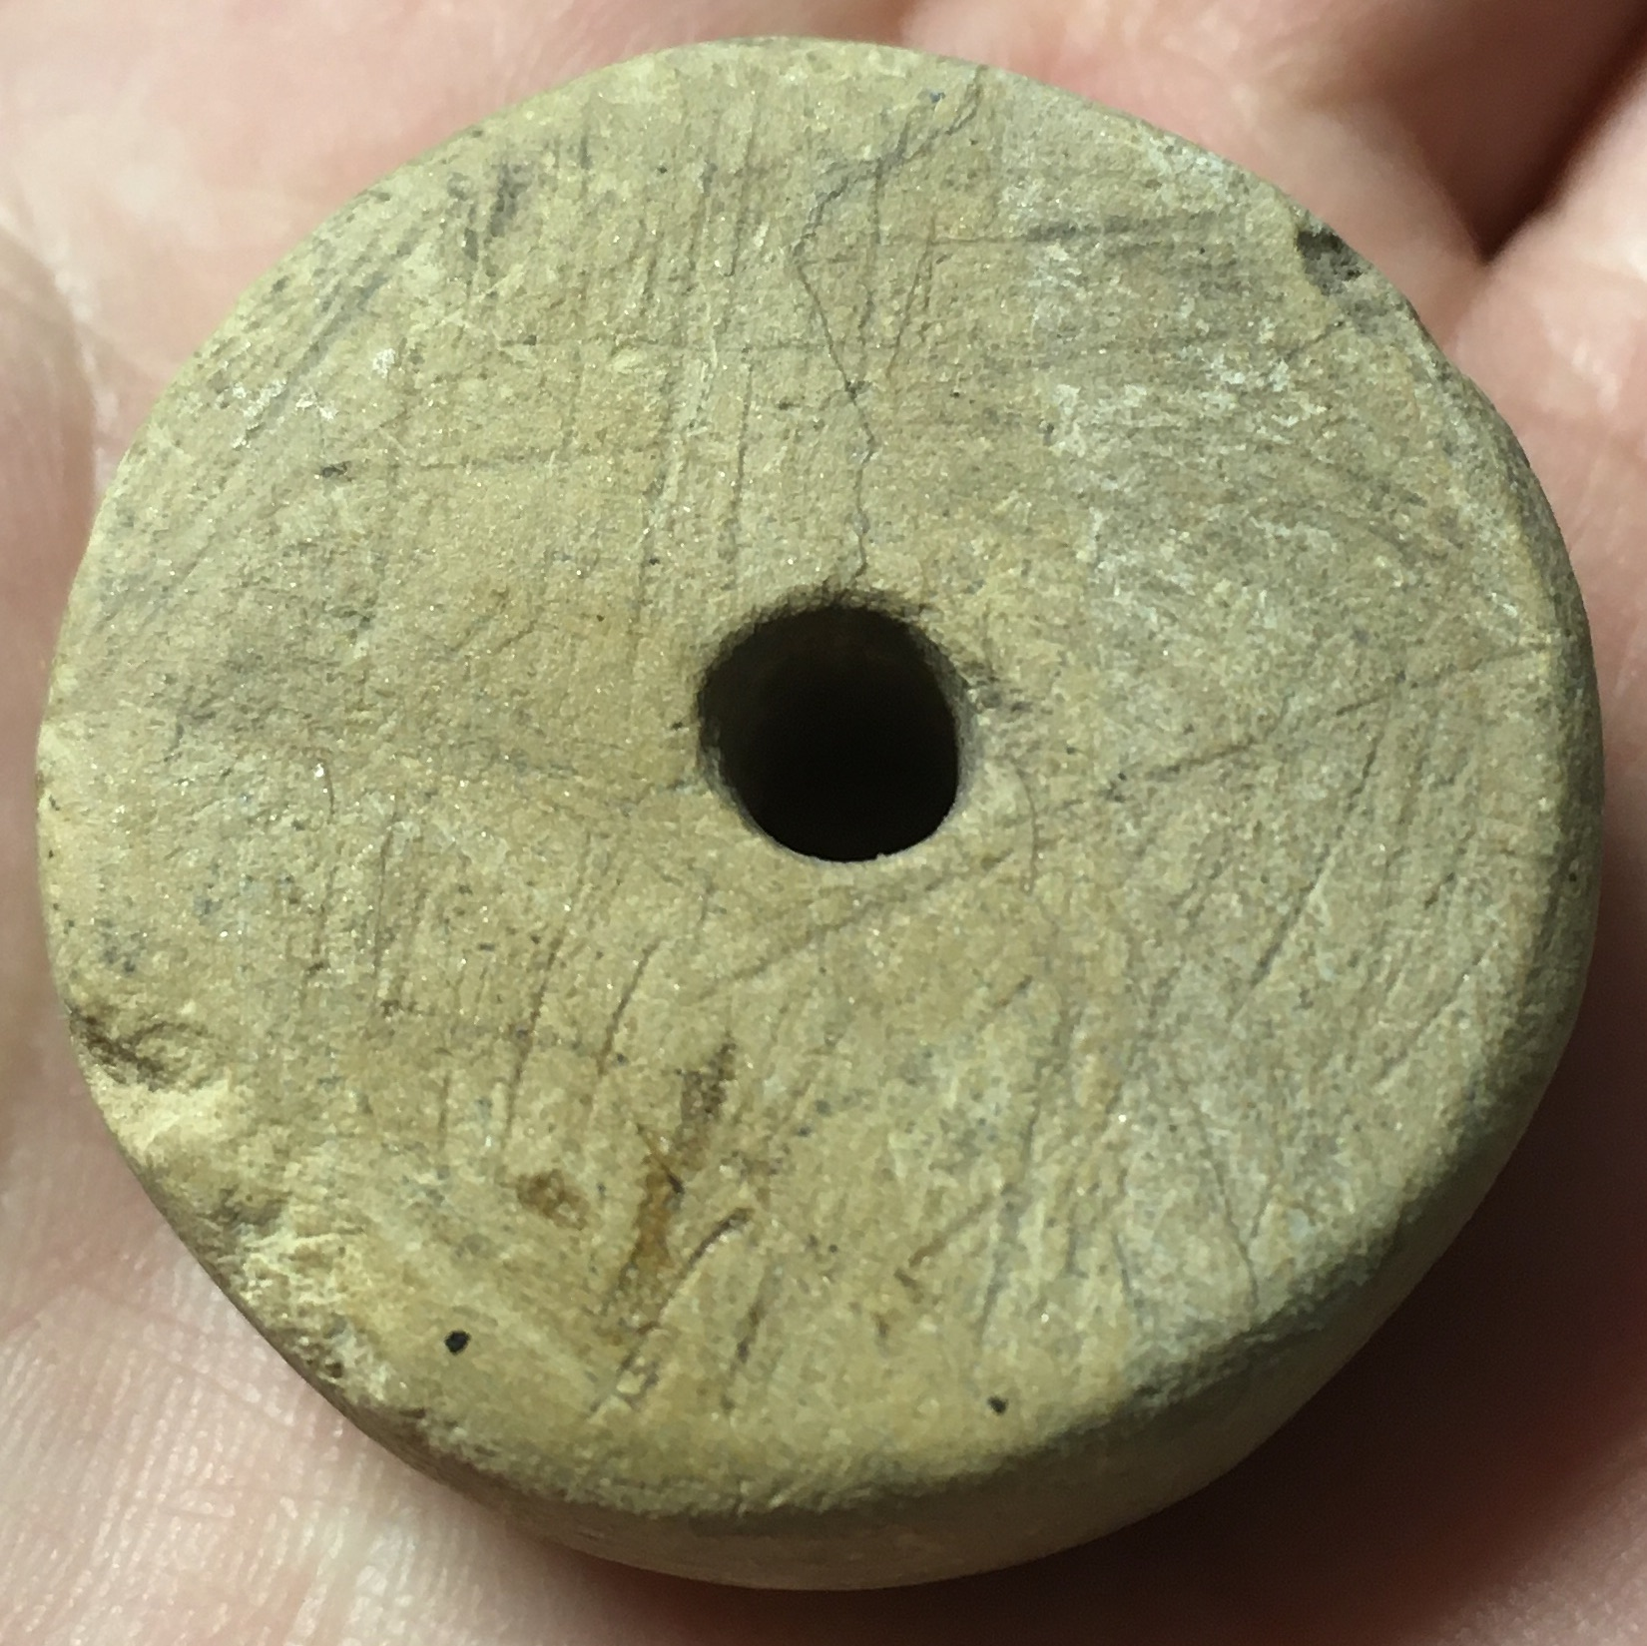
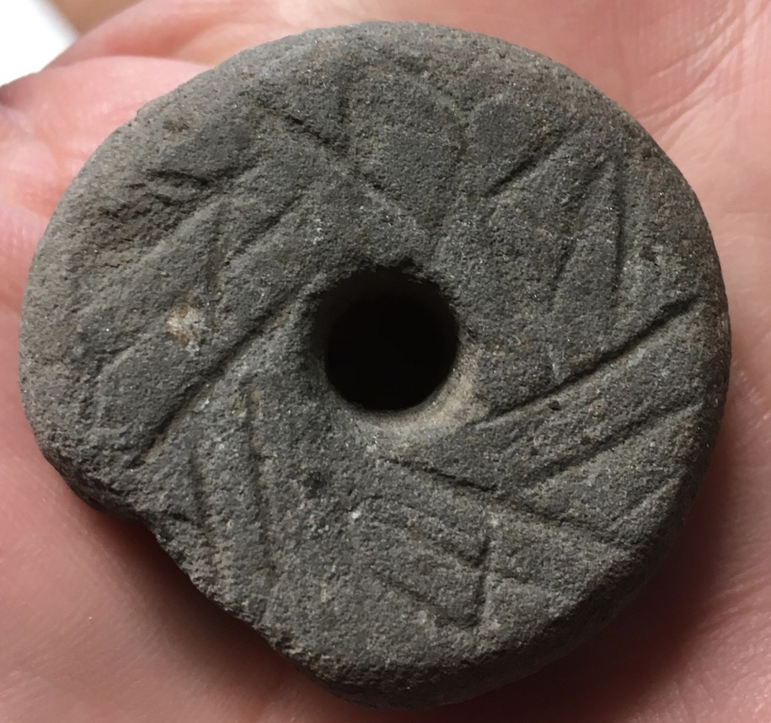
Of interest are the spindle whorls with decorative elements found at St David’s Head and Moel Trigarn. The former site produced 11 whorls, with 3 being decorated. One was class IVa, made of sandstone, and decorated relatively crudely with scratch-marks on the top, base, and edge of the whorl. Two were class IVb, made of sandstone and slate respectively, with lines incised in the top to produce a definite decorative pattern. This sandstone whorl seems to have a more rudimentary pattern compared to the slate whorl, although there is some similarity in the design. Technically, the slate whorl would be harder to process, being a firmer surface with a greater inclination to shatter, whereas the sandstone would be relatively easy to incise and shape because of the properties of the raw material itself. The central perforation in the slate whorl can be seen to have been made using a circular tool and producing a much larger point of ingress than that evidenced in the sandstone whorls. Is this an example of technological development in the use of raw materials? It would be interesting to see where else in Wales are slate whorls found? The design on all three whorls suggests movement, and would have added an interesting element of aesthetics, especially when spun. It is intriguing to consider the diverse visual effects produced on spinning the whorls with different designs, and, again, with more reliable chronology and provenance, it would have been fascinating to analyse the data to see if there was a prevalent motif or style. In contrast to St David’s Head, only one spindle whorl had decoration at Moel Trigarn, but this was exceptional. It is made of stone, class IVc, meaning it
Figure 31 - - St David's Head Type IVb sandstone spindle whorl, Tenby Museum Accession No. TENBM:1983:2051-4. (Photograph: K Davies 2019.)
Figure 32 - St David's Head Type IVa sandstone spindle whorl, Tenby Museum Accession No. TENBM:1983:2051-7. (Photograph: K Davies 2019.)
Figure 33 - - St David's Head Type IVb slate spindle whorl, Tenby Museum Accession No. TENBM:2050-8. (Photograph: K Davies 2019.)
Figure 34 - Decorated spindle whorl from Moel Trigarn. Tenby Museum - Accession Number: TENBM:1983:2046-8. (Photographs: K. Davies. 2019)
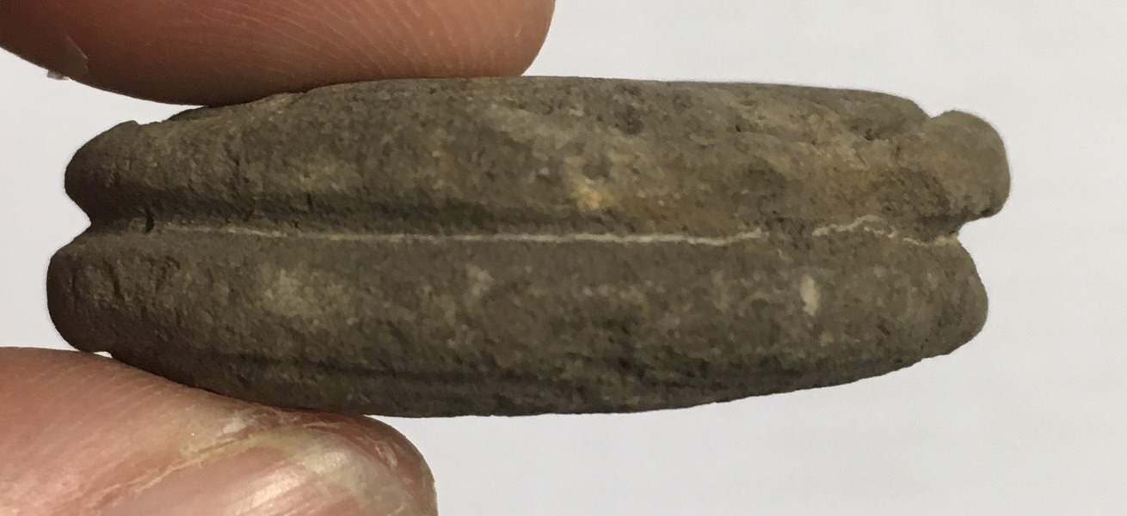
Figure 35 - Decorated spindle whorl from Moel Trigarn. Tenby Museum - Accession Number: TENBM:1983:2046-8. (Photographs: K. Davies. 2019)
has a groove around the mid-line on its edge. It is the only whorl in the dataset with a mid-line groove. Its decoration consists of an outer concentric ring on the top and base, with spots arranged evenly around the perforation, top and base, and a few spots randomly distributed on the top and base. Also, on the top face, are spots arranged evenly around the outer ring, which in addition has the remnants of a white line impressed in its deepest point. This white line motif is repeated in the deepest part of the mid-line groove. None of this decoration would have had an effect on the technical performance of the whorl, so its impact is purely aesthetic, making an everyday, utilitarian object into a very personal item, easily identifiable and displaying a pleasing beauty. As another example of the blasé attitude of antiquarians, this whorl was described as ‘an ornamented spindle-whorl’ by Baring Gould et al (1900:207), with no more elaboration, although it did merit an illustration.
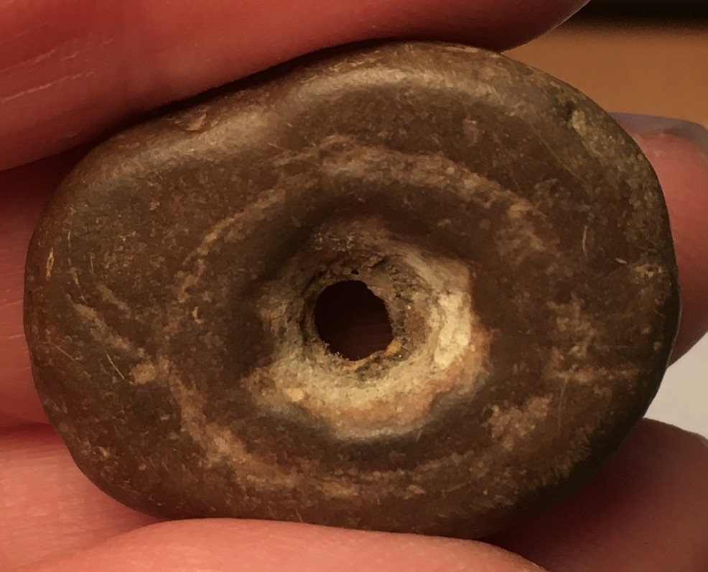
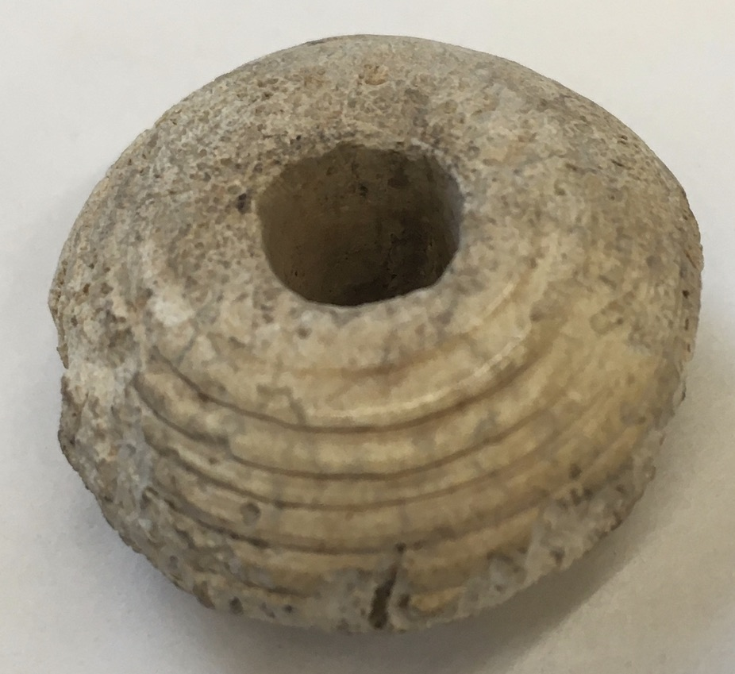
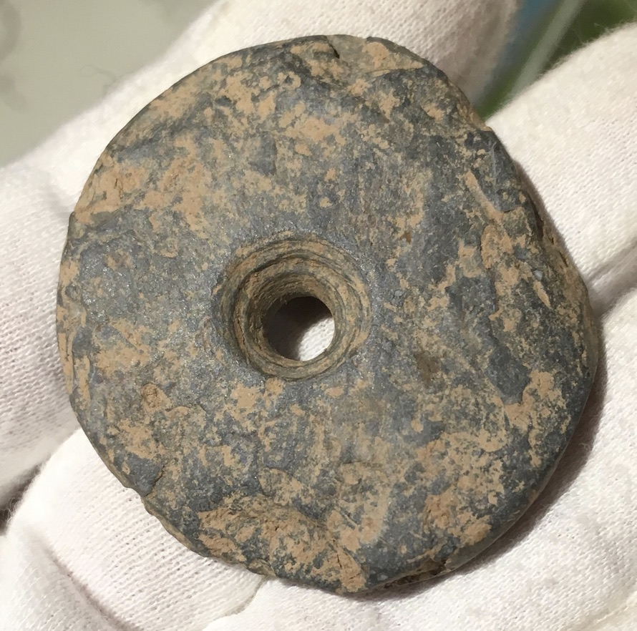
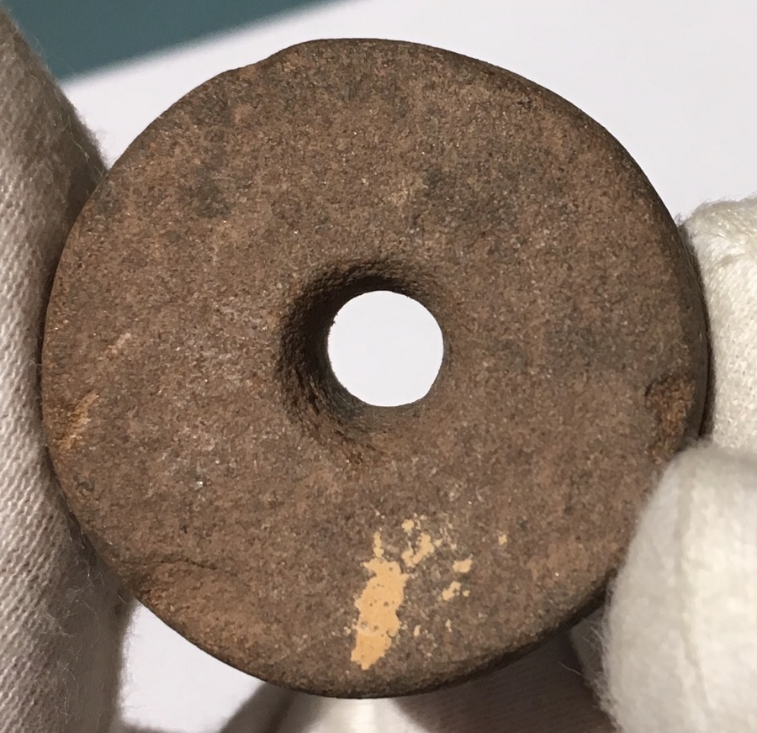
Overall, 65% of the whorls had no decoration, and 14% had scratches on the surfaces which may have been decoration or a result of manipulation. Other motifs evident are incised lines, as in the examples above, concentric circles, pits or spots, and patterns of blank and hatched areas. Looking at this assemblage as a whole, one could position the spindle whorls in a row displaying stylistic change – starting with perforated pebbles with no evidence of adaptation, progressing to shaped stones of varying sizes and materials, to stones shaped nicely with a satisfying weight, to very finely shaped, small whorls using specific raw materials. This exercise shows a pleasing aesthetic progression, but it cannot be interpreted as proof of technological advancement because the only evidence is visual – there is no corroboration, whether chronological, spatial, temporal, or contextual, and therefore no conclusions may be drawn.
Figure 36 - Spindle whorl displaying different stages of refinement: pebble whorl, perforated but shape unmodified with a circle pecked into the pebble, presumably as a decorative motif - this is repeated on the base, Carmarthen Museum Accession No. A1980/0041. (Photograph: K. Davies 2020.)
Figure 37 - Spindle whorl displaying different stages of refinement: stone whorl showing drill marks, no other obvious modification, Ceredigion Museum Accession No. 1983.28/2066. (Photograph: K. Davies 2019.)
Figure 38 - Spindle whorl displaying different stages of refinement: sandstone whorl, finely shaped and drilled, Ceredigion Museum Accession No. 1984.172.1/2354. (Photograph: K. Davies 2019.)
Figure 39 - Spindle whorl displaying different stages of refinement: bone whorl, very finely shaped and decorated, Swansea Museum Accession No. SM1959.11.29. (Photograph: K. Davies 2020.)
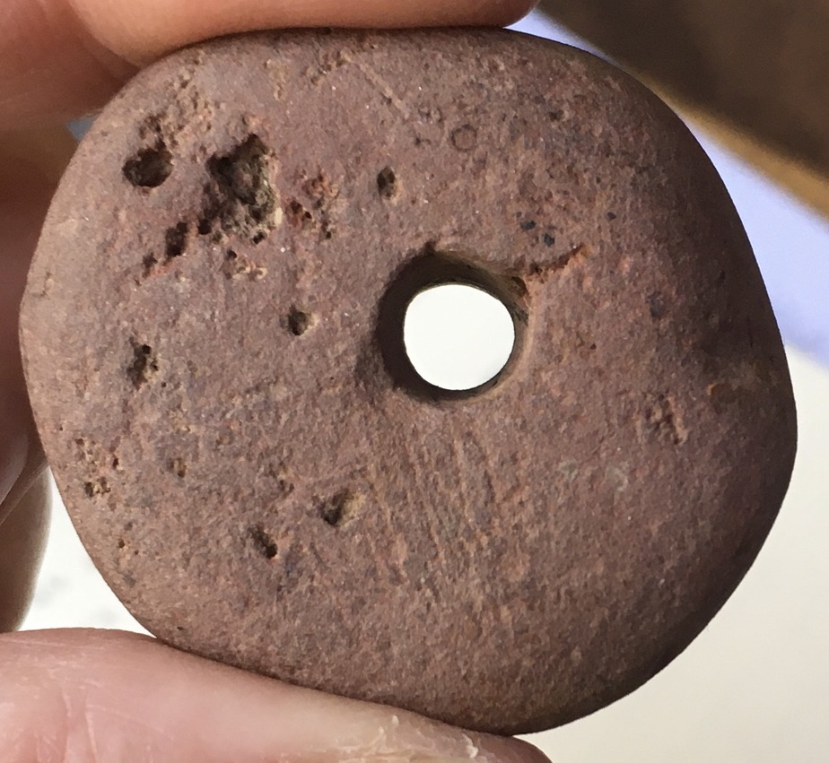
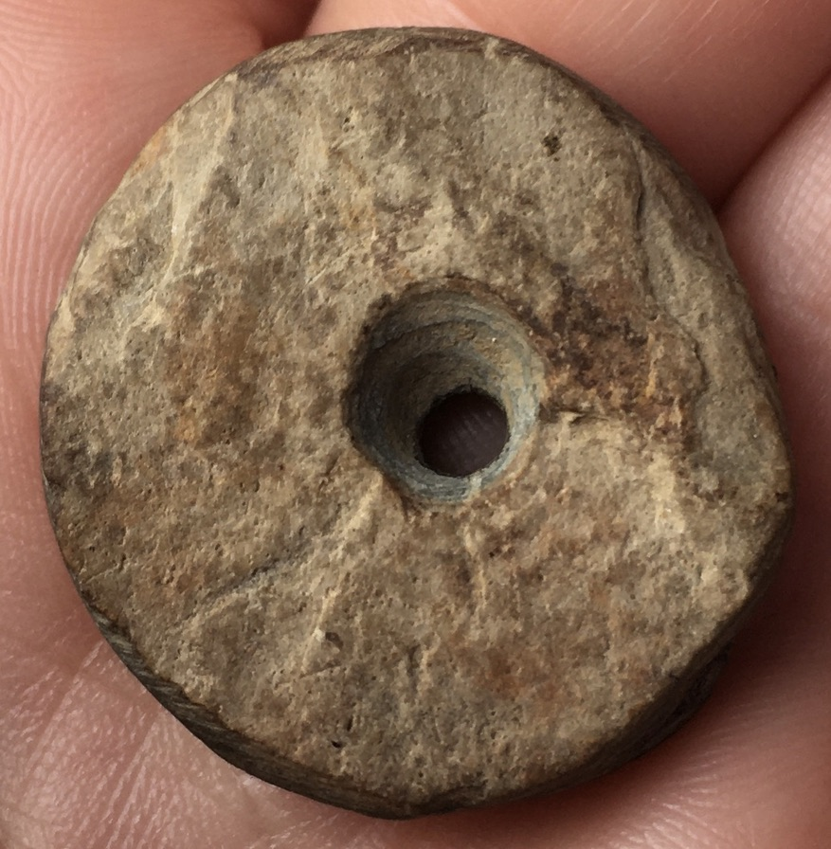
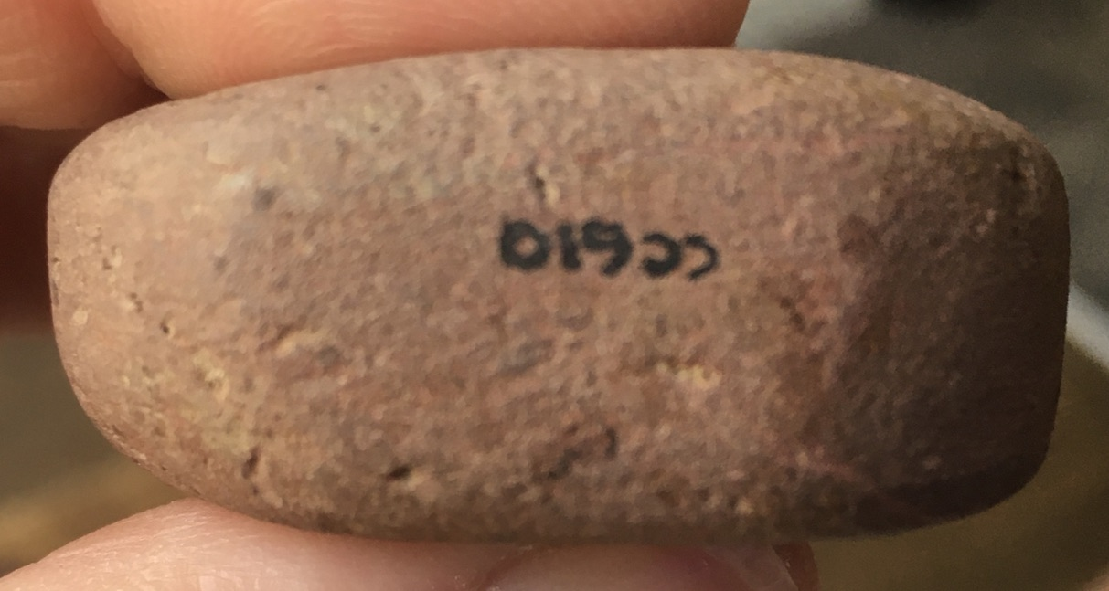
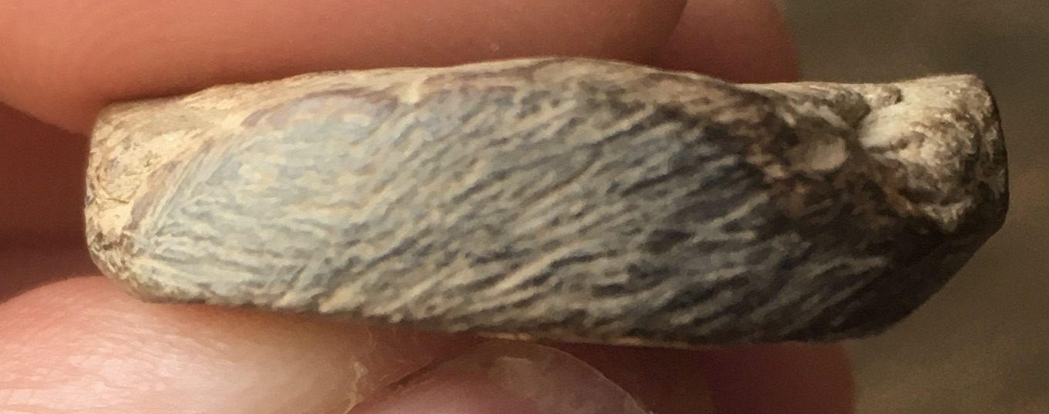
The following two spindle whorls are an example of why care should be taken in making assumptions about technological progression. Both whorls were found at the Caer Cadwgan site, albeit in different contexts. They are both classified as Iron Age. The first was found in context 28, is made of a hard stone, with rough surfaces and an hourglass perforation. The perforation demonstrates the hardness of the stone since the grinding action to produce the perforation is visible from the circular marks. There are decorative scratch marks on the edge of the whorl. The second was found in context 328, and is made of a smooth, red sandstone. Scratches are visible on part of the upper surface, but these do not appear to be decorative. It is less circular and has a straight perforation which is slightly off-centre. Are these latter irregularities caused by wear and tear on a soft stone, thus giving us an example of a well-used whorl? Are the scratches evidence of use wear? Are the differences between these two whorls caused by the raw materials used? Or are they an example of progression from a rough stone object to a more worked sandstone item? Was the choice of raw materials an experiential decision? Does the desire to decorate a utilitarian object imply a more nuanced aesthetic? Without the context and site chronology, one might have interpreted the stone whorl as being an earlier, less technologically advanced version of the sandstone whorl. However, the differences between them could be caused by many factors, not just technical progress. As is manifest, more questions are raised than answered when analysing the evidence of these spindle whorls, and it is important not to make assumptions based on one’s own biases when attempting to make sense of the assemblage.
Figure 40 - Sandstone spindle whorl from Caer Cadwgan, reference no. 610. (Photograph: K. Davies 2019.)
Figure 41 - Sandstone spindle whorl from Caer Cadwgan, reference no. 610. (Photograph: K. Davies 2019.)
Figure 42 - Stone spindle whorl from Caer Cadwgan, reference no. 499. (Photograph: K. Davies 2019.)
Figure 43 - Stone spindle whorl from Caer Cadwgan, reference no. 499. (Photograph: K. Davies 2019.)

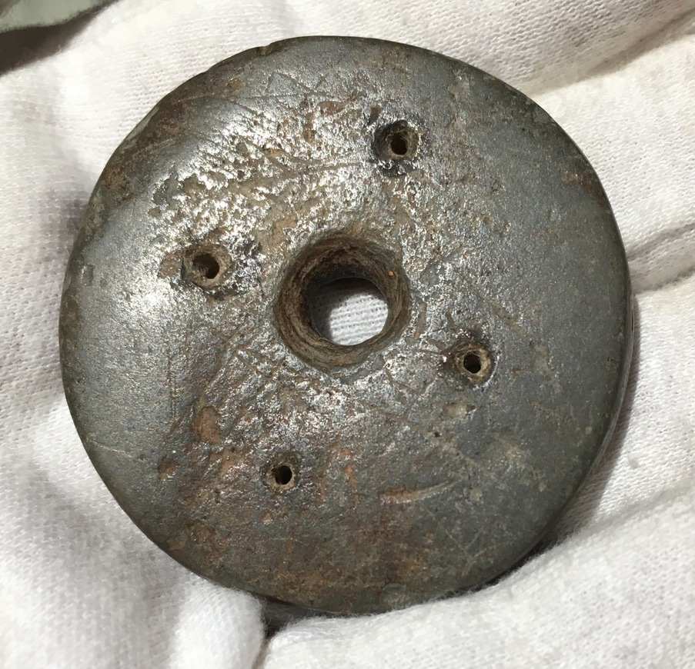
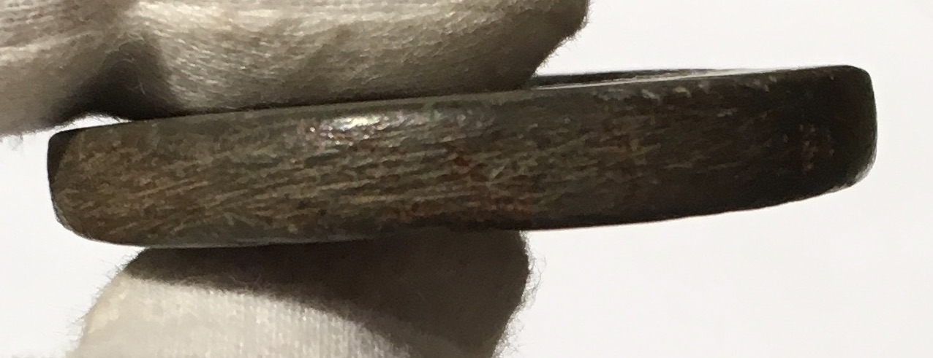
Before leaving the topic of decoration, a mention should be made of another exceptional whorl with an unusual appearance. This spindle whorl is
Figure 44 and Figure 45 - Stone spindle whorl with central perforation and four smaller holes made in a square or possibly diamond shape, scratch marks on edge as possible decoration. CM060 Ceredigion Museum (on loan from Carmarthen Museum). (Photographs: K. Davies 2019.)

recorded as being from north Ceredigion with prehistoric chronology, is made from stone and is class IVb. It is nicely made with a drilled central perforation. What makes it exceptional are the four smaller perforated holes arranged around the central perforation. These are arranged in the four corners of a square or possibly a diamond. Extensive research online has failed to produce evidence of a similar spindle whorl. Are the smaller holes purely decorative? Or could they be utilitarian? Similar to a weaving card on an inkle loom? This latter question might be unlikely because of the object’s weight – 24g – but it could be a possibility. Again, more questions are raised than answered, especially with the limited data as to provenance or chronology, but this is an interesting, and seemingly a unique, whorl.

Raw Materials
Over 90% of the fabric used to make these Welsh spindle whorls was local stone, with stone or sandstone making up 77% of the total. An unusual raw material was slate, comprising 7% of the sample. Online research does not prompt further examples of slate whorls, which prompts the question, are these a specifically Welsh artefact, using abundant local materials? Or is this another example of insufficient data? Spindle whorls made of terracotta/clay/pottery only make up 5% of this sample, which appears to be an unusually low number. Clay spindle whorls made up 97% of Crewe’s 1998 Cypriot assemblage, whereas stone was 2.5%, which is obviously a very different ratio to these Welsh figures. One cause may be taphonomic conditions, with the drier Cypriot environment being more favourable to pottery preservation than the typically damp Welsh climate. Baring Gould (1899) particularly mentions the paucity of pottery remains at the St David’s Head excavation, and this dearth is repeated at Moel Trigarn (Baring Gould et al 1900), so it seems possible that clay or pottery spindle whorls may not have survived. However, if taphonomic conditions were the only factor affecting preservation, why is there not a greater number of stone whorls in Cyprus, as both clay and stone would survive? Crewe’s 1998 figures imply stone whorls are present in Cyprus in low numbers, compared to the Welsh ratio, but hers is a specific sample of Bronze Age whorls. Bernard Knapp (2013) mentions the existence in Cyprus of numerous whorls and other perforated discs made of stone and therefore, although Crewe’s figures are helpful in prompting questions about taphonomic effects, a straight comparison between her figures and these Welsh results ignores their very individual contexts and is less meaningful. There are a few examples of bone whorls (2%) which are possibly Roman and very finely made. This scarcity may also be attributed to taphonomic conditions, with bone artefacts deteriorating in acid soils (Baxter 2004).

Quantification
Excel was used to record the information amassed, thus enabling data manipulation to produce graphs allowing analysis for any patterns evident from the figures, and a selection of these graphs are illustrated in Chapter 5. Graphs were compared when ordered by diameter, by known chronology, and by typology, but no obvious patterns were apparent. With such incomplete data on chronology and provenance, no meaningful conclusions may be drawn anyway. What can be said is there was a broad range of measurements for every variable, with no obvious pattern discernible with regard to known sites or chronology, or even typology. There is no correlative effect when comparing weight and diameter, or diameter and height. The Moment of Inertia Ratio calculation increases with diameter, as would be expected, but the scatter gram is too diffuse to suggest any intentional reductive manufacture of whorls to improve their technical performance. There are outliers on each graph, and one would need a much larger sample with more comprehensive data to allow for a nuanced and more credible interpretation. A further problem with interpretation based on measurements is the presence of broken and incomplete artefacts, which affect the graphical results because of their weighting in such a small sample size. Having a larger base population would moderate this effect.

Chapter 7

Conclusion
The principal aim of this dissertation was to compile a database documenting the archaeological record which provides evidence of textile production in prehistoric Wales in Ceredigion, Carmarthenshire, and Pembrokeshire. This has been achieved through visits to County museums, an independent museum, and contact with an excavation director. However, the background information about their collections was not standardised in the museums, which meant there was insufficient data to interrogate in order to analyse the material for chronological or spatial markers. This is disappointing, as it was hoped the analysis of these markers might have provided clues for artefact mapping, leading to the consideration of ideas of dispersal, population movement, trade and exchange, and transmission of ideas, helping our knowledge of the nature of prehistoric Welsh communities – perhaps an overly optimistic and ambitious aspiration, in retrospect. Nevertheless, the quantitative and photographic data gathered does provide a basis for a systematic study of textile tools throughout Wales and also shows it is possible to assess the characteristics of the tools, and record and analyse their stylistic and functional attributes.

A typology has been created which allows typological analyses and comparisons between the basic kinds of whorl, quantifying the technological differences between types. Functional variability has been investigated, and technological measurements have been made and recorded. This data provides a foundation for a national, as opposed to a regional, database, should further study of Welsh prehistoric textile tools be undertaken. Problems concerning taphonomy are discussed in Chapter 6, and the lack of evidence, or disconnect between different parts of Wales, is discussed in Chapter 2. These are problems which may be solved with larger sample sizes produced by focussing on a bigger area. Stylistic individuality, whether it be through raw materials, shape, size, or decoration showed biases of shape and raw materials, but regional inferences could not be drawn because of inadequate data. Exceptional decorative effects were visible, and the existence of slate whorls is unusual.

Brück (2019) suggests the significance of metal in Bronze Age Britain has been overplayed, with textiles and their production having implications of economic, social, and symbolic importance. These conceptual categories provide topics for future examination.

Future Research?
In spite of the problems with lack of background information, this study contains interesting content and more questions have been raised than answered. A much more comprehensive and wide-reaching Welsh regional database of the archaeological record of textile tools should be compiled. A larger sample size will allow more nuanced and sophisticated analyses and interpretations of the results, which I am sure will be of value. Inspection of antiquarian excavation reports appearing in early issues of Archaeologia Cambrensis are useful sources of information about types of tools found and their provenance and allows an extra layer of context to be applied. An interesting study might be to research, record and compare several excavation sites for which there are articles in Archaeologia Cambrensis, with analyses of the material record and the excavators themselves. An investigation focussing on the use of slate for textile tools would be informative, particularly as they appear to be specifically Welsh and they tend to be decorated very distinctively. The different styles of decoration raise questions as to utility, object agency, and identity, theoretical concepts which do not appear to have been applied to this stylistic topic.

My literature review gave me the aspiration to study Welsh spindle whorls, having read Lindy Crewe’s very comprehensive book about Spindle Whorls of Bronze Age Cyprus, and it would be a fitting future outcome for a study to be produced which achieved the same for Welsh spindle whorls as Crewe’s did for Cypriot spindle whorls.

Reference List
A Research Framework for the Archaeology of Wales 2003. Key Sites. Southwest Wales – Later Bronze Age and Iron Age. https://www.archaeoleg.org.uk/pdf/bronzeandiron/KEY%20SITES%20SW%20WALES%20LATER%20BRONZE%20AGE%20AND%20IRON%20AGE.pdf [accessed 9 April 2020].

A Research Framework for the Archaeology of Wales 2015. Key Sites. Southwest Wales – Neolithic and early Bronze Age. https://www.archaeoleg.org.uk/pdf/keysitesneolithicsouthwestwales2015.pdf [accessed 9 April 2020].

A Research Framework for the Archaeology of Wales 2016. Site of research framework and key questions for Welsh archaeology. https://www.archaeoleg.org.uk/intro.html [accessed 9 April 2020].

Barber, E. and Caulfield, K. 2015. In Search of Roman and pre-Roman Distaffs. Available from https://rogueclassicism.com/2015/08/21/in-search-of-roman-and-pre-roman-distaffs/ [accessed 20 April 2020].

Barber, E. J. W. 1991. Prehistoric Textiles. Princeton: Princeton University Press.

Barber, E. W. 1994. Women’s Work. The First 20,000 Years. New York: W. W. Norton & Co.

Baring Gould, S., Burnard, R., and Enys, J. D. 1899. Exploration of the stone camp on St David’s Head. Archaeologia Cambrensis XVI Fifth Series: 105-131. https://journals.library.wales/view/2919943/2989090/0#?xywh=-1412%2C18%2C5003%2C3275 [accessed 14 April 2020].

Baring Gould, S, Burnard, R. and Anderson, I. K. 1900. Exploration of Moel Trigarn. Archaeologia Cambrensis 17: 189-211. https://journals.library.wales/view/4718179/4718180/0#?xywh=-1677%2C-174%2C5291%2C3464 [accessed 14 April 2020].

Bar-Yosef, O., Belfer-Cohen, A., Mesheviliani, T., Jakeli, N., Bar-Oz, G., Boaretto, E., Goldberg, P., Kvavadze, E. and Matskevich, Z. 2011. Dzudzuana: an Upper Palaeolithic cave site in the Caucasus foothills (Georgia). Antiquity 85: 331-349.

Baxter, K. 2004. Extrinsic Factors that affect the Preservation of Bone. Nebraska Anthropologist 19: 38-45. https://digitalcommons.unl.edu/cgi/viewcontent.cgi?article=1061&context=nebanthro [accessed 11 April 2020].

Bernard Knapp, A. 2013. The Archaeology of Cyprus. From Earliest Prehistory through the Bronze Age. Cambridge: Cambridge University Press.

Brück, J. 2019. Personifying Prehistory. Relational Ontologies in Bronze Age Britain and Ireland. Oxford: Oxford University Press.

Caesar, J. 1869. Commentarii de Bello Gallico. Translated by McDevitte, W. A. and Bohn, W. S. New York: Harper & Bros. http://classics.mit.edu/Caesar/gallic.5.5.html [accessed 15 April 2020].

Cameron, J. A. 2002. Textile Technology in the Prehistory of Southeast Asia. Unpublished PhD thesis, Australian National University.

Catalhoyuk. 2013. Çatal News. Çatal Newsletter 20, available from http://www.catalhoyuk.com/sites/default/files/Catal_News_2013.pdf [accessed 21 April 2020].

Crewe, L. 1998. Spindle Whorls. A study of form, function and decoration in prehistoric Bronze Age Cyprus. Jonsered: Paul Åströms förlag.

Davies, K. 2019. Photographs of textile tools for dissertation.

Davies, K. 2020. Graphs of textiles tools for dissertation.

Davies, K. 2020. Drawings of spindle whorl typology for dissertation.

Davies, S. (trans.) 2007. The Mabinogion. Oxford: Oxford University Press.

Dunning, G. C. 1943. A Stone Circle and Cairn on Mynydd Epynt, Brecknockshire. Archaeologia Cambrensis 97: 169-194. https://journals.library.wales/view/4718179/4739638/250#?xywh=-1877%2C-277%2C6688%2C4378 [accessed 3 April 2020].

Gilligan, I. 2018. Climate, Clothing and Agriculture in Prehistory: Linking Evidence, Causes and Effects. Cambridge: Cambridge University Press.

Grömer, K. 2014. Textile Materials and Techniques in Central Europe in the 2nd and 1st Millenia BC. New Directions: Examining the Past, creating the future. Los Angeles, Textile Society of America Symposium Proceedings 914. 10-14 September 2014. Available from https://www.researchgate.net/figure/Iron-Age-textiles-from-Hallstatt-salt-mine-CNHM-Vienna_fig3_301224448 [accessed 19 April 2020].

Hallmann, A. 2015. More items of funerary linen from the Deir-El-Bahari burial assemblages. Polish Archaeology in the Mediterranean 24/4: 113-136.

Hardy, B. L., Moncel, M.-H., Kerfant, C., Lebon, M., Bellot-Gurlet, L. and Mélard, N. 2020. Direct evidence of Neanderthal fibre technology and its cognitive and behavioral implications. Scientific Reports 10: 4889. https://www.nature.com/articles/s41598-020-61839-w#Fig4 [accessed 20 April 2020].

Harris, O. J. T. and Cipolla, C. N. 2017. Archaeological Theory in the New Millennium. Introducing Current Perspectives. Abingdon: Routledge.

Homer. 1900. The Odyssey. Translated by S. Butler. Project Gutenberg EBook, available from https://www.gutenberg.org/files/1727/1727-h/1727-h.htm [accessed 20 April 2020].

Hume, A. 1863. Ancient Meols: or, some account of the antiquities found near Dove Point on the sea-coast of Cheshire. London: John Russell Smith.

Kvavadze, E., Bar-Yosef, O., Belfer-Cohen, A., Boaretto, E., Jakeli, N., Matskevich, Z. and Meshveliani, T. 2009. 30,000-Year-Old Flax Fibers. Science 325 (5946): 1359.

Lendering, J. 2020. Caesar’s Gallic War. Livius.org. https://www.livius.org/sources/about/caesar-s-gallic-war/ [accessed 8 April 2020].

Louvre Museum. 2020. Photograph of Egyptian linen tunic, accession number E 12026. https://www.louvre.fr/en/oeuvre-notices/tunic-pleated-linen [accessed 18 April 2020].

Murphy, K, Mytum, H., Austin, L., Caseldine, A. E., Griffiths, C. J., Gwilt, A., Webster, P. and Young, T. P. 2011. Iron Age Enclosed Settlements in West Wales. Proceedings of the Prehistoric Society 78: 263-313.

Must Farm. 2015. Textiles at Must Farm, from the Must Farm website, available at http://www.mustfarm.com/progress/site-diary-6-textiles/ [accessed 18 April 2020].

Must Farm. 2019. Post Ex Diary 11: The Must Farm Textiles Parts 1-7. Available from the Must Farm website, http://www.mustfarm.com/post-dig/post-ex-diary-11-the-must-farm-textiles-part-one/ [accessed 18 April 2020].

National Library of Wales 2020. Issues of Archaeologia Cambrensis 1846-1899. https://journals.library.wales/view/2919943/2989090/0#?xywh=-1913%2C-206%2C6004%2C3931 [accessed 9 April 2020].

Ovid. 1794. Metamorphoses. Translated by J. Dryden et al. https://archive.org/details/b24975874/page/44/mode/2up [accessed 20 April 2020].

Redknap, M. and Lane, A. 1994. The Early Medieval crannog at Llangorse, Powys: an interim statement on the 1989-1993 seasons. The International Journal of Nautical Archaeology 23.3: 189-205.

Sabatini, S. and Bergerbrant, S. 2019. The Textile Revolution in Bronze Age Europe: Production, Specialisation, Consumption. Cambridge: Cambridge University Press.

Sackett, J. R. 1977. The Meaning of Style in Archaeology. American Antiquity 42: 59-112.

Savory, H. N. 1976. Guide Catalogue of the Early Iron Age Collections. Cardiff: National Museum of Wales.

Savory, H. N. 1980. Guide Catalogue of the Bronze Age Collections. Cardiff: National Museum of Wales.

Sugden, K. & Cockerill, A. 2018. The Wool and Cotton Textile Industries in England and Wales up to 1850. The Cambridge Group for the History of Population and Social Structure. https://www.campop.geog.cam.ac.uk/research/occupations/outputs/onlineatlas/textiles.pdf [accessed 2 April 2020].

Sweet, R. 2008. Antiquarianism and History. Available from https://archives.history.ac.uk/makinghistory/resources/articles/antiquarianism.html#4 [accessed 21 April 2020].

Tenby Museum 2020. Website for the Tenby Museum and Art Gallery.
http://www.tenbymuseum.org.uk/about/ [accessed 9 April 2020].

Turfa, J. M. 2012. Divining the Etruscan World. Cambridge: Cambridge University Press.

UCL. 2003. University College London webpage - Digital Egypt for Universities. https://www.ucl.ac.uk/museums-static/digitalegypt/textil/wovenlinen.htm [accessed 20 April 2020].

Vedeler M. and Bender Jørgensen, L. 2013. Out of the Norwegian glaciers: Lendbreen – a tunic from the early first millennium AD. Antiquity 87: 788-801.

Vogelsang-Eastwood, G. 2000. Textiles, in Nicholson, P. T. and Shaw, I. (eds.). Ancient Egyptian Materials and Technology. 268-298. Cambridge: Cambridge University Press.

VAM. 2020. Victoria & Albert Museum: The history of hand-knitting. https://www.vam.ac.uk/articles/the-history-of-hand-knitting [accessed 20 April 2020].

Way, A. 1867. Notices of Relics found in and near the Cyttiau’r Gwyddelod, in Holyhead Island. The Archaeological Journal 24: 243-264. https://archaeologydataservice.ac.uk/archiveDS/archiveDownload?t=arch-1132-1/dissemination/pdf/024/024_243_264.pdf [accessed 25 April 2020].

Yvanez, E. and Wozniak, M. M. 2019. Cotton in ancient Sudan and Nubia. Revue d’ethnoécologie 15: 1-53.

Bibliography
Adovasio, J. M., Soffer, O. and Klíma, B. 1996. Upper Palaeolithic fibre technology: interlaced woven finds from Pavlov I, Czech Republic, c. 26,000 years ago. Antiquity 70: 526-534.

Andersson Strand, E. and Nosch, M.-L. (eds). 2015. Tools, Textiles and Contexts. Investigating Textile Production in the Aegean and Eastern Mediterranean Bronze Age. Oxford: Oxbow Books.

A Research Framework for the Archaeology of Wales 2003. Key Sites. Southwest Wales – Later Bronze Age and Iron Age. https://www.archaeoleg.org.uk/pdf/bronzeandiron/KEY%20SITES%20SW%20WALES%20LATER%20BRONZE%20AGE%20AND%20IRON%20AGE.pdf [accessed 9 April 2020].

A Research Framework for the Archaeology of Wales 2015. Key Sites. Southwest Wales – Neolithic and early Bronze Age. https://www.archaeoleg.org.uk/pdf/keysitesneolithicsouthwestwales2015.pdf [accessed 9 April 2020].

A Research Framework for the Archaeology of Wales 2016. Site of research framework and key questions for Welsh archaeology. https://www.archaeoleg.org.uk/intro.html [accessed 9 April 2020].

Barber, E. and Caulfield, K. 2015. In Search of Roman and pre-Roman Distaffs. Available from https://rogueclassicism.com/2015/08/21/in-search-of-roman-and-pre-roman-distaffs/ [accessed 20 April 2020].

Barber, E. J. W. 1991. Prehistoric Textiles. Princeton: Princeton University Press.

Barber, E. W. 1994. Women’s Work. The First 20,000 Years. New York: W. W. Norton & Co.

Baring Gould, S., Burnard, R., and Enys, J. D. 1899. Exploration of the stone camp on St David’s Head. Archaeologia Cambrensis XVI Fifth Series: 105-131. https://journals.library.wales/view/2919943/2989090/0#?xywh=-1412%2C18%2C5003%2C3275 [accessed 14 April 2020].

Baring Gould, S, Burnard, R. and Anderson, I. K. 1900. Exploration of Moel Trigarn. Archaeologia Cambrensis 17: 189-211. https://journals.library.wales/view/4718179/4718180/0#?xywh=-1677%2C-174%2C5291%2C3464 [accessed 14 April 2020].

Bar-Yosef, O., Belfer-Cohen, A., Mesheviliani, T., Jakeli, N., Bar-Oz, G., Boaretto, E., Goldberg, P., Kvavadze, E. and Matskevich, Z. 2011. Dzudzuana: An Upper Palaeolithic cave site in the Caucasus foothills (Georgia). Antiquity 85: 331-349.

Baxter, K. 2004. Extrinsic Factors that affect the Preservation of Bone. Nebraska Anthropologist 19: 38-45. https://digitalcommons.unl.edu/cgi/viewcontent.cgi?article=1061&context=nebanthro [accessed 11 April 2020].

Becker, C., Benecke, N., Grabundžija, A., Küchelmann, H.-C., Pollock, S., Schier, W., Schoch, C., Schrakamp, I., Schütt, B. and Schumacher, M. 2016. The Textile Revolution. Research into the Origin and Spread of Wool Production between the Near East and Central Europe. eTopoi Journal for Ancient Studies 6: 102-151.

Belanová Štolcová, T. and Grömer, K. 2008. Loom-weights, Spindles and Textiles – Textile production in Central Europe from the Bronze Age to the Iron Age. NESAT X, Copenhagen.

Bergfjord, C., Mannering, U., Frei, K. M., Gleba, M., Scharff, A. B., Skals, I., Heinemeier, J., Nosch, M.-L. and Holst, B. 2012. Nettle as a distinct Bronze Age textile plant. Scientific Reports 2(664).

Bernard Knapp, A. 2013. The Archaeology of Cyprus. From Earliest Prehistory through the Bronze Age. Cambridge: Cambridge University Press.

Bombardieri, L. and Muti, G. 2018. Erimi Laonin tou porakou. A textile community of practice in Middle Bronze Age Cyprus. Fasciculi Archaeologiae Historicae FASC 31: 25-38.

Brück, J. 2019. Personifying Prehistory. Relational Ontologies in Bronze Age Britain and Ireland. Oxford: Oxford University Press.

Caesar, J. 1869. Commentarii de Bello Gallico. Translated by McDevitte, W. A. and Bohn, W. S. New York: Harper & Bros. http://classics.mit.edu/Caesar/gallic.5.5.html [accessed 15 April 2020].

Cameron, J. A. 2002. Textile Technology in the Prehistory of Southeast Asia. Unpublished PhD thesis, Australian National University.

Catalhoyuk. 2013. Çatal News. Çatal Newsletter 20, available from http://www.catalhoyuk.com/sites/default/files/Catal_News_2013.pdf [accessed 21 April 2020].

Chmielewski, T. and Gardyński. 2010. New Frames of Archaeometrical description of Spindle Whorls: a case study of the Late Eneolithic spindle whorls from the 1c site in Gródek, district of Hrubieszów, Poland. Archaeometry 52(5): 869-881.

Crewe, L. 1998. Spindle Whorls. A study of form, function and decoration in prehistoric Bronze Age Cyprus. Jonsered: Paul Åströms förlag.

Davies, K. 2019. Photographs of textile tools for dissertation.

Davies, K. 2020. Graphs of textiles tools for dissertation.

Davies, K. 2020. Drawings of spindle whorl typology for dissertation.

Davies, S. (trans.) 2007. The Mabinogion. Oxford: Oxford University Press.

Dunning, G. C. 1943. A Stone Circle and Cairn on Mynydd Epynt, Brecknockshire. Archaeologia Cambrensis 97: 169-194. https://journals.library.wales/view/4718179/4739638/250#?xywh=-1877%2C-277%2C6688%2C4378 [accessed 3 April 2020].

Ferrence, S. C. and Bendersky, G. 2004. Therapy with Saffron and the Goddess at Thera. Perspectives in Biology and Medicine 47(2): 199-226.

Frangipane, M., Andersson Strand, E., Laurito, R., Möller-Wiering, S., Nosch, M.-L., Rast-Eicher, A. and Wisti Lassen, A. 2009. Arslantepe, Malatya (Turkey): Textiles, tools and imprints of fabrics from the 4th to the 2nd millennium BCE. Paléorient 35(1): 5-30.

Frei, K. M., Berghe, I. V., Frei, R., Mannering, U. and Lyngstrøm, H. 2010. Removal of natural organic dyes from wool- implications for ancient textile provenance studies. Journal of Archaeological Science 37: 2136-2145.

Gilligan, I. 2018. Climate, Clothing and Agriculture in Prehistory: Linking Evidence, Causes and Effects. Cambridge: Cambridge University Press.

Gillis, C. and Nosch, M.-L. B. (eds). 2014. Ancient Textiles. Production, Craft and Society. Oxford: Oxbow Books.

Gleba, M. 2017. Tracing textile cultures of Italy and Greece in the early first millennium BC. Antiquity 91(359): 1205-1222.

Gleba, M. and Harris, S. 2019. The first plant bast fibre technology: identifying splicing in archaeological textiles. Archaeological and Anthropological Sciences 11: 2329-2346.

Gleba, M. and Pásztókai-Szeöke, J. (eds). 2013. Making Textiles in pre-Roman and Roman Times. People, Places, Identities. Oxford: Oxbow Books.

Grömer, K. 2005. Efficiency and technique – experiments with original spindle whorls. “Hallstatt Textiles”. Technical Analysis, Scientific Investigation and Experiment on Iron Age Textiles - BAR International Series 2005: 107-116.

Grömer, K. 2014. Textile Materials and Techniques in Central Europe in the 2nd and 1st Millenia BC. New Directions: Examining the Past, creating the future. Los Angeles, Textile Society of America Symposium Proceedings 914. 10-14 September 2014. Available from https://www.researchgate.net/figure/Iron-Age-textiles-from-Hallstatt-salt-mine-CNHM-Vienna_fig3_301224448 [accessed 19 April 2020].

Hallmann, A. 2015. More items of funerary linen from the Deir-El-Bahari burial assemblages. Polish Archaeology in the Mediterranean 24/4: 113-136.

Hardy, B. L., Moncel, M.-H., Kerfant, C., Lebon, M., Bellot-Gurlet, L. and Mélard, N. 2020. Direct evidence of Neanderthal fibre technology and its cognitive and behavioral implications. Scientific Reports 10: 4889. https://www.nature.com/articles/s41598-020-61839-w#Fig4 [accessed 20 April 2020].

Harlow, M., Michel, C and Nosch, M.-L. (eds). 2014. Prehistoric, Ancient Near Eastern and Aegean Textiles and Dress. An interdisciplinary anthology. Oxford: Oxbow Books.

Harris, O. J. T. and Cipolla, C. N. 2017. Archaeological Theory in the New Millennium. Introducing Current Perspectives. Abingdon: Routledge.

Harris, S. 2014. Sensible Dress: the sight, sound, smell and touch of Late Ertebølle Mesolithic Cloth Types. Cambridge Archaeological Journal 24(1): 37-56.

Harris, S., Haigh, S., Handley, A. and Sampson, W. 2017. Material choices for fibre in the Neolithic: an approach through the measurement of mechanical properties. Archaeometry 59(3): 574-591.

Hodder, I., Isaac, G. and Hammond, N. (eds). 1981. Patterns of the Past. Cambridge: Cambridge University Press.

Homer. 1900. The Odyssey. Translated by S. Butler. Project Gutenberg EBook, available from https://www.gutenberg.org/files/1727/1727-h/1727-h.htm [accessed 20 April 2020].

Hume, A. 1863. Ancient Meols: or, some account of the antiquities found near Dove Point on the sea-coast of Cheshire. London: John Russell Smith.

Hurcombe, L. 2008. Organics from inorganics: using experimental archaeology as a research tool for studying perishable material culture. World Archaeology 40(1): 83-115.

Jesch, J. 1991. Women in the Viking Age. Woodbridge: Boydell & Brewer Ltd.

Kania, K. 2015. Soft yarns, hard facts? Evaluating the results of a large-scale hand-spinning experiment. Archaeological and Anthropological Sciences 7(1): 113-13-.

Kramell, A., Li, X., Csuk, R., Wagner, M., Goslar, T., Tarasov, P. E., Kreusel, N., Kluger, R. and Wunderlich, C.-H. 2014. Dyes of late Bronze Age textile clothes and accessories from the Yanghai archaeological site, Turfan, China: Determination of the fibers, colour analysis and dating. Quaternary International 348: 214:223.

Kvavadze, E., Bar-Yosef, O., Belfer-Cohen, A., Boaretto, E., Jakeli, N., Matskevich, Z. and Meshveliani, T. 2009. 30,000-Year-Old Flax Fibers. Science 325 (5946): 1359.

Langgut, D., Yahalom-Mack, N., Lev-Yadun, S., Kremer, E., Ullman, M. and Davidovich, U. 2016. The earliest Near Eastern wooden spinning implements. Antiquity 90(352): 973-990.

Langgut, D., Yahalom-Mack, N., Lev-Yadun, S., Kremer, E., Ullman, M. and Davidovich, U. 2017. On Chalcolithic maceheads and spinning implements. Antiquity 91(357): 777-782.

Lendering, J. 2020. Caesar’s Gallic War. Livius.org. https://www.livius.org/sources/about/caesar-s-gallic-war/ [accessed 8 April 2020].

Louvre Museum. 2020. Photograph of Egyptian linen tunic, accession number E 12026. https://www.louvre.fr/en/oeuvre-notices/tunic-pleated-linen [accessed 18 April 2020].

Lukešová, H., Salvador Palau, A. and Holst, B. 2017. Identifying plant fibre textiles from Norwegian Merovingian Period and Viking Age graves: The Late Iron Age collection of the University Museum of Bergen. Journal of Archaeological Science: Reports 13: 281-285.

Margariti, C. 2019. The application of FTIR microspectroscopy in a non-invasive and non-destructive way to the study and conservation of mineralised excavated textiles. Heritage Science 7(63).

Mårtensson, L., Nosch, M.-L. and Andersson Strand, E. 2009. Shape of things: understanding a loom weight. Oxford Journal of Archaeology 28(4): 373-398.

Médard, F. 2003. Vestiges textiles et activités de filage sur le site néolithique d’Arbon Bleiche 3 (TG, Suisse). Bulletin de la Société Préhistorique Française 100(2) : 375-391.

Murphy, K, Mytum, H., Austin, L., Caseldine, A. E., Griffiths, C. J., Gwilt, A., Webster, P. and Young, T. P. 2011. Iron Age Enclosed Settlements in West Wales. Proceedings of the Prehistoric Society 78: 263-313.

Must Farm. 2015. Textiles at Must Farm, from the Must Farm website, available at http://www.mustfarm.com/progress/site-diary-6-textiles/ [accessed 18 April 2020].

Must Farm. 2019. Post Ex Diary 11: The Must Farm Textiles Parts 1-7. Available from the Must Farm website, http://www.mustfarm.com/post-dig/post-ex-diary-11-the-must-farm-textiles-part-one/ [accessed 18 April 2020].

National Library of Wales 2020. Issues of Archaeologia Cambrensis 1846-1899. https://journals.library.wales/view/2919943/2989090/0#?xywh=-1913%2C-206%2C6004%2C3931 [accessed 9 April 2020].

Ovid. 1794. Metamorphoses. Translated by J. Dryden et al. https://archive.org/details/b24975874/page/44/mode/2up [accessed 20 April 2020].

Redknap, M. and Lane, A. 1994. The Early Medieval crannog at Llangorse, Powys: an interim statement on the 1989-1993 seasons. The International Journal of Nautical Archaeology 23.3: 189-205.

Sabatini, S. and Bergerbrant, S. 2019. The Textile Revolution in Bronze Age Europe: Production, Specialisation, Consumption. Cambridge: Cambridge University Press.

Sabatini, S., Earle, T. and Cardarelli, A. 2018. Bronze Age Textile & Wool Economy: the case of the Terramare Site of Montale, Italy. Proceedings of the Prehistoric Society 84: 359-385.

Sackett, J. R. 1977. The Meaning of Style in Archaeology. American Antiquity 42: 59-112.

Savory, H. N. 1976. Guide Catalogue of the Early Iron Age Collections. Cardiff: National Museum of Wales.

Savory, H. N. 1980. Guide Catalogue of the Bronze Age Collections. Cardiff: National Museum of Wales.

Skals, I. and Mannering, U. 2014. Investigating Wool Fibres from Danish Prehistoric Textiles. Archaeological Textiles Review 56: 24-34.

Słomska, J. and Antosik, Ł. 2017. Textile Products from Świbie. Clues to textile production in the Early Iron Age in modern Poland. Archaeological Textiles – Links Between Past and Present. Prague, NESAT XIII 22-26 May 2017: 31-38.

Smith, J and Tzachili, I. 2012. Cloth in Crete and Cyprus. British School at Athens Studies, Vol 20, Parallel lives: Ancient Island Societies in Crete and Cyprus: 141-155.

Smith, T. M., Austin, C., Green, D. R., Joannes-Boyau, R., Bailey, S., Dumitriu, D., Fallon, S., Grün, R., James, H. F., Moncel, M.-H., Williams, I. S., Wood, R. and Arora, M. 2018. Wintertime stress, nursing, and lead exposure in Neanderthal children. Science Advances 4.

Soffer, O., Adovasio, J. M., Illingworth, J. S., Amirkhanov, H. A., Praslov, N. D. and Street, M. 2000. Palaeolithic perishables made permanent. Antiquity 74(286): 812-821.

Standley, E. R. 2016. Spinning Yarns: The Archaeological Evidence for Hand Spinning and its Social Implications, c. AD 1200-1500. Medieval Archaeology 60(2).

Stirling, L and Milek, K. 2015. Woven Cultures: New Insights into Pictish and Viking Culture Contact using the Implements of Textile Production. Medieval Archaeology 59(1): 47-72.

Sutton, A., Collingwood, P. and Aubyn Hubbard, G. 1982. The Craft of the Weaver. London: BBC.

Sweet, R. 2008. Antiquarianism and History. Available from https://archives.history.ac.uk/makinghistory/resources/articles/antiquarianism.html#4 [accessed 21 April 2020].

Tacail, T., Martin, J. E., Arnaud-Godet, F., Thackeray, J. F., Cerling, T. E., Braga, J. and Balter, V. 2019. Calcium isotopic patterns in enamel reflect different nursing behaviors among South African early hominins. Science Advances 5.

Tenby Museum 2020. Website for the Tenby Museum and Art Gallery.
http://www.tenbymuseum.org.uk/about/ [accessed 9 April 2020].

Troldtoft Andresen, S and Karg, S. 2011. Retting pits for textile fibre plants at Danish prehistoric sites dated between 800 BC and AD 1050. Vegetation History & Archaeobotany 20: 517-526.

Turfa, J. M. 2012. Divining the Etruscan World. Cambridge: Cambridge University Press.

UCL. 2003. University College London webpage - Digital Egypt for Universities. https://www.ucl.ac.uk/museums-static/digitalegypt/textil/wovenlinen.htm [accessed 20 April 2020].

VAM. 2020. Victoria & Albert Museum: The history of hand-knitting. https://www.vam.ac.uk/articles/the-history-of-hand-knitting [accessed 20 April 2020].

Vedeler M. and Bender Jørgensen, L. 2013. Out of the Norwegian glaciers: Lendbreen – a tunic from the early first millennium AD. Antiquity 87: 788-801.

Vogelsang-Eastwood, G. 2000. Textiles, in Nicholson, P. T. and Shaw, I. (eds.). Ancient Egyptian Materials and Technology. 268-298. Cambridge: Cambridge University Press.

Way, A. 1867. Notices of Relics found in and near the Cyttiau’r Gwyddelod, in Holyhead Island. The Archaeological Journal 24: 243-264. https://archaeologydataservice.ac.uk/archiveDS/archiveDownload?t=arch-1132-1/dissemination/pdf/024/024_243_264.pdf [accessed 25 April 2020].

Webb, J. M. 2002. New evidence for the origins of textile production in Bronze Age Cyprus. Antiquity 76: 364-371.

Wincott Heckett, E. 2013. The Lady of Cloonshannagh Bog: an Irish 7th Century AD Female Bog Body and the Related Textiles. North European Symposium for Archaeological Textiles 11: 167-172. Available from http://www.nesat.de/nesat_11_esslingen/abstracts/lecture_wincott_heckett.pdf [accessed 23 April 2020].

Yvanez, E. and Wozniak, M. M. 2019. Cotton in ancient Sudan and Nubia. Revue d’ethnoécologie 15: 1-53.

