Title

Exploring the difference in depression levels between males and females

Abstract
The purpose of this report is to examine differences in depression levels between men and women using a between-group design and t-test. Previous research has shown that women are more likely to be depressed than men, which may be due to a variety of factors (Albert, 2015; Breslau & Kessler, 2001)
The report discusses a depression study that looked at the relationship between depression (DV) and gender (IV).
The current study involved 30 participants, a sample of undergraduate students recruited through an email invitation, including 18 men and 12 women, who completed the CES-D-R 10 ( Bjorgvinsson et.al.,2013).
Data were analysed using an independent t-test. The results showed a significant difference in depression scores between men and women, with women reporting significantly higher levels of depression than men, t(28) =3.33, p=.001.

Introduction
Research has shown that women are more likely to be depressed than men. The aim of this report is to explore differences in depression levels between men and women using a between-group design and t-test."
Early research has shown that there are differences in the prevalence of depression between men and women. Women are more likely to experience depression than men (American Psychiatric Association, 2013). This gender difference is consistent across countries and cultures (Kuehner, 2017).
Women are twice as likely to be depressed as men and there are differences in symptom presentation and response to treatment. Clinical and preclinical studies have been conducted that investigate biological and environmental factors that contribute to gender differences in depression(Eid, 2020). Some possible reasons for this difference may include biological differences, such as hormonal fluctuations during the menstrual cycle and after childbirth (Kuehner, 2017). Socialisation practices may also play a role, as women may be more likely to express their emotions and seek support, while men may be more likely to use avoidance or distraction as a coping strategy (Kuehner, 2017). Additionally, women may experience more stressors related to their gender, such as discrimination or caring responsibilities, which may increase the risk of depression (Kuehner, 2017).
Research has consistently found that women are more likely to experience depression than men (Albert, 2015; Breslau & Kessler, 2001). For example, a study by Breslau and Kessler (2001) found that in an epidemiological sample of adolescents, women were more likely than men to experience first-onset depression.
One potential explanation for this gender difference is that women may be more likely to experience stressful life events, such as relationship difficulties or financial problems, that can trigger depression (Albert, 2015). Women may also be more likely to ruminate about negative thoughts and emotions, which may contribute to the development of depression (Albert, 2015). However, it is important to remember that the causes of depression are complex and likely involve a combination of genetic, environmental, and social factors (Albert, 2015).
Despite the higher prevalence of depression in women, men may be less likely to seek help for their symptoms (Albert, 2015). This may be due to the stigma around mental health issues, as well as societal expectations around masculinity and emotionality (Albert, 2015).
In the article 'Male depression in women? In a prospective study on depression, gender role stress, and cardiovascular risk factors, Anne Maria Möller-Leimkühler and Mete Yücel investigate the relationship between depression, gender role stress, and cardiovascular risk factors in women who experience typically male depressive symptoms. The study included 154 women and found that women with male depressive symptoms experienced higher levels of gender role stress and had more cardiovascular risk factors than women with female depressive symptoms. The study suggests that clinicians should consider the possibility of male depression in women who present with atypical symptoms, and interventions to reduce gender role stress may be beneficial for these individuals.
In the article 'Sex Differences in Recent First-Onset Depression in an Epidemiological Sample of Adolescents', J. Breslau and S. E. Gilman analyse the prevalence of depression among male and female adolescents. The study included a sample of more than 4,000 adolescents aged 14-17 years who were interviewed about their recent experiences with depression.
The study found that female adolescents were more likely than male adolescents to have recently experienced first-onset depression. The authors suggest that this difference may be due to a number of factors, including hormonal changes, differences in coping styles, and gender-based socialisation.
Based on the literature presented, it was hypothesised that women report significantly higher levels of depression than men.

Method
Participants
The study had a sample of 30 participants, consisting of 18 males and 12 females, with ages ranging from 18 to 45 years, M=28.80, SD =8.08.
Participants were a sample of undergraduate students recruited via email invitation, so the recruitment method was volunteer sampling.
All participants were self-declared that they did not have a current or previous diagnosis of depression.
Design
The design was between-subject. Participants were categorised into two groups based upon their gender.
All participants completed the Anxiety Symptoms Questionnaire (ASQ) (see Appendix 3). The independent variable was gender(male, female) and the dependent variable was the level of depression reported by participants on the Centre for Epidemiologic Studies Short Depression Scale (CES-D-R10). The independent t-test was used to analyse the data.
Materials
The CES-D-R-10 ( Bjorgvinsson et al.,2013) was used online via the survey administration tool Qualtrics. Participants were instructed on how to complete the questionnaire. The questionnaire had 10 statements such as ‘ I felt that everything I did was an effort ’. The respondents were instructed to indicate how often they have felt this way during the past week by checking the appropriate box for each statements. Participants had four choices: less than 1day, 1-2 days, 3-4 days , and 5-7 days ( see Appendix 3).
The answers to questions 5&8 were scored as follows from 3 score per answer’ rarely or none of the time ‘ to 0 score per answer ‘ all of the time’ while answers to other questions were scored from 3 score per answer ‘all of the time ‘to 0 score per answer ‘for rarely or none of the time.’
The total score was calculated by finding the sum of 10 items. Did not score the form if 2 items are missing. Any score equal to or above 10 is considered depressed ( see Appendix

Procedure
A volunteer sample of undergraduate students was recruited for the study to explore the difference in depression levels between males and females.
Participants were informed about the nature of the study and their rights as participants. Informed consent was obtained online before the study began. Participants completed a demographics questionnaire that included questions about age, and gender(see Appendix 4).
Participants completed the CES-D-R-10, a standardized measure of depression levels.
The study was completed using Qualtrics, an online survey platform.
Data were analyzed using statistical methods to examine the differences in depression levels between males and females.
Participants were debriefed and thanked for their participation in the study. They were provided with information about the study's purpose and any relevant findings..

Results
The mean depression score for males was 6.61(SD=2.73) and for females was 10.42 (SD=3.53). See table below
Gender | M | SD
Male | 6.61 | 2.73
Female | 10.42 | 3.53
A t-test was conducted to compare the depression scores between males and females. The results indicated a significant difference in depression scores between males and females, t(28) =3.33, p=.001, with females reporting significantly higher levels of depression than males.
The hypothesis that females would report higher levels of depression is supported.

Discussion
In conclusion, this study found a significant difference in depression levels between men and women, with women reporting higher levels of depression than men. This result is consistent with previous research that has consistently shown that women are more likely to experience depression than men (Albert, 2015; Breslau & Kessler, 2001). The higher rates of depression among women may be due to a range of factors, including biological differences, such as hormonal fluctuations, as well as social and environmental factors, such as gender-based discrimination and caregiving responsibilities (Kuehner, 2017).
It is important to continue exploring the gender differences in depression levels to develop effective treatment strategies and reduce the stigma surrounding mental health issues. Men, in particular, may be less likely to seek help for their symptoms due to societal expectations around masculinity and emotionality. Therefore, mental health professionals should be aware of these factors and work towards creating safe and supportive environments for individuals of all genders to seek help for depression.
While this study sheds light on the differences in depression levels between men and women, it is important to note that the sample size was relatively small and limited to undergraduate students, so the generalisability of the findings may be limited. Future research could explore the prevalence of depression across a larger and more diverse sample to obtain a more representative understanding of these differences.
Overall, this study adds to the existing literature on gender differences in depression and highlights the need for continued research and interventions to address the higher rates of depression among women.

References
Albert, P. R. (2015). Why is depression more prevalent in women? Journal of Psychiatry & Neuroscience, 40(4), 219-221. https://doi.org/10.1503/jpn.150205
American Psychiatric Association. (2013). Diagnostic and statistical manual of mental disorders (5th ed.). https://doi.org/10.1176/appi.books.9780890425596
Björgvinsson, T., Kertz, S.J., Bigda-Peyton, J.S., McCoy, K.L., Aderka, I.M.
(2013). Psychometric properties of the CES-D-10 in a psychiatric
sample. Assessment, 20, 429-436.
Breslau, N., & Kessler, R. C. (2001). The stressor criterion in DSM-IV posttraumatic stress disorder: An empirical investigation. Biological Psychiatry, 50(9), 699-704. https://doi.org/10.1016/S0006-3223(01)01226-X
Breslau, J., & Gilman, S. E. (2010). Sex differences in recent first-onset depression in an epidemiological sample of adolescents. Translational Psychiatry, 5(5), e552. https://doi.org/10.1038/tp.2015.45
Eid, R. S., Gobinath, A. R., & Galea, L. A. (2020). Sex differences in depression: Insights from clinical and preclinical studies. Progress in Neurobiology, 190, 101806. https://doi.org/10.1016/j.pneurobio.2020.101806
Kuehner, C. (2017). Why is depression more common among women than among men? The Lancet Psychiatry, 4(2), 146-158. https://doi.org/10.1016/S2215-0366(16)30263-2
Möller-Leimkühler, A. M., & Yücel, M. (2010). Male depression in women? A prospective study on depression, gender role stress and cardiovascular risk factors. European Psychiatry, 25(4), 223-228. https://doi.org/10.1016/j.eurpsy.2009.09.002
National Institute of Mental Health. (2021, February). Depression. https://www.nimh.nih.gov/health/topics/depression/index.shtml

Appendices
Consent form
Debrief form
CES-D-R-10
Demographic Questions
SPSS

Appendix 1

Centre forPsychology and Counselling

Study Consent Form
I understand that this research study is being carried out to explore differences in levels of depression between males and females, and that taking part in this study will involve me completing a short questionnaire on depression symptoms that I have experienced over the last week.
I understand that my participation is voluntary and understand that I am free to withdraw my participation at any time during or at the end of the study without providing a reason.
I understand that, once I have provided consent for my data to be submitted, my data cannot be withdrawn after this point as it will be anonymized in preparation for analysis.
I am aware that if I have any concerns about the study, I can contact the researcher and discus these at any time during or after the study.
I understand that the information provided by me will be held confidentially, with a code assigned in place of my name. These data will be stored indefinitely in accordance with the Data Protection Act.I also understand that at the end of the study I will be provided with a debrief form and the opportunity to discuss any issues with the researcher.

I, ___________________________________(NAME) consent to participate in the study conducted by [NAME],Centre forPsychology and Counselling, University of Wales Trinity Saint David, under the supervision of [SUPERVISORS NAME]

Participant Signature:________________________________________________
Date:___________________
Name and signature of researcher taking consent
___________________________________________________________________
Date:___________________
Name and signature of researcher taking consent
___________________________________________________________________
Appendix 2

Centre forPsychology and Counselling

Centre forPsychology and Counselling

Study Debrief Sheet
(words underlined and in italics should be changed to fit your specific study)
Exploring differences in depression between males and females

Thank you for taking part in the study.

The aim of this study was to explore whether there is a difference in the level of depression (in terms of depressive symptoms as assessed by the Center for Epidemiologic Studies Short Depression Scale [CES‐D-R 10]) between males and females. Previous research has indicated that females are more likely to experience more symptoms of depression and, therefore, report higher levels of depression, and so we expected to find that females would score significantly higher in their levels of depression.

If you wish to withdraw your data from the study, you must tell the researcher now. After this point, all of your data will be anonymised and we will not be able to trace it back to you.

If taking part in this study has raised any questions, please speak to the researcher on put your name and student email address here or contact the academic supervisor insert supervisor contact here, name and email.

Thank you once again for taking time to participate in this study.

Put your name here

Put your programme of study here
(BSc Applied Psychology, or BSc Psychology, or BSc Psychology and Counselling)

University of Wales Trinity Saint David

Appendix 3
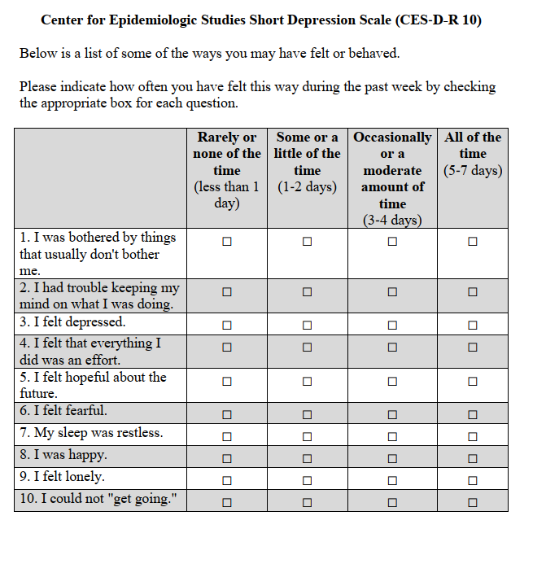

Appendix 4
Demographic Questions

Please indicate your gender below:
- Male
- Female
- Non-binary
- Prefer not to say
- Other

Please state your age:
_______________________________

Do you currently, or have you previously received a clinical diagnosis for depression?
- Yes
- No
If yes, please provide further information:
____________________________________________________________________

Appendix 5
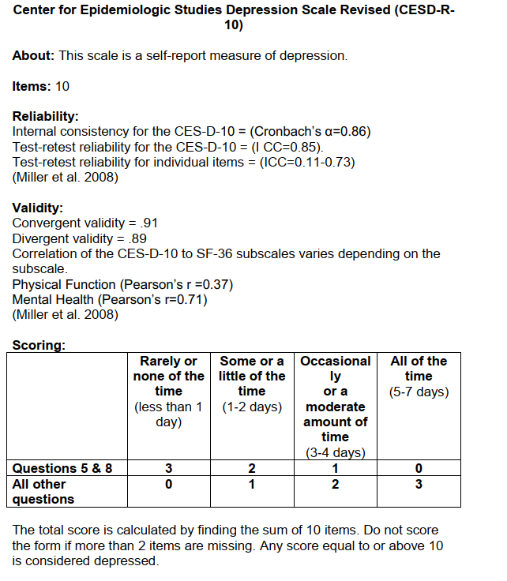

Appendix 6



