Name | Gladys Okechuku
Id # | 1817911
Module | Problem Solving and Decision Making
Module Code | BMSW4004
Lecturer | Yajesh Kumar

Table of Contents
Introduction 3
Problems 3
Tools for the identification of problems faced by Coca-Cola 4
Swot Analysis 4
Strengths 4
Weaknesses 4
Opportunities 5
Threats 5
Solution 5
PESTEL analysis 6
Political factors 6
Economic Factors 6
Social Factors 6
Technological Factors 6
Environmental Factors 7
Legal Factors 7
Solution 7
Porter’s Five Forces 8
Bargaining power of suppliers 8
Buyer’s bargaining power 8
The threat of new Entrants 8
Substitutes as a threat 9
Rivalry as a threat 9
Solution 9
Conclusion 9
References 11
Appendices 14

Introduction
The main object of this assignment is to find problems I encountered working with Coco cola. by using problem-solving tools and provide convincing solutions. It also elaborates on the relationship among the environment, society, and business along with how to adapt to the changing environment of the organization.
It is known as the manufacturer and marketer of non-alcoholic beverages. It has been one of the most valuable brands, with its franchises running all around the world serving around 200 countries with its beverages. It faces challenges to sustain its business, employees go through some issues as well while dealing with the company. (Arsenova and Nikolaeva, 2018).

Problems
Communication problems are faced in between the management team of Coca-Cola. The decisions of junior managers are being neglected and thus they face difficulty in communicating.
Discrimination in the work environment is faced by most of the employees working at Coca-Cola. There are certain rules and regulations that not everyone can follow which leads to racial discrimination (Banks, H., 2016).

Tools for the identification of problems faced by Coca-Cola

Swot Analysis

Strengths
Coca-Cola is known for having the most unique identity as a brand. It has the highest brand equity and was awarded by Interbrand in 2011(Brondoni, 2020). The broad presence of Coca-Cola globally underpins the brand name. It has the largest market share among its competitors and is one of the growth drivers.
The prime reason behind the success and popularity of the Coca-Cola brand is its quality and consistency (Festi and di Belle Arti, 2017).

Weaknesses
The primary weakness of Coca-Cola is when it comes to market competition. To overcome this issue, they require high-end team working for the company to keep going. However, constant pressure is faced by the employees (Gehani, 2016).
While other competitors have made a clever move and introduced new segments, Coca-Cola is left behind. Coca- Cola can be a major source of health issues such as obesity and diabetes due to the sale of carbonated drinks which serves as a drawback.

Opportunities
The company has an opportunity to go with diversification in the food (Gertner and Rifkin, 2018). Coca-Cola can come up with healthier options to earn better revenue from their customers and employees.
They have an opportunity to market their low selling products (Hallak and Onur, 2019). Those products which haven't found acknowledgment in the market.

Threats
Coca-Cola can face issues if the employees complain about the discrimination that the people face while working there.
Coca-Cola can hit rock bottom if the water sourcing is bounded (Herrmann, 2018). Water scarcity is one of the issues the world is dealing with and someone might come at the beverage companies for unlimited use of water for their production.

PESTEL analysis

Political factors
-Coca-Cola has nothing to be concerned about as long as the products are at the mercy of the FDA (Jacobson, 2017). Changes of law regarding taxes, accounting, and internal marketing may limit Coca-Cola from distribution.

Economic Factors
Recent global crises had a huge impact on the market (Jurić, 2016). However, surprisingly Coca-Cola amused the industry by securing its profits and retaining its position. Even though they went through the crises just fine, the wages of employees were not issued on time.
Social Factors
In developed countries, people are mostly switching from carbonated drinks to healthier options (Kang et al., 2017). This major change has led to a decrease in the consumption of Coca-Cola.
People changed their preferences when they realized that most of the soda beverages are loaded with calories. They have adopted healthier lifestyles. It doesn’t go well for the employees as they face continuous fear of getting fired due to the loss.

Technological Factors
Technology impacts Coca-Cola as it ensures an efficient supply chain and timely production (Lacy-Nichols et al., 2020).
The area of technology requires maintenance which serves as an issue. Employees working for the tech team of the company must do double shifts in order to come up with more innovative ideas to promote the company which is not always satisfactory.

Environmental Factors
Water is a necessity for soft drink development. Coca-Cola is consuming water even in the water-scarce regions (Laska et al., 2018). Employees deal with the constant rudeness of their managers and leaders which is difficult for them, however, is focusing on working well with its employees and respecting them more to create a friendly workplace environment. (Ling, 2017)

Legal Factors
The company doesn't face any issues now as it had a tussle with the legal forces regarding its product composition in the past. Coca-Cola has focused on compliance, corporate governance, and ethics.

Solution
- Coca-Cola must follow business regulations to get rid of its political issues (Mburu, 2016).
- They need to work on giving their employees’ wages on time without delaying them.
- They should maintain a friendly environment in the company by putting less burden on the employees and giving them time to complete their tasks.
- Employees should stop competing with one another and work as a team to work in peace.
- Coca-Cola should focus on creating a product that responds to people's needs to gain their attention.
- The company must operate in areas where there is no or less water shortage (Pagani and Pardo, 2017).

Porter’s Five Forces

Bargaining power of suppliers
The dealing power of distributors and suppliers of the brand is weak (Pan et al., 2017). The switching costs of the company are not that high while the number of distributors is high.
Such suppliers use their influence of diplomacy to get high prices from the company (Pan et al., 2019). Thus, it reduces the margin of the company.

Buyer’s bargaining power
The customers usually buy a small amount of Coca-Cola and they are not focused markets either. The company enjoys brand loyalty as customers are not affected by the price of its products, retailers may get some bargaining power only if they buy products in bulk (Renz et al., 2016).

The threat of new Entrants
The brand has the highest influence on the market so new entrants do not serve as a threat or an issue. Huge investments need to be made to compete with a brand as massive as Coca-Cola. Newcomers can compete with Coca Cola at a smaller rate (Riaz et al., 2017). To build a brand this powerful is a huge task that requires both capital and proficient human recourses. New entrants at the workplace is a constant threat.

Substitutes as a threat
Industry profitability may suffer if new products or services independently fulfill customer needs (Steenkamp, 2017). The threats from substitutes are strong as there are several beverages and juices out in the market having convincing quality and low switching costs for the customers.

Rivalry as a threat
Coca-Cola gives a tough competition to other beverages (Tiger et al., 2017). The only competition of Coca-Cola is Pepsi while the other beverages have relatively low market share.
Employees working for Coca-Cola have competition in between them too. They constantly want to push each other behind in order to become more effective and efficient in front of the leaders.

Solution
Coca-Cola should build an effective and efficient supply chain with dedicated suppliers. They need to hire better suppliers and employees to carry forward their work.
New entrants should not be prioritized if they are well trained. (Vos, R.D., Köhne, M. and Roth, D., 2018). The employees should feel comfortable and secure while working for the company.
Healthy environment at the workplace should be promoted to not be afraid of substitutes. Every employee must have the right to express himself.

Conclusion
Coca-Cola is known as the most valuable brand. Even after being on the top, it faces challenges regarding its employees working for the brand. Employees working there are not treated well. They face the issue of communication as well as discrimination. The employees face constant pressure and burden of keeping the company high profile even after getting less salaries and no bonuses due to the crises company faced. Coca cola should focus on providing safe and healthy environment for the employees. Respect and value for the employees are the key points to focus on.

References
Agha, Z., 2017. Always Coca-Cola: Why Environmental Exploitation Should Be Included in the Legal Construction of International Crimes. Amsterdam LF, 9, p.104.
Arsenova, E.A. and Nikolaeva, T.Y., 2018. Influence of introduction of system of economical production on processes of creation and development of an innovative product: company example Â «NestlÃ© RussiaÂ». Strategic decisions and risk management.
Banks, H., 2016. The business of peace: Coca-Cola's contribution to stability, growth, and optimism. Business Horizons, 59(5), pp.455-461.
Brondoni, S.M., 2020. Shareowners, Stakeholders & the Global Oversize Economy. The Coca-Cola Company Case. Symphonya. Emerging Issues in Management, (1), pp.16-27.
Festi, G. and di Belle Arti, N.A., 2017. TOWARD A SEMIOTICS OF FOOD QUALITY: PERSPECTIVES AND INTERPRETATIVE CHALLENGES. TICS, p.888.
Gehani, R.R., 2016. Corporate brand value shifting from identity to innovation capability: From Coca-Cola to Apple. Journal of technology management & innovation, 11(3), pp.11-20.
Gertner, D. and Rifkin, L., 2018. Coca‐Cola and the Fight against the Global Obesity Epidemic. Thunderbird International Business Review, 60(2), pp.161-173.
Hallak, R., Lee, C. and Onur, I., 2019. Examining healthy beverages in the hospitality industry: evidence from Australia and New Zealand. British Food Journal.
Herrmann, S., 2018. Hilltops and Marches: A Cultural and Semiotic Analysis of Pepsi and Coca-Cola Advertising.
Hoewe, J. and Hatemi, P.K., 2017. Brand loyalty is influenced by the activation of political orientations. Media Psychology, 20(3), pp.428-449.
Jacobson, M., 2017. Marketing of Sugar Drinks-and Disease-in Developing Countries. World Nutrition, 8(2), pp.311-318.
Jurić, M., 2016. STRATEGIC RIVALRY IN BEVERAGE INDUSTRY (Doctoral dissertation, University of Zagreb. Faculty of Economics and Business. Department of Organization and Management.).
Kang, J., Grable, K., Hustvedt, G. and Ahn, M., 2017. Sustainable water consumption: The perspective of Hispanic consumers. Journal of Environmental Psychology, 50, pp.94-103.
Lacy-Nichols, J., Scrinis, G. and Carey, R., 2020. The evolution of Coca-Cola Australia’s soft drink reformulation strategy 2003–2017: A thematic analysis of corporate documents. Food Policy, 90, p.101793.
Laska, M.N., Sindberg, L.S., Ayala, G.X., D'Angelo, H., Horton, L.A., Ribisl, K.M., Kharmats, A., Olson, C. and Gittelsohn, J., 2018. Agreements between small food store retailers and their suppliers: Incentivizing unhealthy foods and beverages in four urban settings. Food Policy, 79, pp.324-330.
Ling, X., 2017. Customer Relationship Management: Case study Coca-Cola Company.
Mburu, E.N., 2016. Porter’s five forces influence on Competitive Advantage in the Kenyan beverage industry: A case of large Multinationals (Doctoral dissertation, United States International University-Africa).
Pagani, M. and Pardo, C., 2017. The impact of digital technology on relationships in a business network. Industrial Marketing Management, 67, pp.185-192.
Pan, Q., Xia, H. and Luo, S., 2017, November. Dynamics of Brand acceptance influenced by the spread of promotive information in social media. In International Symposium on Knowledge and Systems Sciences (pp. 1-11). Springer, Singapore.
Pan, R., Wild, A.C.S.G., Drecksler, L.R. and Gonçalves Jr, A.C., 2019. Environmental Impact: Contextualization and Current Reality. Journal of Experimental Agriculture International, pp.1-8.
Renz, F. and Vogel, J., 2016. Analysis of The Coca-Cola Company
Riaz, H., Ahmed, H., Akhter, S. and Hussain, M., 2017. The Impact of Emotional Branding in Customer Buying Behavior in Soft Drink Beverage Industry of Pakistan. KASBIT Business Journals (KBJ), 10, pp.131-150.
Steenkamp, J.B., 2017. Global brand equity. In Global Brand Strategy (pp. 243-273). Palgrave Macmillan, London.
Tiger, A.A., Nance, W., Roach, C. and Emery, B.G., 2017. What’s All the Fizz About? A Teaching Case Study on the Use of Coca-Cola® Freestyle® Machines in Quick-Service Restaurants. Journal of Marketing Development and Competitiveness, 11(2).
Vos, R.D., Köhne, M. and Roth, D., 2018. " We'll turn your water into Coca-Cola": the atomizing practices of oil palm plantation development in Indonesia. Journal of Agrarian Change, 18(2), pp.385-405.

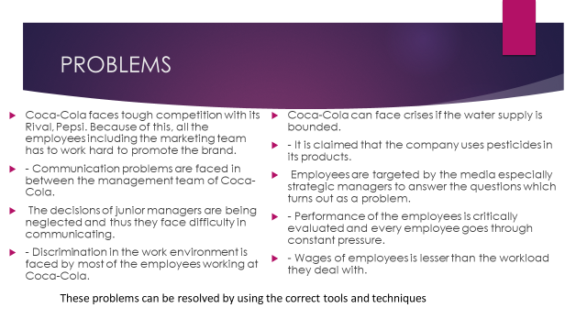
S
- Communication problems are faced in between the management team of Coca-Cola. The decisions of junior managers are being neglected and thus they face difficulty in communicating.
- Discrimination in the work environment is faced by most of the employees working at Coca-Cola.

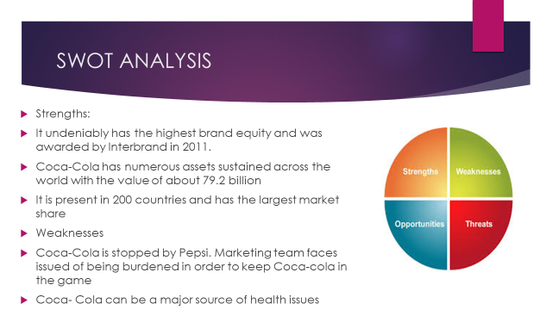

Swot analysis is a tool used to recognize the weaknesses and threats faced by the organization. its internal powers and probabilities which can help overcome those flaws.
Strengths
-Coca-Cola is known for having the most unique identity as a brand. It undeniably has the highest brand equity and was awarded by Interbrand in 2011. Coca-Cola has an extensive global presence.
-
Weaknesses
The primary weakness of Coca-Cola when it comes to market competition. The product diversity of Coca is low. While other competitors have made a clever move and introduced new segments, Coca-Cola is left behind. Coca- Cola can be a major source of health issues such as obesity and diabetes due to the sale of carbonated drinks which serves as a drawback.

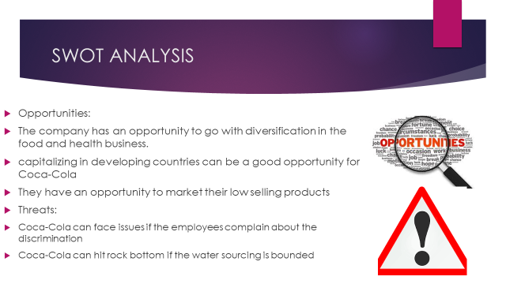

The company has an opportunity to go with diversification in the food (Gertner and Rifkin, 2018). Coca-Cola can come up with healthier options to earn better revenue from their customers.
Coca-Cola can face issues if the employees complain about the discrimination that the people face while working there. It could get tricky for the company to get out of such allegations.

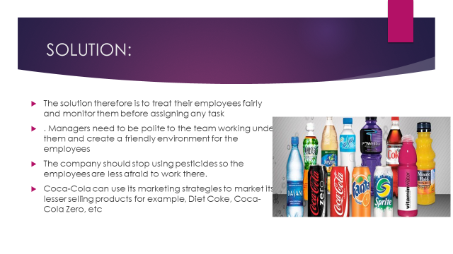

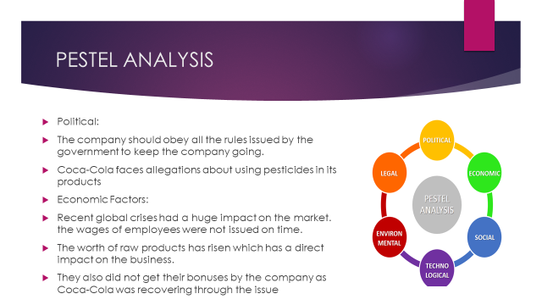

-Coca-Cola has nothing to be concerned about as long as the products are at the mercy of the FDA (Jacobson, 2017). The company should obey all the rules issued by the government to keep the company going.
Recent global crises had a huge impact on the market (Jurić, 2016). However, surprisingly Coca-Cola amused the industry by securing its profits and retaining its position. Even though they went through the crises just fine, the wages of employees were not issued on time.

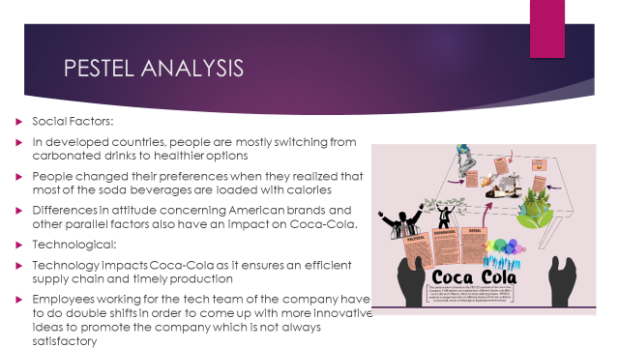

People changed their preferences when they realized that most of the soda beverages are loaded with calories. They have adopted healthier lifestyles. It doesn’t go well for the employees as they face continuous fear of getting fired due to the loss.
The area of technology requires maintenance which serves as an issue. Employees working for the tech team of the company must do double shifts in order to come up with more innovative ideas.
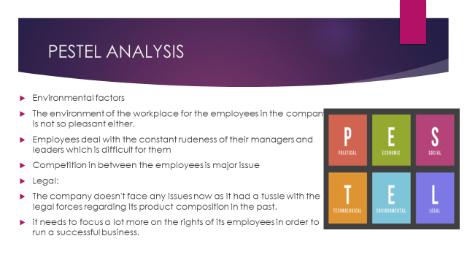

Water is a necessity for soft drink development. Due to any kind of climate change, the company can suffer consequences. Competition in between the employees is major issue everyone working their deals within their workplace environment.
Coca-Cola has focused on compliance, corporate governance, and ethics. The company receives every right relevant to the nature of its business.
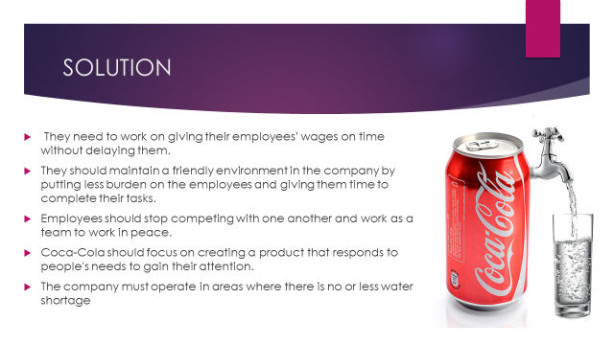

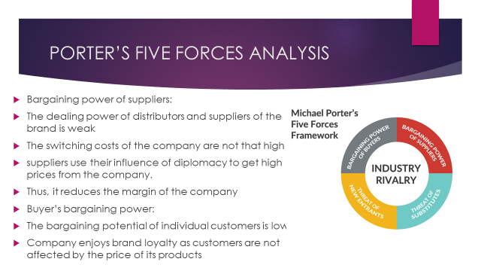

It is conducted to analyze critical factors that may affect the company over time. It serves as an important tool to examine the forces that form shape within an industry.

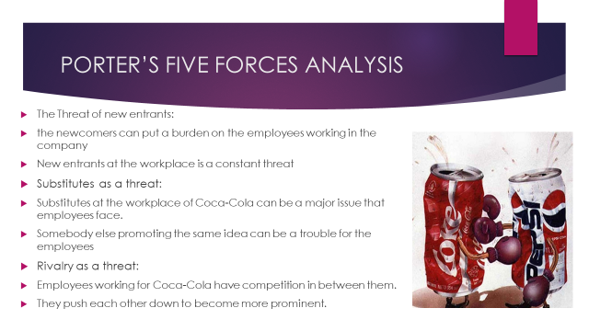

The brand has the highest influence on the market so new entrants do not serve as a threat or an issue.
Substitutes at the workplace of Coca-Cola can be a major issue that employees face. New entrants at the workplace is a constant threat.
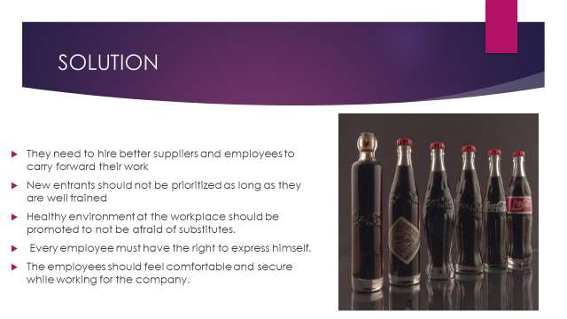

Coca-Cola should build an effective and efficient supply chain with dedicated suppliers. They need to hire better suppliers and employees to carry forward their work.
Healthy environment at the workplace should be promoted to not be afraid of substitutes. Every employee must have the right to express himself.


