
2022
Mahamood Lidheem
University of Wales Trinity Saint David
1/1/2022
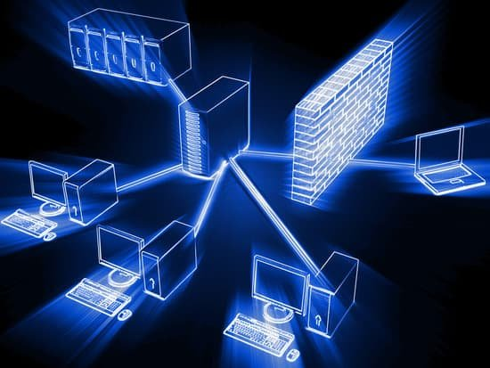
Computer Networks and Cyber Security

Computer Networks and Cyber Security

By

Mahamood Lidheem

2017663

To Assoc. Prof. Carlene Campbell

Table of Contents
1 PART ONE 5
1.1 QUESTION 1-A 5
1.2 QUESTION 1-B 5
1.3 QUESTION 1-C 6
1.4 QUESTION 1-D 7
1.5 QUESTION 1-E 8
1.6 QUESTION 1-F 9
1.7 QUESTION 1-G 9
1.8 QUESTION 1-H 10
1.9 QUESTION 3-A 10
1.10 QUESTION 5-A 11
1.11 QUESTION 5-B 12
1.12 QUESTION 6-A 13
1.13 QUESTION 8-A 13
1.14 QUESTION 8-B 13
1.15 QUESTION 9-A 14
1.16 QUESTION 9-B 14
1.17 QUESTION 9-D 15
1.18 QUESTION 9-E 15
1.19 QUESTION 9-F 16
1.20 QUESTION 9-G 16
1.21 QUESTION 11-A 16
2 LAB CONFIGURATION SCREENSHOTS 17
2.1 PACKET TRACER SCREENSHOTS 17
2.2 PUTTY TERMINAL EMULATOR SCREENSHOTS 25
3 PART TWO-PROPOSAL OF A SECURE NETWORK INFRASTRUCTURE 33
3.1 ABSTRACT 33
3.2 INTRODUCTION 33
3.3 NETWORK SCOPE 34
3.4 FEASIBILITY STUDY 34
3.4.1 OBJECTIVES OF THE NETWORK- PART 1 34
3.4.2 NETWORK NEEDS ANALYSIS-PART 2 35
4 THE NETWORK DESIGN PHASES 38
4.1.1 PHASE ONE – DETERMINING APPROPRIATE DESIGN ARCHITECTURE 38
4.1.2 PHASE TWO- FIREWALL SELECTION AND PLACEMENT 39
4.1.3 PHASE THREE- REMOTE ACCESS AND VPNS 40
4.2 OVERALL NETWORK DESIGN 41
4.3 DETAILED DESIGN DOCUMENTATION 42
4.3.1 COST-BENEFIT ANALYSIS 42
4.3.2 BENEFITS ANALYSIS 43
4.3.3 COST-BENEFIT RATIO 43
4.4 PROJECT IMPLEMENTATION PROCESS AND SCHEDULE 43
4.4.1 GATHERING OF EQUIPMENT 43
4.4.2 INSTALLATION OF HARDWARE 43
4.4.3 SOFTWARE INSTALLATION 43
4.4.4 NETWORK TESTING 43
4.4.5 NETWORK DEPLOYMENT 44
4.4.6 NETWORK MONITORING 44
4.5 TYPES OF NETWORK ATTACKS 44
4.6 TYPES OF NETWORK TESTS 45
5 INVOICE 46
6 CONCLUSION 47
7 REFERENCES 48

LIST OF FIGURES
Figure 1: Router secure administration access password setup 22
Figure 2: TACACS setup 23
Figure 3:AAA model 24
Figure 4: Router ACL setup 25
Figure 5: IPSec setup 26
Figure 6: IPS setup 27
Figure 7: Switch Configuration 28
Figure 8: Zone based firewall setup 29
Figure 9: switch s1 30
Figure 10: switch s2 30
Figure 11: switch s3 31
Figure 12: router r1 31
Figure 13: router r1 32
Figure 14: router r1 32
Figure 15: router 1 33
Figure 16: router 2 33
Figure 17: router 2 34
Figure 18: router 3 34
Figure 19: router 3 35
Figure 20: ASA 35
Figure 21: ASA 36
Figure 22: ASA 36
Figure 23: Packet tracer design 40

LIST OF TABLES
Table 1: A2Z Company Network 32
Table 2: Cost Analysis 32
Table 3:Benefits Analysis 33
Table 4: Cost-Benefit Ratio 33
Table 5:Gathering Of Equipment 33
Table 6: Installation Of Hardware 33
Table 7:Software Installation 33
Table 8:Network Testing 34
Table 9: Network Deployment 34
Table 10: Network Monitoring 34

LIST OF ACRONYMS
ACRONYMS | DEFINITION
DHCP | Dynamic Host Configuration Protocol
IP | Internet Protocol
Pentest | Penetration Testing
TELNET | Teletype Network
TCP | Transmission Control Protocol
ACL | Access Control List
DNS | Domain Name Service
IPS | Intrusion Prevention System
IDS | Intrusion Detection Systems
AES | Advanced Encryption Standard
SHA | Secure Hash Algorithms
DMZ | Demilitarized Zone
WAN | Wide Area Network
VLAN | Virtual Local Area Network
VPN | Virtual Private Network
LAN | Local Area Network

PART ONE

QUESTION 1-A
Explain network security: network security is a set of rules and configurations that use both software and hardware technologies to protect the integrity, confidentiality, and accessibility of computer networks and data. Physical, technical, and administrative controls are the most common types of network security controls. [1]
Types of network security
- Network Access Control: Comprehensive access control policies for both users and devices are required to ensure that potential attackers cannot infiltrate your network
- Antivirus and Antimalware Software: antivirus and antimalware software defend a company from a variety of malicious software, such as trojans, ransomware.
- Firewall Protection: firewalls serve as a barrier between insecure public networks and credible internal networks. Administrators set up a set of defined rules that block or allow traffic into the network.
- Virtual Private Networks: a virtual private network (VPN) connects to your network from another endpoint or location. For example, users working from home typically connect to the organization's network via a VPN.

QUESTION 1-B
Describe various types of threats and attacks.
- Types Of Threats
- Virus: a computer virus is a piece of harmful software that copies itself to another program, system, or host file to propagate. It remains dormant until it is activated, either intentionally or accidently, spreading the infection without the knowledge or approval of the user or system administrator.
- Worms: : a computer worm is a self-replicating program that spreads without the need for a host program or human intervention
- Adware/spyware: adware means software designed to track data about your browsing habits and display advertisements and pop-ups based on it. Adware collects data with the consent of the user. This is a legitimate source of revenue for companies that allow users to try the software for free. Spyware works like adware but is unknowingly installed on your computer. It may contain keyloggers that record personal information such as e-mail addresses, passwords, and even credit card numbers, which is dangerous because of the high risk of personal information theft. [2]
- Types Of Attacks
- DOS/DDOS: DoS attacks are carried out by a computer and its Internet connection by flooding the website with packets and preventing legitimate users from accessing the flooded website's content. DDoS attacks, or distributed denial of service attacks, are similar to DoS but more powerful. Booted from multiple computers, the number of computers involved can range from a few to thousands or even more. It is more difficult to defend against DDoS attacks. [3]
- SQL injection: It attacks target data-driven applications by exploiting application software vulnerabilities. They can use malicious code to retrieve, modify, or even destroy personal data and even invalidate transactions on websites.
- Man in the Middle Attacks: A man-in-the-middle attack is a cybersecurity attack that allows an attacker to eavesdrop on the communication between two targets. It is possible to eavesdrop on communications that would usually be private. Some of the types of MITM attacks are DNS spoofing, HTTPS spoofing, IP spoofing, ARP spoofing, SSL hijacking, and Wi-Fi hacking. [2]

QUESTION 1-C
Explain tools and procedures to mitigate the effects of malware and common network attacks.
- Mitigation Tools
- Antiviruses: antivirus software protects your device from malicious software that threatens your system. It scans your computer to detect and remove malware and provides automatic updates for added protection against newly created viruses.
- Firewalls: Firewalls prevent malicious attacks by blocking all unauthorized access to or from your private computer network. In addition to antivirus software, firewalls provide an additional barrier to malware, reducing the chance of an attack.
- Mitigation Procedures
- Regular System Updates: The software must be updated regularly to prevent attackers from accessing your computer with older or vulnerable systems.
- Avoiding Phishing: Do not click on suspicious links such as "I got an iPhone." Phishing is the easiest way for hackers to install malware on their devices. Phishing scams trick people into opening e-mails or clicking links that appear to come from legitimate companies or sources.
- Full System Scans: Viruses, spyware, and malware are constantly evolving. As a result, it can bypass protection methods and infect computer systems. Implement daily scans throughout your antivirus, antispyware, and antimalware software to detect, quarantine, and remove malicious agents on your network before (or even more) damage occurs. [4]
- Create A periodic System Backup Schedule: Many types of malicious agents may destroy content in your computer. Create a periodic backup schedule to verify that data is available when something harmful to your computer has elapsed. Consider backup options such as cloud services and personal external hard drives. Cloud services can protect data online. Personal external hard drives can be connected to your computer so that updated files can be copied manually. [5]

QUESTION 1-D
Describe the fundamental principles of securing a network
- Authentication: is a method of identifying a user of a system, or an entity.
- Access control: Role management and rule management determine the principle of access control.
- Availability: The availability principle states that the resources will always be available to the authorized party.
- Confidentiality: The level of confidentiality dictates the information's secrecy.
- Integrity: Integrity ensures that the information received is correct and precise.
- Non-Repudiation: is a method that prevents a network's message content from being denied.

QUESTION 1-E
Explain how to mitigate the effects of common network attack methodologies in a small to medium-sized business.
- Compartmentalization: The network needs to be segmented within the organization. If an organization has a flat, open network, after breaking into that network, an attacker could gain a foothold to navigate the network, steal data, and infect critical assets. Network segmentation divides the entire network into smaller subnetworks. The related concept of isolation is to apply a set of rules to how hosts and services communicate. [6]
- Weakest link: All organizations are vulnerable to networks. So to speak, the weakest link in the chain. And unfortunately, for most organizations, this is their people. No matter how strong your IT defences are, if an employee is hit by a phishing scam, all of this can collapse. Organizations need to ensure that they are properly trained to ensure that employees and contractors understand what they need to do to maintain network security. [6]
- Vulnerability Assessment: Once all the different aspects of your network security system are in place, you need to make sure they are working to protect your company's assets. This is where vulnerability testing is essential. Regular tests of defence need to see where the "holes" are. Organizations are encouraged to use a combination of automated and manual approaches.
- Network layering: Tiering is an important aspect of secure network design. Of course, the Idea is that if an intrusion or attack breaks into one layer of defence, another layer of Defence blocks the attack. [6]
- The main layers of network security include:
- Boundary and network control. It is necessary to install a firewall. This is the main barrier between the network and the public internet. Therefore, organizations should be able to use segmentation to localize attacks within their organization.
- E-mail protection.This includes e-mail filtering and encryption protocol settings.
- Web filtering.
- Data encryption of important financial and personal information.
- Terminal management.
- Make sure that all devices connected to your network meet your organization's security requirements.

QUESTION 1-F
Explain how the Cisco Network Foundation Protection (NFP) framework is used to secure a network.
Network Foundation Protection (NFP) is a framework developed by Cisco to logically group the features that occur on your network. The framework combines several security technologies to protect routers and switches and ensure network availability in the event of an attack. It is divided into three basic sections (levels).
Management Level-Protocols and traffic used by network administrators to configure network devices from computers. An example of management plane traffic is SSH or Telnet traffic generated by a network administrator when configuring a Cisco IOS device remotely. Failure at this level can result in the loss of the ability to remotely manage network devices. Control plane– Protocols and traffic that network devices send to each other (without administrator intervention) to automatically detect and configure the network. Examples of such traffic are ARP messages and routing protocol updates. If this layer fails, the device can lose the ability to exchange or learn routing information. Data plane-end user traffic. This is traffic that goes through the network, not the network device. For example, the traffic generated when a user browses a website on your network. If an error occurs at this level, the user may not be able to complete the task. [7]

QUESTION 1-G
Explain how to mitigate the effects of Viruses, Worms, and Trojan Horses in a small to medium business.
In case of working for a company contact IT department, The sooner they can scan and clean your computer, the less damage it will do to your computer and other computers on the network.In case of working on home computer or laptop we perform the following steps: [4]
- Turn off Wi-Fi and disconnect computer from the internet.
- reinstall your operating system. Typically, using the system recovery disc that came with the computer or download/update the operating system and other software from an trusted network.
- Install Anti-virus software and keep it updated and also Installing or Enabling Firewalls
- Install the appropriate patches to address known vulnerabilities.
- Carry out a manual scan of the whole system to determine if an infection remains.

QUESTION 1-H
Describe endpoint vulnerabilities and protection methods.
- Endpoint vulnerabilities
- Man-in-the-middle attack and distributed denial of service attack.
- Phishing and social engineering scams.
- Ransomware, malware, viruses.
- Cross-site scripting and SQL injection.
- protection methods
Tiered Security Scheme
- System-level security
Protect the basic operation of the endpoint and make sure each device is properly configured. This layer focuses on protecting individual computers and monitoring all events and processes that could exploit or endanger security regimes.
- Network-level security
Controls user access to the IOS operating system and critical data stores. This layer is responsible for isolating the internal server from unauthorized users and validating the device's credentials when connecting to the internet.
- Application-level security
It manages how users interact with specific applications on their devices and often works with the network layer. IT managers should always configure security settings for each application and software on the server-side and the client-side.
- Send-level security
Protects data communication within private networks and on all transmission routes, including the internet itself. This layer helps control the flow of information between endpoints and across the boundaries of other security layers.

QUESTION 3-A
Explain how AAA is used to secure a network
Authentication, authorization, and accounting (AAA) are methods that can be used on the network, which administrators can connect to which devices (authentication), what they can do with those devices (authorization), and log. Can I had it while I was logged in (accounting). The following is a description of each process included in AAA.
Authentication
The process of proving that a user is who they say they are, usually by having them enter a valid username and password before granting access. An example of such a process is authenticating administrator access to the router console port. You can authenticate an administrator to a local router database or a remote RADIUS or TACACS + server.
Authorization
After a user is authenticated, approval is used to determine which resources the user can access and what actions they can perform. For example, you can control what users can change or delete.
Accounting
The process of logging the actions taken by a user when accessing a network resource. This includes the amount of data users send and receive during the session, the time spent on the network, the services accessed, and so on. Accounting is done by logging session statistics and usage information for trend analysis, capacity planning, billing, billing, and cost allocation.

QUESTION 5-A
Describe the implementation of a comprehensive security policy.
- Create a Basic Technical Security Policy
- Configure Basic Device Settings
- Configure Secure Router Administrative Access
- Configure a DMZ, Static NAT, and ACLs on an ASA
- Configure ASA Clientless SSL VPN Remote Access Using ASDM
- Configure a Site-to-Site VPN between the ASA and ISR

QUESTION 5-B
Describe the various techniques and tools used for network security testing.
NMAP
Nmap ("Network Mapper") is a network detection and security scanning utility used for tasks such as network inventory, managing service upgrade schedules, and monitoring host or service uptime.
Wireshark
Wireshark is the world's leading and most widely used network protocol analyzer. This gives you a microscopic view of what's happening on your network
Network scan
This technique uses a port scanner to identify all hosts connected to the network. Network services such as HTTP and FTP are also scanned. Finally, this helps ensure that the port is configured to allow only secure network services.
Vulnerability scan
Vulnerability scanners can help you find vulnerabilities in your system or network. There are signs of security gaps that may be improved.
Ethical Hacking
This is hacking done to identify potential threats to a system or network. This helps to identify if unauthorized access or malicious attacks are possible.
Password Cracking
This method can be used to crack weak passwords. This can help in enforcing a policy with minimum password criteria which ends up creating strong passwords and is difficult to crack.
Penetration Testing
Pentest is an attack done on a system/network to find out security flaws. Penetration testing techniques compromise servers, endpoints, web applications, wireless devices, mobile devices, and network devices to identify vulnerabilities.

QUESTION 6-A
Describe the vulnerabilities of and mitigation techniques for securing the Layer 2 infrastructure.
- Vulnerabilities
- MAC Table Attacks
- VLAN Attacks
- ARP Attacks
- Address Spoofing Attacks
- DHCP Attacks
- Mitigation techniques
- Port Security
- DHCP Snooping
- Dynamic ARP Inspection (DAI)
- IP Source Guard (IPSG)

QUESTION 8-A
Explain how network-based Intrusion Prevention Systems are used to help secure a network
The network-based intrusion detection system "NIDS" or network-based IDS is strategically deployed security hardware to monitor critical network traffic. Traditional network-based IDSs analyze the network traffic that passes through and match that traffic with a library of known attacks on the system. The new system uses artificial intelligence (also known as heuristics) to analyze interesting patterns of traffic. When an attack is identified or an interesting pattern is found, an alert is usually sent to the Security Operations Center (also known as SOC). The Security Operations Center reviews the alerts and triages their effectiveness and subsequent escalations.

QUESTION 8-B
Explain how signatures are used to detect malicious network traffic.
Signature-based detection is typically most often used to identify known threats. It works with a pre-programmed list of known threats and traces of their intrusion (IOC). The IOC can typically be a specific action that precedes a malicious network attack, file hash, malicious domain, known byte sequence, or e-mail subject content. When monitoring packets through the network, signature-based IDSs compare those packets to a known IOC database, the attack signature, and flag suspicious behaviour.

QUESTION 9-A
Explain the purpose of VPNs.
A VPN connection establishes a secure connection between your computer and the internet by routing traffic through an encrypted virtual tunnel spoofing your IP address when you use the internet, making your location invisible to anyone. VPN connections protect against external attacks.

QUESTION 9-B
Explain how Ipsec VPNs operate.
Key exchange: A key is required for encryption. A key is a set of random characters that can be used to "lock" (encrypt) and "unlock" (decrypt) a message. IPsec uses key exchange between connected devices to establish a key, allowing each device to decrypt messages from other devices.
Packet Headers and Trailers: All data sent over the network is divided into small pieces called packets. The packet contains both the payload (the actual data sent) and the header (information about that data), so the computer that receives the packet knows how to handle the packet. IPsec adds some headers to data packets that contain authentication and encryption information. IPsec also adds a trailer that comes after the payload of each packet, not before.
Authentication:
IPsec provides authentication for each packet, much like a real stamp on a collector's item. This ensures that the packet is sent from a trusted source rather than from an attacker.
Encryption:
IPsec encrypts the payload of each packet and the IP header of each packet (unless transport mode is used instead of tunnel mode-see below). This keeps the data sent over IPsec safe and private.
Outgoing:
Encrypted IPsec packets are sent to their destination over one or more networks using the transport protocol. During this phase, IPsec traffic, unlike regular IP traffic, uses UDP as the transport protocol instead of TCP. TCP (Transmission Control Protocol) establishes a dedicated connection between devices to ensure that all packets arrive. UDP, the user datagram protocol, does not establish these dedicated connections. IPsec uses UDP to allow IPsec packets to pass through the firewall.
Decryption:
At the other end of the communication, the packet is decrypted and the data provided by the application (browser, etc.) is available.

QUESTION 9-D
Explain how the types of encryption, hashes, and digital signatures work together to provide confidentiality, integrity, and authentication
Digital signatures work by proving that a digital message or document has not been intentionally or unintentionally modified since it was signed. Digital signatures do this by generating a unique hash of the message or document and encrypting it with the sender's private key. The generated hash is specific to the message or document, and any changes to it will completely change the hash.
When complete, the message or digital document is digitally signed and sent to the recipient. The recipient then generates its hash of the message or digital document and uses the sender's public key to decrypt the sender's hash (included in the original message). The recipient compares the generated hash with the sender's decrypted hash. If they match, the message or digital document has not changed and the sender is authenticated.

QUESTION 9-E
how cryptographic hashes are used to ensure data integrity and authentication.
A hash value is a fixed-length number that uniquely identifies the data. Hash values are used in digital signatures because they represent large amounts of data as much smaller numbers. Hash values can be signed more efficiently than larger values. Hash values are also useful for verifying the integrity of data sent over insecure channels. You can compare the hash of the received data with the hash of the sent data to determine if the data has changed.

QUESTION 9-F
How encryption algorithms ensure data confidentiality.
Encryption helps protect your online privacy by turning personal information into ciphertext or hashes which cannot be easily decrypted or broken by reverse-engineering them. To decrypt them, you have to have the shared key and your private key depending on the encrypted algorithm used to secure the information.

QUESTION 9-G
how public key infrastructure is used to ensure data confidentiality and provide authentication.
PKI works with an asymmetric key methodology of private and public keys. Only the owner of the digital certificate can access the private key and choose the location of the public key. A certificate is a way of giving a user a public key that the owner wants the user to have.
Secret and public PKI keys need to work together. Files encrypted with the private key can only be decrypted with the public key and vice versa. If the public key can only decrypt the file encrypted by the private key, the ability to decrypt that file ensures that the intended recipient and sender participate in the information transaction.
Asymmetric encryption is most commonly used for one-way communication and uses a mathematically linked individual key.

QUESTION 11-A
Explain how the ASA operates as an advanced stateful firewall.
Stateful packet inspection is central to how the PIX / ASA firewall works. This functionality is provided through a process called Cisco's Adaptive Security Algorithm (ASA). The ASA uses a stateful security approach. Each incoming packet is extensively checked against the ASA and in-memory link-state information. The ASA applies the following default rule (although this is far from the complete list) to traffic arriving at PIX:
- Allows all traffic connections from the high-security internal network to the low-security external network unless specifically denied ACL.
- Application inspection is configured to allow all traffic that is determined to be acceptable traffic.
- Unless there is an ACL that allows the connection, discard and log any attempt to initiate a connection to the translation slot (such as a firewall-protected server) from the outside.
- Drops and logs IP packets routed by the source.
- Deny all Internet Control Message Protocol (ICMP) traffic through the firewall from a less secure interface unless specifically permitted. This prevents the response to outbound ICMP traffic from being delivered successfully (for example, if the outside host is pinged with an ICMP echo, the ICMP echo-response packet on the outside interface does not arrive and the result is timed out request. Looks like the source host).
- Allow all ICMP traffic to the firewall itself (this can be disabled or controlled by ICMP inspection).

LAB CONFIGURATION SCREENSHOTS

PACKET TRACER SCREENSHOTS
These packet tracer screenshots for illustration purposes

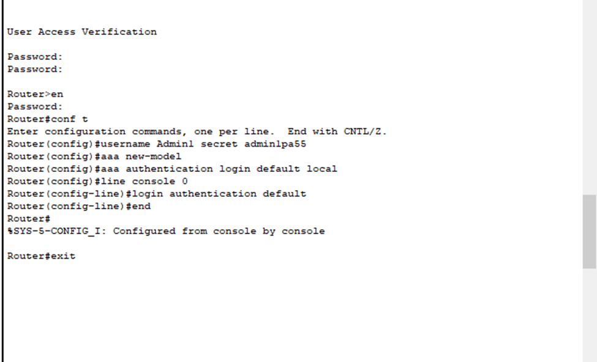
Figure 1: Router secure administration access password setup

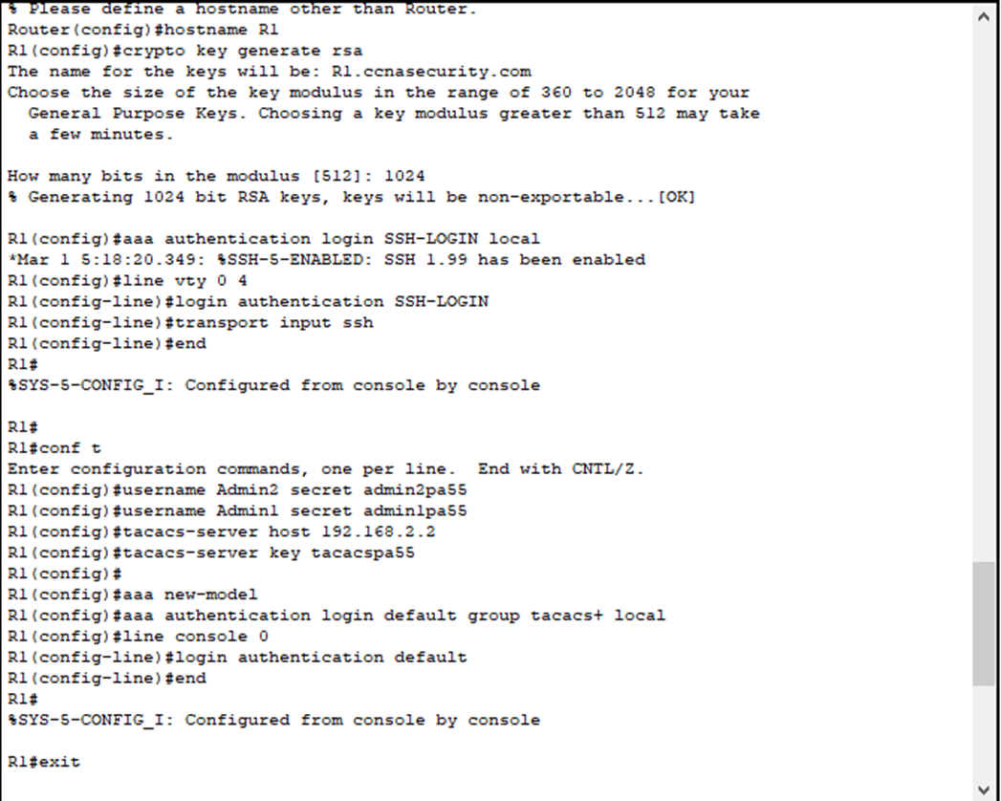
Figure 2: TACACS setup

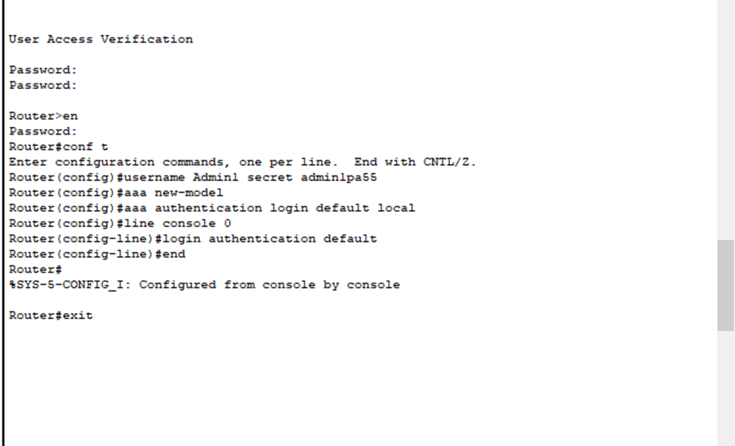
Figure 3:AAA model

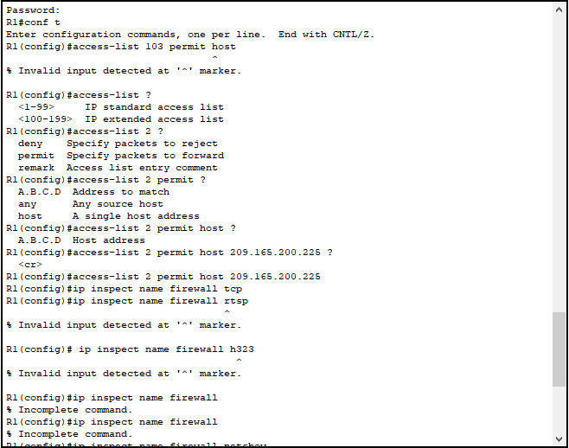
Figure 4: Router ACL setup
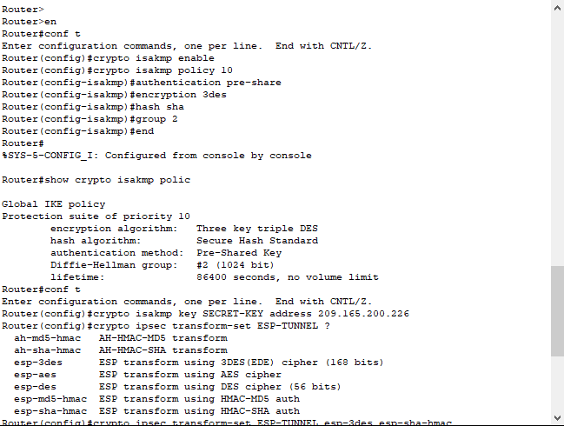
Figure 5: IPSec setup
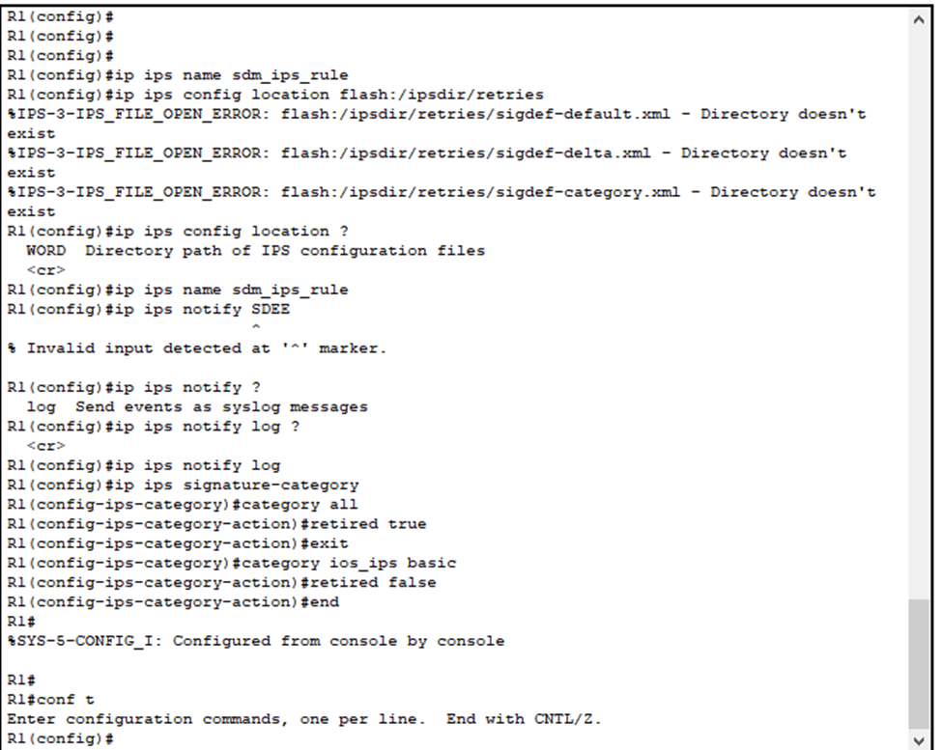
Figure 6: IPS setup
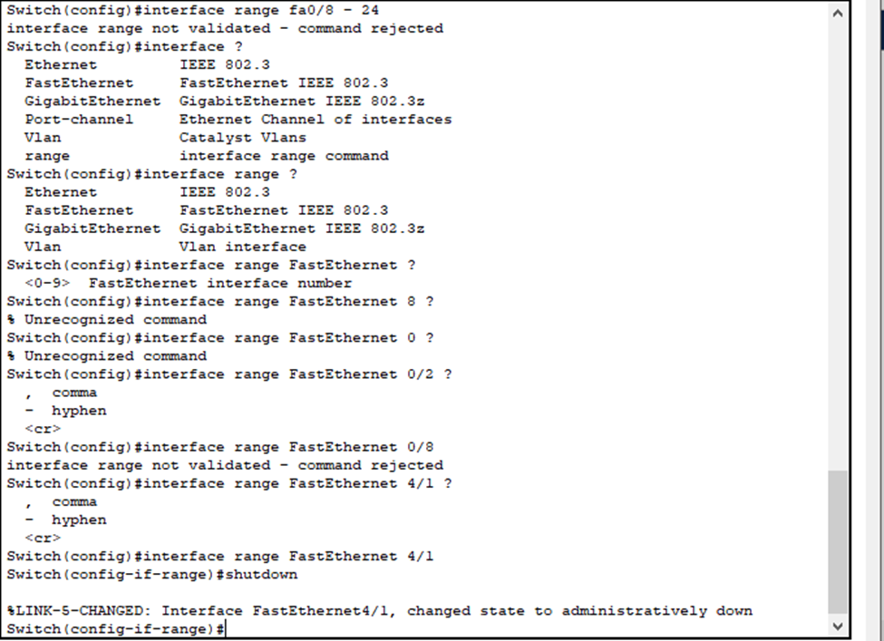
Figure 7: Switch Configuration
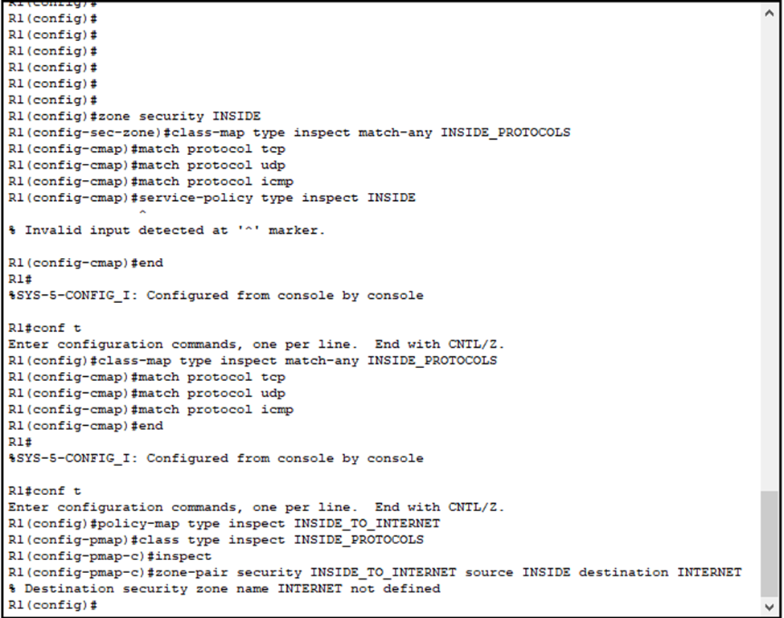
Figure 8: Zone based firewall setup

PUTTY TERMINAL EMULATOR SCREENSHOTS

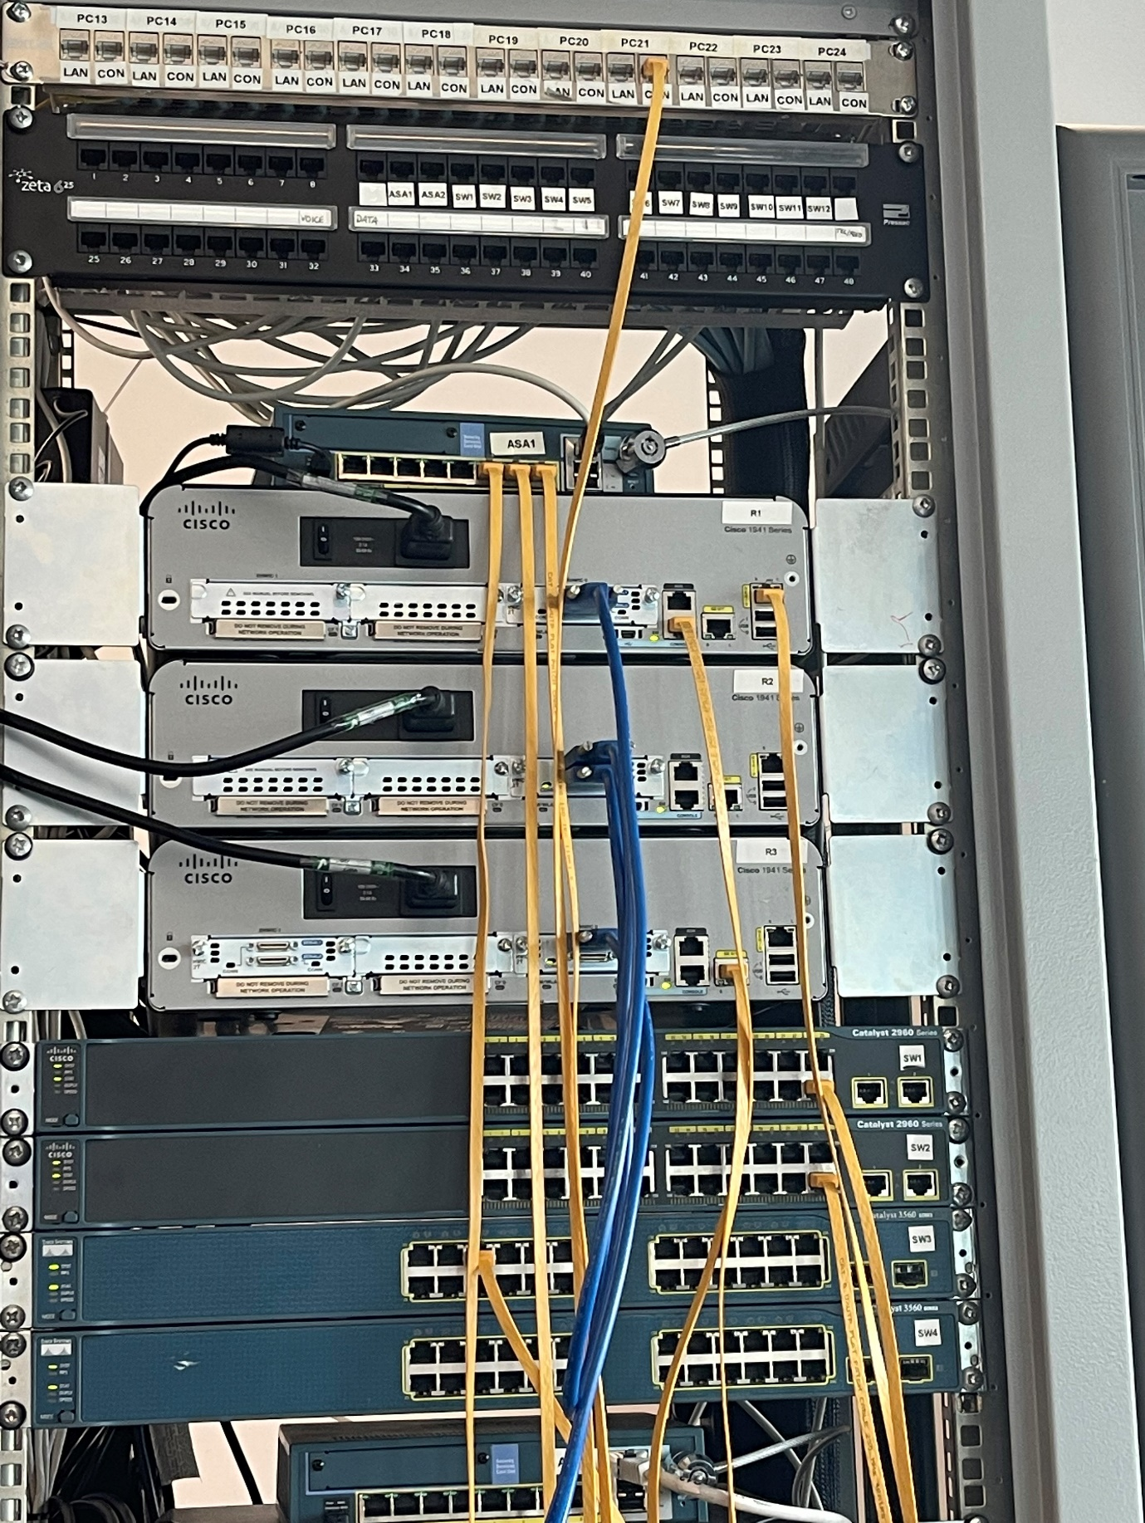
Figure 9: Cisco Lab Assignment Topology
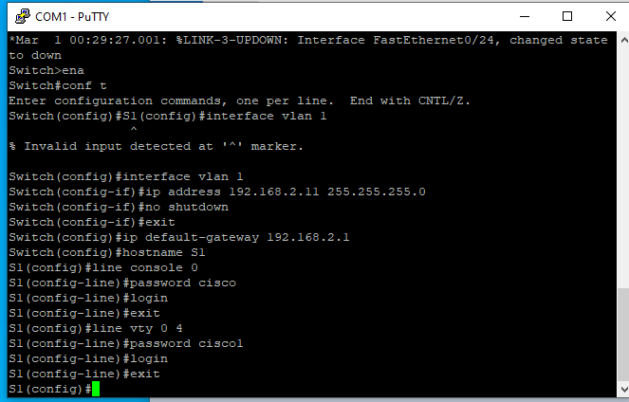
Figure 10: switch S1

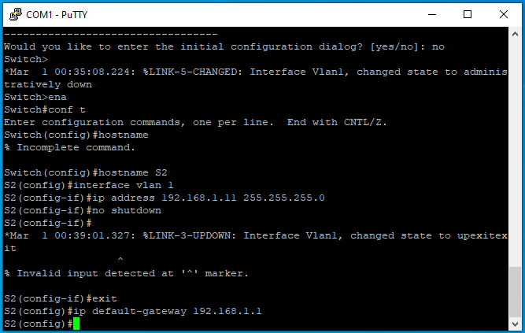
Figure 11: switch S2

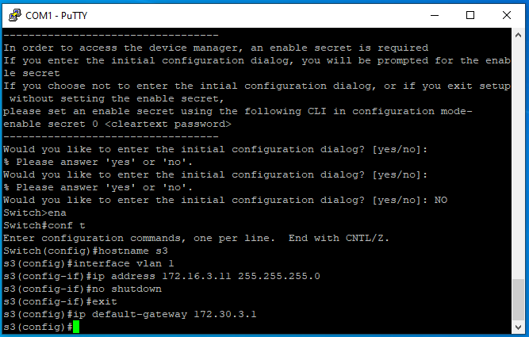
Figure 12: switch S3
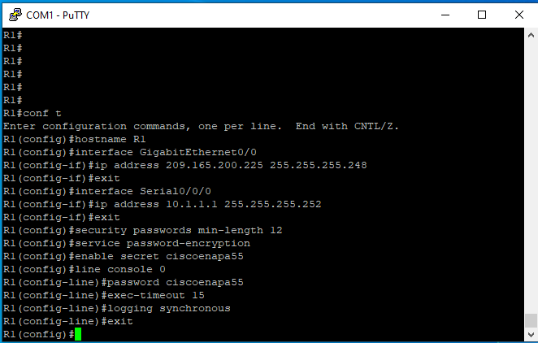
Figure 13: router R1
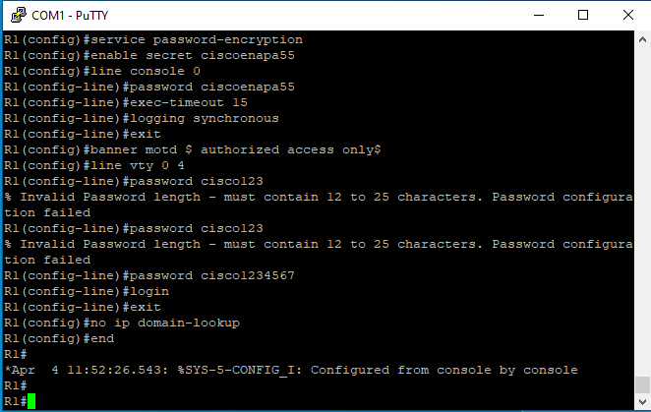
Figure 14: router R1

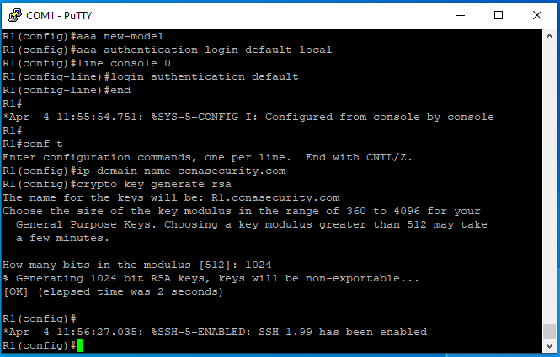
Figure 15: router R1

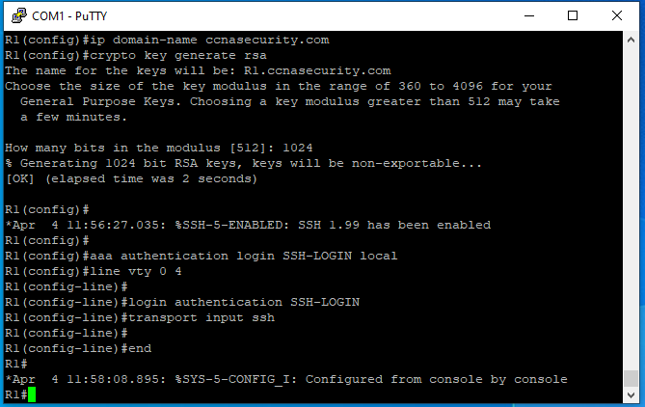
Figure 16: router R1
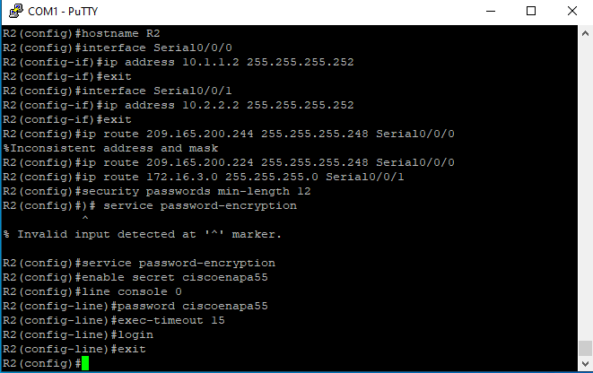
Figure 17: router R2
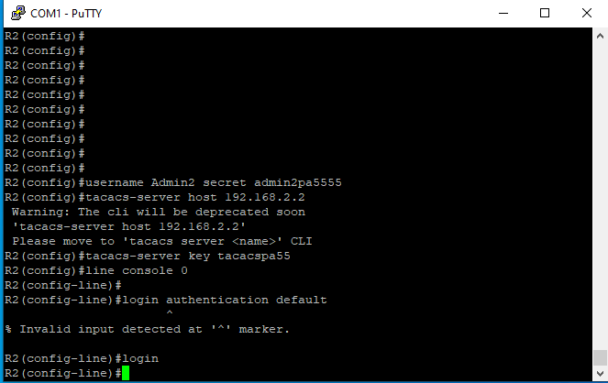
Figure 18: router R2
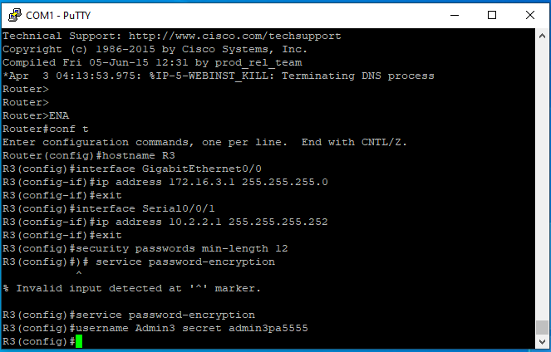
Figure 19: router R3
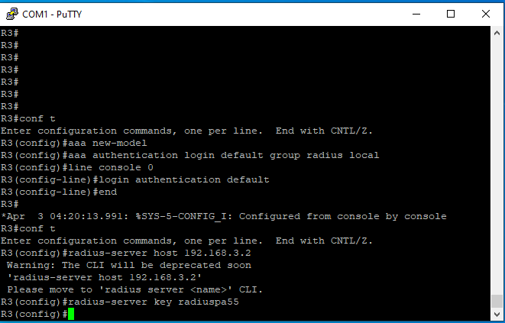
Figure 20: router R3

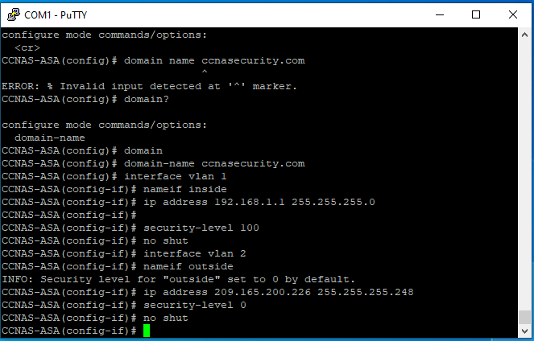
Figure 21: ASA
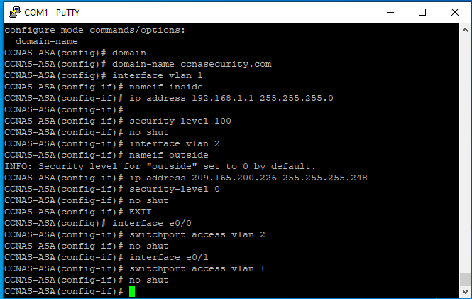
Figure 22: ASA
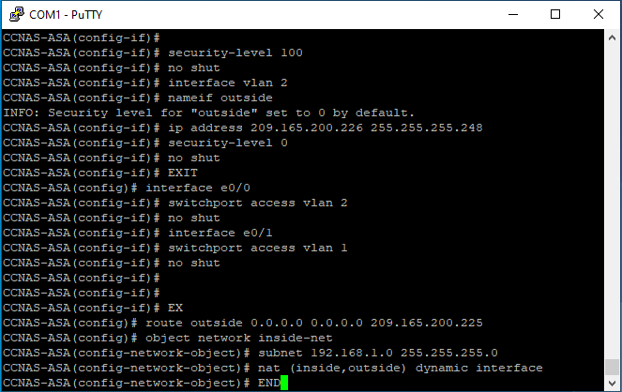
Figure 23: ASA

PART TWO-PROPOSAL OF A SECURE NETWORK INFRASTRUCTURE

ABSTRACT
A2Z Technologies Ltd is a company that specialises in the design and manufacture of high-tech electronic equipment, which are then sold to retailing companies in the UK and around the world. It allows its employees and customers to access the services remotely. Due to the demand of ensuring that some of its employees work at home because of the current restrictions of COVID19, the company’s network requires prior consideration and proper design that would ensure secure access to remote services. [8]
In A2Zcompany, one computer will be appointed as the file server to store all the software that would help the IT administrator at A2Z control the entire networks access both within the company and remote access.
This part of the assignment starts by designing a network that best fits A2Z company. The network designs include the servers, gateways, and a higher plan that ensures the company’s communications are available. The network design also includes a network diagram that will enhance all the activities at A2Z company. After designing the network diagram, the design also provides the best firewall that fits A2Z, including its address network and workstation firewalls. However, to achieve maximum network security, DMZ needs to use DMZ, which sits between the company’s public and private networks [9].
It makes the network secure by exposing the services facing the external network to other untrusted networks and adds an extra security layer, therefor protecting the sensitive data in the organization’s internal network by utilizing the firewalls. Authentication of the network then follows to minimize unauthorized access and ensure that people accessing the Corporation Techs network are authorized.

INTRODUCTION
The importance of the plan proposed by A2Z is ​​to design a simple, uniform, scalable and versatile network. In addition, the newly proposed A2Z network and information security can maintain the confidentiality, availability, and integrity of a system or network,. This regulates access regulates use. In addition, security threats and attacks on networks are increasing, primarily to obtain personal data such as financial information and passwords. Therefore, the proposed network and information systems include the authorization and observation of access, unauthorized access, and the prevention of data, infrastructure, and service areas. [10]

NETWORK SCOPE
The proposed network is designed to serve A2Z Technologies Ltd. The company headquarters contains six departments to be served by this network. This network is for administrative and business operations purposes.

FEASIBILITY STUDY
The situation in which the Project Exists. This proposal is for a data communication network to serve A2Z Technologies Ltd, having sufficiently funded the development of this proposal. Upon proposal acceptance, A2Z Technologies Ltd will implement the proposal.

OBJECTIVES OF THE NETWORK- PART 1
The objective of A2Z Technologies Ltd network infrastructure design is to ensure that the three fundamental principles of information security are met, such as availability, integrity, and confidentiality (CIA)_All security measures, mechanisms, and precautions are executed to secure the A2Z Technologies Ltd information and network. The security plan of A2Z consists of the following features:
CONFIDENTIALITY: The system includes information that involves protection from unauthorized entities [4]
INTEGRITY: The system includes information that must be protected from unauthorized, unexpected or unintended alteration [4]
AVAILABILITY: The system includes information or offers services which must be accessible on a timely basis to meet task requirements or to avoid significant losses [4]
- Firewalls and cryptography
- Access control – Username, Password
- Use of information and information system – Access level.
- Implementation of AAA - Authentication, Authorization and Accounting
The network is designed to achieve several specific business/operational objectives:
- SECURITY
The main objective of this network is to provide secure administrative computing service to the company. It is designed to be functionally and physically isolated from access by outsiders to minimize the risk of unauthorized use.
- INTEGRATION
Presently there is no network in existence. Hence this will be the first of its kind to the company headquarters
- DIVERSE INFORMATION HANDLING
The network will enable users to retrieve, process, and store ASCII and non-ASCII text, still graphics, audio, and video from any connected computer.
- COLLABORATION
The network will combine the power and capabilities of diverse equipment across the location state to provide a collaborative medium that helps users combine their skills and boost productivity.
- SCALABILITY
The design is scalable so that more departments can be added without having to redo the installed network.
- INTENDED USERS.
The primary users of the network will be the company staff, comprising of system administrators, Sales department, HR department, R&D, Finance department, Marketing department, and Customer Relations department.

NETWORK NEEDS ANALYSIS-PART 2
- DATA TYPES.
The types of data served by the network will be reports, bulletins, accounting information, personnel profiles, Computer Aided Designs, programs and web pages. The majority of the data will be text (ASCII and non-ASCII). There will be some still graphics, voice and video(for PC-based teleconferencing). [11]
- DATA SOURCES.
Data will be created and used at all end stations on the network. The data will be produced by software applications in Windows operating systems; however, other operating systems such as Mac and Linux are open for use. Applications that may create the most data are CAD applications, Programming IDEs, and office applications. Diverse video and audio applications will also be in use as a result of teleconferencing and working from home. [11]
- NUMBER OF USERS AND PRIORITY LEVELS.
We project a large number of users for the network, especially at the headquarters, as it will house all devices and communication. On the manufacturing level, the network will be used for monitoring and inter-device communication and management, hence a small number of network users, such as administrators who only monitor the manufacturing process.
There will be three priority levels supported: management (top priority), user (medium priority), and background (low priority). It should be noted that these designations do not correspond to administrative levels within the company but rather to network service levels. Network management processes will be given top priority; most network processes will be given medium priority; and a few processes (e.g., e-mail transfers, backup, and so on) will be given low priority. It should be noted that network management typically consumes a small portion of the available bandwidth; thus, management and user processes typically receive identical support. Background processes will typically receive more than adequate service but will be delayed as necessary to maintain support for management and user services.

- TRANSMISSION SPEED REQUIREMENTS.
The network should be transparent to users. As a result, remotely executed applications, file transfers, and so on should ideally appear to operate at the same speed as processes executed within an end-station. According to user interviews to determine their needs and expectations, an average throughput of 20 Mbps per user within each LAN and 10 Mbps per user between LANs will more than support the required performance in most cases (teleconferencing being the possible exception).
- STORAGE REQUIREMENTS.
Storage requirements need to be large enough to store all company data. Interviews and observations of users’ anticipated storage requirements indicate that each user will need an average of 10 GB of server space, assuming everything is centrally located on servers. The network operating system will occupy about 4 GB on each LAN server. Taking price-performance issues into account, each PC will have a minimum storage capacity of 10 GB [11]
- RELIABILITY REQUIREMENTS.
In keeping with user expectations and industry standards, both the LANs and the WAN are expected to operate at 99.9% uptime and an undiscovered error rate of .001%. [12]
Security Requirements.Unauthorized users will be restricted using a firewall. Users accounts and passwords with limited access will be part of the security. Network administrators and users will have varying levels of access.
- EXISTING NETWORK
There is no existing network.

THE NETWORK DESIGN PHASES

PHASE ONE – DETERMINING APPROPRIATE DESIGN ARCHITECTURE
- NETWORK DESIGN
According to the A2Z circumstances, A2Z needs a secured network design; since some users will be remotely using the company's network, A2Z should be publicly available, considering
In the above situation, the most suitable design for the A2Z company is the design that contains demilitarized zones (DMZ).
DMZ is semi-trusted. It can communicate with the internet and the company’s Local Area Network. [13]
By using the DMZ, the company can place the computers that need to communicate. The Network design will also include public and private IP addresses depending on the firewall configuration.
For the A2Z company, the network infrastructure design will be using public IP addresses and the subnet to keep the network IDs separated so the network administrator can know the network ID for all the employees who uses the A2Z network.
The DMZ will also reduce the complexity involved in filtering the traffic because there would be one rule and only one rule for all computers that the company keeps on the DMZ.
- PHYSICAL AND LOGICAL NETWORK TOPOLOGY
The layout of network elements such as servers, switches, and gateways is very significant. It provides well-modeled nodes and links that interconnect switches and computers. In this case, the physical topology contains different networks components, such as servers, gateways, routers, etc. with various connectors to support the graphic representation of the network topology.
On the other hand, logical topology is an overview of the data flow in the network. Network elements such as gateways, NIC cards, repeaters, routers, modems, switches, firewalls, and bridges occupy a place in the topology.
The router connects to the computer that the node uses to send network packets between different networks in the company.
Switches, on the other hand, connect to other devices such as PCs, printers, and servers to share information. Devices such as servers, routers, and firewalls use UTC, so devices are very important in diagnosing network security issues. The local area network also has servers such as Secure LAN servers, DNS servers, and Kerberos servers to help create ultra-secure architectures for A2Z company. [14]

- COMMUNICATION PLAN
As mentioned earlier, A2Z company does not have an existing network.
We assume that some of its employees will be working from home because of covid19 restrictions; network access is very important as this will give the employee access to the services. Since the company’s network design consists of several computers sharing the same network in the DMZ. To reduce the problems arising from communication issues and ensure communication is available 24/7, the network design includes communication protocols that controls how the network devices communicate and share data.
As a result, this design involves using various types of protocols, including the DHCP, which will enable the company’s network administrators to automate assigning IP addresses to the network. This will save time as any network user can access the internet anytime the employee wants. The other important protocol that will ensure communication availability is the File Transfer Protocol (FTP) between various network hosts, remote users, and local users. [15]
Other important communication protocols included in this network design to enhance communication availability include HTTP, IMAP, Post Office Protocol (POP), SMTP, and DNS.

PHASE TWO- FIREWALL SELECTION AND PLACEMENT
After designing the network for the A2Z company, the next step is to ensure that the network is secured. Security of the entire organization’s network is accomplished by choosing an appropriate firewall and ensuring that its configurations fit the need of the A2Z company. The network firewalls act as a checklist for traffic in and out of the organization’s network, thus ensuring security. There are various types of firewalls based on their method of operation. Therefore choosing the best firewalls for A2Z depend on its network topology as designed earlier. One of the best network firewalls for A2Z is the Packet filtering firewall which operates at the network layer and checks the data packets to determine the source IP address, destination IP address, and the network protocols against various rules defined in the network. [9]
This type of firewall will ensure that any packet from remote users is filtered before allowing it to access the Corporation’s network. Another important firewall for A2Z is Circuit-level gateways which verify the TCP protocol connections and track the active network sessions. This firewall is the best fit for Corporation Techs because it is simple, cost-efficient, and does not affect network performance. Therefore, this type of firewall is placed at the higher level of the OSI model.
For a higher level of network security, the creation of the firewall will incorporate security principles such as the CIA triad. The DMZ sits between Corporation Tech’s public and private internet. The DMZ then exposes the services facing the external network to other untrusted networks and adds an extra security layer, therefore protecting the sensitive data in the organization’s internal network by utilizing the firewalls.

PHASE THREE- REMOTE ACCESS AND VPNS
The Virtual Private Network is critical as it enhances secure connection on the remote users. The selection of the company's VPN technology depends on the company’s size and the number of employees that would remotely access the company’s network. The system and communication pathways are also essential considerations. They will help identify the best VPN protocols that would help secure the company’s end users (employees and technical staff working from home). Based on the above considerations, the best VPN technology that A2Z needs to implement is the L2TP/IPSec, which offers more security features. It stands for Layer 2 Tunneling Protocol over Internet Protocol Security.
DESCRIPTION OF L2TP/IPSEC PROTOCOL
This protocol has two main parts that are L2TP, which provides a secure connection, and IPSec, which would help encrypt the data. With these two features in place, this type of VPN technology fits the A2Z as it will help encrypt the data while on transit from the remote desktop via the company’s network. The L2TP, on the other hand, ensures that the remote employees and technical staff access communicate and transfer data via a secure connection [8]
However, using L2TP alone cannot encrypt data, thus securing the company’s information and data privacy and integrity. Another important aspect that facilitates the selection of this VPN technology for Corporation Techs is that it encrypts data to a military standard. Therefore, with L2TP in place, employees using mobile devices to communicate will have secure access to the network. Additionally, L2TP/IPsec prevents any form of alteration of data between the remote employees and the technical personnel within the company’s premises.

OVERALL NETWORK DESIGN
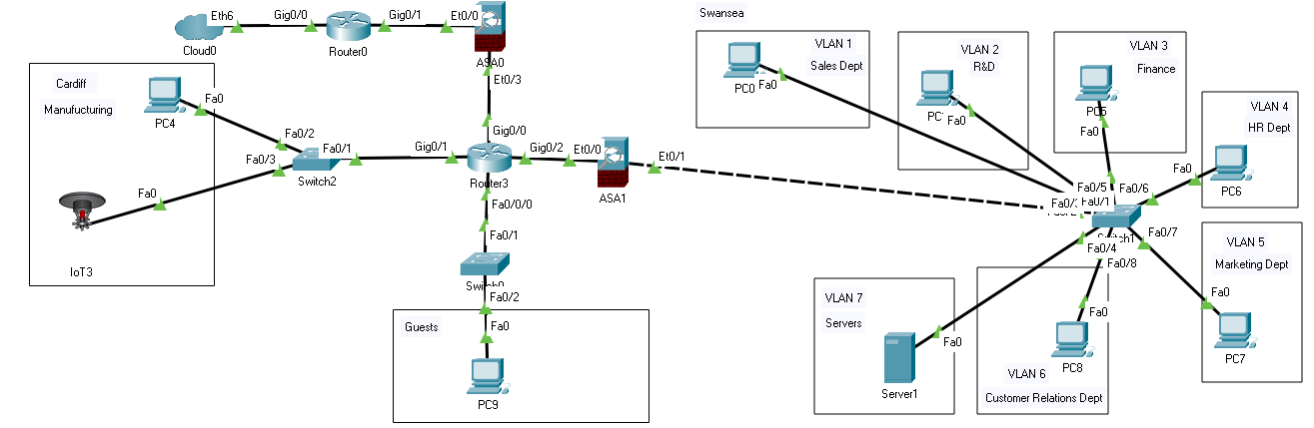
Figure 24: Packet tracer design

A2Z Department | Associated VLANS
Swansea
Sales Department | VLAN 1
R&D Department | VLAN 2
Finance Department | VLAN 3
HR Department | VLAN 4
Marketing Department | VLAN 5
Customer relations Department | VLAN 6
Cardiff
Cardiff Manufacuring | VLAN 7
Table 1: A2Z Company Network

DETAILED DESIGN DOCUMENTATION

COST-BENEFIT ANALYSIS
Product | Quantity | Cost | Availability | Performance | Maintainability
Router | 2 | £2,848.69 | In Stock | Throughput 180Mbps | 5-Year Hardware and 5-Year Software Warranty
Swicth | 3 | £2,612.73 | In Stock | Forwarding bandwidth  100Gbps  Switching bandwidth  199Gbps | 5-Year Hardware and 5-Year Software Warranty
ASA Firewall | 2 | £2,150.00 | In Stock | Throughput Up to 150 Mbps | 5-Year Hardware and 5-Year Software Warranty
Server | 1 | £1,100.00 | In Stock | Variable on configuration | 5-Year Hardware and 5-Year Software Warranty
Cost Analysis
Table 2: Cost Analysis

The above items constitute the core backbone for the network, subject to a few changes based on custom configurations and scalability. End devices like computers and printers have not been factored in as they are highly variable.

BENEFITS ANALYSIS
Benefit | Price
Increased Productivity | £4,000 a year
Increased reliability | £9,000 a year
Less Training Time | £6,000 a year
Increased Connectivity | £3,500 a year
Ease of Record Keeping | £3,000 a year
Table 3:Benefits Analysis

COST-BENEFIT RATIO
Total Cost | £8711.42
Benefits Accrued | £25500
Cost-Benefit ratio | 2.9
Table 4: Cost-Benefit Ratio
The cost-Benefit ratio is 2.9 to 1 in favour of benefits; this means that the network installation cost is lower than the overall yearly profit margins you receive from installing the network.

PROJECT IMPLEMENTATION PROCESS AND SCHEDULE
The Implementation procedure consists of six main steps as follows:

GATHERING OF EQUIPMENT
Task | Person In Charge | Duration
Acquire all necessary hardware | Network Engineer | Day 1 - 14
Hiring of personnel | Network Engineer | Day 1 - 14
Site Preparation | Network Engineer | Day 1 - 14
Table 5:Gathering Of Equipment

INSTALLATION OF HARDWARE
Task | Person In Charge | Duration
Setting up switches | Network Engineer | Day 15 - 35
Laying down cabling | Network Engineer | Day 15 - 35
Setting up power points | Network Engineer | Day 15 - 35
Table 6: Installation Of Hardware

SOFTWARE INSTALLATION
Task | Person In Charge | Duration
OS installations | Cybersecurity Engineer | Day 36 - 50
Device configurations | Cybersecurity Engineer | Day 36 - 50
Table 7:Software Installation

NETWORK TESTING
Task | Person In Charge | Duration
Network Simulation | Cybersecurity Engineer | Day 50 – 80
Penetration testing | Cybersecurity Engineer | Day 50 – 80
Bug and Loophole patching | Cybersecurity Engineer | Day 50 – 80
Table 8:Network Testing

NETWORK DEPLOYMENT
Task | Person In Charge | Duration
Handing over complete network for operation by company | Network Engineer | Day 81 – 90
Training Employees | Network Engineer | Day 81 – 90
Table 9: Network Deployment

NETWORK MONITORING
Task | Person In Charge | Duration
Observation | Network Engineer | After-sales and in-network lifespan
Network Optimization | Network Engineer | After-sales and in-network lifespan
Table 10: Network Monitoring

TYPES OF NETWORK ATTACKS
Dos/DdoS
DoS attacks are carried out by a computer and its Internet connection by flooding the website with packets and preventing legitimate users from accessing the flooded website's content. Fortunately, you can no longer overload a server with just one other server or PC Even if it's due to a protocol bug, it's less common in recent years. DDoS attacks, or distributed denial of service attacks, are similar to DoS, but more powerful. It is more difficult to defend against DDoS attacks. Booted from multiple computers, the number of computers involved can range from a few to thousands or even more.
DDoS attacks can do significant harm. By recruiting many machines into a botnet and directing a flood of traffic against a victim, one can overwhelm the victim and degrade, deny, or in some cases even destroy the service. [16]
SQL Injection
SQL injection attacks target data-driven applications by exploiting application software vulnerabilities. They can use malicious code to retrieve, modify, or even destroy personal data and even invalidate transactions on websites. This has become one of the most challenging privacy issues for data confidentiality. A closer look at the history of SQL injection attacks will give you a better understanding of cybersecurity threats.
Man in the Middle Attacks
A man-in-the-middle attack is a cybersecurity attack that allows an attacker to eavesdrop on the communication between two targets. It is possible to eavesdrop on communications that would usually be private. For example, a man-in-the-middle attack occurs when an attacker wants to intercept the communication between person A and person B. Person A sends the public key to person B, but the attacker intercepts it and sends a fake message to person B. Person B presents himself as A but instead has the attacker's public key. B believes that the message is from person A, encrypts the message with the attacker's public key, and sends it back to A, but the attacker intercepts this message again, opens the message with the private key, and In some cases, modify the message and re-encrypt it with the public key. The key was originally provided by person A. When the message is retransmitted to Person A, they believe it is from Person B, so there is an attacker in the middle who is eavesdropping on the communication between the two targets.

TYPES OF NETWORK TESTS

Network Service Penetration Testing
One of the most common types of penetration testing is network service penetration testing, also known as infrastructure testing. The main goal is to identify the most vulnerable vulnerabilities and security flaws in an organization's network infrastructure (servers, firewalls, switches, routers, printers, workstations, and more) before they can be exploited.

Wireless Penetration Testing
Wireless penetration testing entails identifying and inspecting the connections between all devices connected to the company's Wi-Fi. Laptops, tablets, smartphones, and other internet of things (IoT) devices are examples of these devices. Wireless communications are a service that runs invisibly and allows data to flow in and out of the network. As a result, any flaws in this wireless network, such as unauthorized access or data leakage, must be addressed.
Client-side penetration testing
Client-side penetration testing is used to detect vulnerabilities or security holes in client-side applications. This is a program or application such as Putty, e-mail client, web browser (Chrome, Firefox, Safari, etc.), Macromedia Flash, etc. Programs such as Adobe Photoshop and Microsoft Office Suite have also been tested.

INVOICE

Swansea Cybersecurity Ltd  69 Eversley Road  Swansea  SA2 9DE  01792000123  ccfl.li@ccfl.co.uk | INVOICE  

Invoice # 2307 | Date: March 28, 2022
Bill to
Dr. Carlene Campbell
A2Z Technologies Ltd
Swansea Waterfront
IQ Campus
Swansea SA1 8EW
01792296005
Customer ID 120062307

Description | Quantity | £ / Unit | Amount (£)
Labour services | 1 | 1 | £7000
 |  | SUBTOTAL | £7000
 |  | DISCOUNT | 0
 |  | SHIPPING | 0
Payment is due within [7] days. |  | TAX | 0
 |  | TOTAL | £7000
Thank you for your business!

CONCLUSION
A comprehensive network design is fundamental in ensuring that the company achieves its objectives by protecting its sensitive data. However, the security of the network depends on the design of the network. A good network design needs to incorporate various technologies such as VPN, firewalls, and DMZ to secure the network [17].
This assignment provides a detailed network design for A2Z. The network design involves using various physical components that include hardware devices that are interconnected to form the complete network. Having software and firewall in network design ensures maximum security for sensitive data.

REFERENCES

[1] | N. KRAWETZ, INTRODUCTION TO NETWORK SECURITY, Boston, Massachusetts: Charles River Media, 2007.
[2] | A. Mukherjee, Network Security Strategies, Packt Publishing Ltd, 2020.
[3] | kaspersky, kaspersky, [Online]. Available: https://www.kaspersky.com/resource-center/threats/ddos-attacks.
[4] | Microsoft, "Security Strategies," 19 May 2016. [Online]. Available: https://docs.microsoft.com/en-us/previous-versions/tn-archive/cc723506(v=technet.10)?redirectedfrom=MSDN.
[5] | Michael E. Whitman & Herbert J. Mattord, "Principles of Information Security, Sixth Edition," in Principles of Information Security, Sixth Edition, Cengage Learning, 2017, p. 197.
[6] | secureops.com, "secureops.com," [Online]. Available: https://secureops.com/blog/network-security-design-four-principles/.
[7] | [Online]. Available: https://geek-university.com/ccna-security/cisco-network-foundation-protection-nfp-framework/.
[8] | Mohamad Faudzi, Muhammad Muqri, "Performance Analysis of SSTP and L2TP/IPSEC VPN Network," 2018.
[9] | V. Clincy and H. Shahriar, "Web Application Firewall: Network Security Models and Configuration," 2018 IEEE 42nd Annual Computer Software and Applications Conference (COMPSAC), vol. 01, pp. 835-836, 2018.
[10] | W. Stallings, NETWORK SECURITY PRINCIPLES AND PRACTICE FIFTH EDITION, Pearson Education, Inc, 2011.
[11] | "Sample Network Design Proposal - University of Wisconsin," Sample Network Design Proposal - University of Wisconsin, [Online]. Available: https://people.uwec.edu/hiltonts/101/CBAsample/Projectsample.htm.
[12] | [Online]. Available: https://people.uwec.edu/hiltonts/101/CBAsample/Projectsample.htm.
[13] | Dadheech K , Choudhary A ,Bhatia G , "De-Militarized Zone: A Next Level to Network Security," IEEE, no. Second International Conference on Inventive Communication and Computational Technologies (ICICCT), 2018.
[14] | S. Voigt, C. Howard, D. Philp and C. Penny, "Representing and Reasoning About Logical Network Topologies," Graph Structures for Knowledge Representation and Reasoning, pp. 73-83, 2018.
[15] | S. Al-Sarawi, M. Anbar, K. Alieyan and M. S. Alzubaidi, "Internet of Things (IoT) communication protocols: Review," 2017 8th International Conference on Information Technology (ICIT), pp. 685-690, 2017.
[16] | Stacy Prowell , Mike Borkin ,Rob Kraus , Seven Deadliest Network Attacks, 30 Corporate Drive, Suite 400, Burlington, MA 01803, USA: Elsevier Inc, 2010.
[17] | B. Rababah, S. Zhou and M. Bader, "Evaluation the Performance of DMZ," IJ Wireless and Microwave Technologies, vol. 1, pp. 1-13, 3 2018.

