The World Health Organisation (WHO) has identified physical inactivity as one of the leading risk factors for global mortality (Rossi, 2012). With more than 60 percent of the US adult population not engaged in physical activity (PA) on a regular basis and 31% of adults not engaging in any form of PA, (U.S Department of Health) it is clear that only a small percentage of young people are completing the recommended daily sixty minutes of moderate-to-vigorous intensity PA (WHO, 2010).
It is clear that getting people moving is critical to the nation’s health (Roetert, 2018) and the promotion of physical literacy (PL) has become a key opportunity for the promotion of a healthy lifestyle (Edwards et al., 2016).

This essay will critically analyse the role of physical competence (PC) in the development of PL. PL is defined as ‘The motivation, confidence, physical competence, knowledge and understanding to maintain physical activity throughout the life course’ (Whitehead, 2010, pp. 11-12). PC is defined as ‘an individual’s ability to develop movements skills and patterns, and the capacity to experience a variety of movement intensities and durations’ (Sport For Life, 2020) while enhanced competency is connected with participation in a wider range of activities or settings.

‘While physical competence is at the heart of physical literacy, development limited to this element alone will not necessarily foster physical literacy’ (International Council of Sport Science and Physical Education, 2013) therefore all key attributes of PL outlined by Whitehead in her definition of the notion will be considered throughout this essay. Dudley’s 2015 notion of PL is that of an umbrella of overarching knowledge, skills and understanding with consideration to the four core elements. Figure 1 illustrates the way in which Dudley’s vision somewhat mirrors Whitehead’s definition of PL. Dudley explains that these core elements shown in Figure 1 are intertwined and uses the metaphor employed by Quay and Peters (2009) which shows each of the core elements sitting like Russian dolls, movement competency being the smallest doll thereby showing that all of the elements outlined are key to the development of a PL.

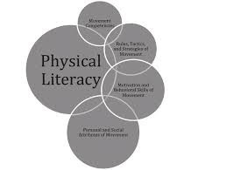
Figure 1 Core elements of PL (Dudley, 2015).

In light of the fact that PL as noted by Whitehead is a ‘cradle to grave concept’, this essay will take into consideration the structure of what Whitehead regards as the six stages that an individual must travel through to become physically literate
Pre-School years
Foundation/Early and Primary School years Secondary School years
Early adulthood years
Older adult years
Adult years

These six key stages of development will be married with the key motor development models and critically analysed as follows;

Firstly this essay will consider the importance of the development of Fundamental Movement Skills (FMS) in early childhood in building the ‘base camp’ to encourage engagement in PA throughout the lifespan. Key thinkers such as Clark and Metcalfe and their ‘Mountain of Motor Development’ model along with Galluhue’s ‘Hourglass’ will considered when analysing the importance of developing FMS competence in early childhood.

Secondly Stodden et al.’s Spiral of Disengagement will be considered in critically analysing the level of engagement and disengagement in PA during early, middle and late childhood (Crane et al., 2015). The relationship between competence and PC and its role in PA will also be considered. Attention will be given to Whitehead’s concept of PL as a stepping stone to sport excellence (Jurbula, 2015) and the importance of breaking Haubenstricker and Seefedlt’s (1986) proficiency barrier to live a PA life across the lifespan.

The final part of this essay will evaluate the last three stages of Whitehead’s PL journey which are the stages of adulthood. Despite Whitehead’s mapping of the PL journey, important consideration will be given to individuals entering adulthood without the prior mastery of skills. Despite the high proportion of research within the field of PL highlighting the importance ‘to start in early childhood, it’s never too late to develop physical literacy. Just get moving’ (www.activeforlife.com).

Laying the Foundations - FMS

The first part of this essay will evaluate the role of motor development and FMS in the development of PC and PL.

The development of FMS plays a key role in an individual’s PL journey. The extent of the importance of FMS in the PL journey varies between researchers. Whitehead places the development of Motor competence as one of the five key components listed in her definition of PL whilst Canadian Sport for Life (CS4L) used FMS development as the anchor of its definition of PL. Written in response to improve rising inactivity and obesity among Canadian children, CS4L define PL as ‘developing fundamental movement skills, leading to fundamental sport skills in various decision-making situations in a variety of environments’ (CS4L, 2016).

FMS are defined ‘as basic learnt movement patterns that do not occur naturally and are suggested to be foundational for more complex physical and sporting activities.’(Barnett LM et al., 2016, p.1). FMS can be split into three main categories, locomotor object control and stability skills such as balancing (Gallahue, Ozmun and Goodway, 2012).

Gallahue et al., (2011) compare the development of FMS as the basic learning of words and the alphabet in a literacy context; without these key literacy elements a child would be handicapped in his reading, writing and language ability which would have a detrimental effect on several aspects of his life far beyond his school reading. In a PL context FMS form the basis of all movement and are considered the ABCs of motor development. Rossi highlights that the employment of key FMS gives individuals the basis to build a varied vocabulary to allow them to develop competency in their chosen activity or sport (Rossi, 2012).

Despite such emphasis put on FMS development as the core of movement, Stodden et al., (2008) highlight the common misconception that children ‘naturally’ learn FMS. Pupils do not develop ontogenetic FMS (Gallahue, Ozmun and Goodway, 2001) therefore one can but assume that the ‘natural misconception that children ‘naturally’ learn FMS are connected to ‘play’ in the broader sense of play that one would expect to see on school yards, playing fields etc. Considering that pupils do not develop ontogenetic FMS (Gallahue, Ozmun and Goodway, 2001) and do not improve their FMS skills through high level play (Robinson and Goodway, 2009) in order to develop the FMS required to allow them to have the high level PA opportunities throughout their life they must be taught FMS.
Although it is clear that FMS are required to be taught rather than developed through play it is important to consider the importance of play and its connection with the development of PL as play according to Maude (2010, pp. 111) ‘play facilitates the establishment of many of the other attributes that are characteristic of a physically literate individual, including motivation, confidence, environmental and interpersonal engagement, self- knowledge and self-expression.’
It is an opinion shared by key authors that motor skills competence form the foundation of PA (Clark & Metcalfe, 2002; Haywood & Getchell, 2005; Seefeldt, 1980). FMS are a predictive of PA, fitness, healthy weight status and cognitive and academic outcomes (Holfelder and Schott, 2014) and as Clarke and Metcalfe (2002) suggest they are the basis of the FMS mountain that children must climb to become physically active adults. Bennett (2016) highlights that the term ’fundamental’ itself or ‘foundation’ as the preferred term for many researchers analysing the development of FMS.The FMS base noted by Bennett can be seen in Figures 2 and 3 both of which visually represent two key motor development theories that recognise early childhood to be the optimal time for the development of MC (Barnett, Salmon, and Hesketh 2016; Barnett et al 2016; Clark and Metcalf, 2002; Seedfelt 1980; Stodden et al. ,2008). Both Figure 2 ‘Clarke and Metcalfe’ Mountain of Motor Development and Figure 3 Gallahue’s Hourglass will be analysed in the next section. Both these models share many common denominators and will be considered in this section.

Mountain v Hourglass

There is a common consensus amongst researchers (Ratrick, 1981, Smoll, 1982; Wade et al., 1974) that motor development is ‘the change in motor behaviour over the lifespan.’(Clark et al.,1989 p.183). Haywood (1986) defines motor development as ‘a sequential, continuous age-related process whereby an individual progresses from simple, unorganised and unskilled movement to the achievement of highly organised, complex motor skills and finally to the adjustment of skills that accompanies ageing’ (Haywood, 1986, p.7) . Clark and Metcalfe‘s mountain as the product model and Gallahue’ hourglass will be analysed in this section.

Both models are based on the original motor development model devised by Seefeledt. The original model created by Seefeledt has been further developed by Hulteen et al. and can be seen in Figure 4 which shows the development of motor skills across the lifespan. All three models recognise similar developmental stages.

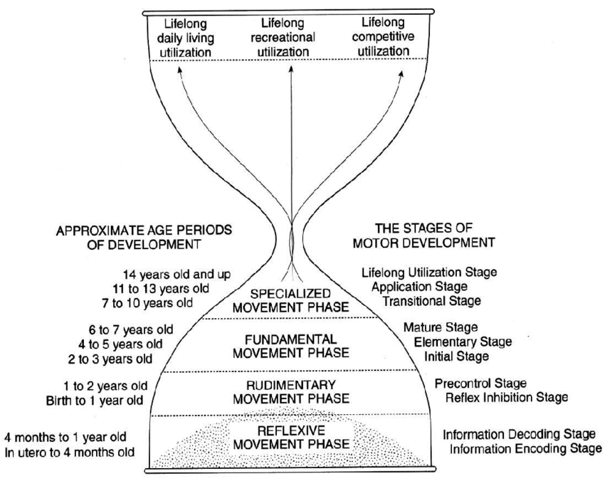

Figure 2 Gallahue’s hourglass model ( Gallahue,Ozmun, & Goodway, 2012)

Just as Whitehead proposes that every person’s PL journey is unique to their own ability and goals, Clark and Metcalfe’s theory mirrors Whithead’s vision that ‘we each climb our own mountain’ (Gallahue et al., 2012) and that although we all start at the same base, our journey may be easier/tougher depending on the ‘interaction between the individual, the conditions or constraints’ (Gallahue et al., 2012, p. 58). This model is non-linear and allows opportunity for regression which is also representative of an individual’s typical PL journey. Just as planning and process is crucial to key stages in early childhood, considerable pre-planning must be considered for the ascent (Payne and Isaacs, 2011) and its effect on the individual’s motivation and participation levels following the peak.

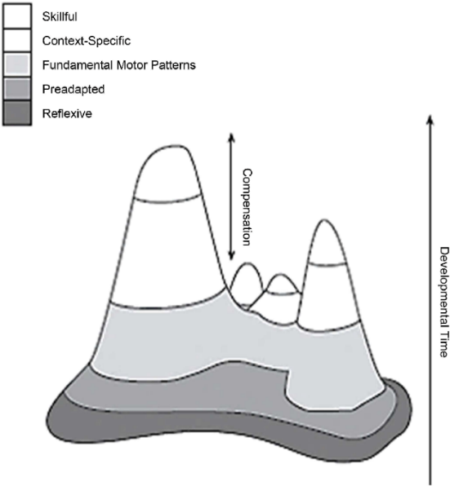

Figure 3 The Mountain of Motor Development (Clark and Metcalfe 2002)

Whilst Clark and Metcalfe liken human development to a mountain, Gallahue conceptualises motor development as a triangulated process/product hourglass model which clearly takes hereditary and environmental issues into account when considering the individual’s motor competence journey in a similar way to Clarke and Metcalfe’s consideration of the individual journey.

Much of children’s motor development within the first two stages of both models is taken for granted by many parents and there is a common misconception that these do not require support for development. These stages of development include stability control of head and limbs, strengthening of trunk, walking et. There is currently not a great deal of research into interventions for development of motor skills within these stages. This is an area which will require possible intervention in the future as with both the mountain and hourglass models it is clear that without these skills, the child’s ability to flourish and progress to develop FMS will be delayed.

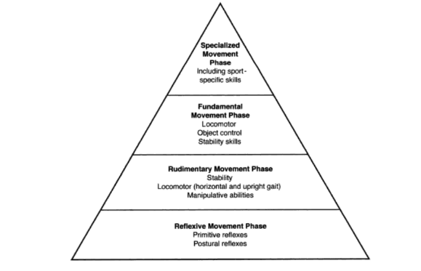
Figure 4 Four movement phases (Gallahue, 1995; McCall 2000)

The key stages on both models are those of the fundamental period patterns of the mountain and the fundamental skills of the hourglass both clearly doorways to future physical engagement and opportunity. Clark and Metcalfe (2002) suggest that FMS are the ‘basecamp’ of the mountain. Gallahue and Donnelly (2003) note that ages three to six are the most sensitive ages for the development of FMS in children (Cools et al., 2008).

Gallahue states that failure to allow opportunities to develop FMS will inhibit the child in progressing to specialised movement skills which allow them to participate in specific sports and argue that it is important to highlight the social mental and physical consequences of failing to reach this stage of development (Salehi et al., 2017) Gallhue, Ozmun and Goodway (2012) note that these FMS defined at the central stages of both models are the skills applied to play, game and daily living situations.

According to Haubenstriker and Seefeldt 1(982) children commonly enter a transitional movement skill period at seven or eight years of age in which they start to show a combination of FMS and specialised skills (Salehi 2017).

The transition between the FMS phase and future stages of motor development are critical to the future of the individual’s physical future. It is at this stage that individuals encounter Haubenstricker and Seedfeldt (1986)’s proficiency barrier as seen in Figure 5 and it becomes clear if they have developed the required fundamental skills to develop into specialised skills to engage in individual sports. ‘When individuals become more skilled, they break the proficiency barrier or experience the ‘transformation of power’ and accordingly become more fully player’ (Brady, 1998, p.3).

Both Figure 2 and 3 put great emphasis on the development of phases as a clear staged structure with little consideration to the concept of ‘every individual’s journey is different’ and to the factors that may impact on the basic development of the three initial stages outlined by Gallahue in Figure 2.

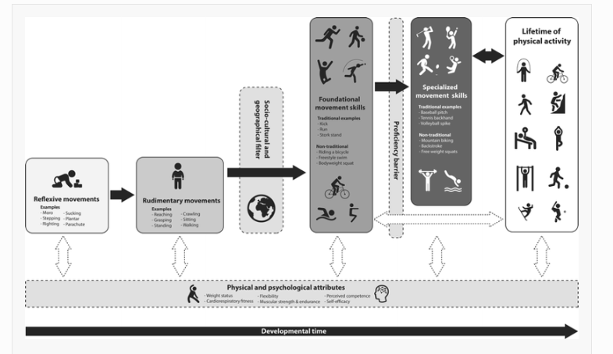

Figure 5 Physical Activity across the Lifespan (Hulteen et al 2018)

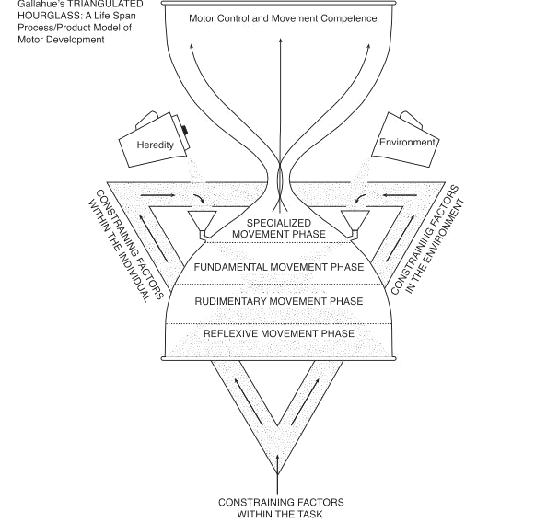

Figure 6 Hourglass Metaphor(Gallahue et al 2012)

Competency v perceived Competency (PC)

Stodden et al., (2008) believe that if a child develops motor skill competence in FMS in the early childhood period (two to five years of age) this will serve to promote PA and physical fitness, increase time spent and the motivation to engage later in life. Much of the motor development models concentrate on PC being the key element to an individual’s forecasted PA journey. Taking into consideration that not all individuals develop equally and are exposed to both hereditary and environmental constraints (Gallahue, Figure 6) and socio-cultural and geographical filters (Haubentstricker and Seedfeldt Figure 5) not all individuals will develop the motor competence levels required to directly engage in a lifetime of PA.

Stodden et al., (2008) created the model that investigates the relationship between motor skill competence and its relationship with PA but also the relationship between an individual’s PC and engagement in PA.
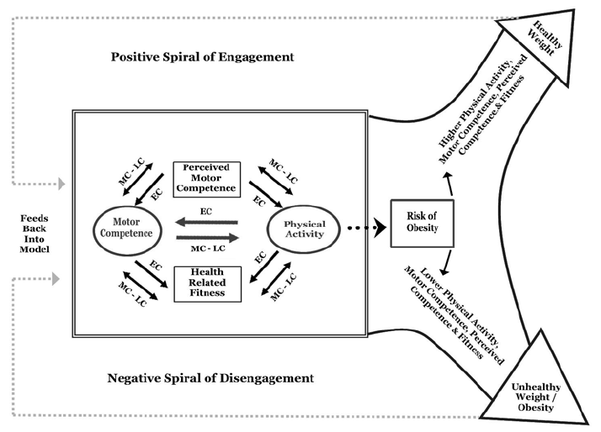
Figure 7 Developmental Model (Stodden et al 2008)

Stodden et al., (2008) highlight in the diagram above the cyclical and reciprocal relationship between motor competence and PA. The diagram suggests that children who as noted by Barnett et al., (2009) are more competent, are more likely to be active and of a healthy weight, whilst those children who lack competency are likely to not participate and be overweight. Research by Lubans et al., (2010) confirms that children who are more competent are more active. As well as PC it is important to note that there is strong evidence to connect FMS to health-related fitness including body composition. Although PA and PC are connected with a healthy weight status it does not follow that all individuals who are competent will be of healthy weight and all individuals who lack competency and are not engaged in PA will be overweight.
Harter (1978, 1982,1988) suggests that an individual’s perceived MC better predicts their motivation to engage in PA rather than their actual competence. It is likely that children who have high perceived PC will engage in PA and therefore suggests that engaging children in PA is the key to raising their PC. However according to Goodway & Rudisill (1997) and Harter (1999) the positive correlation to children’s perceived and actual MC does not appear until adolescence and late childhood. Lopes et al., (2016) found mixed data in relating to the correlation of perceived and actual MC in early ages. Whilst Goodway (2005) is of the opinion that young children demonstrate limited accuracy in perceiving their MC and that their opinions of their abilities are exaggerated until adolescence. Despite this positively motivating students to engage in PA it ‘results in children demonstrating weak, inconsistent levels of gross motor competence.’(Goodway & Smith, 2005; Lopes, 2015 p.130.

Despite some research noting that children high in perceived MC are more likely to engage in PA, Klint et al., (1987) highlights the inconsistencies in these studies as children low in perceived PC may still engage and be motivated to engage in PA due to social and affiliative reasons.
However Feltz and Petlichkoff (1983) highlighted that the PA in sport dropouts were significantly low in comparison to those continuing to participate and the prime reasons for no longer participating was due to not having the skills to improve or develop to reach their desired level of competency highlighting that despite the importance of PC, recognition of one’s lack of ability becomes a key stumbling block in an individual’s PL.
Despite mixed opinions on Stodden’s connection of actual and perceived MC with PA at various stages of the PL journey and despite PC being important to encourage participation as noted by Lopes et al., (2016 ) there is no getting away from the fact that actual competence is key and is important in ‘subsequent years for health behaviours, efforts should still be spent on enhancing motor competence in the early years.’(Barnett, 2016, p.138)

Adolescence

As outlined briefly in relation to the motor development model above, adolescence becomes a crossroads for many depending on the PC developed in earlier stages of life. This part of the essay will evaluate the final stages of Whitehead’s PL journey from adolescence into varied stages of adulthood.

It is with great concern that many key researchers within the field have noted that many individuals do not reach the required level of proficiency in motor skills competence by adolescence and adulthood (Hardy, Reinteen-Reynolds; Espinel, Zask and Okely, 2012; Langendorfer & Roberton, 2002; Stodden, Langendorfer & Roberton, 2009).

If children do not develop at least a moderate level of motor skills competence by the end of adolescence, then their probability of increasing skill and demonstrating and maintaining good fitness into early adulthood may be hampered. (Stodden et al., 2012, p.402)

Stodden et al., (2008) highlights that the lack of development of motor skill competency in early childhood affects engagement in sports-related activities. Adolescence is recognised as a critical period of development of embedding health-related fitness into the PL life cycle and it is also recognised by Stodden et al., (2009) that adolescence is a key period for the maintenance of PA into adulthood.

Despite there being extensive research showing the physical and psychological benefits to adults participating in PA (Shephard, 1995) according to Ostrow and Dzewaltowski, 1986, as age increases, individuals generally gradually disengage with PA. There is little research that discusses the development of PC in regards to PL in the stages beyond adolescence. The question here is ‘What about those who enter adulthood without these skills?’ It is clear that if an individual is keen to have a professional career in a sport, then it is likely that without the competence skills, this opportunity would now have been missed. Important consideration is to be given to Whiteheads’s concept of PL as an individual personalised journey that considers both body and mind; this becomes more evident in the later stages of Whitehead’s PL journey.

More research is required into developing PC in the later stages and how the negative physical and psychological effects in regards to PC and PL can be improved. Regardless of an individual’s competency levels in adulthood, it is key to develop their PL and competence to a level that they wish to engage with PA: ‘The promotion of physical activities for all age groups may be the most effective and also the most cost effective method of enhancing the total well-being of the individual.’ (Brady, 1998 p3). As noted by Hogan and Santomier (1984) ‘older people’s physical, emotional and cognitive functioning could be enhanced if the negative feelings regarding their personal efficacy and competence were modified’ ( Brady, 1998, p.4).

Many of the models discussed previously in this essay represent a staged model however in consideration of PL at adult stages, the spiral of ongoing engagement shown below is a realistic model of an individual’s PL journey representing varying activity levels through their PL journey .Jurbala (2015) highlights key lifestyle benefits of the PL journey rather than having the focus on reaching high levels of motor competence.

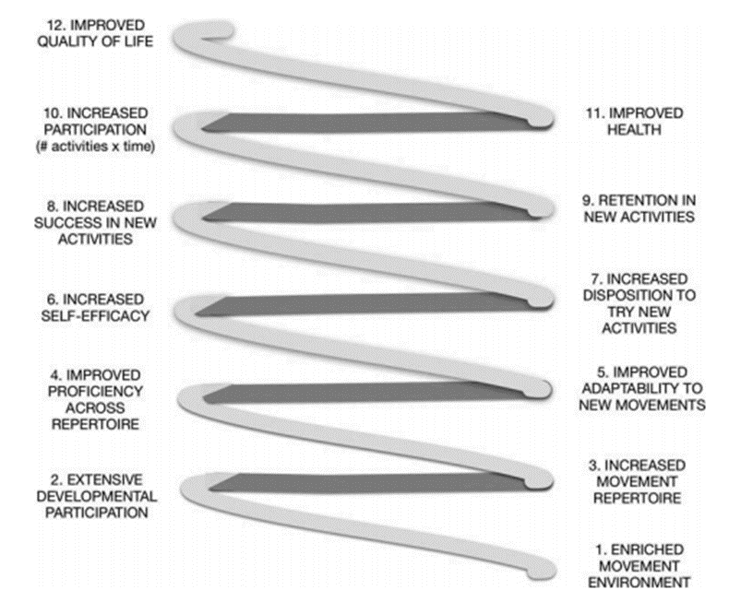

Figure 8.Jurbula 2015 p378

Important note to end this key section is ‘Physical activity may not add years to life but life to years.’(Brady 1998, p 4)

,

Despite the importance highlighted in the motor development models analysed in this section, many researchers disagree with such emphasis being put on FMS in the development of PL as many of the models simply show the strong correlation between early childhood and development of FMS and connect with the physical abilities of an individual which works against Whitehead’s monist view of the body and mind being one.

To conclude this essay on the relationship between PC and PL a vast majority of definitions relating to PL from Whitehead, PHE and CS4L all identify PC as the key driving force of PL. As outlined by ParticipACTION et al., (2015) along with development of ‘motivation, confidence, knowledge and understanding, PC allows for individuals to develop the PL required to take responsibility for physical activities for life.

Research suggests that PL is built from the development motor competency and the effects of an individual’s competency or PC is what drives motivation and confidence to engage in PA.

‘For the children who want to be athletes, for the children who just want to ‘be on the team,’ and for the elderly who must adapt their movement to their ageing body, knowing about motor development is critical’ (Clark et al .,1989)

With evidence showing that active children are more likely to become active adults, it is clear that in order to have a more active population, the foundation for movement and the motivation to participate in lifelong PA must be instilled in early childhood. In order for this to happen, parents, educators and government must recognise that ‘Motor skill literacy is as important as reading literacy’ (Clark, 2007, p43) and that these skills - despite the common misconception that they are developed naturally ‘do not just come as birthday presents. They must be nurtured, promoted, and practised’ (Clark, 2007, p43). Motor development must form the base of Clarke and Metcalfe’s metaphorical mountain or the base of Gallahue’s hourglass. It is clear that consideration needs to be given to sociocultural, hereditary and environmental factors that have a major impact on the development of an individual’s PC and PL together with developing the required level of MC to break through the hypothetical proficiency barrier to ensure the individual is on Stodden’s positive spiral of engagement leading to a healthy active lifestyle.

Many of the models discussed in this paper rely heavily on the early development of MC. If we are to develop a nation of physically active individuals, focus must be given to all ages across the lifespan to improve or competencies for the level of physical engagement required for an individual to be PL leading to a lifetime of PA.

It is clear that just as Whitehead acknowledges that physical competency is key she readily notes that ‘Physical competency on it its own does not constitute physical literacy’ (Whitehead, 2013b, p .30).

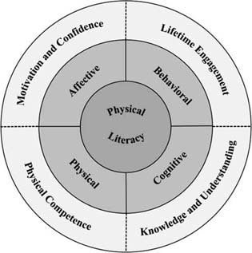
A considerable amount of research highlighting the importance of PL utilises assessment mechanisms within the PL field which are based around competency, with tests such as TGMD focusing primarily on gross motor skill development of children therefore concentrating on one dimension of the ‘ever-changing concept’ (Robinson et al., 2017, p.12) of physical literacy. Considering that Whitehead highlights PL as a journey that continues throughout the lifespan, the absence of assessment or monitoring tools that go beyond childhood and measure the key PL elements outlined in the diagram below as one and provide a full individual PL map is referred to by Tremblay and Lloyd as the missing piece (Tremblay & Lloyd, 2010)
Figure 9 (Robinson et al., 2017, p. 5)

Despite the vast amount of research on PL based around the importance of embedding it in early childhood there is a clear need for further research into interventions for adolescence and for later stages leading into adulthood.

If the goal of PL as defined by (Robinson et al., 2017) is the lifetime participation in PA, an assessment method is required to assess the PL elements throughout the lifespan. An individual’s PL journey should be based on ‘one’s own abilities and interests.with no standardisation or endpoint’ (Robinson et al., 2017 p.6) consideration should be given to Whitehead’s suggestion that considering the individuality of the journey ‘charting progress is more appropriate than assessment’ (Whitehead, 2013b, p. 48) there should be ‘no benchmarking or comparison to others (Whitehead, 2013b, p.45). To conclude, more support is required for excellent interventions like SKIP to inform, equip and develop PC which in turn will create a future of physically literate individuals however we cannot simply dismiss all the young people who have missed the opportunity to develop these PL skills who did break through the hypothetical proficiency barrier. Jurbala (2015) points out that if one is to take PL seriously, more evidence showing that PL is more than simply FMS or PA is required (Jurbala, 2015).

References
Barnett, L.M., Morgan, P.J., Van Beurden, E., Ball, K. and Lubans, D.R., 2011. A reverse pathway?
Actual and perceived skill proficiency and physical activity. Medicine &amp; sciences in sports & exercise, 43(5), pp.898-904.

Barnett, L., Stodden, D., Cohen, K., Smith, J., Lubans, D., Lenoir, M., Iivonen, S., Miller, A.,
Laukkanen, A., Dudley, D., Lander, N., Brown, H. and Morgan, P. (2016). Fundamental Movement
Skills: An Important Focus. Journal of Teaching in Physical Education, 35(3), pp.219-225.

Barnett, L.M., Stodden, D., Cohen, K.E., Smith, J.J., Lubans, D.R., Lenoir, M., Iivonen, S., Miller,
A.D., Laukkanen, A., Dudley, D. and Lander, N.J., 2016. Fundamental movement skills: An
important focus. Journal of Teaching in Physical Education, 35(3), pp.219-225.

Barnett, L.M., Stodden, D., Cohen, K.E., Smith, J.J., Lubans, D.R., Lenoir, M., Iivonen, S., Miller,
A.D., Laukkanen, A., Dudley, D. and Lander, N.J., 2016. Fundamental movement skills: An
important focus. Journal of Teaching in Physical Education, 35(3), pp.219-225.

Barnett, L.M., Van Beurden, E., Morgan, P.J., Brooks, L.O. and Beard, J.R., 2009. Childhood
motor skill proficiency as a predictor of adolescent physical activity. Journal of adolescent health,
44(3), pp.252-259.

Brady, F., 1998. The role of physical activities throughout the lifespan: Implications for counselors
and teachers. The Journal of Humanistic Education and Development, 36(4), pp.234-247.

Canadian Sport for life (CS4L) (2016) Introduction to physical literacy. Retrived from
http://canadiansportforlife.ca/resources/introduction-physical-literacy

Clark, J.E. and Metcalfe, J.S., 2002. The mountain of motor development: A metaphor. Motor
development: Research and reviews, 2(163-190), pp.183-202.

Clark, J.E. and Metcalfe, J.S., 2002. The mountain of motor development: A metaphor. Motor
development: Research and reviews, 2(163-190), pp.183-202.

Clark, J.E. and Whitall, J., 1989. What is motor development? The lessons of history. Quest, 41(3),
pp.183-202.

Clark, J.E. and Whitall, J., 1989. What is motor development? The lessons of history. Quest, 41(3),
pp.183-202.
Clark, J.E., 2007. On the problem of motor skill development. Journal of Physical Education,
Recreation &amp; Dance, 78(5), pp.39-44.

Cools, W., De Martelaer, K., Samaey, C. and Andries, C., 2009. Movement skill assessment of
typically developing preschool children: A review of seven movement skill assessment
tools. Journal of sports science &amp; medicine, 8(2), p.154.

Crane, J.R., Naylor, P.J., Cook, R. and Temple, V.A., 2015. Do perceptions of competence mediate
the relationship between fundamental motor skill proficiency and physical activity levels of children
in kindergarten?. Journal of Physical Activity and Health, 12(7), pp.954-961

De Rossi, P., Mattews, N., MacLean, M. and Smith, H., 2012. Building a repertoire: exploring the
role of active play in improving physical literacy in children. Revista Universitaria de la Educación
Física y el Deporte, (5), p1

De Rossi, P., Mattews, N., MacLean, M. and Smith, H., 2012. Building a repertoire: exploring the
role of active play in improving physical literacy in children. Revista Universitaria de la Educación
Física y el Deporte, (5), pp.38-45.

Dudley, D.A., 2015. A conceptual model of observed physical literacy. The Physical Educator,
72(5).

Edwards, L.C., Bryant, A.S., Keegan, R.J., Morgan, K. and Jones, A.M., 2017. Definitions,
foundations and associations of physical literacy: a systematic review. Sports medicine, 47(1),
pp.113-126.

Gallahue, D, L, Ozmun, J.C, &amp; Goodway, J.D (2012) .Understanding motor development Infants,children, adolescents, adults (7th ed) New York, NY: McGraw-Hill.

Goodway, J.D. and Robinson, L.E., 2015. Developmental trajectories in early sport specialization: a
case for early sampling from a physical growth and motor development perspective. Kinesiology
review, 4(3), pp.267-278.

Harter, S. and Pike, R., 1984. The pictorial scale of perceived competence and social acceptance for
young children. Child development, pp.1969-1982.

Harter, S., 1978. Effectance motivation reconsidered. Toward a developmental model. Human
development, 21(1), pp.34-64.

Harter, S., 1982. The perceived competence scale for children. Child development, pp.87-97.
Harter, S., 1998. The development of self-representations.

Haywood, K.M. and Getchell, N., 2019. Life span motor development. Human kinetics.

International Council of Sport Science and Physical Education, 2013, ‘Physical Literacy’,’Definition of Physical Literacy and Clarification of related Issues.’Bulletin No 65,p29

Jurbala, P., 2015. What is physical literacy, really? Quest, 67(4), pp.367-383.

Klint, K.A. and Weiss, M.R., 1987. Perceived competence and motives for participating in youth
sports: A test of Harter&#39;s competence motivation theory. Journal of Sport and Exercise Psychology,9(1), pp.55-65.

Lopes, V., Barnett, L. and Rodrigues, L., 2016. Is there an association among actual motor
competence, perceived motor competence, physical activity, and sedentary behavior in preschool
children?. Journal of Motor Learning and Development, 4(2), pp.129-141.

McCall, R.M. and Craft, D.H., 2000. Moving with a purpose: Developing programs for
preschoolers of all abilities. Human Kinetics.

Ozmun, J.C., 2011. Understanding motor development: Infants, children, adolescents, adults.
Mcgraw-hill.

Sport for Life Society and Physical Literacy for Life 2020, Physical Literacy, viewed 17 January 2020, https://physicalliteracy.ca/physical-literacy/

Robinson, D.B. and Randall, L., 2017. Marking physical literacy or missing the mark on physical
literacy? A conceptual critique of Canada’s physical literacy assessment instruments. Measurement
in physical education and exercise science, 21(1), pp.40-55.

Robinson, L.E. and Goodway, J.D., 2009. Instructional climates in preschool children who are at-
risk. Part I: object-control skill development. Research quarterly for exercise and sport, 80(3),
pp.533-542.

Roetert, E.P., Ellenbecker, T.S. and Kriellaars, D., 2018. Physical literacy: why should we embrace
this construct?.

Salehi, S.K., Sheikh, M. and Talebrokni, F.S., 2017. Comparison exam of Gallahue’s hourglass
model and Clark and Metcalfe’s the mountain of motor development metaphor. Advances in
Physical Education, 7(03), p.217.

Schutzer, K.A. and Graves, B.S., 2004. Barriers and motivations to exercise in older adults.
Preventive medicine, 39(5), pp.1056-1061.
Stodden, D., Goodway, J., Langendorfer, S., Roberton, M., Rudisill, M., Garcia, C. and Garcia, L.
(2008). A Developmental Perspective on the Role of Motor Skill Competence in Physical Activity:
An Emergent Relationship. Quest, 60(2), pp.290-306.

Shephard, R.J., 1995. Physical activity, health, and well-being at different life stages. Research
quarterly for exercise and sport, 66(4), pp.298-302.

Stodden, D.F., True, L.K., Langendorfer, S.J. and Gao, Z., 2013. Associations among selected
motor skills and health-related fitness: indirect evidence for Seefeldt&#39;s proficiency barrier in young adults?. Research quarterly for exercise and sport, 84(3), pp.397-403.

U.S Department of Health and Human Services, Physical Activity and health. A report of the
surgeon general, atlanta, GA: US Department of Health and Human Services, Centers for Disease
Control and Prevention, National Center for Chronic Disease Prevention and Health Promotion
1996 Retrieved November 12, 2003 from www.cdc.gov/nccdphp/sgr/pdf/chap5.pdf

Wainwright, N., Goodway, J., John, A., Thomas, K., Piper, K., Williams, K. and Gardener, D.
(2019). Developing children’s motor skills in the Foundation Phase in Wales to support physical
literacy. Education 3-13, pp.1-15

Wainwright, N., Goodway, J., Whitehead, M., Williams, A. and Kirk, D., 2018. Laying the
foundations for physical literacy in Wales: the contribution of the Foundation Phase to the
development of physical literacy. Physical Education and Sport Pedagogy, 23(4), pp.431-444

Whitehead, M. ed., 2010. Physical literacy: Throughout the lifecourse. Routledge p11-12

Whitehead, M., 2010. Physical literacy, physical competence and interaction with the environment.
In Physical Literacy (pp. 64-75). Routledge.

Whitehead, M., 2013. Definition of physical literacy and clarification of related issues. ICSSPE
Bulletin, 65(1.2).

World Health Organization, 2010. Global recommendations on physical activity for health. World
Health Organization.Geneva, Switerzland 2010,p7)

