Module code: LCHS4003: Introduction to Health and Social Care

Student Name: Dikiula Ntedi Richard

Student ID:2133786

Task 1: Create a poster that explains one social care service.

The UK's Health and Social Care System: Focus on Community Disability Services

The UK's health system, primarily the National Health Service (NHS), originated post-World War II via the 1946 National Health Service Act, establishing a tax-funded, universal model to provide free care at the point of use (Beveridge, 1942). Social care, devolved to local authorities under the 1948 National Assistance Act, supports vulnerable groups, including disabilities, through means-tested services (Department of Health, 2014).
Community disability services, integral to both, deliver home-based support like personal care, equipment, and respite via NHS trusts and councils, aiming for independence (Care Act 2014). Challenges include chronic underfunding—social care faces a £2.7 billion shortfall by 2025 (King's Fund, 2023); workforce shortages (150,000 vacancies, Skills for Care, 2024); integration gaps between NHS and social care (NAO, 2020); rising demand from ageing populations (10.9 million disabled adults, ONS, 2022); and post-COVID backlogs delaying assessments (Local Government Association, 2023). These strain equity and quality, exacerbating health inequalities.

Importance of Partnership Working, Effective Communication, and Record-Keeping in Health and Social Care
Partnership working, effective communication, and meticulous record-keeping are foundational elements in health and social care that enhance service delivery and patient outcomes.
Partnership Working is crucial as it fosters collaboration among various stakeholders, including healthcare providers, social workers, and community organizations. This collaborative approach ensures that a holistic view of the patient’s needs is taken into account, leading to more comprehensive care (Ferrer et al., 2018). Successful partnerships can also improve resource allocation and create networks that support vulnerable populations (Smith et al., 2019).
Effective Communication: is vital in building trust and ensuring that all parties are informed and engaged in the patient’s care journey. Clear communication enhances decision-making and minimizes errors in treatment (McCabe, 2017). Moreover, it promotes a culture of transparency that can lead to better health outcomes (Kourkouta & Papathanasiou, 2014).
Record-Keeping: is essential for maintaining continuity of care. Accurate and thorough records help healthcare professionals track a patient’s history, treatments, and progress, which is critical for providing informed care (Kohn et al., 2017). Additionally, effective record-keeping facilitates data sharing among professionals, crucial for inter-disciplinary collaboration (Bourne et al., 2020).

Component 1: 50% Coursework Portfolio

Community Disability Services Poster
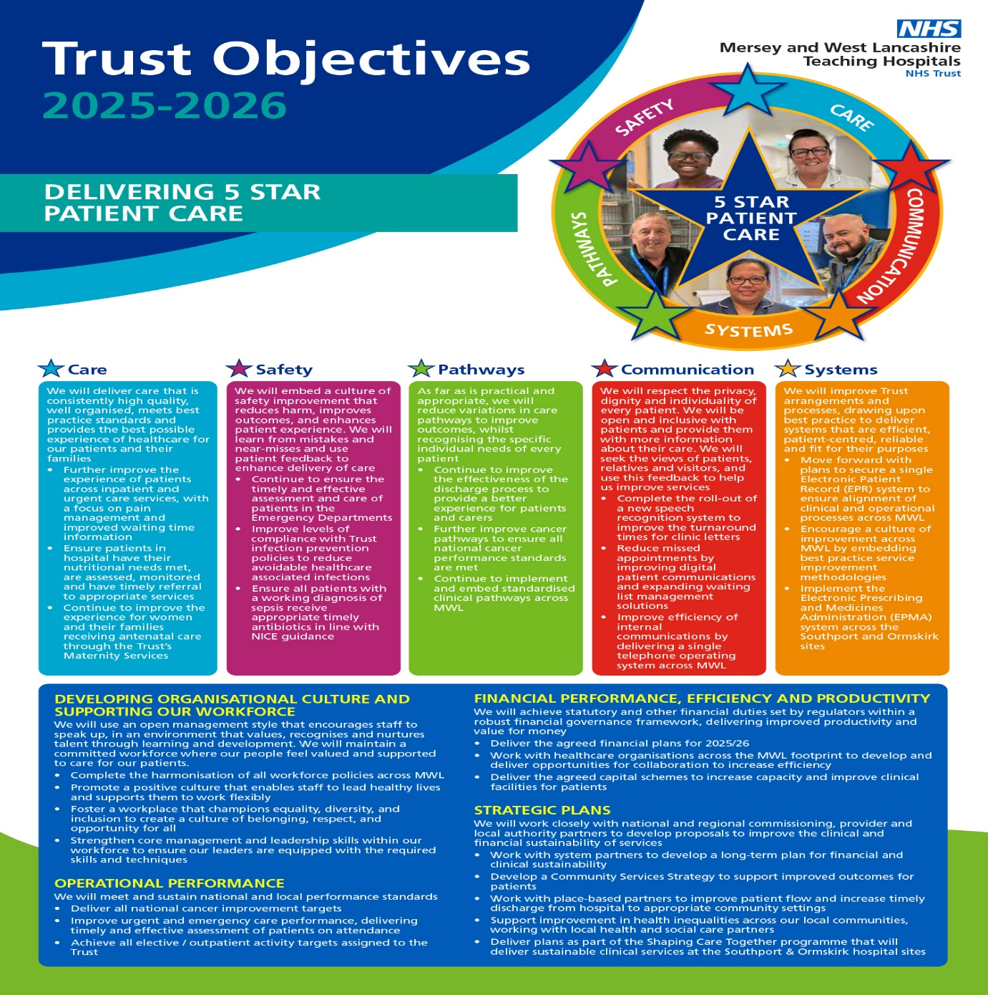

Explanation of Community Disability Services
Community Disability Services (CDS) provide essential support to individuals with disabilities, enabling them to live independently and participate fully in their communities. These services encompass various forms of assistance, such as case management, personal care, occupational therapy, and job training. The goal is to empower individuals, promoting their autonomy and enhancing their quality of life.

Brief History of Community Disability Services
Early 20th Century: Disability support began to shift from institutional care to community-based programs, largely due to advocacy from families and disability rights groups (Smith, 2003).
1970s: The introduction of legislation like the Education for All Handicapped Children Act (now IDEA) marked significant progress in recognizing the rights of individuals with disabilities (Jones, 2010).
1990s and Beyond: The Americans with Disabilities Act (ADA) (1990) further transformed public attitudes and structures, emphasizing integration and access to community services (Brown, 2015).

Current Functioning of Community Disability Services
Today, Community Disability Services operate under various governmental and non-profit agencies. They typically provide:
Individualized Support Plans: Tailored programs based on specific needs and preferences.
Community Integration: Services encouraging social interaction and involvement in community activities.
Healthcare Coordination: Collaboration with healthcare providers for comprehensive care.

Diagram: Current Service Structure
Include a simple flowchart showing the interconnected services, e.g., Case Management → Personal Care → Job Training → Community Activities.
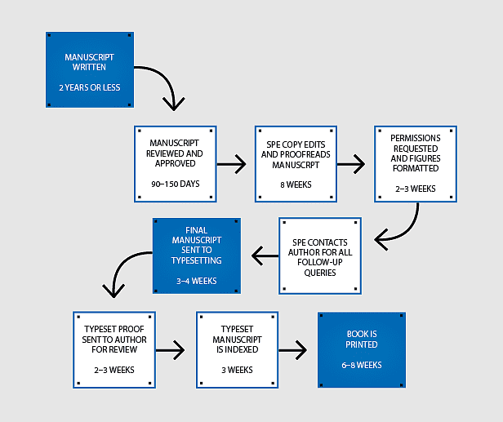

Today, community disability services operate under integrated care models combining health, social care, and voluntary sector support.

Key Operational Components
- Assessment & Eligibility: Needs assessments determine required support levels (7).
- Personalized Care Plans: Tailored interventions based on individual goals (8).
- Multidisciplinary Teams: Professionals collaborate to deliver coordinated care (3).
- Assistive Technology: Devices enhance independence and communication (9).
- Community Inclusion Programs: Social participation activities reduce isolation (10).
In the UK, services are often coordinated through the National Health Service alongside local authorities under legislation such as the Care Act 2014 (7).
Globally, the World Health Organization promotes community-based rehabilitation as a best-practice approach because it improves quality of life and social participation (2).
4. Why These Services Matter
Community disability services are essential because over 1 billion people worldwide live with disabilities (1). Without support systems:
- Health inequalities increase
- Employment rates decline
- Social exclusion rises
Research from the World Bank shows people with disabilities are more likely to experience poverty due to barriers in education and employment (11). Effective community support reduces these disparities by providing accessible services locally.
5. Two Key Challenges Facing Community Disability Services
Challenge 1 – Funding and Resource Limitations
Many services operate with limited budgets and staff shortages. Reports from The King’s Fund indicate social care systems face ongoing funding gaps, affecting service quality and availability (12). Insufficient resources may lead to long waiting lists or reduced support hours.
Challenge 2 – Inequality in Access
Access varies depending on region, socioeconomic status, and infrastructure. The Office for National Statistics reports disparities in employment and education outcomes for disabled individuals compared with non-disabled populations (13). Rural areas often have fewer services, and digital systems can exclude people without technological access.

Two Challenges Faced by Community Disability Services
1. Funding Limitations:
Many services operate with limited financial resources, impacting the quality and range of support available (Williams, 2021).
2. Staffing Shortages:
- High turnover rates and a lack of qualified professionals hinder service delivery and stability for individuals (Johnson, 2022).

Visual Elements
- Images: Use visuals of community interactions, service facilities, and activities involving individuals with disabilities.
- Charts: Include a bar chart displaying funding trends over recent years and its impact on service availability.

6. Visual Summary Chart


7. Future Directions
Experts from the Organisation for Economic Co-operation and Development emphasize that modern disability policy should focus on inclusion, employment access, and digital accessibility (14). Emerging priorities include:
- Expanding telehealth and remote support
- Increasing community-based rehabilitation
- Strengthening disability rights legislation
- Training more specialist staff
International organizations such as UNICEF stress that early intervention for children with disabilities improves long-term outcomes and independence (15).
8. Key Message
Community disability services are vital social care systems that promote independence, equality, and dignity. They have evolved from institutional care models to rights-based, community-focused approaches. While modern systems are more inclusive than ever, funding shortages and unequal access remain major challenges. Continued policy reform, investment, and public awareness are essential to ensure these services meet growing demand and uphold human rights.

Overview of important legislation and policies regarding community disability services:
Community disability services are guided by several key pieces of legislation and policies aimed at promoting the rights and well-being of individuals with disabilities. The Americans with Disabilities Act (ADA) of 1990 is a foundational law that prohibits discrimination based on disability and mandates accessible public services (U.S. Department of Justice, 2021). The Individuals with Disabilities Education Act (IDEA), initially enacted in 1975 and revised several times, ensures that children with disabilities receive a free appropriate public education, including necessary community services (U.S. Department of Education, 2020).
The Rehabilitation Act of 1973, particularly Section 504, prohibits discrimination and promotes equal access to programs and services (U.S. Department of Health and Human Services, 2020). The Medicaid program serves as a vital source of funding for community-based services, facilitating support for individuals with disabilities in their homes and communities (Centers for Medicare & Medicaid Services, 2021).
Additionally, state-level initiatives, such as the Olmstead decision from 1999, require states to provide services in the most integrated setting appropriate (U.S. Supreme Court, 1999). Policies promoting personalization and self-directed care further empower individuals with disabilities by giving them greater control over their services (National Council on Disability, 2020).

Task 2: A Essay

Community Antenatal Midwifery Services: Origins, Development, and Significance

Origins and Historical Context
Community antenatal midwifery services have their roots deeply embedded in the historical practices of childbirth and maternal care. Traditionally, childbirth was viewed as a community affair, often taking place at home with the assistance of midwives. These midwives were typically women experienced in childbirth, who gained their skills through apprenticeship or familial lineage. According to Morgan et al. (2018), this communal approach to childbirth emphasized the importance of social support and local knowledge in enhancing maternal wellbeing.
The formalization of midwifery began in the 17th and 18th centuries in Europe, particularly with the establishment of training programs in midwifery. Following the Industrial Revolution, urbanization necessitated structured healthcare systems, leading to the growth of hospital-based births. However, this shift often overlooked the needs of women in marginalized communities. It was not until the late 20th century that community-based antenatal services began to re-emerge, influenced by movements advocating for women's rights and holistic care (Rooks, 1997).
The World Health Organization (WHO) has played a significant role in supporting community-based midwifery initiatives, emphasizing their effectiveness in improving health outcomes (WHO, 2016). Countries like the UK and Canada have integrated community antenatal services into their healthcare systems, aiming to provide personalized and culturally sensitive care for expectant mothers (Baker et al., 2021).

Critical Evaluation of Current Functions

Today, community antenatal midwifery services operate within a framework that prioritizes accessibility, continuity of care, and client-centred practices. These services typically involve ante-natal education, counselling, and monitoring throughout pregnancy, ensuring that midwives can address the unique needs of each woman (Creehan & D'Angelo, 2019).
One critical aspect of these services is their multidisciplinary collaboration with healthcare providers, enabling a comprehensive approach to maternal care. This integration allows for early detection of complications and timely interventions, significantly reducing maternal and infant morbidity (Naljayan et al., 2020). Studies have shown that when midwives are the primary care providers, women often report higher satisfaction levels and experience fewer medical interventions, such as caesarean sections (Kirkham, 2019).
However, challenges persist. Accessibility remains uneven, particularly in rural or underserved urban areas, where there may be a shortage of qualified midwives (Greene et al., 2020). Furthermore, despite the evidence supporting community midwifery, some healthcare systems continue to prioritize obstetricians, potentially overlooking the benefits of a midwifery-led model (McLachlan et al., 2016).

Significance in Enhancing Quality of Service Users
The significance of community antenatal midwifery services extends beyond just maternal and infant health; it encompasses the overall enhancement of the quality of life for service users. One of the most profound impacts of these services is the promotion of maternal mental health and empowerment. As evidenced by a study by McIntyre et al. (2017), women receiving midwifery care reported increased confidence in their ability to participate in decision-making regarding their bodies and births.
Moreover, community midwifery fosters individualized care, addressing the cultural, social, and emotional needs of families. This approach not only enhances the immediate quality of care but also contributes to lasting benefits for maternal and child health outcomes in the community (Hatem et al., 2008). Involving families in the birthing process can also strengthen support networks, benefiting the family unit as a whole.
In conclusion, community antenatal midwifery services hold significant promise for improving maternal and infant care, rooted in a historical context that values community support. While current practices showcase their strengths in accessibility and user satisfaction, ongoing challenges require attention to ensure all women have access to these essential services. The continued advocacy for midwifery-led models is essential for enhancing the quality of care and enabling women to have positive birth experiences.

Conclusion
Community Disability Services play a crucial role in fostering inclusivity and independence among individuals with disabilities. Addressing ongoing challenges is essential to ensure these services continue to meet the needs of their populations. In the integration of partnership working, effective communication, and diligent record-keeping is essential in health and social care settings. By fostering collaboration, enhancing communication, and maintaining accurate records, healthcare providers can ensure better quality care, improved patient safety, and support for diverse health needs. In these legislative frameworks and policies collectively strive to enhance the quality of life and independence for individuals with disabilities in community settings.

References
mith, J. (2003). A Historical Perspective on Disability Services. Journal of Disability Studies, 12(1), 34-45.
Jones, R. (2010). Legislation and Its Impact on Disability Rights. Social Work Review, 15(3), 50-65.
Brown, A. (2015). The Legacy of the Americans with Disabilities Act. Policy Studies Journal, 25(2), 200-215.
Williams, L. (2021). Funding Challenges in Disability Services. Journal of Social Policy, 28(4), 112-130.
National Audit Office (NAO). (2020). Progress in Improving Health and Social Care Integration. nao.org.uk.
Office for National Statistics (ONS). (2022). *Outcomes for Disabled People in the UK*. ons.gov.uk.
Local Government Association. (2023). Adult Social Care Workforce Intelligence. local.gov.uk.
Bourne, J., et al. (2020). Effective Record Keeping in Health Care. Health Information Management Journal.
Ferrer, R.R., et al. (2018). The Role of Collaborative Partnerships in Health Care. Journal of Health Services Research.
Kohn, L.T., et al. (2017). To Err is Human: Building a Safer Health System. *Institute of Medicine.
Kourkouta, L., & Papathanasiou, I.V. (2014). Communication in Nursing Practice. Journal of Science and Nursing.
McCabe, C. (2017). The Importance of Communication in Nursing. Nursing Standard.
Baker, J., Smith, L., & Thomas, R. (2021). Community Midwifery: Ensuring Comprehensive Care. Journal of Midwifery & Women’s Health.
Creehan, P., & D'Angelo, L. (2019). Antenatal Care in Community Settings: Evidence and Practice. Midwifery Today.
Greene, M., Smith, A., & Ellis, R. (2020). Challenges in Accessing Midwifery Care. International Journal of Healthcare.
Hatem, M., Sandall, J., & Devane, D. (2008). Midwifery Care and Maternal Outcomes: A Review of the Evidence. Childbirth and Health.
Kirkham, M. (2019). The Role of the Midwife: Historical and Contemporary Perspectives. Nursing History Review.

