Introduction to Physiology (assignment 2)
Institution: University of Wales trinity saint David
Term: Oct 2020. BSc Health and Social
Module #: BMHP 5003 London campus
Professor: Adesewa Ajayi

Done by: Mutiat Shobajo

Introduction
A health assessment report for a patient with a cardiovascular condition was done with the aim of assessing the health status of the patient using a questionnaire and identifying the physiological condition of the patient. Cardiovascular disease refers to a constellation of disease that affects the cardiovascular system including the blood vessels and the heart. The primary cause of the disease encompasses atherosclerosis which decreases blood flow. Moreover, several other factors such as inflammation, dyslipidemia, and endothelial dysfunction. Due to cardiovascular disease, the assessment would help to identify the abnormal and normal physiological conditions of the patient. As such, the assessment would ultimately be used for proposing possible lifestyle changes needed for the patient. The objectives of the assessment report encompassed the identification of the health status of the patient and the normal and abnormal physiological conditions of the patient following assessment. The assessment criteria would therefore help to formulate lifestyle changes needed by the patient for the improvement of the health condition of the patient.
Case Study
A 50-year-old British Black African woman was assessed for her health condition using a questionnaire. Patients report a past medical/present history of menopause, prediabetes, Seronegative rheumatoid arthritis, and cataracts bilaterally. She reports a past surgical history of hysterectomy and lab that showed seronegative rheumatoid arthritis factor; she reported stiffness in her right hand. The patient denied a history of tobacco use as indicated in the questionnaire during her diagnosis. Patient reported being a social drinker due and occasionally being pressured to drink by her friends. The patient indicated no history of high blood pressure, heart attack, angina, and stroke. However, a patient reported a family history of a heart attack above age 60 with an accompanied stroke. Patient reports “she is quite knowledgeable about smoking and the effects of smoking on the body”. Patient blood pressure was 128/100mmHg, height was 5’3 while the weight was 16.5stones (103.8kg). The calculation of the body mass index which was taken by taking the weight of the patient and dividing by the height squared showed a BMI value of 40.5. With reference to the classification of BMI among individuals, the patient was extremely obese (NHS, 2020). The patient reported engaging in physical exercise once a week. Considering the patient's dietary intake, the patient reported not being on a specific diet or routine. The patient reports eating anything available. Patients also reported not having time to prepare meals and occasionally fasts for 40 days due to religious demands.

Health Assessment
The patient was suffering from cardiovascular disease which was caused by an array of factors considering the assessment and diagnostic features of the patient. The cardiovascular indicators of disease that the patient exhibited encompassed high blood pressure which was 128/100mmHg compared to the normal blood pressure level of 120/80mmHg. Moreover, the body mass index which is a key indicator of obesity was found to be 40.5. The obesity reference values for BMI have been shown in table 1.
BMI | Weight Status
Below 18.5 | Underweight
18.5-24.9 | Healthy
25.0-29.9 | Overweight
Above 30 | Obese
The high blood pressure and obesity could have resulted from the consumption of alcohol and a poor dietary intake made up of high levels of carbohydrates, fats, and sugars. The poor diet is attributed to the patient's habit of consuming all food she encountered. Alcohol contains high amounts of calories with an energy density of 7 calories per gram (Shelton and Knott, 2014). Considering that BMI may be attributed to high-calorie foods such as alcohol, excessive alcohol intake could have potentially contributed to the high build-up of fats in the body and ultimate obesity.
Traversy and Chaput (2015) posit that the excessive intake of alcohol was associated with adiposity by promoting positive energy balance and the ultimate increase in body weight. Alcohol and beer also contain high concentrations of carbohydrates that can easily be transformed into body fats and adipose tissue. In the UK, alcohol has been found to account for 10% of the total energy intake of adults as a result of the poor knowledge by the population regarding the alcohol calories and food equivalent (Shelton and Knott, 2014). Alcohol intake has also been shown to contribute to disinhibited behavior in food consumption. As such, alcohol users are more prone to consuming a lot of carbohydrates and sugars which ultimately result in the build-up of fats in the body ( Kase, Piers, Schaumberg, Forman and Butyrn, 2016). Since the patient was shown to engage in minor exercises that were not enough for the body, the decreased energy expenditure caused a positive energy balance. Energy expenditure could be achieved through exercise and the intake of low levels of sugars and carbohydrates ( Fazzino, Fleming, Sher, Sullivan, and Befort, 2018).
Since the patient did not take part in many exercises alongside a heavy intake of carbohydrates, the foods were converted to adipose tissue and body fats hence resulting in a higher body mass index and obesity (Rosenberg et al.,2017). Regular exercise which is a recommendation for the reduction of body mass index and obesity has been shown to burn calories and reduce the content of adipose tissue and fats in the body. In other words, exercise reduces weight gain, obesity paradox, maintenance of weight, and initial weight loss in the body (Gupta, 2014). The quantality of fats within an individual body can have a great impact on the weight of the individual compared to the effects of the number of calories contained in the body. Most of the fat calories are stored in the fat cells thus adding weight and body girth as they multiply and expand (Life, 2014). Fats also contribute potentially to abnormal blood cholesterol levels in the blood. Consequently, the circulation of cholesterol could result in the conversion into fatty acids and storage in adipose tissues.
Chaput et al.(2011) ascertained that lack of physical exercise which was characteristic of the patient denied the stimulus required to contribute to the regulation and balance of macronutrients. This balance is vital for the maintenance of body homeostasis and the reduction of obesity. The obese nature of the patient as a result of the high body mass index of 40.5 could potentially result in life-threatening conditions such as cardiovascular diseases(Jiang, Zong, Ruan, and Liu, 2016). These diseases include type II diabetes mellitus, coronary disease, breast cancer, hyperlipidemia, heart failure, and hypertension. The pathophysiology by which obesity leads to high blood pressure starts with the activation of the sympathetic nervous system leading to an increase in the quantities of intravascular and intraabdominal fats (Jiang, Zong, Ruan, and Liu, 2016). There is also an etiology of the retention of sodium resulting in renal absorption. The latter affects the renal angiotensin system which plays important role in the pathogenesis of obesity and hypertension.
Hypertension is a disease condition characterized by blood pressure above 140/90mmHg. Obese patients often exhibit high concentrations of unsaturated and desaturated fats which accumulate in the blood vessel resulting in atherosclerosis (Jiang, Zong, Ruan, and Liu, 2016). Similarly, atherosclerosis causes the infringement of large arteries and the walls of the arteries referred to as visceral fats. Excessive intake of carbohydrates, alcohol, and sugars promotes the increase of triglycerides in the blood thus resulting in arteriosclerosis. Furthermore, the continued accumulation of fats results in the blockage of the blood flow within the arteries. This accumulation is usually in form of a plaque which may continue growing until stenosis and arterial narrowing are achieved (Jiang, Zong, Ruan, and Liu, 2016). Moreover, the narrowing of the vascular walls has a great impact on the arterial lumen obstruction.
High caloric intake and alcohol consumption has been shown to increase the turnover number of norepinephrine neurotransmitters within the peripheral body tissues hence raising the plasma levels of norepinephrine. The latter results in an increased sympathetic nervous system activity. As such, a high intake of alcohol and carbohydrates stimulates the beta and alpha 1 adrenergic receptors thus elevating hypertension and the activity of the sympathetic nervous system (Jiang, Zong, Ruan, and Liu, 2016).
Aronow (2017) posits that the increase in blood pressure in obese individuals is a result of the increased activity of the sympathetic nervous system caused by the increased activation of the rennin-angiotensin-aldosterone system. This mechanism in addition to the narrowing of the blood arteries results in increased blood pressure and ultimate hypertension as seen in the patient's condition (Shariq and McKenzie, 2020). The normal blood sugar range lies between 1.4mmol/L and 6.2mmol/L by a period of about 72 hours of fasting blood glucose. Besides, normal glucose levels in individuals are maintained by an array of factors including the utilization and production of glucose within the body. The latter depends on the concentration of several hormones such as cortisol, epinephrine, glucagon, insulin, and growth hormone. Even though the patient was obese, the glucose levels were within the normal range. However, the pathophysiology of high blood pressure and obesity could subject the patient to type II diabetes mellitus (Guemes, Rahman, and Hussain, 2016).
Arthritis results in joint pain, which is accompanied by swelling, muscle weakness, morning stiffness, joint erosion, and pain. The pain in the joint results in difficulty in movement due to the heavy body mass (Rahnama and Mazloum, 2012). The patient had a BMI index of 40.5 and belonged to obesity class II which is the highest class of obesity. Individuals with a BMI of between 15-19.9 are regarded as underweight whereas individuals with a BMI value of between 20-24.9 are considered to be healthy and have normal body weight. Class I obese individuals have a BMI ranging between 30-34.9 while individuals who belong to class II and class III obesity have a body mass index ranging between 35-39.9 and above 40 respectively (Nutall, 2015; Sangachin, Cavuoto, and Wang, 2018; Weir and Jan 2020).

Recommendations and Holistic Care
The management of the patient would involve a holistic and integrative health care plan encompassing a variety of approaches. For the management of high blood pressure and obesity, physical exercise would be recommended. Physical exercise has been shown to increase the energy expenditure and burn of calories within the body hence reducing the number of body fats. In this regard, exercise reduces the systolic pressure of the heart (Carey, Muntner, Bosworth, and Whelton, 2018). The patient alongside being advised to take part in physical exercise should be advised to avoid the intake of alcohol and incline on taking a balanced diet free of carbohydrates, fats, and sugars while enhancing a high intake of fruits and food with high fiber content such as carbohydrates. Another recommendation is the intake of antihypertensive agents such as anticholinergic drugs (Cohen, 2018). Recommendations following her unscheduled diet are directed towards following a proper diet and perhaps cooking meals for herself to prevent excessive intake of calories and fats.
Bariatric surgery or weight loss surgery is another sometimes used as a treatment for individuals who are obese. This surgery can help patients lose weight and improve obesity related conditions, in this case high blood pressure. Weight loss surgery should be considered if this patient has tried to lose weight through a healthy diet and exercise (NHS, 2020

Conclusion
In conclusion, a patient was diagnosed with a high blood pressure of 128/100mmHg and obesity as a result of the high BMI which categorized her in obesity class II. The patient was engaged in prominent drinking and intake of food without taking into consideration the types of foods she consumed due to personal life-styles. The limited engagement in exercises and a certain amount of alcohol consumption contributed to the build-up of body fats and adipose tissue which resulted in her obese condition. Since the patient had obesity, the activation of the beta-adrenoceptors caused the release of norepinephrine which was caused by a high intake of carbohydrates. Moreover, high norepinephrine levels were caused by the activation of the sympathetic nervous system and the ultimate development of high blood pressure. The clogging of fats and development of plaque in the arteries resulted in atherosclerosis and the narrowing of the blood vessels thus causing hypertension. As such, the management and treatment of the patient would entail avoiding the intake of alcohol, high levels of carbohydrates, fats, and sugars, and engaging in regular exercises. Moreover, the management of hypertension would involve the intake of antihypertensive drugs.

References
Carey, R. M., Muntner, P., Bosworth, H. B., & Whelton, P. K. (2018). Prevention and Control of Hypertension: JACC Health Promotion Series. Journal of the American College of Cardiology, 72(11), 1278–1293.
Chaput, J. P., Klingenberg, L., Rosenkilde, M., Gilbert, J. A., Tremblay, A., & Sjödin, A. (2011). Physical activity plays an important role in body weight regulation. Journal of obesity, 2011, 360257.
Cohen J. B. (2017). Hypertension in Obesity and the Impact of Weight Loss. Current cardiology reports, 19(10), 98.
Fazzino, T. L., Fleming, K., Sher, K. J., Sullivan, D. K., & Befort, C. (2017). Heavy Drinking in Young Adulthood Increases Risk of Transitioning to Obesity. American journal of preventive medicine, 53(2), 169–175.
Sangachin, Ghesmaty M., Cavuoto, L. A., & Wang, Y. (2018). Use of various obesity measurement and classification methods in occupational safety and health research: a systematic review of the literature. BMC obesity, 5, 28.
Gillian Rosenberg, Linda Bauld, Lucie Hooper, Penny Buykx, John Holmes, Jyotsna Vohra, New national alcohol guidelines in the UK: public awareness, understanding and behavioral intentions, Journal of Public Health, Volume 40, Issue 3, September 2018, Pages 549–556,
Güemes M, Rahman SA, Hussain K. What is normal blood glucose? Arch Dis Child. 2016 Jun;101(6):569-574. DOI: 10.1136/archdischild-2015-308336. Epub 2015 Sep 14. PMID: 26369574.
Gupta H. (2014). Barriers to and Facilitators of Long Term Weight Loss Maintenance in Adult UK People: A Thematic Analysis. International journal of preventive medicine, 5(12), 1512–1520.
Jiang, S. Z., Lu, W., Zong, X. F., Ruan, H. Y., & Liu, Y. (2016). Obesity and hypertension. Experimental and therapeutic medicine, 12(4), 2395–2399.
Kase, C. A., Piers, A. D., Schaumberg, K., Forman, E. M., & Butryn, M. L. (2016). The relationship of alcohol use to weight loss in the context of behavioral weight loss treatment. Appetite, 99, 105–111.
Life JS. The Life Plan Diet: How Losing Belly Fat is the Key to Gaining a Stronger, Sexier, Healthier Body. Simon and Schuster; New York, NY: 2014.
Nuttall F. Q. (2015). Body Mass Index: Obesity, BMI, and Health: A Critical Review. Nutrition today, 50(3), 117–128.
Rahnama, N., & Mazloum, V. (2012). Effects of strengthening and aerobic exercises on pain severity and function in patients with knee rheumatoid arthritis. International journal of preventive medicine, 3(7), 493–498.
Shariq, O. A., & McKenzie, T. J. (2020). Obesity-related hypertension: a review of pathophysiology, management, and the role of metabolic surgery. Gland Surgery, 9(1), 80–93.
Shelton, N. J., & Knott, C. S. (2014). Association between alcohol calorie intake and overweight and obesity in English adults. American journal of public health, 104(4), 629–631.
Traversy, G., & Chaput, J. P. (2015). Alcohol Consumption and Obesity: An Update. Current obesity reports, 4(1), 122–130.
Weir CB, Jan A. BMI Classification Percentile And Cut Off Points. [Updated 2020 Jul 10]. In: StatPearls [Internet]. Treasure Island (FL): StatPearls Publishing; 2020 Jan-.

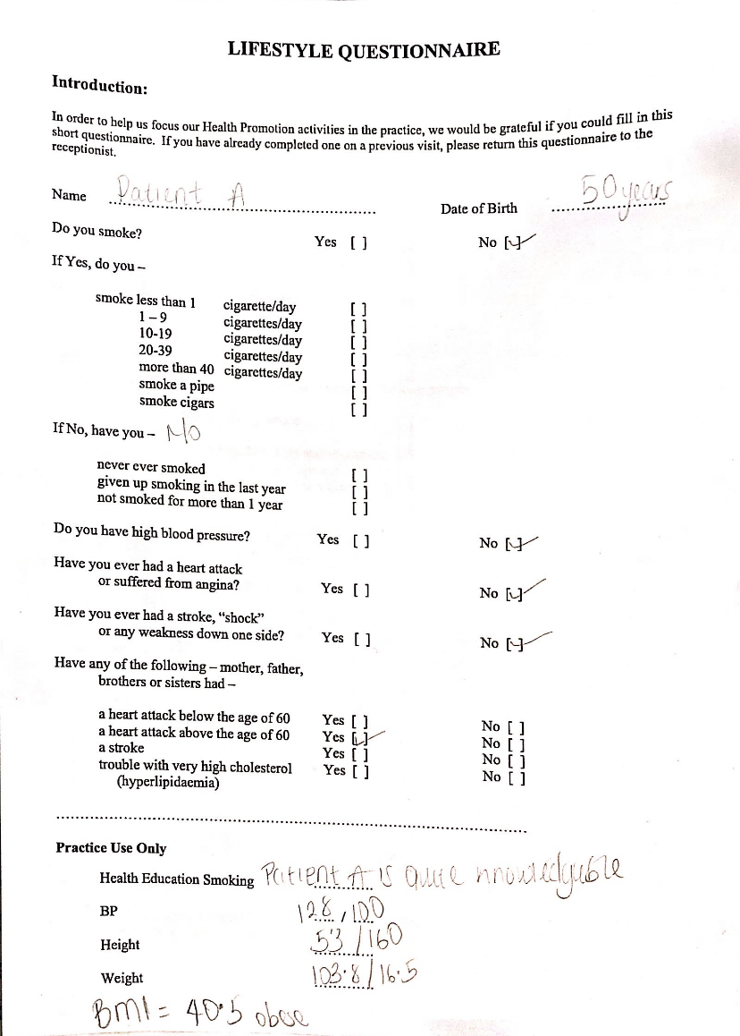

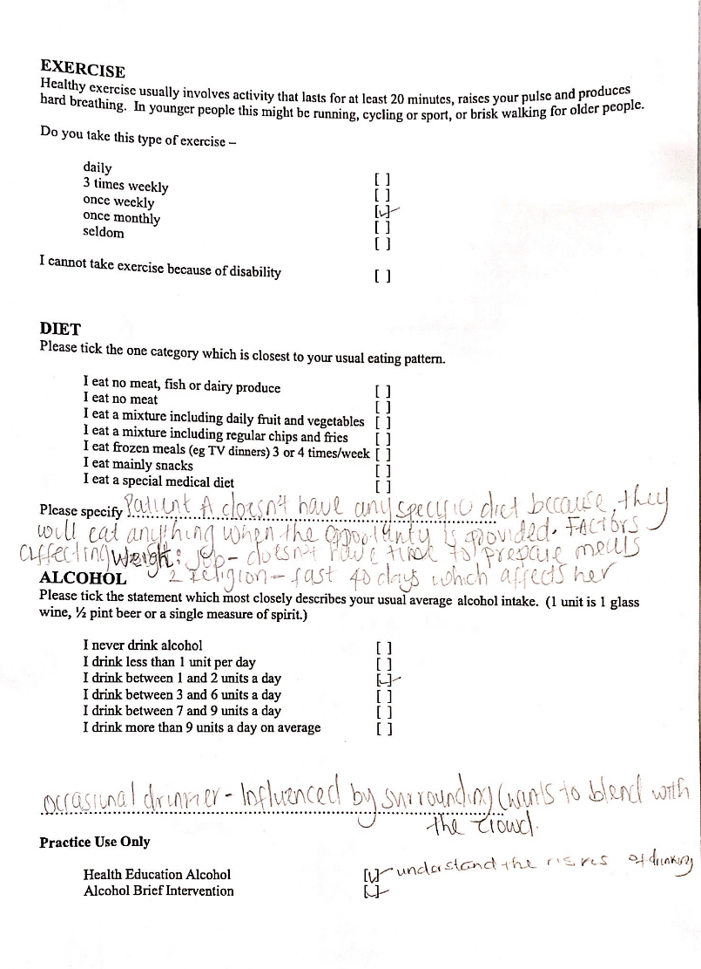
Other medical history/health problems patient A has:
- Boarderline diabetic
- Seronegative rheumatoid arthritis
- Historectomy
- Menopause
- Weightloss problem.

