2022
Danica Dickson (1904977)
Shelha Khan
16/06/2022
Macmillan financial support project.

Contents Page.

Introduction 1.0 page 3
Main findings 2.0 page 4-11
Project Initiation phase 2.1. page 4
Project planning 2.2. page 5-6
Project execution phase 2.3. page 7-11
Conclusion and recommendations page 12
Reference list page 13-14

Introduction 1.0.
According to Prachi Juneja (2021) A project is described as a short-term venture which has a start and an end, it should also be utilized to produce a unique result, provision, or outcome”. A project cannot go on forever and needs to have a clear purpose.
Project management is the implementation of activities, practices, abilities, knowledge, and experience to attain certain project aims. Project management has definitive deliverables which are restricted to a restricted timescale and financial plan, Dr Martin Barnes states that “At its most fundamental project management is about people getting things done." (AMP,2021)
As a team the projects aim is to raise awareness of the financial support which is accessible to all cancer patients with the support of Macmillan charity and develop a flyer directing patients and family to the information they need. This is a project as the team was given a start and end date to complete within and it has an aim.
The report shall critically discuss the use of project tools and techniques such as the project life cycle, a quad chart, Stakeholders analysis, work break down structure, Gantt chart, and risk analysis It shall end with the findings and evaluation discussing the hard and soft outcomes from the project, with a conclusion and recommendations based upon the project’s findings.
Main findings 2.0.
A project life cycle is categorised into four different stages: Project initiation where the purpose of the project is defined and the teams are formed, then project planning stage where detailed projects plans are created and jobs and activities are broken down and arranged into a timetable, then project execution is the observation of the proposal at the same time as confirming quality is being preserved within a costly manner and against a time frame and lastly the project closure at which the project is finished and a complete evaluation of the project is formed. (Pressbooks, 2021)
The project life cycle is a simple model to use and as also easy to understand it is ideal for small and middle-sized projects which worked well for our team. A limitation of the model is a lack of feedback process at each phase, which does not allow the possibility of finding the problem in advance it also it only works when the last stage is completed in the sequence. (wadic,2020)
Paul Naybour (2020) says that an advantage of using the project life cycle is that it Supports interaction between members and stakeholders it helps identify roles in the project as it gives a framework for the project which is visual and easily understood by all team members. Additionally, positions and duties could be allocated corresponding to the project phase.
The project life cycle assisted in guiding the team through the project with its gradual structure, There are four crucial phases of the life cycle of each project, it commences with the initiation phase this is where the team formed and had the idea for the project, next was the planning phase, throughout this phase a quad chart and stake holders analysis and actively started to organise the project, third phase was the execution this is when the main work was accomplished, a Work breakdown structure, Gantt chart and Risk analysis was developed to assist in guiding the team during this phase of the project, lastly was the closure phase when the team evaluated and monitored the project. (Ahmed,2022)
Project Initiation phase 2.1.
the initiation phase, is when all the fundamental targets and guidelines are decided. The team should be conscious of the necessity for such a project. This necessity can either be for a product, service, or a certain problem which needs to be tackled. (Miller, 2022)
The team mutually decided on a plan of action together, after undertaking a Belbin test which would measure the personality traits of the team members, it shows a clear understanding of strengths and weaknesses, and ultimately have a distinct awareness of where each individuals’ roles would be best suited to support the clients. (Mind Tools 2021)
Danicas results from the Belbin test showed that she is a shaper, this role signifies that she has the drive and nerve to overcome complications and will thrive under pressure, Natalies results propose she is a Resource Investigator who is a strong communicator, good at negotiating with others outside of the team and gathering external data and resources, Damiens results show that he is an implementor who is disciplined, prepared and reliable, and has the talent of turning abstract ideas from team members into concrete, actionable plans, Cyrilles results demonstrate he is a Monitor evaluator meaning he can look at circumstances with a logical eye, make impartial decisions and weigh up the teams possibilities in a dispassionate manner. By each member having a different team role this enables them to bring their own contribution to the project and get the best from each other to attain the best results. Belbin thought that the perfect team size was just four people. (Indeed,2022)

Project planning 2.2.
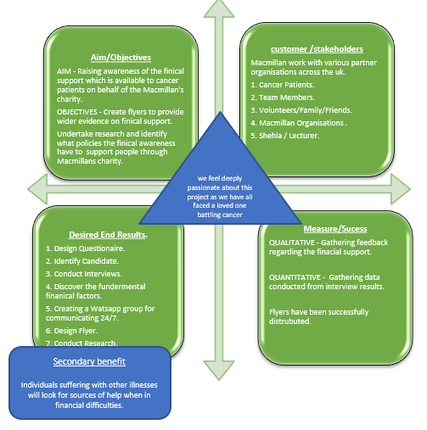
Within in this project, a Quad Chart analysis was applied to find out the advantages, limitations, and desired results.
The team created a Quad chart, Keenan (2021) states a quad chart is a valuable and categorised document which offers a clear explanation of the project over four phases, it is a straightforward effective view, to essentially present the important components of the project.
The aim of the project is to raise awareness of the finical support which is available to cancer patients with the help of Macmillan charity. With the objectives being to produce a flyer that offers evidence of financial help available, and to carry out further research and discover what policies and the financial awareness is available to assist individuals via Macmillan’s charity. The desired end results would be to
• Create a Questionnaire.
• Identify Candidate.
• Perform Interviews.
• Uncover the fundamental financial policies.
• Create a WhatsApp group for communicating and dispersing flyer.
• Design Flyer.
• Conduct Research

the measurement of success will be by collecting the feedback regarding the financial support which is qualitative, The Organic Chemistry Tutor (2020) suggests qualitative as description and observation.
Stevens (2020) states that a quantitative process is what is counted and measured. An example from the project would be, by gathering the data conducted from interview results and questionnaires. And from the flyers being successfully distributed via WhatsApp.
As a team everyone felt very passionate about this project as each member has faced a loved one battling cancer, and hope that a secondary benefit from the project would be that anyone suffering from any illness when in any financial difficulties will search for a source of help and assistance and not battle it alone.

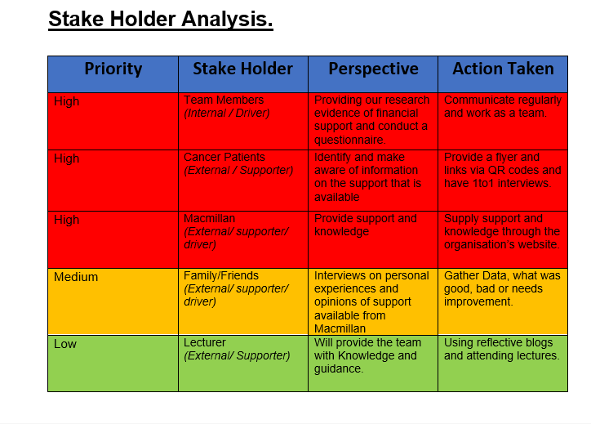
A stakeholder analysis is a project management tool which is used at the beginning of a project, its used to differentiate who are the project stakeholders, the issues that concern them and in how they will be impacted by the project. by creating a stakeholder analysis, it can help the team decide the important persons are and the team must keep communicate with regarding the development and scale of the project, and what they must be kept informed about whilst the project progresses and how often the stakeholder should be contacted. (Hoory,2021)
project stakeholders are defined by teamwork (2022) as People and businesses which are concerned within the project, or those which might benefit positively or negatively from the completion of the project.
The team determined that themselves as a high priority as they would be closely involved in the project. The team would be the drivers and be internal to the project by working closely, regularly communicating between each member, and the project success primarily depending upon the team.
The team also determined cancer patients and Macmillan charity to be of a high priority, and that they were supporters and external to the project, this was decided as the cancer patients were the main aim of the project to help give them the correct information and knowledge of sources of financial help available, and the Macmillan charity was the teams choice of source of financial awareness and to help provide the information and assistance needed to help the cancer patients during their hardships when battling cancer.
Family and friends were used to answer interviews and allow the team to gather information about financial difficulties facing loved ones during their battle with cancer and knowledge of support from Macmillan, the team decided that they were of a medium priority to the project, as if they were unable to take part the team can find another person to volunteer.
Lastly the team decided that the lecturer would be of a low priority to the project, the lecturer would be a supporter and external to the project but would provide the team with knowledge and guidance of how to develop the project.
The stakeholder analysis was useful to the team as it helped to highlight the high priority stakeholders and to know what could be expected from them and what they expected from the team. This tool enabled the team to have improved time management as they did not have to waste time to giving out unnecessary information to stakeholders who did not need it.
Benefits of Stakeholder Analysis are that it can enable the project team leader to clearly see the interests of all stakeholders, and how they will be affected by the project, enables members to be assisted to contribute to various phases of the project, and to identify possible issues which can hinder the project. (Project Management.com, 2022)

Project execution phase 2.3.
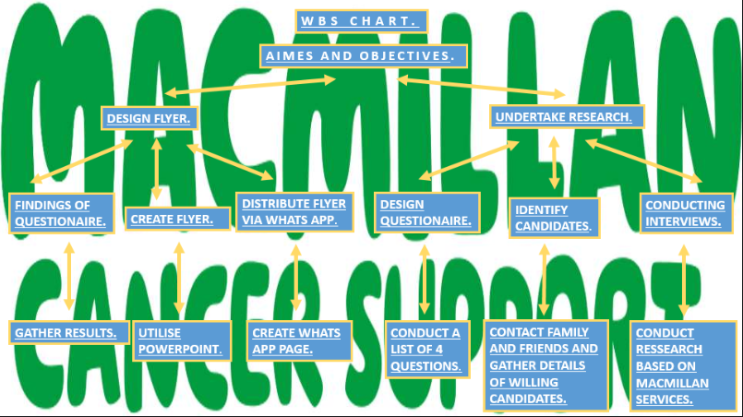

Esther Cohen (2018) says “A Work Breakdown Structure (WBS) is a hierarchical structure of tasks which the project will produce or results that it will provide”.
The WBS structure worked well for the team as it enabled the team to brainstorm suitable methods for the project, the team brainstormed on how to create and produce the questionnaire. The team used a bottom-up approach when making the structure.
The top of the WBS structure is the aim of the team, which was to provide financial information to cancer patients, second layer was the objectives, below are the deliverables next was the actions the team undertook in conjunction with box 3 of the quad chart and finally the last row shows the end results. The deliverables of the WBS chart correspond with the desired results from the quad chart, the desired results were to have a completed questionnaire, Conduct Interviews, and research.
Michael Tupek (2021) states that a benefit of using the WBS structure is that every team member could openly distinguish in what way their own work affects the outcome of the project and how the whole project depends upon the work of each team member. Tupek also believes a disadvantage of using WBS is that the structure operates steps which might promote ‘resentful micromanagement’, and that requirements for a deliverable could be misinterpreted for the task itself.
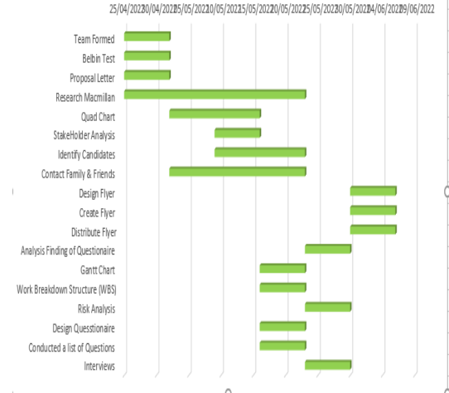
A Gantt chart is a popular form of bar chart that demonstrates a project agenda. (kpvida,2008) this chart worked well for the team as it had a start and end point which worked perfectly as the project only had a 5 week deadline to be completed, the chart allowed the team to envision the project easier and more effectively.
Nicola Gordon-Thaxter (2017) states that a disadvantage of using a Gantt chart is that Projects are not fixed, and Gantt charts are not adaptable, it cannot adapt to such changes, Project managers would have to finish all the estimates before being able to create the chart, each time an estimate changes, then the chart must be redone.
Project closure phase 2.4.

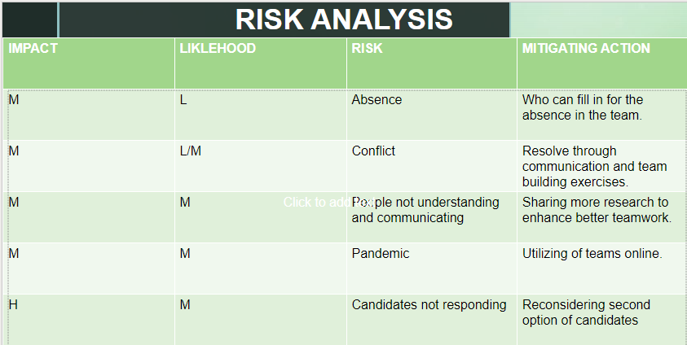

A Risk analysis is a way of uncovering and evaluating potential problems that may negatively impact a project. This analysis is generally done to assist businesses in averting or mitigating the risks. (Rosencrance, 2022)
The team completed a Risk Analysis for the project and have selected a few key issues which was thought to possibly cause problems for the project and have listed them within the chart and indicated if they are of a high, medium or low impact and also the likelihood of the problem happening, lastly the team agreed on what mitigating actions could be taken if faced with such problems.
A PESTLE analysis is a management framework and problem-solving tool. The findings from the analysis are used to support the company to detect problems external to the company which might influence and effect the businesses choices. (CIPD,2021) this tool enabled the team to decide on the mitigating actions that could be taken if such problems happened such as if covid 19 was to stop the team meeting in university they could turn to technology and use Microsoft teams to continue communicating with each other and progressing with the project. This was thought to be of a medium impact as the team all had access to computers and a medium likelihood of happening as the restrictions of covid 19 had just been lifted in Wales.
When looking back at the Gantt chart the team encountered a problem during the first week which was identified as a risk were team members were absent from the university and this caused a delay in conducting and creating a quad chart this then caused the team to have to meet in university on another date and complete the task a week later than planned.
A disadvantage of using risk analysis is that it can become time-consuming and could cause delays to the project timetable, an advantage is that it is a structured method which is simple to duplicate across other projects. (TenSix,2021)
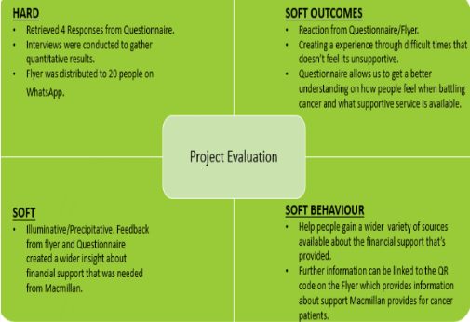
During this phase the team undertook an evaluation of the project whilst they continually monitored the project with the aid of the Gantt chart and risk analysis.
Monitoring and evaluation are equally tools and tactics which support a project to identify when ideas might not be working, and if situations have been altered, it provides the project leader the knowledge they require to develop decisions on the project, and about the adjustments which are required for a strategy or plan. (IEdunote,2022)
The team determined the hard and soft outcomes of the evaluation these were clearly connected to box 4 of the projects Quad chart, the ‘measures of success’. A hard outcome that was determined was that the flyer was circulated to 20 individuals via WhatsApp, this connects to the measure of success to distribute flyers successfully.
An illuminative and soft outcome was the feedback which was gathered from individuals after conducting the questionnaire and dispersing the flyer, it gave more insight to people of the financial support which is available to cancer patients.

This is the team’s final flyer which was created from the research and information gathered to create awareness of the financial support available from Macmillan.

Conclusion and Recommendations.

As a conclusion to the finding of this report in regards to the project, the tools used to assist in achieving the end goal, maximised the teams efforts and allowed the team to have a clearer vision of how to complete the project with a step to step guide, it allowed members to have a direct vision of tasks which needed to be done to reach certain outcomes this was seen by using the WBS structure, the quad chart simply mapped out each section so team members could look back and check they have reached each section, the Gantt chart helped the team to keep to the time frame of the project.
Recommendation for the project would be to develop better time management skills and communication skills as when faced with a very confident group some ideas may go unnoticed or unheard, this could be handles better by each task having a defined leader who would actively listen to each member.

Reference List.
Ahmed, S. (2022) Project Life Cycle: Definition, and Discussion of 4 Phases. Available at: https://www.linkedin.com/pulse/project-life-cycle-definition-discussion-4-phases-shahinur-ahmed. (Accessed on 19th June 2022).
APM. (2022) What is project management? Available at: https://www.apm.org.uk/resources/what-is-project-management/. (Accessed on 22nd June 2022).
Cohen, E. (2018) What is WBS (Work Breakdown Structure) in Project Management? Available at: https://www.workamajig.com/blog/guide-to-work-breakdown-structures-wbs. (Accessed on 27th June 2022).
Gordon-Thaxter, N. (2017) Advantages & Disadvantages of a Gantt Chart. Available at: https://bizfluent.com/info-8045114-advantages-disadvantages-gantt-chart.html. (Accessed on 29th June 2022).
Hoory, L. (2021) What Is A Stakeholder Analysis? Everything You Need To Know. Available at: https://www.forbes.com/advisor/business/what-is-stakeholder-analysis/#:~:text=A%20stakeholder%20analysis%20is%20a%20project%20management%20tool,how%20they%20will%20be%20impacted%20by%20the%20project. (Accessed on 18th March 2022).
IEdunote. (2022) Monitoring and Evaluation: Definition, Process, Objectives, Differences. Available at: https://www.iedunote.com/monitoring-and-evaluation. (Accessed on 10th June 2022).
Indeed. (2022) The 9 Belbin Team Roles (With Examples and Definitions). Available at: https://uk.indeed.com/career-advice/career-development/belbin-team-roles. (Accessed on 9th June 2022).
Juneja,P. (2021) what is a project? Available at: https://www.managementstudyguide.com/what-is-project.htm. (Accessed on 14th June 2022).
Keenan, R. (2021) A Brief Intro to Quad(rant) Charts. Available at: https://positioninginsights.com.au/quad-charts/. (Accessed on 13th May 2022).
Kpvida.(2008) what is a gantt chart. Available at: https://kpvida.wordpress.com/tag/work-breakdown-structure/. (Accessed on 29th June 2022).
Miller, D. (2022) What is Project Life Cycle and What Are its Phases. Available at: https://www.proprofsproject.com/blog/project-life-cycle-and-its-phases/. (Accessed on 23rd June 2022).
Mind Tools (2022). Belbin's Team Roles. Available at: https://www.mindtools.com/pages/article/newLDR_83.htm. (Accessed on 9th June 2022).
Naybour, P. (2020) Explain 5 Benefits of a Project Lifecycle. Available at: https://www.parallelprojecttraining.com/blog/explain-5-benefits-of-a-lifecycle/#:~:text=Five%20Benefits%20of%20a%20Project%20lifecycle%20are%3A%20It,enables%20progress%20to%20be%20tracked%20across%20the%20organisation. (Accessed on 22nd June 2022).
Pressbooks. (2021) the project life cycle. Available at: https://opentextbc.ca/projectmanagement/chapter/chapter-3-the-project-life-cycle-phases-project-management/#:~:text=The%20Project%20Life%20Cycle%20%28Phases%29%201%20Initiation%20Phase.,Implementation%20%28Execution%29%20Phase.%20...%204%20Closing%20Phase.%20. (Accessed on 26th June 2022).
Project Management.com. (2022) What Is Stakeholder Analysis? Available at: https://project-management.com/what-is-stakeholder-analysis/. (Accessed on 29th June 2022).
Rosencrance, L. (2022) what is risk analysis. Available at: https://www.techtarget.com/searchsecurity/definition/risk-analysis. (Accessed on 3rd June 2022).
Stevens, E. (2020) What Is Quantitative Data? Available at: https://careerfoundry.com/en/blog/data-analytics/what-is-quantitative-data/#what-is-quantitative-data. (Accessed 19th June 2021).
Teamwork. (2022) What is a project stakeholder? Available at: https://www.teamwork.com/project-management-guide/project-stakeholders/. (Accessed on 18th March 2022).
TenSix. (2021) Common Risk Assessment Techniques – The Pros and Cons. Available at: https://tensix.com/the-pros-cons-of-common-risk-assessment-techniques/#:~:text=The%20disadvantages%20of%20inspection%20and%20audit%20for%20risk,project%20where%20the%20product%20hasn%E2%80%99t%20yet%20been%20created. (Accessed on 30th June 2022).
Tupek, M. (2021) Work Breakdown Structure Pros And Cons. Available at: https://scionanalytics.com/work-breakdown-structure-pros-and-cons/. (Accessed on 29th June 2022).
Wadic. (2020) PROJECT LIFE CYCLE MODELS & THEIR ADVANTAGES AND DISADVANTAGES. Available at: https://wadic.net/project-life-cycle-models-their-advantages-and-disadvantages/. (Accessed on 26th June 2022).

