

University of Wales Trinity Saint David
School of Engineering

Engineering Design & Materials

Harrison Boakes
1805555

Motorsport HND

28/02/2020

M4X02194

Contents

Introduction (page 3)
Research (page 4)
Design specification (page 5)
OFD (page 6)
Final design (page 7)
Sump drawing (page 8)
References (page 9)

Introduction

The main aim of the assignment is to design a dry sump for the Ford Zetec engine as the engine will then be used in a race application. There are certain parameters that must be incorporated into the design the primary parameters are low cost, easy access/installation and in the event of a roll over the engine should not be flooded with lubricant. This assignment will highlight exactly how a design project should be carried out, following all the appropriate steps. Furthermore, the assignment will have a brief background research into existing products and manufacturing techniques that potentially could be implemented into a design.

Research
Defining what a dry sump is
A dry sump is referred to as “dry” as it is not the main container for the engine lubrication oil. The oil is stored separately elsewhere, the sump is constantly scavenged for oil via the oil pump. The dry sump resides beneath the crank. The typical application for a dry sump can be found in most forms of racing as it offers superior performance. Dry sumps are becoming more prevalent in automotive engineering as the allowing manufacturers more room to design better engine systems.

Existing product
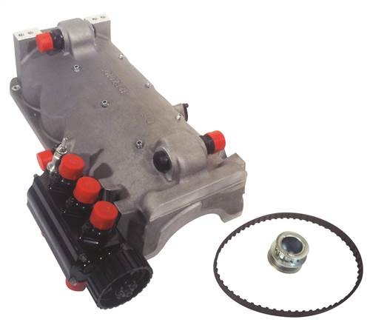
There are some aftermarket dry sumps available for the ford zetec engine. The main competitive product is produced by burton power and is a solid product offering good performance and a simple yet effective design. The sump is made from smooth cast aluminium and comes with the pump and pulley. The price of this product is approximately £1650.00. which is competitive in contrast to existing products. This sumps design is also simple and effective as it can be easily fitted using the existing bolt pattern meaning there is no need for extra bolts to secure the sump. The disavantages of this product is the scavenger fittings as there placement could be prone to impact especialy when under race senarios.
Figure 1: Burton power dry sump

Manfacturing methods
The main method used for manufacturing dry sumps is casting. Casting is commonly used as it is reasonably inexpensive and allows manufacturers to use an aluminium alloy that best suits the needs of the sump. The alloy mixture plays a crucial part in the casting as the mixture will need to be carefully chosen for its properties to ensure the sump has good strength, sealing abilities and is accurately cast. The disadvantage of casting is the that is does not offer the same accuracy as machining as there is often higher tolerances in in the casting process than in the milling process.
Design specifications

Weight saving will be ultimately determined by which material is used and how much of the material is used. Aluminium is a suitable material and is ideal for the dry sump as it has good strength to weight ratio. There are many grades of aluminium so these will need to be investigated to find the best grade for the sump. An ideal grade would be 2011 alloy as it provides excellent strength and is often used for mechanical components. The alloy can also withstand high temperatures, this is crucial as hot oil from the engine will constantly be flowing through the sump.
Ease of install is something that needs to be looked at closely when redesigning the sump. A simply yet effective way to aid with install is to use the pre-existing bolt pattern as will remove the need for an adapter of any kind thus saving weight and reducing the complexity of the install. Other design specifications will be included in ease of installation one of these being the weight of the sump. Ergonomics of the sump will need to consider as they will aid in installation.
Stopping the engine from flooding in an event of a rollover is vital. The engine flooding could potentially cause irreversible damage to components. There are a variety of methods used to prevent engine flooding the main one being using a splash guard located in the dry sump. The guard will help in reducing the oil turbulence as it flows through the sump and retain the majority of the oil in the event of a role over.
The costing of the product is majorly important as the product ideally needs to beat other manufacturers products. The price point needs to ensure that a healthy profit margin is attainable and is competitive with pre-existing products. The price must cover the capital cost to ensure all research and development costs are covered whilst still maintaining a heathy profit margin.
Quick and direct access to the engine sump is vital especially in a race application where dry sumps are normally found. The sump should be easily accessible and require little to maintenance once fixed. All components leading into and out of the sump should be fixed is appropriate places to allow for easy servicing/maintenance. These areas will need to have free space to allow appropriate tools and other devices to conduct any maintenance that might be required.

QFD

Final design
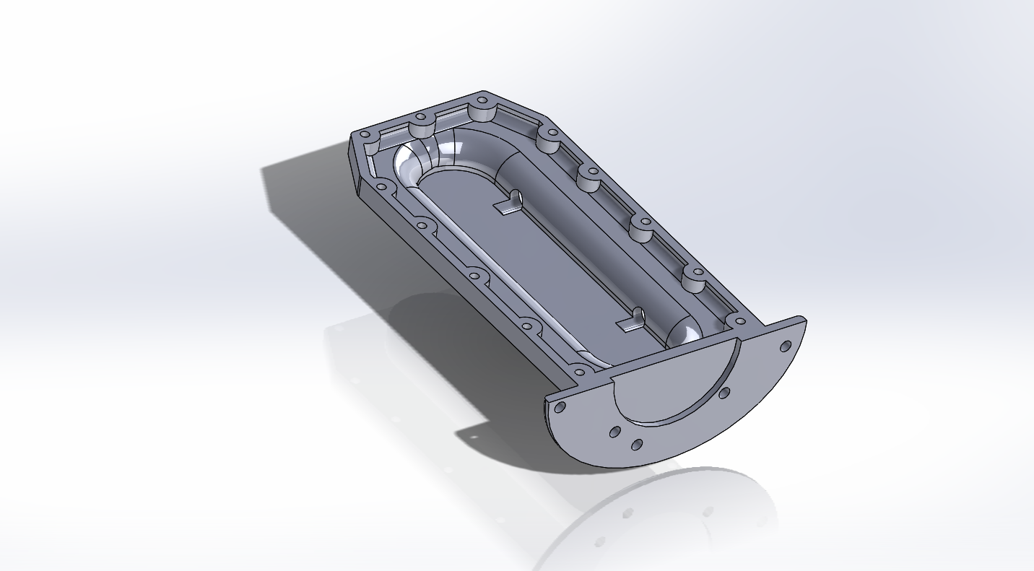

The final design is simple yet effective. The sump will be made via casting protest. In order to achieve an accurate casting, the design utilises champers to allow the molten aluminium to flow and conform to the mould.
The design uses the champers to aid lubrication flow to the scavenging pump pick up located in the bottom of the pan. The bolt pattern matches that of the factory pattern to ensure easy installation. The design caters for the crank shaft and timing belts and pulleys. The holes located on the face of the sump allow direct and easy access to the timing belts and pulleys.
Overall the sump is ideal for its ease of installation cheap but effective production and should be capable of outperforming existing products.

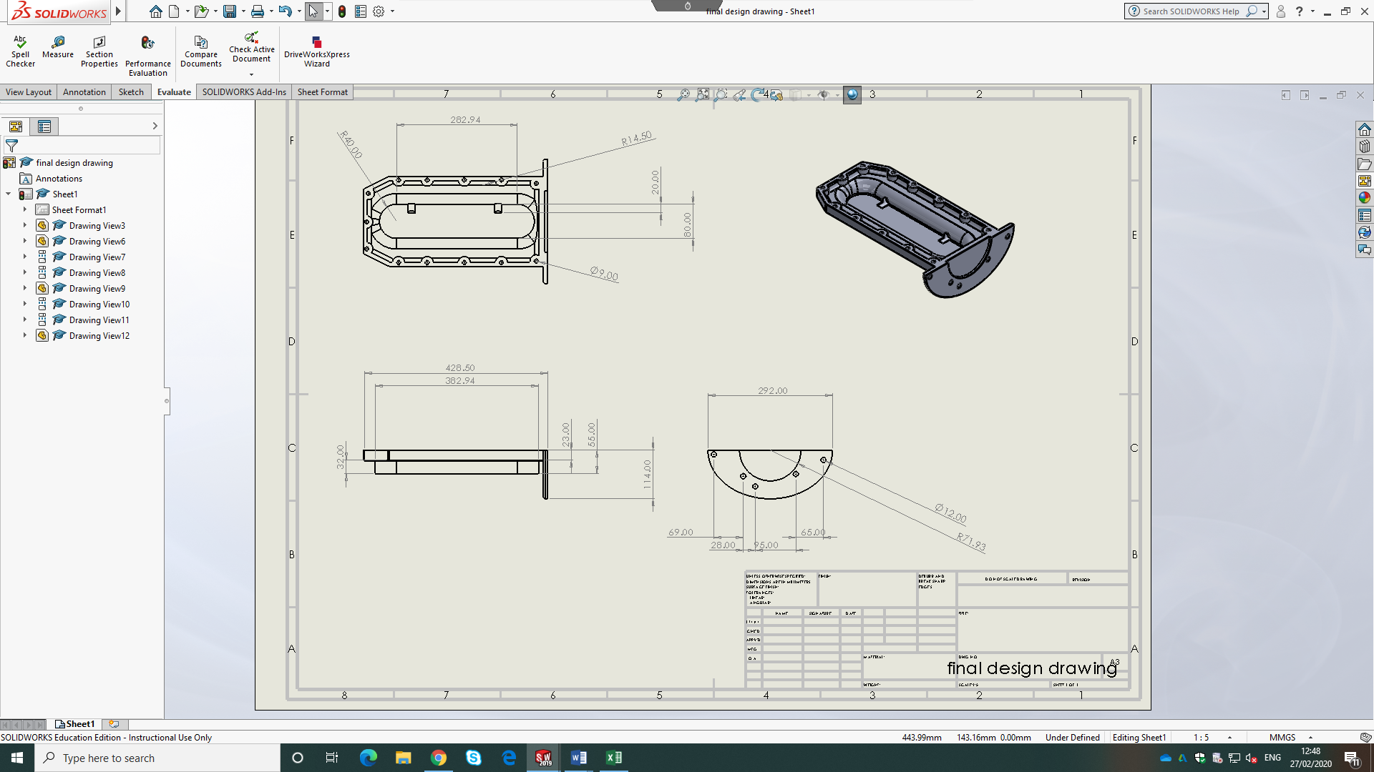

References

Figure 1: Burton power dry sump https://www.burtonpower.com/opi-dry-sump-oil-pump-kit-ford-zetec-e-fwd-rwd-opidsk4.html

Bosh Automotive Handbook, 5th edition (2005) USA Massachusetts: Bentley publishers

