Sharing on Social Media

Let’s learn how to share things in our app on Facebook and Twitter.

We will make our table rows look like this:

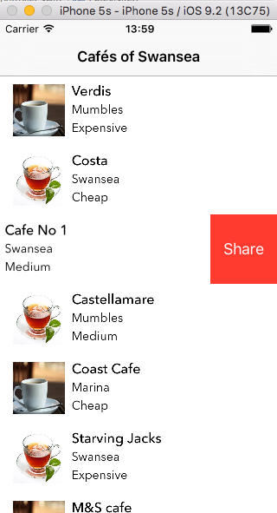

We will add a button to our table rows in order to do this.

In CafeTableViewController.swift add the following function:

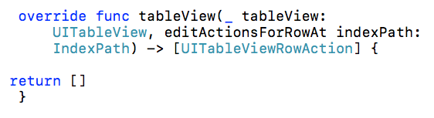

Add the following to the function. Note: UIActivityViewController is a standard built-in controller for social sharing.

First we will add the handler code:

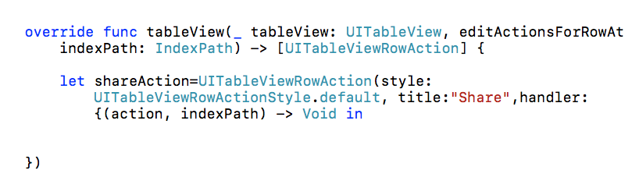

Next we will add the information we want to share to some variables texttoshare and imagetoshare: (We'll get these from our array)

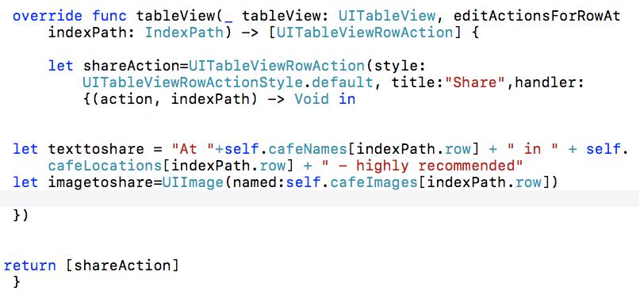

Finally, we add the button to the table row (Note: self.present = the present View Controller ie the Table View Controller)

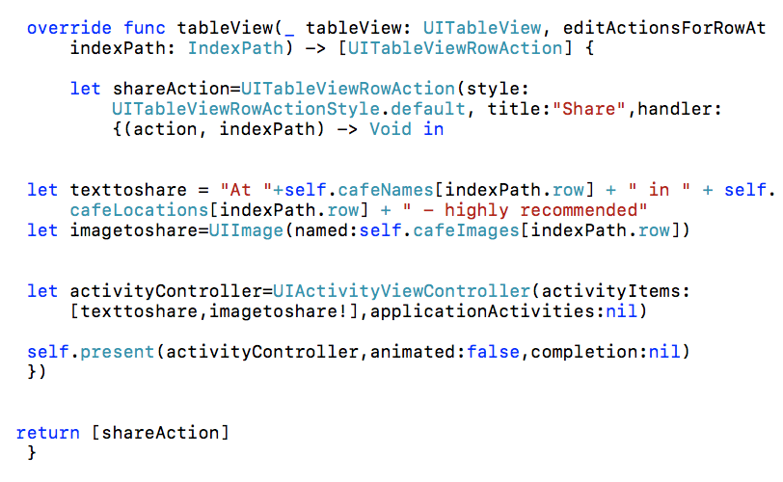

This will give us a button which allows us to Share on social media: (when we swipe left)
(Note: due to our previous segue, you may need to long press and swipe left)

Press the Share button on a row, and you will get a menu:

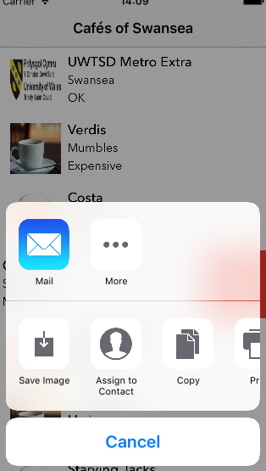

At the moment, Facebook and Twitter cannot be seen on this menu

We need to turn on the Facebook and Twitter in the settings of the iPhone simulator and sign in to our accounts:

To get to the Settings, in the Simulator go to Hardware -> Home and press on Settings

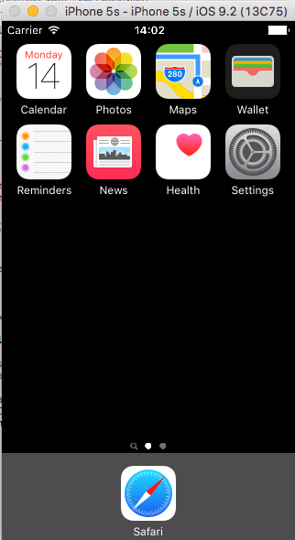
Scroll down in Settings to find Twitter and Facebook:

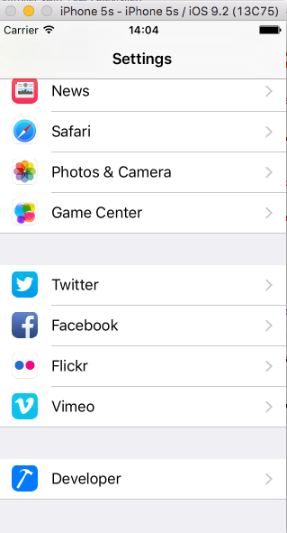

Sign in to Twitter and Facebook:

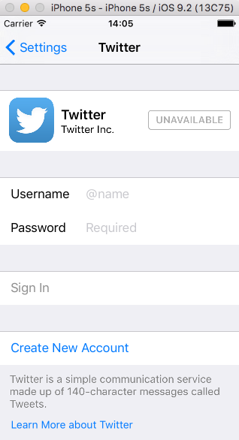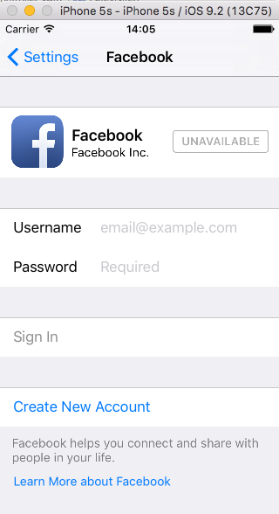

Now when we run our app and click on the Share button, we see Facebook and Twitter in the list:

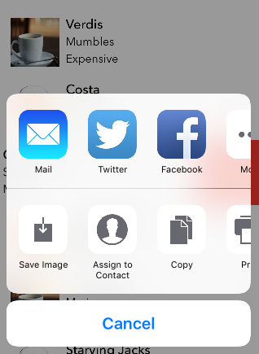

Twitter

If we select Twitter we get the following:

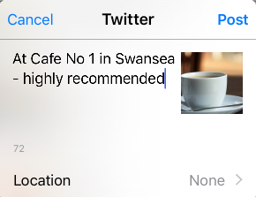

Click "Post" and check the actual Twitter feed:



Facebook

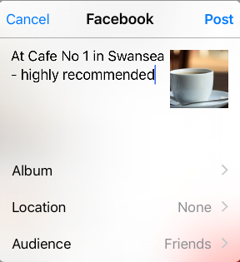

Click "Post" and check your Facebook timeline:



Changing the default colour of the button

The button can be edited as follows:

shareAction.backgroundColor=UIColor(red:28.0/255.0, green: 165.0/255.0, blue: 253.0/255.0, alpha: 1.0)

(Place this just before the return[shareAction])

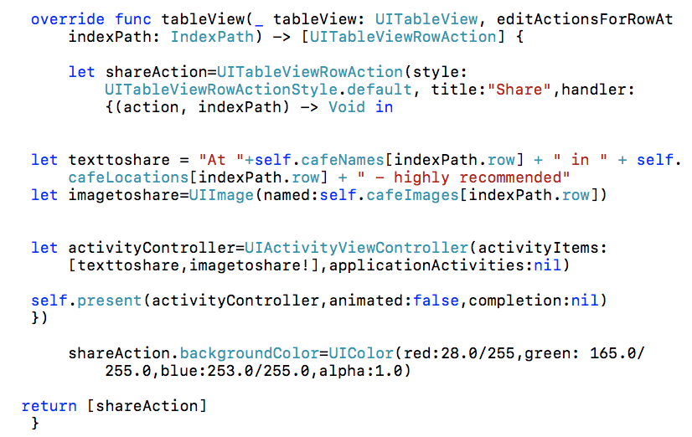

As you can see, the button has changed to blue:

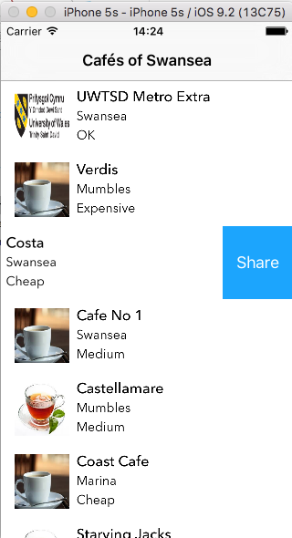
Sharing from a button

If we want to share from our detailed view page, we have to do things a slightly different way (as it is not arranged in a table)

Let’s use a normal button and add it on Main.storyboard: (Detail View Controller)

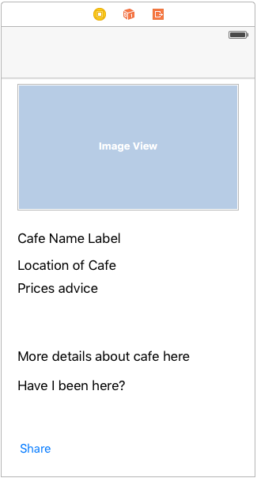

(Use the Attributes Inspector ( ) to change the background colour if required)

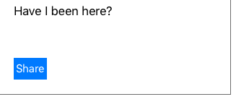

Add the button as an Action on DetailedViewController.swift by click and drag:

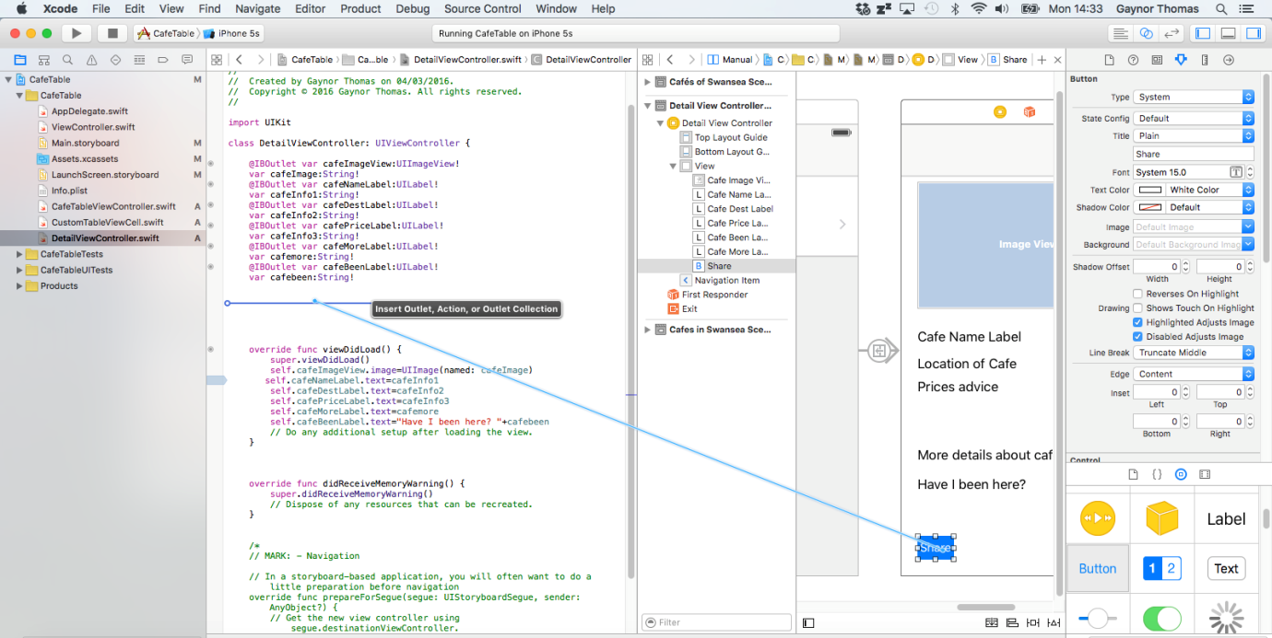

Make sure “action” is selected and give it a name (I’ve called mine “mybutton”)

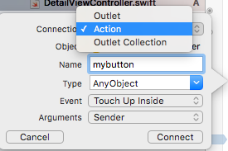

This will create an empty function similar to the following:

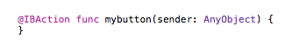

Let’s add some sharing information to it: (remember UIActivityViewController is what allows sharing)

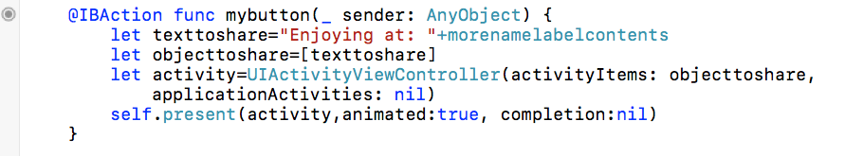

Now we can also share from the Detailed View page by using our new button:



