

Engineering Design Project: Robot arm end gripper

Lecturer: Richard Morgan

Aryan Adibmehr 1802462
BEng Mechanical Engineering

Introduction

This report outlines the design for a robot arm gripper to be used on the end of a Festo UR3 robot for handling mobile phones during their manufacturing process. It is required that the robot gripper be able to be manufactured in high numbers, and also stand up to production use. The aspects that affected the design choices, and the pros and cons of these choices are discussed. The design of the robot gripper is a result of decisions which both affect the production of the parts, and also assembly of the gripper. Many of the design decisions have downsides in one respect as well as benefits. The CAD model of the gripper is used to aid the discussion and help explain some of the design points.

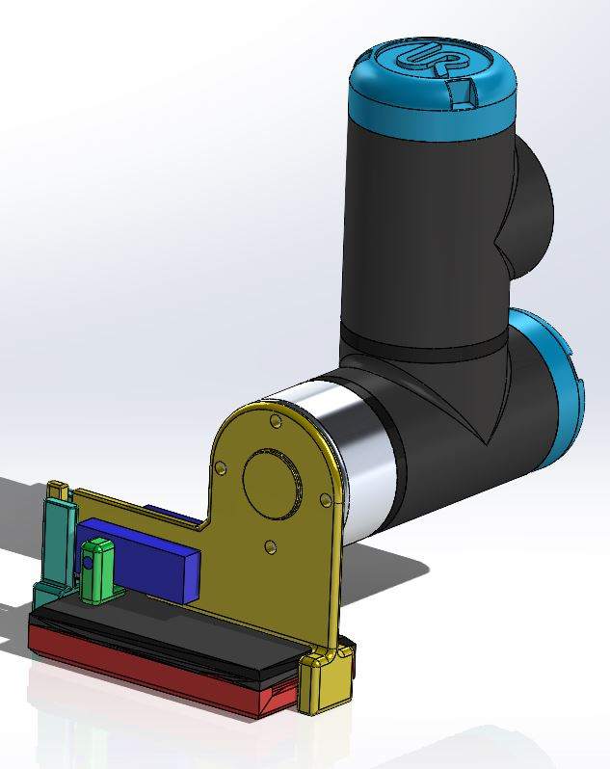
Figure 1. The complete robot gripper shown attached to the end of the Festo robot arm, including the mobile phone that it handles.
Due to the high volume manufacturability requirement of the design, it was decided to use injection moulding as the manufacturing method, and the design was driven by this from the very beginning.
In addition to design for manufacture attention was paid to design for assembly, and in many cases the factors that affect one affected the other, for example the total number of parts making up the gripper assembly, and also the number of distinct parts.

Initially, many different designs were considered, all with the desire to reduce the number of parts as much as possible, reduce the number of specialised/custom made parts (as opposed to standard components such as fasteners, stock dimensions, etc.), and the pros and cons of each concept were weighed against each other to decide on the final design. The final design is not the best in every aspect, such as minimum number of parts, minimum number of specially made parts, and ease of assembly, but it is believed to be a good balance between being easy to assemble with relatively few parts, but also including some fasteners mainly to keep the complexity of the injection moulded parts to a minimum.

The decision to use injection moulded parts was very important as it affected every aspect of design from the beginning. This is because injection moulding restricts the design in many ways because of the need for the parts to be able to eject from the dies during the process.
At the same time, injection moulding allows for quite complex geometry to be put into the part at virtually no expense per part, which would not be the case for machining for example, as every feature must be created on every part which adds time and expense. As a result of this, the design takes advantage of injection moulding and tries to incorporate as many functional features into any single injection moulded part as possible, eliminating the need for any machining operations such as drilling and tapping etc.
The decision to eliminate certain features as built into the components during manufacturing can on the other hand add steps to the assembly stage and was thought about when designing the robot gripper.

The basis for the design of the gripper was to try to use one of the components (yellow part, fig.1) as a ‘’chassis’’ for the entire assembly, and to try to build as many features into this single component as possible, to try to reduce the number of parts and/or fasteners.
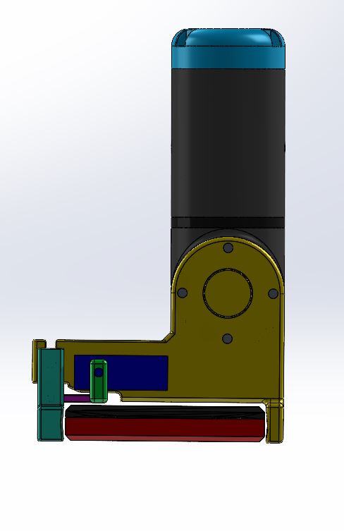

Figure 2. Side view of the robot gripper showing how it fits around the mobile phone. The ‘’stationary jaw’’ (yellow) acts as a chassis for the rest of the components.
When considering the basic design, the first thought was to have 2 identical gripper ‘’jaws’’, mounted to a support structure which would also carry the actuating mechanism. With design for manufacture and design for assembly in mind, it was decided to incorporate one of the jaws into the ‘’support structure’’, which eliminated one part by itself. This is similar to a vice, with one stationary jaw and one movable jaw (see fig. 2). The same concept was carried further to include as many functions as possible within this single component. The mounting interface which attaches to the robot arm was the next function to be integrated into this stationary jaw. The Direction of the minting face was originally vertical, but this would not permit including the 4 holes in the injection moulding process, as the part would be ‘’die-locked’’ (Tadin, J. 2018) and not able to eject from the injection moulding die. This face was changed to be horizontal and in-plane with the rest of the stationary jaw, which simplified the injection mould design.
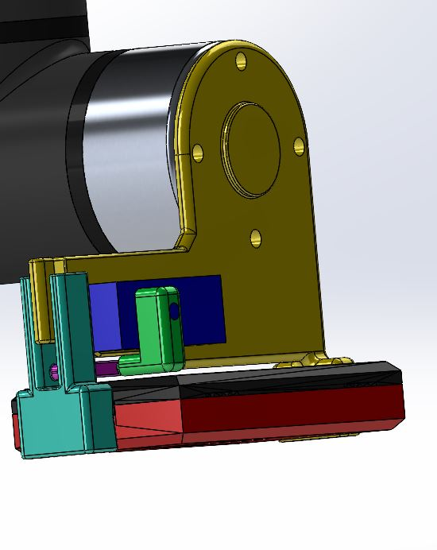
Figure 3. The movable jaw and actuating mechanism shown. The green part is a lever which is actuated by a servo motor (blue) to move the jaw.
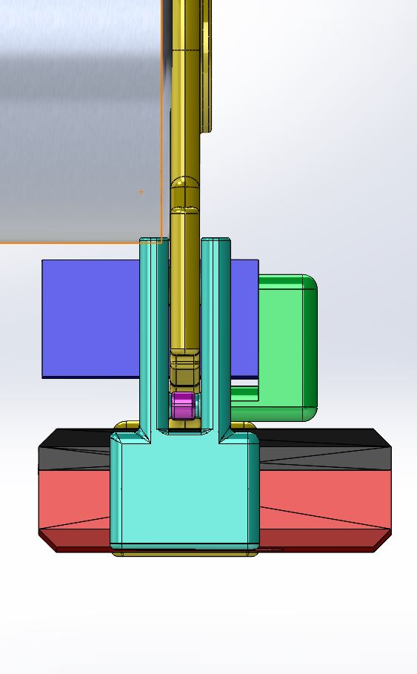

[Grab your reader’s attention with a great quote from the document or use this space to emphasize a key point. To place this text box anywhere on the page, just drag it.]

Figure 4. End view of the movable jaw. The jaw attachment is symmetrical, with the stationary jaw in the centre. This reduces the bending load on the pivot and makes for smoother motion
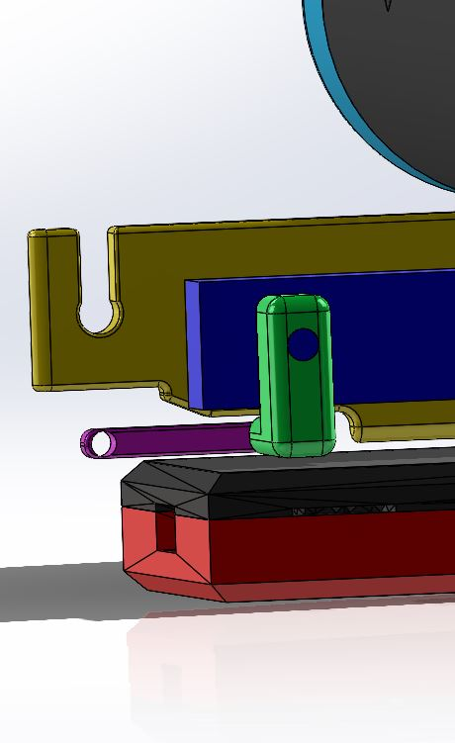

Figure 5. View of the movable jaw fulcrum point with the jaw hidden. An open slot which is 0.5mm smaller than the pivot pin is used to be able to integrate the pin into the movable jaw and reduce parts and assembly time. The slot is slightly sprung during assembly and the pin is captured in the lower section. The loads are horizontal due to the small range of motion of the jaw, so the pin is retained well and cannot slip out in use.

The purple component seen in Figure 5 represents a tension spring, which would limit the force applied to the movable jaw within the short travel of a few mm. This elasticity in the clamping path allows the servo motor to operate within a much wider range of motion without overloading, and reduces the need for extremely precise motion to stay within the specification of the servo motor. An example servo motor which could be used which is modelled for scale, is the Hitec 422 (see references). It can generate a torque of 4.1 kg.cm, which when acting on the 15mm torque arm (green part, fig.5) can apply a force of 2.7 kgf to the spring. This force is equally shared between the point of application at the jaw and the fulcrum point. With roughly 1 kgf can be consistently applied at the jaws. This clamping force together with the 5 degree v shaped jaws ( fig.6) is more than enough to pick up the mobile phone.

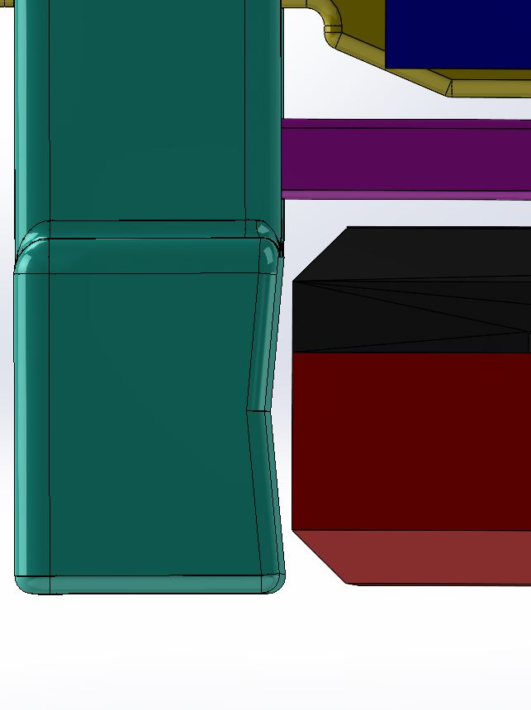
Figure 6. View showing the 5 degree angled jaws. This will help to encapsulate the phone. Any slippage will tend to spring the jaws further and increase the friction.
Three Injection moulded parts make up the robot gripper, with the rest being standard fasteners which mount the servo motor to the stationary jaw, and the lever arm spring pivot.
ABS can be used for the injection moulded parts as it is strong enough to withstand the small loads, and is a commonly available injection moulding plastic (Melito, S. 2018).

Refferences

Tadin, J. (2018) The 10 commandments of injection moulding (East West Manufacturing) Available at: https://www.youtube.com/watch?v=HVNAD14ja9o

Hitec 422 servo motor specifications. Available at: https://www.robotshop.com/media/files/pdf/hs422-31422s.pdf

Melito, S. (2021) The 10 most common plastic injection moulding materials. Available at: https://www.fictiv.com/articles/the-ten-most-common-plastic-injection-molding-materials

