

Student Name: Penka Ruseva

Student ID number:2029255

Programme of Study: BA Business Management

Module: Management economics

Module code: LCBB5003

Module: Vasilios Tavlaridis

Assignment Title: Assessment Component 2: Essay

An Essay on “Following the death of the Her Majesty Queen Elizabeth II, discussing the impact of the UK economy (trade, inflation, tourism, employment and growth) for the next 12 months and the effect on decision of large and small organizations using appropriate economic analysis”

Introduction

The death of Her Majesty Queen Elizabeth II may affect the UK economy and management decisions of small and large businesses. This essay will mainly highlight such influencers through economic analysis which will help students gain knowledge about Management Economics (Keller, 2015). The death of Queen Elizabeth II took place on 8 September 2022, which plunged the world, including the United Kingdom, into a sea of ​​mourning. Ten-day national holiday is granted to mourn the Queen's death and funeral arrangements, which could have a knock-on effect on the UK economy. Moreover, the UK economy is further weakened by the risk of inflation, the risk of strikes, the risk of recession, and a decline in styling. In short, the death of Queen Elizabeth will have an adverse effect on the UK economy, affecting all sectors of the UK economy such as trade inflation, growth, employment, tourism, etc. within 12 months it could throw the UK into an economic crisis and change the way UK businesses, small and large, manage their organization.
This article will briefly discuss its implications for decision-making in large and small organizations in the UK. Economic analysis through economic management will be used as an element of the discussion. Managerial economics is mentioned in the given report, so first of all it is necessary to gain an understanding of it. Managerial economics is a science that mainly deals with ensuring the efficient use of scarce resources in a country. Managerial Economics generally helps students to develop analytical skills. However, in one case, students should have a sound understanding of microeconomics and macroeconomics (Notteboom et al. 2021). The module also mentions the use of an appropriate economic analysis, which can be seen by understanding that there are two general overall methods used in economic analysis, the discounted value analysis, and the inductive analysis method. Some of the other analytical methods used are financial impact analysis, cost-benefit analysis, cost-effectiveness analysis, and cost analysis. The problems were identified and solved using economic impact analysis for the economic analysis of the article.

Discussing the impact of the UK economy (trade, inflation, tourism, employment and growth) for the next 12 months and the effect on decision of large and small organisations using appropriate economic analysis

The impact on the UK tourism

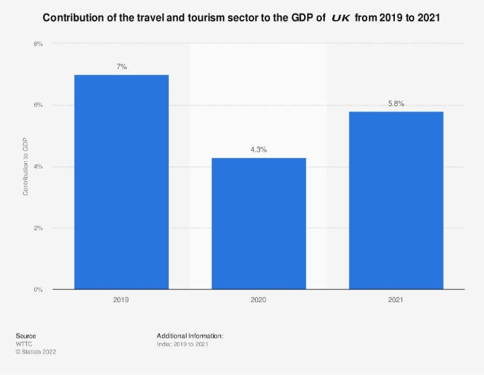
The death of Her Majesty Queen Elizabeth II had both positive and negative effects on the tourism sector of the UK economy. As the world, including the UK, mourns his death, its tourism sector has contracted and expanded (Murphy et al. 2022). All kinds of business events and functions are closed on the occasion of the Queen's death and funeral, which is declared as a holiday in the state. This has had a negative impact on the UK tourism sector. Naturally, the UK's travel, hotel, and tourism sector have been forced to contract after major holiday announcements as the world is currently in an economic recession. On the other hand, guests from different parts of the world have arrived to participate in the funeral of the Queen of the United Kingdom. They depend on the UK tourism sector for their livelihood and security (Raad et al. 2022). Luxury hotels and motels are a major part of UK tourism, preferred by invited and visiting guests. Foreign nationals paying tribute to deceased women and contributing to a piece of history have indirectly positively influenced UK tourism. By looking at figure 1, it can easily understand the situation of tourism from 2019 to 2021. Especially when analyzing the data for 2020 and 2021, it can be seen that the situation has increased slightly from 2020 to 2021. It is believed that 27% of the economic loss incurred in the tourism sector for the queen's funeral will be recovered from here. There is also an allocation of £2.3 million by the Department of Culture, Sport and Media, which is said to be part of the tourism sector.
Figure 1: Tourism Sector Position in UK in 2019 to 2021

The impact on the UK trade
The death and final act of Queen Elizabeth II could have a significant impact on the UK business economy. Businesses in the United States need to be aware and sensitive to customers' feelings during times of bereavement. Businesses across the UK are panicking (Mix, 2021). Its effects can last long after the queen's death. Businesses are quite concerned whether the impact is long-term or short-term. A new monarch would threaten UK trade with additional charges or tariffs. The Queen's death is likely to result in reduced prices, changes to the Royal Warrant, and changes to the postal service. A designated holiday has been announced for the Queen's death and funeral, which may have an economic impact. As a result of payment of holidays, transactions in banking institutions are stopped and the business may face loss of business. This may affect consumer purchases due to financial volatility and uncertainty (Elizabeth II, 2022). Some businesses have created special product ideas for funerals. They manipulate customer perceptions and create new product ideas that impact business growth. The arrival of a new king is likely to see a decline in trade in the business over the coming year to stump the coin. It is estimated that business will be disrupted by 2% this year compared to the previous year.

The impact on the UK Inflation
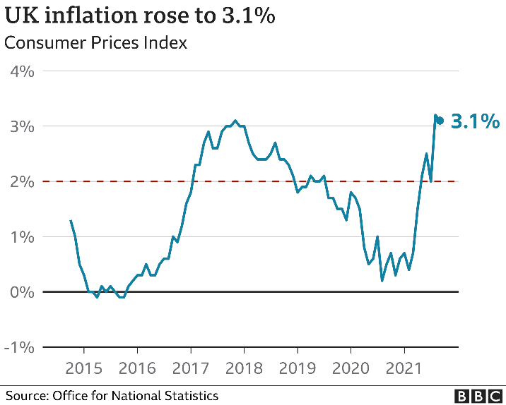
Inflation is not uncommon in the UK today. The Queen's death has led to sweeping action plans in the UK that could have a knock-on effect on its economy (Lucas, 2022). On the other hand, the death of the queen delayed the implementation of a fatal economic plan. This was originally announced by the Bank of England in early 2022. Here it is assumed that the value of the currency may decrease for more than one year. As a result of this, the purchasing power of the consumer may decrease and the price of the product may increase at a proportional rate. The monetary policy committee is meeting to deal with such inflation. They are looking for new ways and methods to deal with it.
Figure 2: The position of inflation in 2020 and 2021
Figure 2 shows the rate of inflation from 2015 to 2021. Here it can be seen that the rate of inflation increased by 3.1% in 2021 compared to 2020. Furthermore, the average price of UK goods may start to rise and the value of money to depreciate (McCabe, 2022). Such price increases are usually expressed as a percentage. Inflation means that a unit of currency is used less efficiently in the market at a given time than in the previous period. However, sometimes monetary policy can be anti-inflationary, causing commodity prices to fall and purchasing power to increase. Such inflation after the Queen's death could collapse the UK economy. It is estimated that the standard of living of the people of the country will decrease by 2.3 %, if inflation occurs. Business, commerce and other sectors also changed dramatically.

The impact on the UK economic growth
Economic growth is very important in every country. Lack of economic growth in a country like the UK is seen as a negative. UK economists see negative economic growth likely in the 12 months following Queen Elizabeth II's death (Coscieme et al. 2019). British households are currently facing rising fuel costs that are disrupting business and other economic activities. British Prime Minister is not able to control the fuel consumption even after adopting and developing various plans. The British economy is therefore likely to experience a severe downward trend in growth. British gross domestic product fell further this month than in July. It is likely to further decline in the next 12 months. It is estimated that the gross domestic product may decline by 0.25% compared to the previous year. This is not only a growing recession but also a threat to the UK economy. Moreover, the Queen's death and extra holidays for funerals have disrupted the country's production, which is having an impact on the economy (Madsen et al. 2017). A preliminary report by National Statistics showed that the country's GDP fell by 0.6% in September and grew by 0.2% in October, which is believed to have put the UK economy at risk of a worse than normal period. Above all, the Queen's funeral and other holidays may affect the UK economy negatively.

The impact on the UK employment
The UK is considered to have more employment opportunities globally. The country's economic condition and upward growth is cited as one of the main reasons behind this (Assa, 2016). The country has a lot of employment opportunities from the manufacturing sector to the tourism sector. But, an economic downturn can break such employment continuity. However, the Queen's funeral has created many additional temporary employment opportunities. According to Mirabaud Brokerage, more jobs have been created in the tourism sector in the UK this year than in previous years. Because of the 20 billion euros generated from the tourism sector, 600 million come from the tourism sector. Moreover, additional employment was created to provide quick service to foreigners arriving for the Queen's funeral. Souvenir sales increased by 60-65 million pounds which used many additional staff to manage (Jones, 2016). Business on the London Stock Exchange was also steady this year which could play a role in the creation of new jobs in the UK. But the holiday declared for the Queen's funeral interrupted the continuity of its work. The current economic downturn may curtail operations on the London Stock Exchange. It is expected that its activities may decline significantly in the next 12 months, which, above all, may affect employment here.
The way business is done is constantly changing. So its functions have to be upgraded with time. The success and failure of a business depends on the decisions it makes. Making business decisions is a complex matter. Decisions have to be taken considering the situation and other circumstances. In the current situation in the United Kingdom, small and large business organizations have taken various decisions. Many have decided to invent new products from the idea of ​​Queen's death and funeral. They have decided to invent new products by adopting various strategies to keep the Queen's memory alive (Knoke, 2018). On the other hand, some organizations have announced the closure of their organizations to pay respect to the queen. Most small firms have decided to keep their businesses open and large firms have announced closures. Even analysts at investment firm AJ Bell pointed out that this could delay the announcement of an emergency budget, which is perceived as a doomsday message for the UK economy. The Queen's funeral and economic impact forced the country's small and large businesses to make slightly different managerial decisions. At the same time, excess leave disrupts economic activity and adversely affects managerial decisions in small and large business organizations.

Conclusion
Above all it is going to be published as an economic management essay which is written with an analysis of the current economic situation in the UK. The essay deals with the current economic situation in the United Kingdom following the death of Her Majesty Queen Elizabeth II and its impact on the country's economy for the next 12 months. It also discusses how it influences managerial decision-making in British small and large-scale business organisations. The impact on tourism, growth, employment, trade etc. after the Queen's death is analyzed and discussed. So, it can be said that this is a comprehensive economic analysis of the 12 months following the death of Queen Elizabeth II.

Reference
Assa, J., (2016). The Financialization of GDP: Implications for economic theory and policy. Routledge.
Coscieme, L., Sutton, P., Mortensen, L.F., Kubiszewski, I., Costanza, R., Trebeck, K., Pulselli, F.M., Giannetti, B.F. and Fioramonti, L., (2019). Overcoming the myths of mainstream economics to enable a new wellbeing economy. Sustainability, 11(16), p.4374.
Elizabeth II, Q. and Jubilee, P., (2022). WESTENDER. Newsletter of the West End Local History Society.
Jones, H.D., (2016). The cultural and economic implications of UK/European co-production. Transnational Cinemas, 7(1), pp.1-20.
Keller, G., (2015). Statistics for management and economics, abbreviated. Cengage Learning.
Knoke, D., (2018). Changing organizations: Business networks in the new political economy. Routledge.
Lucas, S., (2022). Reality Comes at You Fast and Hard, Liz Truss.
Madsen, J.B. and Murtin, F., (2017). British economic growth since 1270: the role of education. Journal of Economic Growth, 22(3), pp.229-272.
McCabe, S., (2022). In Liz We Trust [ed].
Mix, D.E., (2021). The United Kingdom: Background, Brexit, and Relations with the United States. Congressional Research Service.
Murphy, P., (2022). Queen Elizabeth II and the Commonwealth: Time to Open the Archives. The Journal of Imperial and Commonwealth History, pp.1-8.
Notteboom, T., Pallis, A. and Rodrigue, J.P., (2021). Port economics, management and policy. Routledge.
Raad, J., Sharma, A. and Nicolau, J.L., (2022). Will your majesty marry me? The effect of royal weddings on the tourism industry. Tourism Economics, 28(6), pp.1589-1604.

