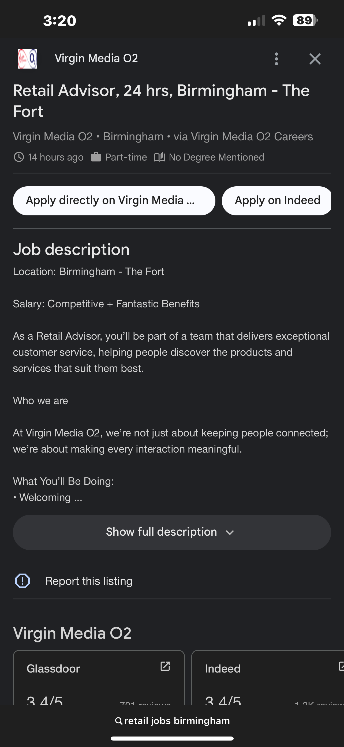
https://jobs.virginmediao2.co.uk/en_US/careersmarketplace/JobDetail/Retail-Advisor-24-hrs-Birmingham-The-Fort/33247?utm_campaign=google_jobs_apply&utm_source=google_jobs_apply&utm_medium=organic

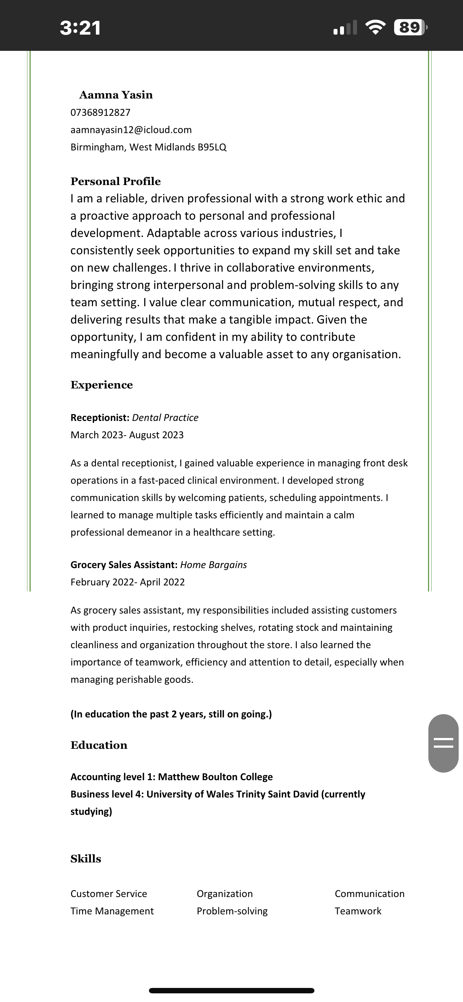
Aamna Yasin
20/10/25

Virgin Media O2
Dear Hiring Manager,
I’m excited to apply for the Retail Advisor position at Virgin Media O2. As someone who enjoys helping people and has a genuine interest in technology, I’m eager to start my career in a customer-focused environment where I can learn, grow, and make a real difference.
Although I’m at the beginning of my retail career, I bring strong communication skills, a positive attitude, and a commitment to delivering great service. In my previous experiences — whether through part-time work, volunteering, or group projects — I’ve developed the ability to listen carefully, work well under pressure, and ensure people feel supported and valued.
What draws me to Virgin Media O2 is your reputation for innovation and putting customers first. I’m enthusiastic about learning how to match customers with the right products and services, and I’m confident that my energy and eagerness to learn will make me a valuable part of your team.
I would love the opportunity to contribute to your store’s success and grow with Virgin Media O2. Thank you for considering my application — I’d be delighted to discuss how I can bring enthusiasm and great service to your team.
Yours sincerely,
Aamna Yasin

