Ewan James Richards (1802187)
University of Wales Trinity St David Database Systems, MSc Software Engineering
Eco Bike Hub Case Study

Abstract
Abstract

Contents
Abstract 1
Table of Figures 2
Task 1: Database Creation 4
Coursework Practical Element 1 4
Data Dictionary 4
ERD Diagram 7
Rationale 8
Task 2: Performance Tuning Enhancement 10
Coursework Practical Element 2 10
File 1 10
File 2 12
Task 3: Report 17
Written Element 1 17
SQL vs. NoSQL 17
Written Element 2 20
Performance Tuning 20
Transaction justification 20
Distributed Database Solution 20
Conclusion 22
References 23

Table of Figures
Figure 1: Store table 4
Figure 2: Staff table 4
Figure 3: Customer table 5
Figure 4: Bike table 5
Figure 5: Parts table 5
Figure 6: Booking table 6
Figure 7: Appointment Types table 6
Figure 8: ERD Diagram 7
Figure 9: Relationships 8
Figure 10: Constraints 9
Figure 11: Create Database 10
Figure 12: Creating the Store/Staff tables 10
Figure 13: Creating the Customer/Bikes/Parts tables 11
Figure 14: Creating the Booking/Appointment Types tables. 11
Figure 15: Test Data: Appointment Types/Bikes/Parts 12
Figure 16: Test Data: Store/Staff tables 12
Figure 17: Test Data: Customer/Booking Tables 13
Figure 18: Booked date constraint 13
Figure 19: Cancelled date/time constraint 13
Figure 20: Customer Date of Birth Constraint 14
Figure 21: Staff Leaving Date Constraint 14
Figure 22: Postcode length constraint 14
Figure 23: Staff bonus range constraint 15
Figure 24: Staff position constraint 15
Figure 25: Discount range constraint 15
Figure 26: Transaction/Commit 16
Figure 27: SQL types 17
Figure 28: SQL Vs. NoSQL 18
Figure 29: Advantages and Disadvantages of SQL and NoSQL 19
Figure 30: Indexes 20

Task 1: Database Creation

Coursework Practical Element 1

Data Dictionary

Store
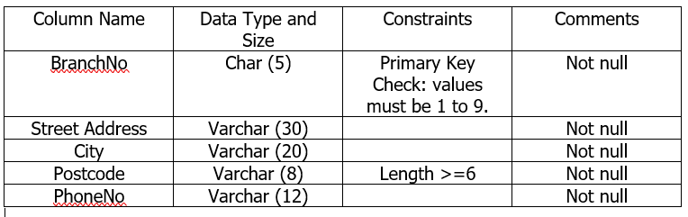
Figure 1: Store table

Staff
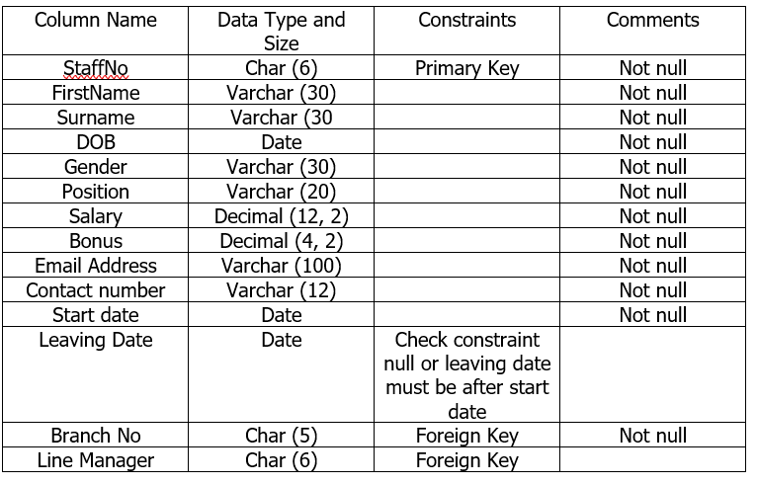
Figure 2: Staff table

Customer
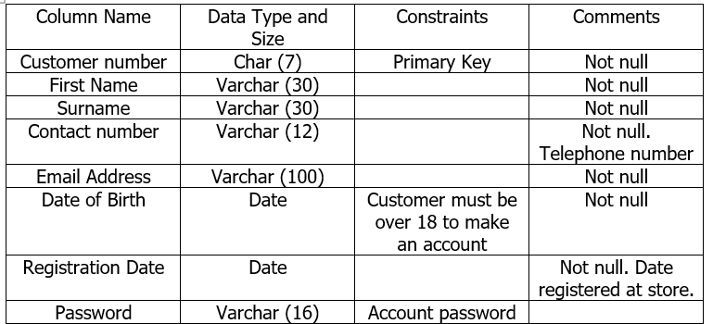
Figure 3: Customer table

Bikes
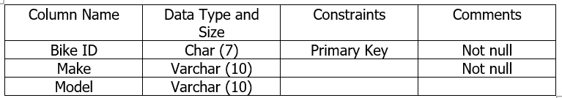
Figure 4: Bike table

Parts
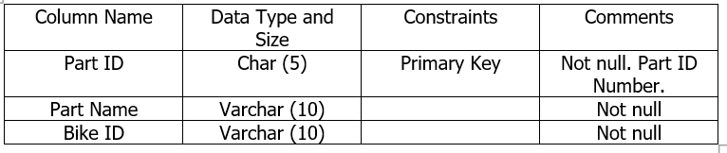
Figure 5: Parts table

Booking
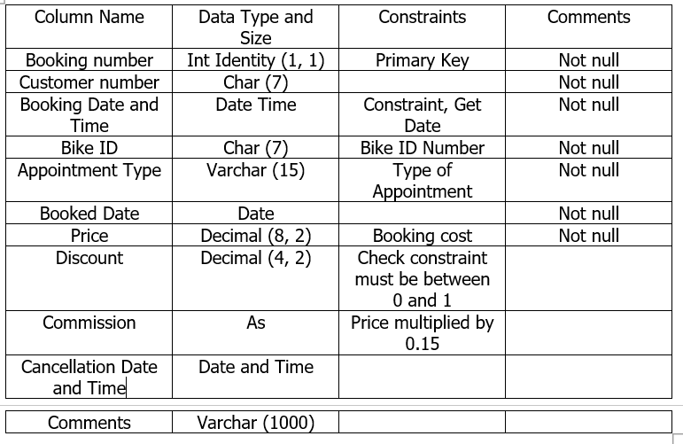
Figure 6: Booking table

Appointment Types
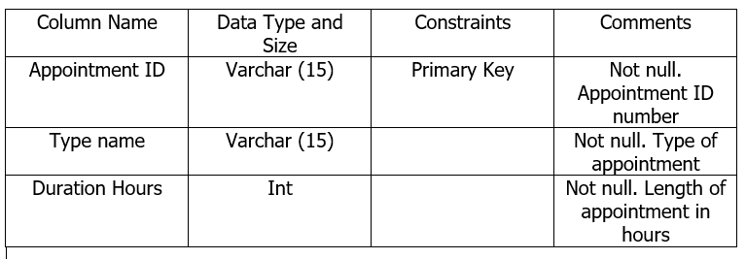
Figure 7: Appointment Types table

ERD Diagram
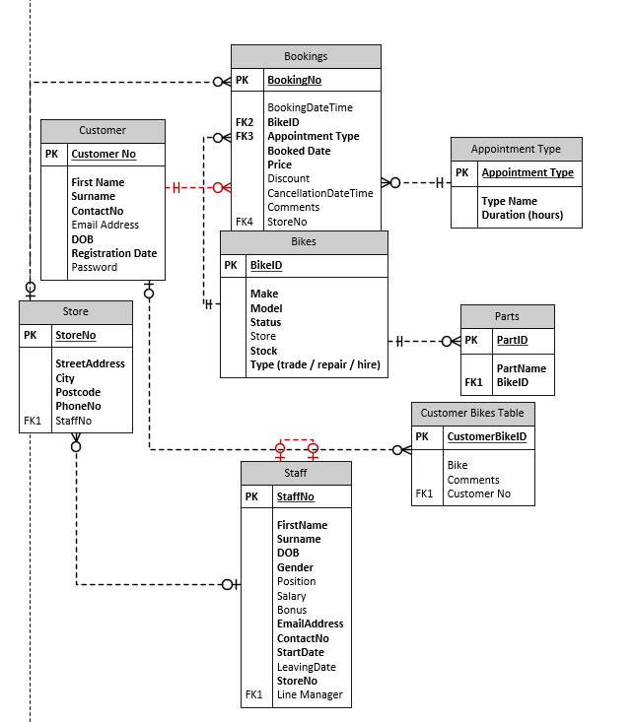
Figure 8: ERD Diagram
There will be eight tables with seven relationships as well as a unique primary key on every table with foreign keys in most tables which are connected to the relevant relationships, as shown in Figure 9.

Relationships
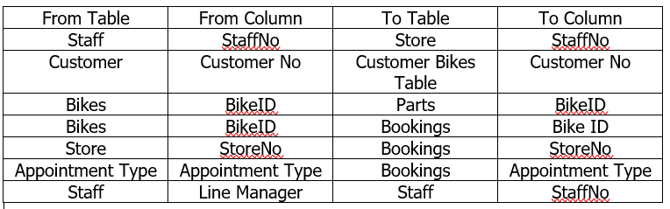
Figure 9: Relationships
StaffNo (Staff) – StaffNo (Store): The StaffNo from the Staff table would be related to the StaffNo to the Store table as there would be 1 member of staff to many stores.
Customer No (Customer) – Customer No (Customer Bikes Table): the Customer No from the Customer table would be related to the Customer No on the Customer Bikes Table as there would be one customer for many bikes.
BikeID (Bikes) – BikeID (Parts): The BikeID from the Bikes table would be related to the Bike ID on the Parts table as there would be one bike for many parts.
BikeID (Bikes) – BikeID (Bookings): The BikeID from the Bikes table would be related to the BikeID on the Bookings table as there would be one bike for many bookings.
StoreNo (Store) – StoreNo (Bookings): The StoreNo from the Store table would be related to the StoreNo on the Bookings table as there would be one store for many bookings.
Appointment Type (Appointment Type) – Appointment Type (Bookings): The Appointment Type from the Appointment Type table would be related to the Appointment Type on the Bookings table as there would be one appointment type for many bookings.

Rationale

Normalisation
Normalization is the method of sorting data in a database that take on a set of conditions which are there is no data repetition, and the data dependencies are logical [1]. Normalisation would be used because it can reduce data repetition and allow databases to function effectively and have the data organised.

Foreign Keys
A foreign key are columns in a relational database that relates data together in two separate tables within the database [2]. Foreign keys would be used because they can be used for relationships and once the foreign keys have been implemented alongside with the relationship, it avoids data duplication as, although some data may be duplicated, it would all be related together and appear on the main table it is related to.

Constraints
A check constraint ensures the authenticity of data being inserted into a database and provides data reliability as well as limiting the value range that can be identified in a column [3]. Check constraints would be used because it would discover any errors and ensure that, using the rollback, that the statement is terminated and does not enter the database.
The table below identifies the table in which check constraints will be used as well as how the constrained will be used in the database. The below table does not include the primary key or foreign keys as these are defined in Figure 8.
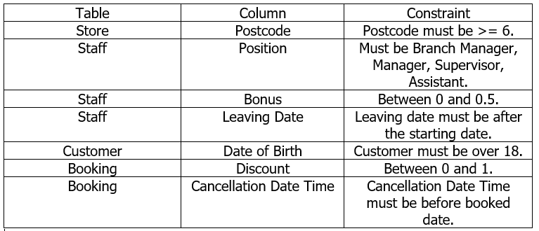
Figure 10: Constraints

Task 2: Performance Tuning Enhancement

Coursework Practical Element 2

File 1

Create Database
Figure 11: Create Database

Table creation
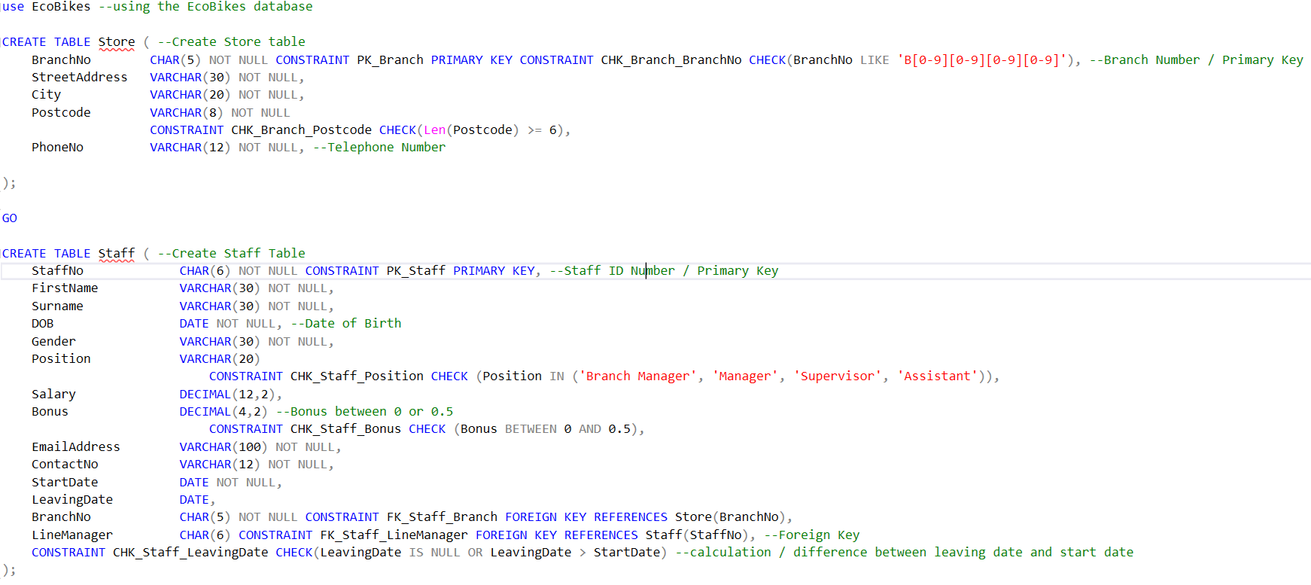
Figure 12: Creating the Store/Staff tables
Store: The BranchNo column is the primary key for the table. For the Postcode, the maximum length of the postcode is higher or equal to 6, not lower.
Staff: The StaffNo column is the primary key for the table with the position being three possible options – Branch Manager, Manager, Supervisor and Assistant. In terms of the Bonus column, this would be for the staff bonus – and would be a decimal number between 0 and 0.5. The BranchNo is a foreign key because it is related with the BranchNo primary key column on the Store table. The Line Manager is a foreign key with the StaffNo on the Staff table as each member of staff is assigned a position, if there is a line manager at a specific staff ID number it will be on the LineManager column.
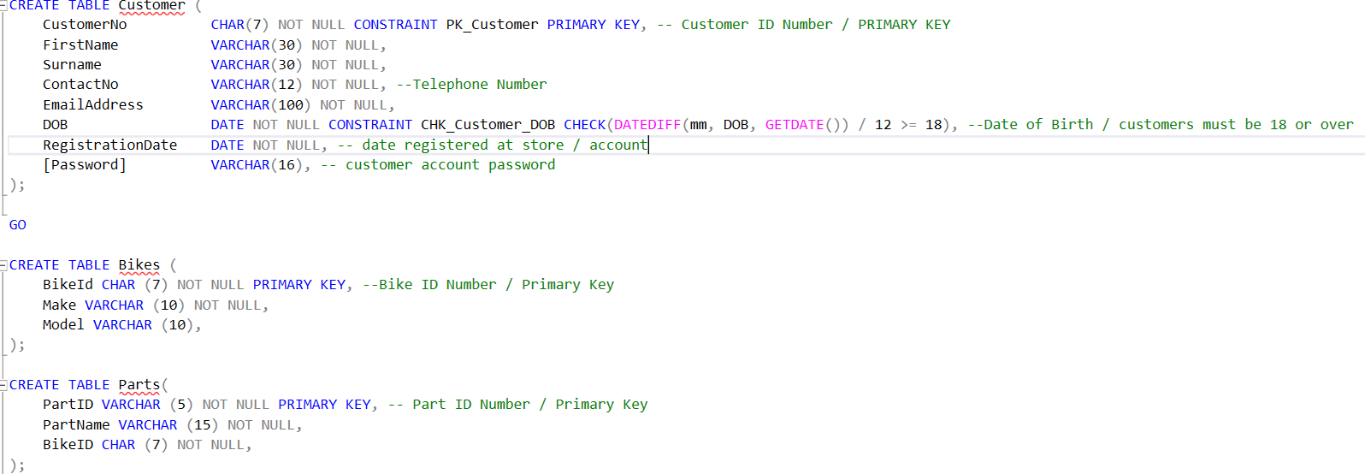
Figure 13: Creating the Customer/Bikes/Parts tables
Customer: the CustomerNo attribute is a primary key. The DOB attribute is the column for the date of birth, to allow the customer to make an account, they have to be 18 or over, if they are under 18, they will not be able to create an account. The RegistrationDate is the date that the customer registered their account with the store. With the exception to the passport attribute, all attributes are NOT NULL – data is required for these fields. This was done because the customer may not want to have an online account, they would not need a password.
Bikes: The Bikes ID attribute is the primary key. With the exception the model, all attributes are NOT NULL – data is required for these fields.
Parts: The PartID attribute is the primary key of the Parts table. All attributes are NOT NULL, data is required for all the fields on the table
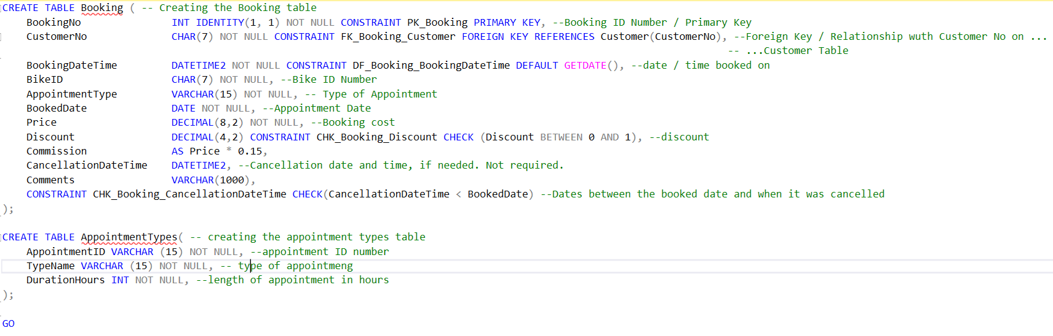
Figure 14: Creating the Booking/Appointment Types tables.
Booking: the BookingNo is the primary key attribute for the booking table. The CustomerNo is the foreign key, it is related to the CustomerNo primary key attribute on the Customer table. The BoookedDateTime attribute is the date and time that the appointment was booked with the Price attribute is for the cost of the appointment. There is a check constraint on the Discount attribute, it is a decimal value of between 0 and 1. There is another check constraint for the CancallationDateTime and Booked date, The CancellationDateTime must be before the appointment date, not after it. Apart from Discount, CancellationDateTime and Comments, all attributes are NOT NULL – data is required for these fields. This was done because some bookings may not have a discount nor be cancelled. For the specific return dates, this would be mentioned in the comments section of the table. Some bookings may not require having any comments, hence why this can be a NULL value.
Appointment Types: The AppointmentID is the primary key of the appointment types table. All attributes are NOT NULL, data is required for all fields in this table.

File 2

Test Data
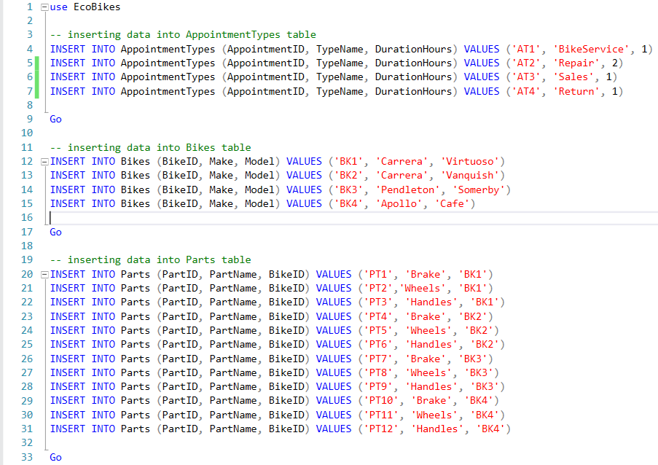
Figure 15: Test Data: Appointment Types/Bikes/Parts
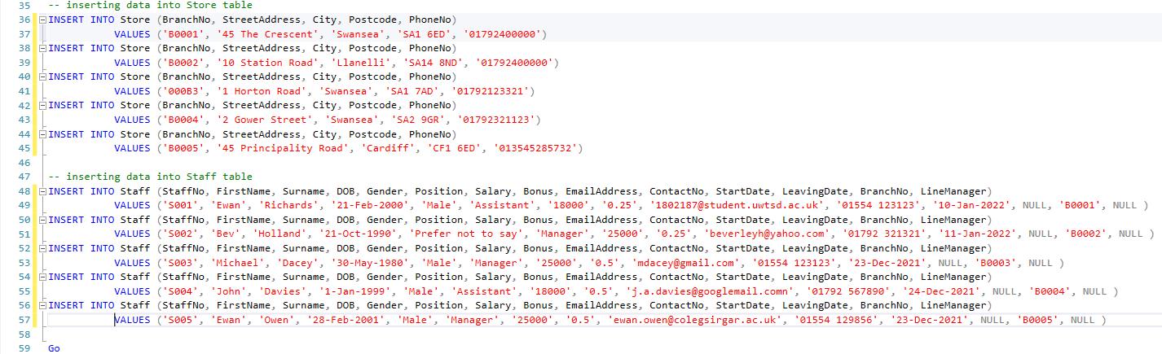
Figure 16: Test Data: Store/Staff tables
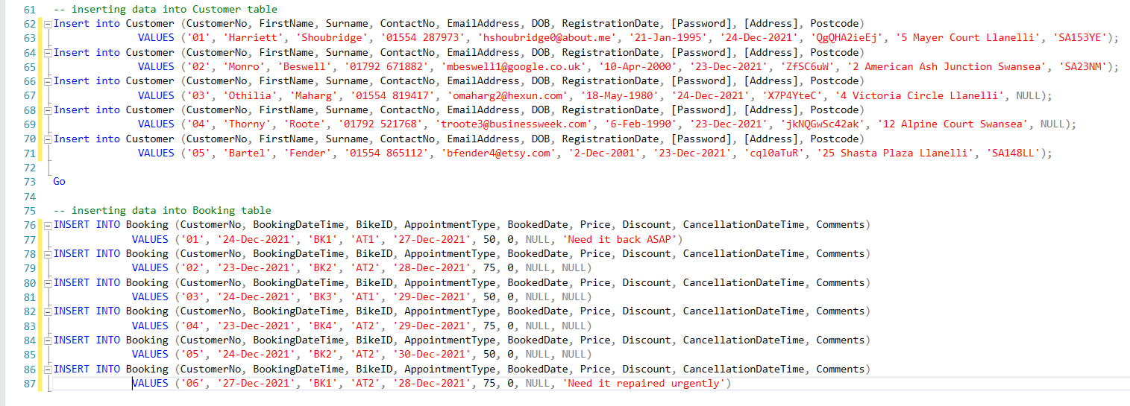
Figure 17: Test Data: Customer/Booking Tables

Testing the constraints

Booked date constraint
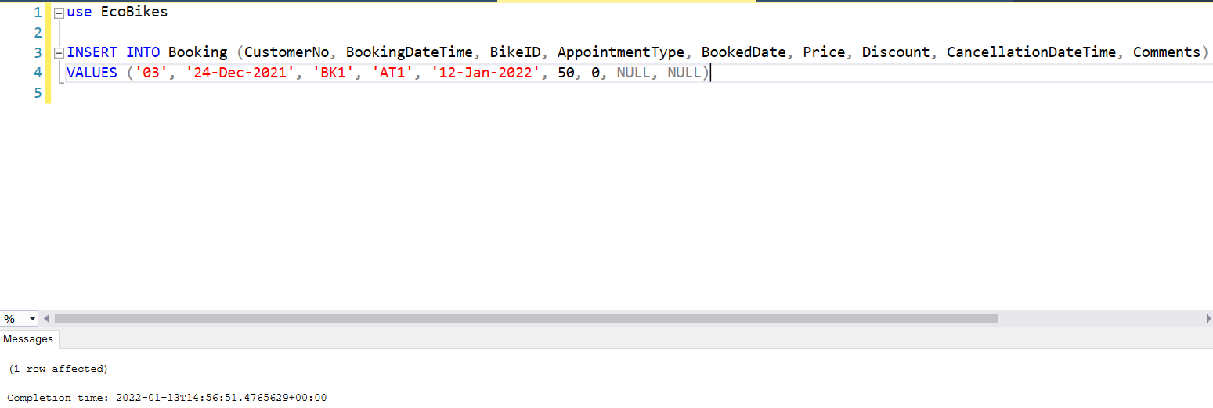
Figure 18: Booked date constraint
This constraint is for the BookedDate column on the booking table, the database can read today’s date and any appointment before today’s date should not be able to added to the bookings table. When this constraint was tested, the date was the 13th January 2022, so the booked date entered was the 12th January 2022, the row was successfully entered which means the date has been inserted onto the table. This constraint was unsuccessful.

Cancelled Date/Time
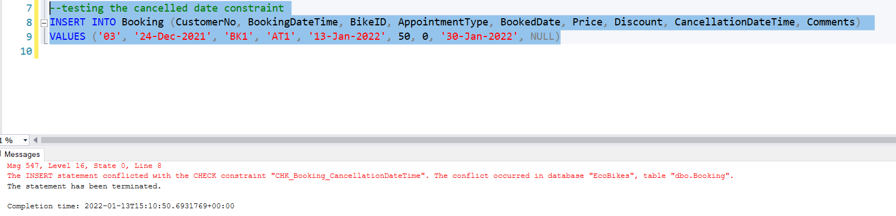
Figure 19: Cancelled date/time constraint
A new record was entered, and the date was after appointment time. As shown in the error message at the bottom of the illustration, the statement has been terminated because the cancelled date is after the appointment date.

Customer Date of Birth Constraint
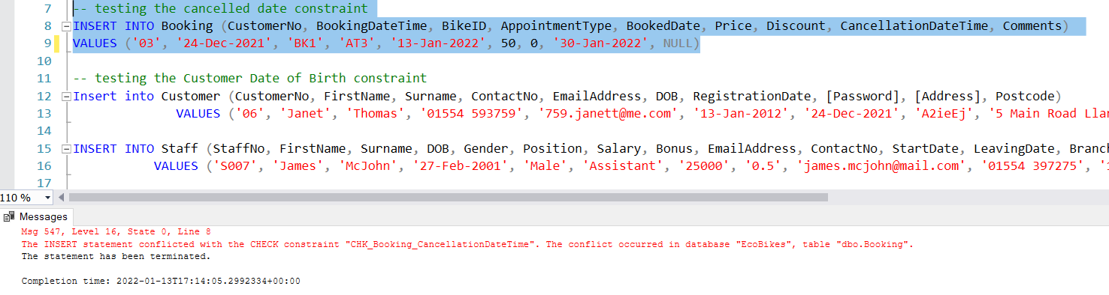
Figure 20: Customer Date of Birth Constraint
The constraint is that the customer must be 18 or over to create an account at EcoBikes. The date of birth entered was the 13th January 2022, meaning that the age of the customer is 11, so their record should not be able to be entered into the database. The constraint has worked.

Staff Leaving Date Constraint
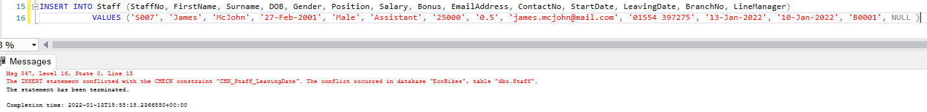
Figure 21: Staff Leaving Date Constraint
The constraint is that the leaving date must not before the start date. For this test, the start date entered was the 13th January 2022 and the leaving date entered was 10th January 2022, the constraint worked and the record has not been entered into the Staff table.

Postcode length constraint
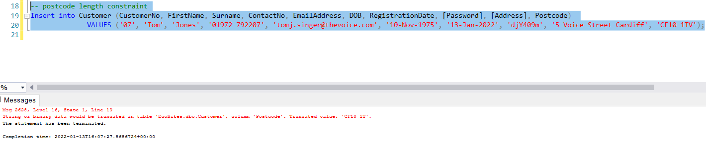
Figure 22: Postcode length constraint
The constraint is that the postcode value cannot be over 6, this postcode has 7 digits in is so it should not be permitted into the table. The constraint has worked and the statement has been terminated.

Staff bonus range constraint
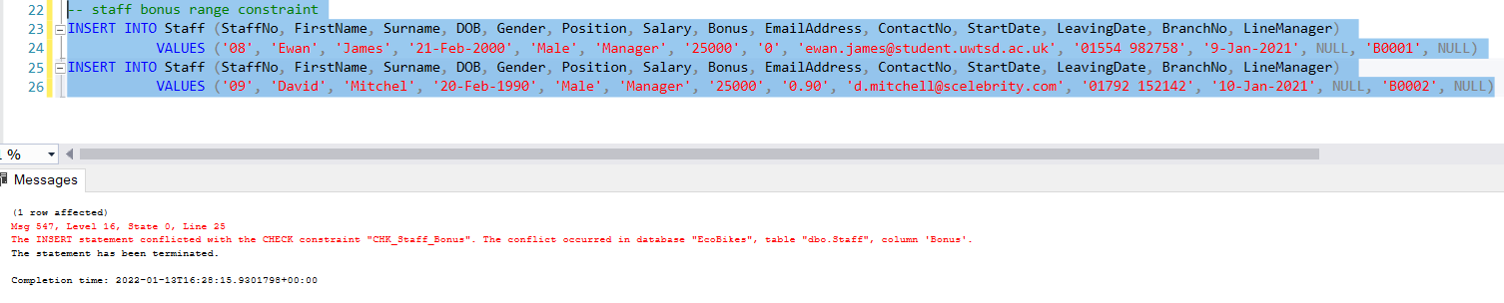
Figure 23: Staff bonus range constraint
The constraint is that the staff bonus must be between 0 or 0.5. One record has 0 bonus, the other having 0.90. the 0 bonus should be committed into the database but the 0.90 should not be committed as it is outside of the range. The 0 bonus record has been committed but the 0.90 bonus record has been terminated, the constraint has worked.

Staff position constraint
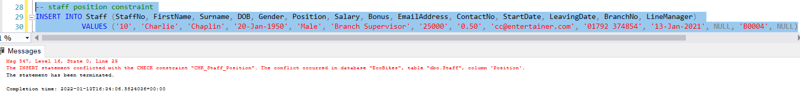
Figure 24: Staff position constraint
The constraint is that the data in this column can only be Branch Manager, Manager, Supervisor, Assistant. For this test, Branch Supervisory was used and the constraint worked as the statement was terminated.

Discount range constraint (Booking table)
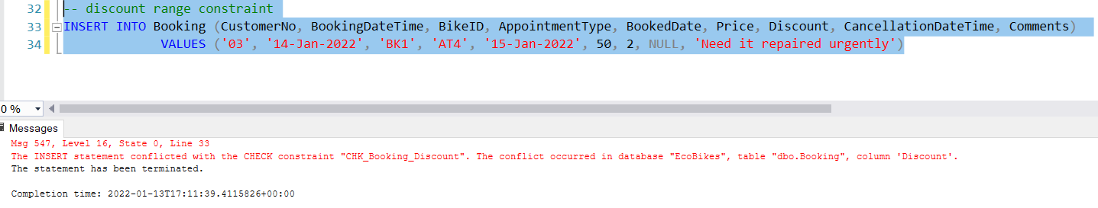
Figure 25: Discount range constraint
The constraint is that the discount must be between 0 and 1. For the test, the discount was 1.5 and the constraint worked as the statement was terminated.

Transaction
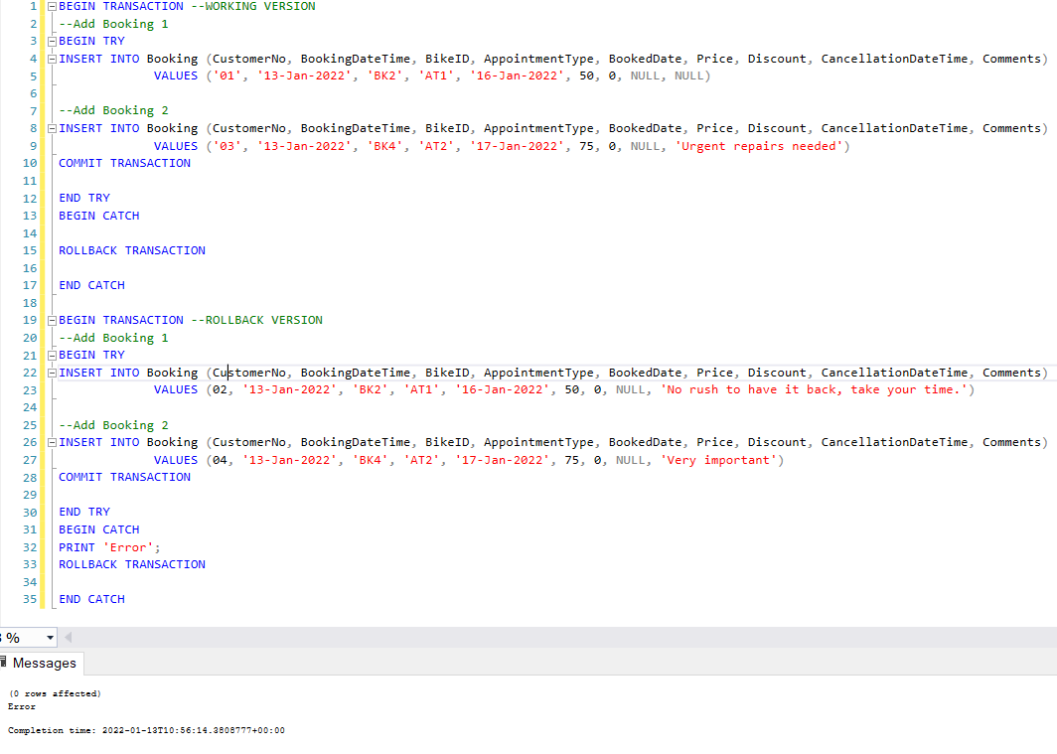
Figure 26: Transaction/Commit
The transaction at Figure 26 worked and the data was successfully added to the database however the transaction at the bottom of Figure 26 did not commit into the database and therefore failed. An error message is printed alongside the number of rows affected, because it failed to commit no rows have been affected by this transaction.

Task 3: Report

Written Element 1

SQL vs. NoSQL
Harrington states that “SQL is a database manipulation language that has been implemented by virtually every relational database management system (DMBS) intended for multiple users, partly because it has been accepted by the American National Standards Institute (ANSI) and International Standards Organization (ISO) as a standard query language for relational databases” [4]. In terms of flexibility, it depends on what type of what SQL developers use to implement their databases. The two types of Structured Query Language (SQL) are dynamic and static, as shown in Figure 27 [5] [6].
Type | Description
Dynamix SQL | Dynamic SQL is more flexible than static SQL mainly because dynamic SQL programs can handle change in data definition values, as SQL statements could be changed anytime
Static SQL | With static SQL, as it is unable to handle these changes – this means that it is not flexible. The majority of databases that are implemented using SQL are vertically scalable – this signifies those developers can increase the capacity on just a lone server by expanding key elements such as RAM
Figure 27: SQL types
According to Mullins, Vaughan, and Beal, “NoSQL is an approach to database management that can accommodate a wide variety of data models, including key-value, document, columnar and graph formats. A NoSQL database generally means that is a non-relational, distributed, flexible and scalable” [7].
Both sources explicitly describe how both SQL and NoSQL are useful for DMBS as well as their connection with relational databases. One of the most significant changes is the scalability with SQL being vertical and NoSQL being horizontal – NoSQL performs better than SQL because of it having more servers available, which means it can handle increased traffic more effectively.
The table below states the difference between SQL and NoSQL databases [8].
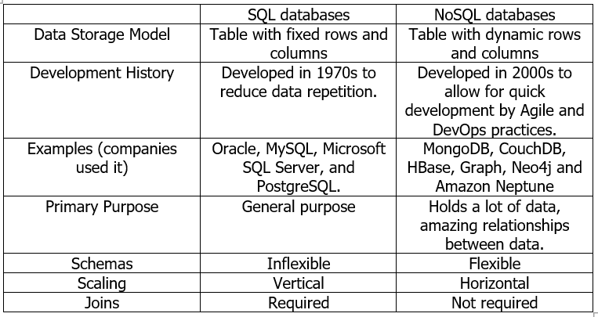
Figure 28: SQL Vs. NoSQL

Advantages and Disadvantages
The advantages and disadvantages of SQL and NoSQL are outlined below in Figure 29 [8], [9], [10], [11], [12], [13].
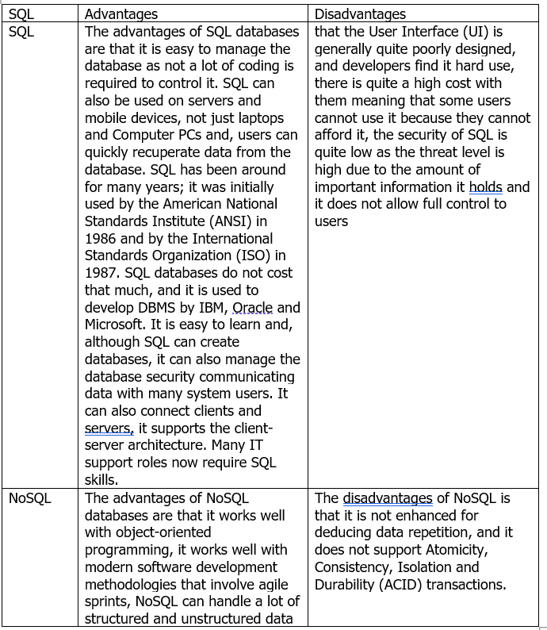
Figure 29: Advantages and Disadvantages of SQL and NoSQL
Based on the research compiled, SQL would be the more efficient language to use because of its connections with major IT communities, its data security models, and development history are more developed, and many major companies have used it since its launch in 1986. The general advantages also outweigh the disadvantages as well as how its generally better than NoSQL. With SQL, it assists with reducing data repetition and it is enhanced just for queries.

Written Element 2

Performance Tuning

Secondary Indexes
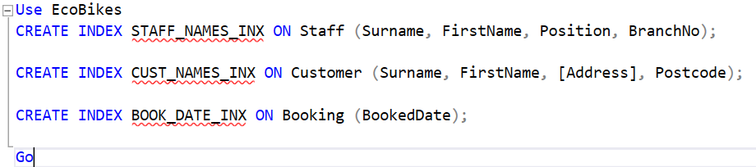
Figure 30: Indexes
The created indexes on the staff, customer and booking tables have been created to make searching more efficient in the database.
STAFF_NAMES_INX. The index was created on the staff table for the surname, first name, position, and Branch number columns. This index was created because management can find staff members surname and first name and view their details. If they want to see all staff working at a particular branch, they can enter the branch number and all staff would appear.
CUST_NAMES_INX. The index was created on the customer table for the surname, first name, address, and postcode columns. The index was created because when customers visit a store, staff members can search the customers surname and first name, and their account would appear. If there is a customer with the same name, the customer would be asked to confirm their address and postcode, which would be visible to the staff member.
BOOK_DATE_INX. The index was created because when customers ask whether there is any date available for a booking, the staff member can search fir that specific date and their query could be answered.

Transaction justification
Figure 26 are the transaction created. The transaction that was implanted can be used to address the problems raised by Eco Bike Hubs as if the wrong data is entered or if the date has already been entered then an error message shall show stating that the transaction would not work however if the transaction has been successful, the record would be entered into the database.

Distributed Database Solution

Distributed Database Management Systems (DDMS)
A distributed database is a compilation of many connected databases, which are distributed substantially across many locations that talks on a computing device. A DDMS is an integrated structure that controls a distributed database in a way as if it was stored in a single location. It has many features such as the following: [14]
- Create, save, revise, and remove distributed databases [14].
- Data can be updated anywhere [14].
- Data integrity [14].
DDMS has many benefits, such as a smaller transmission costs, the data within the database is delivered in an effective method and is dependable. However, there are some disadvantages of DDMS such as it could be complicated and the sensitivity of queries is largely dependent upon appropriate data distribution. [14]

Horizontal
For EcoBikes, the rows would be stored on the Branch table as well as the Booking as the appointments would then show on the Branch table. This also applied with the Staff, the Staff table would appear on the Branch table so that, when searching on the Branch table, the staff members would know where each other is assigned.

Vertical
For EcoBikes, the address and contacts columns could be transferred and put into a separate store contact table and have the branch manager in the main branch table. Also, for the staff table, the salary, bonus and start / leave dates could be placed into a Human Resources (HR) table and the remaining columns remain.
For the Customers table, the RegistrationDate and Password columns would be separated into an online account table with the other columns remaining in the Customer table. The Bikes, Parts, Booking and Appointment Types tables would remain as they were initially created.

Mixed
For EcoBikes, all the locations would have its own table, such as Cardiff would have its own table, Llanelli would have its own table and Swansea would have its own table. The staff and stores based at these locations would be related to these tables.

Derived
Both the Branch and Customer are primary tables which are then related to other tables. The Customer table would be joined with the Branch table as well as the Booking table as the Booking number and relevant data can be saved to the customer table which shows when they had appointments and when it’s related to the Branch table shows which appointments are taking place at particular stores each day as well as which customers would be in the stores and which stores the customer visits. This can identify which store are customers visiting more and whether this could assist expand the company further.

Reconstruction of Global Relations
By using these relevant fragments, it would remain as one big database, but it would be stored in many tables to make it more efficient.

Conclusion
This report set out to analyse the requirements of Eco Bike Hubs and propose a database design. It also addressed problems which had to be demonstrated by using SQL commented code by using testing rollback and commit operations. The report also addressed the debase of using a SQL database verses a NoSQL database. Transaction needed to be explained on how they address the problems raised by Eco Bike Hubs as well as create a suitable fragmentation scheme for the system.
The requirements of Eco Bikes Hubs have been analysed and a database design has been proposed by creating a database schema protype to show the company. A Microsoft SQL Server database, using SQL statements, has been created that will enable Eco Bikes to manage customer requirements. It meets the features of being normalised to 3 normal forms, the design structure has been demonstrated with a primary key being created for each table with referential integrity constrains and check constraints being implemented. Realistic records have been populated on each table using Insert statements. The data has been used to test the functionality of the primary key, foreign key and check constraints.
Sample code has been provided to demonstrate how the use of a transaction may be used to address the problems alongside with testing rollback and commit operations for the actions needed.
SQL and NoSQL have been debated, and SQL has been discussed as being more effective than NoSQL. The database structure has been evaluated and how it could be improved and enhanced further with fragmentations, such as horizontal and vertical. DDMS has been researched and has assisted with writing these enhancements.

References

[1] | Techioedia, “Normalization,” Techioedia, 2022. [Online]. Available: https://www.techopedia.com/definition/1221/normalization. [Accessed 13 January 2022].
[2] | J. Rabelo, “Foreign Key,” Techopedia, 14 August 2020. [Online]. Available: https://www.techopedia.com/definition/7272/foreign-key. [Accessed 13 January 2022].
[3] | W3Schools, “SQL CHECK Constraint,” w3schools, 2022. [Online]. Available: https://www.w3schools.com/sql/sql_check.asp. [Accessed 13 January 2022].
[4] | J. L. Harrington, SQL Clarly Explained, Third Edition, Burlington, MA, USA: Morgan Kaufman, 2010.
[5] | J. Russell, Application Developer's Guide - Fundamentals, Oracle Corporation, 1999.
[6] | L. Shiff and W. Rowe, “SQL vs NoSQL Databases: What’s The Difference?,” BMC Blogs, 5 March 2018. [Online]. Available: https://www.bmc.com/blogs/sql-vs-nosql/. [Accessed 6 December 2021].
[7] | C. S. Mullins, J. Vaughan and B. Beal, “NoSQL (Not Only SQL database),” SearchDataManagement, April 2021. [Online]. Available: https://searchdatamanagement.techtarget.com/definition/NoSQL-Not-Only-SQL. [Accessed 6 December 2021].
[8] | L. Schaefer, “NoSQL vs SQL Databases,” MongoDB, 2022. [Online]. Available: https://www.mongodb.com/nosql-explained/nosql-vs-sql. [Accessed 12 January 2022].
[9] | Java Point, “https://www.javatpoint.com/dbms-advantage-of-sql,” Java Point, 2022. [Online]. Available: https://www.javatpoint.com/dbms-advantage-of-sql. [Accessed 12 January 2022].
[10] | S. Thakur, “What is SQL, its Applications, Advantages and Disadvantages?,” What is DBMS, 2 June 2017. [Online]. Available: https://whatisdbms.com/what-is-sql-applications-advantages-and-disadvantages/. [Accessed 12 January 2022].
[11] | “12 Benefits of SQL (Structured Query Language),” Systematix, 2022. [Online]. Available: https://www.systematix.co.uk/tips-tricks/12-benefits-of-sql-structured-query-language. [Accessed 12 January 2022].
[12] | MongoDB, “Benefits Of NoSQL,” MongoDB, 2022. [Online]. Available: https://www.mongodb.com/scale/benefits-of-nosql. [Accessed 12 January 2022].
[13] | S. Vatsal, “Advantages And Disadvantages Of SQL: A Popular Choice For Databases!,” Dare2Compete, 12 January 2022. [Online]. Available: https://dare2compete.com/blog/advantages-and-disadvantages-of-sql. [Accessed 12 January 2022].
[14] | Tutorials Point, “Distributed DBMS - Distributed Databases,” Tutorials Point, 2022. [Online]. Available: https://www.tutorialspoint.com/distributed_dbms/distributed_dbms_databases.htm. [Accessed 13 January 2022].

