University of Wales Trinity Saint David
School of Engineering
Series Hybrid Vehicle
Electric and Hybrid Propulsion Control
Christopher Robbins
P146163
B.Sc.
05/12/17
Automotive/Motorsport Engineering

Abstract

A design for an off-road course for corporate use has been designed and a duty cycle has been made with Microsoft Excel. The Excel spreadsheet allows an insight of data gathered against time- from resistances, velocity, distance, gradient etc. Data gathered thus far shows how buggy speed/velocity is effected by gradient resistance, aerodynamic resistance and rolling resistances etc.
The graphs plotted from the data calculated and sets gives a knowledge on how the buggy is effected during the duty cycle of a 2-minute course through 4 different terrains (gravel, grass, sand and tarmac). As the different terrains have different amounts of rolling resistances this can be seen with the graphs created and how different aspects of the buggy is affected.
Overall the spreadsheet is reliable with only brief data anomalies which can be disregarded through analysis of the data sets and graphs at that point in the duty cycle.

Acknowledgements

To show a great appreciation to every one of the lecturers and staff at the University of Wales Trinity Saint David. Without the resources and knowledge shown by the staff, none of this work thus far would have been possible. An additional thank you to close friends and family.

List of Figures

Figure 1: Chosen buggy for off-road course (Blitzworld.co.uk, 2017). 5
Figure 2: 4 speed controls and their maximum speeds Blitzworld.co.uk, 2017). 5
Figure 3: The whole drive cycle through all data sets in each terrain (Time against- gradient, velocity, acceleration, power, acceleration resistance, gradient resistance, rolling resistance, aero resistance, and total resistance). 6
Figure 4: Data to be used for spreadsheet calculation (Excel, 2017). 7
Figure 5: Data for each terrain type (Engineeringtoolbox.com, 2017), (Excel, 2017). 7
Figure 6: Additional data used for calculations (Physics.info, 2017), (Excel, 2017). 7
Figure 7: Dimensions of the buggy to calculate area (Polaris Ace, 2017), (Excel, 2017). 7
Figure 8: Average and maximum power and resistance readings from each terrain section (Excel, 2017). 8
Figure 9: Maximum and average power and resistance across the whole off-road course (Excel, 2017). 8
Figure 10: Equations used to complete the duty cycle spreadsheet (Excel,2017). 9
Figure 11: Distances for each terrain section including the total distance for this duty cycle (Excel,2017). 9
Figure 12: Time against gradient and velocity for section 1-Gravel (Excel,2017). 10
Figure 13: Problem Identification- Data blip in graph (Excel,2017). 11
Figure 14: Complete spreadsheet data (Excel, 2017). 13

Table of Contents
Abstract 1
Acknowledgements 2
List of Figures 3
Table of Contents 4
1. Introduction 4
1.1 Background- Chosen Vehicle 5
1.2 Terrain and course length 5
1.3 Research for equations and calculations 5
2. Methodology-Duty Cycle Analysis 5
2.1 Duty Cycle Analysis- Spreadsheet data and graphs. 6
2.2 Duty Cycle Analysis- Calculation 6
3. Conclusion 10
3.1 Summary of findings. 10
3.2 Problem Identification. 11
4. References 12
5. Appendices 13

Introduction

An in-depth look at a specific motorised buggy for use as a recreational and corporate entertainment sector. There will be a consideration into the duty cycle of such a course i.e. running times and the performance of the buggy for when it is in use.
A spreadsheet will be compiled of data calculated e.g. resistance forces, power requirements and vehicle speed. The data will be calculated from a set course designed for the buggies during recreational and corporate use.
The data will be analysed for the duty cycle to be referenced back to the engineering director of the company that manufactures the off-road buggies. See conclusion for problem identification on page 11.


Background- Chosen Vehicle
The chosen buggy is a POLARIS ACE 150cc from the website Blitz World (http://www.blitzworld.co.uk/age-10-adult-polaris-ace-150cc-i3012.html). The buggy is for ages 10 and up and features an electronic speed control so that it can be set to have 4 different maximum speed settings. The power unit is an EFI fuel injected 149cc engine and for the duty cycle will be ran at speed mode 4 for a maximum accelerated speed of 29MPH.
Figure 1: Chosen buggy for off-road course (Blitzworld.co.uk, 2017).

Figure 2: 4 speed controls and their maximum speeds Blitzworld.co.uk, 2017).

Terrain and course length
There will be 4 types of terrain throughout the course, starting with gravel, grass, sand and a final stretch of tarmac. The total course length is 1084.51m and takes around 2 minutes to complete.

Research for equations and calculations

Firstly, the Physics Hypertext Book (online-Physics.info, 2017) was used to achieve the correct calculations from the equations used and the coefficient values were gathered from the Engineers Toolbox (online-Engineeringtoolbox.com, 2017).

Methodology-Duty Cycle Analysis

Duty Cycle Analysis- Spreadsheet data and graphs.
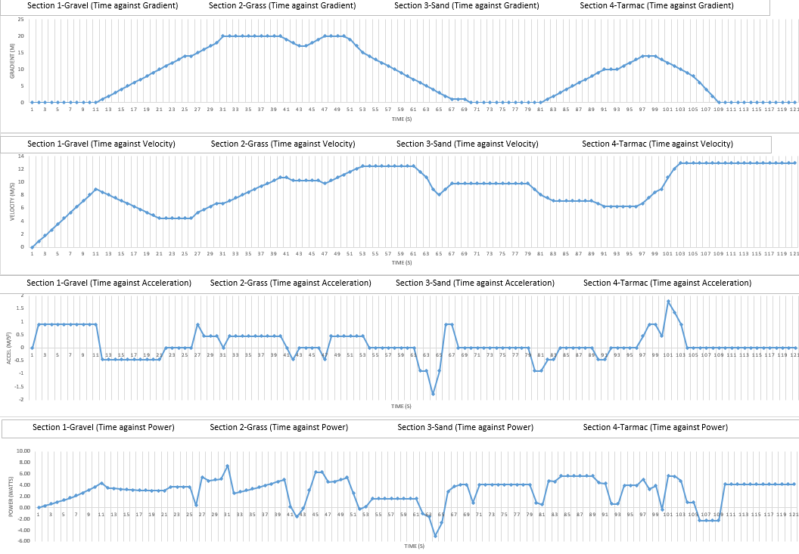
In figure 3 the data is shown for all terrains for 1084.51m (Excel, 2017).

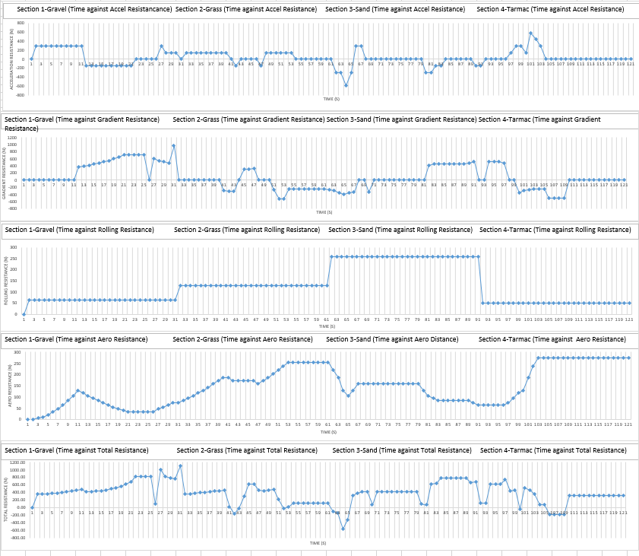

Figure 3: The whole drive cycle through all data sets in each terrain (Time against- gradient, velocity, acceleration, power, acceleration resistance, gradient resistance, rolling resistance, aero resistance, and total resistance).

Duty Cycle Analysis- Calculation

Figure 8 shows wheel radius, max velocity in highest speed, coefficient of drag and total weight from the buggy and 1 average person.
Figure 4: Data to be used for spreadsheet calculation (Excel, 2017).

In figure 9 the rolling resistance coefficients for the different terrains were found on The Engineering Toolbox website and the actual rolling resistances were calculated using- total weight x gravity x the specific coefficient (Engineeringtoolbox.com, 2017).
Figure 5: Data for each terrain type (Engineeringtoolbox.com, 2017), (Excel, 2017).

The total mass of the buggy with 1 person in is 327Kg with 9.81N and assuming the air density is 1.20Kg/m³ as shown in figure 10 (Polaris Ace, 2017).
Figure 6: Additional data used for calculations (Physics.info, 2017), (Excel, 2017).
Figure 7: Dimensions of the buggy to calculate area (Polaris Ace, 2017), (Excel, 2017).

The dimension of the buggy was found on the Polaris Ace website and the area calculated from the length X height X width (Polaris Ace, 2017).
In figure 12 the maximum and average power and resistance readings calculated from the spreadsheet are shown. Section 1 (gravel) has the highest maximum power achieved but section 3 (sand) has the highest average power.
Figure 8: Average and maximum power and resistance readings from each terrain section (Excel, 2017).

The maximum resistance occurs in section 1 (gravel) at the end of the section (30 second mark) which can be seen in figure 7 showing the data results. The highest average resistance is also in section 1 (gravel) with a reading of 0.55KN.
This is unusual as the rolling resistance reading for gravel was the second lowest with sand having the highest reading. The reason for the high resistance readings is because section 1 has the longest stretch of uphill gradient compared to the others, adding the gradient resistance to this section made it have a high total resistance.
The maximum power outputted is 7.43Kw or 9.97HP but during the track the buggy is averaging 3.96HP. The maximum total resistance across the course is 1.1KN with an average of 0.37KN. As there is a significant difference between the maximum and average this could be due to anomalies in the data plot allowing a spike in resistance or power. See problem identification in the conclusion, on page 11 for more detail.
Figure 9: Maximum and average power and resistance across the whole off-road course (Excel, 2017).
These equations in figure 10 allowed for the spreadsheet to be put together correctly to achieve the correct most reliable data sets.
Figure 10: Equations used to complete the duty cycle spreadsheet (Excel,2017).

Seen in figure 11 are the distances for each terrain section including the total duty cycle length of 1084.51m.

Figure 11: Distances for each terrain section including the total distance for this duty cycle (Excel,2017).

Conclusion

Summary of findings.

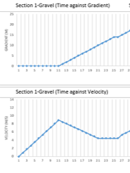
Throughout the spreadsheet and graphs produced, there can be seen a direct relation between the speed of the buggy and each resistance applied e.g. gradient resistance. As in section 1 when the buggy meets the first uphill gradient a direct relation to the velocity of the buggy and gradient resistance can be seen i.e. as an uphill gradient appears so does the increase in the gradient resistance slowing down the buggy but as the buggy slows the aero-resistance decreases as with the velocity- see figure 12 for example (SAE, 2017).
Figure 12: Time against gradient and velocity for section 1-Gravel (Excel,2017).
At some points, e.g. just before a decline the buggy slows down to go down the gradient gradually and the same can be said at the bottom of a descent where it flattens out. This is to make the duty cycle more realistic to life as no one would drive straight off before a descent.
In figure 8 on page 8 highlighted in blue and red for lowest and highest power and resistance values the highest power is produced in section 1 which also has the highest resistance value of all sectors. On the other hand, sector 2 has the complete opposite with the lowest power output and the lowest resistance values. This could be down to that as the resistance is low the buggy doesn’t need a higher power output to maintain its velocity (Www3.epa.gov, 2017).
The higher the total the resistance the greater the impact it has on the buggies speed and power requirement produced. In figure 8 for time against acceleration and time against acceleration resistance can appear to have the same duty cycle style within the graph and this is because it has a direct correlation. The more the buggy accelerates the more acceleration resistance is produced to try and reduce the buggies velocity (Scienceprimer.com- 2017).

Problem Identification.

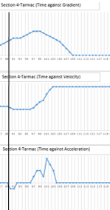
Within the data gathered from the spreadsheet it is highly likely for problems/invalid data points to occur because of the amount of data recorded over a specific time. These points can be found in the graphs where a sudden change in number from the previous point and next point can be seen. As seen in Figure 13 there is an acceleration anomaly around the 100 second mark in section 4.
At this point the buggies velocity is starting to increase due to the downhill gradient change as seen in Figure 13 and instead of a smooth increase in acceleration there is an anomaly where the acceleration reduces significantly but only for a second.
Anomalies like this can be put aside through analysis of the graphs to find out why this might be happening or if it is just an anomaly in the data set. Considering duty cycles can help in designing suitable maintenance sequences for numerous classes of vehicles, project overall vehicle life, etc (Vehicle Service Pros, 2017).
Figure 13: Problem Identification- Data blip in graph (Excel,2017).

References

- XC, P. (2017). Specs: 2018 Polaris ACE 150 EFI - Indy Red | Polaris ACE. [online] Ace.polaris.com. Available at: https://ace.polaris.com/en-us/ace-150-efi-indy-red/specs/ [Accessed 2 Nov. 2017].
- Ehsani, M., Gao, Y. and Emadi, A. (2010). Modern electric, hybrid electric and fuel cell vehicles. Boca Raton: Taylor & Francis Group.
- Blitzworld.co.uk. (2017). Polaris, ace, 150cc, kids, adult, go-kart, buggy. [online] Available at: http://www.blitzworld.co.uk/age-10-adult-polaris-ace-150cc-i3012.html [Accessed 2 Nov. 2017].
- Engineeringtoolbox.com. (2017). Rolling Resistance. [online] Available at: https://www.engineeringtoolbox.com/rolling-friction-resistance-d_1303.html [Accessed 2 Nov. 2017].
- Scienceprimer.com. (2017). Gravitational Acceleration | Science Primer. [online] Available at: http://scienceprimer.com/gravitational-acceleration [Accessed 2 Nov. 2017].
- Vehicle Service Pros. (2017). Do you understand the differences between drive cycle and duty cycle? [online] Available at: https://www.vehicleservicepros.com/on-the-vehicle/in-vehicle/cab-body/article/12003317/do-you-understand-the-differences-between-drive-cycle-and-duty-cycle [Accessed 3 Nov. 2017].
- Physics.info. (2017). Frequently Used Equations – The Physics Hypertextbook. [online] Available at: https://physics.info/equations/ [Accessed 3 Nov. 2017].
- Lee, H., Tesar, D., and Ashok, P., "Expanded Human Choice based on Duty/Demand Cycles for In-Wheel Motors in Electric Vehicles," SAE Int. J. Passenger. Cars - Mech. Syst. 10(1):1-12, 2017.
- Products.office.com. (2017). Microsoft Excel 2016, Download Spreadsheet software | XLS XLSX. [online] Available at: https://products.office.com/en-gb/excel [Accessed 3 Nov. 2017].
- Www3.epa.gov. (2017). Cite a Website - Cite This for Me. [online] Available at: https://www3.epa.gov/ttn/chief/conference/ei10/intemissions/wilsonpres.pdf [Accessed 3 Nov. 2017].

Appendices
Figure 14: Complete spreadsheet data (Excel, 2017).

