Assignment 2
Title: Academic Poster & Written Pitch
Name: Salomey Senya
Student Number: 2408674
Module Code: BMHP5014
Module Title: Changemakers: Creativity and Value Creation
Lecturer Name: Dr. Raheela Shaikh

Date: 30th March 2026

THE POSTER
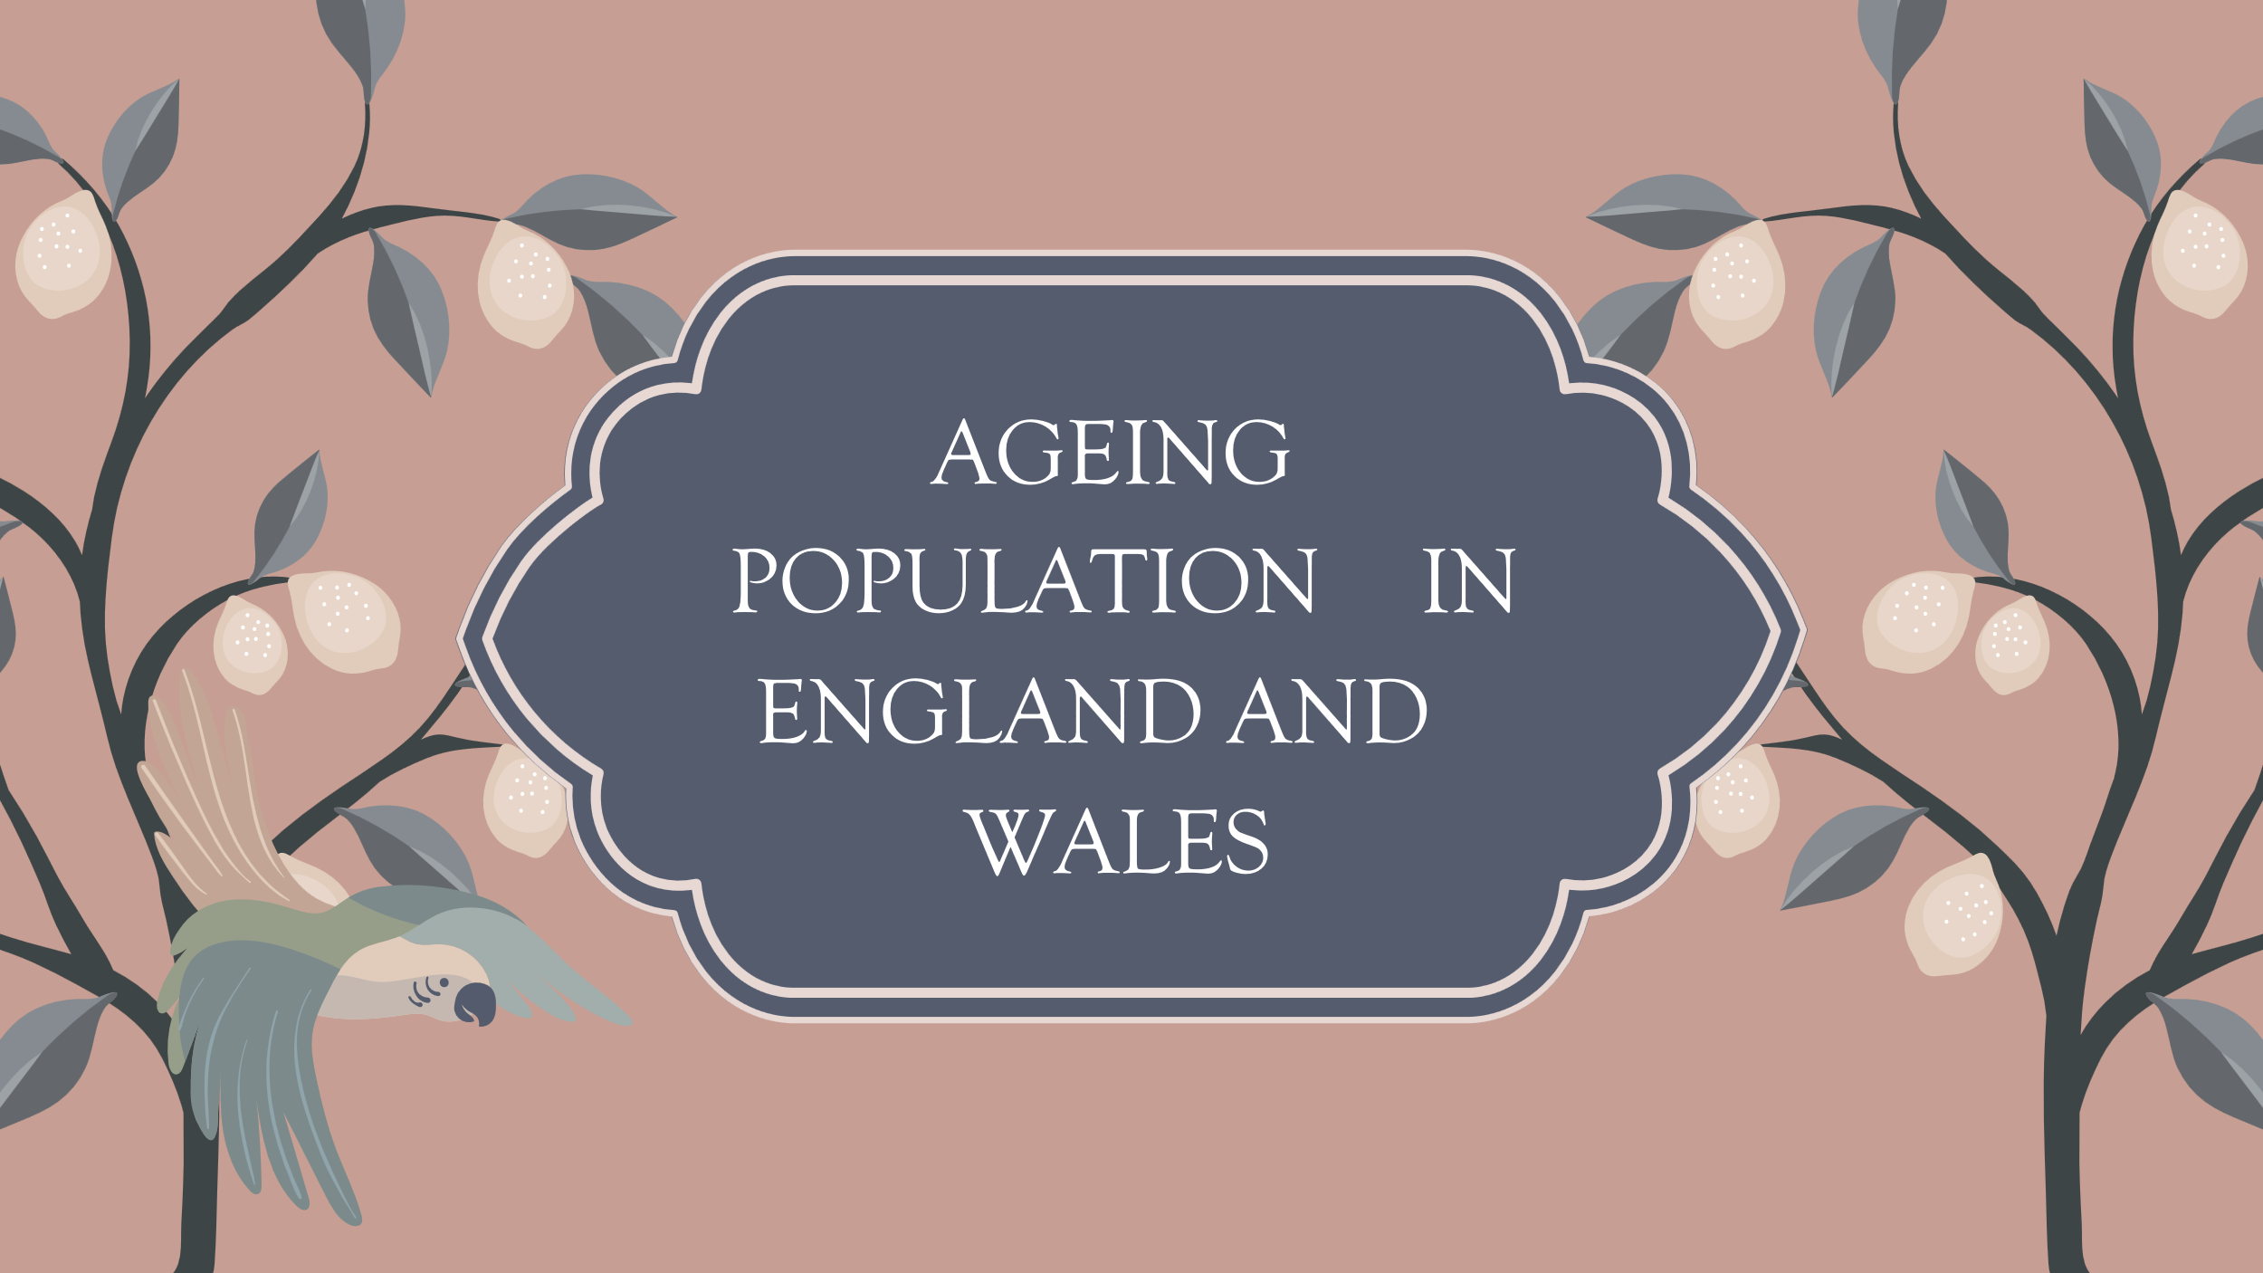
NHS.UK
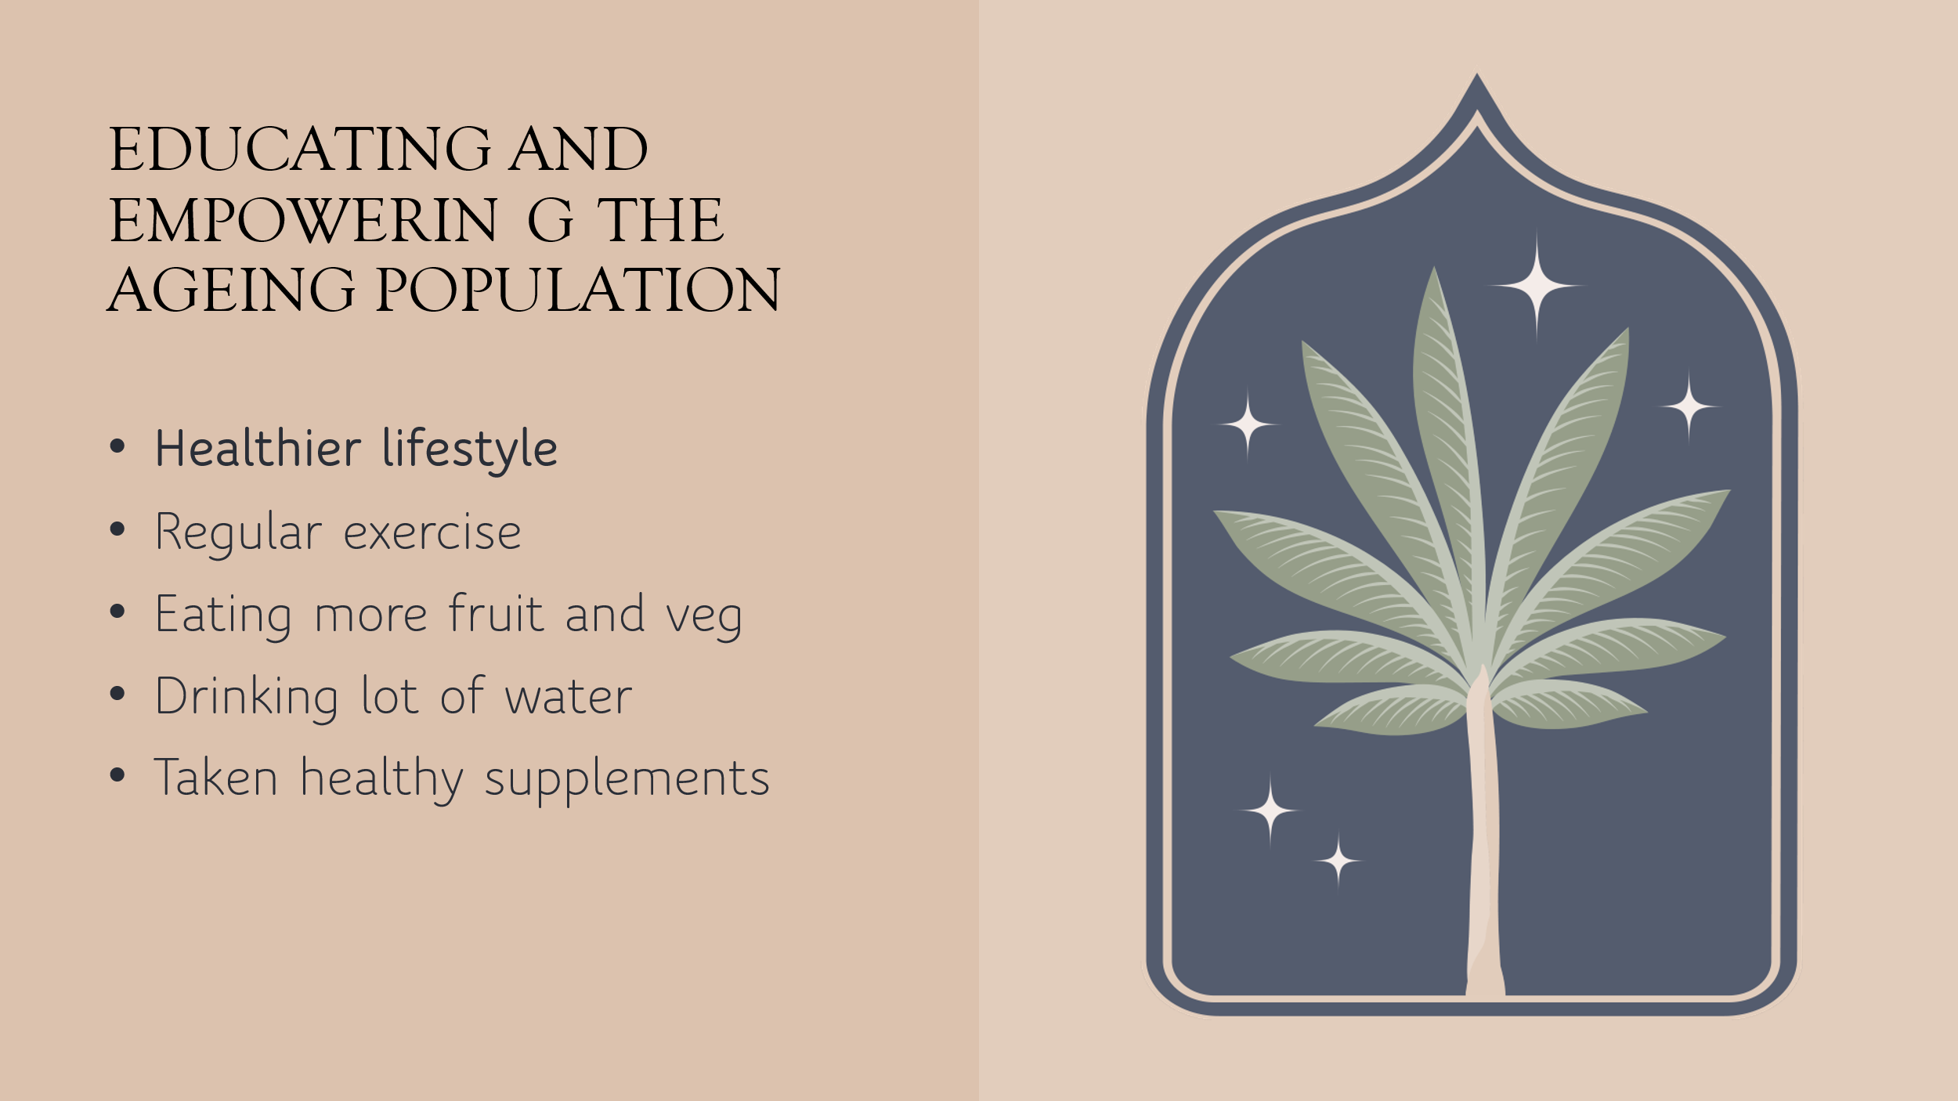
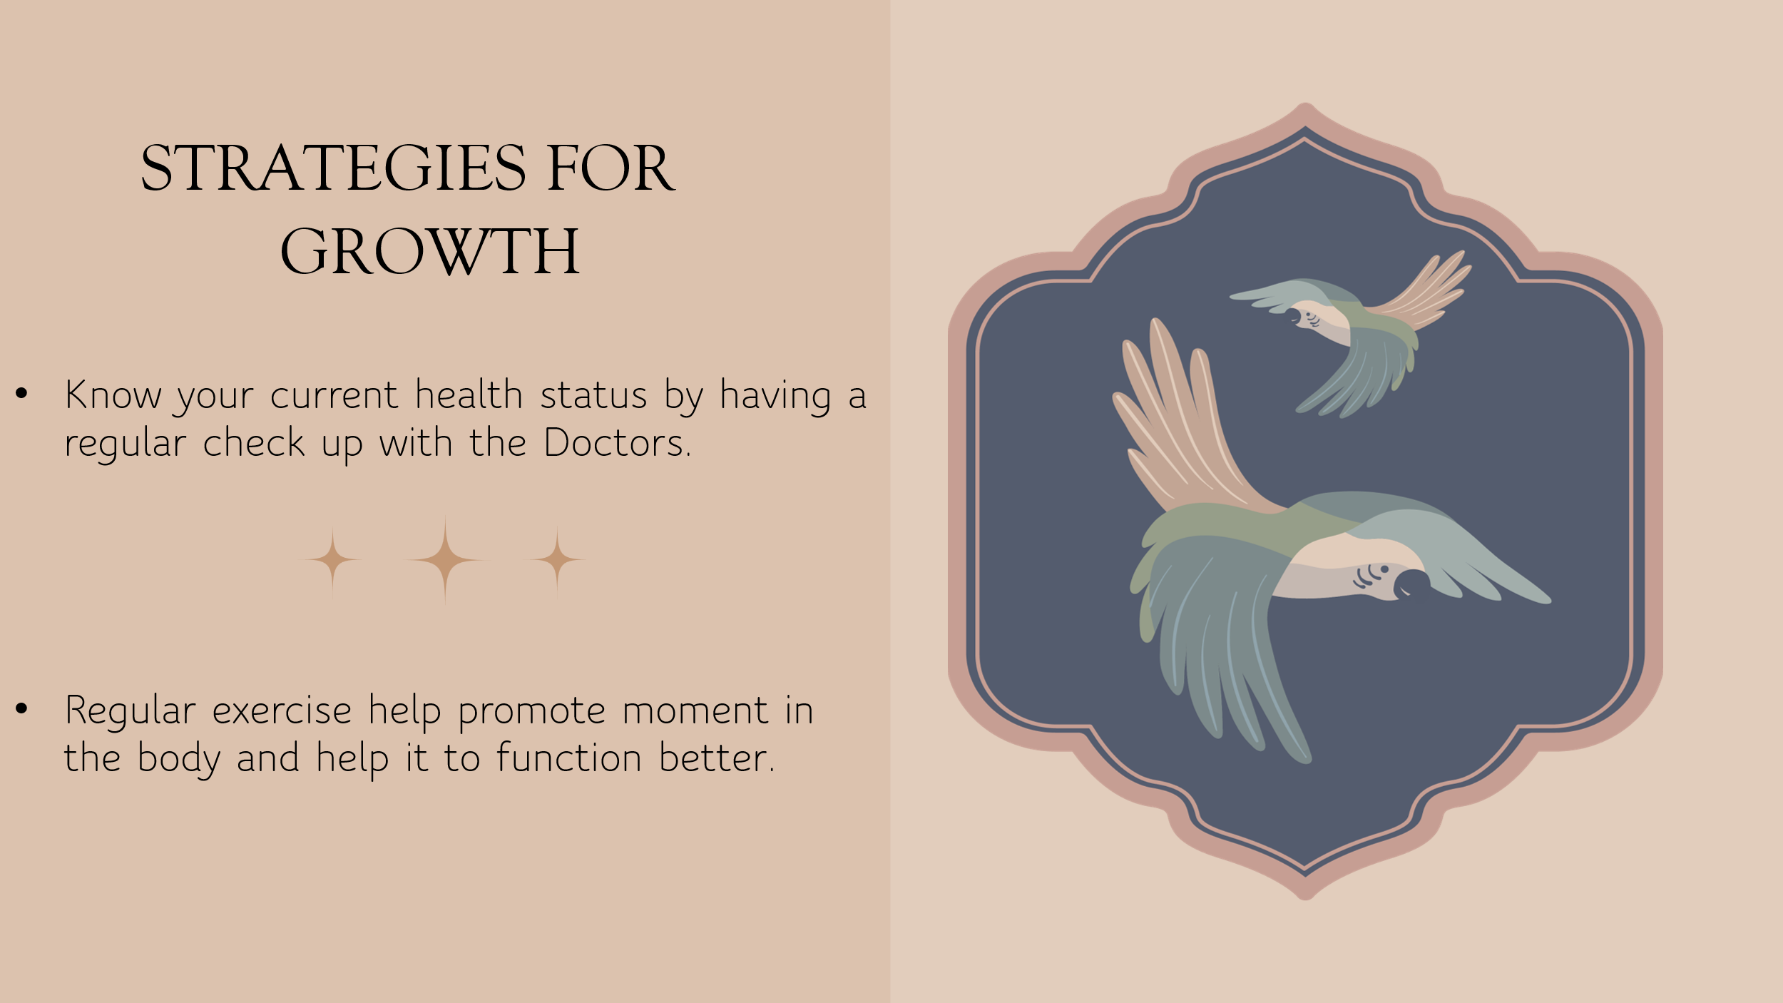
This Photo by Unknown Author is licensed under CC BY-NC-ND
INTEGRATING OUR OLDER POPULATION IS IMPORTANT, BECUASE THEY ARE MORE EXPERINCE AND WE CAN LEARN FROM THEM.

This Photo by Unknown Author is licensed under CC BY

This Photo by Unknown Author is licensed under CC BY-SA-NC
This Photo by Unknown Author is licensed under CC BY

THE AGEING POPULATION IN INGLAND AND WALES
The National health Service (NHS) has implemented several reforms over time to meet the changing health needs of the population in England and Wales. These changes in the health needs because of the eradication and drastic declines in infectious diseases and the changing demography, as well as the rising importance of non-communicable diseases especially among old people (McKee, et al., 2021). The changing demography of these two countries presents new health challenges to the NHS. UK's National Health Service (NHS) has adapted over time to many changing health needs and to advances in the technical and organisational ability to address them (McKee, et al., 2021).
Statistics from the office for national statistics shows a gradual increase in the number of people aged 65 years and above. In 2000, the cohort (65 years and above) represented 15% of the population, in 2009 they represented 16.2% and 18.5 % in 2019 (Office for National Statistics, 2022). About 40% of all admissions in hospitals are elderly people. This cohort takes up approximately 66% of inpatient beds (British Geriatrics Society, 2025). Thus, these changes in demography have contributed significantly to the burden on healthcare services. This is because old people are particularly vulnerable to chronic healthcare conditions such as cardiovascular diseases, diabetes, cancer, arthritis (Khan, et al., 2024) depression and anxiety (Karthika , et al., 2025)
These changes present significant challenges to the NHS. The NHS needs deliberate and elaborate planning to effectively manage all these health conditions. Another problem facing the NHS is the surge in number of older patients with complex care needs (House of Commons Library, 2025). Many Studies have shown that adults have multiple health and social problems that requires person-centred care (Karthika , et al., 2025). However, the challenge for the NHS is not only rising service use, but the increasing complexity of need. Many older adults present with multiple interacting physical, cognitive, psychological, and social issues, which require more coordinated and person-centred care than traditional service models are often designed to provide (McKee, et al., 2021).
As a nation with ageing population needs, it is important for us to have a strategy on how best to manage the situation as the number of people over 65 years keep increasing daily. I will be focusing on ageing healthy and making people over 65 years more active. There are several ways of helping older people live a healthy lifestyle and engaging the in our daily activity and these may include, eating healthy meals, regular exercises, regular check-ups, picking children from school, taken children to social activity like swimming, football, parks, among others.
The NHS have developed a 10-year health strategy booklet called ‘The Practical Guide to Healthy Caring’ to help improve the health condition of our older population, especially those with multiple health condition to reduce frequent visit to the hospital or reduce long time hospitalisation (NHS, 2015). These conditions include diabetes, arteritis, hypertension, Depression, Falls, and other age-related conditions. The idea is to bring Caring to Homes or local communities and Surgeries. If our older population can access all the medical help the need at home or in the community live, they might not need to visit the hospital regularly.

For example, an older person with a high blood pressure, type 2 diabetes, and anxiety can be informed, supported, and trained to manage his or her conditions safely at home without the need to visit the hospital regularly. This person can easily check his or her blood pressure at home regularly by using blood pressure monitor, manage their glucose levels by educating them on what, how, and when to eat. They can also attend online therapy section to manage his or her anxiety safely without the need to go to hospital (Faronbi, et al., 2025).
On the other hand, older people with no close family can also join social clubs, for example community groups like Art Classes, Basic IT Lesson, Dance Classes, Yoga Class, Swimming Lessons, just to mention a few. These community groups are available to support vulnerable people in the society which include pensioners, people with long term conditions and the disable people (National Institute on Aging, 2022).
There are also other strategic plans the NHS have put in place to support older people back into the society after been diagnosed or treated of any of the age-related conditions mentioned earlier on. These strategies help older people to receive after care in their own home, hence reduce or fewer stay or visit to the hospital. These may include; Educating them about healthy eating, advise them to take up new hobbies, and encouraging older people to be more active in their daily life in other to live longer healthier life with little health condition (NHS, 2026). When older patients are empowered with enough knowledge and support required about their health condition and how to manage them, they are less likely to visit the hospital regularly as compared to anyone with no knowledge or support about their health condition ( Ernstmeyer & Christman, 2021).
It is important, we commend the NHS about the investment in AI technology which is currently helping to make faster and more accurate diagnostics of diseases, like cancer, strokes, etc to help improve the life of patients every day. This technology has also help them to improve personal treatments, organised and saved patients’ records which be easily accessed by both doctors and patients at the hospital or at home. Doctors can access and monitor patients from their home without travelling long distance to the hospital with the help of this same technology. The use of AI technology has improved both quantity and quality of service the NHS provide for patients.

References
Ernstmeyer, K. & Christman, E., 2021. Care of the Older Adult. In: E. Claire, ed. Nursing Fundamentals. s.l.:s.n.
British Geriatrics Society, 2025. BGS key messages: Older people's healthcare. [Online]
Available at: https://www.bgs.org.uk/keymsgs
[Accessed 28 March 2026].
Faronbi, J. O., Akinsulore, A., Faronbi, G. O. & Mbada, C., 2025. Barriers and facilitators of social interaction and physical activity participation among Nigerian older adults. Archives of Gerontology and Geriatrics Plus, 2(2).
House of Commons Library, 2025. The implications of population ageing for social policy. [Online]
Available at: https://commonslibrary.parliament.uk/research-briefings/cbp-10338/#:~:text=pensions%2C%20and%20education.-,Health%20and%20social%20care,and%20proposes%20shifting%20healthcare%20policy:
[Accessed 28 March 2026].
Karthika , M., Abraham, J., Kodali, P. B. & Mathews, E., 2025. Emerging Trends of Chronic Diseases and Their Care Among Older Persons Globally. In: Handbook of Aging, Health and Public Policy. s.l.:s.n., p. 641–664.
Khan, H. T. A., Addo, K. M. & Findlay, H., 2024. Public Health Challenges and Responses to the Growing Ageing Populations. Public Health Challenges, Volume 3, p. e213..
McKee, M. et al., 2021. The changing health needs of the UK population. Lancet, Volume 397, p. 1979–1991.
National Institute on Aging, 2022. Participating in Activities You Enjoy As You Age. [Online]
Available at: https://www.nia.nih.gov/health/healthy-aging/participating-activities-you-enjoy-you-age
[Accessed 28 March 2026].
NHS, 2015. A practical guide to healthy ageing. [Online]
Available at: https://www.england.nhs.uk/wp-content/uploads/2019/04/a-practical-guide-to-healthy-ageing.pdf
[Accessed 28 March 2026].
NHS, 2026. Improving care for older people. [Online]
Available at: https://www.england.nhs.uk/ourwork/clinical-policy/older-people/improving-care-for-older-people/
[Accessed 28 March 2026].
Office for National Statistics, 2022. Data and Analysis from census 2021. [Online]
Available at: https://www.ons.gov.uk/employmentandlabourmarket/peopleinwork/employmentandemployeetypes/articles/peopleaged65yearsandoverinemploymentuk/januarytomarch2022toapriltojune2022
[Accessed 27 March 2026].

