Oriane TALBOURDET
1704250

Marketing Planning and Practice

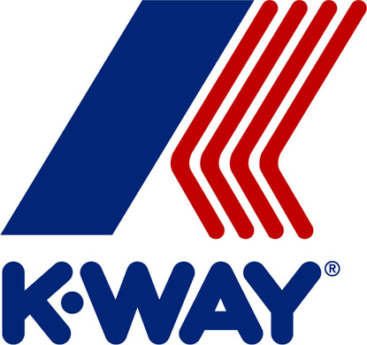
Table of contents
I. Analysis 3
A. Macro environment 3
B. Micro 4
1. Market 4
2. Customer 4
3. Competitors 5
4. The industry structure 5
C. Internal 6
II. Planning 7
A. Mission statement and objective settings 7
B. Segmentation, targeting and positioning 7
C. Strategies 8
III. Implementation 8
A. Tactics- marketing mix 8
1. Product 8
2. Price 8
3. Place 9
4. Promotion 9
5. People 10
6. Processes 10
7. Physical evidence 11
IV. Control/Evaluation 11
V. Implementation 12

K-Way is known for its lightweight packable jacket, ideal for unpredictable weather. Founded in 1965, the brand meets the success quickly. The first year the company sell more than 250,000 copies. In the 80s the jacket became a trend for the whole young generation through a successful movie where the main character is wearing the clothe. However, in the 1992, after the brand dressed the French team and volunteer for the Olympic Games, the factory burned with all the machines and archives. It could be the end of the brand but the company is bought by the Italian group, Basic Net. This is the beginning of a new era for K-Way. (K-Way, 2018)

Analysis

Macro environment

The macro analysis for K-Way is based on the apparel market.
At the political level, we can find all the regulations and laws which are the origin of relocating manufactures. This phenomenon is due to too a strict labour market and to high cost of workforce. In fact, at the origin products from the brand was produced in France but now cost of production are between 3 or 5 times higher. Which would have a big impact on prices of products. However, the company has as aspiration to get back in France to produce capsule production (Huffington Post, 2013).

The apparel market sees its economic environment deteriorated. According to the national institute of statistics and economics studies, budget of French for their physical aspect cut by half since 1960. And in this budget the share reserved for clothing shopping fell by a third. In the clothing sector, French are giving more and more importance to shoes. And in general, this drop can be explained by the apparition of new technologies such as smartphones (INSEE, 2017).
Clothes
Care and personal property
Shoes
Maintenance of property and personal effects
Personal effects

Share of the five budget item in the expenses in physical appearance

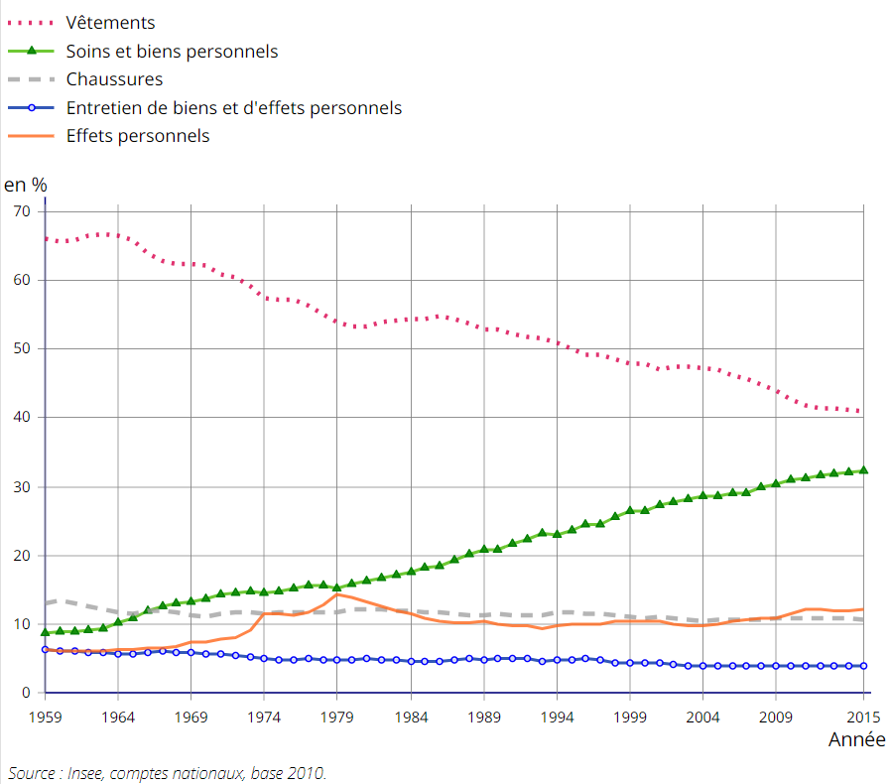

In the social factor, vintage is the new trend in fashion. In fact, it starts with changes in the consumer behaviour and particularly with the young generation. They are more turn to buy sustainable or second hand clothes. (Cassidy, Bennet, 2015). Furthermore, the brand K-Way is present in the mind of French and it is common that people called raincoat from other brand K-Way.
For the technologic factor, since the creation of the first models in the sixties there are new materials. For example, the old design was criticising because it has not enough aeration. In manufacture, technologies improve machines and there is more automation. Moreover, there are also the arrivals of new technologies which transformed the way of doing marketing.

Micro

Market

K-Way is in the clothing sector, more precisely, in the outdoor clothing. They are mainly selling raincoats but they extend their range of product with few tee-shorts, swimsuits and accessories.
In 2016, the company sells for 6.5 million of euros in France. This is low comparing to the principal market, Italy, where K-Way sells for more than 35 million euros (Fashion Network, 2017).

Customer

In Italy, K-Way has been wearing with high fashion pieces, associated with brands such as Dior (Europe 1 JDD, 2016)
In France, when K-Way came back, it was a part of young generation who was buying the products. In fact, it was people qualified as hipsters who was wearing old brands or old styles in order to stand of other people. This phenomenon was on the rise and now it spreads to a big part of the young generation, which concerns people between 15 and 30 years old.
Today, high fashion brands are using more and more streetwear codes and some pieces made their appearance on the podiums. In the Paris Fashion Week, diverse creators modernize the rain coat. The styles seen during the fashion shows are taken up by other brands and therefore become trends. The connected young generation wants to adopt this style. In France a survey highlight that French favour quality products and prefer to buy less clothes in order to have brand clothing (Les Echos, 2017).

Competitors

Competitors of K-Way are big groups such as Nike or Adidas. There is also Decathlon another French brand. But there are also companies that look alike as Aigle.

 | Nike | Adidas | Decathlon | Aigle
Overview profile | Both brands are international and are selling for billions of euros. They are leaders in streetwear. |  | It is a French group selling its own products and brands such as Adidas or Nike. However, its products are at low prices. | This is a French company known first for its rubber boots.
Competitive advantage | Leader in the all world | Challenger | Product at very low prices and product of brands. | Products made in France.
Target Market | People turned to streetwear | People turned to streetwear | Families,  People with small budget | Its product are originally destined for specialists, fisherman, farmer…

The industry structure

Actually, products of the brand are available in 137 places in France. The company has 15 proper point of sale in France. 12 are stores and 3 are stands in department stores. Others are places such as specialist retailers, however they do not offer a large grange of products of the brand (K-Way, 2018). The workforce of the company is currently between 20 and 49 employees; the president is Robert Dodd. The balance sheet assets increased more than the double between 2015 and 2016 (Société, 2018).

Internal

Firstly, K-Way receives a good reputation. It is a French company which is known for decades. The brand is anchor in minds. Indeed, at its creation in the 60s, K-Way was successful thanks to its patent pending on the packable jacket.
Today, besides its reputation K-Way is a whole identity. First the logo which it is the same since the beginning. But it is also the zip with three colours which become mythic.
Since the return of K-Way, the brand tries to be different from the competitors in doing collaborations. These collaborations are only with fashion designers and luxurious brands such as Marc Jacob, Maje, Colette or again Versace.

Strengths  - The brand is using its renown  - Doing collaboration with luxury brand | Weaknesses  - High price  - Commercial coverage
Opportunities  - Exploring more the fashion side with collaborations | Threats  - Budget for clothing less important with the years  - Lot of competitors

Planning

Mission statement and objective settings

If the group Basic bought the company, it is because they see the success that the packable jacket has in Italy. In this country K-Way is selling more than 35 million of euros. In 2016, France was at 6,5 millions of sales, the aim is to first reach 15 million of sales and in a long term orientation be at 50 million of euros (Fashion Network, 2017).

Segmentation, targeting and positioning

The brand is targeting young people between 15 and 35 years old. They are teenagers, students or young workers. Concerning their behaviour, they are sensitive to fashion, they have an active life and they have taste for products of quality. K-Way choose a niche market
Perceptual map of K-Way and its competitors
● Nike
● Aigle
● K-Way
● Hunter
● Adidas
● Décathlon
Prix
Qualité

Even if K-Way is in close competition with brands like Hunter or Aigle at the price quality ratio, the company is distinguishable from the others by a different targeting.

Strategies

With its history and philosophy, K-Way already starts a differentiation strategy. Customers are buying the products because of the characteristics and advantages of the products.
For the defence strategy, K-Way must need to adopt a position defence. In fact, the brand has to work to become the reference in fashion raincoat and be the leader on this segment. It can be on improving promotion or launch new collections with other brands.
The launch of new collection for a defence strategy can also become an offence strategy. Indeed, K-Way can take market share of other brands in ding a flank attack on segment where competitors are weak. Moreover, this strategy is less risky than the frontal attack.

Implementation

Tactics- marketing mix

Product

Raincoat from K-Way are keeping the main attributes from the original designs. They are light and packable. The design is made for the jacket is able to contain in one of its pocket. Like this it can be transported easily everywhere because it is not heavy and does not take a lot of space. Product are also keeping the zip with the three colours and the famous logo.
Moreover, the company decided to move upmarket with a better quality. For that, K-Way is using a new material coming from the NASA. They also improved the quality of their product with finish done with laser technology.
Finally, they are innovated with collaboration with luxury brands to create capsule collection such as tommy Hilfiger. This a touch of modernisation in the design so that the jacket become more fashionable.

Price

In 2014, on the return of the brand in France, where between 50 and 60 euros. However, K-Way raise its prices, around 100 euros, in order to become a premium brand with high quality products. Despite this increase, the price is not allowing the company to produce in France because they do not want to become a luxury brand. However, the company do not close the door for a French production.
This augmentation of nearly a half of the price are not stopping consumers. In fact, after the opening of stores, people are surprised of prices and the company had to explained but after few weeks, consumers integrate this new price (Fashion Network, 2017). As this price is accepted by customers, K-Way does not have to change it.

Place

Generally, the company is not differentiating prices in different countries. For example, prices are the same in Europe. However, in the United Kingdom, prices are a less expensive, after the conversion the price is 15 euros under.
The design of the product makes the transportation and the storage easy. The fact that they are light and do not take place for consumers are also at the benefit of the company.
The company choose a selective distribution. Indeed, the brand refuses to sell its products in stores of Decathlon because it was not in agreement with the image that they wanted to diffused. For the distribution K-Way have recourses to affiliation commission. This form of franchise permitted to the company to have more control on its sales. They can choose which product is going to be sell and it is also K-Way who is taking care of the stocks.
Besides of the stores, K-Way has a website where it is possible to buy. The delivery of the product is free if customers are using a delivery in a parcel drop off point or they are paying a surcharge for a delivery at their place.

Promotion

Actually, K-Way is doing the promotion of the brand mainly on its own website with the presentation of the new collections and brand content, public relations with press talking about last products or about the brand, and social media.
Social media have more and more importance in the promotion of brands. K-Way is present on Instagram, Facebook, Twitter and YouTube. However, despite the presence, they are not performing that well.
Numbers of followers of brands on social medias
 | Instagram | Facebook | Twitter | YouTube
K-Way | 75k | 149k | 2K | 27
Décathlon | 70k | 970k | 37k | 7k
Aigle | 28K | 242k | 10k | 1k
Nike | 77M | 30M | 7,4M | 785k

This table shows that K-Way is late compared to its competitors. With the emergence of social media, there are a new form of promoting on social media. In 2017, in France, nearly 80% of fashion brands put influencer campaigns in place and 70% of them has been efficient to stimulate sales (Luxsure, 2018). If K-Way wants to reach the same volume of sales that in Italy, the company need to act on this. Indeed, according to a Nielsen survey, 85% of consumers say they make their decision after consulting the opinion and articles of these new opinion leaders. Influencers become brand advocates and by their recommendations they can persuade their followers to buy (LaunchMetrics, 2015). For the success of a campaign of this type, K-Way needs to analyse the different profiles to identify which of them could be the best influencer. In fact, the company do not have to choose influencers with the most followers for example. But influencers sharing the same value of the company. It is important to not lose the DNA of the brand. Making partnership with a social media figure is often followed with a promotion. It can be promo code or contest. As K-Way is not doing promotion except during sales. It can be interesting to offer a product as a price through influencers. It would improve the visibility of the brand in social media, the followers, and the affection towards the brand.

During their first era, K-Way used to do television campaign and posters. In order to attract new customers, it could be interesting to start it again. Prices for television campaign are very high in France. Instead if this, clips and videos could be produced to show new campaigns and diffuse on the diverse social media and in the same produce content. For the posters, K-Way can promote its collaboration with other brands in cities, to interest people who were not thinking that the brand could be fashion.

The company will also promote by the way of direct marketing. K-Way collects data including email addresses and thank to that can send emails to the customers. but only for the sales. The goal is not to be intrusive but just to keep informed, consequently it can be just for let consumers know about sales or major events.

People

In the people section, we can find obviously people working for the companies such as the directors in contact with the public relations, but also employees dealing directly with customers. The idea, that everyone need to understand the DNA of the company and for the different target to insist on the quality of the products.
But influencers are also important because they will diffuse an image of the company. As they are not in the company it is more difficult to control what it is said or done. This is why it is important that K-Way makes researches before a partnership. They need to find people consistent with the philosophy of the company and able to touch a large audience.

Processes

Today the delivery is free on condition that customers are taking the product in a parcel drop off point. If someone wants to have a home delivery, he would have to paid 7,50 euros in addition of the total of the shopping bag. It is a high price comparing to the competitors. For example, Nike will offer a free delivery starting from 45 euros. Aigle is like K-Way offering a free delivery for customers who can collect their order and an extra price for home delivery. However, the price is just 5 euros. In order to offer a better delivery service, K-Way can match prices with Aigle.
Moreover, currently they are not guarantee on the product. To prove to the customers that the products are high-quality, K-Way can put a warranty of few years. This will cover the zip, waterproof fabric or seams as the company is promoting on their quality.
Concerning mechanisation, K-Way can also focus on the way of doing their zip. In fact, the process of creation of this part of the jacket is currently the issue to produce in France. If K-Way can find another way to make them requires less human costs the production can be relocated anew. This will give another advantage to buy the product for the consumers.

Physical evidence

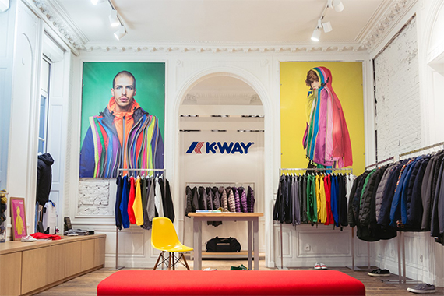
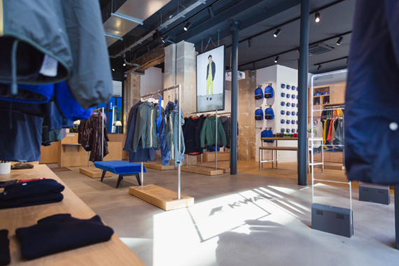
Physical evidence is about ambiance in stores for example. K-Way does not have a lot of stores but each of them is large. Style is style is refined. There are lot of space, and colourful. Sensorial marketing can be used. First the temperature of the stores does not have to be too warm as customers are coming to try coats. Music are also used in stores in order to act on the satisfaction of shoppers. For K-Way is could be interesting to put a playlist with music that the target could like so that customers are feeling closer to the brand.

For the equipment in the stores, the idea is to not give the impression of a cheap brand. Stores are furnished like showroom with sofas. It is a place where customers can take their time to choose. And this is giving an image of a premium brand.
Moreover, employees should wear their own clothes with their own styles, with a badge showing their affiliation to the shop. In fact, customers could feel more comfortable with sellers giving advice if there are dressed following actual trends.

Control/Evaluation

In order to be proactive and to not stay on its achievements, the company needs to control the efficiency of the marketing policy.
Quarterly reports with meeting can be a good way to see the performances of the company. In gathering directors, representatives of the sales department and also representatives of the marketing development they will be able to see if the strategy is working or if they are some modification to makes. They will analyse the evolution of sales in value and volume, look at the market share, see if a reduction of the cost is possible.
It is also important for the company to understand what image customers perceived of the company. The database that the company is building with the creation of customer account to be able to pay on the website or in store, can be used. Survey can be diffuse by emails or by the way of the social media each year before an annual meeting. It can be done to understand expectations of consumers and improve products or promotion. Annual meeting should be with directors of each department of the society (production, logistics, marketing, sales, etc.). They will have to came with a list of ideas to how improve performances of K-Way or fix issues. Then they will have a look on what competitors are doing or new innovation. Finally, they will see the results of the survey and manage to find how they can satisfy more customers.

Implementation

Implementation is based on the resources of the company have to put in place indoor to put in execution the new tactics.
As the social media politic is changing the company will have to hire people in order to be efficient. A community manager to manage the social media but also someone can be hiring to manage all the part on influencers. Moreover, the communication service will need a new person to be able to create content such has posters. It has to be inspired people who will be able to bring creativity.
The budget for this tactics will be substantial. First, they will have to launch promotion campaign with posters and videos. They will also have to pay influencers to speak about their products in front of their community. Always for influencers, they will also have to offer some of their product for creation of contests. But moreover, in hiring people, they are wages which will be count every month. However, if the company cannot afford this, they could choose to take people with block release training or student in work placement.
To be able the implement well the marketing mix, it I important to be careful about the timing. To respect due date and see the advancement the company can follow a Grant diagram.
 | J | F | M | A | M | J | J | A | S | O | N | D
Researches of influencers | X | x |  | X | x |  | x | x |  | x | x
Contact and negotiation with influencers |  | x | x |  | x | x |  | x | x |  | x | x
Creation of the email for sales promotions |  |  |  |  | X |  |  |  |  |  | X
Sending the emails |  |  |  |  |  | X |  |  |  |  |  | X
Creation of posters |  | x | x |  |  |  |  | x | x
Diffusion posters |  |  |  | x |  |  |  |  |  | X
Creation of videos | X |  |  |  | x | x | X |  |  |  | x | x
Diffusion videos |  | x |  |  |  |  |  | x | x

In the material, the company will still need its social media which is a big part of this new plan. But they will also need all computer system to handle the database and all programs too editing pictures, design poster or shoot and edit videos.

References
- Cassidy T. D., Bennet H. R., 2015. The rise of Vintage Fashion and the Vintage Consumer. The Journal of Design, Creative Process & the Fashion Industry, Issue 2, pp.239- 261
- Challenges, 2014. Comment K-Way est devenue une marque fashion? [online] Available at: <https://www.challenges.fr/entreprise/comment-k-way-est-devenue-une-marque-fashion_90405>
- E-marketing, 2017. K-Way signe un retour gagnant. [online] Available at: <http://www.e-marketing.fr/Thematique/retail-1095/Breves/la-strategie-marketing-de-K-Way-pour-se-relancer-312596.htm#OkWURKIjraMBGwE2.97>
- Europe 1 JDD, 2016. K-Way a le vent en Poupe. [online] Available at : <https://www.lejdd.fr/Economie/Entreprises/K-Way-a-le-vent-en-poupe-768699>
- Fashion Network, 2017. K-Way met le Turbo sur L’ouverture de Boutiques. [online] Available at: <http://fr.fashionnetwork.com/news/K-Way-met-le-turbo-sur-l-ouverture-de-boutiques,808674.html#.WuissExFyuU>
- Huffington Post, 2013. La marque K-Way renonce dans l’immédiat à sa production « made in France ». [online] Available at: <https://www.huffingtonpost.fr/2013/08/29/k-way-renonce-made-in-france_n_3835089.html>
- INSEE (Institut National de la Statistique et des études économique). Les dépenses des Français pour leur apparence physique. [online] Available at: <https://www.insee.fr/fr/statistiques/2550287>
- LaunchMetrics, 2015. Marques et Influenceurs : l’importance des prêts produits. [online] Available at: <https://www.launchmetrics.com/fr/ressources/blog/prets-produits-influenceurs>
- Les Echos, 2016. K-Way : une marque imperméable au temps qui passe. [online] Available at: <https://www.lesechos.fr/idees-debats/editos-analyses/0211111602572-k-way-une-marque-impermeable-au-temps-qui-passe-2013388.php>
- Les Echos, 2017. Le marché de l’habillement a perdu 14% de sa valeur en dix ans. [online] Available at: <https://www.lesechos.fr/03/10/2017/lesechos.fr/030648783008_le-marche-de-l-habillement-a-perdu-14---de-sa-valeur-en-dix-ans.htm>
- Luxsure, 2018. L’Etat du Marketing d’Influenceurs. [online] Available at: <https://www.luxsure.fr/2018/04/30/letat-du-marketing-dinfluenceurs/>
- Marketing Strategies, 2017. Brand Content et Mix-Marketing : la Marque K-Way. [online] Available at: <https://www.marketing-strategie.fr/2017/03/02/brand-content-mix-marketing-marque-k-way/>
- Société, 2018, K-Way France. [online] Available at: <https://www.societe.com/societe/k-way-france-753625268.html>
- Strategies, 2014. K-Way Prend Bien le Vent. [online] Available at: <http://www.strategies.fr/etudes-tendances/tendances/229337W/k-way-prend-bien-le-vent.html>

