

Managing Enterprise in 21st Century
BMSW4006
Assignment 1 Business plan
Group report

Diana Decheva student ID 2129230
(group leader)
Table of contents
Business description and history
Business structure

Dinyo Radev student ID 2129750
Product or service description
Market analysis and trends

Ciprian-Nicolae Jalba student ID 2130487
Operations
Technology plan

Theodora Petrean student ID 2029740
Management and organization
Social responsibility and sustainability

Krasen Dinchev student ID 2133257
Development,milestones and exit plan
Financial data

Cover letter
Reasons to contact the funder: The company Nutrition Monster requires funding in order to fully develop its services and business model in order to achieve profitable commercial activities. The funding is expected to cover essential investments at this early stage of business development.
Nature of the business: Nutrition Monster is a start-up service company offering an advanced mobile application (app) in the field of nutrition and dieting. It is a private limited organisation with ten skilful employees and ideas for market success in the fast-growing nutrition mobile app sector.
Amount of necessary funds: The total required funding is £250,000. The commitment of the business owner is clearly demonstrated by investing £150,000 in own capital. Therefore, the new business needs £100,000 of external funding in order to cover all expenses. The amount will be primarily used for equipment investments.
Type of funding: The sought external funding is a bank loan. The bank loan of £100,000 meets the funding needs of the business and prevents excessive indebtedness and bankruptcy risk due to the engagement of considerable equity capital, as well.
Principals and contact information: Diana Decheva, contact information

Executive summary
The business plan analysed the case of Nutrition Monster – a start-up business in the field of nutrition mobile app. The business plan consisted of several thematic sections analysing various aspects of the new company and its future intentions in the marketplace. The discussion included a brief business description, clarifications regarding the business structure and management, service description, operations and technology plan. Strategic decisions and forms of differentiation in the marketplace were also key areas of discussion in the business plan. The analysis also included a detailed secondary data discussion about the external business environment and trends, as well as the most applicable forms of technologies. The information from the report could be seen as quite supportive for the future development of the company, as the latter could operate more efficiently and use the scarce resources in the most effective manner. The discussion also included a detailed plan regarding the future performance of the company in terms of key activities, development goals, scheduling and funding. The inclusion of detailed financial assumptions and future performance metrics were of key importance for analysing the expected performance and areas of possible weakness for the company. Considering all, the business plan managed to clarify many aspects of the future development process; thereby, enabling the company to operate in a more effective manner in order to accomplish the main business goals.

Table of Contents
Cover letter 2
Executive summary 3
Business description and history 5
Business structure 8
Service description 10
Market analysis and trends 14
Operations 17
Technology plan 20
Management and organisation 23
Social responsibility and sustainability 26
Development, milestones and exit plan 29
Financial data 32
References 36

Business description and history
The business plan initially clarifies the overall description of the business idea. One of the key specifics of the new business entity refers to the lack of previous business history. This is an entirely new business entity which is established for the purposes of the current business initiative. Thus, the company may also be a considered as a start-up organisation. The lack of previous business history may be a major drawback when applying for a business loan from a financial institution. It also means no brand value and accumulation of retained earnings. Regardless of these disadvantages, the business idea appears to be quite promising and the new business is motivated to start as a brand new company pursuing worthy commercial goals.
The name of the business is a key element in the description. Nutrition Monster is the selected name with the idea of developing the name as a strong brand over time. This particular name is not randomly selected; instead, it aims at describing the main idea behind the proposed business idea – to facilitate one’s understanding and performance in the field of nutrition and dieting. In addition to meaning, the proposed name is stimulating and easy to memorise. Hence, it may be more easily remembered by prospect users or motivate the choice of the mobile app when seeing several possible options to choose from.
The description process also includes some primary elements, which are used by every serious organisation, such as mission, vision, corporate objectives and values. These elements additionally clarify the business and its description. To begin with, the mission statement shows the main purpose behind the existence of the business. More specifically, Nutrition Monster has the following mission: “To improve one’s physical and mental well-being”. Second, the vision statement describes the ways of achieving the mission. The vision of Nutrition Monster is, as follows: “To develop an advanced digital tool for self-management, inspiration and support”.
Third, it is also important to incorporate several relevant corporate objectives linked to the mission. In the case of Nutrition Monster, the list of corporate objectives includes: 1) development of an open-minded organisational culture; 2) incorporation of the most advanced technological solutions; as well as 3) satisfying changing customer needs.
Last, but not the least, the values of the organisation are key pillars of its organisational culture and determine the attitudes and behaviours of organisational members. The values of Nutrition Monster include integrity, innovation, open-mindedness, flexibility and cooperation. Nutrition Monster will incorporate the values to develop a specific mindset, attitudes and behavioural norms among its organisational members, so that an effective entrepreneurial culture is eventually developed. Such entrepreneurial culture is also expected to strongly support the actual performance of the new business entity.
The main motivation behind the creation of Nutrition Monster stems from the desire to develop a sophisticated mobile app which promotes healthy lifestyle on the basis of nutrition and dieting changes. The actual features of the mobile app are described in more details later in the business plan. Considering the intended product, the business model of the organisation relies on two groups of customers. The first group consists of users with free-of-cost access to the mobile app. They will not pay anything but receive access to basic features of the mobile app. Free-of-cost users should also accept advertising messages by sponsors. In contrast, the premium users, who pay a monthly subscription fee, are expected to have full access to all features of the mobile app, as well as no advertising messages at all.
At this stage of development, it is also important to identify the unique selling point (USP) of the new product. This is important to understand how the mobile app outperforms competitors and delivers exceptional value to customers (Kotler and Armstrong, 2013). The USP of Nutrition Monster stems from its ability to combine the characteristics of many similar mobile apps at a single place. This is unique, as it requires considerable efforts to develop a wide range of services in order to meet a variety of already existing needs of customers. The proposed USP is quite serious and could serve as a foundation for business growth and development.
Another key area of consideration relates to the identification of target customers. Knowing the customer in advance is of help in developing a more relevant business model and product/service proposition. As shown below, customer groups are identified on the basis of segmentation process – a valuable process in the field of marketing where the entire market of potential users is divided into smaller and homogenous groups (Kotler and Armstrong, 2013). Segmentation is done on the basis of four criteria: geographic, demographic, behavioural and psychographic (Kotler and Armstrong, 2013). Each of these criteria has additional specifics, as shown below (Savage, 2019).
Figure 1 – Overview of main segmentation criteria
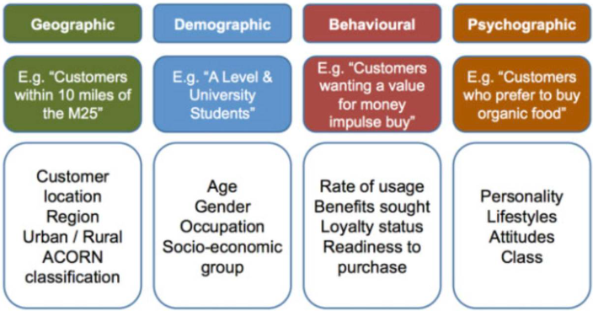
Source: Savage (2019)
Geographically, the services of Nutrition Monster are intended to serve UK customers. More specifically, the large metropolitan areas are targeted. Nevertheless, there are no strict geographic limitations, as the English-based mobile app may be accessed by international potential customers, as well. The importance of demographic segmentation is quite relevant in this case. The company targets mainly users between the age of 20 and 45 years. These are both – male and female users – who are of young (active) age. Behavioural segmentation is also applicable, as the new product aims at attracting already existing users of nutritional mobile apps who look for better services. From a psychographic point of view, the new product aims at attracting individuals with a well-established healthy lifestyle, sustainable values and positive attitudes to health and nutrition.
Considering all, the four segmentation criteria are to some extent applicable in the case of Nutrition Monster. On the basis of the actual business experience and incoming data, the company may apply changes accordingly.

Business structure
The analysis continues with a detailed overview of the business structure and its role for the management of the organisation. Structure depends on the size of the organisation and functional areas of specialisation (Rollinson, 2019). In the case of Nutrition Monster, the organisation is composed of just ten members (including the owner). This number of full-time employees also suggests that the company could be considered as a small organisation. This is the case, as small organisations are defined as having between 10 and 49 employees, according to OECD classification (OECD, 2022). Being a small company in terms of size also predisposes for applying a relatively simple structure, as discussed in this section of the business plan.
There are several functional areas worth being discussed in more details, as they determine the choice of organisational structure. The owner is also the chief executive officer (CEO). This means the owner directly participates in the management of the entity by making all strategic decisions, as well as managing the everyday operations and employees. Thus, the owner has a diverse scope of roles and responsibilities in fields, such as strategy, business development, general management, human resource management and others. These are key areas and the owner has a critically important role for the development of the entire organisation as a whole.
The other roles include IT, accounting, marketing and customer support, as shown below. These functional areas work independently but must align with the goals of the company. These are also the main functional areas of the company but emerging issues may require additional support for professionals. As a result, it is quite likely to hire on-demand professionals in different fields to cope with temporary problems.
Depending on the needs, a different number of professionals are considered in each of the respective areas. There are three IT developers responsible for the creation of the mobile app and supporting activities. Their role could be of decisive important for the long-term performance of the company due to the involvement in the product development stage. The marketing specialists are two and they are responsible for the advertising, brand development and social media presence of Nutrition Monster. Most of the marketing activities will be in the field of digital marketing. The customer support field is composed of three professionals handling various issues and questions of the mobile app’s customers. Respectively, these professional play a key role in delivering exceptionally high quality of customer service. Finally, there is one in-house accountant, as well. The following chart depicts the structure of Nutrition Monster but changes may be considered depending on the actual performance and needs for re-structuring after the start of commercial activities.
Figure 2 – Organisational structure
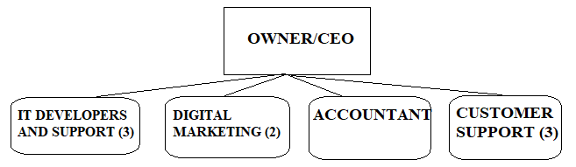
The structure of Nutrition Monster, as seen from the visual presentation, is quite flat. The structure lacks multiple layers of roles and responsibilities which are typical for large and hierarchical companies. This is not surprising as flat structures are common for small-sized organisations.
The structure also clearly shows the functional areas of specialisation. Given the main roles, it can be suggested that workforce members combine skills and expertise in order to effective perform the outlined key job roles. Regardless of the area of specialisation, it is necessary to possess subject-specific skills and competences to be a valuable member of the organisation. Considering the high level of specialisation, the organisational structure provides a rationale for adopting a laissez-faire leadership style. This is a “hands-off” approach to management where highly-qualified employees perform in an autonomous manner (Uzohue et al., 2016). The leader (CEO) provides the main strategic goals and support, if necessary, under the laissez-faire leadership framework (Uzohue et al., 2016). Considering this, organisational members have the freedom to be creative and find the most optimal solutions to a variety of everyday issues. This is a key to the development of a dynamic and problem-solving organisational culture – a key for the success of the start-up company. The laissez-faire approach to leadership is also expected to foster morale and motivation of organisational members in the workplace (Uzohue et al., 2016).
The proposed structure also has a range of additional benefits. First of all, the company can be quite easily managed due to the simplicity of the structure (Rollinson, 2019). The flat organisational structure also promotes fast and efficient communication process at organisational level, as there are no formal communication channels (Rollinson, 2019). As a result, the CEO can be quickly approached by employees due to the fact that they are all physically located in a single office. Moreover, there are no layers between the owner/CEO and the other employees – a key factor predisposing for a direct communication process. Considering these specifics, any problem can be quickly discussed with the owner or colleagues in order to be solved in a fast manner. This is quite important for Nutrition Monster because the company can effectively achieve quick decision-making process – a key for being responsive to the changing needs of the dynamic external environment (Rollinson, 2019).
Given the ability to communicate and exchange ideas, the flat structure also stimulates the process of idea sharing, transparency and creativity (Rollinson, 2019). These benefits can be considered as key factors for success for a start-up organisation in the technological sector.
Taken together, the above-mentioned features of the proposed flat structure indicate the existence of several key benefits for Nutrition Monster. The structure is also in alignment with the proposed organisational culture combining the key values of integrity, innovation, open-mindedness, flexibility and cooperation. The organisational structure is thus seen as one of the key tools to organise the working process, culture and overall performance of Nutrition Monster.

Service description
The service description process is extensive and includes not only an overview of the key features of the service, but also important strategic considerations in the fields of marketing and generic strategy. Thus, the information in this chapter shows the initial service features, as well as the future intentions in the field of service development affecting the long-term performance of Nutrition Monster.
First of all, the service’s main characteristics are analysed. As mentioned earlier in the business plan, ordinary (free) and premium customers can use a different range of functionalities. This description includes the full functionality of Nutrition Monster; thereby, describing what premium users could use as a result of their subscription.
The mobile app intends to deliver extensive information regarding the macronutrients and micronutrients of separate types of food items, as well as meals. This information is expected to inform users regarding their nutritional choices. The mobile app also includes pre-determined meal plans, grocery lists and recipes which can be selected freely or on the basis of predetermined search parameters. In this way, users may find the most appropriate solutions depending on individual preferences or a given type of diet followed by users. In this relation, the mobile app also offers filters which facilitate the access to relevant information; thereby, reflecting the specific wants of users.
The availability of analytical and statistical tools is also a key feature of the mobile app. This facilitates the ability of a given user to monitor performance control the process of eating and dieting. Users can measure many aspects of their behaviours – calories, steps, weight change and others. The mix of analytical and statistical tools is also supportive for the provided performance trackers. The latter are useful in the process of goal-setting – another key feature of the mobile app. There are also predetermined goals, as included in a separate list, but the process of goal-setting is personalised. In addition, users can access a variety of daily, weekly and monthly challenges stimulating the process of change and the feeling of being challenged. This is expected to have a strong impact on the individual level of motivation and engagement of customers. The mobile app also supports the actual performance progress of users by creating and offering thematic databases – physical activities, specific exercises, as well as other helpful activities, such as meditation, relaxation and others depending on the level of customer interest.
As shown, the above-mentioned features aim at delivering a wide range of services to users. Another key feature refers to the personalisation of these services which is to some extent achieved via the implementation of filters and individual goal-setting. Premium users can also access professionals in the field of nutrition and dieting, such as nutritional specialists, psychologists and other experts. In an attempt to strengthen the level of service personalisation, the mobile app also offers tips, advises and even community support groups to boost the sharing of ideas and mutual support of users in a truly community-based atmosphere.
The service description also incorporates a marketing mix analysis. The marketing mix includes product, price, place and promotion – four key elements determining the proposition of the business (Kotler and Armstrong, 2013). The choice of an appropriate marketing mix is of key importance for maximising demand and positioning the new brand in the marketplace (Kotler and Armstrong, 2013). The marketing mix analysis of the service is briefly explained, as follows:
- Product: The mobile app provides a service, not a product. The service is divided into two main types: basic and premium. Basic services include only the most important features of the mobile app. Premium services or the full range of available services are available to the subscribed users. In addition, it is important to note that premium users will not have advertising content on the mobile app.
- Price: Basic users can use the mobile app at no cost. The premium version is offered at a price of £9.99 per month.
- Place: Considering the service, there is no need for physical space, such as stores or others. The actual distribution of the mobile app takes place in an entirely digital format, as customers can download the mobile app via iOS or Android.
- Promotion: This element of the marketing mix will be fully utilised after some time. Promotion will include loyalty schemes for long-term users, such as gifts and discounts when using supporting services.
In addition to the marketing mix, the service description also considers the generic strategy of Nutrition Monster. The choice of generic strategy largely determines the sources of differentiation and general market exposure (Porter, 1985). These in turn can have a considerable impact on the actual service development process. There are four generic strategies on the basis of mixing the two dimensions of market exposure and sources of differentiation. Nutrition Monster has to select only one strategy, as performing different strategies could lead to a lack of strategic clarity and ineffective process of brand development (Porter, 1985). In this relation, the company has to incorporate a clear strategic focus, which determines the future service development, and avoid the risk of being “stuck in the middle” (Porter, 1985).
Figure 3 – Generic strategies
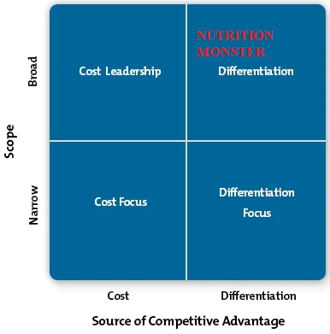
Source: Mind Tools (2022)
As shown, Nutrition Monster applies differentiation generic strategy. This means that the company aims at servicing the broad market (Porter, 1985). The business description in the beginning of the business plan demonstrates the intentions to meet the needs of several customer segments; thereby, aiming at reaching a large market share. More importantly, the differentiation generic strategy also means being competitive on the basis of high service quality which cannot be matched by the existing competitors in the marketplace (Porter, 1985).
Considering these important strategic insights, Nutrition Monster will further develop its mobile app by prioritising service quality, as well as offering even a wider range of service features. In this relation, it is also important to consistently demonstrate innovation, customisation of services, as well as excellent post-purchase support. These are considered as key pillars for success market performance as a whole.

Market analysis and trends
The analysis of the external environment considers the key features of the business environment in the UK under the PESTEL framework (Johnson et al., 2017). The relevant political, economic, social, technological, environmental and legal factors are critically analysis in an attempt to outline the main opportunities and threats influencing Nutrition Monster (Johnson et al., 2017).
From a political point of view, the UK is popular with its political stability. The existence of a well-established democracy, efficient public institutions, rule of law, very low level of corruption and business-friendly regulations are key characteristics of the political environment with a positive impact on business climate and development, as well (World Bank, 2022). The Brexit process and the frequent changes of governments are some factors for uncertainty and instability but the UK has remained an attractive business destination regardless of these temporarily issues (BBC, 2022).
Economically, the UK is considered as a high-income country with annual income per capita of $47,500 (Country Economy, 2022). This means that the UK consumers have a considerable purchasing power – a positive factor stimulating the demand for the mobile app. Moreover, the UK is a large economy as a whole with a total gross domestic product (GDP) of $3.2 trillion per annum (Country Economy, 2022). This means that the size of the entire economy of the UK is quite large – a prerequisite for excellent business opportunities. The market situation is characterised by high inflation, reaching 10.7% as of December 2022 (Country Economy, 2022). The escalating costs of living are a problem for Nutrition Monster because high inflation may increase the costs of doing business, such as rent, salaries, etc. The high inflation level, which is far above the official policy rate of 2% per annum, also means fewer resources for discretionary spending for UK consumers and generally eroded purchasing power – factors inhibiting the demand for the mobile app. The recent increase in the interest rates by the Bank of England (2022) is seen as a positive policy measure to cope with the high inflation; however, the current rate of 3.5% and expectations for future increases certainly means higher borrowing costs for Nutrition Monster.
Social factors are also quite indicative for the nature of the marketplace (Johnson et al., 2017). Demographic trends reveal a sustainable trend for population size increase. Projections by year 2030 suggest almost three million extra people and a total size of 70 million (ONS, 2021). If all other factors are kept constant, the growth of the population means higher demand for the mobile app’s services.
Figure 4 – UK population size by year 2030
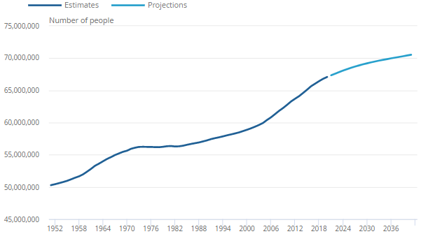
Source: ONS (2021)
Technologically, the UK is one of the most advanced countries in the world, as suggested by the Global Innovation Index (GII, 2020). This means that advanced technologies, qualified professionals and capital for start-up business development are abundant in the UK (GII, 2020). The technological sophistication is a positive factor for the development of Nutrition Monster, as the start-up company requires the implementation of advanced digital skills.
The external market analysis also acknowledges the growing relevance of environmental factors. The UK applies a sophisticated regulatory framework in the field of climate change and environmental protection. Nutrition Monster has to also consider the increasing consumers’ preferences for sustainable development. According to consumer survey, 18% of UK consumers, predominantly young people within the target group of Nutrition Monster, are ready to boycott unsustainable brands (Statista, 2021). As a result, commitment to sustainability has become a factor for differentiation worth being considered by the mobile app, as well (Statista, 2021).
Legal compliance is also necessary by the new company. There are many legal factors worth being considered, such as labour legislation regulating health and safety at work, pay rates, working hours, anti-discrimination rules, etc. In addition, Nutrition Monster must strictly comply with the GDPR 2018 propositions – a set of rules for a safe use and storage of private and sensitive data. This piece of legislation is relevant, as the mobile app will process, collect, store and analyse large volumes of data related to its users. In general, legal compliance may be costly and time-consuming; however, underperformance in the area may be costly in terms of lost reputation and financial penalties (Johnson et al., 2017).
In general, the external environment in the UK is positive, despite the economic challenges and temporary political turbulences. Hence, the external business environment is supportive for the development of Nutrition Monster.
The analysis of the marketplace also includes specific information about the tiny sector of nutrition mobile apps. As of year 2021, the market has a total size of $10.1 million in terms of annual turnover (GVR, 2022). This is per se a small market but the trends are quite positive. First, the resilience of the market during the pandemic 2020 should be noted (GVR, 2022). Second and more important, the growth expectations are quite solid. As shown by the chart, the industry is definitely in its growth stage. The growth expectation up to the end of the decade are solid – 18.8% in terms of compounded annual growth rate (GVR, 2022). Such growth dynamics is quite rare and it delivers exceptional opportunities for profitable business development.

Figure 5 – Market size and projections of the nutrition mobile app sector
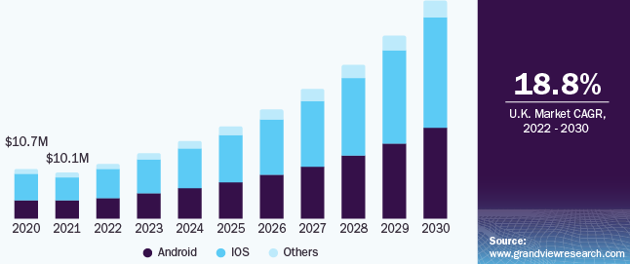
Source: GVR (2022)
The rapid increase of the nutrition mobile app sector, as projected by GVR (2022), also means a generally subdued level of competition. This is the case as existing and newly entering companies have access to a generally larger marketplace with more actual and prospect customers. This situation additional supports the case of being able to maintain healthy profit margin and attract new customers. Moreover, the expected growth also suggests the existence of sustainable consumer trends and preferences towards a healthier lifestyle (GVR, 2022). Considering all, the external trends are quite positive which provide a strong stimulus for future business development.

Operations
This section of the business plan provides more details regarding the operations of the company. This is a critically important area, as operations determine the main processes in the firm and the ways of creating value to customers (Slack et al., 2013). Hence, the conduct of efficient operations is a requirement for business success and competitiveness. The Porter’s value chain model is used to describe the main areas of operations and value creation (Porter, 1985). As shown below, the value chain of a business consists of primary and secondary activities, which is also the case with Nutrition Monster (Porter, 1985).
Figure 6 – Porter’s value chain model
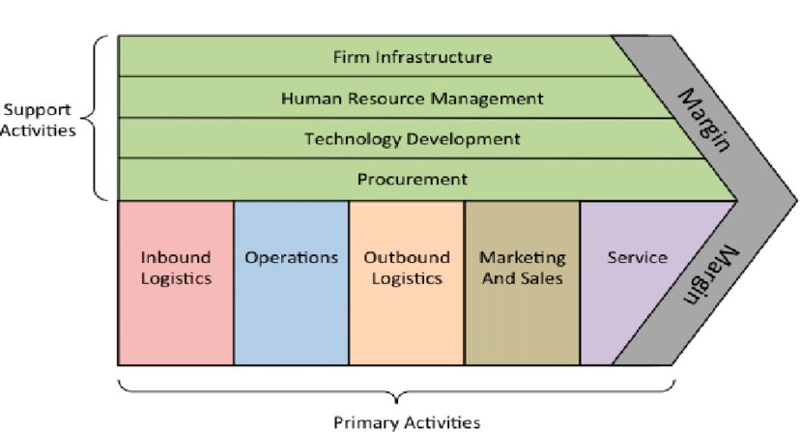
Source: Porter (1985)
To begin with, the company provides a service where the dependence on suppliers is quite limited. Thus, the inbound logistics of Nutrition Monster mainly refers to the acquisition of the initial equipment (hardware) and specialised software. The effective shortening of the value chain due to the elimination of suppliers also means an increased control over operations and minimisation of the risk from inefficiencies which may originate from late supplies or excessive inventory (Porter, 1985; Slack et al., 2013).
The second stage of the model refers to the actual operations (Porter, 1985). In the case of Nutrition Monster, the mobile app operates entirely automatically. The incorporation of advanced technologies, which are discussed in more details later in the business plan, also means the delivery of completely automated services and processes. This also means that the daily operations of the company are not manual and the instances of human intervention are rare and limited to situations when something must be adjusted or fixed. In general, the automatic operations facilitate the achievement of high efficiency and effectiveness, as well as almost 100%v error/defect elimination (Slack et al., 2013).
Third, by definition, outbound logistics refers to the channels through which a product or service is distributed to customers (Porter, 1985). Nutrition Monster uses the standard mobile stores, as the mobile app is downloadable via iOS and Android operational systems. As earlier discussed, both operational systems will continue dominating the market for nutritional mobile apps (GVR, 2022). Therefore, the application of the two largest operational systems is quite expected. In addition, the development of entirely digital outbound logistics also eliminates the necessity to invest considerable resources in physical stores and complex distributional channels. These are key factors for minimised investment requirements and improved efficiency for Nutrition Monster.
Fourth, marketing and sales also add value; hence, their participation in the value chain model is relevant (Porter, 1985). Considering the service nature of the business, the conduct of excellent marketing and sales activities could be a key for maximised consumer demand and strong brand development process (Kotler and Armstrong, 2013). As earlier discussed, sales are made when a given customer decides to download the mobile app and subscribe for the premium membership. Thus, sales take place via phones and with not physical locations. The marketing process incorporates digital marketing channels – Facebook posts, Instagram photos, Twitter announcements, YouTube videos and others. Social media are quite cost-effective and focused on targeting the attractive customer groups (Kotler and Armstrong, 2013). Therefore, digital marketing and omnichannel development appear of being of key operational importance for attracting new customers, especially at the early stages of business development when the Nutrition Monster brand is generally unpopular.
The fifth key primary activity, which determines business operations, refers to service (Porter, 1985). Given the fact that Nutrition Monster offers a service, it is of essential importance to also conduct 24/7 error-free and customised customer service and support processes. This comes as an addition of the fact that the mobile app delivers a wide range of customised and automatic services to its users. Considering the service description and business idea as a whole, the development of highly differentiated and customised services is the most important factor for business success. In addition to all, the hiring of three professionals in the field of customer service and support is also evidence for the prioritisation of the customer service process as a key operational process for Nutrition Monster.
The analysis of the five primary activities from the value chain model indicates that Nutrition Monster creates value from four of them by eliminating inbound logistics. Outbound logistics and operations are also quite tech-savvy and automatic. Thus, the human factor in the general operations is mostly focused on marketing/sales and services. This is evidence for a highly-efficient operational framework which is able to deliver productive and value-added processes.
In addition, Nutrition Monster’s operations also depend on some secondary activities. In brief, the company does not offer a physical product which eliminates the need for procurement (Porter, 1985). Firm infrastructure is relatively simple, as it is a flat organisation with minimum capital and human resources. While the simplicity of the firm infrastructure may be considered as a weakness, it is a positive factor in this case because of the ability to establish a flexible organisation and adjust operations accordingly depending on market- and customer-related changes. Technologies and human resource management are key secondary activities supporting the operations of Nutrition Monster. Technologies are discussed in the next chapter of the business plan. Advanced technological solutions are employed in order to eliminate errors, support automation and customisation of processes (Slack et al., 2013). The reliance on human capital is also extensive given the sophisticated mobile app, high maintenance requirements and customer service standards. As discussed, structurally, the firm closely depends on the recruitment of professionals with niche specialisation, creativity and an innovative mindset.
Considering all, operations eliminate outbound logistics and procurement, while firm infrastructure and outbound logistics are kept simple. The operational success of Nutrition Monster thus depends on the ability to simultaneously use and coordinate talented professionals and advanced technologies. Such operations are typical for many technological start-ups. The achievement of operational efficiency is a key requirement for sustainable business development and overall competitiveness.

Technology plan
This part of the business plan explains the use of technologies by Nutrition Monster. The implementation of the most advanced technological solutions is a key for being competitive in the marketplace. Technologies deliver not only operational efficiency, but also ability to better serve the specific needs of customers which is a key factor for competitiveness.
To begin with, the actual development of the mobile app requires the acquisition of specific mobile app development software, as discussed in more details in the financial plan. The start of the company also requires investments in hardware – laptops and other relevant equipment. Hence, the combination of specific types of software and hardware is seen as a considerable but compulsory initial investment in the new company, so that the latter is able to develop the mobile app and operate in a productive manner.
Second, cloud-based data storage is also an important aspects of the technological development of the company. The operations of the mobile app are related to the collection of sensitive and personal data about customers and their activities on the mobile map. Such data should be properly stored and protected against unauthorised access and cyber security risks. Therefore, using the cloud is seen as an advanced technological solution in maintaining high standards of cyber security (Al Mehdar, 2022). Moreover, the cloud has a considerable storage capacity which is necessary in order to properly handle large volumes of information regarding thousands of customers (Al Mehdar, 2022). Considering the use of the cloud, Nutrition Monster will be able to comply with the best standards in cyber security and the legal regulations, as clarified by the GDPR 2018 Act.
Third, additional cyber security systems are necessary to protect other activities beyond data storage. For example, premium subscribers are expected to make regular payments of the subscription fee. These payments will be protected by advanced cyber security software and systems. The cyber security system Intruder is a reasonable proposition. This is one of the best systems in the marketplace which is also particularly relevant for small businesses (STH, 2022). Intruder is entirely cloud-based and protects against 9,000 different types of distinct security vulnerabilities, including payment security threats (STH, 2022). The security system is able to perform periodic scanning for web application flaws, emerging threats, notifications, network issues and others (STH, 2022). Considering these benefits, Nutrition Monster is willing to invest in Intruder or other potentially relevant cyber security systems.
So far, the focus of the discussion is placed on security protection – a key for developing confidence among users about the reliability of the mobile app. Given the results from the discussion, cyber security is a key factor for the success of the mobile app; hence, this technology is prioritised as a part of the technology plan.
Otherwise, Nutrition Monster also plans to apply several types of technologies focused on better customer service and management. One of these key technologies is Big Data analytics. The technology has proven its value in collecting large volumes of customer-based data in real-time and analysing consumer trends (Rijmenam, 2014). More specifically, Nutrition Monster can apply Big Data analytical tools in order to measure the actual behaviour of customers when the latter use the mobile app. Thus, the company will be aware regarding the rate of usage of the different functionalities of the mobile app and the relevant development trends. As a result of the Big Data analytics, the company can not only improve its awareness regarding the trends of consumer behaviour, but also develop new mobile app’s functions which better meet the changing consumer needs and wants (Rijmenam, 2014). This advantage of Big Data analytics is essential and contributes to the development of more customised services in the future – a key for strengthening the competitive advantage of the mobile app. Moreover, the research and development efforts of Nutrition Monster will be more focused, as the new functionalities will be actually based on changing demand patterns and actual needs of customers, rather than sporadic trial-and-error efforts with uncertain outcomes.
The use of artificial intelligence is also a part of the technological plan. Artificial intelligence has many applications, such as supporting customer communication, analysing data, making independent decisions, substituting humans in some activities and many others (Callaghan Innovation, 2022). These benefits may be a key for improved productivity in the long-run. The use of artificial intelligence; however, is planned to take place at a later stage of the business development process. This is likely to take place in year 2 at the earliest due to the extensive resources for artificial intelligence adoption and the importance of initially integrating the other technologies from the proposed list.
As discussed in the operations section of the business plan, technologies largely contribute to the automatic and efficient processes in the company. Sophisticated information management systems are necessary for this purpose. For example, payments will be automatically processed together with the creation of automatic invoices which are delivered to customers. As a whole, information management systems are expected to play a considerable role in the accounting and money management processes. Similarly, information management systems are also applied in order to automatically process some repetitive operational activities of the company, such as payment of various operational costs, delivery of pre-prepared information to customers and others. The extensive use of information management systems is important for achieving error elimination, increased productivity and use of people for more productive purposes.
Nutrition Monster is open to change, as technologies tend to be constantly evolving and dynamic as a whole. In this relation, the simple adoption of some technologies at the beginning is far from being enough; instead, a constant development is necessary over time in order to maintain technological leadership – a key for being competitive in the mobile app market. Considering this, a relatively large share of the future profit of the organisation will be purposefully directed to the purchase and implementation of new technologies. These investments are compulsory given the nature of the industry and the importance of making more customised decisions and improving internal organisational processes.

Management and organisation
The actual management of the organisation is also a key aspect of the business development process. In this relation, the clarification of the legal form is important, as the latter largely determines the future management requirements.
In the UK, there are several legal forms – sole proprietorship, private/public limited company, partnerships and others (The Formations Company, 2022). Nutrition Monster is organised as a private limited company or PLC.
There are several key advantages of this particular legal form. To begin with, the actual formation of the new business is easy, as it can be completed in an instantaneous manner. It is necessary to submit a Memorandum and Articles of Association which can be done via the Internet. The set-up costs are negligible – just £12 (The Formations Company, 2022). There are also insignificant requirements for company capital. The private limited company also allows for a full control over the ownership, as the owner holds 100% of shares which are not publicly traded (The Formations Company, 2022). In practice, private limited companies are also eligible for a variety of tax deductions and other forms of advantageous treatment (The Formations Company, 2022). In addition, private limited companies have continuity. This means that the company continues its existence, even if the owner is no longer alive (The Formations Company, 2022).
One of the most important advantages; however, stems from the legal separation of the company and its owner. As a result, the owner is independent from the company and not personally liable for any liabilities of the organisation (The Formations Company, 2022). This is quite important in the case of Nutrition Monster because the company plans to borrow £100,000, as later explained in the business plan. The owner of the company is not liable for the loan, if the company experiences difficulties and cease to exist. Thus, the loan can be repaid in a case of bankruptcy by the assets of the organisations.
There are also some obligations and limitations of the proposed private limited company. For example, the owner must organise the management of the company in accordance to the existing legislation. For this purpose, the accountant of Nutrition Monster is purposefully hired on a full-time basis, as the company has to deliver periodic financial statements, such as income statement, balance sheet and others. Thus, financial reporting is one of the responsibilities of having a private limited company. The private nature of the limited company also means no opportunity to sell shares on a public exchange. As a result, it is impossible to get access to capital from public shareholders; thereby, restricting the funding sources to loans from banks, as well as capital from private investors.
Despite the above-mentioned limitations, the private limited company legal form appears to be the most appropriate one. This is shown not only by the high number of private limited companies in the UK, but also when contrasting this legal form with the alternatives. For example, sole proprietorship is simpler to form and manage but the owner will be personally responsible for the debts of the entity. A partnership is also not a reasonable idea given the fact that Nutrition Monster’s owner cannot find a partner and does not want to share profits. The desire to have a full ownership control, as well as the extensive financial and reporting requirements also prevents the formation of a public limited company. Eventually, Nutrition Monster is a brand new organisation with no customer base and a popular brand. In this context, making the company public could be a major mistake due to the risk of no interest by investors and shareholders.
The management of the organisation also requires careful efforts to nurture and protect the assets of the company. The hardware will be maintained accordingly, where software protection is ensured by the use of advanced cyber security programs. Workforce is another key asset of the firm. Hence, extensive human resource management policies and practices will be adopted. They include the creation of a safe and pleasant working environment, maintenance of work-life balance, delivery of attractive remuneration, including performance-based bonuses, development of extensive teambuilding and team-based activities, recognition of individual and group achievement, as well as promotional and professional growth opportunities (Hook and Jenkins, 2019). In alignment with the best practices in the field of human resource management, employees will be stimulated with challenging tasks and autonomy of decision-making, as earlier explained. Job design changes are also considered in order to develop a more customised workplace according to individual employee’s preferences (Hook and Jenkins, 2019).
Intellectual property protection is also a key area of organisational management, especially given the fact that Nutrition Monster incorporates creative output. The brand, logo, interface and other artistic work must be properly protected against unauthorised use, as these elements could be the major source of value for the organisation in the future.
Trademark is the intellectual property protection type which is applicable to protect the brand name of Nutrition Monster, as well as its logo (Kua, 2020). The elements from the interface of the mobile app are also worth being protected by trademark. These are key features which distinguish the company from its competitors (Kua, 2020). Hence, using trademark is of essential importance for preventing their potential unauthorised use by others.
Copyright protection is also considered as quite appropriate in the context of the extensive original and artistic work related to the mobile app content (Kua, 2020). There are many artistic images, unique design features and others worth being protected by copyright.
It is important to note that the management of the intellectual property of the firm is quite important. This is also an expense item, as trademark registration typically costs a fee of £500, whereas copyright protection is received as a basis of a paid monthly fee of £50. These are important costs of doing business which are added to the group of software license costs, as shown in the income statement later in the business plan.

Social responsibility and sustainability
Corporate social responsibility (CSR) is also an important area of discussion given the extensive requirements of modern business organisations (Crane et al., 2019). The CSR pyramid is a model which explains the order to responsibilities. A company should first meet its economic goals to achieve profitability and operate in accordance with the legal and regulatory requirements (Carroll, 2016). After achieving profitability, a company is able to deliver resources for CSR activities. According to Carroll (2016), there are ethical and philanthropic responsibilities worth being considered, as shown by the pyramid model.
Figure 7 – CSR pyramid model
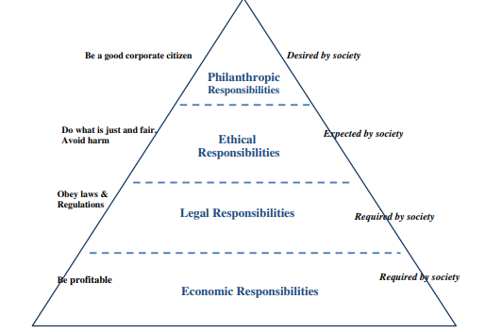
Source: Carroll (2016)
The same prioritisation, as suggested by the theoretical model, is also applied in the case of Nutrition Monster. This sequence of action is necessary in order to have sound priorities and maximum effectiveness. The company first aims at becoming profitable. This is the foundation of all future actions in the field of CSR (Carroll, 2016). Then, it is also important to comply with the legal responsibilities in the UK (Carroll, 2016). The most important legal aspects are discussed in the business plan – paying taxes, protecting sensitive information, complying with safety standards at work and other labour-related regulations, etc.
After addressing the first two layers of the pyramid, it is possible to actually conduct social responsibility activities (Carroll, 2016). As suggested by Crane et al. (2019), small business organisations often lack time and resources in order to deliver extensive policies in the field of CSR. In order to ensure the availability of resources, the company plans to direct 1% of its net profit for CSR initiatives. This means that there will not be any CSR activities, as the company has no profit in the first eight months of operations, as explained later in the business plan. In the long-term, the scope of CSR and sustainability initiatives will directly depend on the profitability of the company.
The main priorities, as shown by the table, are focused on meeting employee and community issues. Therefore, Nutrition Monster plans to dedicate its efforts on soling various community-related problems. This is done by participating in sponsorships of sports and other community-based events fighting against the obesity epidemic. The owner of the company will be directly responsible for the CSR initiatives and many of them are likely to be based on personal relationships, trust and informal contacts (Crane et al., 2019).

Table 1 – Ethical responsibilities across different types of business organisations
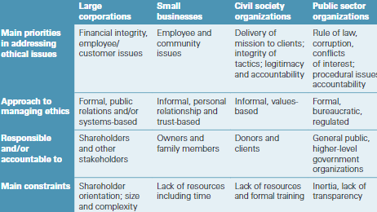
Source: Crane et al. (2019)
The company also plans to develop an ethical business model which takes into consideration issues, such as climate change, environmental protection and sustainability as a whole. Given the importance of sustainability for many consumers, including the ones from the target groups, Nutrition Monster aims at developing sustainable operations and brand (Statista, 2021). This is achieved as a result of extensive efforts. These efforts include many changes in the operations of the company by implementing efficient lighting, as well as extensive waste management and recycling initiatives. Nutrition Monster also plans to use renewable energy sources as a way of reducing the dependence on conventional energy which produces carbon dioxide emissions. In addition, the investments in renewable energy sources delivers direct benefits to the organisation, as the latter can reduce its energy bills and minimise the vulnerability to external price shocks. Nutrition Monster also acknowledges the ethical issue of de-forestification. Hence, the company plans to be a paperless one by removing the use of physical paper from many of its operations.
After the completion of the ethical responsibilities, Nutrition Monster also aims at achieving the highest level of the CSR pyramid – philanthropic responsibilities (Carroll, 2016). This is an ambitious goal but also important in the process of CSR. The actual achievement of effective philanthropic activities also maximises the outcomes of the CSR process (Carroll, 2016). In this field, Nutrition Monster will direct resources to charities. This will be done on the basis of filtering charities according to their specialisation and causes, so that the best use of resources is achieved. Given the nature of the mobile app, the focus of the charitable activities is intentionally placed on supporting causes which fight against the contemporary obesity epidemic in the UK. Some of the potential areas include fighting obesity among children, coping with diabetes type 2, participating in information/awareness campaigns which focus on providing information and support to individuals from vulnerable groups, so that they are able to make better nutritional decisions and many others. The actual choice of charitable activities may depend on contemporary developments and emerging needs.
The conduct of extensive CSR and sustainability policies is a way of developing a strong brand value among consumers – actual and prospect users of the mobile app. The development of a recogniseable corporate brand is expected to boost the level of customer awareness about the company and its offerings in the marketplace. Moreover, sustainable branding is a key source of differentiation among key consumer groups – predominantly young individuals with high life-time value as consumers (Kotler and Armstrong, 2013). This is a long-term goal with considerable impact on the actual value of the company and its market share (Crane et al., 2019). Considering these intangible benefits, the investments in CSR and sustainability are major sources of differentiation in the marketplace. These investments, if conducted wisely, may also have a positive societal impact; thereby, providing additional motivation for the business owner and organisational members to stay engaged in the process of business development and innovation.

Development, milestones and exit plan
The development of Nutrition Monster is not a chaotic process. Instead, it incorporates a strategic planning process which outlines several main stages and milestones to be accomplished over a long period of time. The use of a detailed development plan is essential in project management and business development, as it determined the main goals and associated activities which should be completed for a given period of time (PMI, 2017). This provides not only clarity, but also specific expectations and a framework for monitoring and assessing the work progress.
In terms of development, Nutrition Monster has two stages. The first stage is the pre-launch period, whereas the second development stage occurs after the official launch of the product in the marketplace. The business plan is interested in the most relevant development activities which occur prior to the official launch of the product. The pre-launch development stage is expected to last for ten months.
During the ten-month period, several key activities have to be completed in an effective and efficient manner. First of all, it is important to recruit specialists in professional fields, such as IT development, marketing, accounting, communication, etc., as specified in the organisational structure. Thus, building the team of professionals is of essential importance for the entire development of the new business. Attracting talented, creative and productive employees will largely determine the success of the company given the fact that Nutrition Monster is an intellectual product depending on knowledge and creativity. Second, the early stages of development also require setting-up a legal structure (private limited company), purchase of the necessary equipment and software, finding an office space and developing a legal protection of the company’s brand and logo. The third and most important activity of the development stage refers to the actual mobile app development. A prototype is expected to consumer several months for its development. The actual release of the product in the marketplace will be delayed due to the importance of considering another key activity – testing the prototype with actual consumers and making appropriate changes according to their feedback and ideas for improvement. This is quite important in order to deliver a more valuable and relevant product in the marketplace.
The development of the project at its pre-launch phase is also described by a Gantt chart. This is a commonly used project management tool showing all main activities, as already discussed, as well as their sequence and duration (PMI, 2017). The Gantt chart thus delivers a clear overview of the development stage and the information can be used to monitor whether the work progress aligns with the schedule (PMI, 2017). This is important in order to avoid costly delays and ensure an effective performance. The information from the Gantt chart also indicates that the mobile app development is the most time-consuming activity – a logical expectation given the considerable requirements to develop an advanced and user-friendly mobile app. Most of the described activities are a part of the critical path which means that any delay in a key activity will also lead to a delay in the entire project (PMI, 2017). For example, the mobile app development can be started only after the creation of the team and purchase of software/hardware. Nevertheless, the actual purchase of hardware/software may be postponed by one month, as this is not a critical activity, without causing delays in the start of the mobile app development. In addition to all, the Gantt chart suggests a periodic assessment of performance at a quarterly basis – a new activities which is not discussed in the development process. Such regular performance assessment is quite relevant in order to identify areas for corrections, if necessary.
Table XXX – Gantt chart of the pre-launch stage
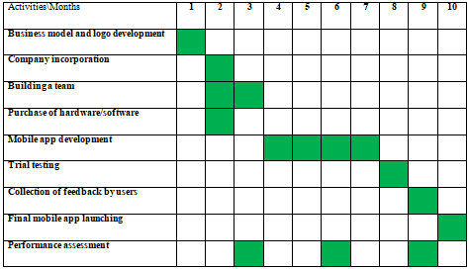
The milestones are also worth being discussed after the clarification of the project’s development. Two of the outlined milestones occur at the pre-launch stage. These critically important milestones refer to the development of an effective team of professionals and, more importantly, the creation of a well-differentiated, tech-savvy and user-friendly mobile app. These milestones are of essential importance for the success of Nutrition Monster. Hence, special attention is needed to achieve the milestones. Even some time delays and investment of additional resources are acceptable in order to accomplish the milestones, as expected.
The next two milestones are related to the actual market performance of the mobile app. Therefore, these can be considered as key indications for business success. The first post-launch milestone is to achieve at least 10,000 subscribers. This is a key number which indicates the ability of Nutrition Monster to gain market share and generate the necessary revenue base, so that the company is sustainably profitable. This milestone shows the bare minimum of paid subscribers and does not include the non-paying basic subscribers or the ability to extend the customer base. The second post-launch milestone identifies the importance of generating the second revenue stream from advertising on the mobile app. Advertisement income is highly desirable and important for Nutrition Monster. This type of income; however, also depends on the number of users, as advertising income requires the access to numerous non-premium users.
Business success, especially in the case of start-up businesses, is not guaranteed. Therefore, it is important to identify the situations where further business operations become non-productive and futile. Nutrition Monster will cease to exist, if the company fails to achieve a monthly profit after 12 months of operations. This means that the company is unable to reach a reasonable number of premium subscribers and advertising income to cover its monthly operational expenses. The risk of exiting the marketplace is also evident in the case of depleting the available financial resources. The company starts its operations with £250,000 used for investments and covering the initial monthly losses. Depleting these resources will be considered as a sign of business failure and inability to continue operations, as intended. The owner of the company has no appetite for borrowing or investing own resources beyond this number in order to maintain an unprofitable company.

Financial data
The creation of a financial plan is quite important for business success. The presented financial data includes the key assumptions regarding the revenues and costs, as well as funding sources and an income statement showing the projections over a period of 12 months.
The set of assumptions is first presented. It is important to develop realistic assumptions in order to avoid excessive optimism and eventual disappointment. The included assumptions also reflect the external developments in terms of product pricing and various types of costs.
In terms of revenue, it is realistic to assume a monthly subscription fee of £9.99. There are even lower prices in the market but Nutrition Monster is a differentiated and high-quality service which supports the proposed price. Initially, the number of paid subscribers is expected to be 1,000 people in month #1. This number can be easily reached on the basis of many friends and colleagues, who are eager to adopt the mobile app, as well as aggressive marketing efforts. After month #1, the premium customer base is expected to grow at a relatively fast rate of 20% per month till the end of year 1. Such high growth rate is possible, as Nutrition Monster is a newly launched product experiencing its growth stage. Naturally, the customer base growth rate is expected to considerably decline in alignment with the average industry growth rate of 18% per annum (GVR, 2022). In terms of advertising revenue, it is expected to begin after half a year of operations (month #7). It is expected to be £10,000 per month till the end of year 1. Advertising revenue is to a great extent a function of the growing customer base. A failure to develop a popular mobile app will also jeopardise the prospects of generating advertising revenue.
In terms of costs, there are many considerations. Some costs are fixed and it is easier for the company to plan them accordingly. On a monthly basis, the fixed costs include rent (£5,000), miscellaneous (£4,000), administrative (£1,000), software licenses (£2,000) and salaries (£30,000). Salaries are calculated on the basis of assuming ten full-time employees (including the owner) with a mean salary level of £3,000 per month. There are variations in the pay rates but these details are not important for the analysis of the financial performance data.
Variable costs include marketing expenses, taxes and potentially interest expenses. Marketing expenses are assumed to be £1 per customer. This means that the company will start with more limited marketing costs and a larger marketing budget once a considerable customer base is developed. These changes are reflected in the income statement, as shown below. Tax expenses occur, if the business is profitable. The corporate tax rate in the UK is 19% (UK Government, 2022). This percentage is applied on the basis of positive EBT number – earnings before taxes. Given the bank loan of £100,000 and annual interest rate of 6%, the monthly interest expense is £500. This number is also shown in the proposed income statement; however, it may change depending on the respective changes in the interest rate of the loan. Recently, the interest rates in the UK has experience a trend for increase; hence, higher interest expenses are quite possible in the short-term (Bank of England, 2022).
The following income statement reflects the above-mentioned revenue and cost assumptions. The numbers are presented on a monthly basis in order to deliver a more detailed picture of the expected financial performance. It is important to note that corporate tax is not applicable in the initial period of losses. The accumulation of a larger customer base over time, as well as the generation of advertising revenue contribute to reaching the break-even point in month #9. The business becomes profitable on a monthly basis from month #9 onwards but the year as a whole is expected to generate a net loss for Nutrition Monster. Such developments can be tolerated given the sound future prospects and ability to quickly reach the break-even point.
Table XXX – Income statement for Year 1
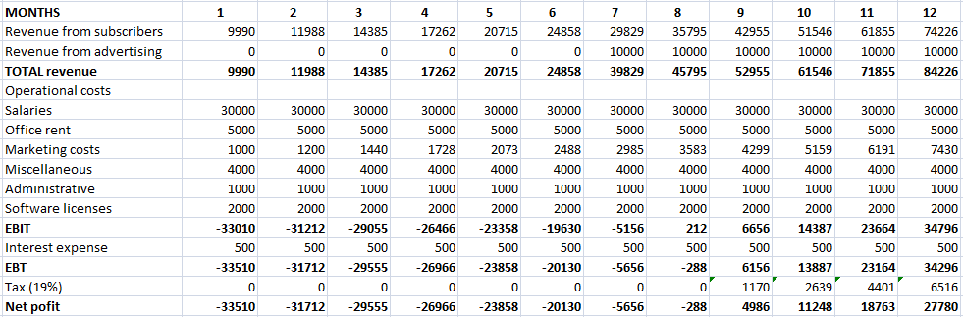
The assumptions are quite realistic and some changes revenues and costs are unlikely to deliver major changes to the overall financial expectations. It is important to note that depreciation expense is not considered during year 1. Nevertheless, this may be a major cost item in the future, although it does not lead to a direct loss of cash.
In addition to the above-mentioned fixed and variable costs, Nutrition Monster also has some initial costs worth being discussed. These are considered as sunk costs, as they are one-time investment which cannot be recovered. More specifically, the company has to purchase software mobile app development software, as well as hardware. These purchases are expected to cost £80,000, but they do not intervene in the operations of the company after the launch of the mobile app which explains their absence in the income statement. It is also important to analyse the accumulated financial losses from the first eights of operations. This is a difficult period for the business because the limited number of premium users and lack of advertising income lead to a net loss for every month. In total, approximately £170,000 of losses is accumulated during the initial eight months of operations. Considering all, Nutrition Monster needs £250,000 to finance the initial purchases and cover the losses at the early stages of operations.
The funding structure is also follows: £100,000 (bank loan) and £150,000 (owner’s capital). This also means having a capital structure with the proportion of 60% equity and 40%. This is a reasonable proportion which prevents the emergence of bankruptcy risk. Moreover, the bank loan may lead to extra interest expenses but it is an advantageous development in terms of acquiring extra resources for the company and establishing business relationships with a financial institution (NI Business Info, 2022).
The following balance sheet is applicable at the start of the business.
Table XXX – Balance sheet at the start
Assets | Liabilities + Own equity
Equipment and software – £80,000 | Bank loan - £100,000 (liability)
Cash - £170,000 | Own equity – £150,000 (equity)
Total: £250,000 | Total: £250,000
The financial plan should be closely monitored in order to maintain discipline and identify areas of potential improvements.

References
Al Mehdar, Z. (2022) Cybersecurity and cloud computing: Risks and benefits, [online] Available: https://rewind.com/blog/cybersecurity-and-cloud-computing-risks-and-benefits/ [Accessed: 20 December 2022]
Bank of England (2022) Official Bank Rate history, [online] Available: https://www.bankofengland.co.uk/boeapps/database/Bank-Rate.asp [Accessed: 17 December 2022]
BBC (2022) Liz Truss: The teenage Lib Dem who lasted just 45 days as PM, [online] Available: https://www.bbc.com/news/uk-politics-58575895 [Accessed: 18 December 2022]
Callaghan Innovation (2022) AI Demystified, [online] Available: https://www.callaghaninnovation.govt.nz/news-and-events/ai-demystified [Accessed: 20 December 2022]
Carroll, A. (2016) Carroll’s Pyramid of CSR: Taking Another Look, International Journal of Corporate Social Responsibility, Vol. 1(3), pp. 1-8.
Country Economy (2022) Country comparison United Kingdom vs Germany, [online] Available: https://countryeconomy.com/countries/compare/uk/germany [Accessed: 18 December 2022]
Crane, A., Matten. D., Glozer, S. and Spence, L. (2019) Business Ethics: Managing Corporate Citizenship and Sustainability in the Age of Globalization. 5th edition, Oxford University Press
Global Innovation Index (GII) (2020) United Kingdom, [online] Available: https://www.wipo.int/edocs/pubdocs/en/wipo_pub_gii_2020/gb.pdf [Accessed: 18 December 2022]
Grand View Research (GVR) (2022) UK Nutrition App Market, [online] Available: https://www.grandviewresearch.com/industry-analysis/uk-germany-diet-nutrition-apps-market-report [Accessed: 5 December 2022]
Hook, C. and Jenkins, A. (2019) Introducing Human Resource Management. 8th edition, Pearson: UK
Johnson, G., Whittington, R., Angwin, D., Regner, P. and Scholes, K.. (2017) Exploring Strategy. 11th edition, Pearson
Kotler, P. and Armstrong, G. (2013) Principle of Marketing. 15th edition, Prentice Hall
Kua, P. (2020) Trademarking a Mobile App and Whether It Is Worth the Hassle, [online] Available: https://www.mobileapps.com/blog/trademark-app [Accessed: 10 December 2022]
NI Business Info (2022) Bank Finance, [online] Available: https://www.nibusinessinfo.co.uk/content/advantages-and-disadvantages-bank-loans [Accessed: 8 December 2022]
OECD (2022) Enterprises by business size, [online] Available: https://data.oecd.org/entrepreneur/enterprises-by-business-size.htm#:~:text=SMEs%20are%20further%20subdivided%20into,employ%20250%20or%20more%20people [Accessed: 17 December 2022]
Office for National Statistics (ONS) (2021) Overview of the UK population: 2020, [online] Available: https://www.ons.gov.uk/peoplepopulationandcommunity/populationandmigration/populationestimates/articles/overviewoftheukpopulation/2020 [Accessed: 18 December 2022]
PMI (2017) A guide to the Project Management Body of Knowledge (PMBOK guide). 6th edition Newtown Square, PA: Project Management Institute
Porter, M. (1985) Competitive Advantage. Creating and Sustaining Superior Performance. Free Press: New York
Rijmenam, M. (2014) Tesco and Big Data Analytics, a Recipe for Success? [online] Available: https://datafloq.com/read/tesco-big-data-analytics-recipe-success/665 [Accessed: 19 December 2022]
Rollinson, D. (2019) Organisational Behaviour and Analysis: An Integrated Approach. 7th edition, London: Pearson
Savage, K. (2019) How to Segment Your Customers to Grow Revenue, [online] Available: https://www.getfeedback.com/resources/cx/how-to-segment-your-customers-to-grow-revenue/ [Accessed: 16 December 2022]
Slack, N., Brandon-Jones, A. and Johnston, R (2013) Operations Management. 7th edition, Harlow: Pearson
Software Testing Help (STH) (2022) Top 11 Most Powerful CyberSecurity Software Tools In 2023, [online] Available: https://www.softwaretestinghelp.com/cybersecurity-software-tools/ [Accessed: 19 December 2022]
Statista (2021) Sustainable Consumption in the UK 2021 Report, [online] Accessed: https://www.statista.com/study/89745/sustainable-consumption-in-the-uk-report/ [Accessed: 18 December 2022]
The Formations Company (2022) What is a Private Limited Company? [online] Available: https://www.theformationscompany.com/knowledge-base/what-is-a-private-limited-company [Accessed: 8 December 2022]
UK Government (2022) Guidance: Rates and allowances for Corporation Tax, [online] Available: https://www.gov.uk/government/publications/rates-and-allowances-corporation-tax/rates-and-allowances-corporation-tax [Accessed: 18 December 2022]
Uzohue, C., Yaya, J. and Akintayo, O. (2016) A Review of Leadership Theories, Principles, Styles and Their Relevance to Management of Health Science Libraries in Nigeria, Journal of Educational Leadership and Policy, Vol. 1(1), pp. 17-26.
World Bank (2020) Ease of doing business in United Kingdom, [online] Available: https://archive.doingbusiness.org/en/data/exploreeconomies/united-kingdom [Accessed: 18 December 2022]

Appendix 1.


