Report for Community Engagement Assignment 2 2018 –
Problems Solving



APRIL 2018

MODULE NAME: COMMUNITY ENGAGEMENT (M4X00799)
Name: ANIQA NISWAT ANJUM
Student Number: 1702530

Table of Contents

1. eXECUTIVE sUMMARY 1
2. Introduction 2
2.1 Report Remit 2
2.2 Brief background of the workplace 2
2.3 The problem 2
3. Problem solving techniques 3
3.1 Solving the problem 3
4. Conclusion 4
5. References 5

list of figures

Figure 3.1- The Ishiwaka Diagram
Figure 3.2- Five Whys worksheet
Figure 3.3- Fishbone diagram of Papa John’s unsatisfied customer
Figure 3.4- Five Whys Analysis of Papa John’s unsatisfied customers

executive summary

The purpose of this report is to enlighten the reader regarding the various problems faced by the pizza industry, Papa John's, an American restaurant franchise company. It runs the third largest take-out and pizza delivery restaurant chain in the United States, with headquarters in Jeffersontown. This report includes the Ishiwaka diagram, also known as the fishbone diagram, and the 5whys technique to solve the problem. The root cause for both of this analysis is unsatisfied customers. The report will analyse the problems faced by the industry, the causes, and the possible solutions to avoid similar cases in the future. One of the many problems the company faces is an unsatisfied customer, due to a number of reasons some of these are: orders being delivered late, the dough is not gluten-free, wrong information and slow service due to untrained employers. The following actions should be taken in order to solve the problem: give something extra to the customer such as better deals, try to deliver the product as soon as possible, manage time and make sure the customer is happy with the results. The success of these solutions can be easily seen by how happy the customer is. If the organisation sees an increase in the numbers of customers coming in the store if they see existing customers coming back.

”

Introduction

Report Remit

The purpose of this report is to show that problems can be easily solved by using different techniques, no matter how impossible it may sound or seem there will always be a way to elucidate the problem. This report will be discussing the various complications and difficulties faced by one of the most popular restaurant franchise company in the world, Papa John’s. This report will also include Ishiwaka diagram by Kaoru Ishiwaka, “which is also called a fishbone diagram, and is a visualisation tool for classifying the potential causes of a problem in order to identify.”
The report will be also be discussing the 5whys analysis by Sakichi Toyoda, which is questioning method to find solutions to its problems. The report will figure out how the two methods can sustain Papa John’s problems.
“Analyses are aimed at testing solutions rather than magnifying problems, solutions are not about direction or decisions but about creating movement.” (Rob van Haastrecht, 2011)

Brief background of the workplace

Papa “John's Pizza is an American restaurant franchise company. It runs the third largest take-out and pizza delivery restaurant chain in the United States, with headquarters in Jeffersontown, Kentucky.” (PapaJohns, 2018)
As stated in Forbes (2017), John Schnatter, also known as Papa John’s, opened the first Papa John's restaurant in 1985. (Forbes, 2017)
Today this pizza chain is one of the most well-known fast food in the world, thanks to the fresh dough they provide and the fresh ingredients used to create their pizzas.

The problem

Despite the success of any other organisation, even Papa John's faces problems, however, there are solutions to solve these issues. The problem Papa John's is dealing with is a lack of customer satisfaction, the output of this might include an impact on returning customers and gaining new customers. Customer satisfaction is crucial for businesses, this is because they are the key to success in every organisation. If the right service is not being provided the customer will be unhappy and they can make bad reviews which will stop other customers from coming into the store.
People “cannot express their cognitive difference if it is unsafe to do so. If leaders focus on enhancing the quality of interaction in their teams, business performance and wellbeing will follow.” (Harvard Business Review, 2018)

PROBLEM-SOLVING TECHNIQUES

“Stubborn and recurrent problems are often symptoms of deeper issues reason why quick fixes may seem convenient. (Mind Tools, 2016) However, they often solve only the surface issues and waste resources that could otherwise be used to tackle the real cause.”
There are many techniques that can be used to solve problems, for this occasion the fishbone diagram by Kaoru Ishiwaka will be used. “Ishiwaka was a Japanese organisational theorist, Professor at the Faculty of Engineering at The University of Tokyo, noted for his quality management innovations. He is considered a key figure in the development of quality initiatives in Japan, particularly the quality circle. “ (Ishiwaka, 1986)

He invented the fishbone diagram, “which can help in brainstorming to identify possible causes of a problem and in sorting ideas into useful categories. A fishbone diagram is a visual way to look at cause and effect. The problem or effect is displayed at the head or mouth of the fish.” (Saeger, 2015)
Possible “contributing causes are listed on the smaller bones under various cause categories. A fishbone diagram can be helpful in identifying possible causes for a problem that might not otherwise be considered by directing the team to look at the categories and think of alternative causes.” (Bowen, 2016)
This how the fishbone diagram is, some organisations make alterations based on their problems, and different companies face different difficulties. “The technique uses graphical means to relate the causes of a problem to the problem itself, in other words, to determine cause and effect. The diagram focuses on the causes rather than the effect.” (Ariane De Saeger, 2008)
Because “there may be several causes for a problem, this technique helps organisations identify the root cause of the problem in a structured and uncomplicated manner. It also helps to work on each cause prior to finding the root cause.” (IBM, 2004)
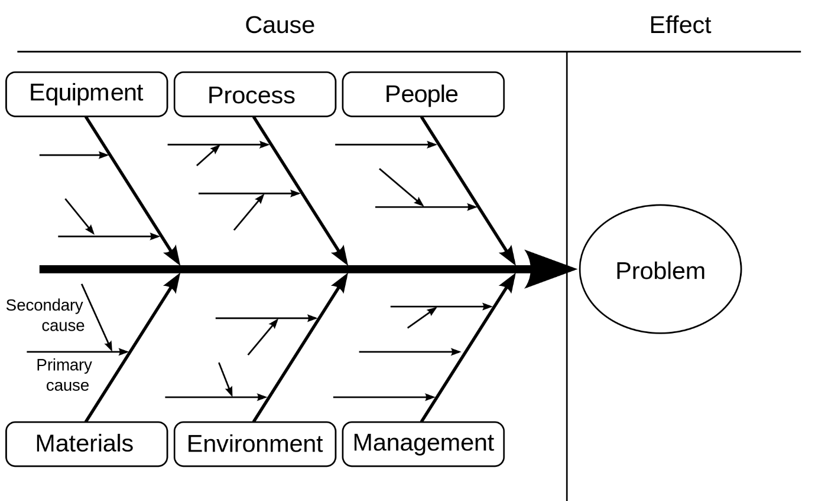

Figure3.1- The Ishiwaka Diagram (Source: The Ishikawa Diagram for Risk Management) p. 8

Another method that can be used to analyse problems and its origins is the 5why analysis, invented by Sakichi Toyoda, the founder of Toyota Industries Corporation. (Toyota Industries Corporation, 2016).
Most “obviously and directly, the Five Whys technique relates to the principle of systematic problem-solving: without the intent of the principle, the technique can only be a shell of the process.” (Cornell University ILR School, 2009)

“There are three key elements to effective use of the Five Whys technique:
- accurate and complete statements of problems
- complete honesty in answering the questions
- the determination to get to the bottom of problems and resolve them”

The benefits of the 5 whys Analysis is that it helps identify the root cause of the problems easily, it determines the relationship between different root causes of a problem and it is one of the simplest tools, really easy to complete without ant statistical analysis.

This is how the Five whys analysis is structured, asking these five questions can thoroughly examine a cause of a company’s problem.

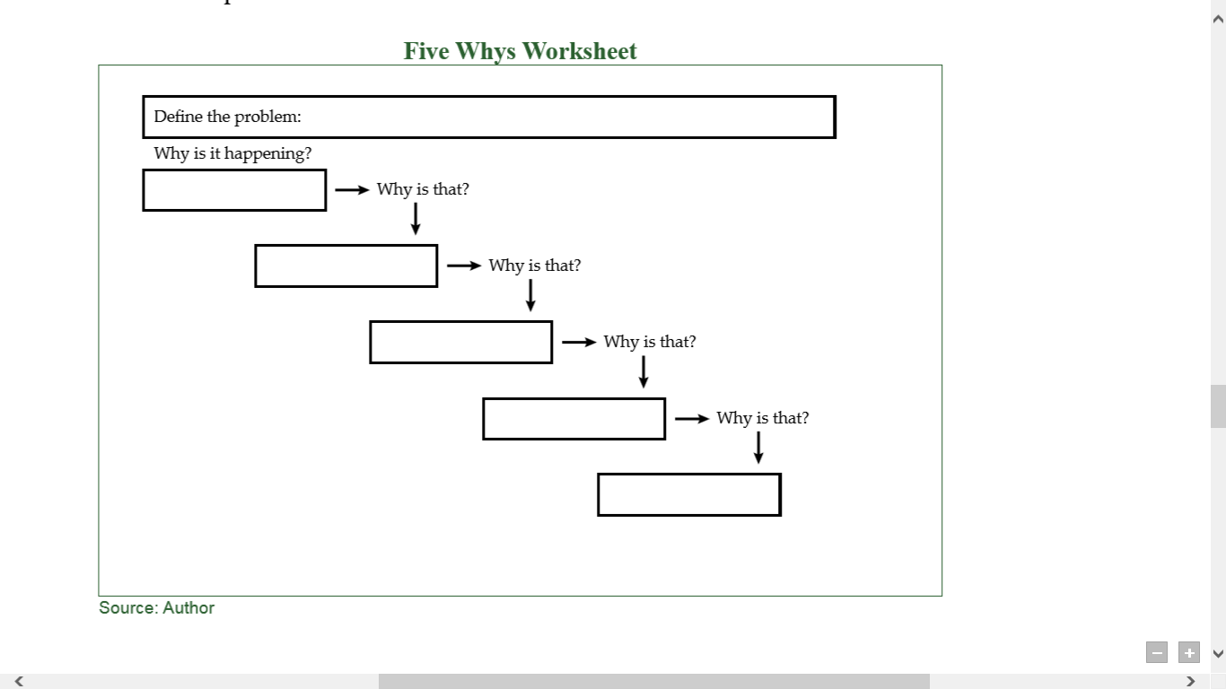
Figure 3.2- Five Whys worksheet (Source: iSix Sigma)

Organisations can go in depth by adding additional “whys” and examining the problems. “The 5 Whys can be used individually or as a part of the fishbone diagram. Once all inputs are established on the fishbone, you can use the 5 Whys technique to drill down to the root causes.” (iSix Sigma, 2018)
Every “why” needs to be justified and backed up by another “why” until a solution has been found.
“If you don’t ask the right questions, you don’t get the right answers. A question asked in the right way often points to its own answer. Asking questions is the ABC of diagnosis. Only the inquiring mind solves problems.” – Hodnett, 2008, p. 66

Solving the problem and PROBLEM-SOLVING IMPLEMENTATION

Some main issues are coming from the pizzas, in spite of the fresh ingredients used, recent studies showed the impacts of gluten sensitivity on the body. (SeekingAlpha, 2016) This may force pizza industries to make changes into their pizzas in order to avoid this problem. “While most people are probably aware of celiac disease and the role that gluten plays in it, some people are completely unaware of the negative implications that gluten may have on a much larger percentage of the population. Simply dubbed as "Gluten Sensitivity", the recent health trend toward gluten-free products and labelling appears to be gaining major traction.” (OfficeOfDiseasePrevention, 2018)
Some “people suffer changes within their bodies after eating gluten that is separate and distinct from those that accompany either celiac disease or wheat allergy.
“
Another problem facing the pizza industry is competition with other pizza restaurants, local pizzerias and other pizza companies such as Dominos and Pizza Hut. One more problem most branches have is running out of ingredients, drinks, not having enough doughs in store or not enough drinks. All these problems can cause business loss if they are not being solved immediately. If customers are not receiving what they order, they will not be satisfied with the service, which can create bad company image, meaning business loss again. All these problems explained above lead to only one thing: unsatisfied customers, this should be solved in a short period in order to keep the business going because unhappy customers can provoke loss for the business.

Customer service “should be made a high priority if a company is aiming to attract and keep the right type of profitable customer.” (Kandampully, 2012)
Papa John’s like any other company has to face these challenges too; the report will cover the different techniques to solve each problem faced by this pizza industry. As written in The CBI Environmental Management Handbook (2001) for some businesses the challenges will be obvious, for others the connection is much less obvious and can require more creative thinking, as in where and how their main raw materials are resourced and what impact this has.” (Confederation of British Industry, 2001)

As discussed above, Papa John's faces a number of problems, however, all these leads to only one major difficulty that can risk the company's image and create a business loss for the future, and that is unsatisfied customers. Unsatisfied customers are an obstacle for every organisations, they can cause problems, reason why Papa John’s should try different methods to solve these problems.
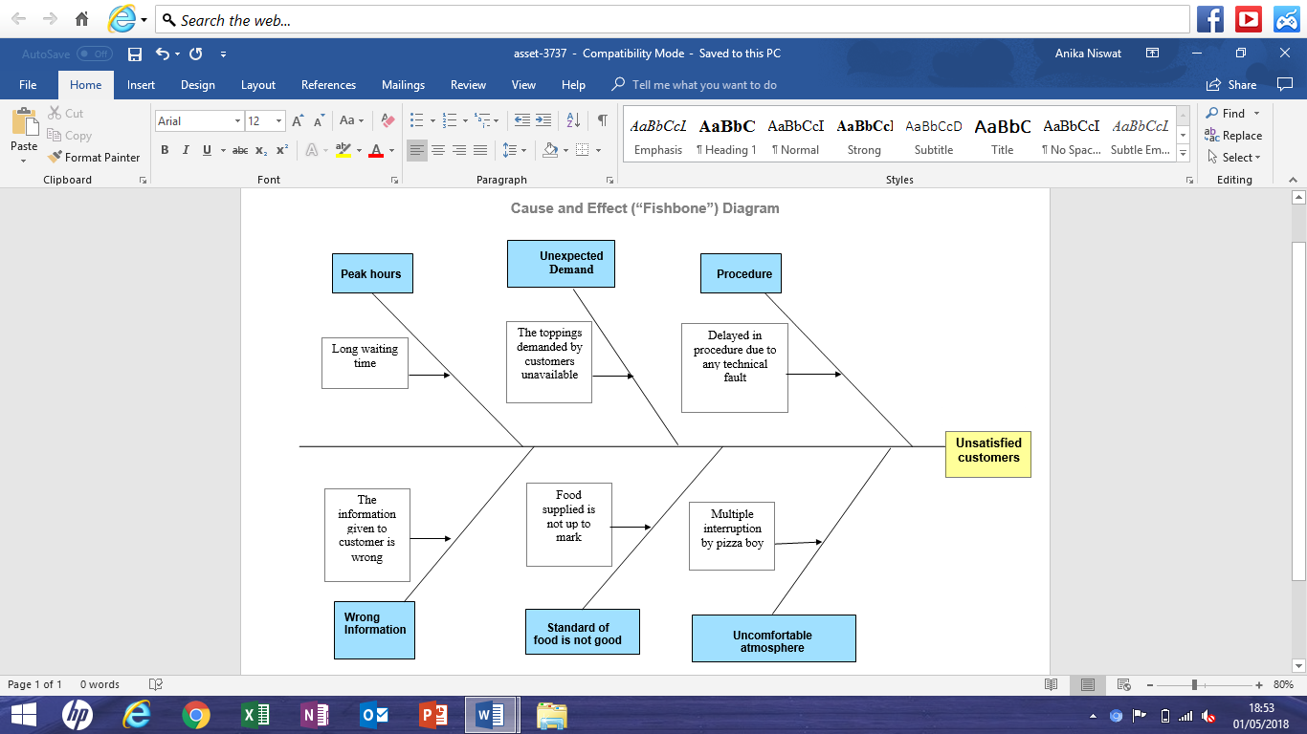
Using the Ishiwaka diagram, Papa John’s can have a deep thinking at the causes and everything that is behind non-happy customers.

Figure 3.3- Fishbone diagram of Papa John’s unsatisfied customers

Most fast food places try their best to give the customer their food within a certain time, however, peak hours can be an enemy sometimes to fast food companies. Peak hours make the waiting time long, nobody likes to wait for too long for their food, reason why customers are unhappy.
Papa John’s need to make sure that everything is in stock, all the products all the toppings are made available if the customer requests them. If toppings or products are not available upon the customer’s request, Papa John’s should try to give the customer another option, but this will not make the customers happy since it is not the primary product they wanted.
Before delivering or giving the customer their food, Papa John’s needs to take a record of the order, put it in the system then go through the rest of the procedures. However technical difficulties can be a major issue in this, monitors can freeze or not work at all, internet system can go down completely, or other issues such as JustEat orders coming through and not being monitored in the system by the team members, due to the peak hours or any other problems. All this can delay the orders, possibly making customers unhappy. Sometimes team members are not trained properly which causes bigger problems such as giving wrong information to the customer if workers are not familiar enough with the whole system, they might struggle taking orders and dealing with clients which again will result in unhappy customers.

Most of the time the delivery boys make multiple interruptions while delivering the food, such as not knowing the directions for the address to be delivered in, or not having any change on them when taking payments. All these problems cause only one big issue for Papa John’s, unsatisfied customers which needs to be solved. A solution for each and every problem is to:
- Train all the employers properly.
- Make sure everything is in stock.
- Order products at least 2 days before they run out or they expire.
- Make sure the monitors, computers system is working properly and efficiently.

Another method mentioned earlier was the Five Whys Analysis which can help solve the problem in a different way, “a discussion of the unexpected event or challenge that follows one train of thought to its logical conclusion by asking “Why?” 5 times to get to the root of what happened.”

“Five Whys involves holding meetings immediately following the resolution of problems the company is facing. These problems can be anything: development mistakes, site outages, marketing program failures, or even internal missed schedules. Any time something unexpected happens, we could do some root cause analysis.”- Ries, 2010 p. 265

5 Why analysis “is more than just an iterative process or a simple question asking activity. The purpose of a 5-why analysis is to get discussing all of the possible root causes of a given defect in a process.
Many times teams will stop once a reason for a defect has been identified. These conclusions often do not get to the root cause. A disciplined 5-why approach will push teams and organisations to think outside the box and reach a root cause where the team can actually make a positive difference in the problem, instead of treating symptoms.” (More Steam, 2009)

Figure 3.4- Five Whys Analysis of Papa John’s unsatisfied customers

As seen above, if the system is not working properly, orders will be getting delayed which means food will not be prepared, which will cause long waiting time for the customer, resulting Papa John’s having unsatisfied customers.
All this can be solved if Papa John’s pays attention to its computers systems, the one employers take orders with. More advantage systems can really make improvements, technology sometimes can be a barrier for organisations if it is not utilised properly.
Another solution the organisation can come with are giving customers loyalty cards, “most customers hold several loyalty cards of competing retailers. Past studies looking into the impact of card ownership on store loyalty showed mixed results.”
Studies show “that when holders are satisfied with the reward scheme of the loyalty card programme, they are more loyal and less price sensitive than unsatisfied cardholders.”
Retailers use “loyalty cards to identify and to reward their customers for their loyalty. More precisely, loyalty cards enable companies to acquire knowledge about and develop a better relationship with their customers.” (Demoulin, 2008)
As seen earlier “the 5 Whys methodology really is simple, effective, comprehensive, flexible, engaging and really inexpensive. All Papa John’s has to do is to make sure they do not mistake symptoms for root causes, sometimes there is more than one root cause to search for, Papa John’s should not settle for the first obvious solution but dig deep, and they should absolutely avoid the blame game and focus on the process.”

Conclusion

Papa John's does successfully manage to solve its problems, technical faults, and untrained employers. The organisation truly values its customers and would do anything to keep the existing ones happy and attract potential customers too. As written in Quality Management (2010), the main objective of a company should be to satisfy customers in a profitable manner. (Dr. Ralf Heron, 2010). Every organisation should, therefore, pay attention to its customers, make them happy with the products available meaning in a profitable manner. Most “organisations are unaware of how much time they spend firefighting, reworking old bugs, and generally expending energy on activities that their customers don’t care about. Yet getting a handle on these sources of waste is hard, especially because they are dynamic. By the time a tops-down company-wide review figured out the main problems, they’d have shifted to another location. Five Whys allows teams to react much faster and then constantly adapt. Without all that waste in their way, they simply go faster.”

References

Ariane De Saeger. (2008). The Ishikawa Diagram for Risk Management: Anticipate and solve problems.
Bowen, P. (2016). The Fishbone Diagram Handbook - Everything You Need to Know about Fishbone Diagram. Emereo Pty Limited.
Confederation of British Industry. (2001). The CBI Environmental Management Handbook: Challenges for Business. London: Earthscan.
Cornell University ILR School. (2009). The Five Whys Technique.
Demoulin, N. T. (2008). Journal of Retailing and Consumer Services. Journal of Retailing and Consumer Services, 386-398.
Dr. Ralf Heron. (2010). Quality Management Your Key To Success.
Forbes. (2017). Retrieved from https://www.forbes.com/profile/john-schnatter/
Harvard Business Review. (2018, April 02). The Two Traits of the Best Problem-Solving Teams. Retrieved from https://hbr.org/2018/04/the-two-traits-of-the-best-problem-solving-teams
IBM. (2004). Applying the Fishbone diagram. Retrieved from https://www.ibm.com/developerworks/lotus/library/fishbone/
Ishiwaka, K. (1986). Guide to Quality Control. In Guide to Quality Control (p. 230). Asian Productivity Organization.
iSix Sigma. (2018). Determine the Root Cause: 5 Whys. Retrieved from https://www.isixsigma.com/tools-templates/cause-effect/determine-root-cause-5-whys/
Kandampully, J. (2012). Service Management: The New Paradigm in Retailing. New York: Springer.
Mind Tools. (2016). Getting to the root of a problem quickly. Retrieved from https://www.mindtools.com/pages/article/newTMC_5W.htm
More Steam. (2009). 5-Why Analysis. Retrieved from https://www.moresteam.com/toolbox/5-why-analysis.cfm
OfficeOfDiseasePrevention. (2018). Retrieved from https://healthfinder.gov/
PapaJohns. (2018). About Papa John’s. Retrieved from Papa Johns: https://www.papajohns.co.uk/franchise/about-papa-johns/
Rob van Haastrecht, M. S. (2011). Thinking Backwards. London: TJ international limited.
Saeger, A. d. (2015). Ishiwaka Diagram. In The Ishikawa Diagram for Risk Management: Anticipate and solve problems (pp. 6-22). Lemaitre Publishing.
SeekingAlpha. (2016). Domino's And Papa John's Face Major Threat As Pizza Industry Is Set To Change. Retrieved from https://seekingalpha.com/article/3995685-dominos-papa-johns-face-major-threat-pizza-industry-set-change
Toyota Industries Corporation. (2016). The Story of Sakichi Toyoda . Retrieved from https://www.toyota-industries.com/company/history/toyoda_sakichi/

