BMIH5005 - Personnel Resourcing and Development

Student Name: Alexandra Elena Vlad
Student ID: 2118684
Lecturer name: Kathryn Roberts
Abstract
Hospitality management in personnel recruitment and human resource management is extremely important for employee satisfaction in the modern market. The proposal has focused its studies on the challenges faced by Dorchester Hotels in terms of recruitment and retention. An extensive elaboration of the research background and rationale has been provided along with the aim and objectives of the research. The following section has provided discussion on the existing literature followed by the issues faced by Dorchester using SWOT and PESTLE analysis. The last section has summarised the findings and provides some recommendations for further improvement of the retention control and recruitment strategies in the hotel chain.
Table of Contents
1. Introduction 4
1.1 Background of the research 4
1.2 Aims and objectives of the research 5
2. Literature review and discussion 6
2.1 Reviewing literature on the impact of current challenges on the 6
2.2 Providing examples on the current affairs affecting the retention 8
2.3 Potential solutions providing industry examples 11
2.4 Research timeline 12
3. Conclusion and evaluation 14
3.1 Conclusion 14
3.2 Recommendation 14
References 16

1. Introduction
The human resource management and personnel resourcing process is extensively important for a strong administrative, and executive structure in a hotel. The foundation of service quality entirely depends on the administrative and managerial functions of a hotel. Dorchester hotel is one of the most popular luxury hotel chains in the UK market with a £29.71 million turnover in 2021 compared to a £208 million loss in 2020 (Kilburn, 2020)‌. The hotel is gradually losing its marketplace with emerging outbound hotel chains like Apex Hotels, The Doyle Collection, Corinthia Hotels and many more (Kilburn, 2020)‌. The proposal will discuss some literature on the retention and recruitment criticality in the hotel industry. External market analysis will be conducted based on PESTLE and SWOT analysis. Moreover, the findings of the research will be presented in the last section.

1.1 Background of the research
Dorchester is one of the most premium hotels in the UK, especially in urban areas. The luxurious and relinquished lifestyle in the hotel is significantly popular among UK citizens. However, the lack of room availability and booking structure is creating extensive issues for the hotel chain to run smoothly in the current market (Kilburn, 2020)‌. Inflation in the market is affecting the supply distribution of daily service resources. The profit estimation and EBITDA of the hotel are gradually declining with the market share in the UK market. This is creating difficulties in controlling retention and providing employee satisfaction (CEGID, 2022)‌. Employees in the company are struggling to adapt to the reduced statutory benefits and stagnant operation format in the post-pandemic situation.
The administrative structure in the hotel does not make opportunities for career growth which is affecting the recruitment opportunities in the modern job market. The market expansion limitation and conventional service structure can be held responsible for this unmovable retention criticality. Therefore, understanding the factors affecting the retention rate and profit optimisation situation in the hotel chain is extremely important (CEGID, 2022)‌. Understanding the external market impact and demographic demand from a hotel is also important to reconsider the targeting and positioning strategy of the hotel.

1.2 Aims and objectives of the research
The aim of the research is:
To understand the importance and impact of recruitment to control the retention rate in a hotel chain.
The research objectives are:
- To investigate some effective recruitment processes in the current market.
- To identify the external market impact on the recruitment and retention of a hotel.
- To evaluate the stages of recruitment and effectiveness of the strategic response to the current market elements.

2. Literature review and discussion

2.1 Reviewing literature on the impact of current challenges on the
CoVID-19 challenges that are influencing the employee recruitment and retention: According to Aguiar-Quintana et al., (2021), hotel industries in the UK, that are major contributors to the economy, have been widely affected due to Covid 19 pandemic, especially the recruitment and retention process of the employees. The pandemic had psychological effects on the mind of the employees that caused anxiety and depression and it somehow affected their job performance. Retention became a difficult process as the existing employees were demoralised and some hotels witnessed a huge number of attritions. Recruitment process got slower due lack of personnels skilled to perform the tasks of a hotel employee.
According to Ntounis et al., (2022), hotel industries have taken a huge hit due to the pandemic that caused rupture in the recruitment and retention processes of the employees. Rapid recruitment and retrenchment in the UK had accelerated the spread of virus that affected the hotel business. Hotels had to be shut down and it halted the hospitality and tourism activities that caused a problem for employee retention. The businesses had to retrench their employees for survivability. The hotel industries in the UK had furloughed 80% of their employees as the retention policies did not bring any change to the system.
Economic challenges: The market economy in the hotel industry has not been prolific for the last 2 years after the 2020 global pandemic. According to Michael and Fotiadis (2022), a global £1.21 trillion loss has been reported in the hotel industry which was responsible for more than 67% supply contract termination in the first quarter of 2021. According to Michael and Fotiadis (2022), the 9.9% GDP reduction in the UK in 2020 has impacted the food, hospitality, transport and tourism industry massively. These challenges have increased the impact on the social economy. According to Michael and Fotiadis (2022), the 15% limit on the payscale cut has created a significant impact on the GDP per capita in countries like the UK and other European countries. An average of 81% reduction of travel accommodation resulted in reduced RevPAR in 20202.
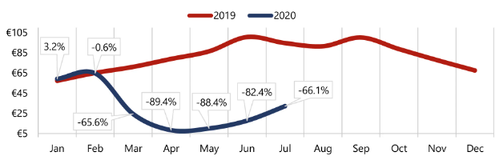
Figure 1: RevPAR of the European Hotels (2019-20)
(Source: Michael and Fotiadis, 2022)
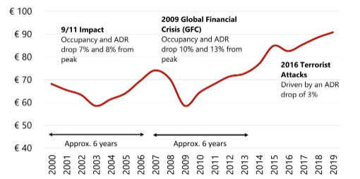
Figure 2: RevPAR recovery between 2000 and 2019
(Source: Michael and Fotiadis, 2022)
Moreover, the increasing automation and hybrid working structure has impacted the RevPAR rates in hotel industries. Hospitality industry and especially hotel industries are filled with services that require physical presence. Therefore, the retention and recruitment process is extensively critical when merged with the modern job market demands (Seo, 2022)‌. Coincidentally it also increased substitutive demand for not being provided with remote working facilities by hotel staff. This has created significant issues in the hotel industry regarding retention control and recruitment. According to Michael and Fotiadis (2022), hybrid working facilities, increased medical plan demands and statutory benefits have become some of the prime requirements for the employees in the hotel industry.

2.2 Providing examples on the current affairs affecting the retention
PESTLE Analysis
PESTLE factors | Description | Impact
Political factors | - Brexit uncertainty creates issues to handle the migrant workers from the EU countries due to the restrictions of getting passports and visas to work in the UK reducing the employee retention of the hotel.  - The Government imposed 15% of taxation on the hotel services with 5% of the VAT on foods increasing the service charge of Dorchester Hotel (Statista, 2023). | High
Economic factors | - The inflation rate in the UK increased to 10.1% in 2023 increasing the service charge of the hotel (Statista, 2023).  - The unemployment rate in the UK increased by 0.1% in 2022-2023 affecting the purchasing power of the customers. | High
Social factors | - The customers’ demands for hotel services are increasing which will help Dorchester Hotel to explore its business (Shatilo, 2019).  - Covid-19 reduces the presence of employees in their workplace affecting employee retention by weakening employee-employer bonding. | High
Technological factors | - E-commerce website development trends help Dorchester Hotel to develop a trustworthy and verified website (Shatilo, 2019).  - Technological advancement helps the hotel to automate its service and customer connection indexes. | Moderate
Legal factors | - Equality Act 2010 is enacted to remove workplace discrimination based on age, race, gender, religion, and sexual identity assisting Dorchester Hotel to maintain a fair working index (Citation, 2022).  - Health and Safety Act 1974 is enforced to ensure the occupational safety of the employees increasing the employee retention of Dorchester Hotel (Citation, 2022). | High
Environmental factors | - The UK Government passed a net-zero carbon emission policy for reducing the carbon emission assisting Dorchester Hotel to reduce carbon emissions (Citation, 2022).  - The instant climate change including foggy weather and monsoon reduces the presence of customers in their workplace. | Moderate
Table 1: PESTLE Analysis
(Source: Author)
SWOT Analysis of Dorchester Hotel
Strengths  - The diversified employee portfolio in Dorchester Hotel increase the brand reputation of the hotel (The Dorchester, 2022).  - The extensive knowledge of providing excellent customer service helps the hotel to become the top-most customer priority. | Weaknesses  - The workplace conflicts in Dorchester Hotel create challenges for the management to ensure maximum employee retention.  - The staff turnover rate in Dorchester Hotel increased by 4.5% in the 2022-2023 fiscal year reducing the changes to implement fair employee recruitment and retention (The Dorchester, 2022).
Opportunities  - Customers prefer to use online hotel booking applications to assist the hotel to expand its business online (Shatilo, 2019).  - The technological advancement helps Dorchester Hotel to increase its employee retention through remote working and flexible working schedules. | Threats  - Covid-19 increases the staff turnover rate in the hotel reducing employee engagement and retention (Shatilo, 2019).  - Brexit uncertainty creates restrictions on the employees of EU countries to work in the UK reducing the employee retention capabilities of the hotel.
Table 2: SWOT Analysis of Dorchester Hotel
(Source: Author)
Retention rates
Dorchester hotel operates with around 3500 employees in its 9 locations. Despite a 100% increment in the training process, the employee turnover rate (21.1%) in the hotel chain has been reduced by only two points between 2021 and 2022 (CEGID, 2022). The cross-training scheduling has significantly managed to increase guest engagement in the hotel resulting in a 97 percentile positive feedback along with increased RevPAR. This has allowed the hotel to increase the retention rate from 57% to 58.18% creating an additional £4.5 million profit compared to the estimated profit (CEGID, 2022). Moreover, the changes in the administrative communication matrices and managerial structure has created opportunities for career growth which has possibly increased the retention rate in the hotel chain.
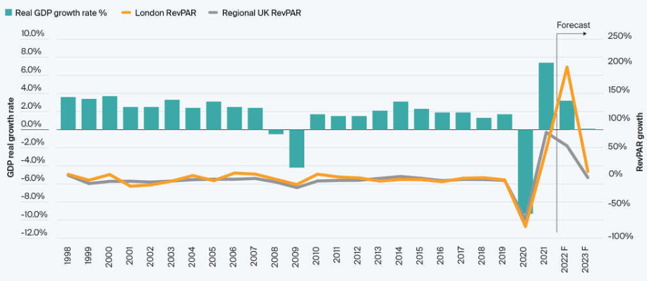
Figure 3: London and regional RevPAR growth rates compared to GDP
(Source: CEGID, 2022)

2.3 Potential solutions providing industry examples
Marriott: Marriott Hotel provides constructive employee feedback to develop their engagement and motivate them to participate in different organisational functions (Marriott Hotel, 2023). The employee retention process of this hotel is contingent which is dependent on employee satisfaction. Employee satisfaction depends on four factors including positive work culture, sustainable growth opportunities, effective recruitment practices, and open communication index. Marriott focuses on fair recruitment practices by forming a board of HR teams with 5-6 members (Marriott Hotel, 2023). The members are capable to express their opinions regarding the hiring of eligible candidates.
IHG: IHG Hotel focuses on encouraging skilled employees to join the hospitality industry for developing the service quality and customer retention of the company (IHG, 2023). IHG is concerned about conducting employee training sessions once per month and understanding the pitfalls of developing their skills. Equal opportunities are provided to employees to develop their careers in the hospitality sector. The strategy of IHG Hotel is to demonstrate value creation through the establishment of preferred brands (IHG, 2023). It delivers a superior proposition and strengthens the loyalty program of the company.
Radisson: Radisson Hotel focuses on generating shared value by creating job opportunities for youngsters as well as experienced people. People development is an important strategy of employee retention at Radisson where the skills of the employees are developed (Radisson Hotel Group, 2023). The skills are developed through systematic skill development through skill audits and personal development plans. Rewarding opportunities are provided to the employees for acknowledging their contribution to the workplace. Regular employee feedback collection is conducted to understand the contemporary requirements of the employees (Radisson Hotel Group, 2023).

2.4 Research timeline
Research activities | Week 1 | Week 2 | Week 3 | Week 4 | Week 5 | Week 6 | Week 7 | Week 8
Research topic selection and objectives formation
Research background analysis
Reviewing the literature on the research topic for representing other authors’ views
Understanding the current affairs affecting the research arenas.
Analysing other companies in the hospitality industry
Conclusion and evaluation
Submission of the research report
Table 3: Research timeline
(Source: Author)

3. Conclusion and evaluation

3.1 Conclusion
Based on the above assessment, it is stated that the hospitality industry faced issues to hold maximum employee retention and recruitment. Covid-19, Economic challenges, poor management, lack of staff retention knowledge, and lack of training negatively affect employee retention in the hospitality industry. The research report has focused on the background of the research topic along with the research aim and objectives. The research aim is to develop the employee recruitment process and sustain employee satisfaction for strengthening employee retention. The research report has reviewed different literature for collecting the opinions and statements of different authors. The researcher has selected journals, articles, and books related to the employee retention and recruitment challenges faced by the hospitality industry with a recovery strategy. The current affairs including Covid-19, Brexit, and inflation affect employee retention at Dorchester Hotel. The PESTLE Analysis, SWOT Analysis, and retention rate have been explained in this research paper to highlight the current affairs affecting the business operations of Dorchester Hotel. The research paper has focused on the employee retention contexts of Dorchester Hotel along with the strategic issues faced by the hotel in employee retention. The potential solutions have been provided to express the examples of different hotels that have taken necessary steps to mitigate the issues.

3.2 Recommendation
The management of Dorchester Hotel needs to focus on the strategies implemented by different hotels for making the strategy unique and competitive. The recommendations for Dorchester Hotel for mitigating employee recruitment and retention issues are expressed below.
Recommendation 1 (Educational program): Dorchester Hotel needs to conduct 3 months to 6 months of an educational program for its employees. It will help the hotel to develop its knowledge to perform the organisational functions. This program will be conducted for both remote employees and offline workers for developing their skills and knowledge. It is important to establish a fair recruitment process with the formation of a board of HR team for approving the HR decisions to hire candidates.
Recommendation 2 (Workplace Equality): The management of Dorchester Hotel needs to maintain workplace equality for developing equal growth opportunities for the employees. Workplace equality will increase workforce sustainability and ensure higher employee retention. It is important to maintain the legal provision passed by the UK Government for maintaining workplace equality.
Recommendation 3 (One-to-one communication): The management of Dorchester Hotel needs to conduct one-to-one communication sessions for the employees to understand their individual problems. It is important to establish an open communication index while conducting one-to-one communication. Dorchester Hotel will be capable to understand the issues faced by the employees in the workplace and discuss with them to resolve the communication gap among the employees.

References
Aguiar-Quintana, T., Nguyen, T.H.H., Araujo-Cabrera, Y. and Sanabria-Díaz, J.M., (2021). Do job insecurity, anxiety and depression caused by the COVID-19 pandemic influence hotel employees’ self-rated task performance? The moderating role of employee resilience. International Journal of Hospitality Management, 94, p.102868.
CEGID, (2022). It’s Your Future – Let’s Create It Together: the importance of the employee journey in delivering the ultimate guest experience. Available at: https://www.cegid.com/en/studycases/dorchester/ [Accessed 02 March 2023]
Citation, (2022). UK employment Laws Explanation. Available at: https://www.citation.co.uk/news/hr-and-employment-law/uk-employment-laws-explained/#:~:text=UK%20employment%20laws%20are%20in,relationship%20between%20the%20two%20fair [Accessed 02 March 2023]
IHG, (2023). IHG Hotels and Resorts. Available at: https://www.ihg.com/hotels/us/en/reservation [Accessed 02 March 2023]
Kilburn, H., (2020). The Dorchester, where style will always conquer over fashion. Available at: https://hoteldesigns.net/editors-picks/the-dorchester-where-style-will-always-conquer-over-fashion/ [Accessed 02 March 2023]
Marriott Hotel, (2023). Marriott Hotel. Available at: https://www.marriott.co.uk/default.mi [Accessed 02 March 2023]
Michael, N. and Fotiadis, A.K., (2022). Employee turnover: The hotel industry perspective. Journal of Tourism, Heritage & Services Marketing (JTHSM), 8(1), pp.38-47.
Ntounis, N., Parker, C., Skinner, H., Steadman, C. and Warnaby, G., (2022). Tourism and Hospitality industry resilience during the Covid-19 pandemic: Evidence from England. Current Issues in Tourism, 25(1), pp.46-59.
Radisson Hotel Group, (2023). Radisson Hotel Group. Available at: https://www.radissonhotels.com/en-us/corporate/responsible-business/people [Accessed 02 March 2023]
Seo, J. (2022). Dorchester Collection returns to profit but warns of ‘escalating’ costs. Available at: https://www.thecaterer.com/news/dorchester-collection-returns-to-profit [Accessed 02 March 2023]
Shatilo, O., (2019). The impact of external and internal factors on strategic management of innovation processes at the company level. Ekonomika, 98(2), pp.85-96.
Statista, (2023). Inflation rate in the UK. Available at: https://www.statista.com/statistics/1317058/uk-core-inflation-rate/#:~:text=In%20January%202023%20the%20core,and%20energy%20from%20its%20calculation [Accessed 02 March 2023]
The Dorchester, (2022). The Dorchester. Available at: https://www.dorchestercollection.com/en/london/the-dorchester/?gclid=CjwKCAiAr4GgBhBFEiwAgwORrZTzqvl55GUMM2LA3ujaw5XLSJQm_627xWK_muhgwapBQWko_jZothoC0XcQAvD_BwE&gclsrc=aw.ds [Accessed 02 March 2023]

