When exploring a school in a unique historical area - Can cultural connections be integrated into the curriculum to engage learning?

Kirsten Jennie Westgate

Submitted to the University of Wales in partial fulfilment for the
Degree of Master of Education

University of Wales Trinity Saint David

2019

P133270

Chapter 1: Introduction and Context

Context

In an area situated between the River Seven and Wye steeped in ancient historical mining traditions lies the Forest of Dean (FoD). The FoD has an ancient right of Freemining for coal iron ore and stone granted by Royal Charter in the reign of Edward II (1284-1327). The Royal Charter testifies the liberties and privileges of Miners within the Forest. This research is location-specific based on ancestral connection and the ancient Freemining traditions within this community.

At an Academy in this location students with ancestral connections in mining showed interest in understanding their heritage with practical Freemining. The Design and Technology department at this Academy structures their KS4 Engineering model by using booklets designed specifically for each group, inviting professionals to provide industrial insights and expert clarification. Booklets are differentiated for age ability content and understanding. The booklet enables the design process by documenting progress understanding knowledge and effort. Companies provide apprenticeships and training with career development for a sustainable career (Winstanley, 2016). Throughout the research the Academy will be referred to as School A, [Ethical considerations BERA (2019)].

The revival of interest in the FoD’s historical heritage has been stimulated by a recent Heritage Lottery Funded Grant (HLF (2015)), designed to protect the History and Heritage of the FoD, leaving a legacy for the future. Local historical, cultural, and heritage values of the Forest of Dean (FoD) do not feature in The School’s curriculum (2014). Curriculum constraints provide no availability for local diversity.

Focusing on Year 10 and 11 students, fascinated by the appeal of becoming Freeminers or Forest Miners, stimulated my interest in the demise of the Foresters’ heritage. The Engineering model (taught from Year 7) develops students’ knowledge over 3 years.

The Freemining research will need explanations and an understanding of local history before any interventions can begin. A specifically designed booklet (Appendix 3) for this research was provided and enable the participants to develop their own personal notes and glossary of terms. Freeminers, invited into School A for their local knowledge created the ontology regarding the time and circumstances. Verbal information from the Freeminers will not be replicated in the pre-designed booklet.

Over the course of eight months the research brought Freeminers and students together to exchange information, stories, experiences and personal insights into the History and Heritage of Freemining in the FoD. Interventions took place after school providing adequate time for discussions. Inter-mixing the generations for discussions regarding the past and future, to consider solutions with suggestions and recommendations of how to integrate the History and Heritage in The School. Interventions combined Freeminers, Foresters, mining experts, geologists, historians, authors, local interest groups with pre-recorded television documentaries together with a plethora of written memories and research provided by authors and members of the locality to enable this traditional legacy to be preserved into the future.

Rationale

In the past primary, secondary-modern, grammar and comprehensive schools have incorporated the History and Heritage of the FoD in their curriculum.

In a conversation with the Foresters Forest project manager (Middleton, 2016) it was revealed that the Forestry Commission had been provided with a £2.4 million grant from the Heritage Lottery Fund to develop 38 individual projects. All projects were to be based on the history, heritage, culture and built environment of the FoD. Accordingly, the Mining Industry provided a pivotal project concerning the promotion of Ancient mining industry methods, bringing the awareness of traditional cultures and values to the FoD residents, visitors and tourists. Year 10 students became interested and intrigued with their personal ancestry and Freemining history of the FoD.

These students felt that they are losing their connections with their inheritance in the FoD as the older generation of Freeminers and Foresters are dying. Students’ heritage was determined by how they are able to connect with the ancient traditions and whether this generation could sustain small mines and continue their forefather’s legacy.

Aims

- To research the practicalities for students in the FoD to incorporate cultural connections of the FoD.
- To research the potential of developing interventions regrading history and heritage of the FoD at Ks2, Ks3 and Ks4.
- To develop strategies and processes that enable cross-curricula engagement at key stages between local schools

Summary

In summary, School A formed the focus point of the research, through qualitative and quantitative data. This research is location-specific to schools in the FoD, using: -
- Primary research - questionnaires, interviews, visiting speakers and group discussions,
- Secondary research - historical documentation, books and journals
- Tertiary research - the internet and recorded programmes.
Whilst collating the research in a specifically designed age-related project booklet (Appendix 3).

School A and the Freeminers were pivotal to any recommendations or further research. Literature surrounding the FoD and Freemining is limited to historical documentation and personal reflections from members of the community.

In the next chapter, the literature will undertake a review of the historical status and practicalities of Freemining.

Chapter 2: Review of the literature

Introduction

This chapter examines the historical context of mining of the Forest of Dean and the unique strict criterion required to become a Freeminer. Literature surrounds the community and how ancestral links have impacted on the FoD youth’s career decision to focus on Freemining. No other literature or research based on the desires and demands of the young people living in the FoD has been undertaken. Literature surrounding the FoD is purely based on past experiences.

Historical context of the Forest of Dean

Howell, (2016) and Hart (1974) explain that the FoD is located on the opposite side of the River Severn to Bristol, astride the Welsh border. Hart (1974) explicitly describes the FoD by revealing that it is within this eight by ten-mile area of forest that Freeminers exist. Coal mining has been an essential part of community life in the FoD for centuries. Baggs & Jurica, (2016) believe coal mining dates to beyond Roman times, despite no documentary evidence to prove this. Wright (2014) speculates that Romans worked the coal seams, mining wherever coal was found either where the seam pierces the surface or deeper in changing directions underground. Braggs & Jurica (2016) conclude that coal has been mined by the Freeminers of FoD for the past 700 years. Baggs & Jurica, (2016) found that as time moved on and coal became more profitable, companies capitalised to maximize their profits. Matunhire, (2016) discusses that traditional workings of coal mining in the FoD was to underground mine.

Sharifzadeh & Tarifard, (2013) acknowledge that coal mining is dangerous, land slip, tunnel collapse, rock-falls and flooding are expected. Azadeh & Osanloo (2009) conclude that coal mining depended on the geology of the strata and stability of the area. Oldham, (2016), reports that coal deposits only occur if carboniferous limestone is present. Murley, (2016) found coalfields in the FoD were sometimes visible from the surface making location of coal easy to source. Morris (1981), reports that the problem of soft ground in the FoD results in the support work becoming an inherent danger. Hayes, (1988) affirms that mining will always be a difficult and dangerous occupation wherever a mine is situated. Mangan, (2016) agrees that Freeminers knowledge of the underlying rock mass is invaluable. Hart (2000) and Daniels (2010) portray miners having to kneel or lie on their side with a hand pick. Bent (2017), from personal experience discussed this stressful technique was the main way to acquire coal from FoD seams. Wright (2006) affirms that veins of coal are best worked on a longwall system, (Appendix 1), which gives good holding. Pegler (2015) maintains that the coal using the longwall system was taken to the surface by specially designed wooden or leather hods.

Hayes (2015) spoke of transporting mined coal or ore from deep in the forest to a minor road. Baggs & Jurica, (2016), Marland (1981), with Oldham, (2016) agree that trade of FoD coal started to cease during WWI when rivers Wye and Severn were used for transporting military equipment not coal. Both Oldham, (2004) and Baggs & Jurica, (2016) acknowledge that Freemining is environmentally accepted as mines are small, in off-road locations within dense woodland. Marfell, (2009) believes that traditional coal mining with caps, props, slags and lags used for tunnel construction are one of the most successful supporting systems as the surrounding hardwood forest provided all that was needed. Hayes (2015) reports that Freeminers used traditional methods to maintain the woodland where the mine was situated. Pegler (2016) agrees that the combination of the forest providing the structural timber for underground supports as coal was being mined from under the forest floor was and is ideal for successful, long term mining. Peck, (2006) maintains many men systematically made up supports, then mined and replaced weak supports in order to keep safe whilst mining. Both Hale (2016) and Hayes (2015) believe the entire system of mining must be considered when calculating profit.

When privatization of mines occurred (1946) the demise of a very traditional way of life in the FoD changed. Marland, (1981) acknowledges that the FoD coal faces are near the surface so underground mining could be replaced by the unpopular opencast mining, Marfell, (2009) observed that the locals, wildlife and environment suffered from an opencast site experience in the 1970s. Oldham (2004) suggests that in the FoD traditional heating for domestic use was coal. Coal was used in blast furnaces by mixing the coke with iron ore and limestone (all easily found in the FoD) to produce Pig Iron. Matunhire, (2016) agrees that opencast mining is a ‘better’ way to retrieve coal from the FoD, yet Morris (2016) contradicts this by reporting that financially, opencast mining is more profitable but only for the multimillion-pound companies with ‘better’ machinery and faster techniques (but not meaning for the local people). Marschalko, (2012) agrees with Marland, (1981) concluding that after all the options are explored the financial option is always the only option regardless of whether it is the best option. Both Marschalko, (2012) and Ozturk, (2013) believe that it does not matter how or what grade coal is mined it is solely down to profit and financial gain. Morris, (2016) found that ‘outsiders’ came in to take the coal by scouring the landscape. Hart, (2002) recognises there was not another successful attempt after an opencast project in 1970/80s. Hart (2003), criticised opencast companies who took the product and left without a care for the FoD landscape.

Marfell, (2009) reports that the locals in the FoD were such a tight-knit community which passionately held onto their gale-rights forcing the companies to lose and leave. Cinderford Council, (1968), Woorgreen Opencast, (1971), Crompton Papers (1982) were critical of when previous opencast occurred and there was descent between Coal Companies and FoD Freeminers/miners and local Councils. Morris. J, (1981), Rowe, (2016) and Hart, (2000) found that the FoD traditions were in the forefront of people’s minds when proposing to bring coal to the surface. Hart (2000) with Hawkins (2011) observes that this includes the local community where environmental impact and traditions are considered. Hooper, (2010) concluded that Woorgreen was the only successful opencast mining in the FoD. Though the resulting ‘returned land’ was unviable for anything but grazing. Morris, (2016) acknowledges that this was due to community action and traditional values. Middleton, (2016) and Cooper (2012) agree that the FoD considers all factors before a method of mining is chosen, or consent is given. Sullivan (2016) insists there has been no opencast mining application since 1983 after the negative responses of the Mining company and the local community.

Structure of the unique criteria of becoming a Freeminer

Ancestral connections are rooted within mining in the FoD. FoD miners have extensive privileges which are steeped in culture, heritage and age, yet ultimately determined by birthplace. Hart (2002) claims this unique ‘birth-right’ has a set of criteria which needs to be met before the claimants can be registered. Morris. (2016) and Forest of Dean Local History Society (FoDLHS), (2016) disclose that in 1668 the Crown passed a law for the FoD, stating that a male child, born in the Hundreds of St. Briavels with the birth registered, the male when 21 years and had completed 366 days underground (bringing a product to the surface) the edit for the individual and the status of a ‘Freeminer’ and associated rights could be claimed.

In the present day Baggs & Jurica, (2016) agree with Oldham, (2004) to insist that the traditional ‘Freeminers’ rights still apply. Marland, (1981) acknowledges that Freeminers are still able to claim and register the outcrop as ‘theirs’ with the Deputy Gaveller. Howell (2016) – the present Deputy Gaveller, admits there are still small coal mines opening in the ancient traditional line.

The closure of the local maternity hospital built by MP Charles Dilke (who raised a 1pence levy from miner’s wages) provided the birth-right for Freeminers. Closure of the Dilke Hospital compromised the eligibility to become a Freeminer. Morris, (1981), Marfell, (2009), Morris, (2016) and Hart, (1995), agree that without a maternity ward open in the Hundreds of St. Briavels (an invisible boundary drawn when a hundred miners were chosen from within the FoD to go to war in France with Chares II) homebirths are the only way male child can begin to claim ‘Freeminer rights’. Baggs & Jurica, (2016) report that the official register of Freeminers once 4,345 is kept by the Deputy Gaveller. Howell (2016) researched the nine Freeminers’ mines in operation concluding there are less than 15 Freeminers working.

In 2010, through The Sexual Discrimination Act 1975, a woman born within the Hundreds of St Briavels won the right to be classified as a Freeminer, amongst much controversy, having worked as a miner of Ochre for several years. Harvey, (2018) one of the remaining Freeminers admits that the criteria to become a Freeminer needs to be altered to enable the present generation to claim a Gale. A Gale defined by the mining of Iron Ore, Stone, Coal or Ochre with any associated minerals (restrictions being that work must not be undertaken under churches, churchyards, gardens or orchards). A Gale owned by a Freeminer is a valuable commodity and not subject to ‘rent’. Hodge (2015) acknowledges that Freeminers have a rare privilege – sole rights to dig for minerals in the FoD. Howell (2016) emphasises that Foresters and Freeminers are a stubborn bunch and will continued alone regardless. Freeminers have a fierce passion for freedom, independence, hard work, determination and innovation! Even though mining is a dangerous environment, there are further education establishments that specialise in Geological and Engineering mining, but not to become a miner. Hayes (2015) agrees but through awareness, education and understanding of the mining environment Hayes (2015) believes that mining can be a safe atmosphere and a secure career. Harvey (2018) reports that there remain youths that desire a mining career but concludes that these numbers are limited and may not be enough to preserve the Freeminers in the future.

Miners work in almost total darkness with narrow confined spaces making them hot and sweaty, with limited space for movement. Bowring, (2012) reports that mining is an unpleasant atmosphere – hot, dirty, gritty and sweaty with humid air where feet stand in water due to the water table and/or rain seeping through from above. Health and Safety Council, (2014) assume that the youth do not want to undertake hard manual work and have no understanding of how arduous, physically and mentally demanding a coal mining career becomes. Marfell, (2009) notes that the youth (as a collective) are not keen on living a life underground as mining is long hours of hard physical labour. Morris, (2016) surmises that modern youth in the FoD seem to be having an identity crisis, as they do not understand their ancestry, History or Heritage, yet consider this a loss. Marland, (1981) suggests that miners’ offspring need knowledge and understanding of the FoD to develop their identity.

Historical community of the Forest of Dean

BBC Points West, (2004) reports that the FoD was known for its ‘black gold’ (Coal) with mining being a way of life, not a chore. Morris, (2016) acknowledges that mining is a lifelong tradition engrained into the History and Heritage of the people in the FoD.

Jones (1981) observes that towns and villages were built near the mines, by the Freeminers, so miners could walk to work. Their gardens were long and thin with a self-sufficient vegetable patch, sometimes chickens and pigs were shared between gardens all imperative to support family life. Marland (1981) and Kelly (2017) supports the ‘grow your own’ philosophy of the past miners’ gardens, as he set up a gardening club at ‘the school’ believing that as prices of fresh food rise, returning to growing your own as Foresters, is the most cost-effective plan’. Harvey (2018) supports this idea and adds that simple planting and arrangement of vegetables even on a small patch of land can transform a budget and allow many families to be self-sufficient. Since ‘The School’ gardening club has developed, Kelly (2017) reports that the fresh produce has brought income to the club and allowed expansion for the next season. This style of growing your own mimics the reports from Marland, (1981) when discussing the self-sufficient gardens of miner’s families.

It is necessary that participants in the research understand the history of the area to further interrupt the historical status of the venture. Both Adams, (2012) and Marland (1981) report that Hamlets were built where mines were found, settlements grew into towns and villages bringing community and developing camaraderie. ‘The School’ is trying to recreate this community effect, yet in the modern day the community is known as ‘building on social-capital’. Smith (2018) believes that allowing the community into the school the community will support the school in the future. Yet Jones (2018) believes ‘The School’ needs to become part of the community by engaging, supporting and absorbing activities in the community. Jones (2018) continues to disagree with Smith (2018) adding that being part of the community does not mean that simply bringing certain members of the community into the school will make the school part of the community. Foley (2002), rekindling history wrote a ‘Child in the Forest’ which initiated great interest in the spartan life of miners and Freeminers families. Middleton (2016) found that the FoD community is a tight-knitted unit intertwined with friendships and relationships. Middleton (2016) believes that ‘The School’ could learn and understand from the past when it comes to ‘social-capital’.

Hodge, (1978) found the spirit of the FoD’s proud history had a reputation for resistance to stand up for what they believe and stand strong together. Adams, (2012) adds that Freemining has a long and proud history stating that most Forest families can ‘tell a mining tale or two’ and will proudly claim a Freemining ancestor/relative. Wright (2014) argues that Freemining continues to be an important part of what makes the FOD unique and special. Mangan, (2016) alleges when the mines began to close in the FoD the History and the Heritage started to decline. Communities began to change and become more diverse whereas Rowe, (2016) writes that mining defined the communities and individuals giving the FoD an irreplaceable atmosphere and culture which was the heart of the mining community. Howell (2016) reports that mines gave the Freeminers a sense of belonging, pride, purpose, routine and a unique status which will never be re-established. Williams (2006) adds that the FoD is a place like no other in the world, with proud, unique, hard-working miners. Communities built on ‘black gold’ where camaraderie, friendship, hardship and loss sit hand in hand, Hodge (2015) agrees with Williams (2006) that Freemining was more than a job. It was an expression of freedom.

Adams, (2012) perception is that once the mines closed, settlements shrank, and the towns and villages changed socially and culturally. Communities continued but in a different way. ‘Outsiders’ came in causing not everyone to know each other, losing the unique community. Gardner (2008) was disgruntled believing that ‘outside industries’ introduced factories, causing the community of adults to travel out of the villages for work on new industrial areas merging with ‘outside labour’. Miners’ offspring became the workforce. The changes in town planning also impacted on the disintegration of traditional communities. Adams & Ham, (2013) report when ‘outsiders’ came into the FoD’s unique area they contributed to the loss of the supportive community. Hayes (2015) acknowledges since the Industrial Revolution times have changed for the better, but latterly for the demise of miners in the FoD, there are few left of an aging generation to carry the torch of a Forester and Freeminer forward. According to Labour (2016) the FoD was a firm ‘leave vote’ when it came to the ‘Brexit’ referendum. This supports the narrative that the FoD is a unique ‘local’ close-knit community where the ‘Foresters’ do not want ‘outsiders’ coming to live, work or change the dynamics of the ‘local’ community.

Ancestral links on the Forest of Dean youth’s career decision.

Morris (2016), maintains that coal mining was the life blood of the FoD but now the ‘youth’ want different lifestyles and easier money, thus coal mining is changing and failing. Mangan, (2016) acknowledges that the toughness and camaraderie was a way of life. Morris, (1981) Marfell, (2009) and Howell, (2016) agree and consider the heritage which determine that as the youth become more educated traditional labour becomes less desirable for all but a few. Having agreed with Howell (2016), Morris (2016) believes that through education, the youth can help recover the issues in the community and develop schemes that involve renewable energy and could become a long-term solution to protect the environment.

Harvey (2016) a Freeminer himself (2018) adds that coal mining is dangerous exhausting dirty work. Buckley, (2008) admits that the harsh environment is extreme - everything in mining tends to be dangerous. Harvey (2016) with Hayes, (2015) discussed mining fatalities in which they were involved. Howell (2016) also a Freeminer added that coal mining is hot and smelly with no toilets or facilities for food or rest underground. Dust is continually rising, and it is hard to breathe. Howell (2016) continues to add that modern youth are used to clean occupations rather than physically working for ‘an honest day’s pay’.

Middleton (2016) reports there is a resurgence in town planning for more housing, as a large percentage of 30-40-year olds are returning to the FoD with their children who desire a safe, quiet, peaceful community Odling (2019) reports that the cost of property and lack of space in the city are encouraging the return to rural life. Cooper (2017) remarks that most of the 30-40-year olds lived, grew up and were educated in the FoD but moved away for work/further education. Middleton (2016) speculates that with focus on the FoD in the forefront of parent’s minds, it is essential that the Foresters Forest promote, advertise and attend events which showcase all aspects of the FoD. Smith (2018) states The School has seen a rise in interest of the FoD as students have been asking for FoD related projects. Pegler (2016) found that primary schools are now taking pupils to local sites for hands-on history and heritage lessons. Middleton (2016) credits the Foresters Forest for providing finances and enthusiasm to promote interest in the FoD by supporting students with an informed choice on careers, cultural connections and traditional industrial employment.

The HLF grant (£2.4 Million, 2014) has provided funds for thirty-eight individual enterprises to establish references for dialect, artefacts, flora, arboreal habitats, archelogy, Freeminers, tourism, roads, infrastructure and leisure facilities. Tourism has changed ideas for the FoD planning and development. Bowring (2012) observes that much of the mining machinery has been cleared; engine houses and surface buildings have been demolished, the wastes tips levelled – retaining a waste tip at New Fancy now grassed over and turned into a tourist attraction where people walk to the summit accessing panoramic views of the woodland. Provision and activities are considered in all areas – off-road cycling, updated places of interest, toilets, waymarked paths all with improved signage. Middleton (2016) notes this demand. Howell (2016) indicate youths are interested in mining with the Foresters way-of-life and the unique back catalogue of the FoD. Howell (2016) agrees that the Foresters Forest provides the optimism that Freeminers with Mines’ History and Heritage of the FoD can be part of a legacy through the revival of interest and enthusiasm of youth participation and local school intervention. These developments provide school project work with a plethora of information across the key stages in education.

The research literature acknowledges that Freeminers, their History and Heritage, camaraderie and the developing local based communities are supporting each other with the decline of the mines which is both important and imperative. Middleton (2016) realising that decline is apparent disagrees that the mines, miner’s History and Heritage past recollections and knowledge will be lost. Middleton (2016) employee of Forestry England seemingly has few connections with the FoD.

The following chapter will investigate the methodology of the research, how the sample was selected and the ethical issues surrounding the research.

Chapter 3: Methodology

Chapter 3 will consider the ways of knowing (epistemology) how students gain a historical heritage connection to the local area and how this knowledge can be acquired. The ontology of the research is to systematically understand and gain knowledge from the FoD and its historical connections. However, the fundamental reason (axiology) of this research is to understand and explain if the history and heritage of the FoD can be used to improve the engagement and progress of students in all key stages within FoD schools. The paradigm of the research are the theories, assumptions and ideas from the interventions and discussions which contribute to the wider consensus and endeavours to create a structure or framework from which sessions can operate every day. Qualitative data will be explored through interventions and discussions on Tuesday sessions when visitors attended. Quantitative data will be expressed in questionnaires and assessments.

This structured programme will be a focused case study using naturalistic observations to develop elicit data with specific interest in the research. The epistemology being developed from observations, interventions, transferral of understanding and underlying techniques of mining construction concluding after eight months. According to Graziano & Raulin (1999), my research concentrates on the ontological assumptions based on the reality of nature and the natural occurrence of ‘things’ this gives way to the epistemological notions in which the types, ways of research and enquiry are based. The ontology for this sample deems to consider the promotion of the mining industry, ancestry connections and student desires. Is there a fixed reality or does the ontology of this study shift depending on experience, knowledge, context, time and circumstances of the two groups?

The ontology for this research deems to consider the promotion of the mining industry, ancestry connections and student desires based on a fixed reality or whether the ontology shifts depending on experience, knowledge, context, time and circumstances of the group. Graziano & Raulin (1999) argue that regardless of qualitative or quantitative data, the methodology selection is important. However, Cohen and Mannion (2011) argue that for this research body an inductive approach is best suited as the research is looking at influence and responses to the interventions via participants, whereas a deductive approach would be looking to prove (or disprove) a hypothesis. Breen (2006) agrees but suggests that inductive approaches may not be uniquely scientific, more of a daily life approach.

In discussion the participating students enquired about their cultural connections, their identity involving their historical heritage in the FoD. When in discussion this transpired that the students wanted and desired to understand and gain knowledge of where they live, their personal family history and connections and aspirations for the future. Additionally, the discussions provided information and an insight into traditional values, past experiences and knowledge. Vital information was gained from interventions when traditional Foresters and Freeminers provided first-hand experience of mining governed by historical, legal and statute constraints unique to the FoD together with the environment, nature and geology of the underground strata.

This research will use a constructivism methodology with elements of mixed methods as there will be qualitative and quantitative data within the study. Qualitative data focuses on the influences, experiences and opinions through historical heritage and personal insights and stories which the Freeminers will provide from this data themes and generalisations can be obtained for use by the students. Constructivism examines the interactions between human experiences as they reflect and impact on behaviour patterns. Hand & Bailey (2010) suggest these interactions as ‘schemes’, Johnson et al (2007) add that these ‘schemes’ as methodological pluralism rather than an affinity to a single paradigm. Hand & Bailey (2010) imply that constructivism theories has a wide-ranging impact on teaching methods, education and reform. Von Glasersfeld (1989) supports Hand & Bailey (2010) with idea of social constructivism and emphasises the importance of the learner being actively involved in the learning and not just for the instructor to teach whilst the learner played a passive, receptive role. My interventions will be predominantly practical based enabling the students to be hands on and experience the interventions. Specifically, designed booklets will allow the interventions to be documented and give the students structured background understanding of the research. Social constructivism will be a high importance as students will learn through dialogue, interaction, communication and physical practical sessions.

Through constructivism, Cohen & Mannion (2011) discuss the triangulation of data which enables richer data to be gathered and errors to be eliminated. Qualitative data can give directional and strategic planning for interventions which allows for the triangulation process to give truth through opinions, insights and experiences. Cohen & Mannion (2011) support the triangulation of data claiming that it is a powerful technique that facilitates validation of data through cross verification from two or more sources, referring to application and combination of several search methods. In the research triangulation will take place though semi-structured interviews, interventions and questionnaires. Questionnaires will provide quantitative data to enable the elimination of bias and errors.

This mixed method approach will give a quantitative element to the research, however Schwandt (2010) argues that all research is interpretive, Onwuegbuzie and Leech (2005) argue that not all quantitative approaches are positivist and not all qualitative approaches are constructivism, suggesting the terms ‘quantitative’ and ‘qualitative’ would be better replaced by ‘confirmatory’, and ‘exploratory’ research. On the other hand, Denscum (2008) suggests that mixed-method research can increase the accuracy of data, provide a more complete picture, help obtain and develop the analysis and aid sampling for the potential participants. This research will be a mixed method approach as the use of quantitative and qualitative data will be used throughout the research.

All questionnaires have limitations and weaknesses. Graziano & Raulin (1999) support their use as these provide patterns with a frequency of common answers and trends which are a reliable with an affordable source of information. Questionnaires give opportunities for participants to answer sensitive, opinionated questions or raise issues which participants may not be comfortable with discussing face to face. Questionnaires are familiar common sources of data collection and can give perspectives on situations. Questionnaires use either open or closed questions or a mixture of both. Open questions allow participants to answer questions in a comprehensive manner, favouring people who like words, or as briefly as they wish, even declining to answer. Closed questions do not ask for expansion and are less time consuming to answer. They provide simple, easily analysed, statistical data, which may not give a realistic overview. Closed questions produce a higher return, but only interested participants may return questionnaires thus distorting responses, results and data. Graziano & Raulin (1999) think that questionnaires should be used alongside quantitative data. Consequently, this research will comprise of questionnaires, interventions and focus group interviews.

Breen (2006), acknowledges that focus groups are beneficial to research but need restricting and controlling to allow clear, concise data to be achieved, the danger with focus groups is that they can generate mountains of data. Fuller et al (2003) express that focus groups gain an insight into the topic from perspectives and seek points of views with clarification of information if needed. Focus groups can deepen answers given, explaining statistical data, understanding themes, common patterns and give the ability to compare responses.

Breen (2006), discusses that the generation of ideas, opinions, and expressions are freer flowing and appropriate within focus groups as participants are more willing to discuss topics and respond to suggestions, conversations and not be intimidated as in a one-to-one interview. Strauss & Corwin (1990), adds that an ability to conduct analysis can occur with valid data as the focus group confirms the quantitative data gained from the questionnaires. Breen (2006) agrees by adding that the questionnaire provides confirmation of qualitative data with valid triangulation.

Nagal & Williams (2010) suggest that focus groups facilitate a connection between participants, these encourage interactions and a transferral of knowledge, living experiences and the traditional values. Focus groups suit constructivism research as participants represent a diverse range of backgrounds, experiences and ages. According to Breen (2006) focus groups cross boundaries of age, ability and generations gaining a selection of opinions, viewpoints and perceptions which give an array of themes, ideas and responses. Nagal & Williams (2010) argue with Breen (2006) that focus groups gain the depth of knowledge and understanding needed for constructivism research.

However, Graziano & Raulin (1999) insist that both questionnaires and focus groups give reasons behind perspectives, issues and situations. Cohen & Mannion (2011) claim that both methods give good insight and are generally supportive of truth. Overall these methods are reliable, have viability and provide rich discussion, supporting the research together with the vibrant discussion between the Freeminers and students. Although Cohen & Mannion (2011) express concerns of both these methods they are mainly to do with bias, favoured opinions, limited discussions and variable points of view depending on dominance in the group. This is supported by Nagal & Williams (2010) as they make the awareness of validity important by presenting the pitfalls and issues that occur with focus groups similar to those expressed by Cohen and Mannion (2011).

Sample

For selecting the focus sample, a non-probability convenience sample was chosen for the student participants. The research selection process was open to all years (within the school) ages, genders, abilities and cultures enabling a broad range for a proportionally representative sample to give relevance to the research. However, Ben-Shlomo et al (2013) state that convenience sampling gives way to a certain amount of bias as only interested participants sign up, unlike quota, judgement or snowball sampling. Convenience sampling selects a broad range of specific participants to encourage a proportionally representative sample of the population. Cohen and Mannion (2011) disagree by suggesting that convenience sampling works with case study research enabling reliable, valid non-bias responses which if triangulated will eliminate errors and bias. Alternatively, the second group of participants in my research, were selected on a much more regimented selection process, the Freeminers group is location, age, experience and birth-right specific which lending itself to a single cluster sampling. Ben-Shlomo et al (2013) describe this sampling process as probability single cluster sampling where there are specific requirements for selection. Consequently, Graziano & Raulin (1999) consider this limited sample of 15 a valid, non-bias sample of the population of Freeminers.

In the locality, Middleton (2016) with the Foresters Forest (2016) upheld and campaigned for the mining industry in the FoD. Students became aware of FoD mining history, the heritage and their personal ancestry connections being lost. Students at ‘School A’ remarked that the FoD would just become an ‘insignificant forest’ in the UK which once had underground mines. Students enquired if research could discover whether the practicalities of becoming a Freeminer were still possible, whether there was a demand for the preservation of ‘Freemining’ and if through education a legacy of the History and Heritage of the FoD could be developed.

To select the convenience sample, a presentation was given to all year groups (7-11). Students indicated their interest to participate in the research. There was no selection process. The interested participants needed parental acceptance to attend ‘Freemining’ sessions after-school (forms were provided to be signed and returned). BERA (2018) and the official Safeguarding Codes of Practice (2016) needed assurance that participants could get home ‘safely’ after each session. This introduces availability and practicality of students participating in an afterschool activity when contracted transport is unavailable. These practicalities enabled fifteen students to take part. The students met every term-time week for eight months. Interventions included practical sessions which involved the construction of a Freemine entrance (Appendix 4) based on information taken from interactions with the Freeminers and members of the students’ families. Talks and discussions were included. Students personal interests and questions drove the discussions and lead to practical interventions with the Freeminers. Known as the Student Focus Group (SFG) their number remained constant throughout the research.

Participating Freeminers (FMG) met monthly. From the cluster sampling fifteen Freeminers attended. Each Freeminer had spent time underground and worked with the mined product - ochre, iron ore, stone, coal. Nine had been part of a small team who had worked a Gale. Six miners had experience of a small Gale but also larger mining enterprise. The FMG provided personal stories, insights of the past, present and any future considerations from their experience. They expounded, by discussion and recall, the mining conditions in which they worked, the camaraderie, experience, family life, working hours, conditions, money, weather implications, seasonal control, privatised ownership and management with limitations and financial concerns. Meetings included information from Freeminer contacts and friends. All members of the Freeminers Focus Group (FMG) were older than 66 years. Students found that the communication process was fluid and rewarding - accepting concerns, information, back history and the offered companionship with ease. The Freeminers provided many documents and artefacts cultivating interest, further knowledge, discussion and an awareness of the students concerning restrictions, controls and conditions of Freemining.

An initial meeting and recap at the end of the research was instigated to discover through the results of questionnaires, discussion, practical investigation, past history and information to determine the impact of viewpoints within the experienced FMG and those with youth and desire (SFG).

Ethical issues

All ethical issues were considered as the participants were part of a school-based research with ‘informed consent’ which accepted BERA guidelines, (2014, 2018), Research Ethics and Integrity Code of Practice (2015) and Ethical guidelines for educational research (2011).

The research ensured that all participants understood how the research would be produced and used including who could have access to the research and data. In accordance to BERA guidelines 2018, participants were informed of the right to withdraw from the research and/or interviews at any point for any or no reason without question. No coercion was applied. All participants would be allowed a choice and clear transparent explanation of any research to be conducted.

A debriefing took place at the conclusion of the research. Results, photos and images were explained, and copies of reports handed to all participants for approval. All necessary school safeguarding and counselling services were available for every participant (The School Policy 2017). There was no potential for harm/discomfort/distress caused to the participants. A school First Aider was informed of the sessions. All Health and Safety guidance were given, and rules and regulations were followed by each participant.

Parents and carers were given a structured letter for signing giving permission for the student to participate in the research. The letter outlined the storage and use of personal data which is considered normal practice according to BERA guideline (2018).

BERA (2018) states researchers must employ methods that are fit for the purpose, relatively unproblematic as a form of ‘information’, which yield consent making both rational and an ethical approach to the research whilst maintaining the notion of ‘informed consent is taken ‘given’ and ‘essential’. Notes from the focus group were stored in a locked locker with password-protected files. Participants are entitled to know how and why their personal data is being stored, to what use it is being put and to whom it may be made available. The implications were discussed with Freeminers and students.

All data is confidential and anonymous as colour, number and ID coding replaced all identities. A full disclosure of the nature of the research was given as a debrief.

The next chapter will contain the research findings, discussions and analysis of results from the SFG, FMG and the questionnaires.

Chapter 4: Discussion and results

During this chapter qualitative and quantitative data discussed and collected. Data was analysed and triangulated to understand what conclusions could be drawn from the research findings. These findings were based on the cultural connections of the area. Booklets were designed and provided for each student (Appendix 3). Booklets related to the historical heritage and providing structured tasks, data, insights and the parameters of the research. Worksheets within the booklets provided assessment points parallels, enabling the research to develop and progress to determine engagement with information provided by the two groups. The SFG sessions took place every week on a Tuesday with guest speakers in attendance.

Booklets given to the students were provided at the start of the research. These booklets were specifically designed for the students to record their work and enable the development of their ability to collect data, develop and evaluate this research. An assessment of knowledge and understanding was given at the beginning to gauge a starting point for data processing. This would be later analysed by the students and concluded. Bushby (2018) claims a need to understand students cultural backgrounds and connections is vital to gain trust and achievement. Learning through local cultural knowledge enthuses the students as they can draw on familiarities and connections which can positively contribute to the classroom environment. All interventions considered the Ofsted Framework 2019. Individual booklets enabled each student the ability to record their involvement and progress during the research. Rowe (2019) suggests that teachers need to build on the culture to improve the behaviour and low attainment issues in schools. The unique nature of the local rural area has the potential to utilise the diversity of the students’ personal perceptions through their own connections.

Drawing conclusions will enable the group to discuss analysed finishing’s and determine whether the aims have been successfully met.

The aims for this research were: -
- To research the practicalities for students in the FoD to incorporate cultural connections of the FoD.
- To research the potential of developing interventions regrading history and heritage of the FoD at Ks2, Ks3 and Ks4.
- To develop strategies and processes that enable cross-curricula engagement at key stages between local schools

Interventions – Findings

Figure 4.1 (below) illustrates and outlines the data provided by the SFG questionnaire and their desire to understand the cultural connections with the FoD. 83% thought that education was the key using their identity, history and heritage in the local area. Rowe (2019) confirms that basing the curriculum on local ideas, events, history, culture and connections enables students to progress and produce positive behaviour as all students have thoughts, ideas and knowledge about where they live. Pugh (2018) supports this finding suggesting that the cultural connections are a natural local convenient recourse, offering huge benefits to their pupils across all areas of the curriculum which now fits with the framework 2019. Bushby (2018) adds that this natural resource most importantly supports children’s social and emotional development. Paton, (2019) supports the results from the research as the SFG have suggested that having the cultural connections in school are a positive engagement and that they allow all students to participate by developing their own skills and language which is suited to their learning needs and abilities but gain progress and attainment as they are enthused and engaged in their learning. It may encourage parent participation in school endeavours. Many parents isolate themselves from schoolwork.
Figure 4.1
Figure 4.2

Figure 4.2 is based on the SFG questionnaire data that the SFG believe that the cultural connections should be delivered in education but start at the Early Years (Primary/KS2/KS3) where historical heritage connections can be worked into subjects. Paton (2019) positively acknowledges and supports this result and adds that the development of language and extension of the student’s vocabulary would be extended which will positively impact on the access to the KS4 curriculum.

Figure 4.3

Figure 4.3 illustrates the SFG questionnaire asking if students would be more interested in the subject if they developed a personal connection to the subject. With their parents able to participate in research/homework with their knowledge. It may encourage communication between parent and child this improving behaviour through contact. The results in Figure 4.3 clarifies this by 72% supporting the fact that subjects are more interesting if they have a personal connection or a relatable content. Rowe (2019) agreeing and supporting this data stating that cultural connections could encourage retention of information. In addition to this Pugh (2018) suggests that if retention of information occurs, it can only be a positive and one that Ofsted would encourage. Cain (2017) has researched schools (London area) on this basis since early 1980s, stating that using the local area as a natural resource enriches the curriculum, taught student’s life skills and contributed to the emotional and physical health of both students and teachers.

Figure 4.4

Figure 4.4 graphically displays the data from the questionnaire regarding the topics that the SFG feel they would like to learn about in school in relation to the FoD. Figure 4.4 identifies many aspects that the FoD that could explore through the curriculum. Adopting these areas would result in a wide-ranging, varied, exciting and expansive curriculum. Figure 4.4 reveals the availability of subjects being developed and combining various methods of teaching techniques. Bushby (2018) agrees with the results and supports students understanding their identity placement in the local area. Rowe (2016) adds that evidence shows that students are more engaged and enthuse about who they are taking responsibility for themselves when subjects are related to them. If education incorporated the topics in Figure 4.4 there is a possibility that Bushby’s (2018) theory would be correct and that students do become more engaged and enthuse which in turn improves the behaviour.

Figure 4.5

Figure 4.5 displays the percentage data from the questionnaire which discusses what the SFG believe would improve if cultural connections were included in the curriculum. Rowe (2019) supports the data by adding, with the Ofsted framework there are areas where the local culture, history and heritage can develop into a substantial base for the curriculum under the new sections within the framework (intent, implementation and impact). This would enable measurable outcomes identifying progress, attainment and behaviour. According to Lightfoot (2018) London schools found connections between culture and curriculum to be a major breakthrough and has changed many challenging (London) schools from being in the ‘inadequate’ or ‘requires improvement’ (Ofsted terminology) to ‘good’, as the teaching and learning has been transformed. Pugh (2018) adds cultural connections have proven to increase scientific knowledge and understanding, improved literacy, numeracy and orally. Lightfoot (2018) adds cultural connections improves pupil’s confidence resilience and self-esteem, giving students a sense of responsibility, which fosters positive behaviour particularly for those with behavioural and learning difficulties.

Summary of Questionnaire findings

Overall, the questionnaire findings revealed that participants had a desire to understand their local area and were clear if local cultural heritage and historical connections were the basis on their learning, they believed that more engagement, learning and interaction in lessons would occur than poor behaviour and avoidance to learn. Questionnaire results provided an insight into topics/areas that students have an interest in and what they would like to study. Interestingly, the variety of the learning was varied, creative, practical and inspiring. The curriculum could take the FoD, its cultural historical connections into the community to provide the driving force for projects as the school develops its new curriculum around the Ofsted framework 2019. Wyatt (2017) supports basing school curriculum on local cultural connections, local areas and local historical heritage which has the potential to lead onto enhancing progress, attainment and the improvement of behaviour.

Surprisingly, all SFG thought that the learning should start in primary school. Most participants thought that primary schools were more able to develop this type of broad subject project-based learning spanning many subjects as primaries do not ‘change’ lessons or have a different teacher during the day. Rose (2018) supports the cross-over project from primary to secondary which could help students settle to their secondary school, the change of routine, timetabling and multiple teachers. Students would have the continuity of settled learning when all other areas of school life had changed. Some participants suggested that when primaries have developed the basis of local cultural connections, the learning process and schemes of works could be shared with secondary schools for further adaptation, in-depth knowledge and learning in KS3. Meredith (2018) agreed with the idea, suggesting that ‘Transition Week’ (Year 6 to Year 7) could be themed on local cultural connection allowing the students to be further embedded into the area and community.

An RHS study (2018) found that when the curriculum is fundamentally based on local cultural and historical connections it radically improves student’s resilience, responsibility and readiness to learn. Learners become more active and capable of independent learning, adopting their own skills and knowledge for future challenges. This RHS study (2018) fulfils the outlined Ofsted framework (2019). From my questionnaire data this trend is suggested, and that gaining student resilience and responsibility will have a positive influence on their education and progress. RHS study (2018) supports this and adds that students gain more resilience, confidence and responsibility to achieve their own personal goals through local life. Pugh (2018) agrees and supports RHS (2018) adding that students develop and enhance their ability presentation skills, team work, communication and patience when discussing subjects, they are passionate about, this is clear in the way the SFG developed their booklets and work ethic when in the sessions. Rowe (2017) supports developing the ability to work and communicate with others from various backgrounds which enhances confidence and communication.

NFER (2019) claim that having cultural connections as the backbone of enrichment resource allows the community to bond with the school. Bushby (2018) adds that the relationship between cultural connections and students will become stronger and more robust. Furthermore, when parents play more active role and contribute their childhood experiences their own children experience will enhance. NFER (2019) agree parental interest is when improving students’ interest, capture their goals, change attitudes and improve experiences of school life for the better.

Assessment Results

From the assessments conducted there is a clear progression, many SFG could not answer the questions at the beginning, whereas all participants answered all questions at the end of the research.

The Start Assessment

SFG knew there was a long-established history but did not realise how far back the FoD settlers started. There were limited and mixed answers to why the people settled in the FoD, vague answers to why the FoD was important or a valued settling place. Some SFG knew where centre of the FoD was, but most placed it in the nearby town but with no justification or reasoning. SFG did not understand the importance/heritage connection with the Speech House or how you became a Freeminer which are all linked to cultural connections and historical links in the FoD. However, participants knew elements of the requirements for eligibility of a Freeminer but not the full extent. 50% claimed a Freeminer was unique to the FoD.

Cultural answers were as varied as the history and heritage connections. There were no answers for ‘What is a Verderer?’ SFG understood that there were requirements, but a limited response was returned. All SFG enjoyed living within the FoD, most remarked on the beauty, history and family connections they have with the area. Geographical area answers were clear, but participants lack understanding of the location of the FoD, within Britain. No participant knew that the FoD was in the South West region many thought the county was England. Participants understood there were two rivers which boarder the FoD but could not give names. Various answers were given regarding the pride of the FoD and where the best place is in the FoD.

Initial assessment illustrates an awareness of some cultural connections, but SFG lack detail, understanding and in-depth knowledge of the FoD. The SFG were proud and felt privileged living in the FoD as all agreed that the FoD is a unique special place to live. Participants had connections but could not identify why the FoD is special to them or explain the closeness of family ties were so strong and connected to the area. No participant disliked living here and no participant wanted to leave the area to find work. Cultural connections were positive and SFG had a desire to learn about the FoD. Nevertheless, these participants had ‘opted’ for the research and wanted to gain further knowledge of the FoD, this could have produced a biased result. However, some SFG admitted they signed up for the research was to ‘put it on their CV so they ‘look good’ when they leave school, or their school mentor told them to sign up as it would count towards their Achievement Award. These admissions meant there was less chance of a bias result. I think this statement eliminated bias and gave a broad sample range. When starting the research participants had little understanding of their cultural connections to the area of historical significance to the region and wider world. Smith (2018) suggests that participants learn from themes and project-based schemes are easily accessible than a stand-alone lesson. Mooney (2018) agrees that learning from project-based booklets give the participants the ability to work independently but develop multiple skills, allowing differentiation to occur without separating the students in ability. These booklets create independent learning, a sense of achievement and provide ownership in their work and development.

The last assessment

At the climax of the research the same assessment was completed. Pleasingly and positively the assessment with increased knowledge noticeably took longer to complete. All questions were answered.

The last assessments showed there was a vast expansion of knowledge and understanding of the cultural connections in the FoD. The assessments found the description, explanation and transferral of knowledge had occurred. All questions in the assessment were able to be answered, described and explained in detail. Length of expressive detail depended on written ability, however participants who could not articulate in written word spoke to others in the group who wrote their answers for them, this communication and camaraderie did not occur at the beginning of the research. As the research has shown the skills and connections that have been developed had a profound effect on the participants, as the weeks continued there was an improved attitude, engagement and enthusiasm from all SFG. Practical sessions improved in language, understanding and vocabulary.

Summary of Assessments

Cain (2017) identified that (school) students with cultural connections who understand their historical heritage students take greater control over their own well-being and behaviour. The research has shown that Cain (2017) agrees that the questionnaires, assessments and interventions have improved the behaviour of the participants, prepared participants for challenges and changed learning environments and ways to learn. Participants have benefited from the mixture of generations, background and cultures, which have been involved in the research. Participants have enhanced their social skills through the research (both theory and practical). Participants have developed a caring, resilience and an awareness of others when tackling different topics.

Teaching participants to take control of their own safety and surroundings in the workshop highlighted the development and behaviour improvements from the participants. Practical sessions gave rise to challenge, responsibly and progress as participants were enthusiastic and wanted to have a hands-on session, this gave the participants a new focus and enabled them to make their own success in the sessions. When combining the practical and theory sessions participants developed tactics to promote their ability in an area where they felt most confident. This provided dramatic improvements in behaviour, confidence and a sense of a can-do attitude by participants that usually are disengaged, disadvantaged and have low self-esteem. Thornton-Wood (2019) agrees that participants not only rose to the challenge and enjoying their newfound responsibilities and confidence. Working with the community towards a common goal gave participants a sense of achievement and pride in what they had created. The research has developed a powerful tool of responsibility, resilience and self-esteem, which in turn provides valuable skills for later in life.

The research found participants had a greater willingness to try new things and were more interested in their work taking their time over what they did, write, make and create. Participants started being proud of showing their work to gain further praise and positivity. Rowe (2019) agrees that the new Ofsted framework would be compatible with this style of curriculum. Teaching enables students to access project-based subjects which have a creative, expanding and interesting range of topics to broaden their cultural connections, language, understanding, knowledge and long-term memory.

RHS (2018) proposes that when cultural connections are linked to the school’s curriculum, this will conform to the Ofsted framework 2019 and would benefit the school and students, potentially improve the overall Ofsted grading of the school. Thornton-Wood (2019) supports the RHS (2018) and my research as linking the new Ofsted framework (2019) with a cultural connected project curriculum has the potential to engage, improve and enhance every students’ progress and attainment. All is needed is the support of the school and staff.

The interventions

During the research there was a mix of practical and theory sessions with guests brought in express their knowledge, expertise, experiences and tell their personal stories. Booklets gave structure and enabled documentation of all participants, regardless of participant ability. Bushby (2018) supports mixed research including cross-curricula teaching. Cultural connections have been proven to have a profound impact when it comes to student’s interaction, skills and meeting their full potential in life. According to Lightfoot (2018) she states cultural connections which are built into the curriculum, participants become more active, inquisitive type of learning. Pugh (2018) insists there is a great need for cultural connections to be embedded across all areas of the curriculum enabling a better connection. Blake (2019) supports the mix theory which allows students to ‘count on each other’ using their various strengths to support others in lessons. Research sessions enabled students to mix and support each other to produce beneficial and credible outcomes.
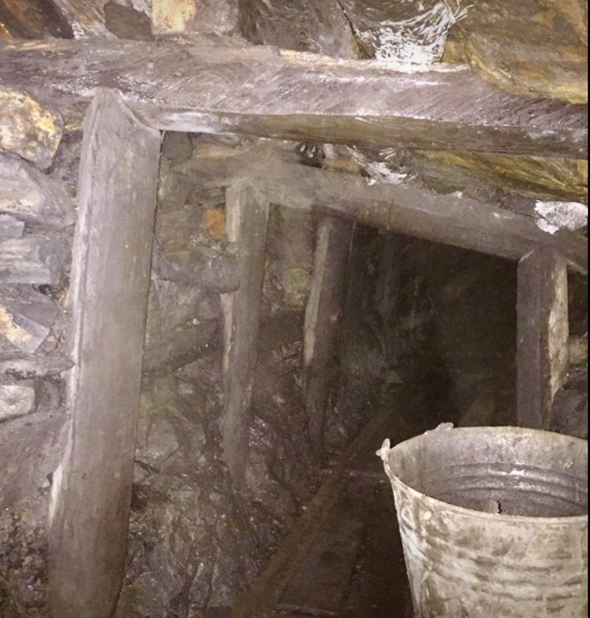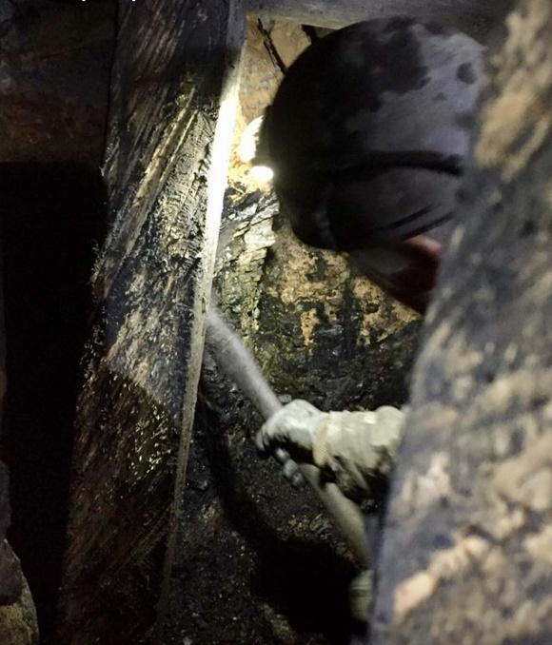
Image 4.0 Image 4.1
Image 4.0 and 4.1 are extracts from a theory session designed to understand the importance of a Freeminer and the cultural significance of Freeminers within the FoD. Without this vital understanding and visual aids knowledge recall for participants would be incredibly difficult. Following theory sessions, participants created and made their own model mines which including the building of props, caps and lags. These practical sessions developed their skills and understanding from theory lessons and learning through practical experiences to gain further understanding. This enables SFG to develop their cultural connections and enhance their memory. Howell (2016) agrees that combining theory and practical sessions allows a solid foundation for creating positive reinforcement of understanding.
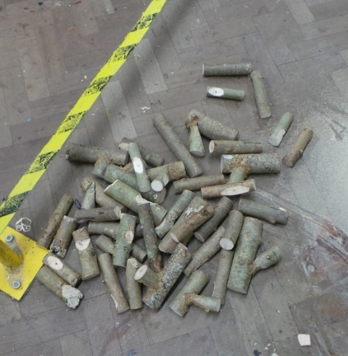
Image 4.2
Image 4.2 shows the preparation of the timber/logs ready for the practical session. Cut to a rough size under the direction of the guest Freeminers who demonstrated and worked with the participants to develop traditional skills. Participants were taught by the Freeminers how to create the traditional timber frames for underground mine supports. Harvey (2018) explained (in theory sessions the previous week) the importance of having the correct type of timber, with the grain, sap and nap of the timber so the support would be able to withstand the pressure of the ceiling and over ground pressure from above. Marfell, (2009) believes and agrees with the sessions, that traditional coal mining with caps, props, slags and lags is one of the most successful supporting systems as the surrounding hardwood forest (FoD) provided all that was required. Hayes (2015) agrees that Freeminers used traditional methods to maintain the woodland which was a sustainable method in the FoD. Pegler (2016) adds that the combination of the forest above and coal below provided an industry which was profitable and sustainable for both large and small businesses. Peck, (2006) maintains miners systematically worked at making and replacing supports on a regular basis in order to keep safe whilst mining.
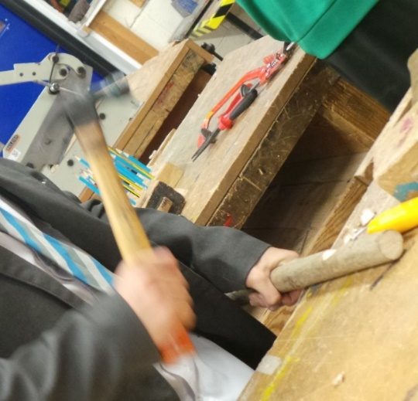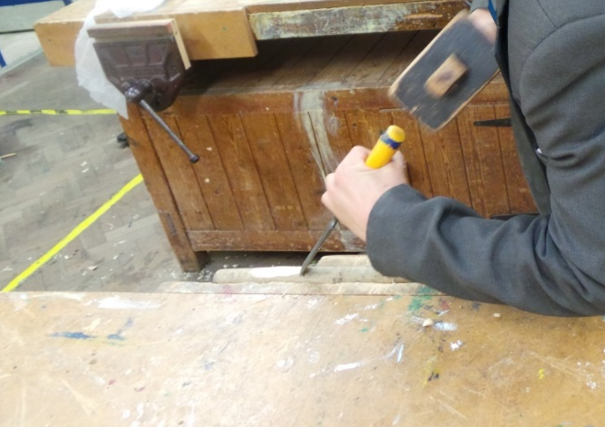
Image 4.3 Image 4.4
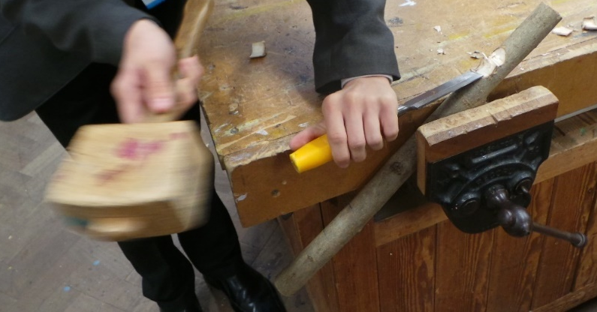
Image 4.5
Image 4.3, 4.4 and 4.5 displays the SFG practicing with hand tools to create ‘caps, lags and props’ for building the interior of a FoD coal mine.
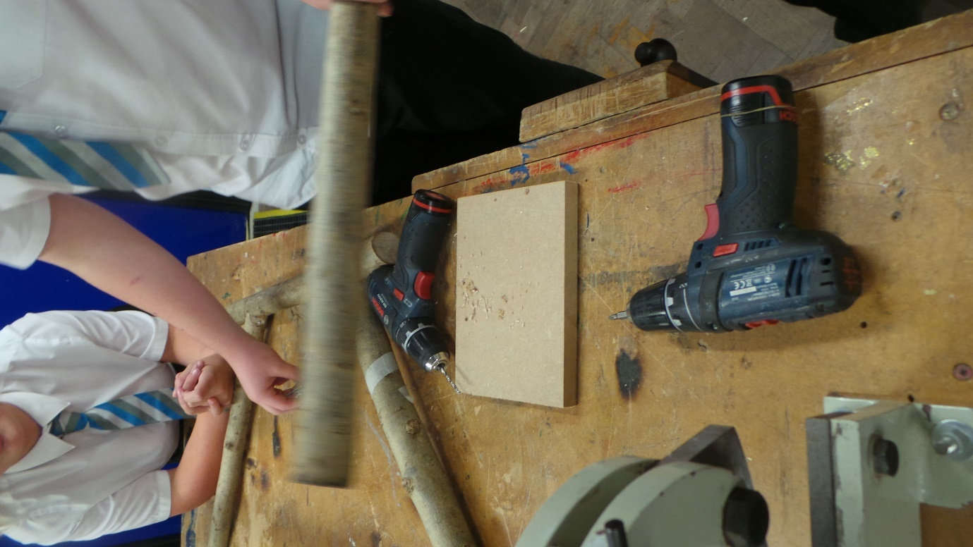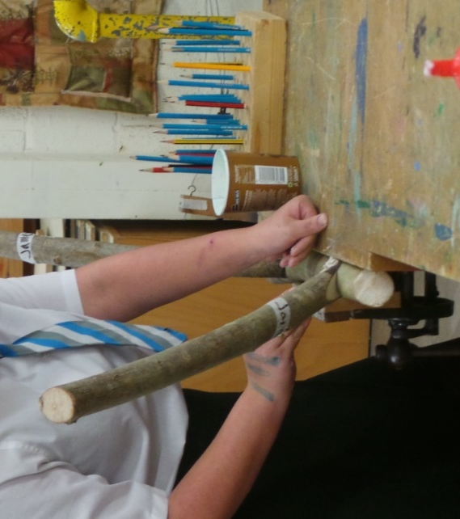
Image 4.6 Image 4.7
Image 4.6 and 4.7 shows the SFG working to understand the difficulties and complex nature of the work that goes into making the supports that make tunnels safe.
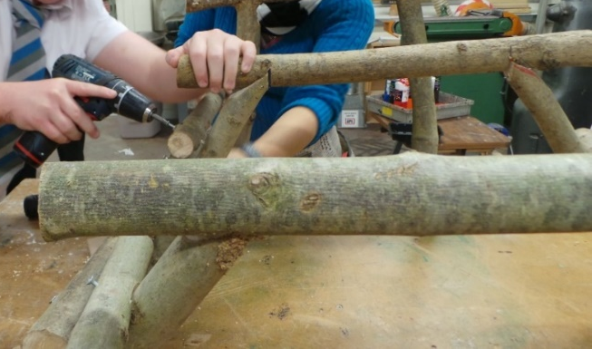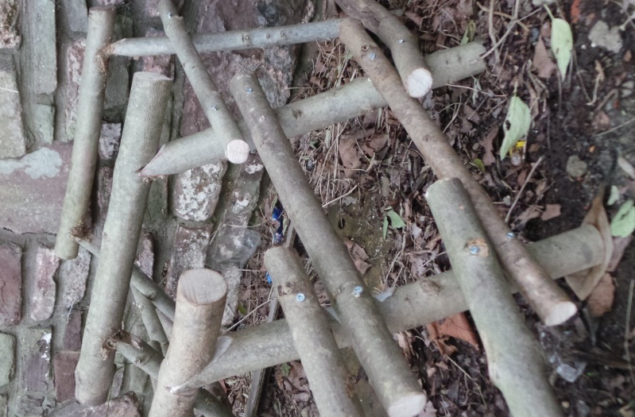
Image 4.8 Image 4.9
Image 4.8 and 4.9 demonstrates the completed supports produced during the practical sessions. These sessions noticeably improved and helped boost self-esteem, according to Williamson (2018) practical sessions help confidence motivation and self-esteem. The FFG gained confidence, communication and transferred their knowledge, language and skills to the SFG which in turn develop their skills, teamwork, camaraderie and communication. Conversations became more in-depth, creative and the participants language became noticeably more expansive. Participants vocabulary extended as they learnt to cope with challenging concepts and difficult situations when faced with building the structure. All participants were dedicated as they returned week after week for the research. Smith (2018) supports this interaction and states that knowledge retrieval becomes easier as students recall knowledge for the practical sessions. Sessions grew longer in length as the participants became more motivated and determined to learn more from the guests. According to Smith (2018) 80% of the SFG had poor behaviour records, lacked concentration and engagement across the school. 60% were underachieving in 4 or more subjects across the school. 85% of SFG had attendance under 85%. Furthermore, Paton (2018) SFG who attended sessions became more creative and more resilient. Staff commented on individual participants regarding the improvement of attitude, attainment and progress in their lessons. Smith (2018) referenced the impact on the cultural connections and research as playing a positive part in this improvement.

Participants with special needs or behavioural issues who had been identified by various teachers around the school were able to be main players in the interventions as the practical sessions played to their creative problem-solving ways. Jones (2018) agreed that special needs and poorly behaved students often respond better in unconventional classroom lessons as this allows them the ability to work to their strengths and not be singled out from their peers.
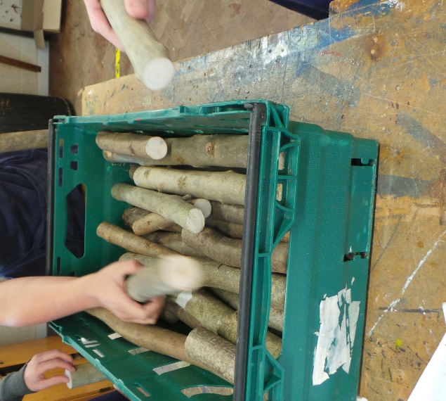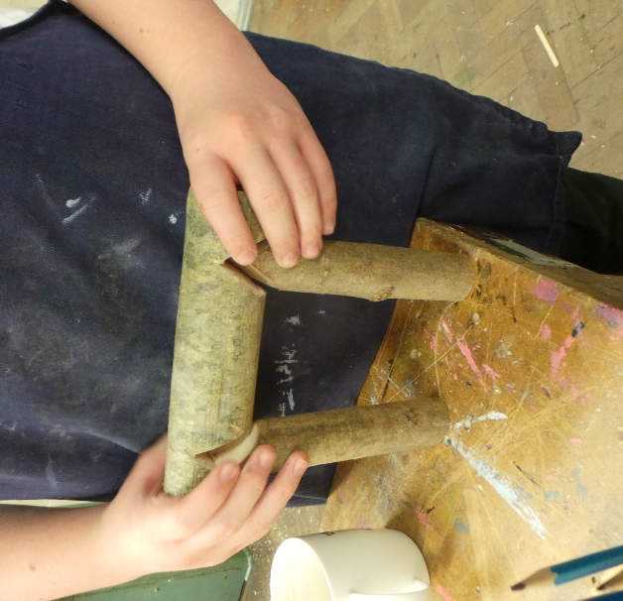
Image 4.11 Image 4.12
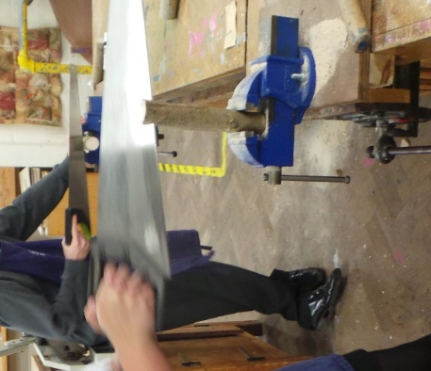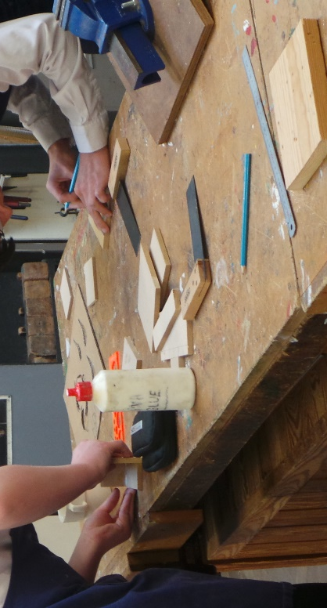
Image 4.13 Image 4.14
Images 4.11 – 4.14 sees new skills being deployed and used to develop a scale model of a drift mine. Skilled tasks identified whether the participants had developed and understood key skills to be able to make a mine shaft. This scale model was created in-line with real-sized supports which would be able to sustain the force and pressure within a mine shaft. Image 4.12 demonstrates one support that a student had built correctly making sure that the ‘notches’ and ‘angles’ were correct for the props to fit into the ‘lags’ securely.

Image 4.13 and 4.14 show participants building, communicating providing support for each other and good team work to produce and high standard mine shaft.
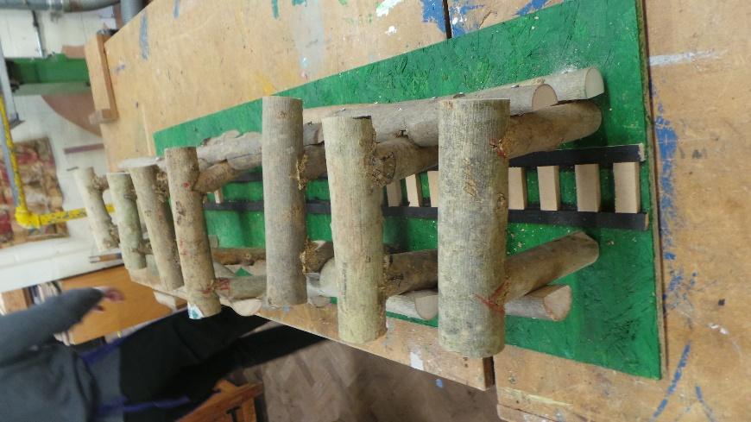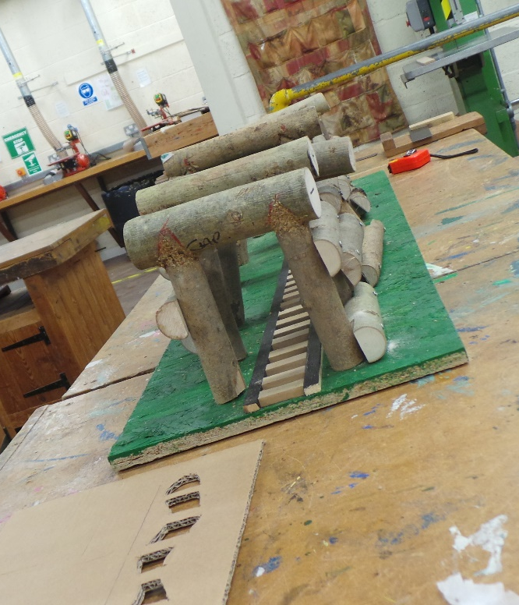
Image 4.15 Image 4.16
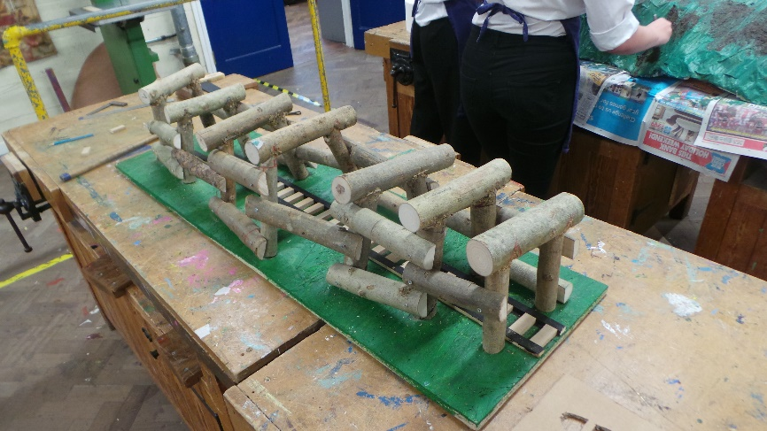
Image 4.17

Image 4.15-4.17 displays participants development of skills and as they complete a scale model of a mine. The skills and knowledge disseminated to the participants from the freeminers were positive, productive and useful. Participants clearly understood the processes, planning and creation of the supports and how important the supports are to the safety of a mine. Whilst learning about the traditional skills to build a mine the SFG gained knowledge and understanding from the FFG and how working with good communication can make the work more engaging, interacting and joyful. Harvey (2018) supports this camaraderie and friendships as they are essential for a community. Pegler (2018) continues to support the research stating the SFG were taught about how the cultural and historical heritage connections were made and founded with why they were important to residents living in the FoD. As the sessions continued participants became more engaged with the research and found familiarities between their parents/grandparents and FFG building a friendship and camaraderie within the sessions.

The scale model was built to investigate if the SFG could be educated on traditional mining methods enabling the SFG to connect with the cultural connections and whether the SFG became more engaged in their learning. The research found that participants
discussed the research with parents and the sessions produced conversations which enabled parents to tell their stories of the FoD. Howells (2016) supports these parental conversations by adding that cultural historical heritage could potentially foster a sense of community identification and spirit. These practical sessions produced the SFG with a sense of pride and engagements with the FFG which would not have occurred without this research. Furthermore, this research produced engaged, enthusiastic students making progress and improving their behaviour around the school without any structured behavioural intervention policy.

Chapter 5 summarises and concludes the research against the aims which started this research. Chapter 5 will investigate recommendations for the school and further research which could be compiled to secure and develop the curriculum in the new Ofsted framework 2019.

Chapter 5: Conclusion and recommendations

Chapter 5 speculates and determines the outcomes from the assessments, questionnaires and interventions which were developed for the research and to investigate the question and aims set out in the start. This research was based in a unique area in Gloucestershire. The importance of the cultural historical and heritage connections was significant to the research, together with the low social economic base of the school. The research question was When exploring a school in a unique historical area - can cultural connections be integrated into the curriculum to engage learning? The complexity of this question resulted in three aims. Through this chapter these will be summarised, and recommendations drawn. The aims were developed to understand the school with the local community through cultural connections and historical heritage.

The three aims were as follows
- To research the practicalities for students in the FoD to incorporate cultural connections of the FoD.
- To research the potential of developing interventions regrading history and heritage of the FoD at Ks2, Ks3 and Ks4.
- To develop strategies and processes that enable cross-curricula engagement at Key stages between local schools

Each aim will be addressed, summarised and concluded to achieve a clear understanding of the success of the research. This research focused on developing the cultural connections of the FoD and how to incorporate this into the local educational curriculum.
Middleton, (2016) Harvey, (2018) Hogg, (2017) and Royall (2017) support the research and agree that there is a valid reason for investigating and researching this area of the FoD. Successes from the research are already occurring.

5.1 Aim: To research the practicalities for students in the FoD to incorporate cultural connections of the FoD.

The research has shown that when participants engage with their surrounding area and their cultural connections learning becomes natural and free flowing. Research found SFG did not object to this learning process predominantly through the mix of practical and theory sessions. Participants learnt new skills, developed a range of recent vocabulary and approaches in expressing themselves. SFG discussed and displayed new knowledge and skills through community links, guest speakers and hands-on learning. Harvey (2016) and Middleton (2016) acknowledged that the dynamics between the generations was extremely encouraging. Howell (2016) declared that the participants desired an identity, the title of a ‘Forester’, participants were prepared work hard to realise this identity. From research Rogers (2014) found that when the Australian Government prioritised a cultural and historical curriculum embedding Aboriginal cultures students felt connected to the area studied providing them with a sense of purpose and identity.

During my research the SFG felt a profound achievement when they began to understand the cultural connections and belonging to the FoD. Boswell (2015) remarked on conversations between the generations being informative and insightful, critically stimulating and exhilarating, producing personal and enlightening bonds across the generations. Boswell (2015) positively supports my research with the mix of generations attending these sessions. Rogers (2014) concluded that similarly with the Australian public, bonds were formed by the mix of generations enabling the cultural, historical and heritage connections to cross different societies, cultures and beliefs and an understanding of other ways of life.

5.2 Aim: To research the potential of developing interventions regrading history and heritage of the FoD at Ks2, Ks3 and Ks4.

Investigating the adaption of the curriculum the adaptive practice could include the high achieving students delving deeper using scientific and academic approaches encompassing cultural connections whereas low ability and SEND students could develop their social, verbal, interpersonal and practical skills. Pugh (2018) supports this adaptive practical but argues that SEND and low ability students require significant emotional support. When establishing new topics with changes in the curriculum cultural connections could potentially help change students’ outlook and provided a greater sense of achievement.

Cooper (2017) and Hart (2018) agree that mining, culture, community, with heritage and history need developing into a passionate, exciting, enthusiastic educational project with knowledgeable, informed, driven, people who have a desire to preserve the FoD. Lightfoot (2018) agrees that educational projects are achieved when cultural connections form the structure of the curriculum. However, Wyatt (2017) acknowledges that changing the whole school curriculum is not for the faint hearted. Rogers (2014) suggests that knowledge, understanding and principals of cultural connections need strong, outstanding, determined, well informed staff which allow the students to develop respectful rich well-rounded knowledge of cultural differences. Cain (2017) adds there are only some teachers that are willing to engage, change and adapt curriculums. My research displayed that once the project started participants became enthused and interested to learn about the local cultural connections about the area with ideas to develop extension work being suggested by the participants. Generally, however staff responded as expected to Cain’s (2017) research. Flexibility at this stage was imperative.

Smith (2018) stated that participants’ individual progress across the school improved. For three participants behavioural issues significantly reduced and the change in their concentration and participation during lessons had remarkably improved. Pegler (2014) by continuing Morgan’s (Hopewell) mine provided a tourist attraction by way of a short shaft mining experience. Middleton (2016) adding that this mine could become a link with schools which develop hands-on educational knowledge with cultural connections ensuring that traditional historical values and practicalities of physical endeavour as experience beyond the classroom are available for the future. Pegler and Daniels (2014) agree that providing this mining experience with a small dedicated artefact museum, provides a connection with the cultural of the local area more specifically with Freemining. Powell (2018) agrees that this facility emphasises the educational value for culture and historical connections which comply and enrich the framework prospects for this work.

5.3 Aim: To develop strategies and processes that enable cross-curricula engagement at key stages between local schools

The research was welcomed by participants, individual answers and questioning gained valuable insight into how cultural connections could be developed. Interventions gained an understanding and knowledge which was a positive forward move. Answers highlighted that the passage of time is limited as many personal experiences and stories were being lost due to the age of the Freeminers and local history experts in the area. Research needs to develop processes and links between local schools to harness the cultural connections through their research from their locality. Participants acknowledge that the transfer of Freeminers stories, skills and understanding of the FoD geology is needed so that the next generation can protect this information for future generations. Qualitative data displayed the sense of proud ‘Forest Students’ who desire an identity and yearn for an understanding of their ancestors’ abilities, knowledge and working life. Lightfoot (2018) agrees that students do not always verbalise their desires, but most would like to be mindful and conversant with their local area and cultural connections.

Saunders (2017) agreed a sense of community life and attitude is still present and strong, adding that being part of the research was inspiring, exciting and engaging. Both Powell (2017) and Saunders (2017) support the research and add that with hard work in changing the scheme of work for KS3 teachers need encouragement to change the content to captivate the students. Powell (2017) added that the students in the FoD still possess the passionate traits of a ‘Forester’ and desire this title. Participants demonstrated that they want to continue a legacy for future generations, Pegler (2015) agreed with Powell (2017) and Saunders (2017) that the underground mining experience educates local school students on mining history, cultural connections, and the heritage of the FoD. Middleton (2016) openly encourages educational projects which have been highlighted in this research, maintaining that the Foresters Forest organisation would support this curriculum change and give financial support where possible.

Successfully, the participants grasped their cultural connections and have found purpose in their idea of identity. These participants genuinely demand success and desire to continue the understanding of the FoD. This research provided an insight into cultural connections and historical heritage which improved concentration, progress, understanding and vocabulary of the participants involved. Lightfoot (2018) agreed with the findings and supports the ideal that when students understand their cultural connections other aspects of learning improve. Bushby (2018) commented that when communities are involved school links are improved and the school benefits. Rogers (2014) insists that the Aboriginal cultural interventions deepened knowledge for students resulting in students being immersed and stimulated by their own personal connections. Focus for local students could incorporate their own interests and areas of study together with finding a format for presentation of their work. For lower ability student’s positive demonstration of engagement and understanding of their personal research developed their learning which became more inspiring and relevant. Inclusion for all became apparent.

Through this research project, schemes and strategies have been developed to enable local schools to create sections/areas of cultural connections within their curriculum. Local schools can individually expand an area/section of the topic, thus reducing the workload while enabling cultural connections to be established. Structures and schemes will require adaptation for relevance, age and ability at the school.

Locally

A local primary school piloted a FoD cultural project for all year groups (KS2 Yr3-6). Enthusiastic, staff developed a scheme of work which provided the cultural connections for Geography, Science, Art, Technology and English. Lusted (2016) discusses a journey through time from Iron Age settlements to the Industrial Revolution, developing creative writing skills, persuasive texts, designs, adverts, leaflets and letters. Food technology lessons based on recipes from the time of study while students developed their own vegetable patch and harvested the produce for seasonal meals and understanding. Redfern (2017) stated students were enthused and immersed in FoD attributes, whilst researching and investigating their locality. Redfern et al (2017) was excited and captivated by the FoD. Future projects are planned to integrate more aspects of the local area into the curriculum. Lusted (2016) added that most of all this project work displayed and indicated how the FoD became the primary focus for education and attainment throughout the school. Lusted (2016) deemed the pilot study as both an achievement and successful. Busby (2018) agreed with Lusted (2016) that changing the curriculum to involve cultural connections with the need for enthusiastic and competent staff with engaged, enthused, excited students willing to learn was instrumental for success.

The Academy’s research has enabled two participants to gain apprenticeships within the local mining sector, the participants decided on this sector once the projects had started. Harvey (2016) supports these participants on their career choice. Howell (2016) supported Harvey (2016) adding that he was willing to mentor students to promote local history if needed. Harvey (2016) and Pegler (2017) add that this is a small but significant step forward.

Nationally

Expanding Local History projects in local schools is becoming particularly positive. In Bath (2015), their local History Society (History of Bath (1986)) developed a scheme of work for local primary schools based on the history of their Transport Systems, this considers how the transportation system began, developed and was established. Williams (2016) suggests local education projects encourage passion and excitement with understanding of the local area whilst incorporating curriculum learning and enthusiasm. As a result, this project continues to be taught through KS2 (Year 1-Year 5) in Bath’s surrounding schools. Williams (2016) declares that Bath schools have adapted schemes of work to allow this historical project to lead their curriculum. Students local to Bath, discuss investigate and give reasons why the transport system developed. Humphries (2018) supports these types of projects and indicated that there are currently 26 Bath primary schools attached to this study. All schools and teachers shared resources, projects, schemes of work, information, trips and experiences to make the projects richer, more exciting and creative for the students. Having 26 schools involved resulted in teachers being able to share resources, ideas and schemes of work resulted in more supported interventions and a reduction of planning.

Kings College London (KLC) (2006) detailed that local schools should seek local approaches for projects, furthermore Humphries (2018) agreed that cultural connections can cover many subjects engaging students relating to their surroundings leading to the understanding of where they live, community structures and values with their personal identity. KCL (2006) agrees that when students develop an understanding of where they live, they become more aware of their locality and become more protective of their community and surrounding area. KCL (2016) added that projects being completed through localised connections produces community spirit, inspiring conversations and a passion for the surrounding area. Williams (2016) supports KCL (2016) together with my research by suggesting that understanding the local communities produced stronger bonds with enthusiastic committed students who invest their time into projects developed from localised connections.

Recommendations

Lusted (2016) indicated that local projects in Primary Schools have the engagement, passion and excitement generated by staff and other students, however Secondary schools are a little more apprehensive. Smith (2018) highlighted that timetabling in Secondary schools is complicated, but Bushby (2018) disagreed with Smith (2018) suggesting that teachers made obstacles and excuses for not changing curriculums. Familiar routine results in reduced preparation and planning as staff understand the pitfalls and stumbling blocks for learners. Heads of Faculty (2017) (in secondary schools) did agree with Lusted (2016) regarding the development of cultural connections at KS3 and were positive about change, however, Lusted (2016) admitted that changing the curriculum takes time, committed staff and determination. Pearce (2017) advocated that more persuasion and discussions are needed for Secondary schools to adopt this project but Pearce (2018) could appreciate the benefit of cultural connections. My research has shown immersing students in local communities and their cultural connections enables them to acknowledge and understand their surroundings. Lusted (2016) embraces the research stating that understanding the FoD is essential for students grasping cultural connections enabling them to find a balance and sense of pride in where they live and who they are. Meanwhile Rogers (2014) insisted that it is essential that students are given a genuine opportunity to learn cultural development - facilitating a balanced education.

Lusted (2016) affirmed that Freeminers working with Primary schools at Key Stage 1&2 have positively developed history, heritage, culture and community connections projects. Lightfoot (2018) promotes a sense of flexibility in scheme of work as adaptation would be necessary consideration depending on the school setting, with interests, age and ability of the children. Middleton (2016) indicates that there is a real possibly that every Primary school (within the FoD) could develop a rich resource for sharing the cultural connections. Tuffley (2017) agreed but acknowledged that time is of the essence, with Rogers (2014) supporting this and reinforcing cross-curricula education enabling students to value and support each other through the learning of cultural and historical connections whilst developing knowledge of all subjects required in education. Expanded use of internet facilities will encourage cross-transfer of research and verbal histories between schools.

Primary schools are developing cross-curricula projects such as articles, leaflets, and newspaper reports as part of the English curriculum, site-specific locations (Worldwide, UK based and locally) in geography for utilise placement and understanding. Geology providing awareness of flora and fauna for science purposes. History gives encouragement for enriching the curriculum. Secondary schools could adopt a similar scheme of work at KS3 but whether staff would be willing to attempt this change will need further research. Dawson (2009) agreed but stated it ultimately comes down to the staff’s commitment to make the changes and meet the challenges that will be associated with changing the schemes of work. Senior leadership at School A determined that cultural connections were not a focus point in their curriculum. The primary school plan to expand their FoD topic through Years 2-6 with an array of subjects was inspirational. The Primary School encompassed the cultural connections in the FoD, this includes ancestors, families, occupations, work, housing, finances, locality and an understanding of how important the FoD people and products were to the rest of the UK. Favourably, Howell (2016) stated the Forestry Commission were looking to develop an ethos link between the Forestry Commission itself and the educational projects suggested by the research together with the collaboration of selected primary schools.

However, the research was taken to another FoD school. This school (School B) was more engaged and enthusiastic about the research and the link between progress, engagement, and attainment for the students. School B decided to adopt a pilot study for selected subject running through Religious Studies, Geography and History at Ks3. School B understood the possibility of implementing the interventions throughout KS3 as a whole school initiative. Middleton (2016) supported this development and the positivity of School B’s transition leader, who presented a proposal which links Yr6 to Yr7. Redfern (2017) advises that cultural connections could become a key topic in the transition between primary and secondary education. Having a coherent project enabled students to feel more comfortable providing continuity and possibly relieving anxiety, stress and any uncertainty which the transitioning students may feel. School B concluded that if the pilot study is deemed a success (based on improvement of concentration level, engagement and behaviour) School B will run a second pilot study engaging all students across KS3 (September 2019). School B recognised that changing schemes of work was a substantial undertaking, taking considerable effort and organisation, however my research recommends that educational establishments (within the FoD) need a major investment. If individual schools provided structured and skeleton schemes of work while sharing resources - reducing the workload for all involved - many local group projects, industrial sites and visitor attractions which are able to practically and physically contribute to project work.

Howell (2016) suggests that the demographic population of the FoD is changing as new housing development takes place as an overspill for the larger areas (Bristol, Gloucester, South Wales), non-local and cultural differences alter populations and the idea of ‘identity’. Sullivan (2016) believed that families have cultural connections to the area and would still contribute their ideas, experiences and stories to the school. Furthermore, such families would support local communities, amenities and established attractions in the area. Families need encouragement to participate in the interventions. Middleton (2016) did not see the changing of the demographic to be an obstacle and certainly the research has not seen this trend.

Professional development

To work with a passionate, dedicated, demanding but respectful group of participants who consistently explored the research was motivating and invigorating. Participants provided optimism. They immersed themselves in the cultural connections, finding the research fascinating leading to sessions which lasted longer than scheduled. Some sessions took a different direction as the SFG and FFG exchanged stories, experiences, questions, answers and queries about cultural connections and how previously territorial communities were linked through common ground. Ultimately, SFG want to leave a legacy and understand their surroundings, this research enables them to do exactly that.

My professional development was driven by passion and desire to try and make a difference to the children in the FoD, providing them with an understanding of their cultural connections. My research has been enlightening, amazing, challenging and enthusiastically brilliant, educating students using cultural connections as a starting point and developing alternatives to engage student learning. Pearce (2018) suggests that this research has developed a substantial educational scheme of work which is robust and incorporates cultural connections within the curriculum. Essentially though, aiding the transition between Primary and Secondary school and KS2-3 for the majority of pupils apprehensive of school change between September and December.

Personal development

I selected this form of research as I felt there was a need to be counted, to stand up to and challenge the current education curriculum. A critical incident occurred when I realised other counties and schools were using their local surroundings as the backbone of their curriculum. I grew up in the FoD, my grandfathers and relatives had personal experiences and colleagues with experiences of the Freemines, Freeminers, Miner’s Strikes together with being a miner working underground. The effects of two World Wars contributed to the decline of mining with a momentary lapse into Opencast mining. Family, households and domestic culture were different – more hardship, a much more basic existence and were less financially driven. This provided an insight to life as a Forester introducing awareness of the culture community and connections to the FoD. In my opinion my generation (30(+) year olds) are (probably) the last generation whose grandparents have influences, contact and personal experiences with the mining history and domestic heritage in the FoD.

Without an understanding of cultural connections, working mines and miners the FoD will be forgotten. Locals and visitors use the FoD for recreation pursuits, the tranquillity of the woodland provides reparative repair. The FoD is accessible to all generations with interest as diverse as designated play areas for toddlers to rare bats, newts and woodland flora and fauna, with an increasing development for recreational art and sport. Educating FoD students about the area and their cultural connections will provide them with the ability to appreciate the culture, heritage, history and community, and in turn pass on their impressions and knowledge. Unless education and the FoD’s schools change attitudes and commit to pass on the legacy of understanding and knowledge by embedding local cultural connections in the curriculum the vast historical heritage of the FoD will be lost.

These participants believed that the FoD is to be cherished, remembered, protected and be part of their childhood and their education. For the moment these ancient processes and experiences are available. They form a bond exclusive subject matter for study. This will be available forever. These students could leave their own legacy.

My research has provided a comprehensive overview which indicates using projects in education to secure and harness the understanding and knowledge of the cultural connections, improves progress, concentration, engagement and behaviour for students.

Dissemination

Having investigated the aspirations of the SFG they are motivated to develop projects through the curriculum. The Forest of Dean Local History Society (FoDLHS) showed an interest in celebrating the research by
- An evening presenting the participants with certificates for their part in the research.
- Published an article written of the findings for the New Regard (September 2017).

All participants met with enthusiasm and exchanged inspirational exciting stories. The collaboration between the groups and individuals was insightful and creative. The intergenerational dialogue enabled the project to thrive as these dynamics exhilarated participants. This research provided knowledge and understanding of cultural connections for SFG. Participants felt that collaboration and ‘story-telling’ was imperative in developing cultural understanding of the FoD. The SFG adapted easily to older members of the community providing their wealth of experience, abilities, interests and conversations. There are local schools (both primary and secondary) which are interested in this project, these will need to be explored further.

Further research

Lusted (2018) has implemented a developing scheme of work for Ks2 students, this discovers the historical heritage and cultural connections of the FoD from Roman invasion to the Industrial Revolution. Discussions are continuing to extend schemes into the present day. Middleton (2016) agrees but adds that time, support and dedicated staff are required to develop the scheme. Redfern (2017) and Lusted (2018) agree with Middleton (2016) regarding passionate staff being the key to success when teaching cross-curricula topics to 5-11 yr. old understand the importance of teaching cross-curricula topics to 5-11-year olds. Cooper (2017) maintains extending schemes of work into all aspects of the curriculum will enable more cultural connections to be explored. Redfern (2017) agrees with both Cooper (2017) and my research, adding further schemes of work will be developed soon.

School A showed a clear reluctance for curriculum change, however School B (5 miles away) was interested and enthused by my research. School B has decided to adopt the research as a pilot study for a selected KS3 class. Holyrod (2017) concurs that cultural connections cover many aspects of student engagement but also incorporates the Ofsted framework 2019. Lightfoot (2018) supports my research in which the curriculum is based on cultural connections enabling valuable and progressive projects to be accessible for the whole school. My belief is that cultural connections lie in the educational system with passionate local dedicated teachers. A genuine interest has been shown in the research, the FoDHS hold the insight into the past in written articles and seminars which will be critical for continuing and supporting the educational cultural connection project. More research and collaborations with local schools are required to fully incorporate cultural connections within schools in the FoD. Primary experiences will not be available for ever.

15043

