
Assessment Title:
Research, build, and deploy a Virtualized Enterprise network.

Applied Computing.

Network Operating Systems and Services.

ACCA5023.

Dr. Sadeque Imam Shaikh (Lecturer)
University of Wales Trinity Saint David
(London Campus)

Student Name: Jasin Navas
Student Number: 2426726
Group: 01
Date: 27/03/2026

Table of Contents
Table of Contents 2
Introduction 1
Task 1 2
Research on Hypervisor: 2
Research on IP Addressing: 2
Research on Routing: 3
Research on Network Services: 3
Task 2 5
2.1. Choose your Hypervisor: 5
2.2. Download and Setup: 6
2.2.1 Evidence of Download and installation. 6
2.2.2 Deploy your network as per the given topology: 12
2.2.3 IP addressing: 18
2.3. Configure IP Addressing 19
2.3.1. Use appropriate IP addresses to configure your network. 19
2.3.2. The above topology gives network address for the networks 21
2.4. Test and Troubleshoot 23
2.4.1. Perform Connectivity tests 23
Task 3 26
3.1. Reflection 26
3.1.1. Technical reflection covering network deployment and testing. 26
3.1.2. Write your Personal Reflection 27
References 28

Introduction
This report explains the research and practical work completed for Coursework 1 in the Network Operating Systems and Services module. It looks at the main networking technologies needed to design and set up the BIRMINGHAM.ACCA domain shown in the coursework topology. The research focuses on understanding different hypervisors, IP addressing methods, routing options, and key network services so that Windows Server 2022 and Debian Server can work together in a multi-network setup. By reviewing recent academic and industry sources, the report compares virtualisation platforms, examines how IPv4/IPv6 and subnetting support efficient network design, and considers how static and dynamic routing affect communication between servers. It also explores important services such as DHCP, VPN, Active Directory Domain Services, and Certificate Authorities, explaining how they help create a secure and scalable domain environment. Overall, this research provides the technical background needed for the deployment, configuration, and testing tasks that follow in building the BIRMINGHAM.ACCA network.
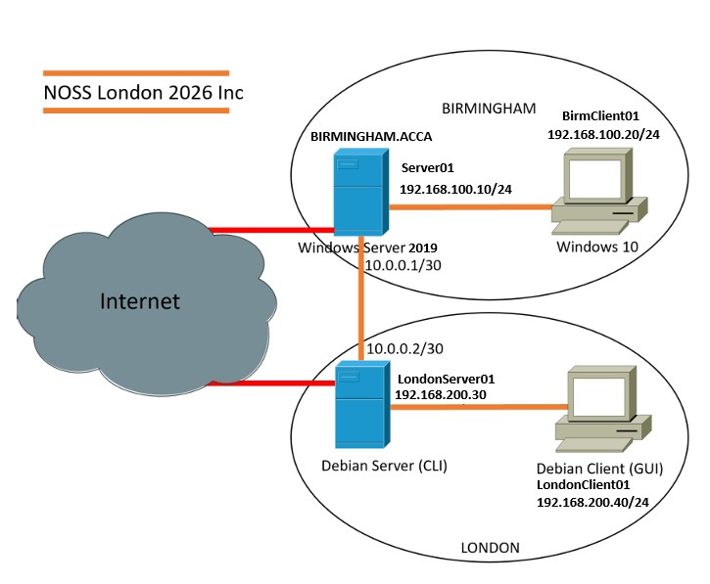
Topology for the Coursework

Task 1

Research on Hypervisor:
A hypervisor is software that creates and runs virtual machines. It allows one computer to run several operating systems by sharing the computer’s memory, processing power, and other resources. Hypervisors are used to running more than one operating system on the same computer, but the way they are built, known as their architecture, affects how they work. Type 1 hypervisors run directly on the computer hardware with no normal operating system underneath, and this is why they are called bare metal. Because of this design, they are fast, secure, and stable. Research shows that this bare‑metal architecture gives better performance and stronger isolation between virtual machines [1].
While Type 2 hypervisors work differently. They run on top of a normal operating system such as Windows or Linux, which is known as host-based architecture. The hypervisor depends on the host operating system to communicate with the hardware. This makes Type 2 hypervisors slightly slower, but they are much easier to install and use. Studies show that Type 2 hypervisors are very common in education, training, and small labs because they work well on normal laptops and desktops without needing expensive or high-performance hardware [2].
For the BIRMINGHAM.ACCA domain, where both Windows Server 2022 and Debian CLI are required, a Type 2 hypervisor is the best choice. Student machines usually have limited hardware. Type 2 hypervisors support various operating systems, allow easy snapshotting, and provide quick rollback options. These features are important for repeated testing in the improved topology. Services like AD DS, DHCP relay, and certificate management often require cloning and isolated test environments. Type 2 hypervisors manage these tasks effectively without the extra complexity of bare-metal systems. Given the need for scalability, compatibility, and hardware limitations, a Type 2 hypervisor offers the best balance for this coursework.

Research on IP Addressing:
In my research, I found that IP addressing is a fundamental component of how communication occurs across networks. Every device connected to a network requires a unique logical address so that data can be accurately sent and received. When information is transmitted, it is divided into packets, and each packet contains a source and destination IP address. Routers use these addresses to determine the most efficient path for forwarding packets between networks, while switches operate at Layer 2 to forward frames within the same local segment. This structured addressing system ensures reliable, organised, and efficient communication across different network environments [3].
I also explored the structure and representation of IPv4 and IPv6. IPv4 uses a 32bit -dotted decimal- format, which limits the number of available addresses. IPv6 expands this to a 128bit hexadecimal format, providing a significantly larger address space and improving routing performance. Subnetting is another key concept that divides a large network into smaller, manageable segments, reducing broadcast traffic and improving efficiency. Variable Length Subnet Masking (VLSM) enhances this by allocating- address ranges based on actual host requirements, preventing waste and supporting scalable network design [4].
Overall, my study showed that IP addressing is essential for maintaining network functionality, supporting routing decisions, and ensuring predictable communication across all connected devices. Without a structured addressing system, modern networks would not be able to operate reliably or efficiently.

Research on Routing:
Routing plays an important role in how information moves across different networks. When data is sent from one device to another, it does not travel in a straight line. Instead, it is broken into packets that must pass through several network devices before reaching their destination. Routers are responsible for guiding these packets by reading the destination IP address and choosing the most suitable path. This process ensures that data can travel across long distances and through many interconnected networks without getting lost [5].
To make these decisions, routers rely on routing tables. These tables contain information about available networks and the paths used to reach them. In small or stable networks, routes can be added manually, which is known as static routing. However, in larger or constantly changing networks, dynamic routing is more effective. Dynamic routing protocols, such as RIP and OSPF, allow routers to share updates automatically. This helps the network adapt when links fail or when traffic increases, keeping communication smooth and reliable [5].
Routing also depends heavily on IP addressing. Without a clear addressing structure, routers would not know where packets should go. Subnetting helps organise networks into smaller sections, reducing unnecessary traffic and making routing faster. IPv6 further improves routing by offering a larger address space and a simpler header format. Overall, routing is essential for ensuring that data reaches the correct destination efficiently and reliably across complex network environments.

Research on Network Services:
Network services help organisations manage users, devices, and secure communication. One important service is the Virtual Private Network (VPN). A VPN allows people to connect safely to a private network over the internet. It protects data by encrypting it, which stops attackers from reading the information. VPNs are commonly used for remote work and secure access to internal systems [6] .
Another key service is the Dynamic Host Configuration Protocol (DHCP). DHCP automatically gives IP addresses to devices when they join the network. This makes network management easier because administrators do not need to assign addresses manually. It also reduces mistakes and helps large networks run smoothly, especially when many devices connect and disconnect often.
Active Directory Domain Services (AD DS) is used in Windows networks to manage users, computers, and security settings. AD DS provides centralised login, meaning users can sign in once and access the resources they are allowed to use. This improves security and makes it easier for administrators to control permissions and apply policies across the organisation [6]. Certificate Authorities (CAs) are also important for secure communication. A CA issues digital certificates that confirm the identity of websites, users, or devices. These certificates allow encrypted connections, such as HTTPS, and help prevent impersonation or data tampering by creating trust between systems. Overall, VPNs, DHCP, AD DS, and Certificate Authorities work together to keep networks secure, organised, and reliable.

Task 2

2.1. Choose your Hypervisor:
For this coursework, Oracle VirtualBox 7.2.6 was chosen as the Type 2 hypervisor to build the NOSSLONDON2026 network. It is easy to use, works well with both Windows Server 2022 and Debian Server, and does not require special hardware. Because it is free and supports multiple virtual machines, it is suitable for student work and for expanding the network in Coursework 2. VirtualBox also provides useful features like snapshots and flexible network settings, which help with testing and troubleshooting during the setup.
Oracle VirtualBox 7.2.6 was chosen because the research showed that it offers the most practical and flexible option for building this network. It works on Windows, macOS, and Linux, which makes it easy to use on different devices and supports a wide range of learning environments. Since it is open-source, there are no licensing costs, which is important in education where budgets are limited. This makes VirtualBox a cost-effective choice compared to paid hypervisors like VMware Workstation Pro.
Another key reason for selecting VirtualBox is its strong networking features. The NAT Network option allows the Birmingham (192.168.100.0/24) and London (192.168.200.0/24) subnets to be created as separate, isolated network segments while still allowing controlled internet access. This is essential for accurately simulating the two-site topology required in this coursework. VirtualBox also supports multiple network adapters, which helps when building multi-subnet environments.
VirtualBox’s snapshot and cloning tools provide major benefits for this project. These features allow you to save the state of a virtual machine before making changes, which is especially important for Coursework 2 when more services—such as DHCP, DNS, IIS, and RDS—will be added. If a configuration fails, the system can be rolled back quickly without rebuilding the entire setup. This makes testing and troubleshooting much easier.
Performance and usability are also improved through VirtualBox Guest Additions, which provide better drivers, shared folders, and smoother mouse and display integration. This is helpful when managing several virtual machines at the same time. In addition, VirtualBox uses Intel VT-x and AMD-V hardware virtualisation features, allowing both Windows Server and Debian to run efficiently with near-native performance.
Taken together, these features provide strong evidence that VirtualBox is the most suitable hypervisor for completing this network and for continuing the topology in Coursework 2, where more services and configurations will be added.

2.2. Download and Setup:

2.2.1 Evidence of Download and installation.
- Creation of Virtual machine windows 1 and 2.
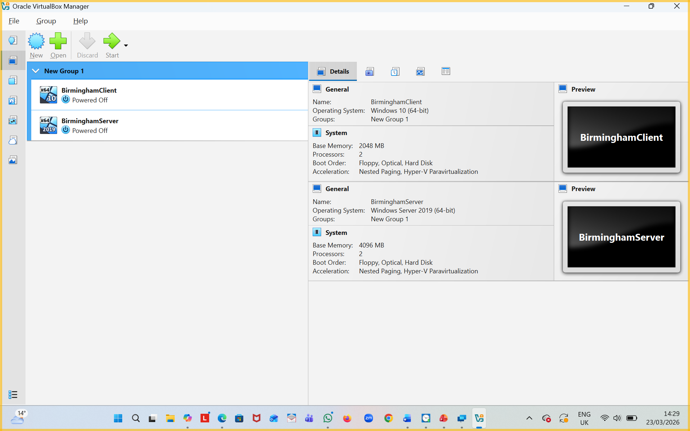
Figure 1: Virtualmachine created for Birmingham Server & Client.
Oracle VirtualBox Manager showing the two Birmingham VMs already created — “BirminghamServer” (Windows Server 2019) and “BirminghamClient” (Windows 10 Pro). This proves the Windows-side VMs were successfully built

- Creation of Virtual machine Linux Debian 1 and 2.
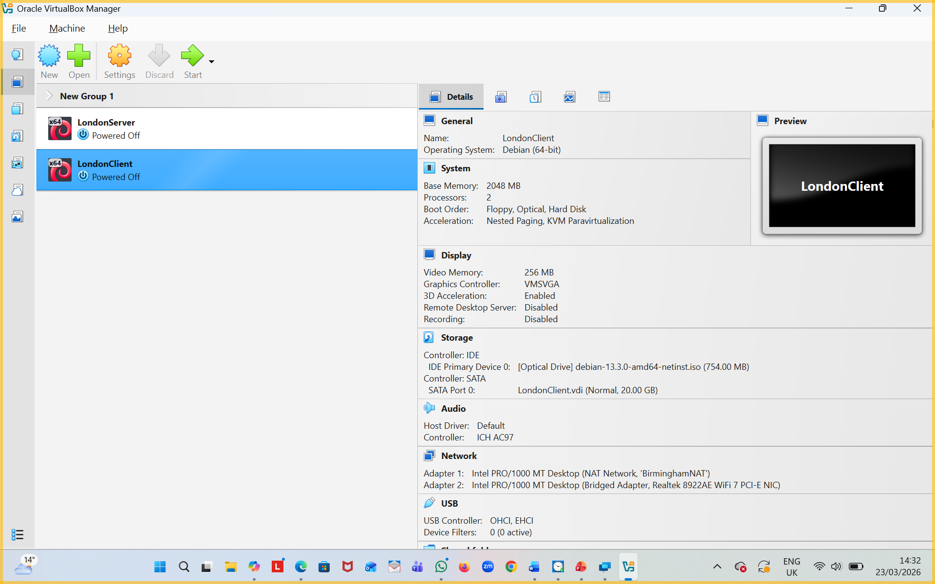
Figure 2: Virthualmachine created for London Server & Client.
Oracle VirtualBox Manager showing the two London VMs — “LondonServer” (Debian 13 CLI) and “LondonClient” (Debian 13 GUI). This proves the Linux-side VMs were successfully built.

- Installation of windows and Linux OS.
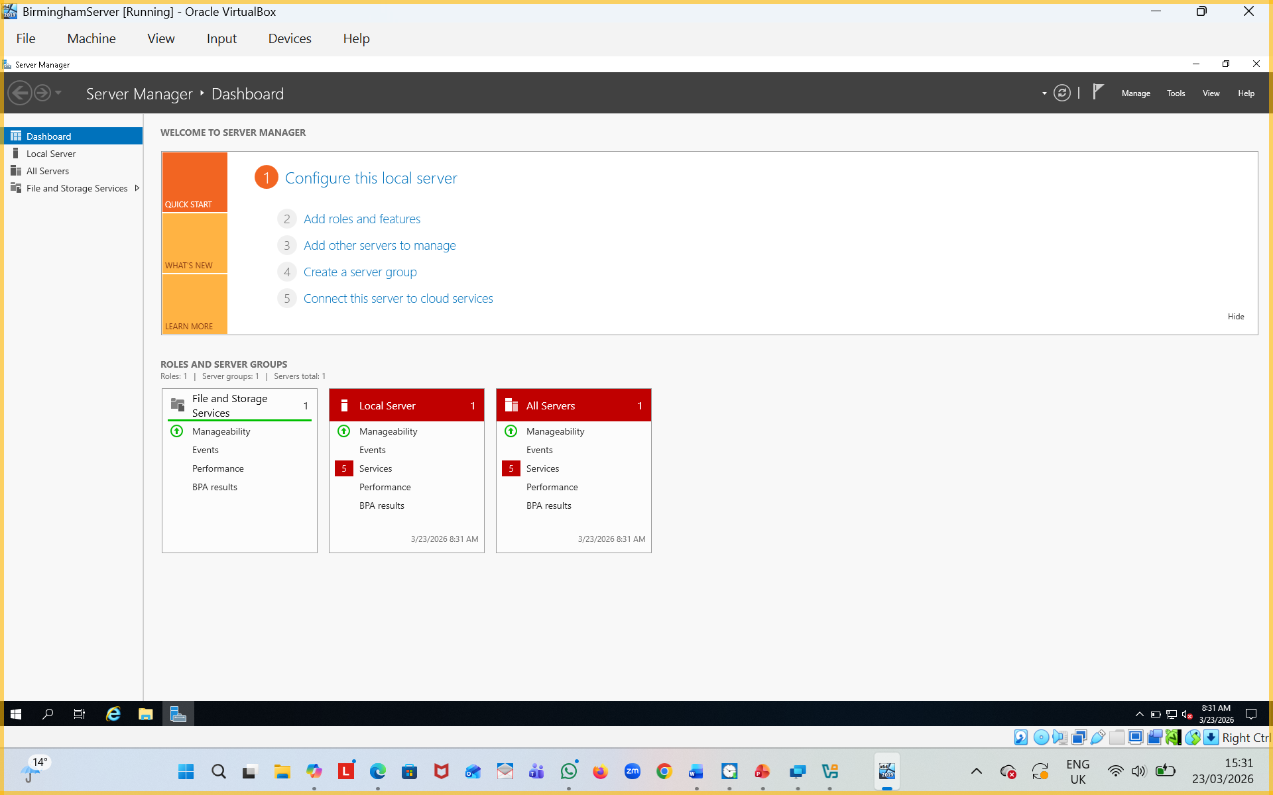
Figure 3: Windows 2019 Server for Birmingham Server01 installed.
Windows Server 2019 Server Manager dashboard on the BirminghamServer VM. The OS installation is complete, and the server is ready for configuration.
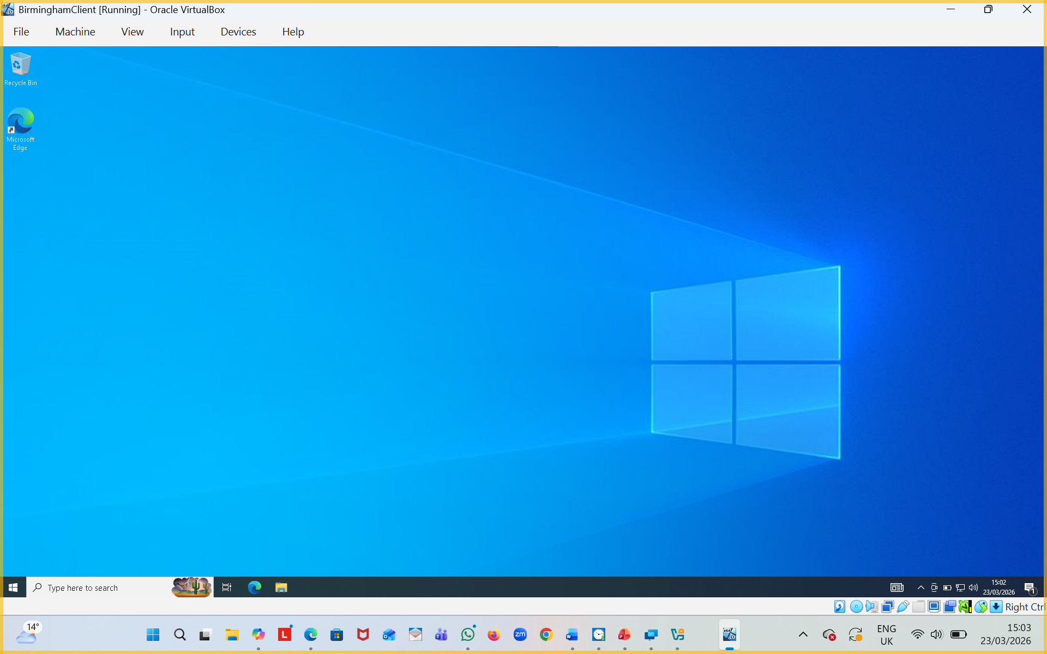
Figure 4: Windows10 for Birmingham Client01 installed.
Windows 10 Pro desktop on the BirminghamClient VM. The client OS installation is complete.

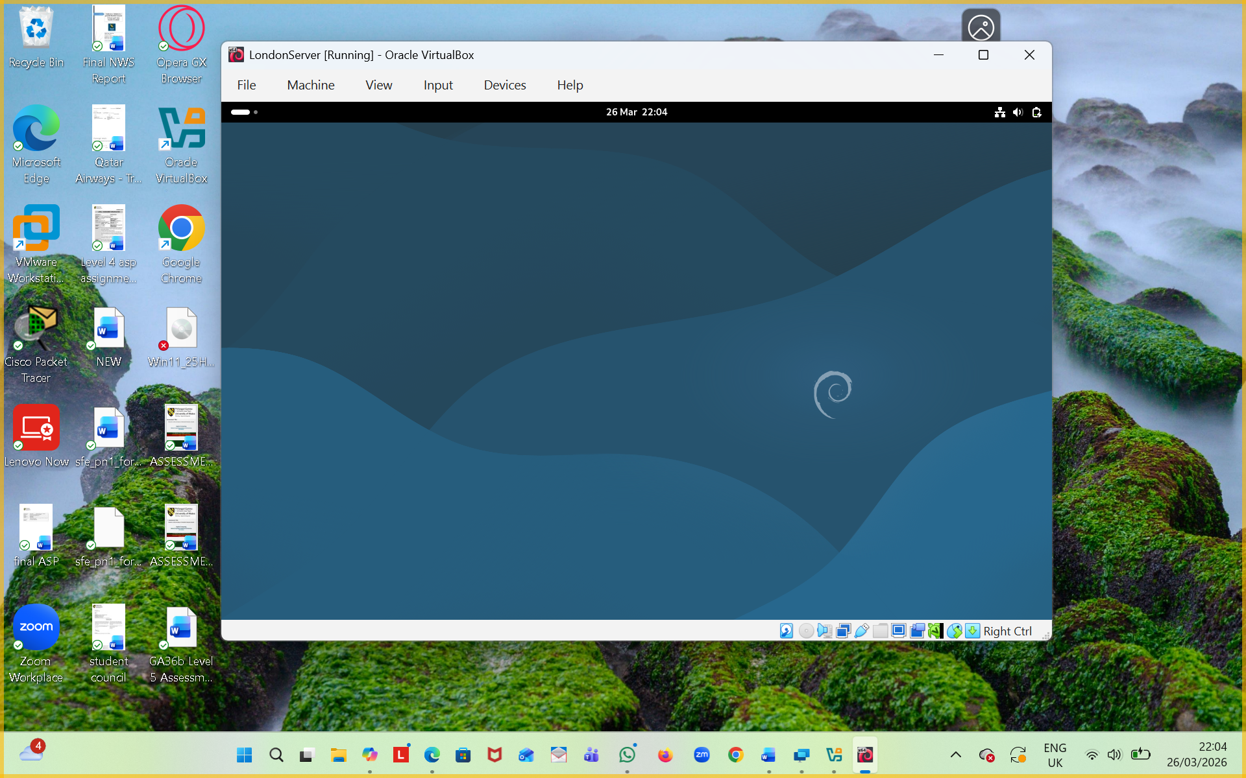
Figure 5:Linux Server for London
Debian 13 Server (CLI) desktop environment running inside VirtualBox (LondonServer).

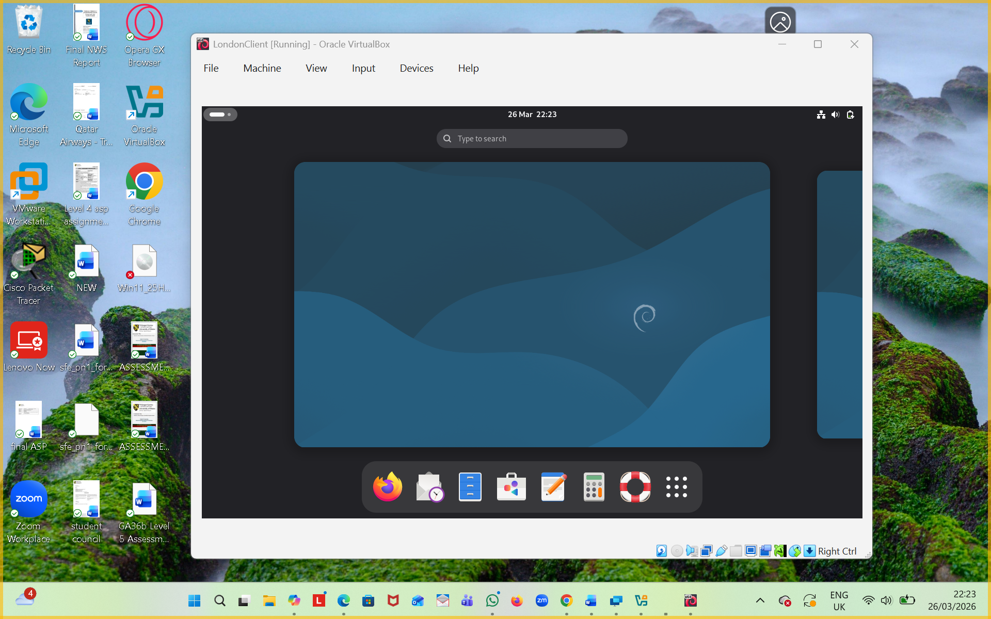
Figure 6: Linux Client for London.
Debian 13 Client (GUI) desktop environment running inside VirtualBox (LondonClient).

2.2.2 Deploy your network as per the given topology:
- Creation of Network with NAT Network1 for windows.
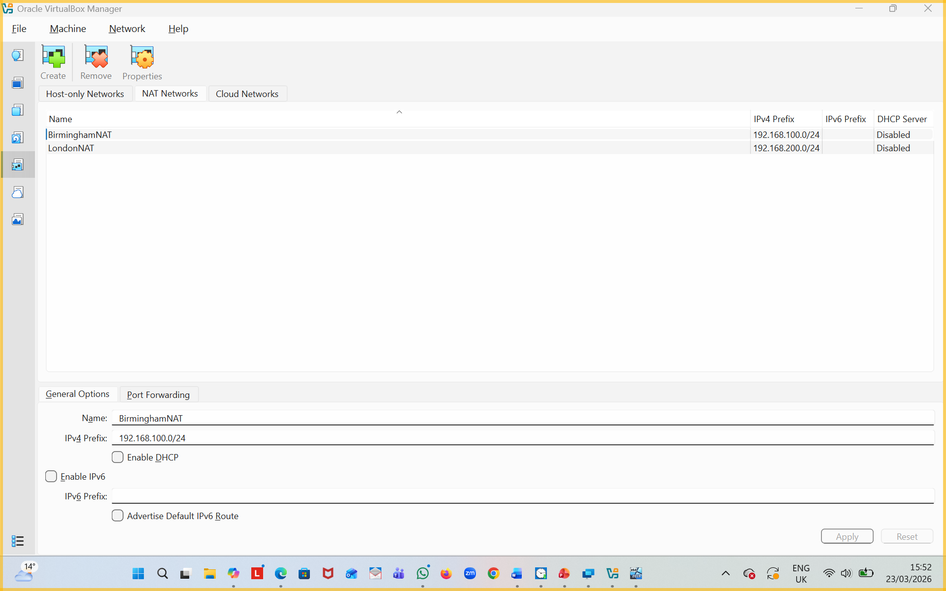
Figure 7: Nat Network for Birmingham.
VirtualBox “NAT Networks” settings panel showing the newly created BirminghamNAT network (192.168.100.0/24). This is the isolated network for the Birmingham site.

- Creation of Network with NAT Network 2 for Linux.
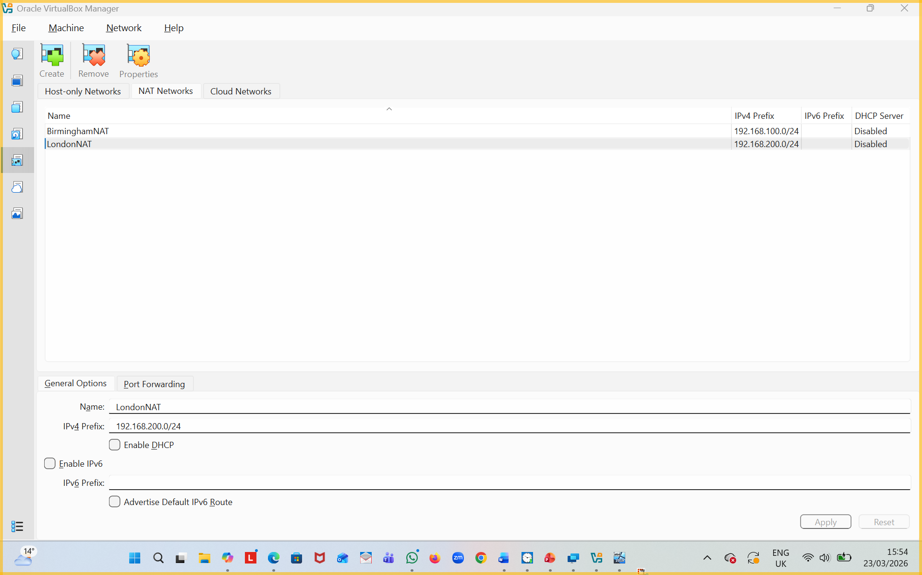
Figure 8: Nat Network for London.
VirtualBox “NAT Networks” settings panel showing the newly created LondonNAT network (192.168.200.0/24). This is the isolated network for the London site.

- Evidence of 2 Windows PCs are connected with NAT Network1.
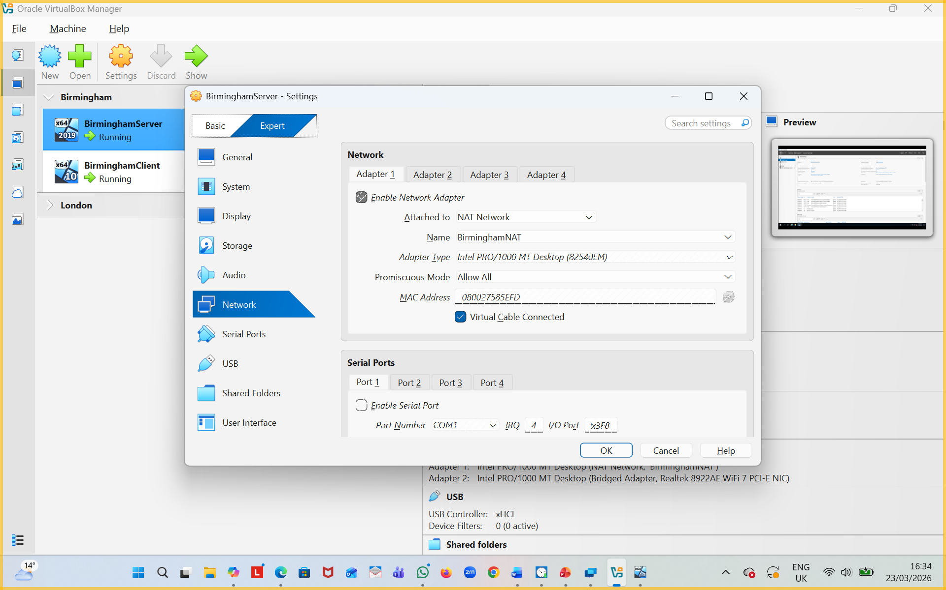
Figure 9: Birmingham Server Configure with BirminghamNAT
BirminghamServer network adapter settings — Adapter 1 attached to BirminghamNAT

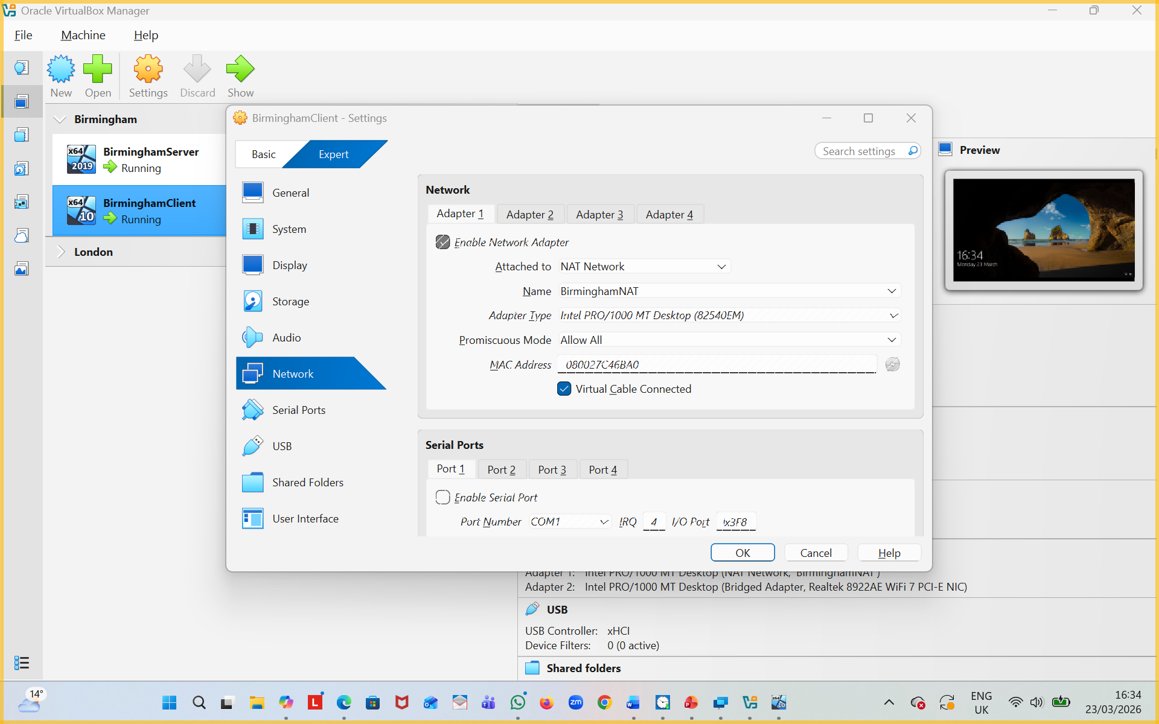
Figure 10: BirminghamClient Configure with BirminghamNAT
BirminghamClient network adapter settings — Adapter 1 attached to BirminghamNAT. → Both Windows machines are now connected to the same isolated NAT network.

- Evidence of 2 Linux PCs are connected with NAT Network2
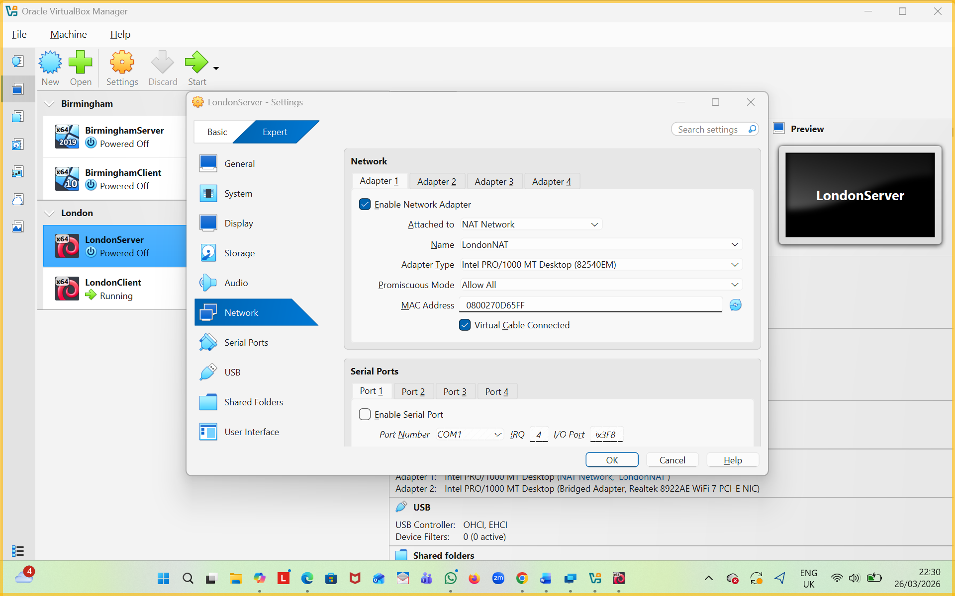
Figure 11: LindonServer Configure with LondonNAT.
LondonServer network adapter settings — Adapter 1 attached to LondonNAT
.

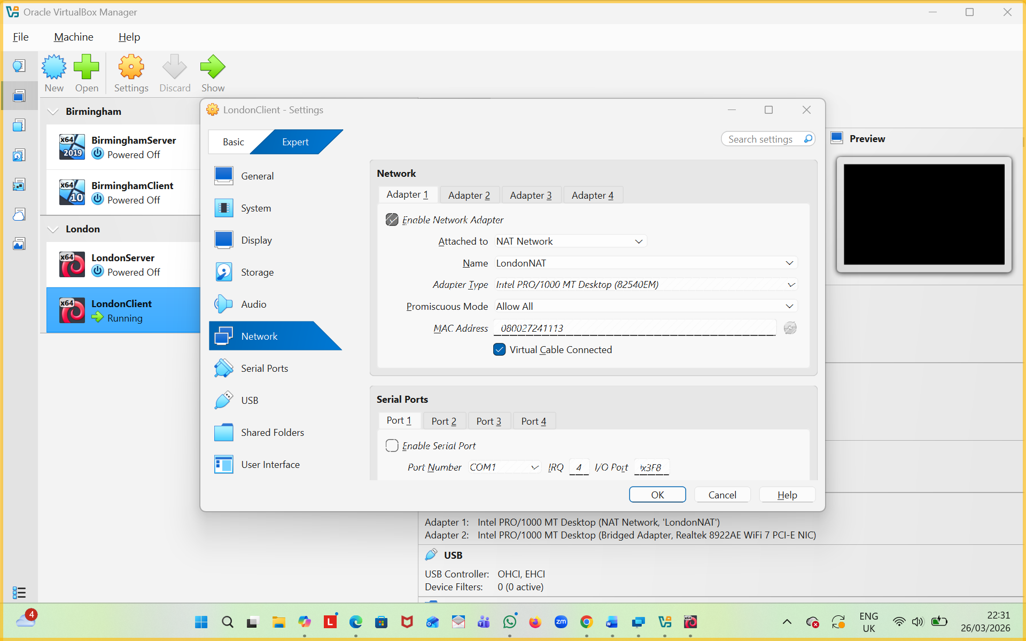
Figure 12: LindonClient Configure with LondonNAT
LondonClient network adapter settings — Adapter 1 attached to LondonNAT. → Both Linux machines are now connected to the same isolated NAT network.

2.2.3 IP addressing:
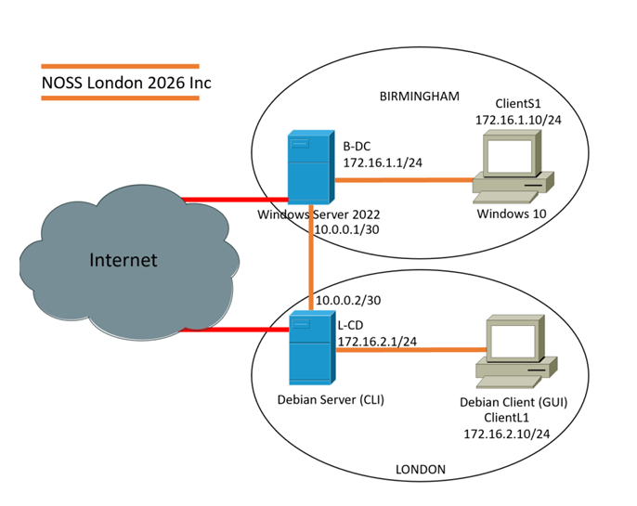
Figure 13
Machine | OS | Ip address | Network
Server01 | Windows Server2019 | 192.168.100.10/24 | Birmingham
Client01 | Windows 10 Pro | 192.168.100.20/24 | Birmingham
DebianServer | Debian 13 | 192.168.200.10/24 | London
DebianClient | Debian 13 | 192.168.200.20/24 | London
Table 1

2.3. Configure IP Addressing

2.3.1. Use appropriate IP addresses to configure your network.
- Evidence of IP addresses set up in 2 Windows and 2 Linux machine
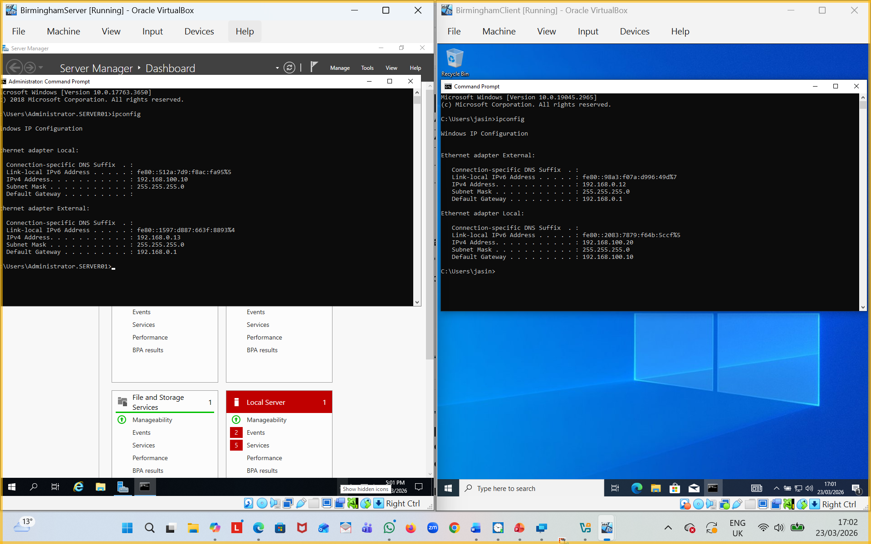
Figure 14: Windows Server & Client IPConfig.
Side-by-side ipconfig output on BirminghamServer and BirminghamClient showing correct static IPs and subnet masks.

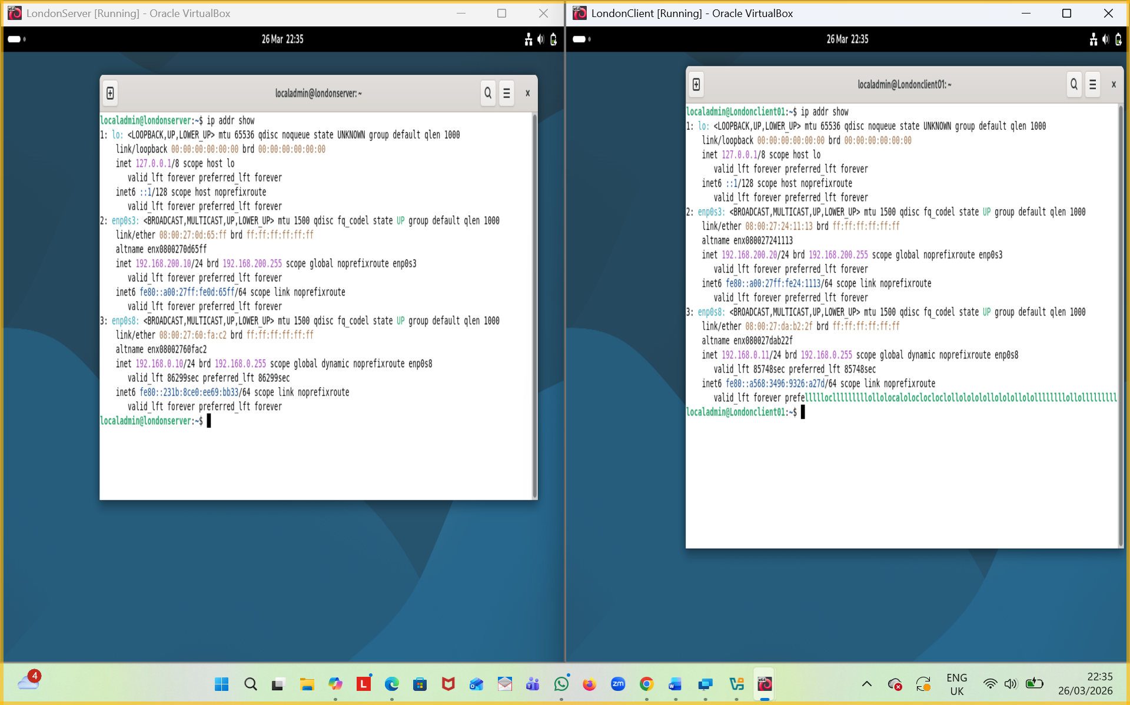
Figure 15: Linux Server & Client IPConfig
Side-by-side ip addr output on LondonServer and LondonClient showing correct static IPs and subnet masks.

2.3.2. The above topology gives network address for the networks
- Network IP address from NAT Network1 for windows.
Figure 16: Nat Network for Birmingham.
BirminghamNAT network settings confirming the 192.168.100.0/24 range.

- Network IP address from NAT Network 2 for Linux.
Figure 17: Nat Network for London.
LondonNAT network settings confirming the 192.168.200.0/24 range.

2.4. Test and Troubleshoot

2.4.1. Perform Connectivity tests
- Outcome 1: Successful connectivity within windows network.
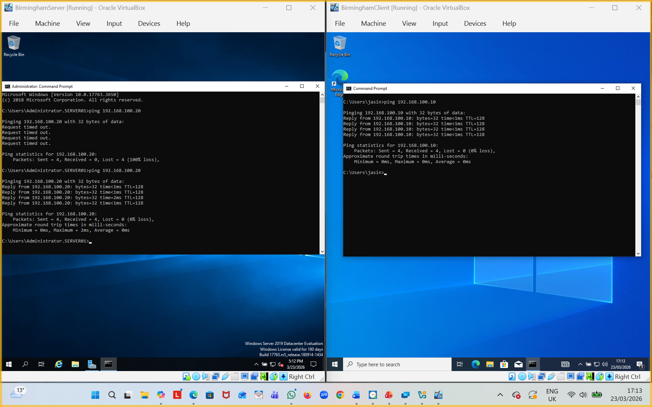
Figure 18: Windows server & Client are Successfully connected.
Successful ping from BirminghamServer to BirminghamClient (and vice-versa) — proves intra-site Windows connectivity works.

- Successful connectivity within Linux network.
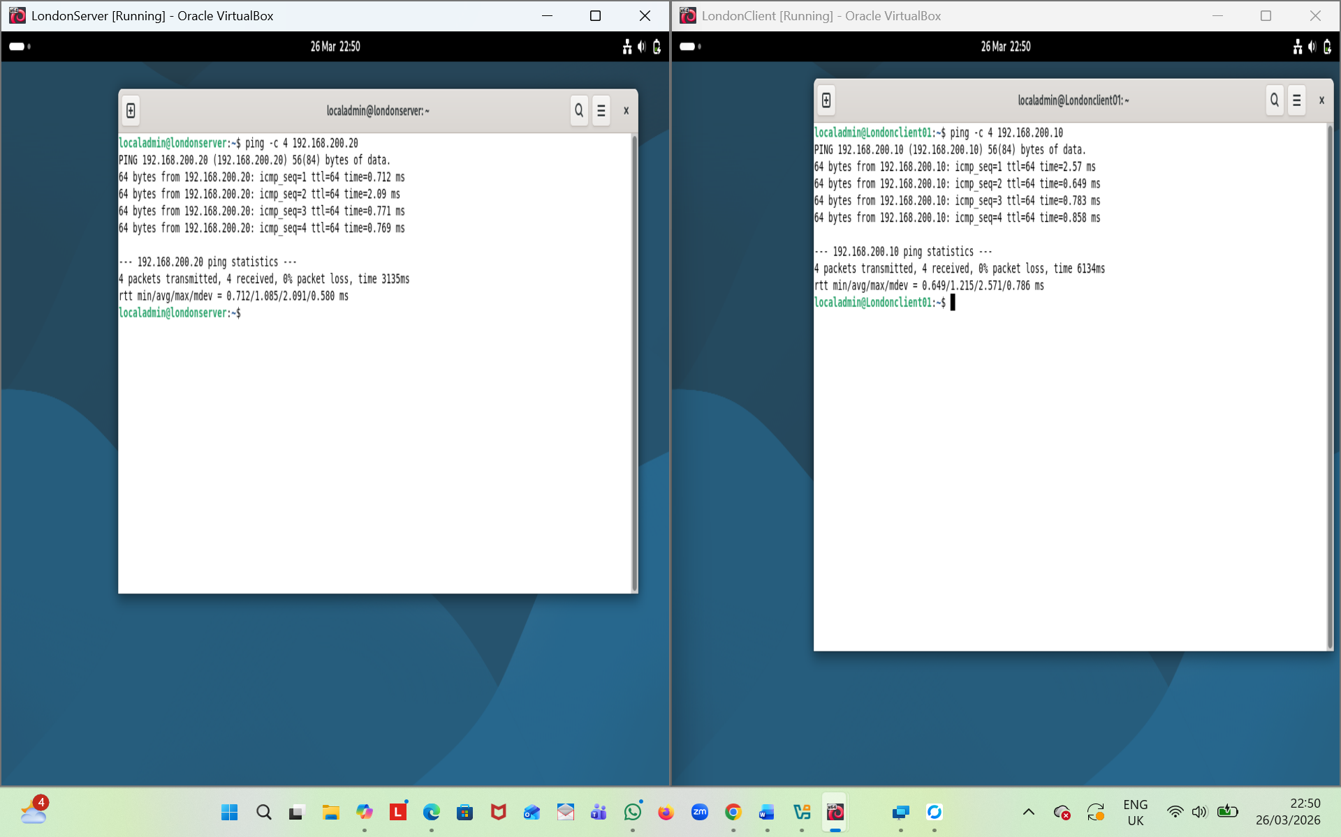
Figure 19: Linux server & Client are Successfully connected.
Successful ping from LondonServer to LondonClient (and vice-versa) — proves intra-site Linux connectivity works.

- Outcome 2: Unsuccessful connectivity between Linux and windows networks.

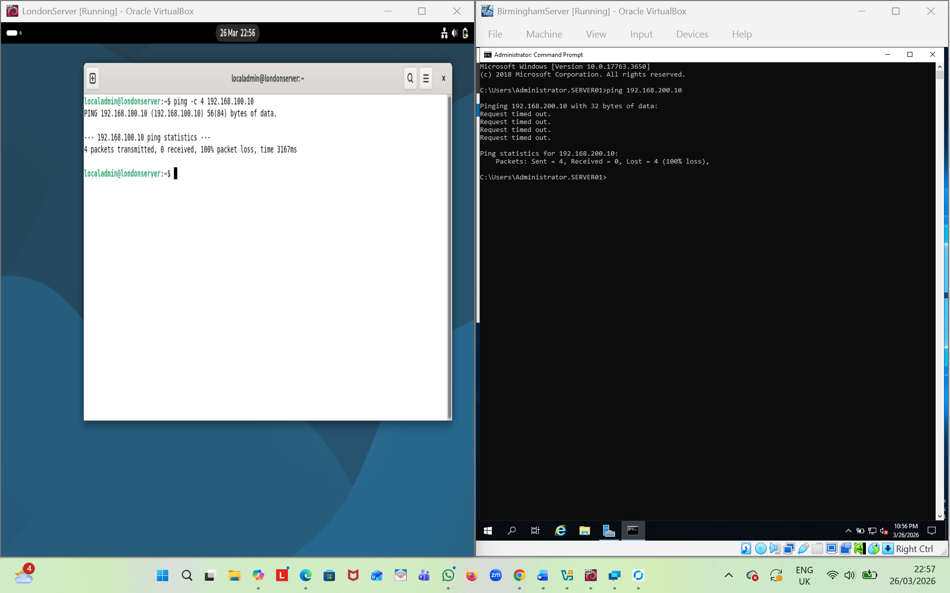
Figure 20: Windows and Linux servers are not connecting
The Windows and Linux servers can’t ping each other, indicating that inter-site connectivity is unavailable. This is expected because the two NAT networks are fully isolated and no routing or linking configuration has been set between them.

Task 3

Reflection
Throughout the deployment and testing stages, I encountered several issues that helped me better understand how different network components interact. The process highlighted the importance of systematic troubleshooting and careful configuration when working with multi-site or multi-network environments.

Technical reflection covering network deployment and testing.

NAT vs. NAT Network Confusion:
At the start of the deployment, I struggled to understand why Windows Server and Debian Server could not communicate. Both machines were placed on separate NAT networks, and I initially expected basic connectivity to work. After reviewing the configuration, I realised that NAT networks in VirtualBox are isolated by default. This meant the two servers were effectively on different “sites” with no routing path between them.
I diagnosed the problem by first checking the IP addresses on both machines and confirming that they were on different subnets. I then tested connectivity by running ping commands from each server, and both attempts failed. After that, I looked at the VirtualBox network settings and saw that the servers were placed on separate NAT networks with no router or link between them, which explained why they could not communicate. Then I found that Windows Firewall can silently block essential network tools like ping. Understanding firewall behavior is crucial when diagnosing connectivity issues.

Static IP Configuration on Debian (Not Persisting After Reboot)
During the deployment process, I encountered a problem where the static IP address assigned to the Debian server did not remain in place after a reboot. Although the IP worked temporarily, it reverted to a different address each time the system restarted, which made network testing inconsistent. To diagnose the issue, I first checked the active IP address after reboot using the ip a command and confirmed that the static configuration had not been applied. I then reviewed the Debian network configuration files and realised that the settings had been entered manually but were not saved in the correct persistent file. This meant the system was using temporary settings instead of a permanent configuration. I resolved the issue by updating the correct network configuration file with the static IP details, restarting the networking service, and rebooting the server to ensure the IP address now remained consistent. This experience helped me understand how Debian handles network persistence and highlighted the importance of saving configuration changes in the correct location.

Windows Firewall Blocking ICMP (Ping) Replies
During connectivity testing, I noticed that the Debian server could not ping the Windows Server, even though the Windows Server appeared to be configured correctly. This suggested that the issue was related to the firewall. To diagnose it, I ran ping tests from both servers and compared the results. I then checked the Windows Firewall inbound rules and discovered that ICMP Echo Requests were disabled by default. This meant the Windows Server was blocking ping replies, making it appear offline. I resolved the issue by enabling the “File and Printer Sharing (Echo Request – ICMPv4-In)” rule, which immediately restored ping functionality. This challenge showed me how firewall rules can affect basic network testing and highlighted the importance of checking firewall settings when diagnosing connectivity problems.

Cross Site Connectivity Failure and Network Isolation Verification
During testing, I examined whether the two servers could communicate across their separate network segments. As expected, cross site communication failed because no routing or bridging had been configured between the isolated NAT networks. This confirmed that each network was functioning independently, exactly as designed. The inability to connect showed that the isolation between the two sites was intentional and effective, reinforcing the idea that multisite environments require explicit routing before any communication can occur.

Write your Personal Reflection
Throughout this coursework, I strengthened my understanding of how networks function and how different systems behave during deployment and troubleshooting. Working through issues such as NAT isolation, static IP configuration, and firewall restrictions helped me develop a more structured and logical approach to diagnosing problems. These tasks taught me to check configurations carefully, test methodically, and rely on evidence rather than assumptions. As a result, I became more confident using both Windows and Linux tools to identify and resolve network issues.
This learning experience also supported my long-term career goals in IT and cybersecurity. The practical skills I gained—such as analysing network behaviour, managing IP configurations, and understanding how security settings affect connectivity—are essential in professional technical roles. The coursework showed me the importance of accuracy, documentation, and systematic testing, all of which are key skills in the cybersecurity field. Overall, this module has strengthened my technical foundation and increased my confidence in progressing toward a career focused on network management and system security.

References

[1] | Avi Kivity,Yaniv Kamay,Dor Laor,Uri Lublin,Anthony Liguori, "kvm: the Linux Virtual Machine Monitor," in Proceedings of the Linux Symposium, vol 1 ed., Ottawa, Ontario,Canada, 2007.
[2] | Borislav Dordevic,Srdan Milenkovic,Nikola Davidovic,Valentina Timcenko, "Performance comparison of native host vs. ESXi".
[3] | Andrew S.Tanenbaum,David J.Wetherall, "Computer Networks," fifth edition ed., pearson.
[4] | "Internet Protocol, Version 6 (IPv6) Specification".
[5] | C. Severance, "Introduction to Networking," S. Blumenberg, Ed., 2015.
[6] | Charlie Scott, Paul Wolfe, Mike Erwin, "Virtual Private Networks".

