PROBLEM SOLVING AND DECISION MAKING

Liliana Calin st id 1818714

REPORT

Table of contents
Executive summary
Introduction
Analysis of the selected problem
Scope and consequence of the problem
The importance of the correctly information for an effective decision making
Different solutions of the problem
Brainstorming , creative thinking , problem solving
Problem solving and decision making criteria
Swot analysis , Fish bone diagram , pestle analysis
Process of an organisational change and management
Benefits and participation of change
Conclusion
References

Executive summary
American airlines is having a range of problems , the company American has managed to negotiate major union concessions and stay afloat, but not without a mountain of debt and pension obligations. How long can AA continue to operate in the red? With $17.1 billion in debt, it's really only a matter of time. Shareholders are nervous - parent company AMR's share price is down 75% this year. Another problem facing American Airlines is security problem. The greatest security problem that the airline has faced since its establishment is the September 11 attacks. Suicide bombers hijacked two of its aircrafts and one of them was crashed into the Pentagon building in Washington DC, while the other one was crashed into the North Tower of the World Trade Center in New York. Since the occurrence of these events, the airline has tried to increase its security measures
INTRODUCTION
When operating a business a company can face a range of different problems , that can be solved by using a problem solving methods and their tolls . This report was structured to find out the problems of American airlines and discover the futures solutions and methods that can be applied to the problems . As we can see in the description there are mayors problem facing this airline company . American airlines it is the one of the largest airplane and its serving more than 50 countries, and more than 133,700 employees. This massive company is an important source of income in the workforce .

ANALYSIS OF THE SELECTED PROBLEM

One of the problems which this company are facing is the financial crisis . The company has debts with over 19 billion £ and the mayor factor is the rising fuel cost . Since 2009 the airline is trying to stay afloat. The other complaint is the security system which started begin with the 11 September attacks. The airline was detected on one of the flights with a passenger carrying a bomb this factor brought a number of problems for the company's image and its security . Continuing with this range of problems is regarding the environmental pollution . The airlines is one of the big contributor in air pollution trough noise gas and emissions . This appear even the biggest effort to stay In environmental clean record .

SCOPE AND CONSEQUENCE OF THE PROBLEMS
The identified problem for the American airlines has a big impact on the profitability and growth because many factors as already contributed in this situation. Below are few of them .
Losing marketing share
The total value in the market place on American airlines is lees than 16b$ comparing with others company which is 34 and 35 b£ . The market believes that the company is on the wrong track. American is ceding the important premium market in the country . They also refuse the only chance to reach India Pakistan and North Africa . A segment are showing that the largest airline seems uninterested in competing for or even helping customers to reach .

Lack of innovation
A big concern of the American airlines is the lack of technology for a better manage , run of the operations, increase the customer experience and a prize analytics to understand the business . However innovation should be consider as more than the application of new ideas. American airlines system is very old that’s fact contributed on negative impact for the company .

Preventing the company’s growth
Since the terrorist attacks the company has experienced many changes and brigs bad factor to the company . including substantial revenue declines and cost increases . the company has continued experience a reduction of a high number of customers during that time. On December 2003 the net loss of the company was 773$ million , or 6.40£ basic and diluted loss per common share compared to a net loss 1.3 bilion £ for the end od December . This happened for an 3 years consecutive .

Lower system security
Another problem is the security system for this airline . The biggest concern was that in September 11 attacks , suicide bomber has hijacked two of this aircrafts , and one of them was crashed into the pentagon building in Washington dc, and one passenger transported with him a bomb inside the aircraft. A fter this occurrence the airline was tried to increase its security system and measures .

The importance of the correctly information for an effective decision making
Collecting this data clearly the company has many issues and must do a decision making about these complains. for these reasons the airline have tried to uncover the negative impacts and the scope of the problems. They tried to give support for the company and brainstorm ideas to identify the reasons of the problems and make strategies and decisions that are effective in solving the problems. For example the costumers feedback . The company give an compensation to passangers not happy for some reasons which is included vouchers for future travel, free meals , and bonus miles in American advantage frequent -filer program.

Different solutions of the existing problems
FINANCIAL CRISIS
When American airlines lost his market share a merger with the airlines us airways sounded like a good solution. After this fusion the new entity became become a leader airline in terms of size, network and finances . American airlines stock recovered good and has risen more than 270% since he declared banckrupcy . A higher demand for travel appear, lower fuel prices and savings . this strategy helped the airlines generate a huge cash plies and the performance of the company for many years .

Lack of technology
American airlines is putting its faith smartphones to make more comfortable the flights for long term or delays . Another has improved the airlines ability to set together the families. After many efforts the company handful improves their apps , kiosks, and website.

Security system
They continuously advance the safety and security practices to provide customer a travel experience that is safe efficient and worry free. The safety management approach combines robust employee training With cutting edge safety technologies and key partnerships to the public and private sectors. Safety operations begins with a process to identify analyse and mitigation of the risks hazard and incidents. In 2012 the safety management system and the federal aviation administration get a higher level of implementation and improvement in the safety security system.

Environmental pollution discharged

The global warming pollution in American airlines is to reduce the co2 emissions over the next 30 years and the airline try to use different methods to achieve their target. The American airlines aircraft in 2013 they brought 500 new planes, per hubs they are retiring the oldest models to be more productive fuel aircraft. However, this made the highest model in the aircraft industry. In conclusion the consumption and the different risky - facilities they used to damage the environment . In the case of the American airlines Chicago they trying to not contaminate the pollution as the case study its says in Dallas international airport used 100% of electricity renewable , making this being more advantageable for this company and the environment , because they are taking precautions and new ways to save energy .

Brainstorming , creative thinking , problem solving

“The best way how to have a good idea is to have many ideas” Alex F.Osborne.1939. This is a technique which already has been used on the American airlines . That we can se they bring creativity for generated problems, innovation for solving discussed problems , This steps of brainstorming and creative thinking ended with recommendations of a reliable and valid solution for solving the problem.

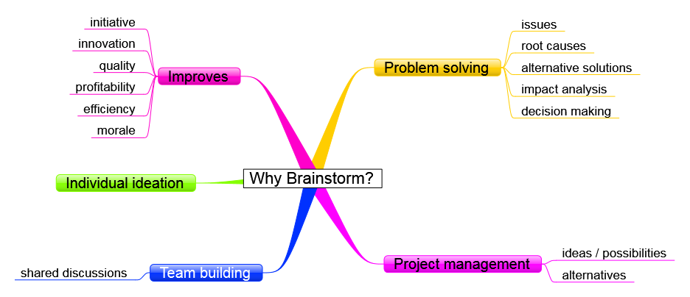

Problem solving and decision making criteria
There are three forms of applied thinking that we all need : decision making, problem solving , and creative thinking . They may also be taken to imply that problem solving can be clearly distinguished from decision making , or creative thinking from either or the former, in terms of the process involved. However for getting a decision and analysing the potential of the company in response to the solution of the problem the company have followed that steps to get the correct decision making .

Swot analysis American airlines

STRENGHTS | WEAKNESSES | OPORTUNITIES | THREATS
The aircraft is one of the biggest airlines . Collaborating with regional partner American eagle offers around 6,700 flights a day to 350 destinations in 50 countries . AAdvantage is a program of this company , within 1000 partner’s participating which earning can be miles when they flight . this miles can be used for hotels stays, rent cars, and others retails. Financial position is an important aspect , in 2018 the company reported an important earning for that period 1,9b£ . | The company has been accused of discrimination and not respectful behaviour . The costumers complains and feedback appear in online world . Another factor was that one technical problem in 2017 with its pilot scheduling system . That created a chaos and made passengers worried . | The airline has announced international service to locations where doesn’t provide their service for example Budapest , Prague Reykjavik . it was a opportunity to introduce more routes in the international market . For example using the charlottes airport which is the second largest hub . this opportunity his a important factor to the company growth . | The airlines is facing a stiff competition for a big number of competitors . For example delta air , southwest airways , uc holdings , jet blue etc..  Competition with others giant aircraft in different international routes is also a big threat for the airline.

Fish bone diagram American Airlines

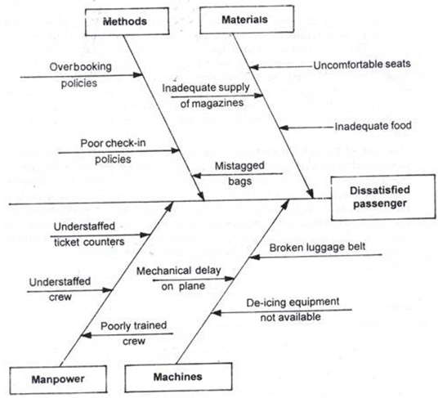
Figure 2 ishikawa diagram

Process of an organisational change and management
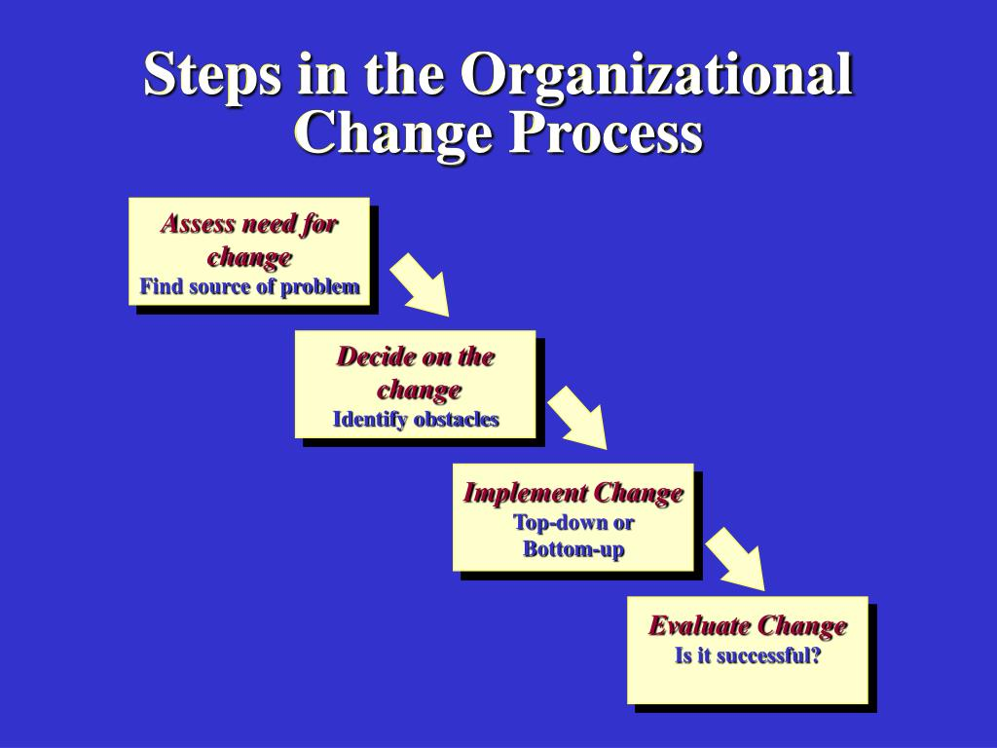
Figure 1 organizational change
- Strong domestic presence the company has generate more than60% of the revenue from the domestic routes .
- Oneworld alliance American airlines is one of the member of this organization wich serves more than 1000 flights in more than 150 country
- Focus on business pasangers the airline operate in 3 strategic business units
- Brand equity in the marketing strategy American Airlines has been ranked 247 in FORBES magazine list of global 2000 brands and ranked 67 in Fortune 500 list . This generate a revenue of 40,18 billion $
- Investment and capacity planning American airlines start creating projects in order plan view enterprise
- The American airlines have the capacity for the details and the business units to deal with the roles and models required , developing and creating new resources and extend the new resources .

Benefits of participation on change
The company aims is to restructure the financial resources to improve its financial strengths. The company performance and competitive landscape is viewing the performance by business segments like a operating revenue , mainline passengers and regional passengers , expand the stores and location and brand of company , alliances with new partnerships, providing services in new locations and countries , put in function new strategies such as the MarketLine premiums which this can provide a depth coverage of the performance in the worlds leading airline companies .

Concluison

We can clearly see al the process and the challenges faced this company . Team working and a good organisational change and management with the key elements can be a important factor in any company . Faced big problems can be a new begin and a important background for solving problems and decision making . As already founded in this case study .

References

Reed, T . (2018) American airlines Wants to grow In Charlotte
Raffety , A. E.,& Griffin. M. A. (2006). Perception of organizational change . 91, 1154/1162.
D .W., Taylor( 2013) Handbook of organization .

Gells, D. (2019 ) . The New York Times . American Airlines

Reed,T. (2020). Forbes .American Airlines bankruptcy

Dawson ,R (2018). Secrets of power problem-solving. Pompton Plains , NJ: Career Press .

Kwoka, J ., Shumilkina , E. The price Effect of Eliminating Potential Competition : Evidence from an Airline Merger . The journal of Industrial Economics.

Russell , E ., Dunn, G., Perry , D. Virgin -Delta Joint Venture Has Legs. Airline Business , Vol.29. no 1, 2013 , p. 8.

Janae ,Wise . Slide serve , Organizational change two Metaphors .

