Student Name: Cristina Larisa Negesc
Student ID: 1917996
Module code: BMSW6103
Assignment section: Change management portfolio
Lecturer’s name: Nauman Ali

1 Introduction 3
2 Organisation power and politics 3
2.1 Power 3
2.2 Politics 3
2.3 Power and politics in organisation 3
2.4 How power and politics is affecting the situation 4
2.5 What impacted the strike 4
2.6 The impact on Royal Mail 4
2.7 Moral issues 5
2.8 3 steps Change Management theory 5
3 Stakeholder and analysis models 6
3.1 Stakeholder management within organisations 6
3.2 Internal and external stakeholders 7
3.3 The role of different stakeholder analysis models to understand the importance of stakeholder 7
3.4 Salience model definition 8
3.5 Power Interest Matrix model definition and application 9
3.6 Power interest matrix elements explained in relation to the case study and communication plan 11
3.7 Model Limitations 13
4 Thomas Kilmann’s Conflict resolution model 13
4.1 Brief description of Conflict resolution model 13
4.2 Advantages and disadvantages of conflict approaches 14
4.3 Case study resolution 15
5 Conclusion and Recommendations 15
References 16

1 Introduction

1.1 Purpose of the portfolio
The purpose of this change management portfolio is to analyse, discuss and identify the best resolution for the current problem faced by Royal Mail. Different techniques, models and strategies will be defined and applied. Some of those are the 3 steps Change management theory to identify and understand the problem, the Power Interest Matrix to discover the most important stakeholders and the Thomas Kilmann’s conflict resolution model to find the best approach to resolving the problem.

1.2 Structure
The portfolio structure consists of three main headings which further break down in sub-headings. The first heading will review the Organisation power and politics, where power and politics will be defined, and debated compared to the case study. This heading will end with the definition and relevant application of the 3 steps change management theory. The second heading will cover stakeholders and analysis models, where stakeholders will be defined, the Socio-economic and Neo-classical theories will be defined and debated, internal and external stakeholders will be discovered, the Salience model will be defined, and the Power Interest Matrix model will be defined and applied. The third heading will cover the Thomas Kilmann’s conflict resolution model, the resolution model will be defined, the advantages and disadvantages of each approach will be discussed, and the best approach will be applied to the case study. This portfolio will end with conclusion and recommendations.

2 Organisation power and politics

2.1 Power
Each person, in exchange for some type of material and physical benefit, cedes control of themselves to the "organisation." Being a member requires committing to certain management policies and giving up part of their autonomy in decision-making (rules). Membership has both a limiting and a liberating effect due to the fact that penalties are a tool in the arsenal of those in charge, and it is not always in those in charge's best interests to permit an excessive amount of deviation from their rules. Omisore and Nweke, (2014) make the observation that diversity has an effect on "internal group processes" and hinders performance. They also note that variety may bring greater innovation to the process of problem solving and product development, but it may make implementation more difficult. To put it another way, in order for management policies to be carried out, one must first carry out control measures. This suggests that some type of power is being utilised in order to combat the undesirable circumstances (Stowell, 2021).

2.2 Politics
Politics is considered to be a functional way for organisations to help managers train by generating political climate and competition. Others see politics as dysfunctional because politicians focus on self-interest. Politics is three-dimensional, according to Ferris et al. (1989b). Ferris (1991) outlined these dimensions politically related. Kacmar and Carlson found that political behaviour is high in companies without clear norms and regulations (1997). Politics may impact judgments made under uncertainty. Lack of resources, such as transfers, wages, office space, and budgets, breeds political rivalry. Organizations with a limited budget may have a more political climate. "Go along to get ahead" is defined as "non-action" (e.g. quiet) with the purpose of gaining valuable resources. According to Kacmar and Carlson (1997), the best strategy for advancing one's own interests and benefits in a political context is to work with others. People's political behaviour is reflected in their pay and promotion policies, which are implemented and made decisions about (Ferris et al., 1989a). Performance evaluations serve as the foundation for determining salaries and advancement opportunities inside organisations. The process of evaluating and promoting employees is often politicised (Kumari, 2016).

2.3 Power and politics in organisation
Systemic power and politics are integrated in the social systems of the organisation. Episodic power consists of resource management and process management (Goldberg et al. 1983). In order to exert influence over decisions, finite resources are deployed to leverage their power. How can individuals influence decisions to their advantage? is the primary question. Power is the capacity to compel people to act against their will. When judgments must be taken in an open conflict, this sort of authority becomes evident. There are numerous resources capable of exerting such influence. A resource is something that a person desires or requires (Pfeffer, 2010). Thus, politics is the use of resources (including power) to influence others to support one's own goals. In reality, power over processes is about nondecisions. Using processes and routines, the more dominant organisations dissuade others from the decision-making process. This implies that not only are certain groups excluded from decision-making in the event of conflict, but also that power is employed to prevent a conflict from occurring. This form of power resides in the decision-making processes of organisations and is comprised of a number of procedures and political routines that the dominant coalition can employ. By utilising these methods, the dominant coalition can ensure that particular individuals or groups cannot participate in the decision-making process or can only do so partially. Then, politics records the particular techniques employed to exclude people from decision-making processes (Maes, & Geert Van, 2022).

2.4 How power and politics is affecting the situation
The case study is a clear example of power and politics used by the post office management team. In spite of the corporation producing a substantial profit over the last two years throughout the pandemic due to the efforts of their core workers, the CWU claimed that Post Office management team had insisted on a salary freeze for 2021-22. This is a clear example on how politics were used. Power on the other hand, came from whoever approved the salary freeze. If Royal mail would have followed the government policy their employees would have had a substantial salary increase, while they were asked questions about this, they have tried to say that they have followed the government policy, however they have contradicted themselves so many times that at the end they have said it was their decision for the salary freeze. Therefore, it is not a question of cost, antagonizing key workers in this way is a tactic used by management to assert its own power.

2.5 What impacted the strike
The employees came together with the union to fight for their rights. The post office managers froze the salary increase for the 2021-22 and offered only a two percent raise in 2022-23, even if the organisation had substantial profit during the latest challenges faced by the world. The cost of living has increased at least by 7%, however their salary remained the same. The employees are only asking for the organisation to follow the government policy, the organisation in response, is refusing and on the other hand, trying to use its power to offer a different unsuitable alternative. The CWU stated that the dispute is involving approximately 3,500 employees. On an attendance of 70.2 percent, its members voted 97.3 percent in favour of going on strike. The employees already had a strike on May and decided to carry on if Royal Mail is not taking their request into consideration.

2.6 The impact on Royal Mail
This argument made public will definitely have a negative effect on the image of Royal Mail, however, in terms of service disruption will have a minimum effect as 114 Crown Post Offices, which are the company's own post offices, will be closed for a 24-hour period, and no cash will be delivered to or collected from any sub-post offices during this time, unfortunately are not enough comparing to 11000 branches. The strike will impact more the customers as all the 114 branches are bigger and mainly in city centres, but Royal Mail had enough time to prepare for this disruption and to create alternatives for the customers.

2.7 Moral issues
The moral on the other hand is very affected not only for these employees but for all post office employees who worked really hard during the pandemic. If the post office had a substantial profit, was mainly due to the hard work of these key workers who risked their health during the pandemic to go to work. Therefore, Royal Mail is proving unethical leadership and is not taking the moral responsibility to fulfil the rights of these employees. A change management theory will be applied in order to discover how the management should deal with the problem.

2.8 3 steps Change Management theory
  - Definition
One of the most influential psychologists of the 20th century was Kurt Lewin (1890-1947). Modern social psychology is often referred to as his legacy. He argued that the three stages of change in organisations are: unfreeze, implementing the change, and refreeze.
- Unfreezing – is the first step convincing individuals who will be affected by the change that is the only solution going ahead.
- Implementing the change - To put Lewin's concept into action, wait until all stakeholders have agreed that a change is necessary.
- Refreezing - To ensure that the change is long-lasting, steps must be taken after it has been put into place to strengthen and maintain it (Tanner, 2022).

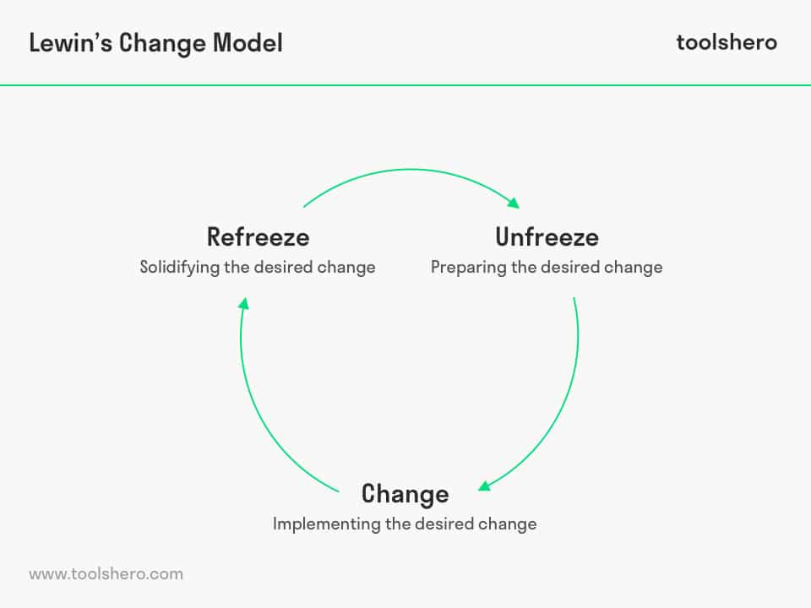
Fig 1 - Lewin's Change Model - Toolshero
  - Case study application
  - Unfreezing
When it comes to fulfilling the rights of its employees, Royal Mail exhibits unethical leadership and refuses to accept moral responsibility for it. Therefore, the employees are trying to fight the salary freeze by striking. This will decrease Royal Mail’s profit, or worst will start losing value employees, so a change in the management approach and structure is absolutely necessary to avoid this from happening.

  - Change
The change should start from the management. The Royal mail management should make the employees feel more involved in the process and the communication should be maximised. Every negative thought that the employees have should be taken away and a salary increase should be discussed and applied towards the mutual goal. In addition, a bonus for the hard work of the employees during the pandemic should be given. Therefore, a change in the structure and approach is necessary. A rewords scheme can be introduced to encourage employees to reduce the absenteeism which is also affecting the business in this case.
  - Refreezing
Once everyone is on the same page, steps to further implement the new changes are necessary. This will have to be planned and contained miles stones confirmation with continuous reviews where both the management and employees should be informed periodically, therefore each side is satisfied and doesn’t have any problems. Before any changes should be implemented, the first step should be towards the management feedback from the employees, so a new management approach should be introduced based on the reviews.

3 Stakeholder and analysis models
One of the stakeholders’ definitions is, an individual or a smaller community who have the authority to react to, interact with, and influence the organization's strategic future (Eden and Ackermann 1998: 117).

3.1 Stakeholder management within organisations
In his ground-breaking book, "Strategic Management: A Stakeholder Approach," Dr. F. Edward Freeman, originally described Stakeholder theory also known as Socio-economic theory. It implies that a company's shareholders are just one type of stakeholders among numerous. The stakeholder ecosystem, according to this notion, includes anyone who is empowered and involved in, or impacted by the company: shareholders, employees, customers, suppliers, media, local communities. According to Freeman's idea, a company's true success is measured by how well it serves all of its stakeholders, not just those who stand to gain financially from the company's profit.
Throughout his works, Dr. Freeman emphasises the importance of keeping everyone involved in a company's success at the centre of every decision. An organisation will eventually fail if it treats its staff poorly, according to stakeholder theory. The same would probably occur if it imposes its initiatives on communities in a way that harms them. Dr. Freeman stated in an interview that a corporation "cannot neglect any of its stakeholders and fully succeed."Short-term gains may be made, but the company cannot exist if stakeholders are dissatisfied and feel let down" (Simon,2016).
On the other hand, the Neo-classical theory implies that organizations exist to generate financial gain. To the extent that a company follows the rules of the game, competes fairly and openly in a free market, there is just one social obligation of the firm it operates: to use its resources and engage in activities that raise its profits (Friedman, ).
In relation to the case study and different research conducted, it seems that for Royal Mail shareholders are the most important. In 2021 it was announced that £400 million would be paid to the shareholders due to the profit from parcels during the pandemic. On the other hand, while the shareholders are happy, the stakeholders are very disappointed. The employees are not benefiting from a salary increase, actually Royal Mail decided to freeze the salary increase even if they had relevant profit in 2021. The customers are very disappointed with the services, especially in Oxford where all their letters and parcels are delayed. Royal Mail is not benefiting from the media eighter as there are more and more articles of their bad service, Royal Mail should start looking more after its stakeholders otherwise will soon sink. Next the most important stakeholders will be identified based on the case study.

3.2 Internal and external stakeholders
The term "internal stakeholders" refers to individuals and groups that are located within the company. In contrast, external stakeholders are defined as third parties that are not affiliated with the company but are nevertheless influenced or affected by its activities (Surbhi, 2017).
Royal Mail internal stakeholders: employees, customers, directors, sub postmasters and Government
Royal mail external stakeholders: competitors, media, environment, community and CWU.

3.3 The role of different stakeholder analysis models to understand the importance of stakeholder
An examination of the stakeholders and groups that may have an impact on the achievement of a company's goals is what a stakeholder analysis is designed to do: give decision-makers with information about those stakeholders and groups. This makes it simpler to foresee challenges, win the support of the most significant stakeholders, increase what the organisation delivers to various groups and individuals, and enhance how it communicates with those groups and individuals.
The salience model helps to identify who is important among many stakeholders. The selection of the right stakeholders and the prioritisation of the competing communication requirements are likely to be challenges. Different stakeholders' importance is made clearer by the use of a salience model (Puneet, 2014)
The power interest matrix is a method for identifying stakeholders and their potential impact on the project based on two important factors: stakeholder power and stakeholder interest. As a result, it can successfully communicate with all project stakeholders in the manner that works best for them (Martinis, 2021).

3.4 Salience model definition
For the Academy of Management Review, Ronald Mitchell, Bradley R. Agle, and Donna J. Wood produced an article in 1997 that discussed the concept of Stakeholder Salience. With the proliferation of stakeholder terms and a lack of consensus on "Who Counts" in stakeholder management, the authors came up with a theory on stakeholder identification and salience. (Mitchell et al. 1997, p.853-854).
The degree to which managers give importance to competing stakeholder claims is what is meant to be understood when referring to the salience model. Their technique analyses the degree to which a stakeholder is outspoken, noticeable, and significant. This enables an individual to construct a typology of stakeholder groups to which the organisation should pay attention (Harrin, 2022).
It categorises stakeholders based on three factors:
Power – The stakeholders who can have an impact
Legitimacy – the stakeholders’ degree of being valid
Urgency – The communication time anticipated by stakeholders for solutions to their expectations.

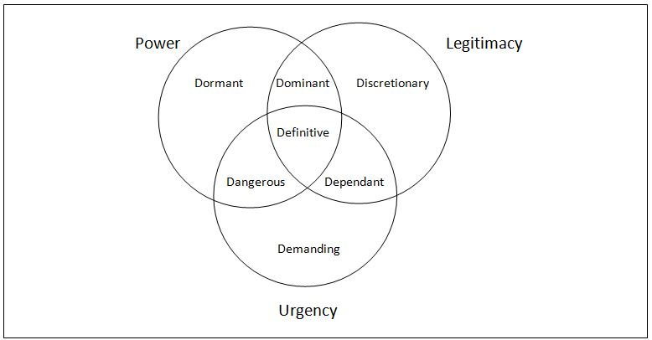
Fig 2 – Salience model The Salience Model for Project Managers (velopi.com)

Dormant stakeholders: People with the authority to impose their will on the project but who have no validating or urgent requests for doing so are known as inactive stakeholders. These parties have almost no contact with the business. If they can have a second feature, it becomes more difficult for the management to maintain control and attention.
Discretionary stakeholders: those who are legitimate, but do not have a significant impact on the project or urgent requirements.
Demanding stakeholders: They have a lot of demands, but they don't have the authority to make them happen. Latency can't be shifted by urgency if stakeholders can't or won't put their claims in a higher-status position first.
Dominant stakeholders: are legitimate and powerful in their own right. Managers tend to view these expectations as highly appreciated. The most important stakeholders expect and demand the most attention from companies, but they represent just a small portion of the many stakeholders to which managers should report.
Dangerous stakeholders: an urgency and power to influence, but no legal standing to do so. These stakeholders have the potential to turn abusive and coercive, putting the project at risk. The activities of these people may also have a negative impact on the project's other stakeholders, persons, and organisations.
Dependent stakeholders: Those who, despite their lack of power, have a sense of urgency and authenticity about their claims. For this reason, they are deemed reliant on other stakeholders.
Definitive stakeholders: the fact that they embody all of the qualities listed above gives them a high level of importance. It is critical for managers to treat stakeholders that wield significant authority and legitimacy with the utmost care and urgency (Caputo, 2013).

3.5 Power Interest Matrix model definition and application
  - Definition:
In 1991, Mendelow's Matrix was developed with the purpose of assessing the relative importance of various stakeholders. This data can then be utilised to estimate their influence on a major corporate decision (Mendelow's Matrix - Marketing Theories, 2020).
Mapping stakeholders allows to see who the greatest impact on a project can have, as well as who will be most impacted by it, in order to develop future engagement tactics that are more effective and less disruptive. Using tables or charts to organise or prioritise stakeholders can be helpful in summarising their qualities so that relevant engagement techniques can be developed. Power/influence vs. interest/importance are widely used in stakeholder analysis.
When conducting stakeholder mapping, Aubrey L. Mendelow's Power-Interest Matrix was utilised to analyse the power and interest of stakeholders as depicted in Figure 3. For each stakeholder group, different levels of participation are necessary based on their amount of power and interest, which is determined by the methodologies (Ginige, Amaratunga and Haigh, 2018).
Each category is as follow: High Power – Low interest: those stakeholders must be properly updated of the project's progress. Even if they don't care about the outcome, they still have influence. Stakeholders of this sort should be approached with caution, as it is possible for them to utilise their power in an unfavourable manner.
High-power – high-interest stakeholders are those who exert the most influence and control over the project's result. Maintaining regular communication with these stakeholders is critical to ensuring that everyone is on the same page.
These individuals, who are a low-power but high-interest group, should be kept informed and consulted frequently to prevent significant problems. These professionals might be of great assistance in regards to the finer details of the project.
Those with low power and low interest should be observed, but no time or energy should be expended communicating with them excessively. Monitor these individuals, but don't bother them with excessive communication.

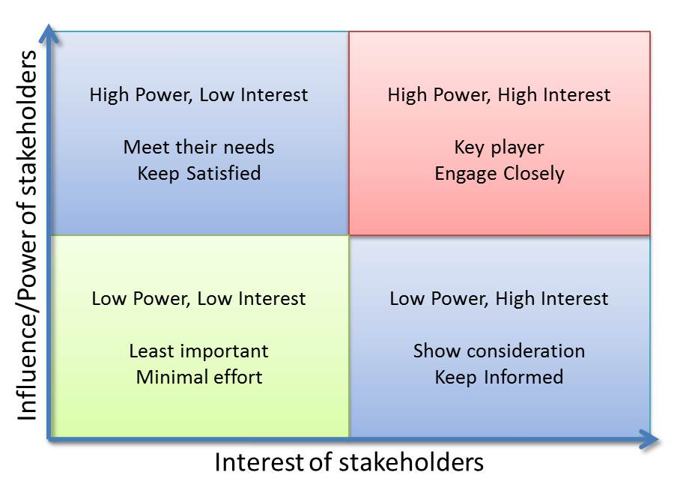
Fig 3 – Power interest matrix
Source Serra, C stakeholder analysis (projectizing.com)
  - Case application:
In order to be able to resolve the problem created within the Royal Mail the Power interest matrix will be applied. The reason behind it, is because the categorisation of the stakeholders during a change management process helps to effectively manage them. In addition, the data gained from the application will be utilised to influence the final resolution. The places of the stakeholders will remain exactly as they are and there is no need to change the stakeholders’ places as in the Salience model. It could be said, that the Power Interest Matrix is easier to be applied. However, in terms of the case study given, due to its functionality it is a better approach than the Salience Model.

High power – Low interest | High power – High interest
Senior executives  Government  Customers | Management  Creditors
Low power- Low interest | Low power – High interest:
Media,  Community  Competitors  Environment | Employees  Sub post masters  CWU

Stakeholder | Power/Interest | Key Interest & Issues
Senior Exec | High-Low | Profit
Government | High-Low | Profit
Customers | High-Low | Influencing sales
Management | High-High | Making the change happen
Creditors | High-High | Lending money
Employees | Low-High | Salaries and making the change happen
Sub post masters | Low-High | Salaries and making the change happen
CWU | Low-High | Salaries and making the change happen
Media | Low-Low | Publicity
Community | Low-Low | Not being affected by the change
Competitors | Low-Low | Not being affected by the change
Environment | Low-Low | Not being affected by the change

3.6 Power interest matrix elements explained in relation to the case study and communication plan
  - Elements
High power – Low interest: each stakeholders have high power in different ways, the Senior executives have steered power and the profit is the goal, Government have policy power and the profit is the goal, where customers have the power of influencing the sales, therefore the profit. However, all these stakeholders have low interest in the change management process.
High power – High interest: in terms of high power, the management is the one that will ensure the change happen, the creditors have also high power due to fact of lending money. Both of them have high interest due to the stakes at risk.
Low power – High interest: All stakeholders in this category have low power in the change management process, however they have high interest due to being directly affected financially by the change itself.
Low power – Low interest: these stakeholders are not directly affected of the change nor the outcome of the change management process, they are only feed with minimum information.

  - Communication Plan:
Stakeholder Communication Plan
Stakeholder |  | Power/Interest | Key Interest & Issues | Communication strategy |  | Frequency | Comments
Senior Exec |  | High-Low | Profit | Persuasive strategy |  | Often
Government |  | High-Low | Profit | Informational strategy |  | Often
Customers |  | High-Low | Influencing sales | Informational strategy |  | Often
Management |  | High-High | Making the change happen | Dialogue strategy |  | Often
Creditors |  | High-High | Lending money | Dialogue strategy |  | Often
Employees |  | Low-High | Salaries and making the change happen | Persuasive strategy |  | Show consideration
Sub post masters |  | Low-High | Salaries making the change happen | Persuasive strategy |  | Show consideration
CWU |  | Low-High | Salaries making the change happen | Persuasive strategy |  | Show consideration
Media |  | Low-Low | Publicity | Informational strategy |  | Minimal
Community |  | Low-Low | Not being affected by the change | Informational strategy |  | Minimal
Competitors |  | Low-Low | Not being affected by the change | Informational strategy |  | Minimal
Environment | Low-Low |  | Not being affected by the change |  | Informational strategy | Minimal

In relation to the main problem, and change management, the most important stakeholders are, the management, employees, sub post masters and the CWU. The management is important because this is where the change will start, while the employees, sub post masters and the CWU have a high interest in the change happening, if the change will not happen they can become dangerous, therefore, the best resolution must happen.

3.7 Model Limitations
The model however has some limitations. The main important one is that subjective evaluation of the findings of analysis is possible, therefore, the evaluation may not be accurate. Another important limitation involves the scope of each stakeholder, each stakeholder has a different amount of interest or power and those cannot always be meet based on expectations. The purpose of the Interest Power matrix is to categorise the stakeholders based on the interest and power; therefore, it is only focusing on the most important stakeholders, and latest, it requires to know the stakeholders, otherwise, based on assumption the stakeholders can be placed in the wrong element.

4 Thomas Kilmann’s Conflict resolution model

4.1 Brief description of Conflict resolution model

A concept of conflict created in the 1970s by Kenneth Thomas and Ralph Kilmann described conflict as the state in which people's interests are different. In a confrontation, the interests of two individuals are at odds. The word "conflict" naturally conjures images of fighting, yelling, accusing, and disputing, all of which are unfavourable. This creates the impression that conflict has to be avoided whenever possible. Nevertheless, disagreements, questions, and challenges to the status quo are all constructive aspects of conflict. Conflict can be resolved rationally by deciding on a course of action based on the facts of the case at hand.
Assertiveness and cooperativeness are two qualities identified by the Thomas Kilmann model when deciding on a strategy to follow in a conflict situation. Efforts to satisfy one's own desires are known as assertiveness. Cooperativeness is the extent to which an individual seeks to meet the needs of others. Five conflict management approaches are derived from this, Avoiding, Accommodating, Compromising, Competing and Collaborating (Ian, 2012).

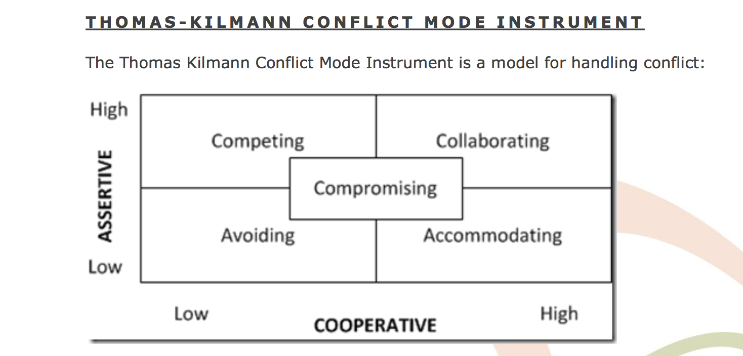

Fig. 4 – Thomas-Kilmann conflict resolution model Conflict Management (tbwconnect.com)

4.2 Advantages and disadvantages of conflict approaches

Avoiding: This happens when the conflict is ignored. By ignoring the problem, an individual is not assertive or cooperative. This approach can be useful in some situations: when the problem is extremely expensive, when there are minimal or non-existent chances of victory, or, when an individual needs to clear their head when there is tension in the air. However, apart from the situations stated above, it is not a good approach to solve a problem. This approach is only temporarily and cannot be successful as a long-term solution.
Accommodating: This is the Lose-win approach. It works when an individual is very cooperative but not assertive. Therefore, the individuals' ideals, interests, and planned results are harmed by this approach. This can be used as a strategy when the other individual is a specialist or has a better alternative for the problem. However, this approach cannot be always used as it is not constructive for an individual to always give up on his ideas, as this will always lead to constant submission of his personal values and beliefs.
Compromising: No one wins in this situation, which is known as a lose-lose approach. This necessitates a fair amount of assertiveness and cooperation. If there is required a short-term solution, or if all parties have equally vital interests, this may be the best approach. While compromise can be an easy and fast solution, it's not always the best option in the long run because the expectation is that everybody has something to win in a long-term decision.
Competing: this is when an individual is very assertive, it is also called the win-lose approach. An individual operates in an extremely assertive manner in order to achieve his aims, without seeking to work with the opposing side, and this could happen at the cost of that party. When time is short, or when decisive action is required, and individuals are conscious of and embrace the approach, this strategy may be appropriate. In the long-term run, however, is not a good approach. This is very similar to the authoritarian leadership style, therefore, the employees who have this kind of leader, feels insignificant, are always told what to do and there is no place for their own ideas.
Collaborating: In this scenario, two people work together to accomplish a common goal. This is the win-win approach. This approach can be useful in situations requiring creative problem solving. This could also involve re-contextualizing the problem so that everyone's ideas have room to grow. Because it demands a significant amount of trust and a lot of effort and time to get everyone on board and synthesise all of the suggestions, it has certain drawbacks (Conflict Management, 2019).

4.3 Case study resolution
Based on all the information’s gathered thanks to the relevant models applied, a quick solving resolution would be the Accommodating approach. By applying this approach, Royal Mail will give the requested salary increase to its employees and will solve the problem in the short time run. However, the problem is more complex than this and unfortunately with this approach further action will be necessary. By using this approach, the employees would understand that, by striking, they have high power in the decision making, and this is not true. This will further complicate the problem and more requests from the employees will arise. The best approach, however, would be the collaborating approach. By using this approach, Royal Mail, the employees, and the management would have to work together towards a common goal without compromising. In order to do so, Royal Mail should review its profit and invest more in both, management and employees. Firstly, in terms of management, the leadership style should be reconsidered. If management could use a transformational leadership or a democratic leadership style, the employees would feel more involved, included, will understand better the goal and process of what they are doing and will be happier in the work environment, therefore the requests will be lower, but the involvement will be maximised. So, training for the management in terms of leadership style or approach is necessary. The employees, on the other hand, have a valid point, and are only requesting their rights. A salary increase must be provided by Royal Mail, even if it doesn’t add up to the current living cost, these employees must be rewarded for the hard work conducted during the pandemic. Communication between Royal Mail and the employees must happen in such a way that, the employees are getting what they are asking and in return Royal Mail will continue to be the highest postal service in the United Kingdom. If Royal Mail makes these changes, the management will improve, the employees will be happier and in return, the profit will be even higher as everybody will be more involved.

5 Conclusion and Recommendations
In conclusion based on all the data gained from the application of different models, in order to solve the current situation, Royal Mail would have to go through a change management process where a change in the structure is necessary, the leadership styles have to be reviewed and all the stakeholders should be treated equally fair. At this moment in time, it seems Royal Mail is only trying to please the shareholders; therefore, the Stakeholders strategy should be taken more into consideration. Royal Mail’s approach should change towards the employees and the sub post masters, and if in a positive way, as specified in the previous point, Royal Mail will have more profit, happier employees and better trained management team.
It is highly recommended for Royal Mail to follow the approaches seen in this case management portfolio. The 3 step model, would identify the problem, the Power Interest Matrix will help place the most important stakeholders and the Thomas Kilmann’s conflict resolution model will help find the best solution to the problem. Therefore, it is mandatory to use at least these models and strategies in order to solve the current situation created.

References
Caputo, Andrea. (2013). Systemic Stakeholders’ Management for Real Estate Development Projects. Global Business and Management Research: An International Journal. 5. 66-82.
Eden, C. and Ackermann, F. (1998) Making Strategy: The Journey of Strategic Management, p117, London: Sage Publications.
Ferris, G. R., & Judge, T. A., (1991). Personnel/Human resources management: a political influence perspective. Journal of Management. 17(2), 447-488.
Ferris, G. R., Russ, G. S., & Fandt, P. M. (1989). Politics in organization and its perception within the organization. Organization Studies. 9(2). 165-179.
Fig – 1 3 steps change management theory, Lewin's Change Model - Toolshero
Fig – 2 Salience model The Salience Model for Project Managers (velopi.com)
Fig – 3 Power interest matrix, Source Serra, C. stakeholder analysis (projectizing.com)

Fig – 4 Thomas-Kilmann conflict resolution model Conflict Management (tbwconnect.com)
Freeman, R. E. (1984) Strategic Management: A Stakeholder Approach, p46, Boston, MA: Pitman. Latest edition
Friedman, M. 1912-2006. Capitalism and Freedom. Chicago :University of Chicago Press, 19631962.
Goldberg, A., Cavanaugh, M. and Larson, C. (1983). The meaning of ‘power’. Journal of Applied Communication Research 11: 89–108.
Ginige, K., Amaratunga, D. and Haigh, R., (2018). Mapping stakeholders associated with societal challenges: A Methodological Framework. Procedia Engineering, 212, pp.1195-1202.
Harrin, E., (2022). The Stakeholder Salience Model and How to Use It. [online] Rgpm. Available at: https://rebelsguidetopm.com/stakeholder-salience/ [Accessed 8 August 2022].
Ian, J., (2012). Conflict and challenge (The Thomas Kilmann Model). [online] Challenging Coaching. Available at: https://challengingcoaching.co.uk/conflict-and-challenge/ [Accessed 9 August 2022].
Kumari, G., Saradadevi, D., (2016). A study on organizational politics. International Journal of Science & Engineering Development Research.1(12): 17 – 22
Maes, G., Geert Van, H., (2022). Power and Politics in Different Change Discourses, Administrative Sciences 12(2): 64. https://doi.org/10.3390/admsci12020064
Martins, J., (2021). What is stakeholder analysis and why is it important?. [online] Asana.com. Available at: https://asana.com/resources/project-stakeholder [Accessed 8 August 2022].
Mitchell, R., Agle, B. and Wood, D. (1997). Toward a Theory of Stakeholder Identification and Salience: Defining the Principle of Who and What Really Counts. The Academy of Management Review, 22 (4), pp. 853-886.
Omisore BO, Nweke AN (2014) The Influence of Power and Politics in Organisations. Int J Acad Res Business Social Sci 4(7):164–183.
Pfeffer, Jeffrey. (2010). Power: Why Some People Have It—and Others Don’t. New York: HarperBusiness
Professionalacademy.com. (2020). Mendelow's Matrix - Marketing Theories. [online] Available at: https://www.professionalacademy.com/blogs/mendelows-matrix-marketing-theories/ [Accessed 8 August 2022].
Puneet, K., (2014). Stakeholder Analysis:Salience Model. [online] Linkedin.com. Available at: https://www.linkedin.com/pulse/20140927071637-3351237-stakeholder-analysis-salience-model [Accessed 10 August 2022].
Simon, B., (2016). What Is Stakeholder Theory? | Smartsheet. [online] Smartsheet. Available at: <https://www.smartsheet.com/what-stakeholder-theory-and-how-does-it-impact-organization> [Accessed 10 August 2022].
Stowell, F., (2021) Power in the ‘Organisation’: A Soft Systems Perspective. Syst Pract Action Res 34, 515–535. https://doi.org/10.1007/s11213-020-09541-w
Surbhi, S., (2017). Difference Between Internal and External Stakeholders (with Comparison Chart) - Key Differences. [online] Key Differences. Available at: https://keydifferences.com/difference-between-internal-and-external-stakeholders.html [Accessed 10 August 2022].
Tanner, R., (2022). Unfreeze, Change, Refreeze: Is This a Child’s Game?. [online] Managementisajourney.com. Available at: <https://managementisajourney.com/unfreeze-change-refreeze-is-this-a-childs-game/> [Accessed 10 August 2022].
Tbwconnect.com. (2019). Conflict Management. [online] Available at: https://tbwconnect.com/understanding-conflict-management-styles [Accessed 10 August 2022].
the Guardian. (2021). Royal Mail is failing everyone but shareholders | Letters. [online] Available at: https://www.theguardian.com/business/2021/nov/21/royal-mail-is-failing-everyone-but-shareholders [Accessed 10 August 2022].

