University of Wales Trinity Saint David
Wales Institute of Science and Art


Modelling Industrial Control Systems in MATLAB

Control Technology (ACMA6001)
Owen Bell
2316885
3rd August 2026
Contents
1 Introduction 3
1.1 Aims 3
1.2 Objectives 3
2 Background 4
2.1 PID general background 4
2.2 Cruise control standards 4
3 Encoding and Decoding Signals 5
3.1 Encoding code 5
3.2 Decoding code 6
4 PID tuning 7
4.1 Method 7
4.2 Results and analysis 7
4.2.1 Proportional 7
4.2.2 Integral 8
4.2.3 Derivative 9
4.2.4 Standards & Controller Comparison 10
5 Sampling Time impact 12
5.1 Method 12
5.2 Results and analysis 12
6 Signal delay impact 14
6.1 Method 14
6.2 Results and analysis 14
7 Number of Bits impact 16
7.1 Method 16
7.2 Results and analysis 16
8 Conclusion 18
9 Bibliography 19
10 Appendix A - Coding 20
A.1 Main Script 20
A.2 Controllers Function 22
A.3 getRawVelocity Function 23
A.4 getRawVelocityDemand Function 24
A.5 sendControlCommand Function 24
11 Appendix B – Tuning Results 25
B.1 Proportional Gain - 20 25
B.2 Integral Gain - 6 25
B.3 Derivative Gain - 5 26
B.4 Signal Delay – 0.30s 26
B.5 Bit Resolution - 8 27

Figure 1 - Control Signal Encoding (Main Script) 5
Figure 2 - Sensor Signal Encoding (getRawVelocity Function) 5
Figure 3 - Demand Signal Encoding (getRawVelocityDemand Function) 5
Figure 4 - Control Signal Decoding (sendControlCommand Function) 6
Figure 5 - Sensor Signal Decoding (Main Script) 6
Figure 6 - Demand Signal Decoding (Main Script) 6
Figure 7 - Initial Proportional Gain [Kp = 1] 7
Figure 8 - Initial Proportional Gain Results [Kp = 1] 7
Figure 9 - Tuned Proportional Gain [Kp = 6] 8
Figure 10 - Tuned Proportional Gain Results [Kp = 6] 8
Figure 11 - Tuned Integral Gain [Ki = 1] 9
Figure 12 - Tuned Integral Gain Results [Ki = 1] 9
Figure 13 - Tuned Derivative Gain [Kd = 1] 10
Figure 14 - Tuned Derivative Gain Results [Kd = 1] 10
Figure 15 - Ziegler-Nichols Tuned Setup 11
Figure 16 - Ziegler-Nichols Tuned Results 11
Figure 17 - Sampling Time 0.11s Code 12
Figure 18 - Sampling Time 0.11s Results 12
Figure 19 - Sampling Time 0.12s Code 13
Figure 20 - Sampling Time 0.12s Results 13
Figure 21 - Baseline Gains Signal Delay 0.01s Results 14
Figure 22 - Adjusted Gains Code 14
Figure 23 - Signal Delay 0.25s Code 15
Figure 24 - Adjusted Gains Signal Delay 0.25s Results 15
Figure 25 - 9 Bit Signal Resolution Code 16
Figure 26 - 9 Bit Signal Resolution Results 16

Table 1 - Ziegler-Nichols Equation Table, (PLC Programming Expert, 2026) 10

Introduction

Aims
The aim of this report is to design and analyse a Proportional-Integral-Derivative (PID) controller for a vehicles cruise control system using MATLAB. The study focuses on achieving stable and accurate velocity tracking whilst considering real world implementation constraints such as sampling time and communication delays.

Objectives
The objectives of this report are to implement a PID-based cruise control system and evaluate its performance under varying operating conditions. These conditions include controller tuning, sampling time, signal resolution and communication delay. The impact of these factors on system stability, accuracy and control effort will be analysed.

Background

PID general background
PID controllers are widely used in feedback control systems to regulate dynamic processes. They operate by applying proportional, integral and derivative actions to the error between a desired setpoint and the system output. The proportional term responds to the current error to improve responsiveness, while the integral term accumulates past errors to eliminate steady-state error. The derivative term reacts to the rate of change of the error, improving system stability and reducing overshoot. By combining these terms, PID controllers can balance responsiveness, accuracy and stability, making them suitable for various engineering applications (Aström and Hägglund, 1995).

Cruise control standards
Cruise control systems are designed to maintain a vehicle at a driver defined speed. A cruise control system is expected to accurately track this setpoint while maintaining stable driving behaviour (Xiao and Gao, 2010). To achieve this, the system must respond to changes in demand by adjusting its control input, ensuring minimal steady-state error, a smooth and gradual response in vehicle speed and avoiding excessive overshoot or oscillation to provide stable and comfortable vehicle operation (Dorf and Bishop, 2017).

Encoding and Decoding Signals

Encoding code
To realistically model a PID-based cruise control system, encoding is performed to convert sensor, demand and actuator signals into a format suitable for transmission across a communication bus, by scaling the physical values (mph or throttle/brake%) to a proportion of their operating ranges and converting them into an unsigned integer at 16-bit resolution (R=2¹⁶) using the function dec2bin (Figures 1-3).
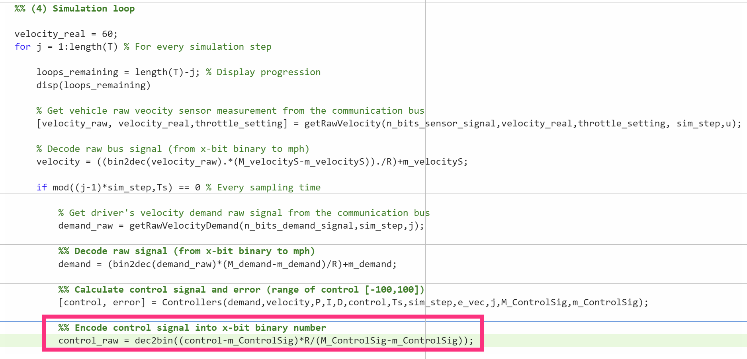
Figure 1 - Control Signal Encoding (Main Script)
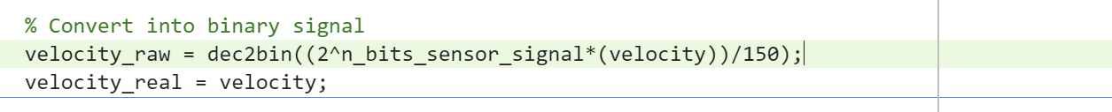
Figure 2 - Sensor Signal Encoding (getRawVelocity Function)
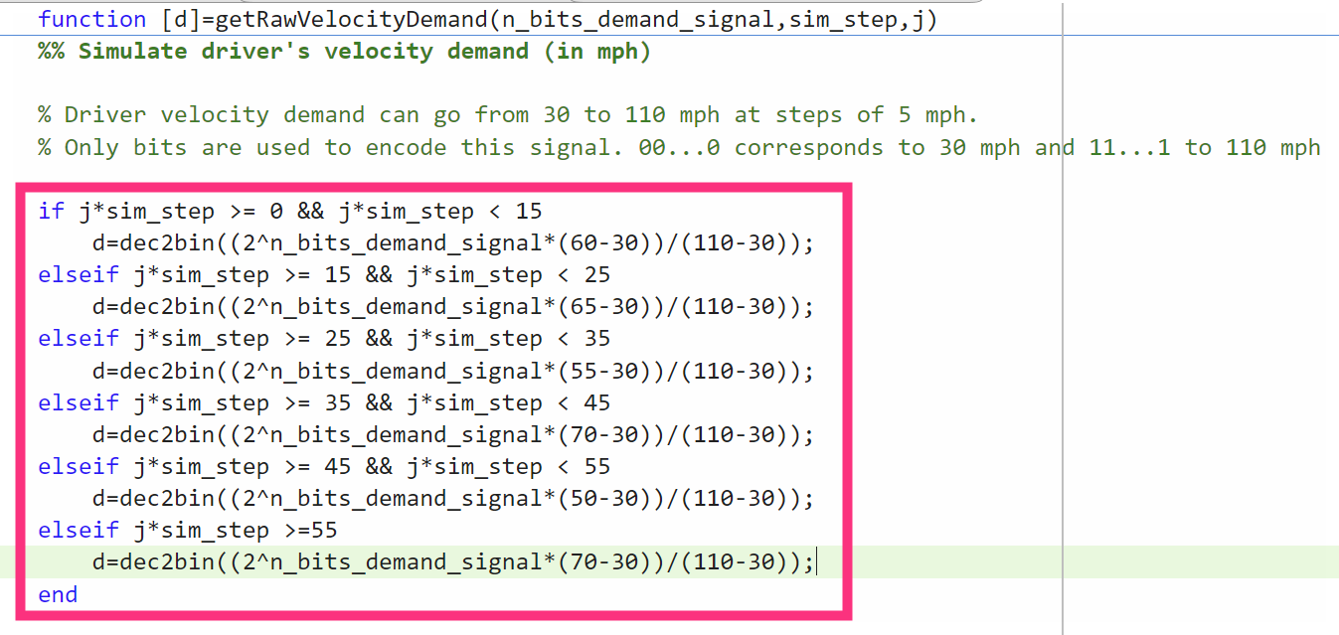
Figure 3 - Demand Signal Encoding (getRawVelocityDemand Function)

Decoding code
To recover usable physical values (mph or throttle/brake%) from the communication bus, decoding is performed on the received control, sensor and demand signals by using the function bin2dec to obtain the corresponding integers, then rescaling them using each signals operating bounds, allowing the controller to compute the tracking error for the sensor and demand signal and actuation for the control signal, (Figures 4-6).
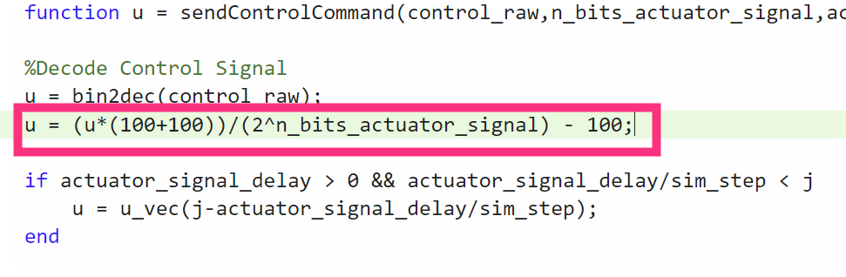
Figure 4 - Control Signal Decoding (sendControlCommand Function)
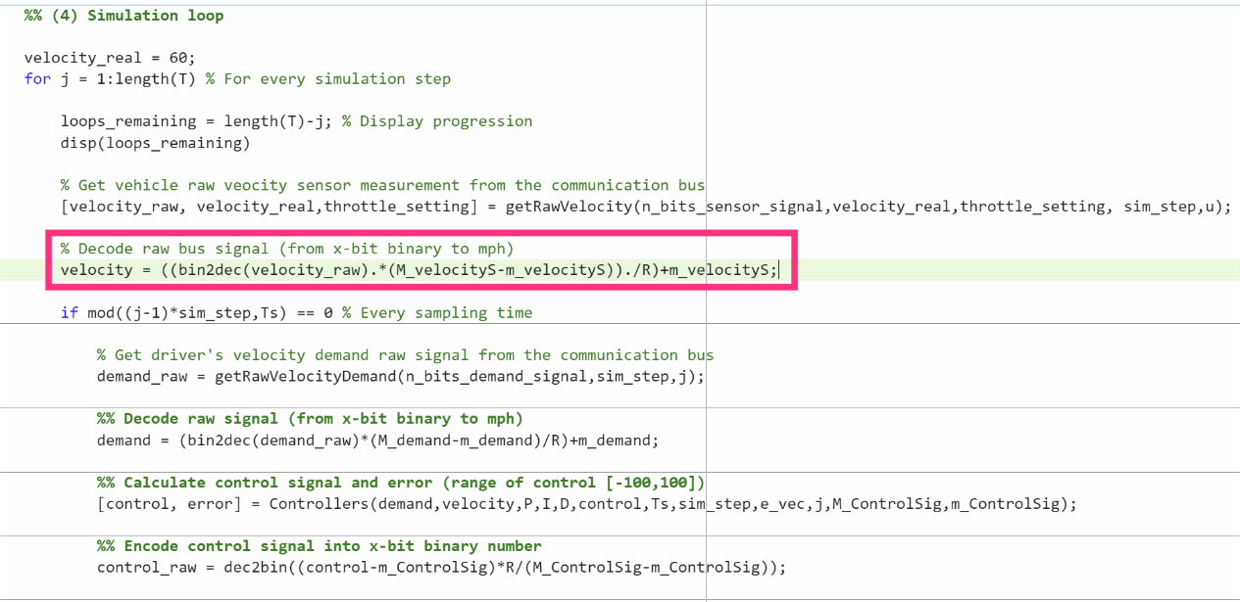
Figure 5 - Sensor Signal Decoding (Main Script)
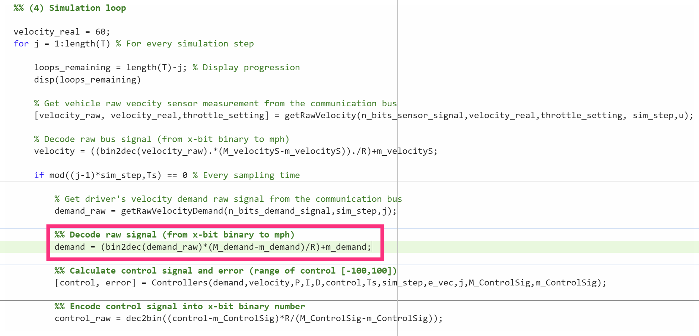
Figure 6 - Demand Signal Decoding (Main Script)

PID tuning

Method
Two common tuning methods are Ziegler-Nichols which presents guidelines for finding term values based on the transient response characteristics, and Cohen-Coon used on first-order systems with a time delay providing gradual step changes to reach steady state (Abbas and Mustafa, 2024). However, the approach used in this report was trial and error rather than the method based techniques as it allows for trade-offs in velocity response and control effort to be determined by observing the results rather than predefined mathematical rules.

Results and analysis

Proportional
To determine a baseline Kp was set to 1 (Figure 7) which displayed that PID controller was currently insufficient in utilising the available control effort to adjust velocity response (see Figure 8).
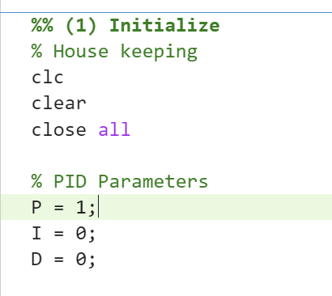
Figure 7 - Initial Proportional Gain [Kp = 1]
Figure 8 - Initial Proportional Gain Results [Kp = 1]

After establishing the baseline, Kp was increased to 20 to improve velocity response and improve control efforts but caused the controller to excessively overcorrect preventing the system to settle (Appendix B.1). Until Kp was revised to 6 with the system displaying a fast response and allowing velocity response to settle with the control effort operating within reasonable bounds (Figures 9 & 10).
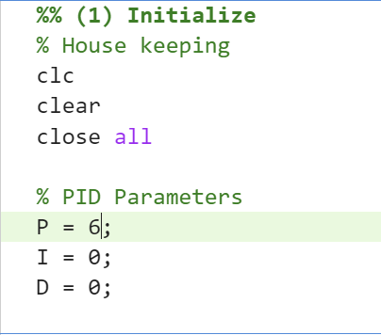
Figure 9 - Tuned Proportional Gain [Kp = 6]
Figure 10 - Tuned Proportional Gain Results [Kp = 6]

Integral
A steady-state error of roughly 7.5mph is present (Figure 10). To minimise this error Ki was adjusted to 6 which resulted in substantial overshoot and the control effort reaching its limits (Appendix B.2), indicating the controller experienced integral windup, with the integral term continuing to accumulate error beyond the control efforts limits (Bohn and Atherton, 1995). Ki was subsequently lowered to 1 (Figure 11), reducing the steady-state error to a marginal level and displaying a fast transient response (Figure 12).
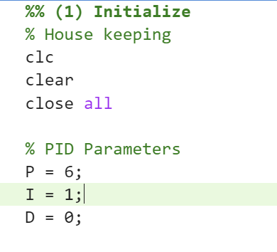
Figure 11 - Tuned Integral Gain [Ki = 1]
Figure 12 - Tuned Integral Gain Results [Ki = 1]

Derivative
Finally, Kd was set to 5 to dampen the overshoot observed at each step change. However, this amplified small fluctuations in the sensor signal causing the controller unable to track the driver demand (Appendix B.3). Correcting Kd to 1 resulted in a gradual rise meeting drive demand with near zero overshoot with the control effort momentarily reaching its limit before returning to a steady-state condition (Figures 13 & 14).

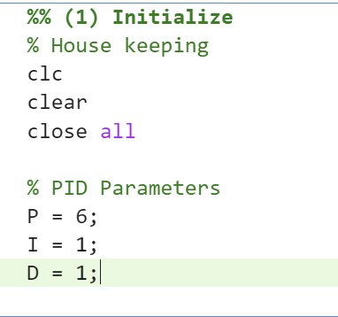
Figure 13 - Tuned Derivative Gain [Kd = 1]
Figure 14 - Tuned Derivative Gain Results [Kd = 1]

Standards & Controller Comparison
Using the Ziegler-Nichols equations in Table 1 provided the controller setup in Figures 15. Where Ku is the ultimate gain and Pu is the ultimate oscillation period at which the system first exhibits sustained, constant oscillations (PLC Programming Expert, 2026).
Controller | Kp | Ki | Kd
P only | 0.5 × Ku | — | —
PI | 0.45 × Ku | 1.2 × Kp / Pu | —
PID | 0.6 × Ku | 2 × Kp / Pu | Kp × Pu / 8
Table 1 - Ziegler-Nichols Equation Table, (PLC Programming Expert, 2026)
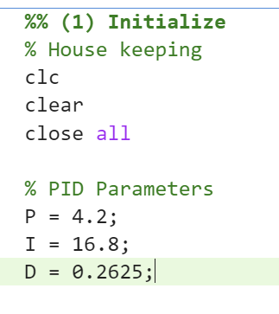
Figure 15 - Ziegler-Nichols Tuned Setup
Figure 16 - Ziegler-Nichols Tuned Results
Comparing the results (Figures 14 & 16), manually tuning the controller provides a more effective a cruise control system. The Ziegler-Nichols method overshoots the driver demand without correcting the velocity with the control effort stuck at its limit. Additionally, the manually tuned controller better satisfies ISO 15622 maintaining the set speed (ISO, 2010). However, it does not fully meet the ISO standards with acceleration greater than 2m/s² at various moments (Figure 14).

Sampling Time impact

Method
Using the PID setup from Figure 13, the sampling time was manually increased from the baseline 0.05s to identify the longest sampling time that achieves reasonable performance, with performance considered reasonable if results remain comparable to those seen in Figure 14.

Results and analysis
Increasing the sampling time to 0.11s (Figure 17), produced results comparable to the baseline, with velocity response tracking the drivers demand effectively with a slightly longer delay before settling to marginal error (Figure 18). However, the control effort saw a drop in performance compared to the baseline with the control effort having a brief decaying oscillation after each step change in driver demand.
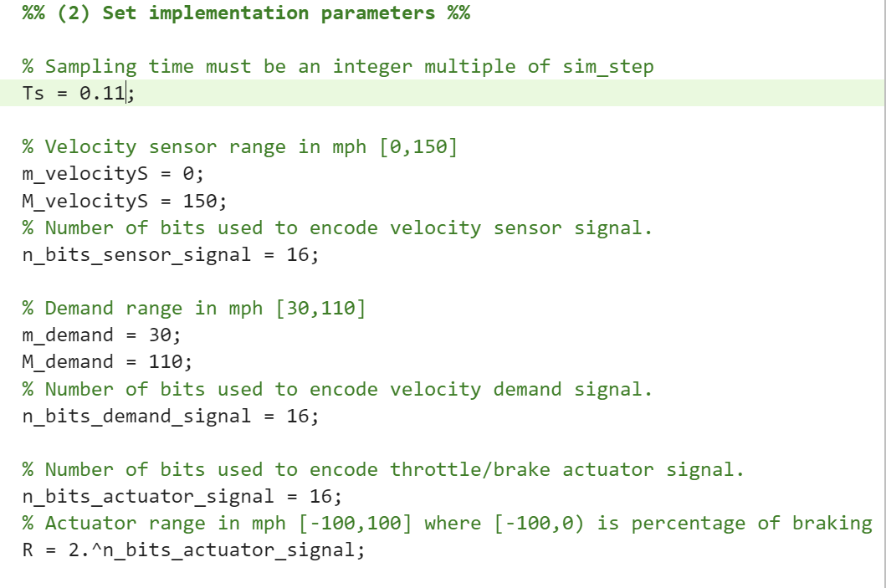
Figure 17 - Sampling Time 0.11s Code
Figure 18 - Sampling Time 0.11s Results
Further increasing the sampling time to 0.12s (Figure 19), resulted in the controller failing to track the driver demand with the control effort unable to settle between 45 & 55 seconds (Figure 20). Demonstrating that 0.11s is the longest sampling time that provides reasonable performance.
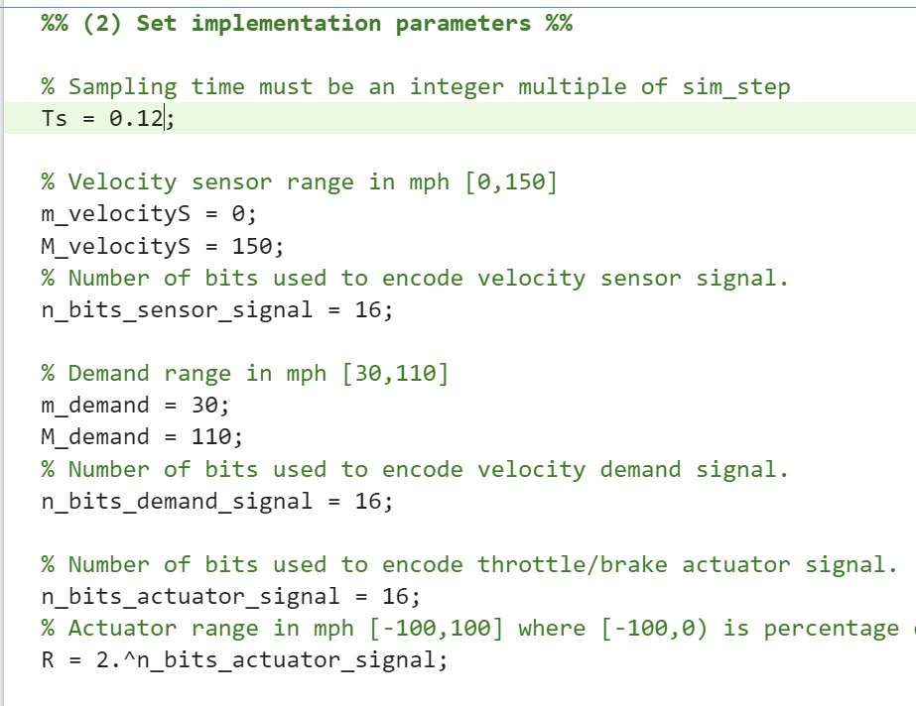
Figure 19 - Sampling Time 0.12s Code
Figure 20 - Sampling Time 0.12s Results
These results illustrate the trade-offs when selecting a sampling time, with shorter sampling times such as the 0.05s baseline providing consistent performance to meet driver demands and reliably settle to a steady response, but increases computational load, communication bandwidth and hardware demands on the controller. However, longer sampling times reduce these demands, enabling more cost-effective and energy-efficient controllers at the risk of instability, with real world applications often constrained by the processing capability of the hardware used in controllers.

Signal delay impact

Method
Using the PID setup from Figure 13, the signal delay was manually increased from the baseline 0.00s to determine the maximum delay that can maintain reasonable performance, with performance considered reasonable if results remain comparable to those observed in Figure 14. Once the maximum reasonable delay has been reached, the gains were readjusted to assess whether further delays could be introduced and provide similar performance achieved to the baseline.

Results and analysis
With the originally tuned gains, introducing a signal delay of 0.01s resulted in sustained, unstable oscillations throughout the simulation meaning no signal delay could be tolerated to achieve reasonable performance with the baseline gains (Figure 21). This highlights a limitation with the controller’s tuning as real world implementation of PID controllers inevitably introduce some form of delay.
Figure 21 - Baseline Gains Signal Delay 0.01s Results
To identify a suitable PID setup for real world application, where some signal delay is present, the gains were adjusted to Kp = 1.9, Ki = 1 & Kd = 0.01 (Figure 22) with a signal delay of 0.25s (Figure 23).
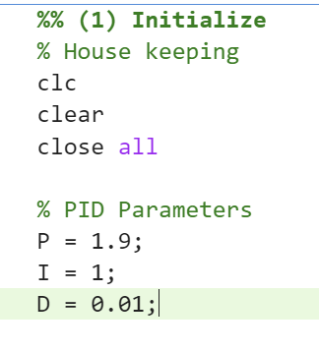
Figure 22 - Adjusted Gains Code
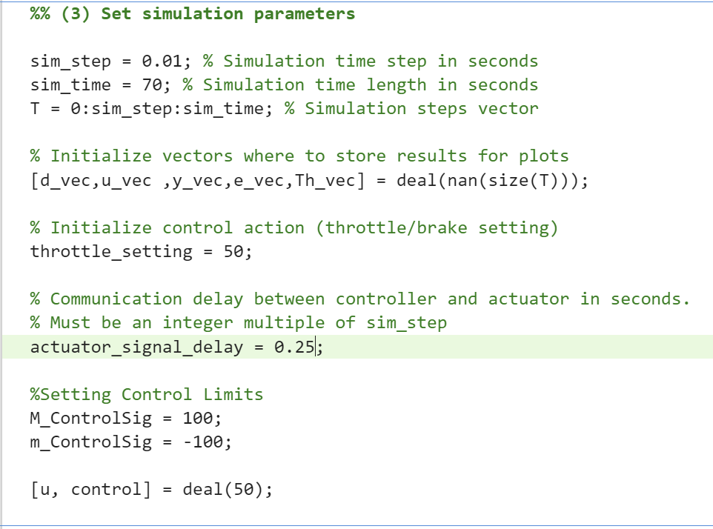
Figure 23 - Signal Delay 0.25s Code
This restored a stable response comparable to Figure 14, with only marginally larger residual error and settling time (Figure 24), though performance began breaking down as signal delay increased to 0.30s (Appendix B.4), confirming 0.25s as the maximum delay achieved through manual tuning. Overall, the large gain adjustment required to accommodate signal delay highlights that restoring stability comes at the expense of the controller’s responsiveness.
Figure 24 - Adjusted Gains Signal Delay 0.25s Results

Number of Bits impact

Method
Using the PID setup from Figure 13, the number of bits used to encode & decode signals was reduced from the baseline of 16 to determine the minimum number of bits that can achieve reasonable controller performance comparable to that seen in Figure 14.

Results and analysis
Reducing each signals bit resolution to 9 (Figure 25) maintained a velocity response closely resembling Figure 20, however the control effort now displayed moderate jittering (Figure 26).
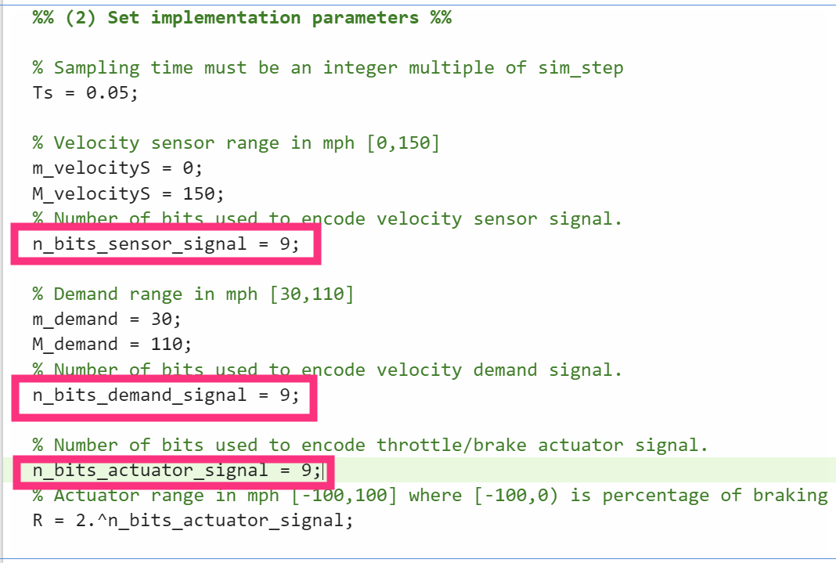
Figure 25 - 9 Bit Signal Resolution Code
Figure 26 - 9 Bit Signal Resolution Results
Lowering the signals to 8 bits resulted in the jittering becoming substantially more aggressive, despite velocity response tracking effectively (Appendix B.5) making 9 bits the lowest resolution that provides reasonable performance with the jittering observed deemed acceptable.
The reduction demonstrates that bit resolution primarily affects the smoothness and precision of the control action, rather than the stability of the controller’s velocity response. With the number of values the decoded signal can represent being reduced, the rounding true signal values experience between representable levels increases. Causing the controller to react to larger artificial steps creating, the high frequency jittering seen in the control effort.

Conclusion
During this report, the design of a PID-based cruise control system was reviewed along with the trade-offs that tuning decisions can have on the controller’s performance. The report demonstrated that for the controller’s purpose trial and error tuning outperformed the Ziegler-Nichols method, achieving a fast, stable response with marginal steady-state error, whilst better satisfying ISO standards, though not fully meeting all requirements.
Investigating the impact of sampling time, signal delays and bit resolution independently showed the controller could tolerate a sampling time up to 0.11s before becoming unstable. Signal delay proved far more limiting, with the original gains failing at 0.01s resulting in the gains being substantially readjusted to accommodate a signal delay up to 0.25s, providing a more appropriate controller for real world application and bit resolution could be lowered to 9 bits before the control effort jittering became excessive.
However, this report did not investigate the combined effects of these factors, likely further reducing the controller’s stability and responsiveness requiring further adjustments before being practical for real world application.

Bibliography
Abbas, I. and Mustafa, K. (2024). A review of adaptive tuning of PID-controller: Optimization techniques and applications. Int. J. nonlinear anal. Appl, [online] 15(2), pp.29–37. doi:10.22075/ijnaa.2023.21415.4024.
Aström, K.J. and Hägglund, T. (1995). PID Controllers: Theory, Design, and Tuning, 2nd Edition. [online] Google Books. Available at: https://books.google.co.uk/books?hl=en&lr=&id=oUu7EQAAQBAJ&oi=fnd&pg=PA1&dq=pid+controller+background&ots=zfHfXrsVuD&sig=lDq-goJkw5jOSBxQpSljnv5MHUo&redir_esc=y#v=onepage&q=pid%20controller%20background&f=false [Accessed 20 June 2026].
Bohn, C. and Atherton, D.P. (1995). An analysis package comparing PID anti-windup strategies. [online] IEEE Xplore, IEEE, pp.p.34–40. Available at: https://ieeexplore-ieee-org.uwtsd.idm.oclc.org/stamp/stamp.jsp?tp=&arnumber=375281 [Accessed 31 July 2026].
Dorf, R.C. and Bishop, R.H. (2017). Modern Control Systems Thirteenth Edition. [online] Proquest.com. Available at: https://ebookcentral.proquest.com/lib/trinity/reader.action?docID=5185883&c=UERG&ppg=35# [Accessed 20 June 2026].
ISO (2010). ACC_ISO_15622_document. [online] Scribd. Available at: https://www.scribd.com/document/487739936/acc-iso-15622-document [Accessed 25 July 2026].
PLC Programming Expert (2026). PLC PID Tuning Complete Guide: Kp, Ki, Kd for Real Industrial Loops. [online] PLC Programming IO. Available at: https://plcprogramming.io/blog/plc-pid-tuning-complete-guide#the-three-terms-in-plain-english [Accessed 23 July 2026].
Xiao, L. and Gao, F. (2010). A comprehensive review of the development of adaptive cruise control systems. Vehicle System Dynamics, [online] 48(10), pp.1167–1192. doi:10.1080/00423110903365910.

Appendix A - Coding
- Main Script
%% MAIN FILE FOR CRUISE CONTROLLER SYSTEM
% (1) Initialize
% (2) Set implementation parameters
% (3) Set simulation parameters
% (4) Simulation loop
% (5) Plot results

%% (1) Initialize
% House keeping
clc
clear
close all

% PID Parameters
P = 6;
I = 1;
D = 1;

%% (2) Set implementation parameters %%

% Sampling time must be an integer multiple of sim_step
Ts = 0.05;

% Velocity sensor range in mph [0,150]
m_velocityS = 0;
M_velocityS = 150;
% Number of bits used to encode velocity sensor signal.
n_bits_sensor_signal = 16;

% Demand range in mph [30,110]
m_demand = 30;
M_demand = 110;
% Number of bits used to encode velocity demand signal.
n_bits_demand_signal = 16;

% Number of bits used to encode throttle/brake actuator signal.
n_bits_actuator_signal = 16;
% Actuator range in mph [-100,100] where [-100,0) is percentage of braking and (0,100] is percentage of throttle.
R = 2.^n_bits_actuator_signal;

%% (3) Set simulation parameters

sim_step = 0.01; % Simulation time step in seconds
sim_time = 70; % Simulation time length in seconds
T = 0:sim_step:sim_time; % Simulation steps vector

% Initialize vectors where to store results for plots
[d_vec,u_vec ,y_vec,e_vec,Th_vec] = deal(nan(size(T)));

% Initialize control action (throttle/brake setting)
throttle_setting = 50;

% Communication delay between controller and actuator in seconds.
% Must be an integer multiple of sim_step
actuator_signal_delay = 0.00;

%Setting Control Limits
M_ControlSig = 100;
m_ControlSig = -100;

[u, control] = deal(50);

%% (4) Simulation loop

velocity_real = 60;
for j = 1:length(T) % For every simulation step

loops_remaining = length(T)-j; % Display progression
disp(loops_remaining)

% Get vehicle raw veocity sensor measurement from the communication bus
[velocity_raw, velocity_real,throttle_setting] = getRawVelocity(n_bits_sensor_signal,velocity_real,throttle_setting, sim_step,u);

% Decode raw bus signal (from x-bit binary to mph)
velocity = ((bin2dec(velocity_raw).*(M_velocityS-m_velocityS))./R)+m_velocityS;

if mod((j-1)*sim_step,Ts) == 0 % Every sampling time

% Get driver's velocity demand raw signal from the communication bus
demand_raw = getRawVelocityDemand(n_bits_demand_signal,sim_step,j);

%% Decode raw signal (from x-bit binary to mph)
demand = (bin2dec(demand_raw)*(M_demand-m_demand)/R)+m_demand;

%% Calculate control signal and error (range of control [-100,100])
[control, error] = Controllers(demand,velocity,P,I,D,control,Ts,sim_step,e_vec,j,M_ControlSig,m_ControlSig);

%% Encode control signal into x-bit binary number
control_raw = dec2bin((control-m_ControlSig)*R/(M_ControlSig-m_ControlSig));

%% Send control command to throttle/brake actuator via communication bus (record the control signal instance as u)
u = sendControlCommand(control_raw,n_bits_actuator_signal,actuator_signal_delay,j, sim_step, u_vec);
end

% Store values for plotting
e_vec(j) = error;
d_vec(j) = demand;
u_vec(j) = control;
y_vec(j) = velocity_real;
Th_vec(j) = throttle_setting;
end

%% (5) Plot results

figure
% Plot velocity response
subplot(2,1,1)
plot(T,d_vec,'g-');hold on
plot(T,y_vec,'b-');
plot(T,d_vec-y_vec); grid;
title('Velocity response');
subtitle([' Kp = ', num2str(P),' Ki = ', num2str(I),' Kd = ',...
num2str(D)]);
ylabel('Velocity (mph)'); xlabel('Time (s)');
legend('Driver Demmand','Real Velocity','error')

% Plot throttle/brake actuator effort
subplot(2,1,2)
stairs(T,u_vec,'g-');
hold on;
plot(T,Th_vec,'r-'); grid;
title('Throttle/Brake control effort');
ylabel('% throttle/brake pedal'); xlabel('Time (s)');
legend ('Control %','Throttle position')

- Controllers Function
function [control_Out,error] = Controllers(demand,velocity,P,I,D,control,Ts,sim_step,e_vec,j,M_ControlSig, m_ControlSig)

% Controller
% Using PID values and systems current state calculates required control action within reasonable limits.

error = demand - velocity;

%% Proportional
P_part = error*P;

%% Previous Value
persistent Previous_I_part % When next called will remember the value when last used
if j > 1 % If not the first time step
Previous_val = e_vec(j-Ts/sim_step);
else
Previous_val = control;
Previous_I_part = Previous_val;
end
%% Intergral
I_part = ((error+Previous_val)/2*Ts+Previous_I_part)*I;

%% Differential
D_part = ((error-Previous_val)/Ts)*D;

%% Control
control_Out = P_part+I_part+D_part;

%% Limits
if control_Out >= M_ControlSig
control_Out= M_ControlSig; %Upper Limit
end
if control_Out <= m_ControlSig
control_Out = m_ControlSig; %Lower Limit
end

end

- getRawVelocity Function
function [velocity_raw, velocity_real,throttle_setting] = getRawVelocity(n_bits_sensor_signal,velocity_real,throttle_setting,sim_step,u)

%% U initial throttle setting as whole percentage

h = sim_step;
throttle_setting = u;% (u/300)+ throttle_setting;
persistent d v_dot x_v v_dot_last x_v_old

if isempty (d) % this just Initializes
d = 1;
% x_v = 0.25;
x_v_old = 0.25;
v_dot_last = 0;
end

% Parameters
gear = 1.2;
final_drive = 2.82;
rs_to_rpm = 9.549; % rad/s to rpm
mps_to_mph = 2.2369;
radius = 0.3;
cd = 0.29;
roh = 1.23;
area = 2;
mass = 1854;

if abs(throttle_setting) > 100 % Limit throttle to +/-100%
throttle_setting = 100;
end

if throttle_setting < 0
brake = abs(throttle_setting);%P;
throttle_setting = 0;
else
brake = 0;
end

wheel_speed = (velocity_real / mps_to_mph) / radius; % rad/s
engSpeedRPM = wheel_speed * rs_to_rpm * gear * final_drive;

x_v_dot = (-10 * x_v_old + 0.05 * (throttle_setting)); % Internal dynamics of throttle actuator
x_v = x_v_old + x_v_dot*h; % Numerical integration
x_v_old = x_v;

engSpeedRPM = 528.7 + (engSpeedRPM * 0.152) + (-0.0000217 * engSpeedRPM^2);
engine_torque = x_v * engSpeedRPM*gear * final_drive;

%v_dot = ((engine_torque / radius) - (cd * roh * area* 0.5 * velocity^2) - (0.05 * mass * 9.81) -(brake * mass * 9.81)) / mass;
% N wheel force % - aero force N
v_dot = ((engine_torque / radius) - (cd * roh * area* 0.5 * velocity_real^2) ...
- (0.05 * mass * 9.81) -(brake * mass * 9.81)) / mass;

acc = v_dot + (h / 2) * (v_dot - v_dot_last);
v_dot_last = v_dot;
velocity = velocity_real + acc;
% old_velocity = velocity;

if velocity < 0 || isnan(velocity)
velocity = 0;
end
if velocity > 150
velocity = 150;
end
throttle_setting = throttle_setting + brake; % Gives negative output to plot if braking

% Convert into binary signal
velocity_raw = dec2bin((2^n_bits_sensor_signal*(velocity))/150);
velocity_real = velocity;

- getRawVelocityDemand Function
function [d]=getRawVelocityDemand(n_bits_demand_signal,sim_step,j)
%% Simulate driver's velocity demand (in mph)

% Driver velocity demand can go from 30 to 110 mph at steps of 5 mph.
% Only bits are used to encode this signal. 00...0 corresponds to 30 mph and 11...1 to 110 mph

if j*sim_step >= 0 && j*sim_step < 15
d=dec2bin((2^n_bits_demand_signal*(60-30))/(110-30));
elseif j*sim_step >= 15 && j*sim_step < 25
d=dec2bin((2^n_bits_demand_signal*(65-30))/(110-30));
elseif j*sim_step >= 25 && j*sim_step < 35
d=dec2bin((2^n_bits_demand_signal*(55-30))/(110-30));
elseif j*sim_step >= 35 && j*sim_step < 45
d=dec2bin((2^n_bits_demand_signal*(70-30))/(110-30));
elseif j*sim_step >= 45 && j*sim_step < 55
d=dec2bin((2^n_bits_demand_signal*(50-30))/(110-30));
elseif j*sim_step >=55
d=dec2bin((2^n_bits_demand_signal*(70-30))/(110-30));
end

- sendControlCommand Function
function u = sendControlCommand(control_raw,n_bits_actuator_signal,actuator_signal_delay,j, sim_step, u_vec)

%Decode Control Signal
u = bin2dec(control_raw);
u = (u*(100+100))/(2^n_bits_actuator_signal) - 100;

if actuator_signal_delay > 0 && actuator_signal_delay/sim_step < j
u = u_vec(j-actuator_signal_delay/sim_step);
end

Appendix B – Tuning Results
- Proportional Gain - 20
- Integral Gain - 6
- Derivative Gain - 5
- Signal Delay – 0.30s
- Bit Resolution - 8

